The Stephen James
CSRA Coin Club of Aiken
P.O. Box 11
New Ellenton, SC 29809
Web site: www.sjcsracc.org
The SJ CSRA CC of Aiken, SC meets on the 1st Thursday of the month at the Aiken Public Library

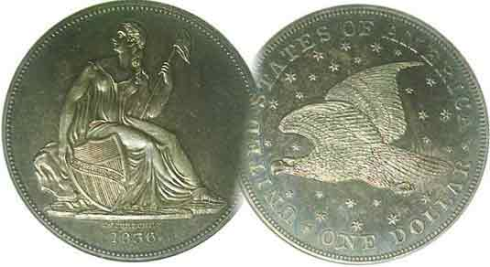
Pres. Willie Simon
V .P. Pat James
Sec. Jim Mullaney
Treas. Chuck Goergen
Sgt. in Arms: Jim Sproull

Programs: Pat James
ANA Representative: Jim Barry
Show Chairman: Steve Kuhl
Photos: Helen Barry
Publicity: Pat James
Newsletter: Arno Safran
E-Mail: arnosafran@comcast.net
Auctioneer: Jim Sproull
Web site: Susie Nulty (see above.)

2015 Club Meeting Schedule
Volume 14, Nos. 1-2 the Stephen James CSRA Coin Club, Founded in 2001 Jan, - Feb. 2015
Monthly Newsletter
Our next meeting will be held on Thursday, Feb. 5, 2015 at the Aiken Public Library

Club enters 2015 in upbeat mode, Coin Market mixed
Jan. 8 Apr. 2 July 2 Oct. 1
Feb. 5 May 7 Aug. 6 Nov. 5
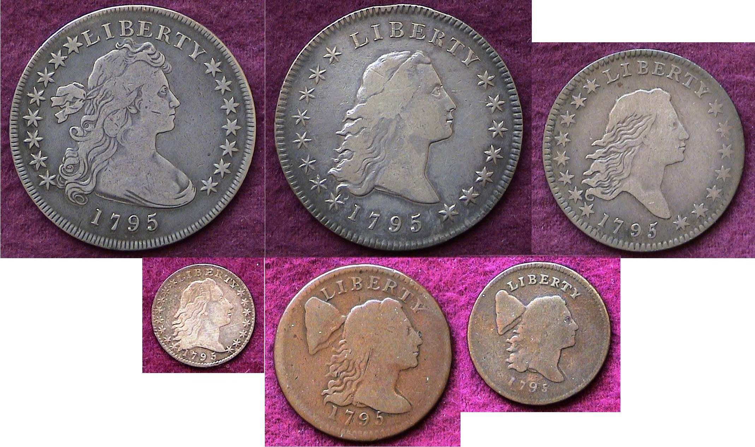
Mar. 5 June 4 Sept. 3 Dec. 3

Dec. 2014-pre Holiday Dinner one of the Best

Our club ended the 2014 year with another enjoyable pre-holiday dinner. The attendance was excellent, the food tasty, lots of prizes to go around and good company. Despite the Jan. 8 meeting running against the FUN Show, fourteen members attended which included an interesting Show & Tell exhibit and a program. VP Pat James arranged to have Sec. Jim Mullaney run an ANA video entitled Golden Coin Rarities from the Sea. Prior to the program, member Mac Smith displayed four gold coins struck at the Carson City Mint which operated from 1870 thru 1893. These` included two $20.00 double eagles and two $5.00 half-eagles. Our next meeting is February 5. Member Walter Kublius will present a PowerPoint program on the Coins and currency from Lithuania.
The 2015 F.U.N. Show
The first major coin and currency show of the year is the FUN Show sponsored by the Florida United Numismatists. It is usually held in Orlando in one of the large halls of the Orange County Convention Center with a space encompassing sixteen aisles, two city blocks long. As the largest show of the year it has become the bell weather for the numismatic market. It has often been said, if the collector cannot find the particular piece he or she is a seeking at FUN, it probably no longer exists. While not entirely true, the current state of the market is simply this: Higher-end uncirculated certified coins--both common or rare--are available for a price and can be found either at the major auctions held during the event or at specific dealers’ tables who tote exceptionally high priced material. Low grade common date coins are also plentiful but most are uncertified and a goodly number have problems. What is scarce in this current market are the certified VF-30 to MS-63 problem-free type coins including an increasing number of dates that were once were thought to be common .
_________________________________________________________________________________________________________________________

Collecting the US Coins of 1795: (excluding Gold)
220 years Ago By Arno Safran

A 1795 US Year set: $1.00 types plus 50c, half-disme, 1c and ½¢

Back in 1995, it was still possible for a person earning a middle class salary to assemble a set of well circulated yet still reasonably attractive 1795 dated US coins (excluding the two gold issues, the $5.00 half eagle and $10 Gold Eagle.) Such a challenge could not have been met during the previous decade when early US type coins had been promoted at prices well above what most collectors could afford nor is it likely to be accomplished today. In 1982, an 1805 Draped Bust dime grading VF was bid at $1,700 but a decade later, the coin in the same grade had fallen to $550. By 1995, I reasoned it might be possible to assemble a two-century old year set of 1995 coinage, (excluding gold.)

In 1793, the Philadelphia Mint struck only cents and half-cents. The following year, they produced three silver denominations but in very small numbers. In 1795, the Mint added two gold denominations but increased the mintages of the copper and silver denominations with the result that enough survivors of the cent thru the dollar were still available for the contemporary collector to acquire at reasonable prices.
_______________________________________________________________________________________________________________________
(Continued on page 2, column 1)
US Coins of 1795: (excluding Gold)
(Continued from page 1, column 2)

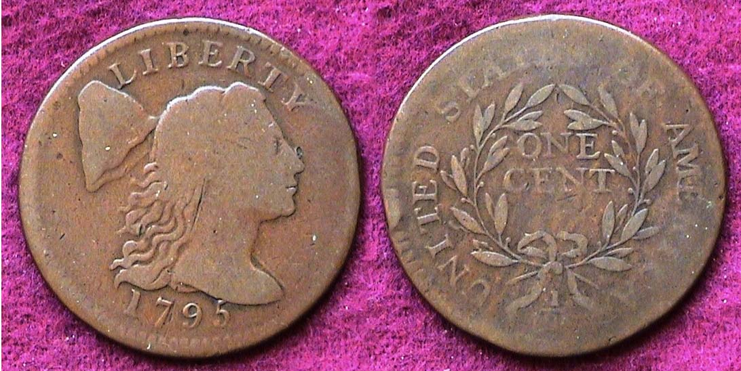

A 1795 Liberty Cap Large Cent graded VG-10 by NGC
Sheldon 76b, Plain Edge, R2 (actual size)

The 1795 Liberty Cap large cent was struck with a lettered edge (37,000), a reeded edge (only 9 known) and a plain edge which had recorded mintage of 501,500 or slightly more than half a million. Considering the size of our nation’s population back then, this was a fairly large number and the plain edge 1795 Liberty Cap cent is still the least expensive date of the four year series (1793-96). The cent quickly became the workhorse of the economy and circulated heavily The plain edge specimen shown above may only be a VG but it has nice original brown color with enough detail showing on both sides and since its acquisition in 1995 has increased in value. The Liberty Cap cent was originally designed by John Wright in 1793 but he succumbed to the Yellow Fever epidemic during the summer of 1793. Robert Scot, our first chief engraver (from 1793 thru 1823), adapted the design for the 1794 thru 1796 issues. The Liberty Cap cent had a diameter of 29mm and weighed 13.48 grams. In 1795, the cent had the purchasing power of around 20¢. The example was originally purchased in an NGC-VG-10 holder but was removed shortly after purchase in order to align it with the other 1795 denominations for display. Due to the changing numismatic market conditions, today, this would not be advisable.

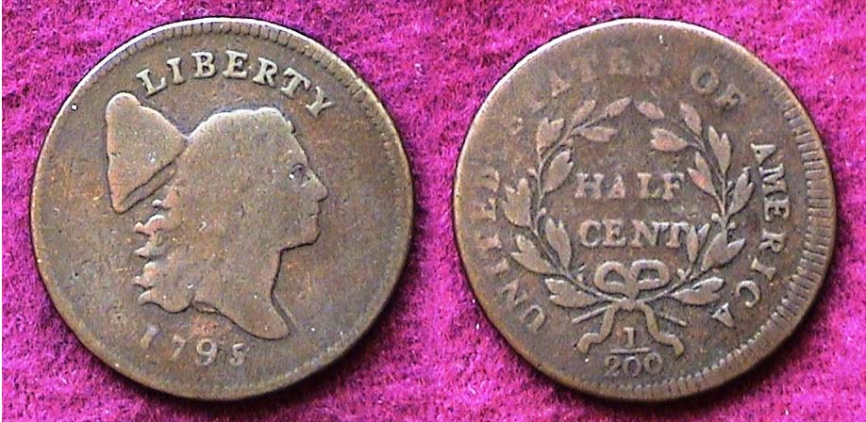

A 1795 Liberty Cap ½¢, C-1 R2 graded VG-8 (actual size)

In the early years of our nation, our coinage program was partially influenced by Great Britain and Spain, but structured by the recommendations of Ben Franklin and Thomas Jefferson that the United States adopt the decimal system. The Liberty Cap half-cent had a diameter of 23.5 mm, closely resembling in size the British copper farthing. Since silver for coinage was expensive to attain during this period, the US Congress accepted the Latin American silver Peso and its parts to circulate freely. The problem was that the dollar size Hispanic Peso (or 8 Reales) was divisible by eight, not ten, with the result that the Real, a silver coin slightly larger than our early disme was valued at 12 ½¢. The ½¢ coin enabled merchants to provide change to customers using the Real for purchases. The reported mintage of the 1795 half-vent was 139,690, the largest of the three year Liberty Cap facing right series (1794-96).
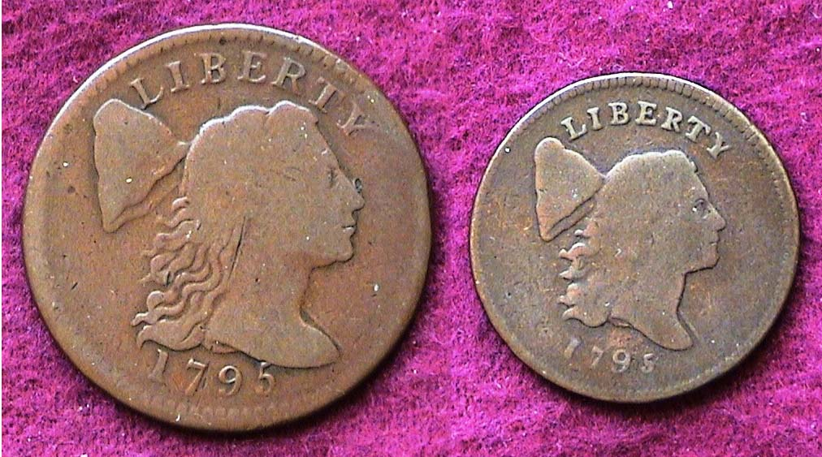

Comparative actual sizes of the 1795 1c & ½¢ obverses

While the particular die variety shown of the 1795 half cent is not considered rare, it is somewhat costly today, even as low as VG specimen shown.

The Flowing Hair Silver Coinage of 1795

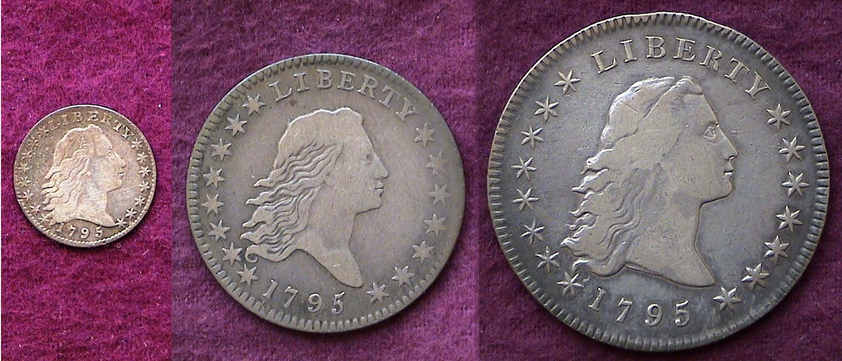

The obverses` of the 1795 disme, half-dollar and dollar (actual sizes)

In 1794, Chief Engrave Robert Scot produced three silver denominations out of the five originally authorized by the Coinage Act of 1792. These were the half disme, half dollar and silver dollar. All three had the Flowing Hair design. They were struck in very small numbers and are rare and extremely expensive. In 1795, the mintages of these same design types were much larger providing the contemporary collector with the opportunity of acquiring an example of each, a good thing too as the series was discontinued later that year.

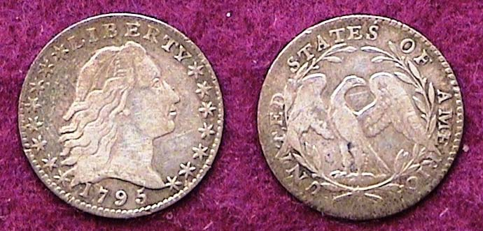

A 1795 Flowing Hair Half-disme (about actual size)
Originally acquired “raw” but later graded VF-25 by PCGS

The reported mintage for 1795 half disme was 66,416. The tiny coin was 16.5 mm in diameter and weighed just 1.35 grams. having a composition of .8924 silver and .1076 copper. It had a value of five-cents. The original spelling, disme is supposed to have been a derivation of the French and may have been pronounced “deem” or possibly dime. If a collector is hoping to acquire one for type, it will most likely be the 1795 dated issue but a perusal of the 2015 Red Book shows that even a specimen grading Good-4 will be costly today. The VF-25 specimen was acquired twenty years ago from a collector friend who wanted to obtain a higher grade specimen. It was sold to as a VF-20. In 2012, the writer submitted it for certification to PCGS at the FUN Show and it was graded VF-25. In 1795, the five-cent silver coin had the purchasing power of $1.00.
_____________________________________________________________________________________________________________________________
(Continued on page 3, column 1)
US Coins of 1795: (excluding Gold)
(Continued from the previous page)

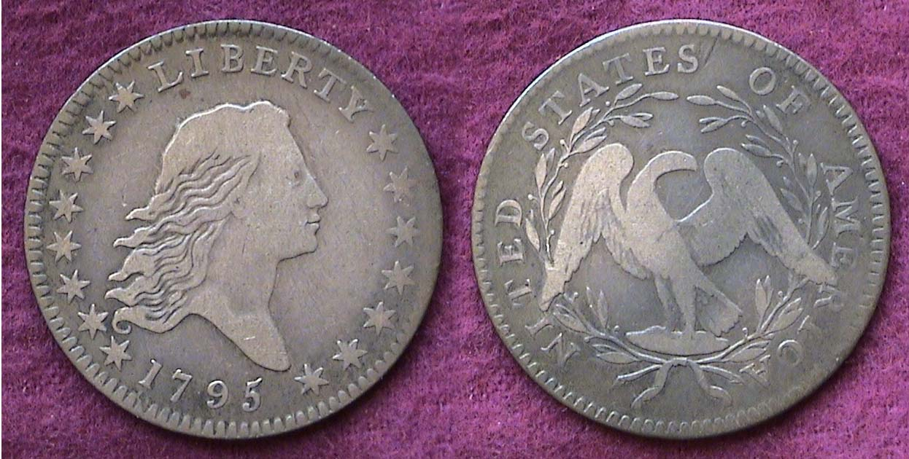

A 1795 Flowing Hair Half dollar, O-102, R4, (a scarce die variety)
Later graded Fine-15 by PCGS

Shortly after turning fourteen I became interested in coin collecting. A young New Yorker, I acquired a Waite Raymond catalogue and noticed that a 1795 Flowing Hair half was listed in Fine grade for a retail price of $20.00. My allowance was $2.00 a week for doing house chores and errands. I saved for ten weeks, then took the subway into Manhattan and walked over to Stack’s Galleries, the premier place to acquire rare coins. I was “pumped”! I entered the store with great anticipation. A clerk in a checkered vest came over and asked what I wanted and I replied, “a 1795 Flowing Hair half-dollar for $20.00.” He replied, “Sorry, son! We don’t have one but I can sell you an 1892 Barber Half! Impetuously, I bought the Barber coin and found out many years later when I returned to collecting during the 1976 bicentennial year that it had been severely polished. Not all my early experiences had` turned out negative. During my teen years one of the major downtown department stores, Gimbals had a coin department and I bought an 1825 Capped Bust dime there graded Extra-Fine with “Russet toning” for $4.50 which in 2012, PCGS certified AU-53, current retail value $1,000.

It would not be until 1989 that I would come across another 1795 half dollar. The coin was “raw” but both the dealer and I agreed that the specimen was a Fine-12, and original.(i.e., un-cleaned). The dealer wanted $565 for the piece and I told him that I would think it over and left the store. I was almost ready to drive on to the Jersey T’pke when I U-turned and drove back to the shop. The dealer had a big grin on his face when he saw me arriving. The particular specimen turned out to be a better variety as well. At the 2012 Fun Show I submitted the coin to PCGS for certification and it came back in a Fine-15 holder. The current Red Book retail value is around $2,750, with dealer bid listed at around $2,300.

The Flowing Hair half dollar was 32.5 mm in diameter and weighed 13.48 grams. It was composed of .8924 silver and .1076 copper, the same proportions of the half disme. The reported mintage for the 1795 Flowing Hair half was 299,680 with most survivors surfacing in no higher than VG to Fine condition but since the reported mintage for the 1794 issue was a only 22,464, the 1795 has been “pushed” upwards in value by the dealers because of collector demand.

In 1795, a half dollar had the purchasing power of $9.57. While the denomination has never circulated greatly, the size of the coin brings out the best aspects of the design.

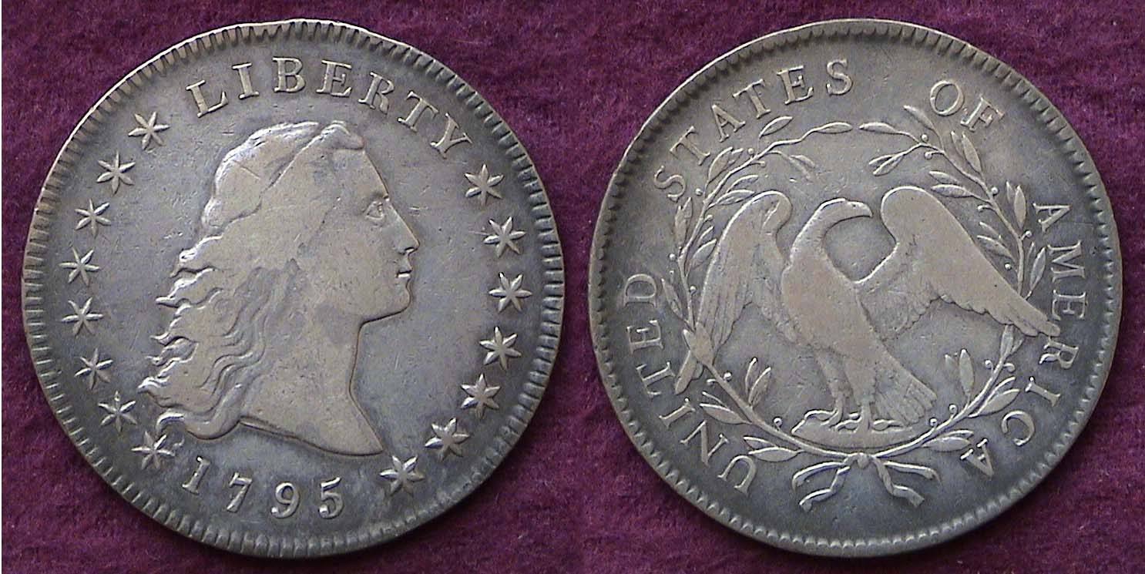

A 1795 Flowing Hair silver dollar, B-2, R2 graded Fine-15

As with the half disme and half dollar, Scot’s Flowing Hair obverse and small eagle reverse design–type was placed on the silver dollar and first coined in 1794. The reported mintage was only 1,758 and the date is extremely rare in all grades listed in AG-3 from $37,000 to over $600,000 in MS-60 according to the latest Red Book. In 1795, the reported mintage was increased considerably to 160,295. Back in 1995, it was still possible for a collector to save up for a 1795 Flowing Hair dollar grading Fine and occasionally, one could still find a specimen so graded at a local Sunday show. The coin pictured was acquired under those circumstances and later certified in 2012 as a Fine-15. In the twenty years since then, the 1795 Flowing Hair dollar has risen in value four times the price paid.

The Flowing Hair dollar was struck in .900 fine silver and .100 copper. It weighed 26.96 grams and was 39 to 40mm in diameter. In 1795, the dollar had the purchasing power of around $19.10.

The Beginning of Draped Bust coinage

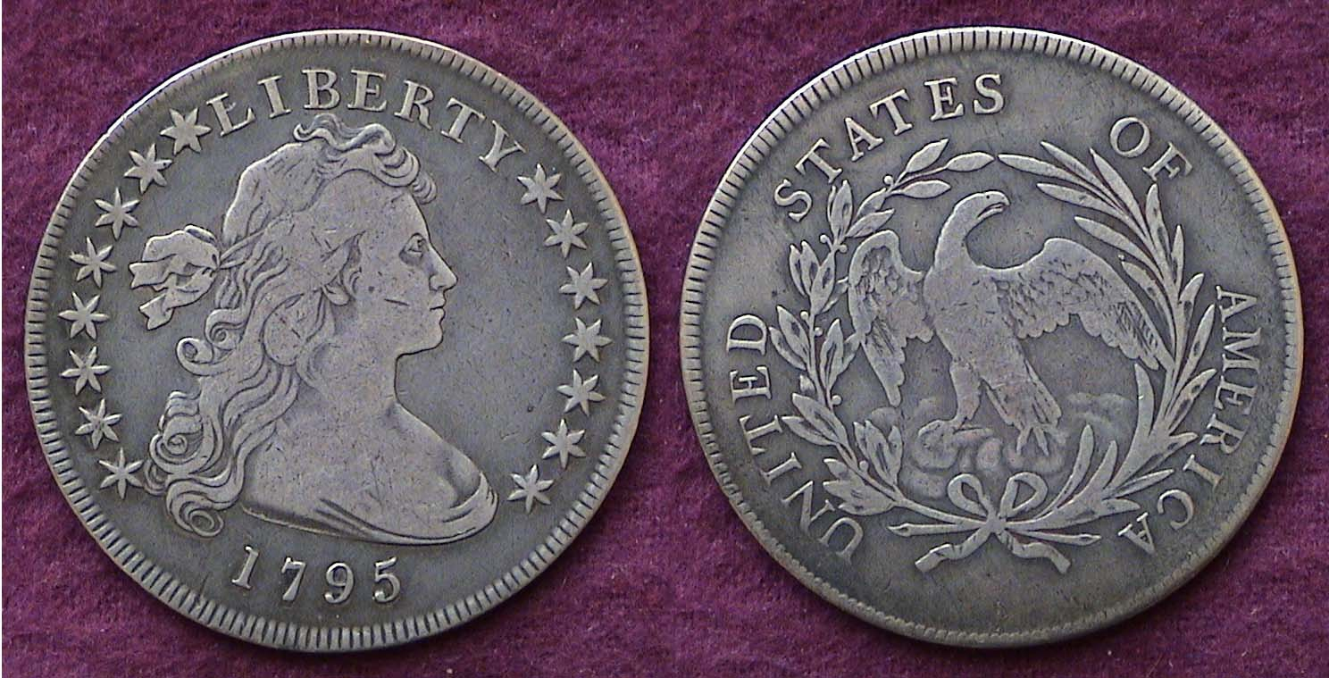

A 1795 Draped Bust $1.00 with small eagle graded Fine-15 by PCGS

In mid 1795, Mint Director Henry William DeSaussure, wishing to improve our design types for our silver coinage, authorized a new design type for the silver dollar. According to the late numismatic scholar, Walter Breen, DeSaussure asked noted portrait painter Gilbert Stuart to submit a sketch emblematic of Miss Liberty. It is believed that the person who posed for this drawing was Philadelphia beauty Anne Bingham, wife of Pennsylvania Senator, William Bingham. Two die varieties were struck of the new type in 1795 totaling a reported mintage of 42,738. The Bust slightly towards the left and not centered (as shown) is the more common of the two. The coin was acquitted in 1995 forming a nicely matched pairing to the Flowing Hair.
____________________________________________________________________________________________________________________________
(Continued on page 4, column 1)
US Coins of 1795: (excluding Gold)
(Continued from the previous page)
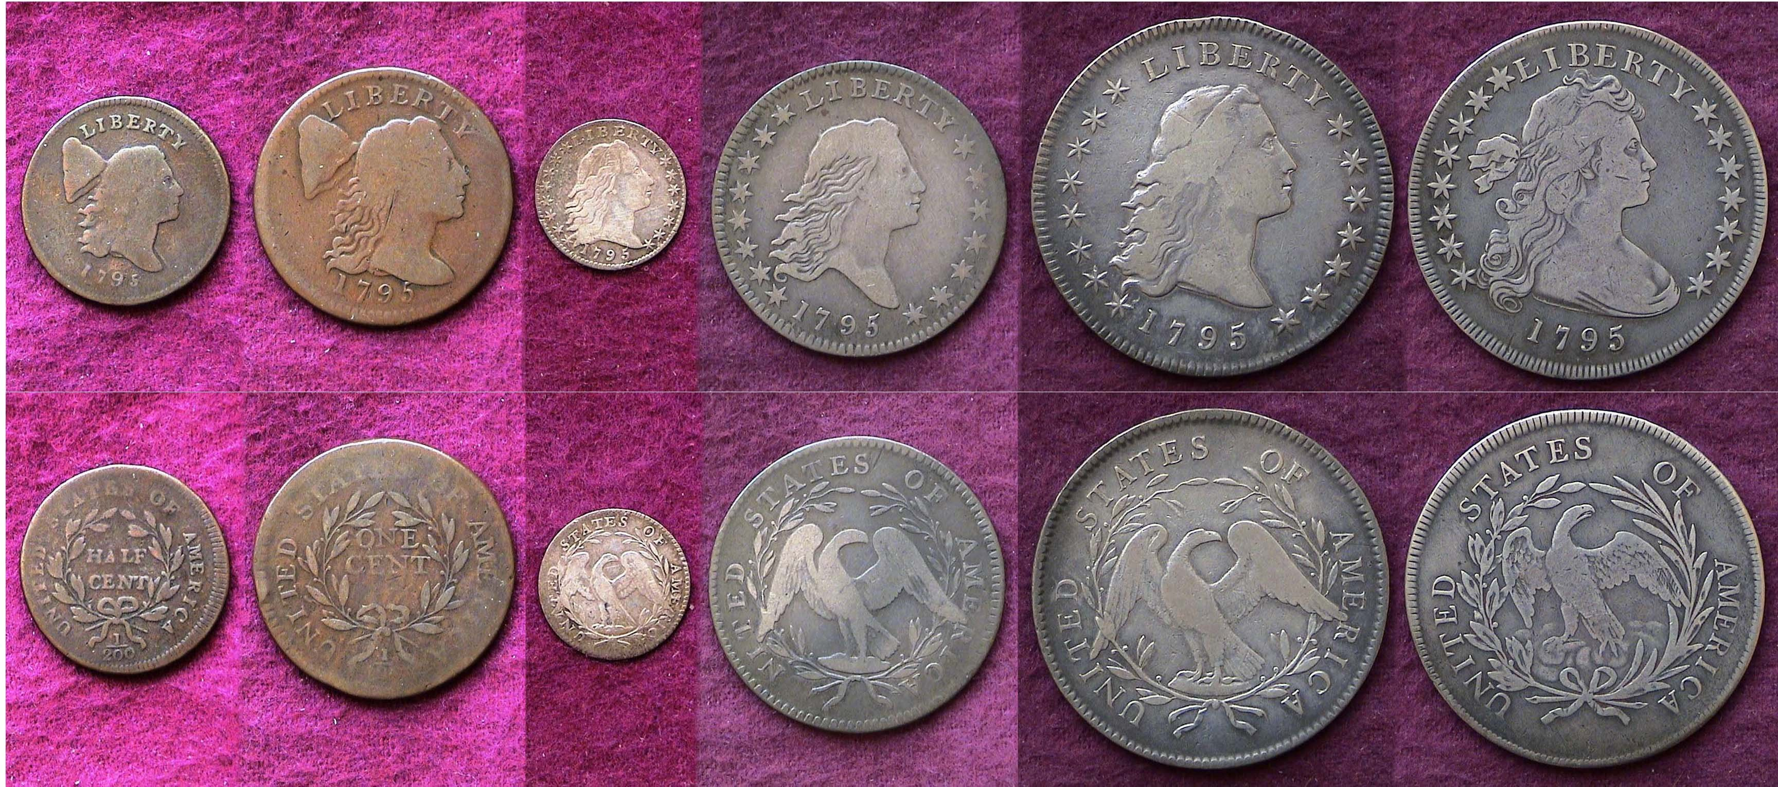

A 1795 denominational year set [reduced in size] (excluding gold)
From l. to r.: Lib. Cap ½¢, 1¢, Flowing Hair 5¢, 50¢ & $1.00 and Draped Bust $1
[Magnify to fit monitor screen to view details more clearly.]

It should be noted the coins of 1795 shown in this article were mostly graded VG to Fine with only the half-dime being rated a low range VF. While well circulated, none of the coins have been notably tampered with or exhibit problems other than wear. They form a balanced set. The adage, “Buy the best you can afford” was in play here and so far, the original cost of the six pieces have turned out to be a sound investment as well as providing pleasure of completion to the collector. Five of the six coins of 1795 display something of the portrait-Bust style of that era having mostly been influenced by the French.
Coin Collecting is more than how much an individual piece cost or is worth. As with the Ancient classical coins of Greece, Rome and the Byzantine Empire, the early coins of the United States offer the viewer a portal to the past showing the artistic taste of the time often including the sociological, economical and political thinking of the period.
___________________________________________________________________________________________________________________

Augusta Coin club to Move Once Again

Since a number of SJ CSRA CC members also belong to the Augusta Coin Club, the following information is now available regarding the Augusta coin Club’s meeting situation.

Just before year’s end, the ACC was notified by the Augusta Public Library that beginning on Jan. 1, 2015, the downtown main library would be closing its doors at 8:00 instead of 9:00 PM. As a result, ACC President Steven Nix called a Board Meeting held on January 13 to discuss alternatives. The Board agreed to hold an abbreviated meeting at the Augusta Public Library on Jan. 15 and announce that a new alternative site that had been found, but both the Show & Tell and Program had to be scratched to allow time for the auction which usually requires at least one hour of time. Starting on Thursday, Feb. 19, the ACC will meet at the Sunrise Grill, a breakfast and lunch eatery located at 3830 Washington Road in the West Town Shopping Center in Martinez. Despite there being no deadline to vacate the premises, the official start of the meeting will still be 6:30 PM which may pose a problem for the more distant members wishing to dine beforehand.
_________________________________________________________________________________________________________________________

STEPHEN JAMES CSRA COIN CLUB
Regular Meeting
Aiken County Library
January 8, 2014

President Willie Simon called the meeting to order at 6:52 p.m.
Glenn Sanders reported there were 14 members and no guests in attendance. Glenn also related information about three upcoming coin shows in the area. Glenn reminded the club that National Law Enforcement Appreciation Day is January 9th this year, so tomorrow we should be sure to thank any member of law enforcement that we see for their service.
Charles Braun won the members’ door prize, a Franklin Half Dollar.
There was a motion by Mac Smith to waive the reading of the minutes of the November meeting. Roger Worpell seconded the motion, which was voted upon and carried. A copy of the minutes will appear in the Club Newsletter and are on file in the Club’s records.
Treasurer Chuck Goergen sent in a report that the January balance was $1627.70.
Willie Simon thanked everyone who contributed to the success of December’s Holiday dinner.
The February club meeting will be on the coins and currency of Lithuania, by member Walt Kublius.
There was a brief discussion on the Augusta Coin Club’s change of meeting location. Changes to the Augusta library’s operating hours remove that as an option for next year. Starting in February, the Augusta club will meet at the Sunrise Grill, West Town Market Square, Martinez, GA.
There were one Show and Tell presentation by Mac Smith. Mac shared a pair of Carson City double eagles and a pair of Carson City half eagles.
Willie Simon reminded the club that we intend to offer for sale golf shirts with the Club’s logo early this year. Details on the shirts and order forms will be made available soon.
The January program was an ANA video, Golden Coin Rarities from the Sea, on gold coins recovered from shipwrecks.
Barbara Zirps won the 50/50 - $11.
Glenn Sanders conducted the club auction. The meeting was adjourned at 7:55 p.m.

Respectfully submitted,
Jim Mullaney, Secretary
_______________________________________________________________________________________________________________________

What About the 1795 Gold Coinage of the USA?

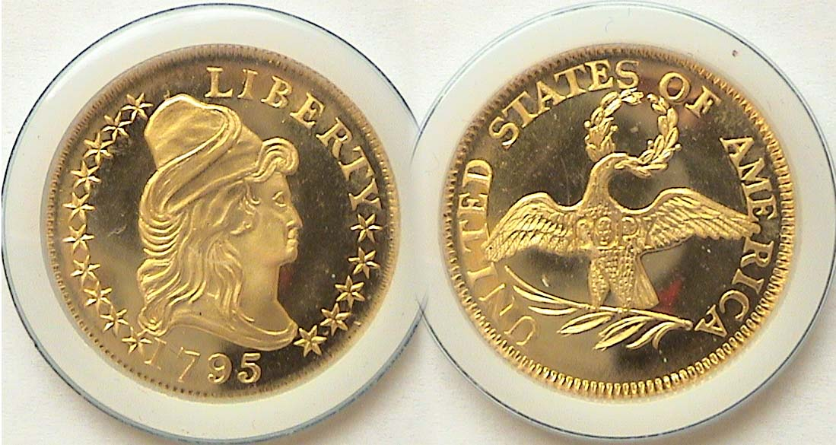

A 1795 $5.00 gold half Eagle replica
Struck by the Gallery Mint

In addition to the six 1795 denominations reported in the feature article, the US Mint in Philadelphia struck two of the three authorized gold denominations, the $5.00 half eagle and $10.00 eagle. The $2.50 quarter eagle would not appear until the following year, 1796. The 1795 half eagle was 25 mm in diameter, contained .9167 gold bonded to .0833 copper and weighed 8.75 grams. It was designed and engraved by our first chief engraver Robert Scot. The design type is quite attractive showing the Bust of Liberty facing right wearing a Phrygian Cap surrounded by 13 stars with date below on the obverse. The reverse displays a small spread- eagle with a wreath in its beak surrounded by the legend, UNITED STATES OF AMERICA.. The reported mintage was a scant 8,707 pieces. The 2015 Red Book lists a theoretical Fine-12 specimen at $20,000 and a MS-63 at $155,000.
The 1795 $10 gold eagle has basically the same features and measurements but with larger diameter of 33 mm. There are two known varieties, one with 13 leaves below the eagle and the other with nine, the scarcer of the two. The reported mintage for the date was just 5,583 with the current value ranging from $27,500 for a 13 leaves specimen grading Fine-12 to $500,000 in MS-63 for the nine leaves example according to the same source.

Since neither coin is likely to grace the cabinet of 99% of the collecting community, the Gallery Mint, decided to celebrate the bi-centennial of our first gold coinage by creating a replica that included the exact gold specifications of the 1795 $5.00 half eagle, thus making it possible for moderate income collectors to acquire one; the price to the collector, $150.00. (See above!)
The Gallery Mint Museum began operations in 1993, the 200th anniversary of our first cent and half cent coinage. Ron Landis was the chief engraver. The firm had a screw press manufactured to the same specifications as the one used by the original Philadelphia Mint. They attempted to recreate our early coins using the same design types, measurements and alloys. Critics praised the results. During the 1990s and continuing into the early years of the 21st Century the Gallery Mint reproduced many of our extremely rare colonial and US coinage designs including an entire set of all 1796 denominations in business- strike and proof. Sadly, as a result of death of one of the staff’s most beloved members, the Mint closed its doors for good. These replicas--especially the gold and silver coins--have increased in value since they were created.
_____________________________________________________________________________________________________________________________

Kindly Patronize Our Advertisers

