Pres. Willie Simon
V .P. James Barry
Sec. Helen Barry
Treas. Pat James
Sgt. in Arms: J.J. Engel
Committees:
Auction: J.J. Engel
Programs: James Barry
Newsletter: Arno Safran
The Stephen James
CSRA Coin Club of Aiken
P.O. Box 1739
Aiken, SC 29802
Web site: www.sjcsracc.org
The Stephen James CSRA Coin Club Usually Meets on the 4th Thursday of the Month at the Aiken Public Library
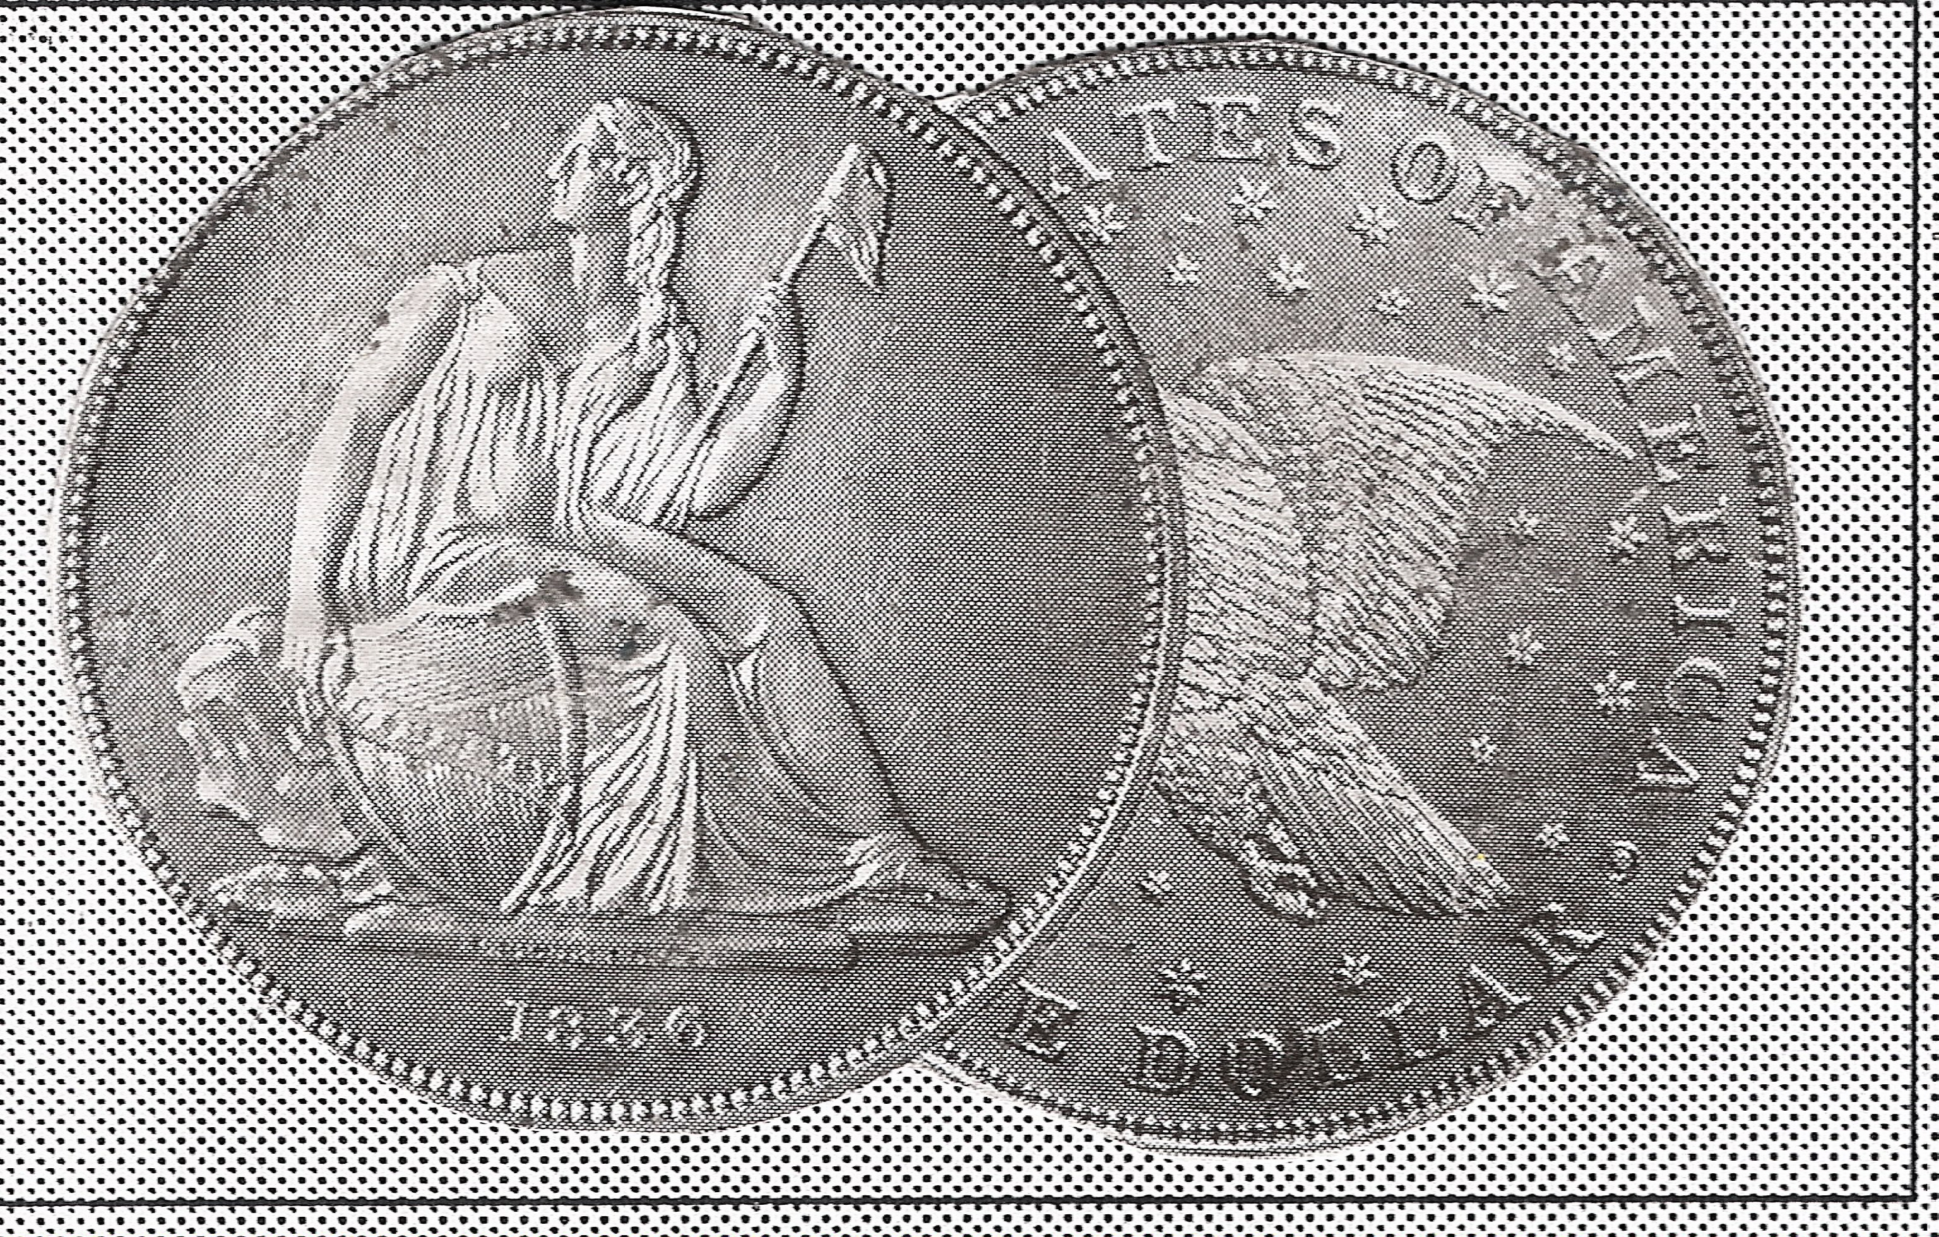
Volume 5, Number 1 the Stephen James CSRA Coin Club Monthly Newsletter January, 2006

Our Next Meeting is Thursday, Jan. 26, 2006 at the Aiken Public Library at 6:45 PM
“Hot” Coin Market Continues Into New Year
F.U.N. Show in Orlando Offers Clues to Market Direction

With this issue we begin our fifth year of the club newsletter... The editor wishes all our members a very Happy New Year as we look forward to our first meeting in 2006, scheduled for Thursday, January 26. Our last get-together ended with a delightful pre-holiday dinner at EE-Jays Restaurant on December 8. President Willie Simon served as host in his inimitable warm and welcoming style as he presided over the event, listing future goals. Pat James arranged for the club prizes and there were plenty of winners. These included Paul and Marjorie Simons, Helen Barry, President Willie Simon who won $33.00 in the 50/50 drawing. Doug Moody was the Grand prize winner taking home a 2005 silver Proof Set. Other members received silver rounds or commemorative silver dollar prizes in appreciation for their efforts on behalf of the club. The food was good and the conversation flowed from table to table. A good time was had by all.

Earlier this month, members Jim and Helen Barry, Bill Myer and his wife Cathy, member Bob Ward and yours truly attended the big F.U.N. show (for Florida United Numismatists) held in Orlando January 5-8. Bill Myers displayed two exhibits, taking 2nd prize in the Foreign Coins category and winning both 1st prize and “Best In Show” for his exhibit on P.O.G.S; the topic of his fine slide presentation here last year. As a result, Bill was presented with a full scholarship to attend the ANA’s Summer Seminar in Colorado Springs. Congratulations, Bill!

It was evident upon entering the huge bourse area that the 2006 FUN show was going to be another stellar event but with some subtle differences. For one thing, choice type material was difficult to find as better date coins--especially among the early US coin types--appear to be drying up. Dealers were complaining that many similarly graded replacements displayed less eye appeal for a higher price tag which they were being forced to pass along to their customers. With gold trading around $540 an ounce, prices for even common gold coins were higher. The only weak spot seemed to be among the super grade modern common dates and proofs (MS-66-68’s). They were “soft” at this show.

America’s Large Cent
Part 1 of two by Arno Safran

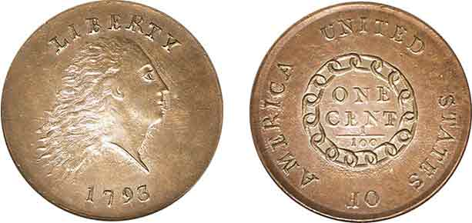

A 1793 Chain Cent, our nation’s first federally struck cent

The U.S. Large Cent boasts one of the widest collector bases of any American coin. The denomination’s genesis goes back to the sestertius of Imperial Rome almost 2,000 years ago. From these majestic copper pieces, the sestertius gradually went through a series of transformations which led to the follis during the late Roman and first half of the Byzantine era. The follies or 40 nummi represented a copper denomination about the same size as our large cent. It could be sometimes larger as during the reign of Justinian I when silver dollar sized follii were struck, but they also could appear as small as our half cent. After centuries of war, the coinage of Byzantium became debased affecting even the copper coinage. The bronze tetarteron may be considered a descendent but eventually all reference to the nomenclature of follis disappears. The Moslem armies finally conquered the Byzantines in 1453. A little more than two centuries later in 1672, England issued its first copper half pennies during the reign of Charles II.

Our own large cent has a distinguished history. No less than three transitional-date sub-types were issued the very first year, 1793. These included the Flowing Hair with Chain reverse, the Wreath reverse and the Liberty Cap obverse; the latter being the scarcest of the three. The first two sub-types were designed by Henry Voight; the Liberty Cap by Joseph Wright. They appear to be based on French engraver Augustin Dupree’s Libertas Americana medal of 1783. All three 1793 cent types are rare. Even in AG-3 these pieces are costly but there is a silver lining for the budget conscious collector.
(continued on page 2, column 1)
America’s Large Cents (continued from page 1, column 2)

In the early 1990’s, the Gallery Mint Museum was established to reproduce coins using devices and equipment similar to that of our first US Mint. Their initial offering was the 1793 Chain Cent and the charge for an uncirculated business strike specimen was $8.00.Many collectors availed themselves of the opportunity to own an example of America’s first coin issued for commercial use even though the word COPY was incused on the reverse(or obverse depending one’s preference.) The GMM soon followed with the Wreath and Liberty Cap versions of the 1793 as well; thus the silver lining alluded to earlier.
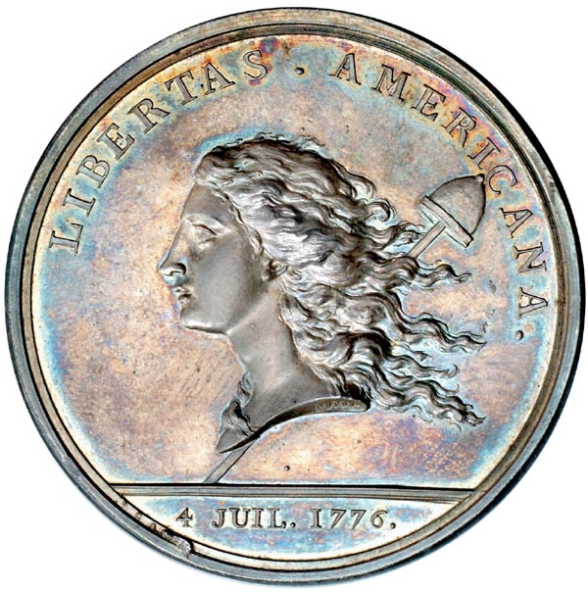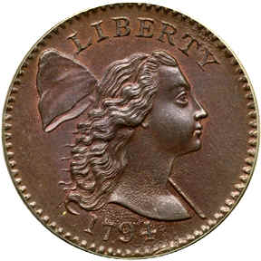

The obverse of Dupree’s Libertas Americana Medal and
Joseph Wright’s 1794 dated Liberty Cap Cent

The Liberty Cap cent type was struck from 1793 thru 1796 (with a number of modifications) when Chief Engraver Robert Scot’s Draped Bust type was introduced. Since both types were issued the same year, the collector has the opportunity to acquire two transitional type cents for 1796. The problem is that even in VG-8 the coins are fairly expensive, listed at $450 and $500 respectively in the 2006 edition of A Guide Book of United States Coins. (AKA the Red Book).
Again the Gallery Mint has come to the rescue. In 1996 the GMM commemorated the bicentennial of the first striking by the US Mint of all ten authorized denominations in a single year. Included were the two large cent types of 1796, the Liberty Cap and Draped Bust. For $8.00 each both types are still available.
For those who prefer the real thing to replicas, the least expensive date for the Liberty Cap series is the 1795, the plain edge variety listed in the 2006 Red Book at $350 in VG-8.

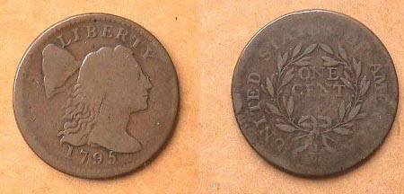

A 1795 Liberty Cap Large Cent, S-76b grading VG-10

The most common dates in the Draped Bust series are the 1798, 1802 and 1803 issues. In Fine-12 they range in price from $150 to $200. These prices represent coins that are considered “average” for grade and not “choice.” A large cent to be considered” choice” should exhibit natural brown color along with unblemished and, be well struck. Such coins will cost more than “average.” There is another term used by EAC graders; “scudzy”. Such coins are fraught with problems including dark color, porous and corroded surfaces along with unsightly rim-nicks, digs and scrapes. These sell well below “average” coins. These terms define a coin’s “net grade.”
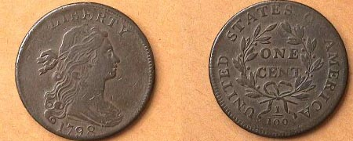

A 1798 Draped Bust Large Cent (S-167, R1, a common variety)

In 1807 John Reich was brought in as Assistant Engraver to Robert Scot with the sole purpose of improving all our coinage designs, The real reason is alleged to have been political as Mint Director Robert Patterson of Pennsylvania had been selected by President Thomas Jefferson, an advocate of States Rights. Chief Engraver Scot had been appointed during the second administration of George Washington and retained by President John Adams, both Federalists. Reich created his Classic Head (sometimes called Turban Head) style for the large cent beginning with the 1808 dated issue. Some collectors consider this type to be our most beautiful large cent design.

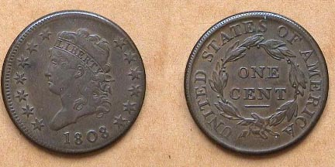

An 1808 Classic Head Large Cent (S-279, R1)
A common variety but uncommonly “choice” for this series

Finding choice specimens for this series (1808-14) represents quite a challenge for collectors. During this era the US Mint received all their copper planchets from the firm of Mathew Boulton in Soho-Birmingham, England. Boulton’s reputation as a manufacturer of copper planchets was highly regarded. Despite this, most of the copper blanks used to strike the cents suffered corrosive damage as a result of being stored in the damp holds of ships crossing the Atlantic. This would account for the often poor quality of many of these coins. As relations between the two countries deteriorated in 1812, it was becoming increasingly difficult for Mint Director Patterson to obtain new orders from Boulton and once the War of 1812 had begun, all shipment of copper blanks ceased. So, despite the beauty of Reich’s Classic Head design, it has been difficult to find chocolate-brown specimens free of porosity or granulation. Many Classic Heads appear black while others surface with a surfeit of problems such as verdigris, scratches or scrapes; occasionally rim nicks along with attempts at enhancement that may include buffing, polishing, re-coloring or retooling the design elements. According to numismatic scholar Robert W. Julian, a large percentage of these cents were paid out in salaries to Mint employees. Despite the problems associated with production, one should be able to pick up a VG-8 example for around $150 but Fines and VF’s will cost a lot more.
_________________________________________________________________________________

A Lion’s Tale by David Bailey

We live in a wondrous age. Cell phones are everywhere. A recent television commercial explained that under their plan, one could call England, Germany or China for just 2¢ a minute. Allowing for a few seconds for hook-up, conversation is virtually instantaneous. However, December 24, 1814 was a different story and therein lies this Lion’s tale.

In 1812 an optimistic America declared war on Great Britain. Impressions of sailors’ and other slights to our national honor turned war fever into a national epidemic. Also, with the British distracted in Europe, Canada seemed to be an easily taken prize to be added to the American nation.

It was not to be and by 1814 America and Great Britain both wanted to end the hostilities. Delegations were sent to the city of Ghent which is located in Belgium. The peace treaty was finally hammered out and signed on Christmas Eve day, December 24, 1814. AQ medal was struck shortly afterward which featured a figure of Peace standing on a globe. Peace holds the symbolic olive branch as well as the cornucopia that symbolizes the benefits to both nations peace will bring. The obverse legend reads, ON EARTH, PEACE GOOD WILL TO MEN, the universal holiday wish. The reverse featured a legend with a wreath and the inscription, TREATY/ OF PEACE+AMITY/ BETWEEN/GREAT BRITAIN/ AND/ THE UNITED STATES OF AMERICA /SIGNED AT GHENT /DEC 24, 1814.

England and America were finally at peace with each other. Sadly, this news dispatched to America arrived to be proclaimed several weeks later. On January 6, 1815, a coalition of frontiersmen, militia, pirates and slaves defeated an invasion of some of the finest units of the British army. Several thousand were killed or wounded at New Orleans in a battle fought after the war had officially ended.

I look at this medal from time to time and think of the needless loss of humanity if only we could follow the message of the obverse of a medal struck in 1814.

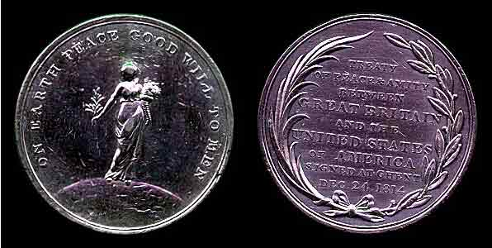

The Treaty of Ghent Medal
___________________________________________

Thanks, Dave for another illuminating article from your ongoing series, “the Lion’s Tale”. In the hope that a successful conclusion to the War of 1812 would result in the annexation of Canada to the U.S., it is interesting to observe that during the pre-war hysteria, those same war hawks who cried out, “On to Canada!” exclaimed after the Treaty, “Not one inch of territory lost!” Sounds all too familiar, doesn’t it? (Ed.)
__________________________________________________________________________

President’s Message

Greetings everyone!

I hope that each of you had an enjoyable holiday season and you are ready to get back to our Hobby of Coin Collecting. I have missed seeing each of you and have been looking forward to our next meeting where we can again enjoy the talents and fellowship that each of you offer.

As our club enters its sixth year in 2006 I would like to encourage each member to become more involved in the activities our club provides.

First, the Show and Tell gives us the opportunity to display that special collection which you have worked to obtain while sharing your experience and knowledge each of you have.

Second, the Newsletter welcomes stories about your collecting interests and experiences.

Third, I would like to encourage more members to become more involved in our Coin Show activities. Our next show is still far off, Saturday, September 16, ’06 but we will be needing your help in the form of suggestions, publicity, advertising and most importantly, volunteer work if we are to make the show an even better success this year.

Fourth, I would like the members to feel free to discuss with me any new suggestions, goals, activities and programs that you believe would enhance our club.

Finally, I would encourage you to invite a friend or family member to attend one of our meetings.

I thank each of you for continuing to help make our club into being the very best. Together we will improve our club while increasing its membership. I make this commitment to you.

Willie Simon

Member Larry Lucree Opens Coin Store in New Location

Of you haven’t noticed fellow member Larry Lucree loves coins with a passion; so much so, he decide to open a coin shop several months ago. It is called the Augusta Coin Exchange. Two days after Christmas Larry moved his store to a more ideal location in Martinez, Georgia. His shop is now situated on the Evans bound side of Washington Road among a small group of shops at 4015 Washington Rd., Suite L between Columbia Road and Flowing Wells Road. Store hours are 10:30 AM to 4:30 PM Tuesday thru Friday and 9:00 AM to 3:00 PM Saturdays. The store phone number is 706-210-5486.

Larry’s new place is very attractive, bright and commodious and it is well stocked with a nice selection of US type coins (large cents to Bust halves to Morgan dollars and gold) with proof sets going back to the 1950’s, not to mention a number of choice BU Lincolns and Buffalo nickels at reasonable prices. He also has a wide selection of foreign coins and coinage accessories such as holders, flips, coin tubes and albums. Larry with his wife Deborah hopes to attract more members from both the Augusta and Aiken clubs with an ever expanding stock. Check their ad on page 4 and why not stop in and see them?
________________________________________________________________________

“Jim” by Bill Myers
An Introduction

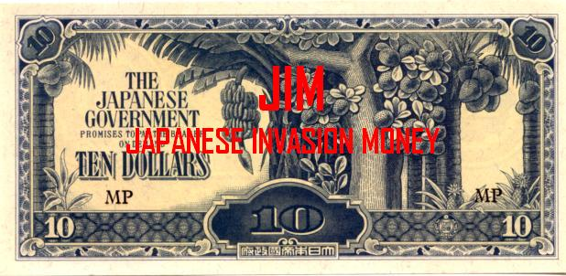

A $10.00 “JIM” note issued by the invading Japanese during W W II

In World War II, Japan wanted to free the Pacific of European and American influence and unite the Asian nations into a greater East-Asian co-prosperity sphere. Towards this goal, the Japanese issued "Japanese Invasion Money", or "JIM", to create economic control of the areas it conquered. The notes were tied to the yen at par (e.g.: 1 yen=1 peso) except for the Oceania pound, which equaled 10 yen.
JIM was issued for:
Burma (cents and rupees)
Malaya (cents and dollars)
Netherlands East Indies (cent and gulden)
British Oceania (shillings and pounds)
Philippines (centavos and pesos)
the notes were issued in multiple series, with and without serial numbers. They used a system of code letters called blocks. Block letters consist of a letter for the series which are:
B - Burma
M - Malaya
O - Oceania
P - Philippines
S - Netherlands East Indies (Sumatra)
They also include a letter (A to Z) for the block (e.g.: BA, BH). When the block letter combinations were exhausted, fractions were used (e.g.: B/AA, B/AH).
The estimates of the issues of JIM show that a significant number were issued.
RUPEES 5,700,000,000
DOLLARS 5,700,000,000
GULDEN 3,300,000,000
POUNDS 10,000,000
PESOS 10,100,000,000

Many JIM are easily located and inexpensive, but there are also some issues that are difficult and expensive to collect. The notes have interesting designs and come in a large variety of colors. Due to their relative lack of popularity there are "cherry-picking" opportunities available for collectors. Some of the countries have more then one style of notes for a particular de- nomination. There are also specimen notes, (trials with perforated holes), replicas as well as counterfeits for some notes. Each country’s series will be explored in more detail in subsequent installments.

This is the first of a series on Japanese Invasion Money from World War II by member Bill Myers. The next installment will feature J.I.M. notes from Burma. Bill was elected President of the Augusta Coin Club in December.
_____________________________________________________

Kindly Patronize Our Advertisers

For the serious and casual collector

COINS, STAMPS & CURRENCY

P.O. Box 1738 143 York Street, S.E.
Aiken, SC 29802 Aiken, SC 29801
(803)- 643-9957

Tony’s Coin Shop

Buying & Selling Coins
Proof Sets and Mint Sets
Bullion and Rare Coins

Tony Fulmer
1631 Whiskey Road (next to Hearing Center)
Aiken, SC 803-648-1388

Augusta Coin Exchange
Fine Rare Coins

Buying US Coins, Currency, Gold and Silver Bullion

4015 Washington Rd. Suite L Martinez, GA 30907

Larry Lucree ANA Member # R-21285
PH 706-210-5486 Tues-Fri. 10:30 am – 4:30 pm
Evenings 706-339-7275 Sat. 9:00 am - 3:00 pm

E-mail: coolhandcoins@comcast.net

