Pres. Willie Simon
V .P. James Barry
Sec. Helen Barry
Treas. Pat James
Sgt. in Arms: J.J. Engel
Committees:
Programs: James Barry
Newsletter: Arno Safran
Show Chairman: JJ Engel
The Stephen James
CSRA Coin Club of Aiken
P.O. Box 1739
Aiken, SC 29802
Web site: www.sjcsracc.org
The SJ CSRA CC Now Meets on the 2nd Thursday of the Month at the Cedar Creek Community Center in Aiken, SC

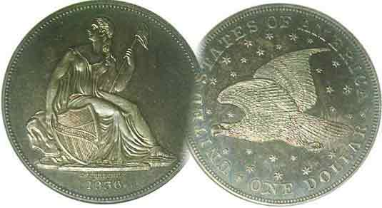

Volume 6, Number 1 the Stephen James CSRA Coin Club Monthly Newsletter January, 2007
Annual Club Dinner, another Festive Affair
Our next meeting is on the 2nd Thursday of the month, January 11, 2007 at 7:00 PM
2007 Club Meeting Schedule - 2nd Thursdays at 7 PM Jan. 11 Apr. 12 July 12 Oct. 11
Feb. 8 May 10 Aug. 9 Nov. 8
Mar. 8 June 14 Sep. 13 Dec. 6
Club Show: Sat. Sept. 15, 2007
_____________________________________________________________________________________________________________________________

Dinner meeting at EE-Jays an Absolute Delight

The club’s sixth annual pre holiday Christmas dinner party took place at EE-Jay’s Restaurant in Aiken on December 7 with more than 30 persons enjoying an extremely joyous evening of good food and drink along with numismatic camaraderie and fellowship. Our club is indebted to Jim and Helen Barry who arranged for the numerous prizes and presentation awards and to the leadership of President Willie Simon as perennial host. His warmth and graciousness made everyone feel inclusive and comfortable. As a result of their efforts, the evening went off without a hitch. Willie cited two fellow members who could not be with us. The first was Col. Bill Myers who is currently serving in Iraq as an orthopedic surgeon. Willie praised Bill for his contributions of interesting articles in our club newsletter and for the fine programs he has presented. The second was for Treasurer and club co-founder Pat James, recovering from successful minor surgery. All present wished her a speedy convalescence.

Awards were given to JJ Simon for all the work he put in as General Show Chairman and to Willie Simon and Jim and Helen Barry for the work they have done on behalf of our club. Arno Safran was presented with an ANA Award Certificate for his PowerPoint talk on “the Coins of 1806, 1816 and 1836” that he presented earlier in the year before the club and at the South Carolina Numismatic Association Convention in October. Many members received prizes of one ounce silver rounds; some with South Carolina motives, provided by member Tony Chibbaro, a noted authority on SC medalic art.

Willie wished everyone a Merry Christmas and Happy New Year and requested members to let him and the Executive Committee know what kind of programs they would like the club to present in the coming year. The next meeting will be on January 11 at the Cedar Creek Activity Center. Bring in an item for Show & Tell and Happy New Year everybody!
_________________________________________________________________________________________________________________________
The Case for Collecting Circulated Barber Halves by Arno Safran

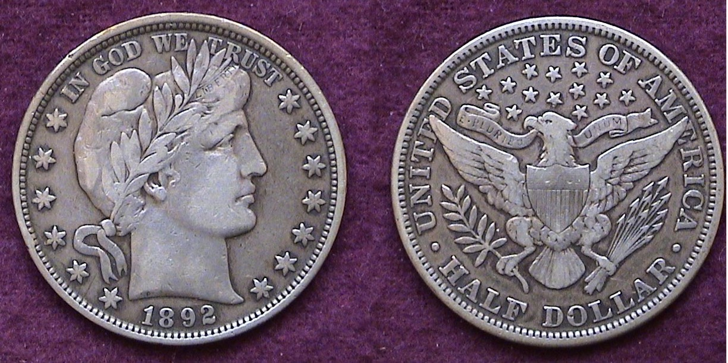

An 1892 Barber Half Dollar grading VF-25
From the author’s collection

There are a number of US coin types that still look attractive to the eye yet grade no better than Fine or VF. One such coin is the Barber Liberty Head half dollar. While unpopular at the time of issue (1892-1915) Charles Barber’s bold obverse and reverse design holds up well with extensive wear down to VG-8, especially if the coin still appears original gray and problem-free.

The obverse design features a bold Grecian Laureate Bust of Miss Liberty facing right. On her brow under the sprigs of Laurel are the letters L I B E R T Y; above, the motto IN GOD WE TRUST with six stars to the left and seven at the right of the central device. The date is centered below. The reverse displays what some contemporaries have uncomplimentary referred to as a moth-like eagle that is centered under thirteen stars over a sprig of olive branches at left and arrows at right. At the eagle’s neck is a ribbon containing the motto E PLURIBUS UNUM. Above is the legend, UNITED STATES OF AMERICA with the denomination HALF DOLLAR centered at the bottom of the coin.

Today Barber’s Liberty head halves are considered artistically pleasing as well as a prime example of what functioning coinage should be. They have become a popular series with collectors, because as a set, there are no “stoppers”. A “stopper” is an extremely rare key date of a series that is priced well out of proportion to all or most of the other dates at all grade levels such as the 1901-S Barber quarter.
___________________________________________________________________________________________________________________
(Continued on page 2, column 1)
The Case for Collecting Circulated Barber Halves
(Continued from page 1, column 2)

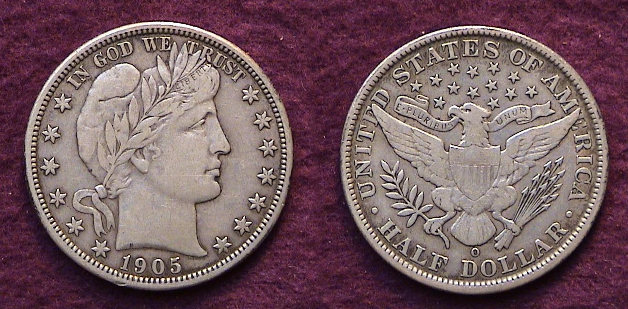

A 1905-O Barber half grading VF 30 from the author’s collection

During its 24 year run, Barber halves were produced at four Mints; in Philadelphia (no mint mark) and San Francisco, (S) (1892 to 1915 inclusive) at New Orleans, (O) (1892 through 1909) and at Denver, (D) (1906–1908, 1911–1913 and 1915.) The mint mark was placed on the reverse and centered under the eagle’s tail feathers. In all, there are 73 collectible issues required to form a complete set.

There are several ways one can approach collecting this series. First, one has to establish the grade range. The biggest challenge is Fine to VF because these are the scarcest. The collector can choose to assemble a four piece Mint set, a date set of 24 pieces that are the least expensive; a Philadelphia or San Francisco Mint set; the Philadelphia set being the easiest of the two or a complete set of 73 pieces; (1892-P thru 1915-S).

Back in 1992, in commemoration of the 100th anniversary of the Barber silver series, this collector decided to assemble an 1892-1915 Philadelphia Mint set of Barber halves grading Fine12 thru VF-35; perhaps an occasional XF-40 to 45 if it appeared original and not “blast white” in order to blend in with the natural gray color of the Fine-VF pieces. The project took 1½ years to complete. The first acquisition was dated 1901, very common, having the fourth highest mintage of 4,268,813. It was a lovely gray coin graded Fine-15 (today’s VF-20). The last Philadelphia Mint acquisition turned out to be the elusive 1905. With a mintage of only 662,727, it represented the eleventh lowest of the entire 73 piece set. The piece graded Fine-12 (today’s 15). What about the three key dates? The 1913, (188,000) 1914 (124,230) and 1915 (138,000). As these turned out; they were all available for a price. The 1913 acquisition was purchased as a type coin back in 1990 because it was a beautiful original gray specimen grading XF-40 (today’s 45 or 50) at the time, very reasonably priced . It blended so well with the rest of the set I decided not to go for a lesser grade piece.

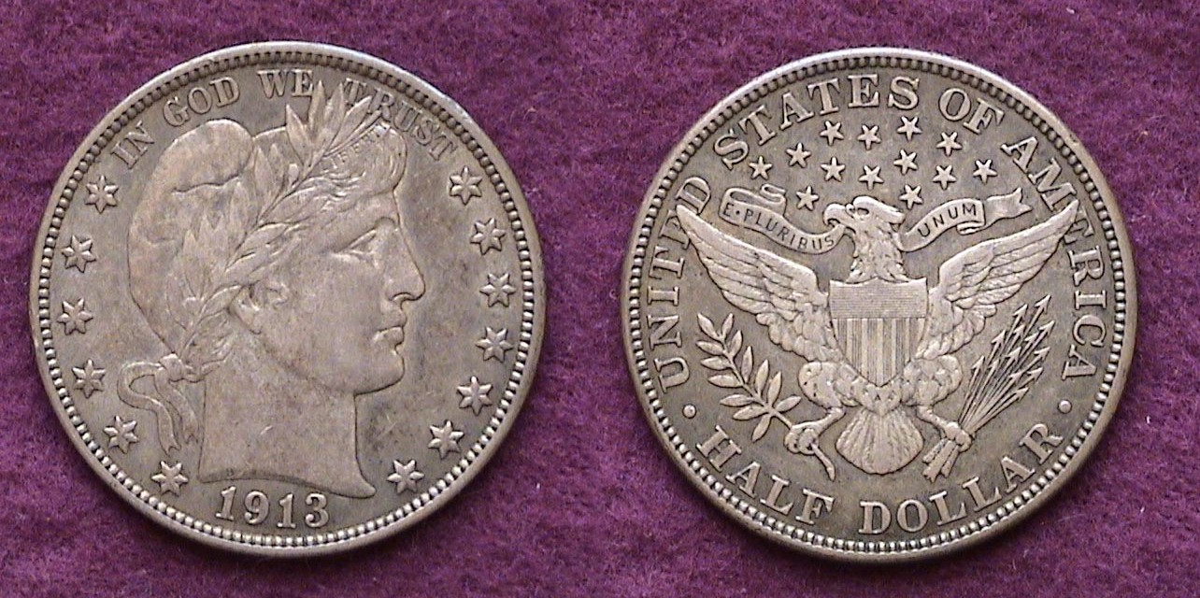

A 1913 Barber Half dollar grading XF-45 from the author’s collection
In 2003 I returned to Barber Half collecting; these times to go for the branch mints and complete the set. Upon entering the bourse at the South Carolina Numismatic Association convention, there was a dealer on the right who had a fairly good size display of Barber halves, and lo and behold, there it was; a 1904-S graded FINE right in the middle of the pack. While not a “stopper”, this was the key date of the entire series in all grades above Good-6. The coin looked “original” with all seven letters of the word LIBERTY visible, if some just barely. Since 2006, the Red Book describes FINE-12 as showing “LIBERTY nearly completely legible, but worn.” These two key words, “nearly” and “legible” are a departure from (not “completely readable” as seen in earlier editions). Fortunately there are other factors required to ensure the grade of FINE. On the reverse there was a strong definition of the overall design with the motto E PLURIBUS UNUM clearly shown on the ribbon above the eagle. Only a couple of minor rim bruises kept the coin from being a FINE-15.

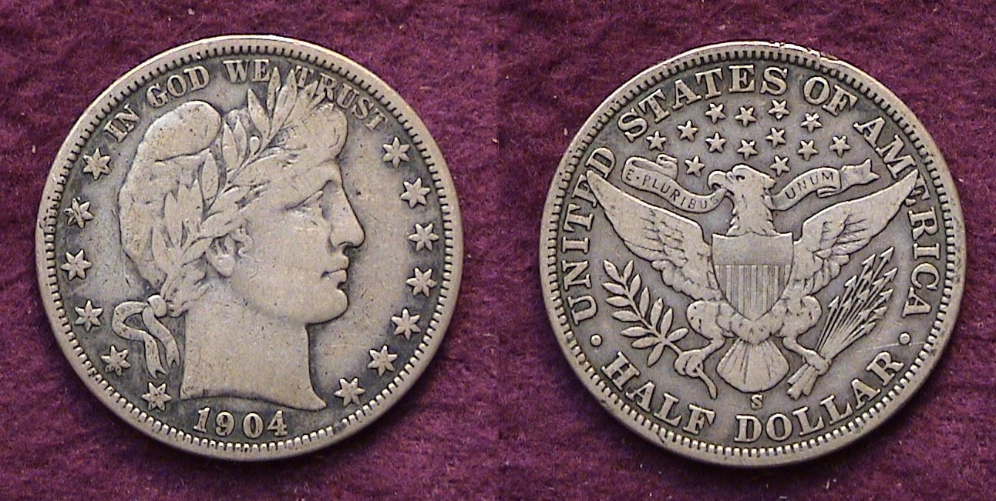

A 1904-S Half dollar grading F-12 from the author’s collection

There are a number of other ‘tough” dates that are difficult to find in Fine-12 to VF. Second to the ’04-S is the 1897-O and right behind it, the 1897-S and 1898-O.

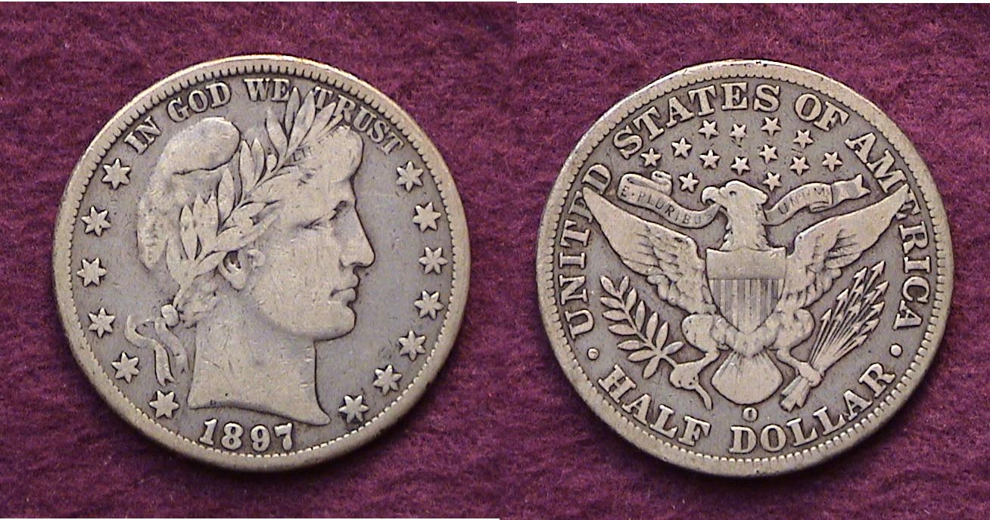

An 1897-O Barber half grading Fine-12 from the author’s collection

Others are the 1901-S and 1904-O. Then there are the four earliest branch mint dates, the 1892-O and S and the 1893-O and S. All four are easy to find in AU through uncirculated but seldom surface in the circulated grades above VG. After three years of trying to complete the series, these four last named dates remain the most elusive for the writer.

Why are Barber halves so difficult to find above VG-10 and below AU-50? It may have to do with a special period in our nation’s history when America was in the throes of a large influx of immigrants from Europe and the orient. Many second generation Americans and older laborers found themselves in competition for factory jobs with the newly arrived immigrants.
_______________________________________________________________________________________________________________________________
(Continued on page 3, column 1)

The Case for Collecting Circulated Barber Halves
(Continued from the previous page)

A large number of our urban ancestors were forced to live in cold water flats at $15 a month. These five story walk-up tenements had no elevators with bathrooms situated off the hallways. While a $15 monthly rental may seem astoundingly low in comparison with today’s housing market, the wages for entry level workers were even lower; as little as 8¢ an hour for men. Young women were paid just 2½¢ an hour (in Chicago) to 4¢ an hour (in New York). Employees worked 10½ hour days, six days a week. Even at 8¢ an hour, a weekly salary barely exceeded $5.00. The average family man with several years experience earned around $8.50 a week, so a monthly rent of $15 represented a pretty sizeable chunk out of his paycheck especially with a family to feed. Any newly struck Barber 50¢ pieces that may have entered great grandfather’s weekly pay envelope quickly went out to buy basic goods. Only the rich and well born could put aside a brand new issue and only the very wealthy can afford Choice to Gem BU specimens today. As for the surviving circulated portion of the Barber half series; roughly 80% surface in grades of About Good (AG-3) to Very Good (VG-8). Unlike half dollars from the 1940’s on, these coins were spent because 50¢ had tremendous purchasing power during the 1890’s and first two decades of the 20th century. According to the author’s research, 50¢ had the value of $11.00 during the years the coin type was issued. As a result, finding original problem-free Barber halves grading Fine-12 through VF-35 represent a major challenge for today’s collector.

The best source of information on the series is n 8½” by 11” paperback book entitled The Complete Guide to Barber Halves by David Lawrence; a pseudonym used by the late David Fegenbaum who founded David Lawrence Rare Coins. The book was published back in 1991 by the DLRC Press, Virginia Beach, VA but is still available at the larger regional coin shows where numismatic book sellers set up. Of course, the prices have all increased from those listed but the evaluation of each date and branch mint regarding mintages, availability, strike and grade rarity are all still highly relevant.

As a collector, I have found the Barber half series to be one of the most challenging. My aim is to complete the set by year’s end while upgrading the weaker more common date pieces. Because coin market prices have been rising steadily since 2002, the only way to accomplish this goal is to sell of the lower grade specimens for the better ones. For those similarly inclined, happy hunting!

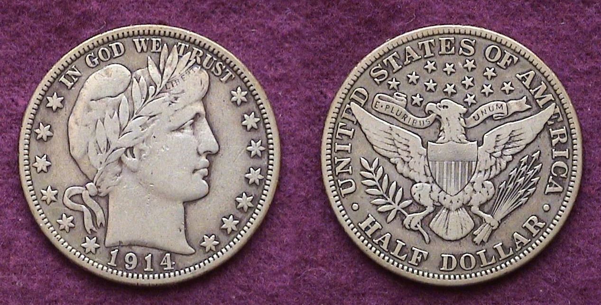

A 1914 Barber Half Dollar in Fine-15; more available than the 1905.
_____________________________________________________________________________________________________________________
NUMISMATICS IN IRAQ
By Bill Myers

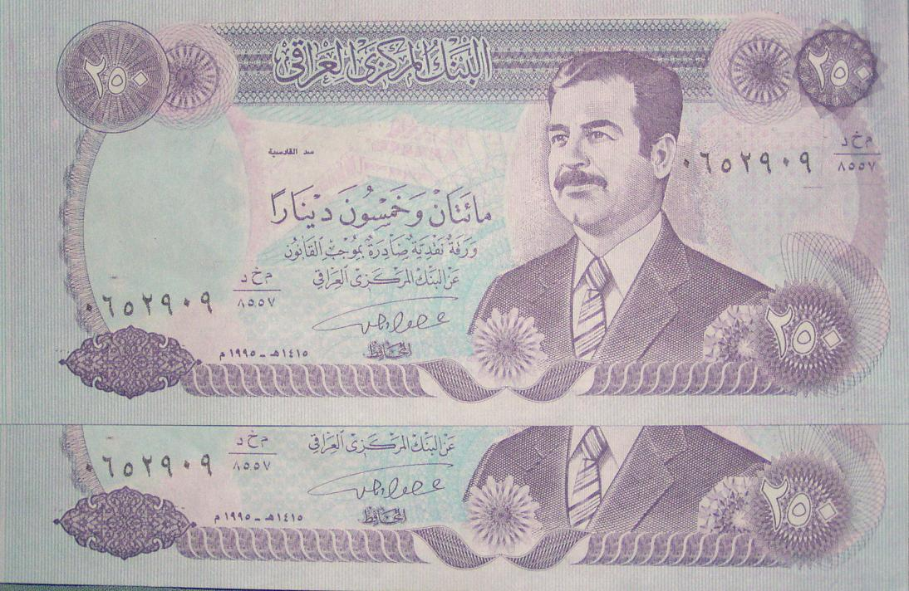

A 250 Dinar Note from Iraq

My last tour in Iraq started my interest in AAFES POGs, which is continuing this tour, but I have had opportunities to pursue other areas of numismatics here as well. In early November I flew to Tikrit to visit the hospital there. In addition to working in the hospital I explored what I could of the base. The PX there had a permanent bazaar. It was a long tent with various merchants in it. A majority of the items for sale did not interest me but my attention was drawn to some items on a counter top. It was stacks of Iraqi notes with Sadam Hussein pictured on them. They were in CU condition. The paper they were printed on was not of regular note quality because the embargo had cut Iraq off from their European printers, so some were printed in Iraq (1990, 1991) and in China (1992, 1993) and were of varying quality.

In the bazaar there were 5 dinars (P80c), 100 dinars (P84b), 250 dinars (P85 & P88) and 10,000 dinars (P89) available.

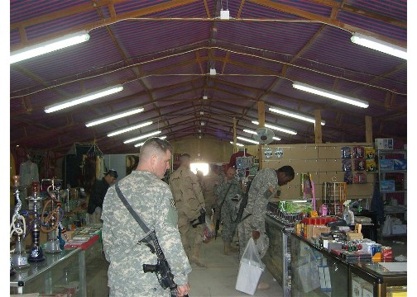

Soldiers browse at the PX Bazaar in Tikrit, Iraq

What particularly caught my attention is that the 100, 250 (P85) and 10,000 dinar notes all had the same serial numbers. There were also several 100 dinars notes with the serial number printed upside down, as well as the correct way, on the same note and there were some 10,000 dinars without
________________________________________________________________________________________________________________________
(Continued n page 4, column 1)
Numismatics in Iraq (Continued from previous page)

any serial numbers. They were inexpensive so I purchased some of them. The 5 and small 250 dinars notes may be authentic as they fit the description in the Standard Catalog of World Paper Money. On closer examination the 100 and 10,000 dinars notes are printed by dot matrix, not lithographed. I feel this adds further evidence that these notes are counterfeit. The 250 dinars (P85) notes are lithographed but the serial numbers appear to be dot matrix. What I cannot determine is if they were made to pass off as real notes at the time when the notes were valid or just copies to sell to "tourists" who may want a note with Sadam Hussein's picture on them. The merchant could not or would not tell me when he was questioned. I still find them interesting and they are now a part of my collection. I am only out a few bucks and I have an interesting numismatic item.
________________________________________________________________________________________________________________________________

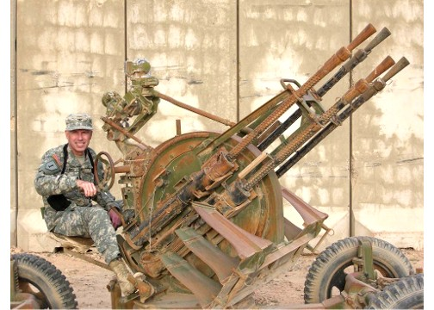

Col. Bill Myers mounting an Anti-aircraft gun in Tikrit, Iraq
sends his regards and best wishes for a Happy New Year
to the members of the Stephen James CSRA Coin Club.
_________________________________________________________

Pictures from the Club Dinner
Courtesy of President Willie Simon

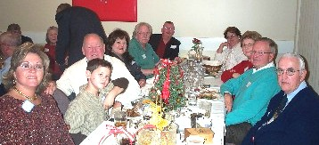

Mrs. Willie Simon across from Glenn Sanders and
other festive SJ CSRA CC members enjoying the dinner.

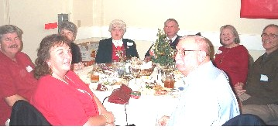

Enjoying the meal with fellow club members clockwise from the center are the Smoot’s, the Moody’s, the Simons’ and the Safran’s.

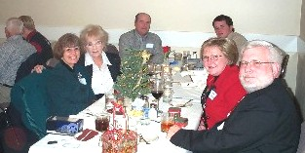

In an equally festive mood are Marion Engel, Charles and Liz Goergen, Chris and Larry Lucree and new member.

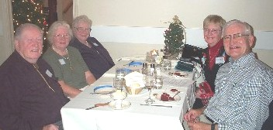

Rounding out the festivities we see the Riggins’s
and guest at left and Barry’s at right.

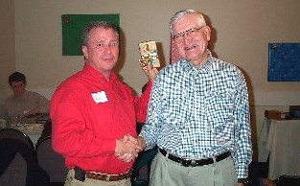

The fellow on the left took all these pictures. That’s our President, Willie Simon with VP Jim Barry at the right.
_____________________________________________________
More pictures may be seen on the club web site at
www.sjcstacc.org

2007 F.U.N. Show in Orlando: Another Classic Show

The 2007 FUN Show is now history and once again was an extremely rewarding if hectic four day affair. If you are an avid collector you owe it to yourself to get down to Orlando for one of these events. The size of the bourse is enormous. Upon entering the hall, one sees twelve rows of dealers stretching the equivalent of three to four city blocks deep. Dealers representing virtually all aspects of the hobby appear to be manning tables as far as the eye can see offering coins, tokens & medals, paper money and scrip.

As one becomes more focused on a particular area of Numismatics, he/she soon learns to know what to expect at these large shows. There are sections of the “slab” dealers who carry particularly expensive high-grade coins selling for thousands of dollars. Most of these are generic; (i.e., common dates) many grading MS-65 and higher. One soon learns which dates are extremely common and which are quite scarce. A case in point is the Shield nickel type. This collector was looking for an 1867 with rays sub-type in MS-63. The type was struck from 1866 thru 1883. The rays were removed early in 1867 because the coin did not strike up or stack well. Those with rays are scarce, if not rare while the ones without rays are quite common. As I walked along the bourse floor I came across a number of 1879/8 Shield nickels certified in super grades such as MS-66 or 67. I found only three mint state 1867 with rays pieces on the floor; one grading MS-65 priced at over $4,500, somewhat lustrous with a typical weak strike but not awesome as one would expect in a “65” coin. A little later I came across one housed in a MS-64 slab. This one was priced at $1,200; had less luster and a few minor but distracting spots on the reverse. Earlier I had spotted a “raw” one graded only MS-63. At first glance it looked like it might be a “slider”; (i.e., AU-58). The MS-63 specimen had numerous die cracks, none considered a distraction. It was also characteristically struck from rusted dies. Still, the coin had lots of luster remaining and despite the typical weak strike appeared to be what it was, a Mint State-63.

Morgan dollars represented closer to 25% of the bourse along with US gold coins. There were three major dealers in Large cents; two in Indian Head cents and a number of minor dealers touting high grade Lincolns from the 1940’s on. There appeared to be only five or six major dealers touting Bust and Liberty Seated silver coinage. There was not one dealer who specialized in Barber silver coinage which tells one something right there! Paper Money dealers were fairly numerous scattered throughout the hall and there were a larger than expected number of dealers in Foreign and Ancient coins. Finally there were the lower end dealers who are situated at the extreme sides and rear of the hall. They tout just about everything from “raw” to certified, a lot of material that is one must scrutinize very carefully. Sometimes, interesting finds are made there.

There was also a Mark Headquest sighting. He looked great and sends his regards to the club members. At such major shows there are wonderful exhibits. One of the best was a multi case display on Georgia bank notes. Another smaller one featured a three piece type set of Charlotte gold coins; the $2.50, $5.00 and $10. If you cannot find it at FUN, it doesn’t exist!
___________________________________________________________________________________________________________________________
Kindly Patronize Our Advertisers

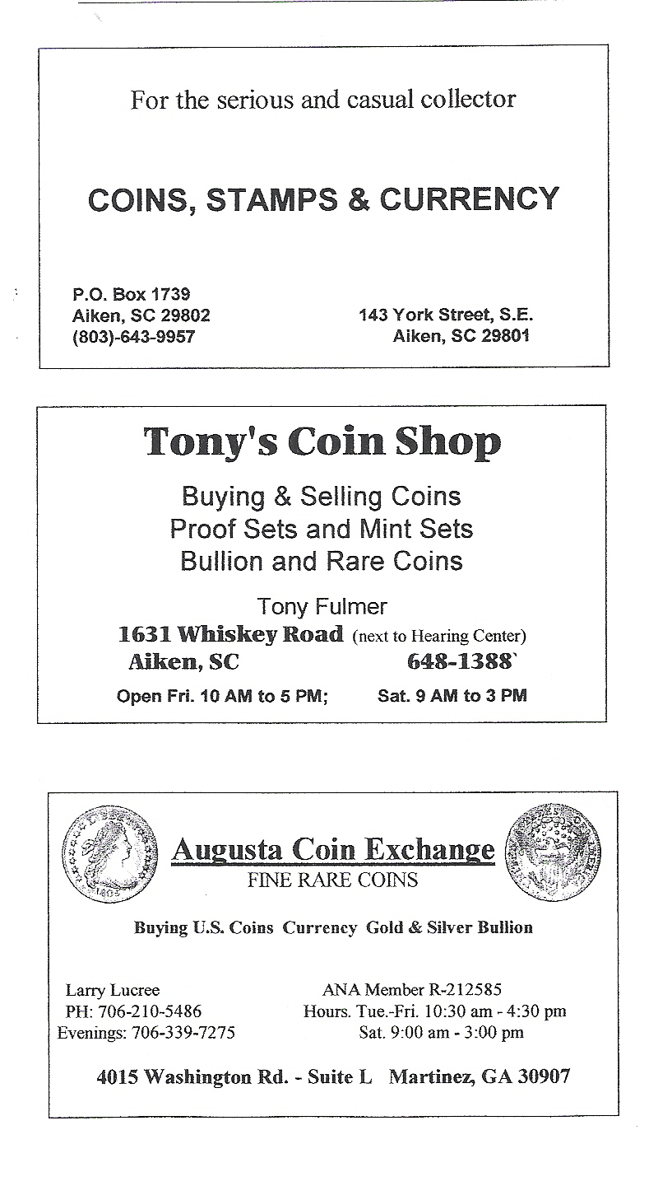
Next Meeting Coming Up Fast

Due to Christmas, New Year’s and the just reported F.U.N. Show (Jan. 4-7), the Newsletter was completed right up against the “wire” as it were. Our first meeting of the new year is this Thursday, Jan. 11 at the Cedar Creek Community Center. Our program will be on PCGS Grading; the first professional certified grading company established in 1986. For those who want B/W mailings, the editor will endeavor to do so or he will bring extra copies to the meeting Thursday night.
_______________________________________________

