Pres. Willie Simon
V .P. James Barry
Sec. Helen Barry
Treas. Pat James
Sgt. in Arms: J.J. Engel
Committees:
Programs: James Barry
Show Chairman: JJ Engel
Newsletter: Arno Safran
E-Mail: arnosafran@comcast.net
The Stephen James
CSRA Coin Club of Aiken
P.O. Box 1739
Aiken, SC 29802
Web site: www.sjcsracc.org
The SJ CSRA CC Now Meets on the 2nd Thursday of the Month at the Cedar Creek Community Center in Aiken, SC

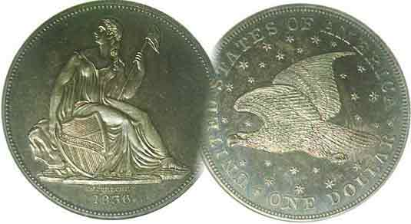

Volume 7, Number 1 the Stephen James CSRA Coin Club, Founded in 2001 January, 2008
Monthly Newsletter
What Will the Hobby Bring in 2008?
Our next meeting this month only is on the 1st Thursday Jan. 3 at 7:00 PM

2007 Club Meeting Schedule
Jan. 3 Apr. 10 July 10 Oct. 9
Feb. 14 May 8 Aug. 14 Nov. 13
Mar. 13 June 12 Sep. 11 Dec. 4 dinner

_____________________________________________________________________________________________________________________________

Hobby’s Future Difficult to Predict

With this issue we begin our seventh year of publication. Back in January of 2002 when Volume 1, No. 1 was released one could find pictured on the internet a plethora of attractive type coins ranging in grades from VF-30 to AU-58. Many were listed at prices that collectors could absorb given their discretionary income. That has all changed. With the tremendous increase in the collector base during the past six years the supply of desirable type coins has diminished to the point where these same retailers can no longer replace what they have sold with comparable material and when they do acquire these “replacements” their price tag has doubled. Adding to the problems are the questionable grading practices of the third party certification services in which the same coin graded XF-45 will resurface in an AU-50 holder a few months later. This has not been an isolated experience. In the past two years an increasing number of internet dealers are now listing their numismatic items by Bid or Buy arrangements, a la EBay. If you’re willing to pay the exorbitant asking price, the coin is yours. Otherwise you must compete by bidding on line until the deadline expires. Sadly, there are enough wealthy entrants who are less discriminating than their predecessors willing to pay top dollar for less desirable material under the impression they are rare. The same situation applies to both Foreign and Ancient coins.

So, what can the moderate income collector do? One option is to seek numismatic type coins currently in low demand such as the ½¢, 2¢, 3¢ & 5¢ Shield and Liberty nickel pieces grading XF-40 thru MS-63. Another is to search for problem-free obsolete type that still retains eye appeal in grades ranging from VG-8 thru VF-20. A number of common date Barber halves would meet those criteria. A third option is to seek low cost alternatives such as tokens and medals.
_________________________________________________________________________________________________________
(Look for Club News on pages 4 and 5)
A Fantastic Bargain from the United States Mint
By Arno Safran

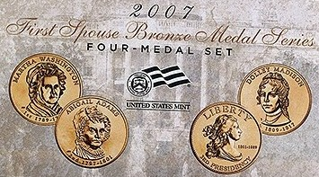

The complete 2007 First Spousal set struck in bronze
by the US Mint Goes on sale January 5, 2008

If you began collecting the Presidential dollar series inaugurated last year you were probably looking forward to acquiring the corresponding first spousal set until you learned that it was being offered as a group of ½ ounce gold pieces with a legal tender value of $50.00. Since the four First spouse coins were being offered at a premium over the value of gold which has been trading at over $800 an ounce, the latest First spouse gold coin in the uncirculated version is now priced at $509.95 with the proof listed at $529.95. The cost for collectors in round numbers could come to $2,040 for the complete uncirculated set and $2,200 for the four proofs. But that’s probably not all, for there’s the shipping charges plus the option of either the uncirculated four coin presentation case @ $18.95 or the more elaborate proof version @ $31.95. All those factors will increase one’s possible total cost from $2,125.00 to $2,250.00.

Fortunately, the Mint has provided the collector with an alternative. At a recent Augusta Coin Club Show & Tell session member Bill Myers brought in examples of the first three first spousal pieces that had been issued, but not in gold. These were beautiful replicas struck in bronze and priced very reasonably. If the reader checks out the Mint’s web site at
_________________________________________________________________________________________________________________
(Continued on page 2, column 1)
A Fantastic Bargain from the Mint
(Continued from page 1, column 2)
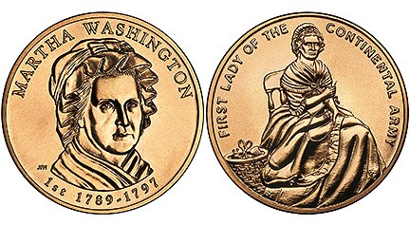
The 2007 Martha Washington Bronze Medal
(All photos, courtesy of the US Mint Web site)

www.usmint.gov under medals you can order each first spousal medal separately (except the Jefferson Draped Bust replica) at $3.50 each or wait until January 7 (subject to change) and order the complete 4 piece set (Cat-X-15) for $12.95 plus shipping. Each medal is 15/16” in diameter--about the size of a quarter--and is arguably as attractive, [perhaps even more so] as their expensive gold counterparts. Like the presidential dollars, the first spouse coins and medals were struck and offered to the public in order of their corresponding administrations.

The first of the four medals shows Martha Washington on the obverse designed and engraved by US Mint engraver Joseph Menna. The reverse designed by Susan Gamble depicts our very first First lady (1789-1797) sewing a button on George Washington’s uniform jacket.
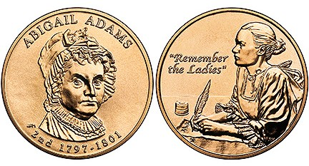

Abigail Adams is featured on the second 2007 Spousal medal

Abigail Adams of Boston, MA was one of the most well educated women in colonial America. The letters exchanged between she and her husband John Adams while he was attending the second Continental Congress in Philadelphia document some of the major issues discussed at the time our republic was being formed. The obverse of this first spousal medal was also designed by Joseph Menna. The reverse by Thomas Cleveland was fashioned from a portrait made by renowned painter Gilbert Stuart. It depicts Abigail Adams writing one of her many letters, this one, “Remember the Ladies”. Mrs. Adams served as first lady from 1797-1801.
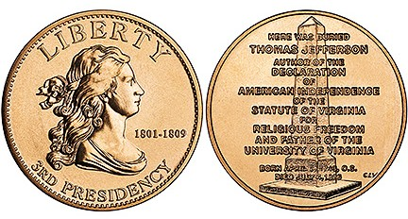

Thomas Jefferson’s Liberty ½¢ Replica

As Thomas Jefferson’s wife had died prior to his becoming president, the Mint struck a bronze replica of the Draped Bust half cent that was in circulation at the time of his presidency (1801-1809) It was originally engraved by our first chief Mint engraver Robert Scot. The reverse was designed by current Mint engraver Charles Vickers showing Jefferson’s grave marker with an epitaph displaying his many accomplishments.

James Madison was president from 1809 to 1817. He was the primary author of our Constitution. His wife, Dolley Madison, herself a widow was 18 years younger than her husband. She was both attractive and charming; indeed one of the more vivacious socialites of her era. Thomas Jefferson had asked his good friend Madison if Dolley would be willing to take on the first lady’s duties as the nation’s “official hostess” since he was a widower and Dolley consented.

As first lady, Dolley gave big parties with plenty of fruit, wine and confectionaries which endeared her to the people. During the War of 1812 when the British soldiers were approaching the presidential grounds, it was Dolley Madison who rescued the White House silver, a large number of important papers along with a famous Gilbert Stuart portrait of George Washington.
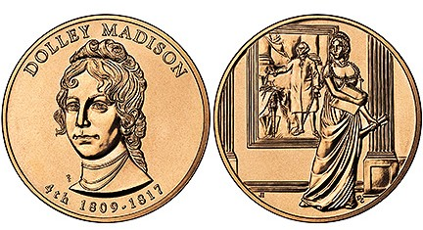
The 2007 Dolley Madison Bronze Medal

The obverse of the medal was designed by Mint engraver Dan Everhart while the reverse was fashioned by Joel Iskowitz showing Dolley Madison in the act of saving the articles described above.

These four medals paired with the four presidential “golden” dollar coins would cost a total of $20.00 and would make for a very attractive display; a set that some of our younger collectors could be encouraged to complete. The author’s appreciation goes out to member Bill Myers for calling attention to this option.
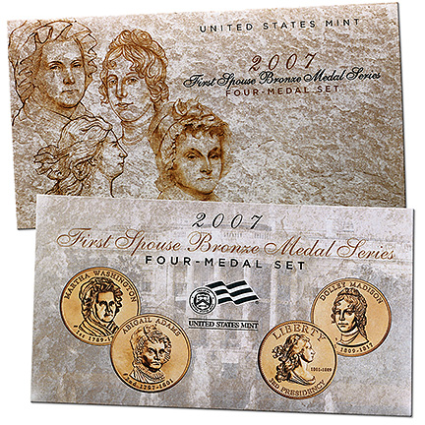
_______________________________________________________________________________________________________________
WW II U.S. EMERGENCY NOTES
By Bill Myers HAWAII

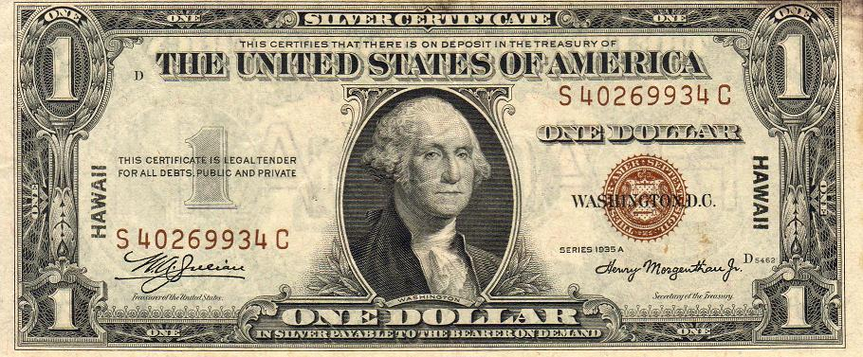
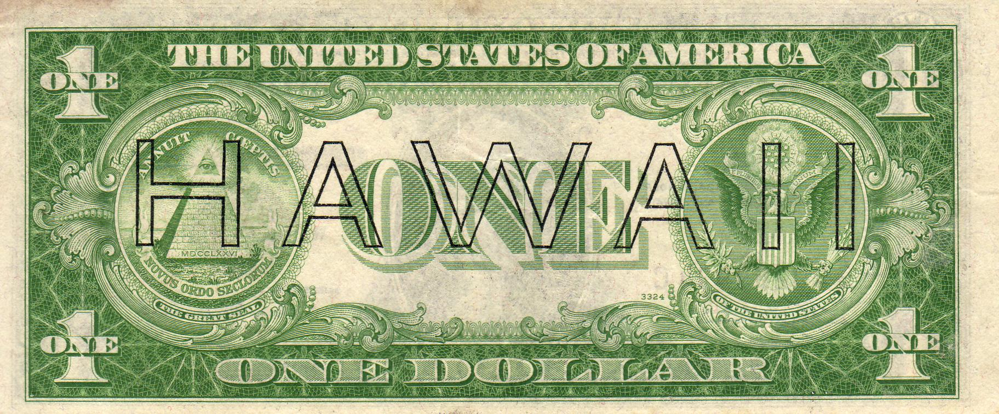

$1.00 Series 1935A Silver Certificate WW II Emergency Hawaii Note

The terrorist attack of September 11, 2001 initiated the Global War on Terrorism. Although U.S. monetary system has not required alterations as a result of this attack, that was not the case 66 years ago. When the Japanese launched an attack on Pearl Harbor, Hawaii on December 11, 1941, the U.S. feared that the Japanese would further invade Hawaii, so a special series of notes was issued in July 1942. “Hawaii” was printed in small letters on the right and left sides of the face and in large letters across the back of the notes. The seal and serial numbers were brown, to distinguish them from other U.S. notes. If the Japanese invaded Hawaii, these notes would be declared valueless, and would be useless to the Japanese. It was mandatory for those in Hawaii to possess only the Hawaii notes after August 15, 1942, unless a special license was obtained. In October 1944 the restrictions were lifted. The Hawaii notes have remained legal tender to this day.

All of the issues of these notes bear the signatures of Julian and Morgenthau. There are replacement (star) notes for each denomination and they are scarcer and more expensive to collect. The numbers referred to below are the Friedberg numbers.
The $1 note (2300) is a Silver Certificate. The remaining denominations are Federal Reserve Notes from the San Francisco Federal Reserve (L-12). The $5 note is available as series 1934 (2301) and 1934A (2302).

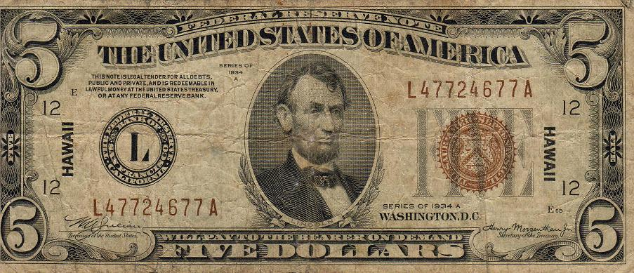

Hawaii $5.00 Federal Reserve Note Series 1934A Face
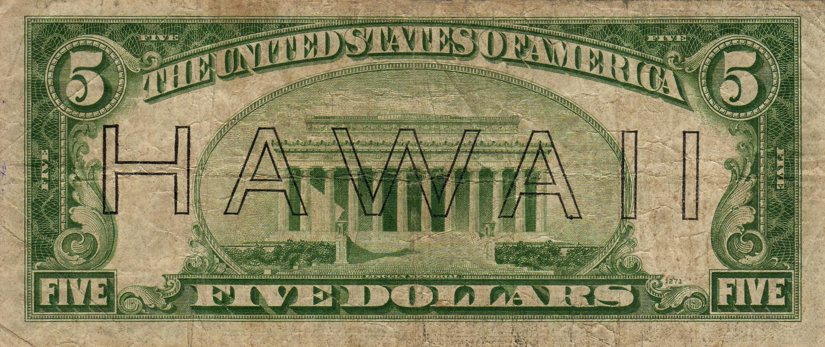

Hawaii $5.00 Federal Reserve Note Series 1934A Back

The $10 is found only in series 1934A (2303).
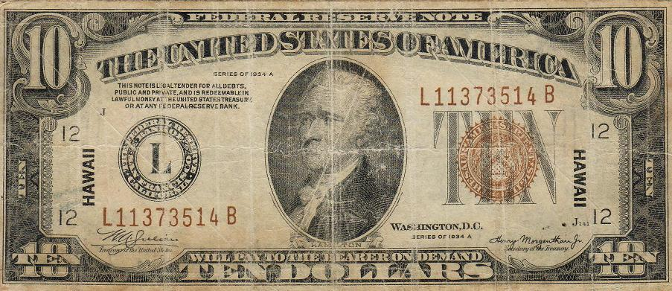
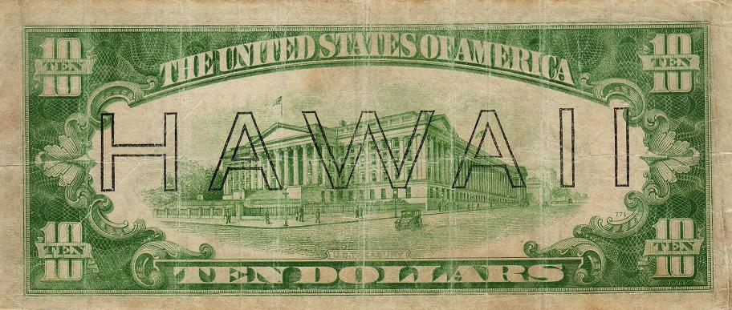

The $10.00 Series1934A Federal Reserve Hawaii Note

The $20 is available as series 1934 (2304) and 1934A (2305). I recently completed my type-set and have one of each denomination.

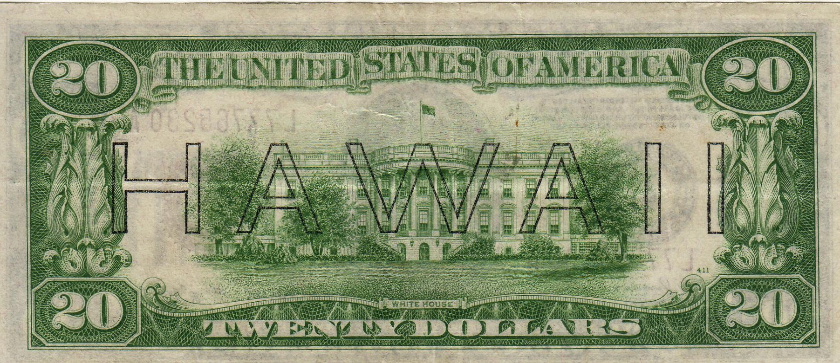

The back of the Hawaii $20 Federal Reserve note

Denom & Series Type of note US Treas & Sec. Friedberg #

$1 1935A Silver Cert Julian/Morgenthau 2300
Federal Reserve
$5 1934 Federal Reserve 2301
Of San Francisco
$10 1934A Federal Reserve 2302
2303
$20 1934 Federal Reserve 2304
1934A “ “ “ 2305

In next month’s issue, I will look at another series of emergency notes.
_________________________________________________________________________________________________

Club News

As of the November meeting, Treasurer Pat James reported a balance of $1,482.42. VP Jim Barry announced that our December pre-holiday annual dinner will be held at EeJays Restaurant on Thursday, Dec. 6 and due to the FUN Show in Orlando, FL our first meeting of the New Year will also be held on the first Thursday, Jan. 3, 2008. Starting in February the club meeting schedule will revert back to the second Thursday of the month.
There were two Show & Tells: Jim Barry brought in a contemporary silver replica of the 1782 Libertas Americana medal by Augustin Dupré struck by the modern French Mint to commemorate the 225th anniversary of the Battle of Yorktown. The medal was based on the dies used to strike the original bronze medal dated July 4, 1776. He described the obverse as being the prototype for the third version of the 1793 US large cent with the reverse portraying Minerva representing France fending off the British Lion while protecting the cherub (America) during the Revolutionary War (Oct. 1777-1781).

As this was the final official club meeting of 2007, Arno Safran brought in a 1937 US Proof Set which included the Walking Liberty half dollar, Washington Quarter, Mercury dime, Indian Head/ Buffalo nickel and Lincoln/ Wheat back cent; each displaying a mirror proof finish. He reported that only 5,542 were produced in 1937 at an initial cost of $1.90 and believed it was still undervalued considering the beauty of the coins and its relatively low mintage.

Bill Myers presented a PowerPoint program entitled “Numismatics in Iraq”: Part One. Bill had served two tours of duty as a Colonel in the US Army Reserve Medical Corps and during his most recent deployment (8/06-7/07), he reported on the array of numismatic collectibles he found. These included AAFES POGs, Iraqi currency (real and counterfeit) and Iraqi coinage (also real and counterfeit.) He described POGS as circular plastic tokens in denominations of 5¢, 10¢ and 25¢ featuring photographs or illustrations that included Operation Iraqi Freedom, Enduring Freedom, classic WW II photos and figures from earlier periods in US history such as Teddy Roosevelt. He mentioned that during his most recent service in Iraq the POGS he encountered were in their 8th, 9th and 10th printings. Like rare coins, most were fairly common but some POGs were rare and highly desirable as collectibles. These included errors such as clips, off center examples and over struck paper as in the case of Teddy Roosevelt.

From POGS, Bill went into Iraqi currency showing notes in denominations of ¼ and ½, 1, 5 & 10 dinars going back to 1959. Some of the engravings depicted historic scenes, mosques and aspects of Iraqi life before Sadaam, during Sadaam and post Sadaam. Some of the earlier notes had coins pictured on them while the more recent ones displayed duplicate motifs with inflated denominations rising through the hundreds into the five figures category.

Bill also found a number of interesting Iraqi coins that were either still in circulation or those he acquired from merchants or off the base. These also included some commemorative issues. As a specialist in hand surgery, Bill reported on some of the Iraqi coin finds he discovered showing hands; some being real and others counterfeit. This was a most fascinating survey, well illustrated and creatively presented.

Prize Winners: In other Club news, President Willie Simon won the Door Prize and Bill Myers took the 50/50.
________________________________________________________________________________________________________________________

Highlights from the Dec. 6 Club Dinner

The club held its seventh annual pre-holiday club dinner at EeJays Restaurant in Aiken. President Willie Simon served as amiable host giving thanks fore another successful year for our club and recognizing the many members that made this possible. Thanks to the replenished treasury, courtesy of another successful show run by Show Chairman J.J. Engel, Treasurer Pat James purchased a number of numismatic prizes which were awarded to those who helped out at the show and during the year. There were also a number of door prizes handed out in the form of silver coins and proof sets. Member Jack Seech took home the “biggie”, a 2007 Presidential Proof set. The 50/50 was won by Pat James. Non member guests received table baskets and a good time was held by all.

The one sad note of the club year was the passing of member Gene Riggins. He was a stalwart member who enjoyed attending our meetings, a good hearted soul and we shall miss him. Our next meeting is January 3 at the Cedar Creek Activity Center. Hope to see you all then.
____________________________________________________________________________________________________________

Club Annual Dinner Pictures of 2007

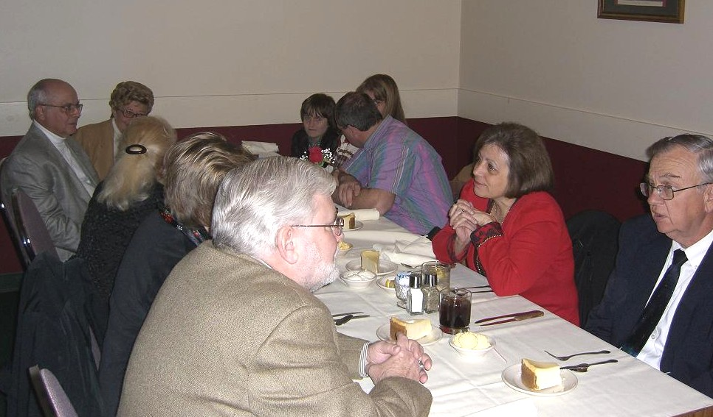

The Goergens and Engel’s enjoying dinner conversation

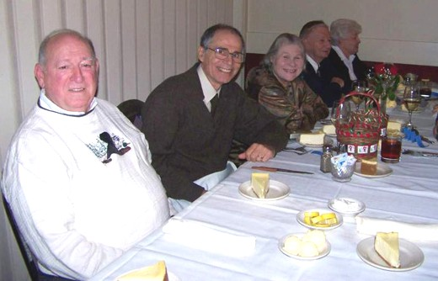

Jack Seech, Arno & Vilma Safran and the Simons
_________________________________________________
More photos continue on page 5
More Pre Holiday Dinner Photos

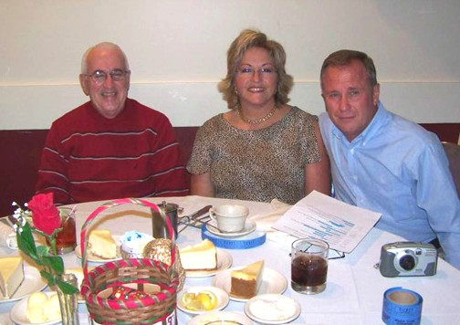

Glenn Sanders with Sue and Willie Simon

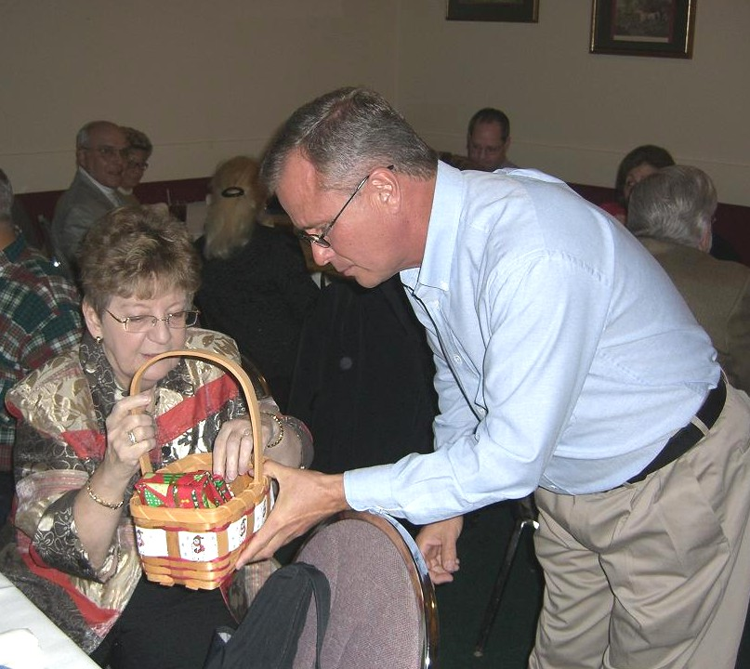

President Willie Simon presenting Treasurer Pat James with gift

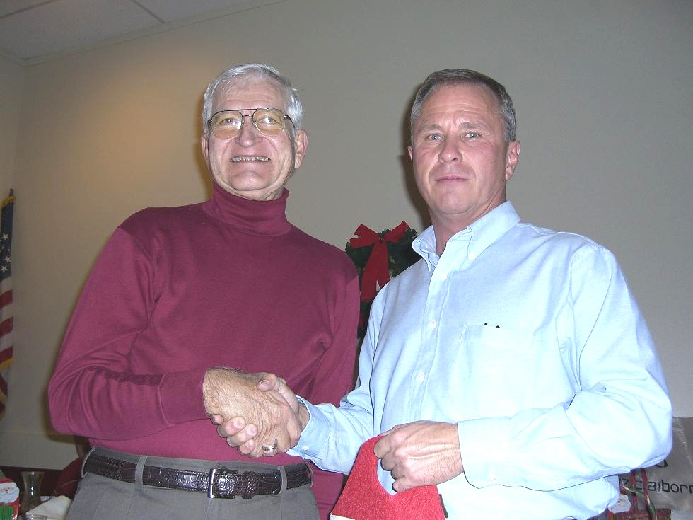

VP Jim Barry presenting Pres. Willie Simon with gift

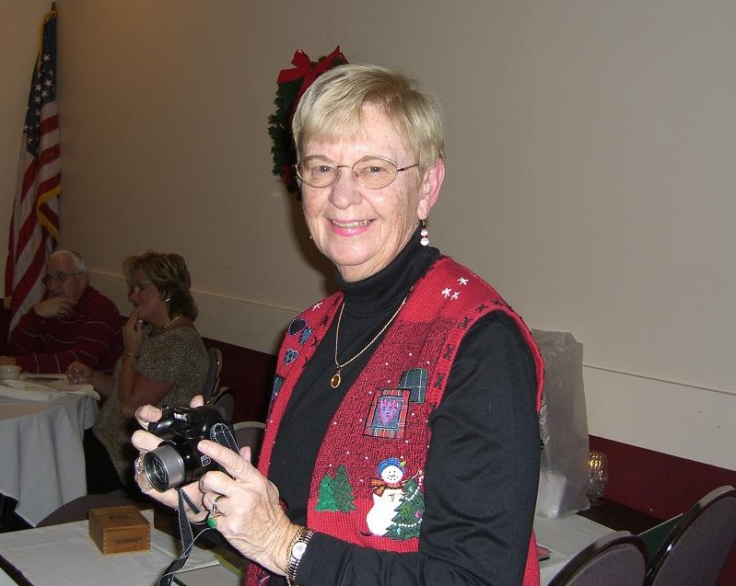

Sec. Helen Barry casts a warm smile

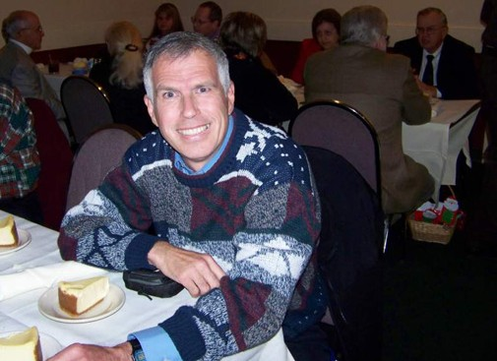

Member Bill Myers enjoys a bit of Cheese Cake

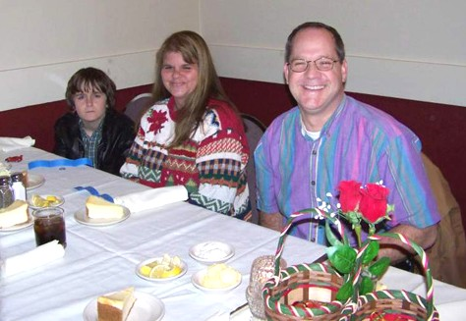

The Kuhl Family enjoying dinner.
Austin received the “Young Numismatist of the Year” gift

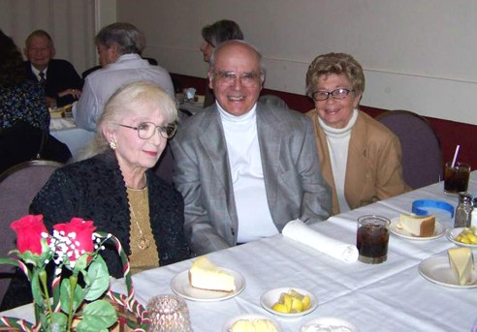

Marlene Leich and the Worpels

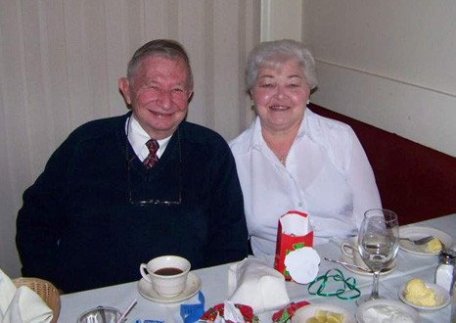

Paul and Marjory Simons
___________________________________________________________________________________________
More dinner photos on page 6, column 1
And Still More Dinner Photos

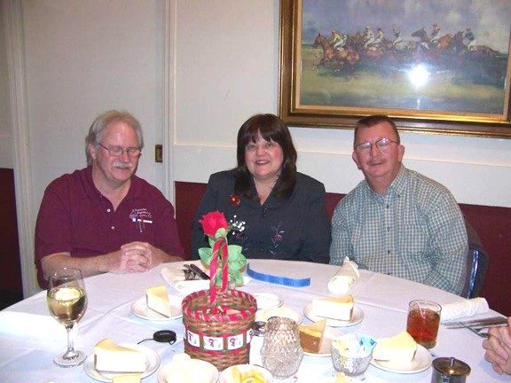

John and Linda Attaway with Howard Black

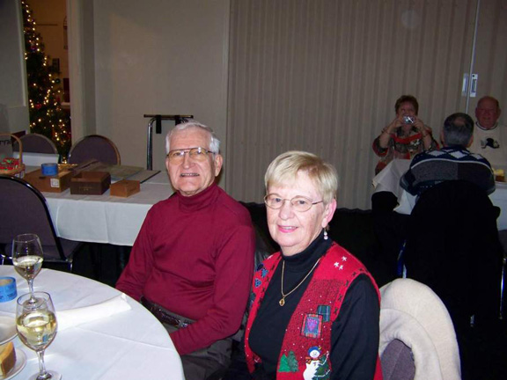

Jim and Helen Barry

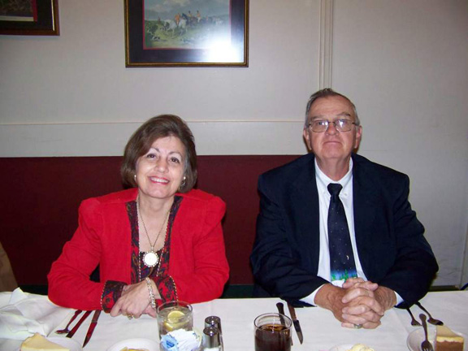

Marion and J. J. Engel

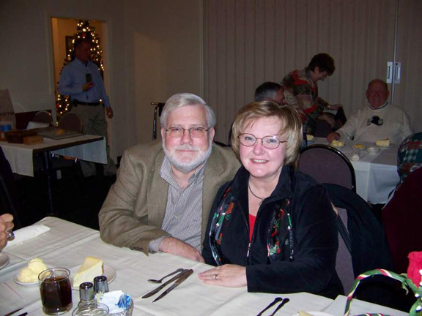

Chuck and Liz Goergen
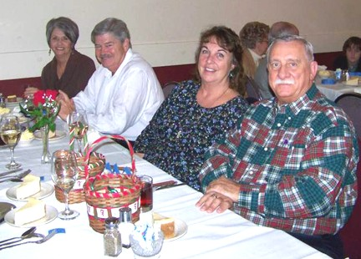

The Smoots and the Moody’s enjoying the festivities
______________________________________________________________________________________________
Photos courtesy of Helen Barry, Bill Myers and Arno Safran

Kindly Support Our Advertisers

