Pres. Willie Simon
V .P. James Barry
Sec. Helen Barry
Treas. Pat James
Sgt. in Arms: Glenn Sanders
The Stephen James
CSRA Coin Club of Aiken
P.O. Box 1739
Aiken, SC 29802
Web site: www.sjcsracc.org
The SJ CSRA CC meets on the 2nd Thursday of the Month at the Cedar Creek Community Center in Aiken, SC

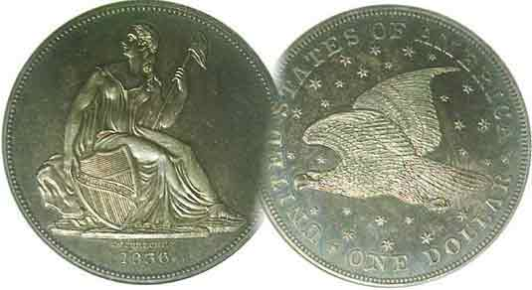
Committees:
Programs: James Barry
Show Chairs: The Barry’s
Newsletter: Arno Safran
E-Mail: arnosafran@comcast.net
Auctioneer: Glenn Sanders

2009 Club Meeting Schedule
Volume 8, Number 1 the Stephen James CSRA Coin Club, Founded in 2001 January, 2009
Monthly Newsletter
December Dinner a warm gathering for our Club
Our next meeting is Monday, January 5, 2009 from 6:15 to 9:00 PM
Jan. 5 Apr. 9 July 9 Oct. 8
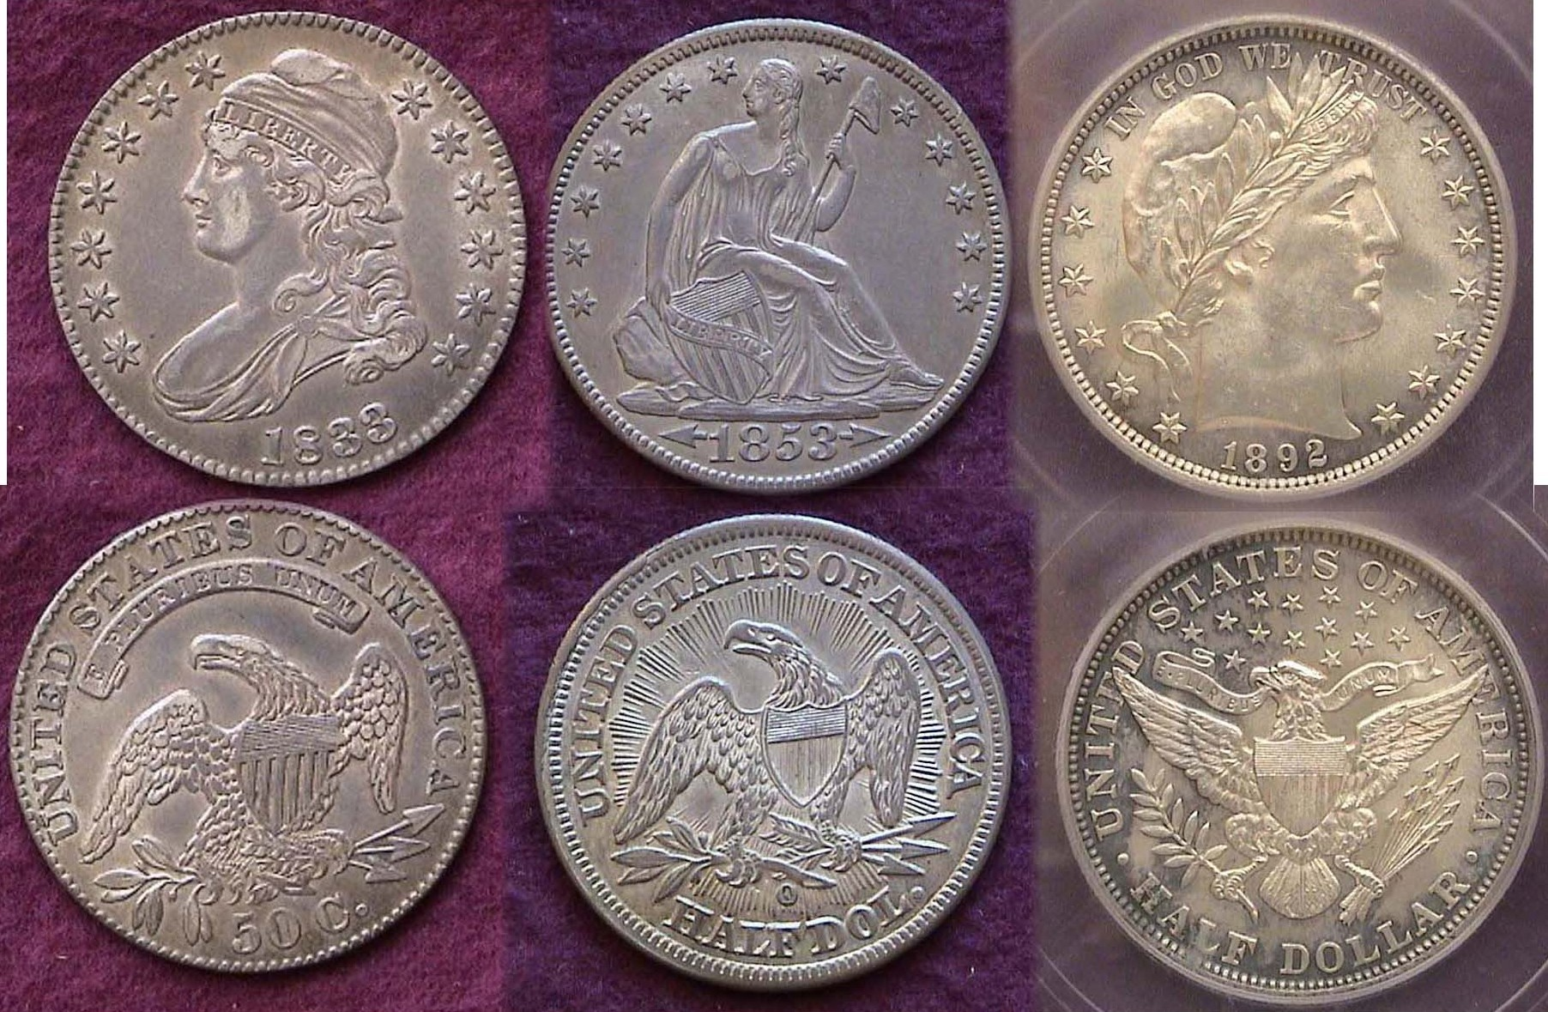
Feb. 12 May 14 Aug. 13 Nov. 12
Mar. 12 Jun. 11 Sep. 10 Dec. 3 Dinner
_________________________________________________________________________________________________________________________

Club Ends Year with Best Dinner Fare Ever

This year our annual pre Christmas holiday dinner was held on Thursday, December 4 at a new site, the Houndslake Country Club Dining Hall located off Hitchcock Road (Rte 118). Members began arriving for libations and soft drinks around 6:15 PM. A special section was arranged with five large round tables set up in a private dining area. Present Willie Simon greeted each arrival and when all were seated he thanked everyone for coming and invoked the Grace prior to dining. The food was excellent and the service could not have been better. Twenty-six persons attended. Treasurer Pat James brought some prizes and a 50/50 drawing was held. During and after the meal, members mingled with each other at the various tables and an enjoyable evening was had by all. The club thanks Jim and Helen Barry for arranging for the dinner and its location.

The Nov. 13 Meeting: President Willie Simon called meeting to order at 7:00 PM and asked for a moment of silence in honor of Linda Attaway, member John Attaway’s wife who had succumbed after a long illness. There were 24 members and 3 guests present. Pat James reported a treasury balance of $1,785.56 with all expenses paid. Some of that money would be paid for gratuities for the December dinner and prizes still to come but the club finished the 2008 year overall with its largest balance since its founding in 2001. VP Jim Barry announced that Arno Safran was the fifth SJ CSRA CC member in 7 years to receive the Numismatist of the Year award from the South Carolina Numismatic Association, the others being Jim himself (2003), Tony Chibbaro (2005), Helen Barry (2006) and Bill Myers (2007). Due to a conflict with the upcoming Florida United Numismatists annual show in Orlando in early January, the club agreed to move their next meeting to Jan. 5, 2009 which falls on a Monday. Please see 2009 schedule above.
_____________________________________________________________________________________________________________________
(More Club News continues on page 4, column 1)

Collecting Short Sets by Denomination: Half Dollars
By Arno Safran

The first half of a Basic Affordable 50¢ Type Set shown actual size when printed. Left, 1833 Capped Bust, center, 1853-O Liberty Seated with
Arrows & rays, right 1892 Barber Liberty Head half [Magnify to 200%.]

Shown above is part of a US 50¢ type set that was mostly acquired before the age of third parting certification. At one time it was inserted in a US Type Half Dollar Lucite holder. Realizing that the early Flowing Hair (1794 & 1795) and Draped Bust (1796-1807) 50¢ types might be considered too expensive even back when the holder was made, the manufacturer produced one slot dated (1794-1839) thereby offering collectors the option of selecting the most common type which was the lettered edge Capped Bust type (1807-1836). The coin at left is an 1833 grading EF-45. It is an extremely common date with a reported mintage of over 5 million and therefore is not rare or expensive. The Liberty Seated type (1839-1891) in the center is an 1853-O arrows & rays specimen. It grades AU-50. Over 1.3 million were struck but as a one year type is in high demand and more costly. The Barber half series (1892-1915) is represented by its first year of issue the 1892. It grades MS-62 and is one of 934,000 minted in Philadelphia.
_________________________________________________________________________________________________________________
(Continued on page 2, column 1)
_Collecting Short Sets by Denomination: Half Dollars
(Continued from page 1, column 2)

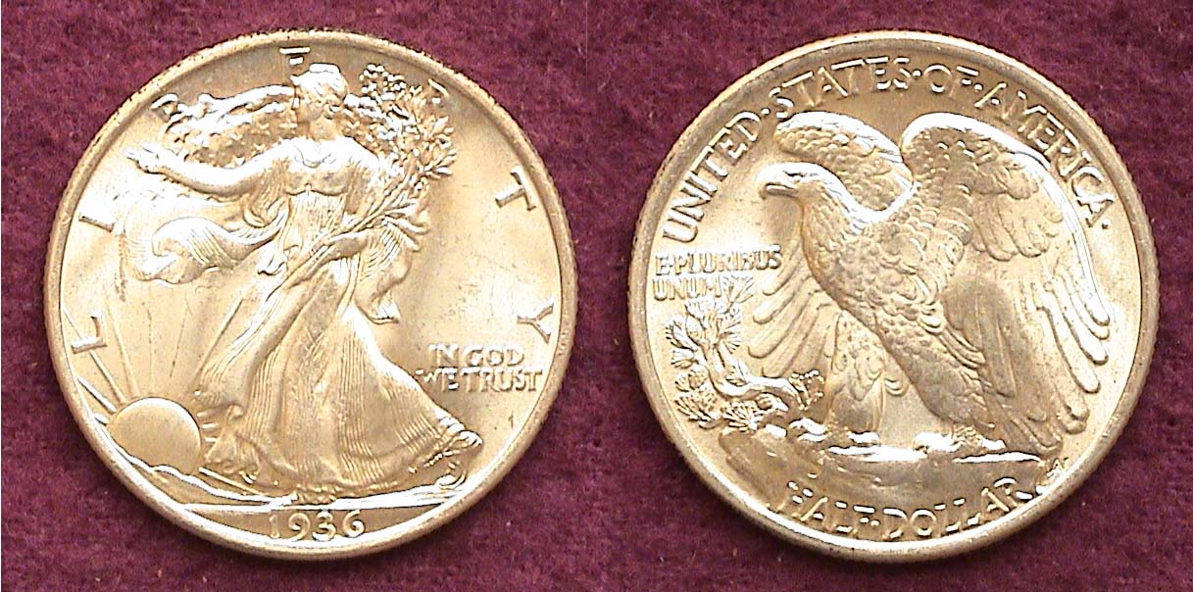

A Gem BU 1936-P Walking Liberty Half dollar
The most common date for the 1930’s
[Magnify to 200%]

Of all our half dollar types, the Walking Liberty is arguably the most beautiful and an MS-65 specimen such as the one pictured above is exquisite to behold. The coin type replaced the Barber half in 1916 and was struck through 1947 though not in every year. No Walking Liberty halves were coined in 1922, 1924 thru 1926 or from 1930 thru 1932. The engraver was Adolph A. Weinman who also designed the Winged Liberty dime (AKA Mercury dime). With the exception of 1916-P & D, 1917-P, 1918-S and 1920-P, most of the early dates through the 1933-S are scarce in XF-40 or better.

Most people 70 years or younger have seldom if ever received a half dollar in change or see one turn up in circulation but from 1794 through 1933, the 50¢ piece functioned as a productive part of our coinage system. There were three factors that brought about this change. One was the putting aside of numerous uncirculated Rolls by dealers. Another, with a few exceptions, was the increased production of half dollars coming out of the three US Mints and the third must be laid at the feet of the vending machine industry.

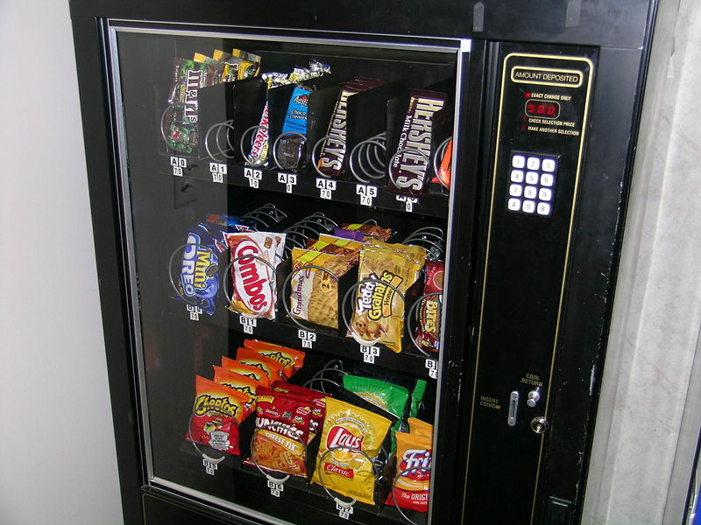

A modern Vending Machine type often seen at Road Stops

In 1934, coin dealers started to put aside rolls of the latest uncirculated coins and despite the Great Depression when 50¢ had tremendous purchasing power the Walking Liberty half were included. That same year, all three Mints, San Francisco, Denver and especially Philadelphia began to increase their coinage production. In 1936 a record 12.6 million P Walking Liberty halves were struck there alone surpassing the output of 1917. While vending machines go back a long way in history, the invention of the cigarette machine in 1926 by William Rowe encouraged the public’s appetite for its use even more. As one could purchase chewing gum, candy bars, soft drinks, cigarettes, post cards, postage stamps and countless other items for no more than a nickel to a quarter, there was little need for the half dollar slot which was probably considered too large and cumbersome anyway. With many uncirculated rolls of Walking Liberty halves languishing for years in dealers stock or in banks, there became more than enough BU specimens of WL halves to meet the demand resulting in low prices for the later date issues.

Both the 1927-S and the 1946-D Walking Liberty half dollar have a mintage of slightly over 2 million but according to the 2009 Red Book the 1927-S is listed at $2,000 in MS-63 compared with just $60 for the 1946-D in the same grade. The reason: The ’27-S Walking Liberty half circulated heavily while the ‘46-D saw hardly any circulation at all. As a result many late date specimens grading MS-63 are priced at $45 or less today.

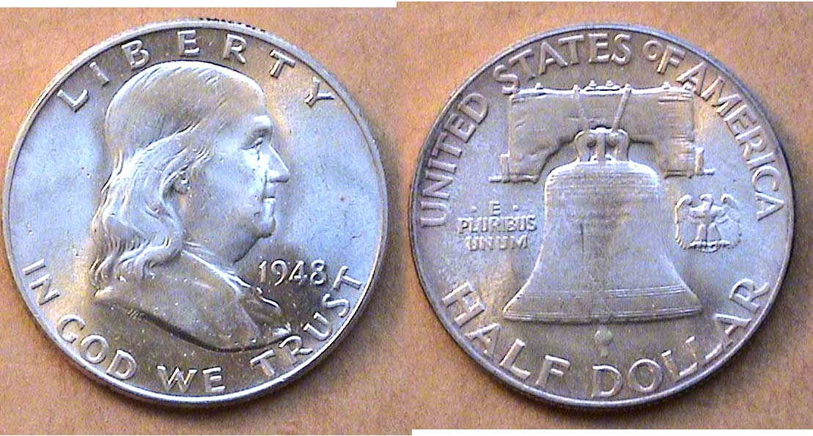

A 1948 Franklin Half Dollar grading MS-63
The first year of issue [Magnify to 200%]

Franklin half dollars were issued from 1948 thru 1963, a total of only sixteen years. During its short tenure thirty-five dates and mints were struck. A complete set averaging MS-63 or MS-64 is fairly easy to acquire as there are no “stoppers” to impede the collector. Most dates grading MS-63 should run no higher than $13.00 according to the latest Red Book. The closest thing to a “key date” in that grade is the 1949-S listed at $100. For those wishing to acquire one for type at a premium grade, say MS-65, the most inexpensive dates are the 1954-S, 1956-P 1957 P & D & 1958 P & D; all listed between $50 and $60.

Like the later date Walking Liberty halves, Franklins saw little circulation but as a young teacher back in the 1950’s, I remember receiving a number of these in change when I tendered a dollar bill for a 35¢ lunch at the school cafeteria.

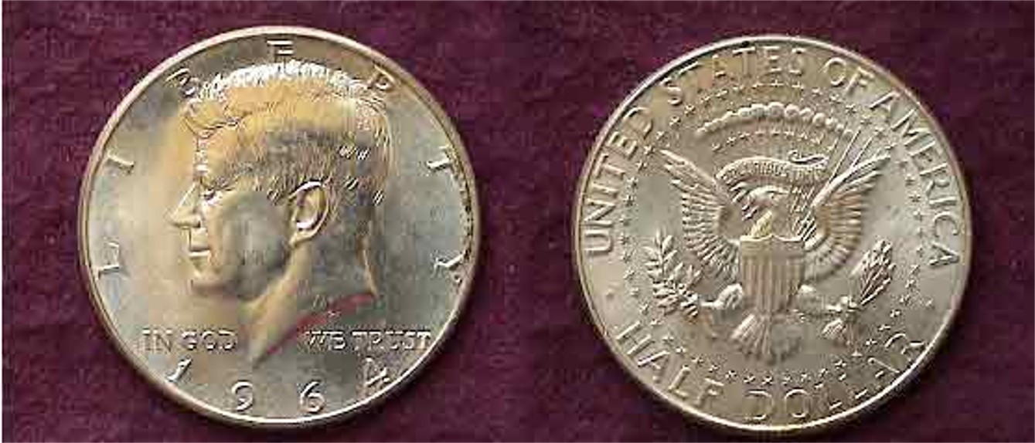

A 1964 silver Kennedy Half dollar [Magnify to 200%]

The assassination of President John F. Kennedy on Nov. 22, 1963 prompted the Government to authorize a new half dollar coin in his honor. As a circulating coin only the 1964 P & D (first year of issue) was struck in .900 fine silver. More were issued in that initial year than all the Franklin halves combined.
__________________________________________________________________________________________________________________________
(Continued on page 3, column 1)
_
Collecting Short Sets by Denomination: Half Dollars
(Continued from page 2, column 2)

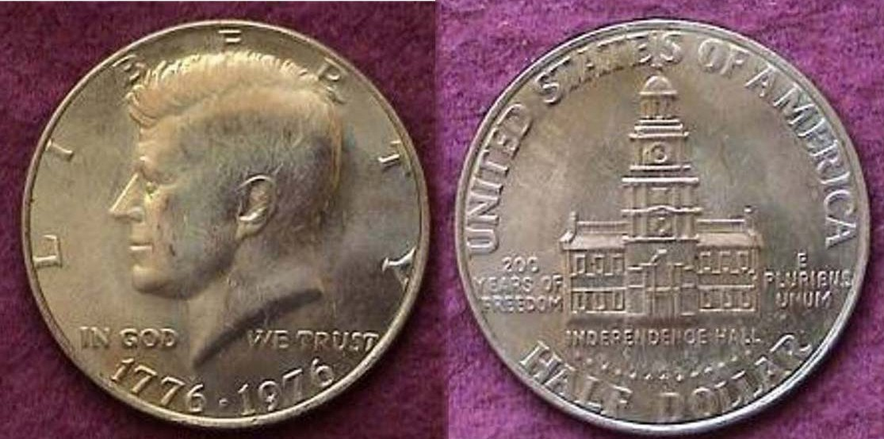

A 1976-P Kennedy Bicentennial clad half dollar
[Magnify to 200%]

In 1964 the government realized that the rise in the value of silver was making it too expensive to continue issuing the standard .900 fine silver coins; (these being the Roosevelt dime, Washington quarter and new Kennedy half dollar.) The Coinage Act of 1965 signed into law by President Lyndon Johnson on July 23 of that year authorized that the dime and quarter were to be replaced by an alloy of 75% copper with 25% nickel bonded by an inner core of pure copper. The 50¢ coin received a more liberal silver allowance; 40% to 60% copper bonded to an inner core of 21% silver and 79% copper. This alloy remained through the 1970 half dollar coinage before it was changed in 1971 in keeping with the dime and quarter. Thus the era of clad coinage began. In 1976 the nation decided to offer a modified reverse design for the three largest denominations which now included the Eisenhower dollar (1971-78). The quarter, half dollar and dollar received the dual date of 1776-1976 but were actually struck in both 1975 and 1976. For the Bicentennial Kennedy clad half dollar issue, Independence Hall in Philadelphia was placed on the reverse. The Bicentennial coinage was issued in clad (for circulation) and 40% silver for collectors both in proof and non proof souvenir packages. Pictured above is a regular business strike that has become nicely toned over the years.

The Kennedy half dollar series has no key dates per se and since hardly any are seen in circulation one must assume that virtually all dates are common in mint state or proof and available either at face value or for a small premium over the 40% and .90% silver content contained in those special souvenir sets and proof sets the US Mint sells every year. The two exceptions are the 1979-S and 1981-S Type 2 proof issues that carry a fairly hefty premium over the Type 1 sets though still affordable if one wants them badly enough. Collecting a complete set of Kennedy halves that include every date and mint, proof and alloy combination can add up to quite a bit of money if one wants to take the time to pick through back issues of mint and proof sets in an attempt to get the best quality. The type has been around for 45 years and there are well over 125 issues to consider. For your 50¢ type set, one up to three are required; the 1964 .900 fine silver, one of the many clad business strikes (from 1971 on) and one of he Bicentennials.

An attractive half dollar type short set can be assembled inexpensively by acquiring choice VF to XF examples of the Bust, Seated and Barber types and MS-63 or better for the Walking Liberty, Franklin and Kennedy issues.
__________________________________________________________________________________________________________________
Has the statehood Quarters series come to an end?

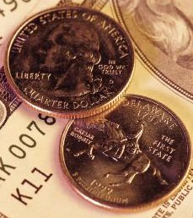
After 10 years and 50 states later, the statehood quarter program has come to an end. Well not exactly. What has come to an end is that portion of the coinage program that includes the actual states that make up the union that began with Delaware, the first state to ratify the Constitution in 1787 and concluded with Hawaii, the last state admitted in 1959. There is definitely more to come however.

The 1999 Delaware Quarter

In 2009, the US Mint will release six more commemorative type quarters honoring the nation’s capital and the five territories. Unlike the statehood quarter series, the date will be moved to the right of the motto E PLURIBUS UNUM on the reverse. George Washington and the mint mark will continue to be placed on the obverse. The first of the 2009 quarters will pay tribute to the District of Columbia. It will feature a portrait of the renowned Jazz composer Duke Ellington. The remaining five in order of their release will honor Puerto Rico, the Island of Guam, American Samoa, the U.S. Virgin Islands and finally the Northern Mariana Islands. The six piece clad proof set of 2009 quarters is scheduled for release on January 5, 2009.

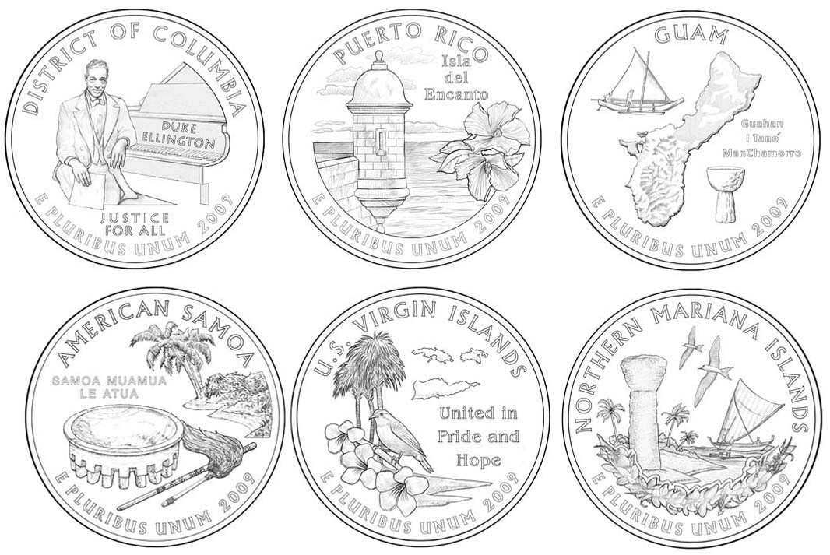
US q
The six 2009 25¢ reverse designs
Top: D.C, Puerto Rico and Guam; Bottom: American Samoa,
The U.S. Virgin Islands and Northern Marian Islands
[Magnify sketches to 200% to see details more clearly.]
(Courtesy of US Mint Web site)
________________________________________________________________________________________________________________

Also coming in January from the US Mint
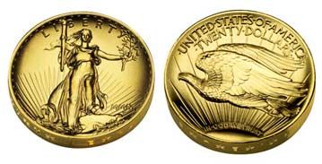
The 2009 high relief Saint-Gaudens $20.00 Double Eagle
Unlike the original 1907 issue, the date will be in Arabic and not Roman numerals and the motto IN GOD WE TRUST will appear on the reverse.
_________________________________________________________________________________________________
More Club News – The November meeting
(Continued from page 1)

For Show & Tell Jim Barry brought in a silver Greek Nomos from Neapolis, Italy (Greek for Naples meaning New City) c.300-275 BC. The obverse featured a diademed head of a Nymph and the reverse displayed a man-headed bull being crowned by Nike flying aloft. The silver coin was slightly larger than our 5¢ nickel weighing around 6.90 grams.

For the program Arno Safran gave a PowerPoint presentation on “US Coins of the Great Depression: The 1930s”. The slides included not only the coins struck by year from 1930 through 1938, but the mintages, newspaper headlines and images of the period as well as the economic, social and political changes that occurred during that turbulent decade. At the upcoming January 5 meeting Jim Barry will present a program on “The coinage of the American Federation”.

Prize winners at the November meeting were Steve Kuhl who won the attendance drawing, a 2008 silver eagle and Jim Barry who won the 50/50 - $30.00. Congratulations gentlemen!
______________________________________________________________________________________________________

Coin of the Month

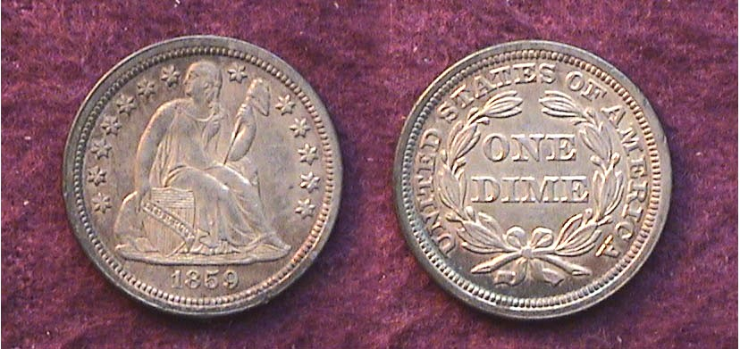

An 1859 Liberty Seated dime grading AU
[Magnify to 200% to see details.]

The coin pictured above is 150 years old this year. It is an example of the Liberty Seated with stars “with drapery” obverse type that was first coined as such in 1840. With a reported mintage of 429,200 struck at the Philadelphia Mint-- compared with the almost 1,000,000,000 clad Roosevelt dimes coined there in 2007--an 1859-P dime is considered a relatively common date. Brian Greer, author of “The Complete Guide to Liberty Seated Dimes” (1992) believes the coin‘s availability decreases above VF and is scarce in mint state however.

In 1859 ten cents had the purchasing power of what $2.50 could buy today. Before the Coinage Act of 1965 ‘removed’ the silver from our circulating coinage, one could occasionally come across a Barber or Mercury dime in circulation but seldom did someone report finding a Liberty Seated type in that manner. So, why are so many obsolete coins like the 1859-P dime pictured above still considered common? The answer comes in two words: Coin collectors! In the trendy Trivial Pursuit game one of the questions drawn was, “What is the most popular hobby in the United States? The answer was and still is, “Coin Collecting!” Numismatics in this country goes back a long way and so do coin dealers who earn their living buying obsolete coins via shows, auctions or estate purchases based on the needs and income level of their collector clients. More than ever, supply and demand remains the dominant forces regarding generic and rare coins.
____________________________________________________________________________________________________________

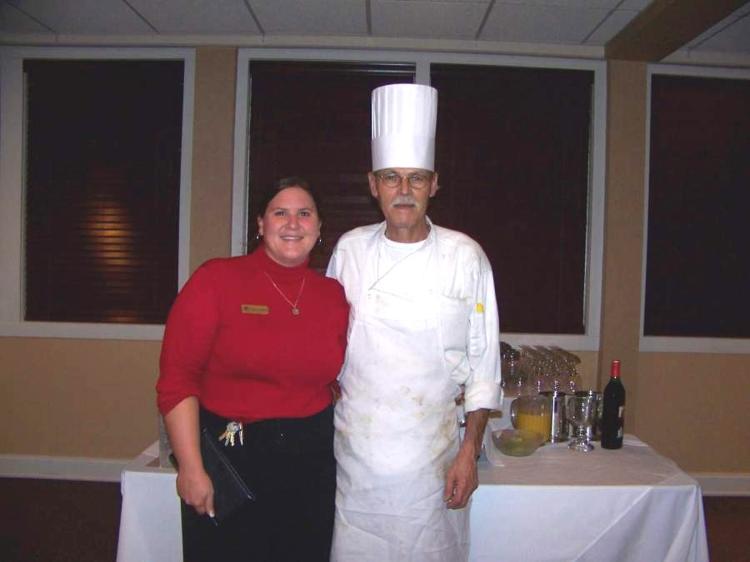

Houndslake Country Club Food Mgr. Julie and Exec. Chef Don
Photo, courtesy of Helen Barry
_____________________________________________________________________________________________________________

Kindly Patronize Our Advertisers

