Pres. Steve Kuhl
V .P. Arno Safran
Sec. Jim Mullaney
Treas. Sharon Smoot
Sgt. in Arms: Glenn Sanders
The Stephen James
CSRA Coin Club of Aiken
P.O. Box 11
New Ellenton, SC 29809
Web site: www.sjcsracc.org
The SJ CSRA CC of Aiken, SC meets on the 1st Thursday of the month at the Aiken Public Library

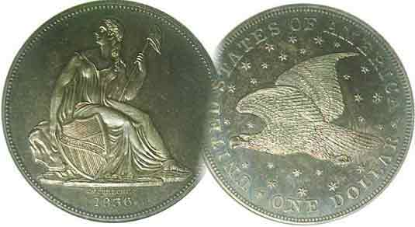
Committees:
Programs: Arno Safran
2010 Show: Jim & Helen Barry
Publicity: Jim Clapp
Newsletter: Arno Safran
E-Mail: arnosafran@comcast.net
Auctioneer: Glenn Sanders

2011 Club Meeting Schedule
Volume 10, Number 1 the Stephen James CSRA Coin Club, Founded in 2001 January, 2011
Monthly Newsletter
New Year Brings New Challenges
Our next meeting is on Thursday, Jan. 6, 2011 from 6:00 to 8:45 PM

Jan. 6 Apr. 7 July 7 Oct. 6
Feb. 3 May 5 Aug. 4 Nov. 3
Mar. 3 Jun. 2 Sep. 1 Dec. 1

____________________________________________________________________________________________________________

Joyous Club Dinner closes out 2010

More than 30 members and guests attended our annual pre Christmas holiday dinner. For the third year in succession, the dinner was held at the Hounds Lake Country Club and the attendees were once again treated to good food, friendly company and a chance at winning some numismatic prizes. Past President Willie Simon led the members in the grace before our dinner and current President Steve Kuhl welcomed everyone warmly, thanking members for their help during the year. Six door prizes were awarded. The lucky members whose names were drawn were Jim Mullaney who won a Morgan dollar. The next five won Peace dollars. They were Roger Worpell, Willie Simon, Rick Owen, Marjorie Simons and Austin Kuhl. The 50/50 winner was Elaine Attaway who won a $38 cash prize. Congratulations go out to all the winners.

Our next meeting is scheduled for January 6, 2011 at the Aken Public Library. [Please observe the 2011 calendar of meeting dates shown above.] Our program for the evening will be "Odds & Ends: The 'Non-State' Quarters of 2009." presented by member Todd Starbuck. Todd will be the fifth club member to present a program. This kind of club participation is good for our local hobby organization. As mentioned in the December issue, the increase in the number of club members offering Show & Tell exhibits was also gratifying. With attendance on the upswing, the SJ CSRA CC would seem to have come into its own as we begin our second decade. There is still one important area of concern that needs to be addressed; that is finding a Bourse Chairperson to run our 2011 Show.

The club derives its operating income mainly from its annual coin show. Without a chairperson, someone to contact the dealers or others who know dealers, there will be no show. A year without a show makes it more difficult to reestablish the cycle even if a show chairperson emerges the following year because dealers opt to do other events within the same time slot.
__________________________________________________________________________________________________________________________
(Continued on page 2, column 2)
The Minor US Coinage of 1851: 160 years ago
By Arno Safran

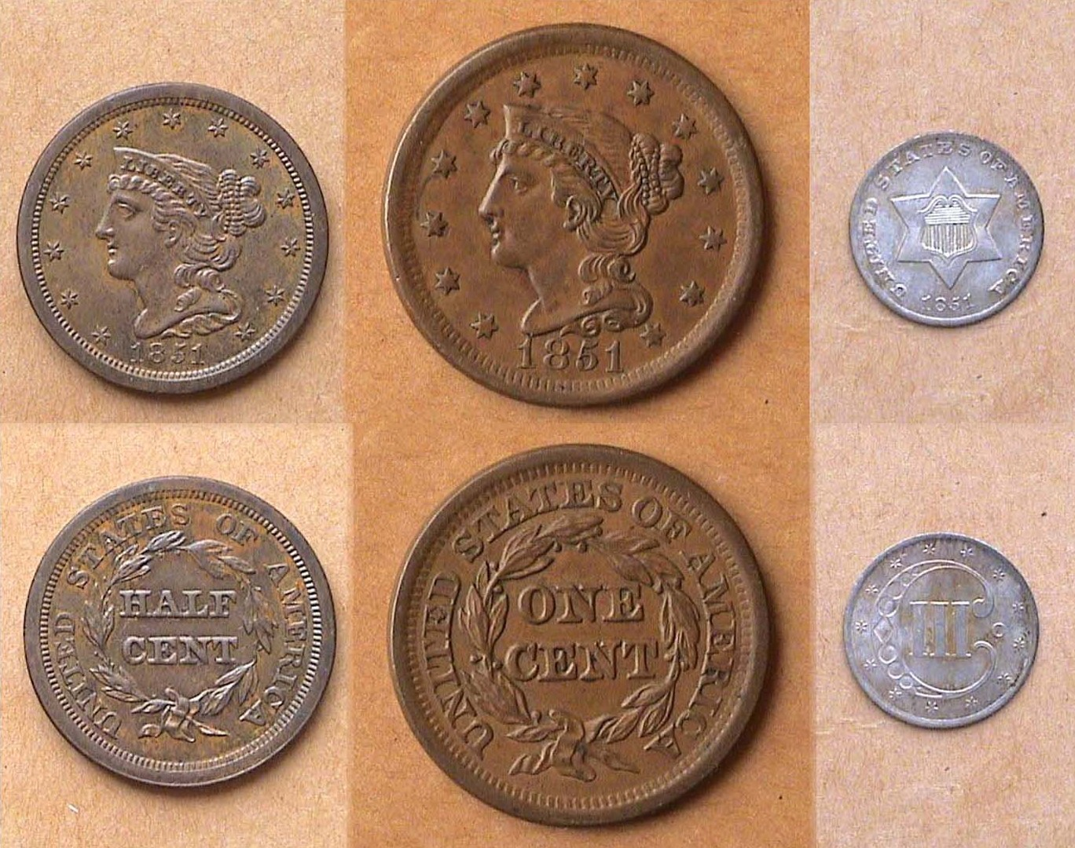

An 1851 ½¢, 1¢ & 1851-O 3¢ silver “trime”
[Use 3X glass or magnify to 200% to view details.]

By 1851, US coinage had fallen into a relatively steady pattern. The copper ½¢ and 1¢ denominations continued to feature the Mature Head version of the Coronet Liberty design. The silver 5¢, 10¢, 25¢, 50¢ and $1.00 still displayed the Liberty Seated design. Only the recent addition of the $1.00 & $20.00 Coronet Liberties in 1849 added some spice to our coinage. What was new to American coinage in 1851 was a tiny silver coin valued at 3¢. Why was this coin necessary?

With gold deposits discovered at Sutter Mill along the American River near Sacramento, CA in 1848, prospectors from the east and other parts of the world came west in the quest for gold. By 1850, the value of silver rose in ratio to gold and soon, bullion traders were taking silver coins out of circulation. Meanwhile the cost of a first class postage stamp had been reduced from 5¢ to 3¢. With the shortage in silver coinage deepening, Congress in 1851 decided to authorize a new 3¢ denomination containing 75% silver bonded to 25% copper. The passage of the act partially helped to relieve the coinage crisis while making it more expedient to buy a postage stamp.
___________________________________________________________________________________________________________________
(Continued on page 2, column 1)

The Minor US Coinage of 1851: 160 years ago
(Continued from page 1, column 2)

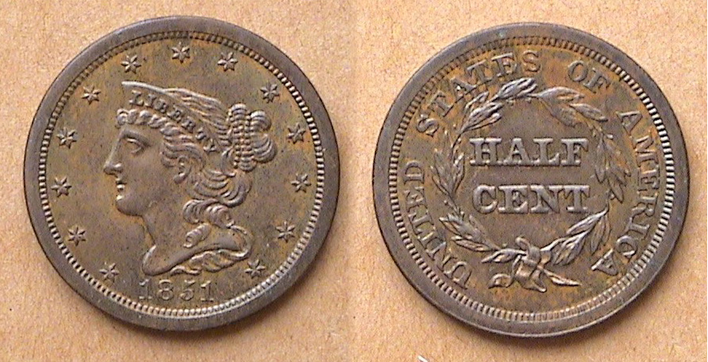

An 1851 Mature Head Braided Hair Half Cent grading AU-55
The diameter was 23 mm. [Use 3X glass or magnify to 200% to view details.]

Unlike the large cent which was dated every year except 1815, the half cent denomination experienced a number of interruptions and suspensions. By 1851, it was supposedly being used to buy stamps for postcards. The mintage of only 141,672 half cents in 1851 may seem small today but it was actually the largest mintage since 1835. By the 1850’s the coin had already become unpopular and was hardly used with the result that enough high-end survivors surface on a regular basis and this keeps the price reasonably modest up through AU-58. Today the 2011 Red Book lists the 1851 ½¢ at $$100 in XF-40 and $165 in AU-50, perhaps closer to $200 in AU-55 In 1993 the specimen shown sold for $135.

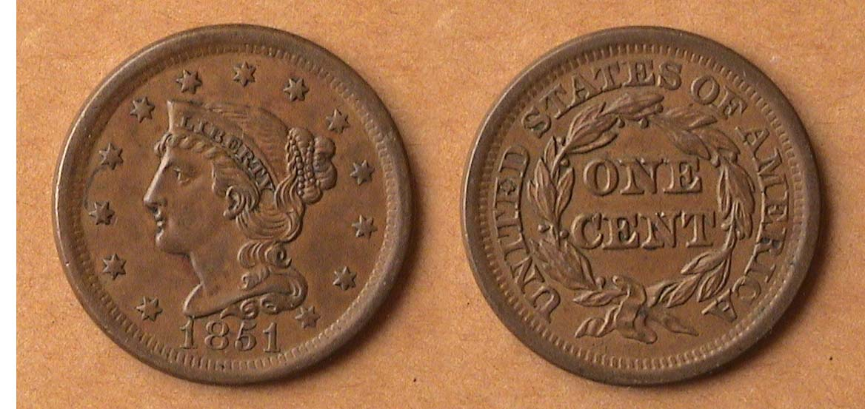

An 1851 Mature Head Beaded Hair Large cent grading XF-45
The diameter was 28 mm. [Use 3X glass or magnify to 200% to view details.]

For the serious and casual collector

COINS, STAMPS & CURRENCY

P.O. Box 1739 Patricia James
Aiken, SC 29802 143 York Street
(803)-643-9957 Aiken, SC 29801

In 1851, 9,889,707 large cents were minted at the Philadelphia Mint. This represented an all time record for the denomination up to that point in time. While the cent had been the workhorse of the economy since its inception in 1793, by 1851 the coin was beginning to become increasingly unpopular due to its cumbersome size and weight considering its small value in the marketplace. Survivors for this date are aplenty in all grades. According to the 2011 Red Book, a low-grade specimen, say VG-8 is listed at just $18 retail. for one grading Fine-12, $25.00. On the upper end of the grading spectrum, the coin is listed at $110 in AU-50 and $275 in MS-60. An EF-45 specimen such as the coin pictured above would retail for $75.00 today. It cost just $40.00 in 1988, which indicates that common date type coins can keep up with inflation if attractive.

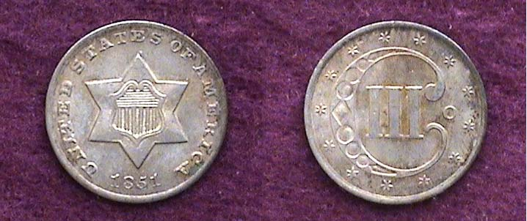

An 1851-O 3¢ silver piece grading AU-50
As our smallest silver coin, the coin was only 14 mm in diameter.
[Use 3X glass or magnify to 200% to view details.]

The 1851-O 3¢ silver coin was the only year the New Orleans Mint struck the denomination. 720,000 were minted there compatred with 5,447,400 at the Philadelphia Mint. Upon magnifying, the coin shown at the bottom of the previous column the reader will observe the New Orleans mintmark O on the right side of the reverse just outside the ornate letter C containing the Roman numeral III. The AU-50 coin pictured sold for $170 back in 1995. Today it is listed at $220. Despite the novelty of the mintmark issue, the coin is not rare and surfaces frequently in this grade. The tiny silver “trime”, as the US Mint called it, continued to be minted through 1873.

As for the upper silver denominations from the half dime through the dollar, specimens grading XF or better are scarcer and more costly. With gold bullion listed at around $1,400 an ounce at present, all 1851 gold issues are priced beyond the reach of most moderate-income collectors.

In 1851, the President was Millard Fillmore, having succeeded to the office upon the death of “Old Rough and Ready”, General Zachary Taylor, our twelfth president.
_______________________________________________________________________________________________________________________

More Club News
(Continued from page 1, column 1)

During the first week in January, some of our members will be attending the Florida United Numismatists (FUN) Show in Tampa, FL this year. Those who are able to be present at our January 6 meeting are encouraged to bring in a Show & Tell item or share a past numismatic adventure you think the members would enjoy hearing. In addition to Todd Starbuck’s program on the Quarters of 2009 there will also be an auction conducted by our incomparable auctioneer Glenn Sanders.
__________________________________________________________________________________________________________________

Kindly Patronize our Advertisers

