Pres. Steve Kuhl
V .P. Pat James
Sec. Jim Mullaney
Treas. Sharon Smoot
Sgt. in Arms: Glenn Sanders
The Stephen James
CSRA Coin Club of Aiken
P.O. Box 11
New Ellenton, SC 29809
Web site: www.sjcsracc.org
The SJ CSRA CC of Aiken, SC meets on the 1st Thursday of the month at the Aiken Public Library

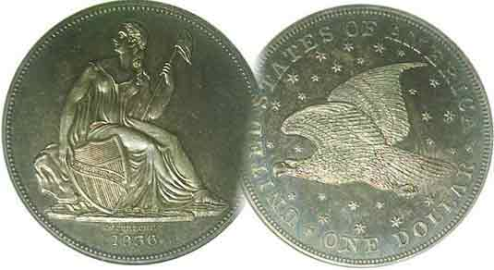
Programs: Pat James
Show: by Committee
ANA Representative: Jim Barry
Publicity: Jim Clapp
Newsletter: Arno Safran
E-Mail: arnosafran@comcast.net
Auctioneer: Glenn Sanders
Web site: Susie Nulty (see above.)

2012 Club Meeting Schedule
Volume 11, Number 1 the Stephen James CSRA Coin Club, Founded in 2001 January, 2012
Monthly Newsletter
Members Enjoy another Delightful Year-end Dinner meeting
Our next meeting is on Thursday, January 5, 2012 at the Aiken Public Library

Jan. 5 Apr. 5 July 5 Oct. 4
Feb. 2 May 3 Aug. 2 Nov. 1
Mar. 1 Jun. 7 Sep. 6 Dec. 6

______________________________________________________________________________________________________

Numismatic Prizes, Yarns and Show & Tells
among Dinner Highlights

The annual pre holiday club dinner held at the Houndslake Golf Club on December 1, 2011 was another enjoyable affair and much thanks and appreciation go out to Jim and Helen Barry for arranging the event. In addition to the fine dinner, a number of members either received numismatic prizes of appreciation or were 50/50 winners.

During the dinner, there were a couple of Show & Tells accompanied by two different yarns involving the sum of $175.00. Rick Owen displayed one of the new limited edition 5 piece 2011 silver eagle sets offered by the US Mint along with an XF-45 1877 Indian Head cent. He then told the unhappy tale of how a dealer unwittingly allowed a $5,000 coin to be sold to another for the unbelievable sum of $175.00.

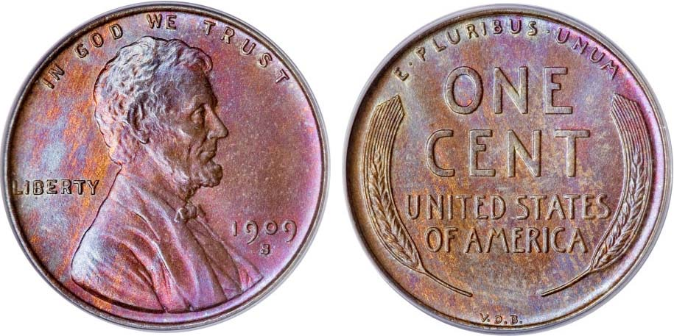

A 1909-S V.D.B. Lincoln Cent graded MS-65-Red-Brown by PCGS
This coin realized $5,462.50 at the Heritage Long Beach, CA Feb. 4, 2009 [Courtesy of Heritage Auctions Archives] [Magnify to 500% to see details.]

Many dealers often leave their tables at a show in charge of an assistant while they peruse the bourse for new material to sell to their customers. Since all their coins are priced on the holders, they feel confident that no grievous errors will be made during their absence. But in this one case, that is what actually happened. A show attendee stopped by the dealer’s table and pointed to a coin that happened to be a 1909-S VDB Lincoln cent housed in a PCGS holder grading MS-65 full red requesting a price. The aide quoted $175.00 mistaking the slab just behind the key date. “I’ll take it”, said the buyer and walked off with the 1909-S VDB cent. When the dealer returned, he asked what purchases had occurred in his absence and the delighted aide mentioned the number of pieces sold including the key date coin.
___________________________________________________________________________________________________________________
(Continued on page 3, column 1)
The Case for Buying Certified Coins By Arno Safran

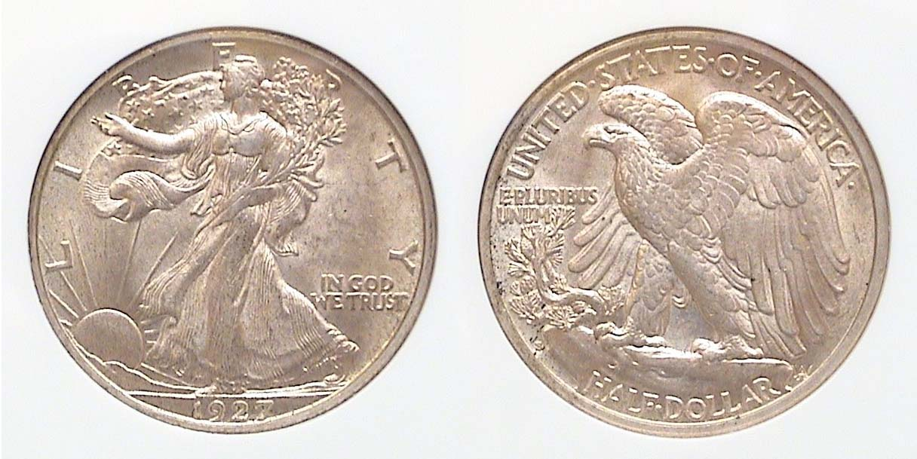

A 1927-S Walking Liberty Half dollar graded AU-58 by NGC
[Use a 3X magnifying glass or enlarge page to 200% to view details.]

Before 1986, coins were not certified. They were sold “raw”, usually housed either in a stapled 2 x 2 cardboard holder or inserted into a vinyl or Mylar flip. On the holder or inside the flip, the dealer provided the date (and Mint mark if from a branch Mint other than Philadelphia) its denomination and the grade. If the purchaser felt confident in matters of grading a deal could be consummated after a little haggling. The problem was that despite grading guidelines, the owner of the coin usually believed the grade was higher than the potential buyer and to some extent that situation still exists today.
The Professional Coin Grading Service (PCGS) was founded in 1986 primarily to eliminate the disparity in grading between dealer and collector by having three different professionals independently grade a coin after concluding the coin was authentic. The coin was then placed in a hermetically sealed hard plastic see through holder with the date, denomination and grade labeled on the obverse side of the “slab”. A year later PCGS was joined by the National Guarantee Company, NGC, ANACS and a host of other entrants that didn’t last and finally, the Independent Grading Company (ICG). These four head the pack today with PCGS followed closely by NGC as the primary leaders in the numismatic marketplace.

The NGC graded specimen shown above is an attractive example of how an AU-58 graded coin should appear. It is lustrous, showing virtually little to no wear. Unfortunately, not all certified AU-58s appear as such which is why one must still grade the coin before you buy the “slab”.
___________________________________________________________________________________________________________________
(Continued on page 2, column 1)

The Case for Collecting Certified Coins
(Continued from page 1, column 2)

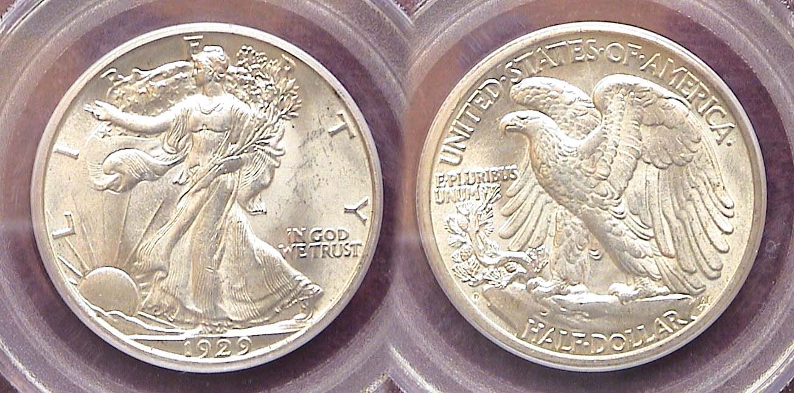

A 1929-D Walking Liberty Half Dollar graded MS-63 by PCGS
[Use a 3X magnifying glass or enlarge page to 200% to view details.]

Above is a striking example of the 1929-D Walking Liberty Half Dollar. It was acquired at the Georgia Numismatic Association (GNA) Show held at the Dalton Convention Center in April, 2009. Notice the sharpness of the strike along with the stronger luster compared with the certified AU-58 example of the 1927-S shown on the previous page. Both coins are attractive but the ’29-D is definitely unc. But suppose these coins were displayed “raw”, (as the one shown directly below) would you, the collector feel as secure in acquiring either one, especially if the dealer had graded all three MS-63?

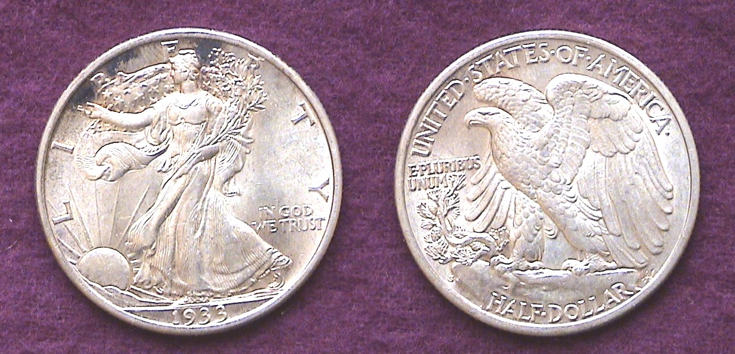

An uncertified 1933-S Walking Liberty Half dollar
[Use a 3X magnifying glass or enlarge page to 200% to view details.]
How would you grade it?

The 1933-S Walking Liberty half dollar was acquired back in January of 1981, (21 years ago) at Stack’s Coin Galleries in New York. That was a full five years before professional grading and certification came into existence. After magnifying the picture to 200%, how would you grade this coin? It has lots of luster and looks pretty sharp. It was sold as a Choice AU (today’s AU-58) and would probably certify no higher than that even now. While extremely attractive, upon visualizing the actual coin it does not appear to the eye as an uncirculated specimen. The luster is a bit off and the high point of the eagle’s breast on the reverse is a tad flat. Nonetheless, it would be interesting to learn how the grading companies would certify it today.

The 1927-S, 1929-D and 1933-S halves are among the scarcer dates of the Walking Liberty half-dollar series (1916-1947) and grading AU-58 through MS-65 can be extremely costly compared with those struck from 1941 to the end of the run. Today, collectors would be advised to select only certified specimens as they are far more expensive than they were two decades ago.

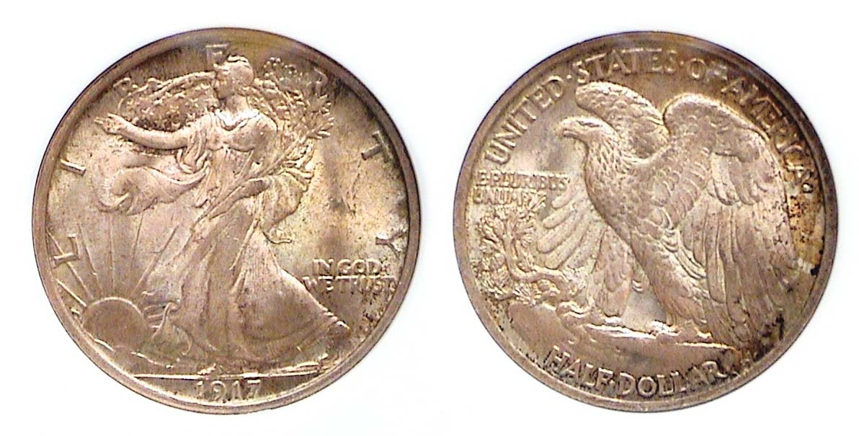
A 1917 Walking Liberty Half Dollar graded MS-63 by NGC
[Use a 3X magnifying glass or enlarge page to 200% to view details.]

This specimen of the 1917 Walking Liberty half dollar was acquired recently at the Blue Ridge Numismatic Association show last August also held at the Convention Center in Dalton, GA. Here is a rare case of seeing a “raw” coin a couple of years earlier, deciding not to buy it because the russet toning, although quite lovely, clouded the features enough to cause uncertainty about the coin’s grade. Despite the early year, the 1917-P with a mintage of well over 12 million is considered a common date among the series. According to the 2012 Red Book it is priced at $70 in AU but in MS-63, it lists for $200. I recognized the coin as being at the same dealer’s table from the earlier show but now housed in a NGC holder graded MS-63. Buoyed by this sense of security I did not mind paying the $175 for the piece.

The same consideration applies to earlier types such as the Liberty Seated half dollar series. Locating a true certified AU-58 that has virtually the same eye appeal of an MS-63 specimen can save the collector money and grief.
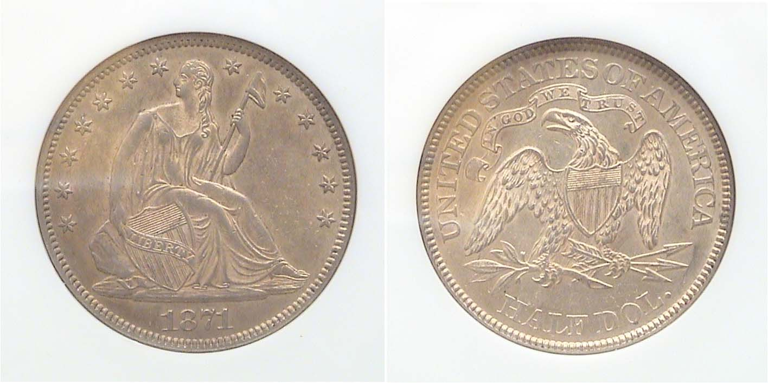

An 1871 Liberty Seated Half dollar (with motto) graded AU-58 by NGC
[Use a 3X magnifying glass or enlarge page to 200% to view details.]

The 1871-P Liberty Seated half had a mintage of 1.2 million and while low compared with the 53 million struck for the 1943-P Walking Liberty half is considered one of the more common dates for its type and not an expensive coin in AU. The certified NGC AU-58 specimen shown above sold for $265 at the SCNA convention held in Greenville in 2005. An MS-63 of the same date would have cost $1,100 or higher according to the latest Red Book.

Although there has been occasional evidence that some of the major US dealers receive higher certified grades when they submit “raw” coins for grading than those with smaller inventories, certification guarantees a coin has not been artificially “improved” and that is in itself extremely important especially in this current high priced numismatic market. Overall, certified authentication and grading has resulted in about an 85% improvement over the pre-certified grading era that was in place prior to the 1990’s, a big step forward.
________________________________________________________________________________________________________________________
Dec. 1, 2011 Dinner Meeting and Show & Tell
(Continued from page 1, column 1)

When the proprietor learned what the coin was sold for, he hunted around for the buyer, finally catching up with him and explaining the mistake but the buyer explained he had already sold the piece to a dealer on the floor but couldn’t remember who.
Arno Safran followed with the tale of how he acquired an 1859 Indian Head copper-nickel cent at a Philadelphia suburb commercial show back in the mid 1990s for $175; recently sent it out to become certified and was pleasantly surprised to see it reemerge in its new home graded MS-65, now wholesaling for $3,000. He had no plans to sell it at this time.

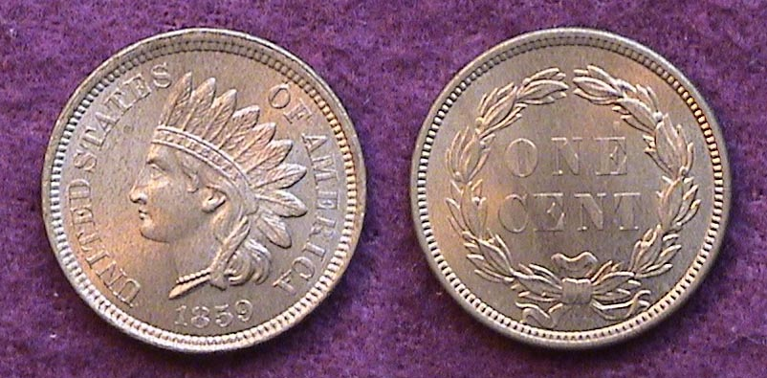

An 1859 Indian Head Cent grading MS-63
[Magnify to 200% to see details.]

Our next regularly scheduled meeting will be back at the Aiken Public Library on Thursday, January 5, 2012. Please see the 2012 Meeting Schedule calendar atop page 1, column 1 of this issue of the newsletter.
Show & Tell Piece

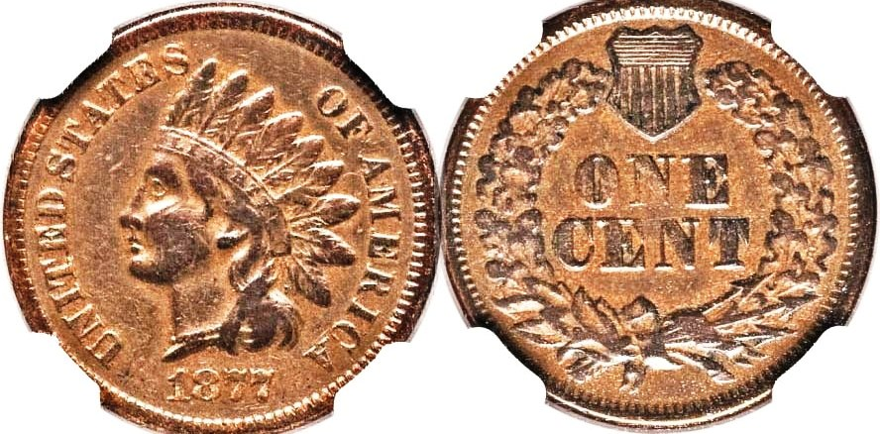

An attractive 1877 Indian Head 1c graded XF-45 by NGC
[Courtesy Heritage Auction Archives Sale Dec. 11, 2011]
[Magnify to 200% to see details.]
____________________________________________________________________________________________________________________

2012 Numismatic New Year Resolutions

Hobbies or Pastimes involving collectibles cost money and every coin collector has their financial limits. A general rule of thumb is to buy the coin you are seeking in the highest grade you can afford because the most essential aspect is to acquire a coin that has eye appeal regardless of the grade. Some coins look attractive in grades as low as VG-8 such as a Classic Head large cent while other coins such as the Standing Liberty quarter begin to lose their eye appeal below XF-45. Knowledge is the key to enjoying Numismatics and learning about grading, coin rarity and demand are essential to fulfilling one’s collecting goals in a orderly and relaxed manner.

Another resolution to consider is that of focus rather than accumulation. Having a specific collecting goal offers greater investment potential than mere accumulation. The completion of sets whether a full series or a shortened version of same, (e.g.; P Mints only) establishes boundaries that make it easier for collectors to acquire items within their budget. If one cannot afford the key dates within a specific series, try another category that is affordable over time. Finally, opt for certified coins for items costing $150 or higher. It may cost more but is far safer.
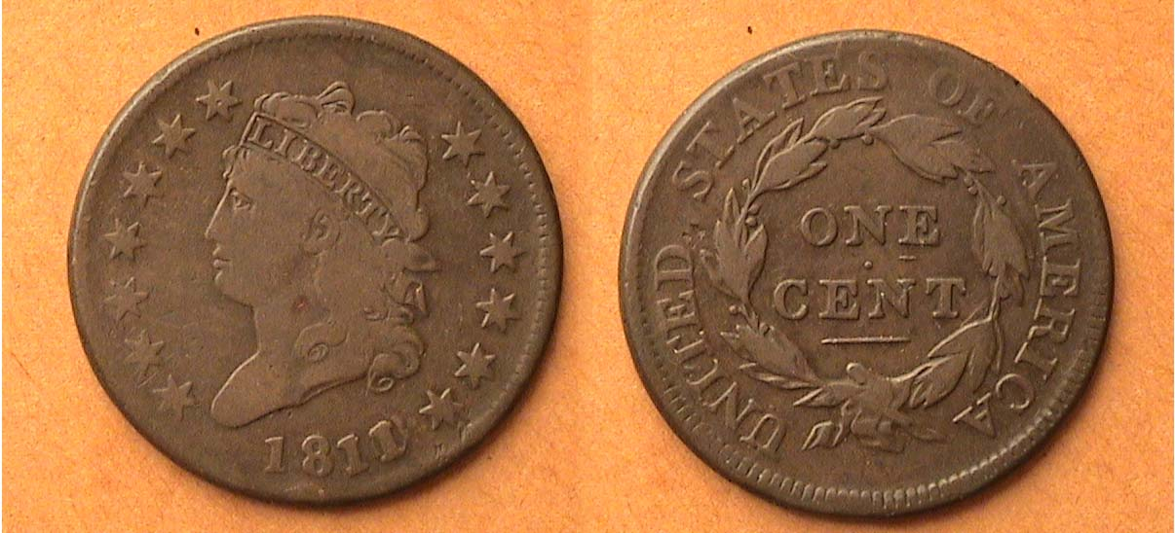

A 1811/10 Classic Head Large cent (29mm) grading VG-8
[Magnify to 200% to see details.]

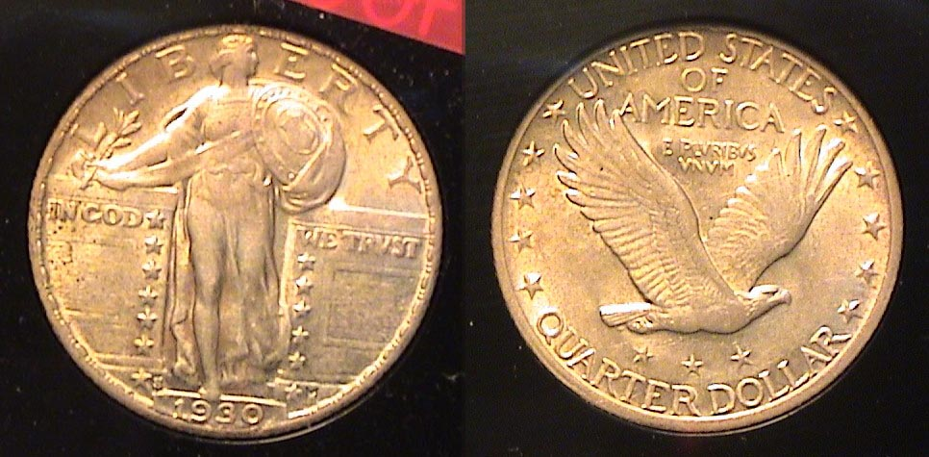

A 1930-S Standing Liberty Quarter grading XF-45
[Magnify to 200% to see details.]

________________________________________________________________________________________________________________

Kindly Patronize our Advertisers

