The Stephen James
CSRA Coin Club of Aiken
P.O. Box 11
New Ellenton, SC 29809
Web site: www.sjcsracc.org
The SJ CSRA CC of Aiken, SC meets on the 1st Thursday of the month at the Aiken Public Library

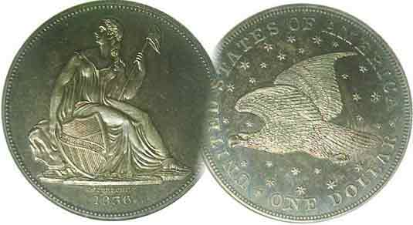
Pres. Steve Kuhl
V .P. Pat James
Sec. Jim Mullaney
Treas. Chuck Goergen
Sgt. in Arms: Glenn Sanders
Programs: Pat James
ANA Representative: Jim Barry
Photos: Helen Barry
Publicity: Pat James
Newsletter: Arno Safran
E-Mail: arnosafran@comcast.net
Auctioneer: Glenn Sanders
Web site: Susie Nulty (see above.)

2013 Club Meeting Schedule
Volume 12, No. 1 the Stephen James CSRA Coin Club, Founded in 2001 January, 2013
Monthly Newsletter
Best Holiday Dinner Ever Ends 2012 Club Year
Our next meeting will be held on Thursday, Jan. 3, 2013 at the Aiken Public Library

Jan. 3 Apr. 4 July ? Oct. 3
Feb. 7 May 2 Aug. 1 Nov. 7
Mar. 7 June 6 Sept. 5 Dec. 5

______________________________________________________________________________________________________

Dinner Held at West Side Bowery Restaurant

As has been custom, the SJ CSRA CC concluded its meetings for the year with a pre holiday bash, this time held at the West Side Bowery Restaurant just off the Alley in Aiken. This was a most enjoyable affair for a number of reasons. The site was centrally located. The service was excellent. The offerings were tasty and the open bar offered more choices but best of all was the camaraderie. About 30 members attended, filling two long tables with everyone seemingly engaged enjoying conversation with one another. President Steve Kuhl welcomed everyone at the start of the get-together, thanking various members for their service to the club. Former President Willie Simon said the grace before the victuals were served. Each attendee received a surprise gift package that featured BU specimens of 2012 P & D Kennedy halves plus a set of 2012 Presidential an d Sacagawea dollars.

While our fiscal year begins in April, the club concluded the 2012 calendar year on a highly rewarding note, which included another successful September show run by President Steve Kuhl and VP Pat James. This provided a healthy balance of around $2,700 near year’s end as reported by Treasurer Chuck Goergen. The club held a series of refreshing meetings thanks to the efforts of Program chairperson Pat James. The presentations were varied and interesting and included such topics as “The Numismatic Legacy of Fort Sumter” by Tony Chibbaro, “Coinage of the First Olympiad” by Jim Barry, “The Theft of the Confederate Treasury” by Dr. Mark Waters, “US National Banknotes” by Robert Moon, “The Coins of the 15 Caesars” by Steve Damron, “Propaganda on Latin American Bank Notes” by Walter Kublius, and “The US Coinage of 1850” by Arno Safran. There were numerous Show & Tells displayed by members Rick Owen, Jim Barry, Chuck Goergen, Arno Safran, David Amey Andrew Goslen and Glenn Sanders, the last named, our colorful auctioneer.
__________________________________________________________________________________________________________________________

Collecting the US Coins of 1813
200 Years Ago By Arno Safran

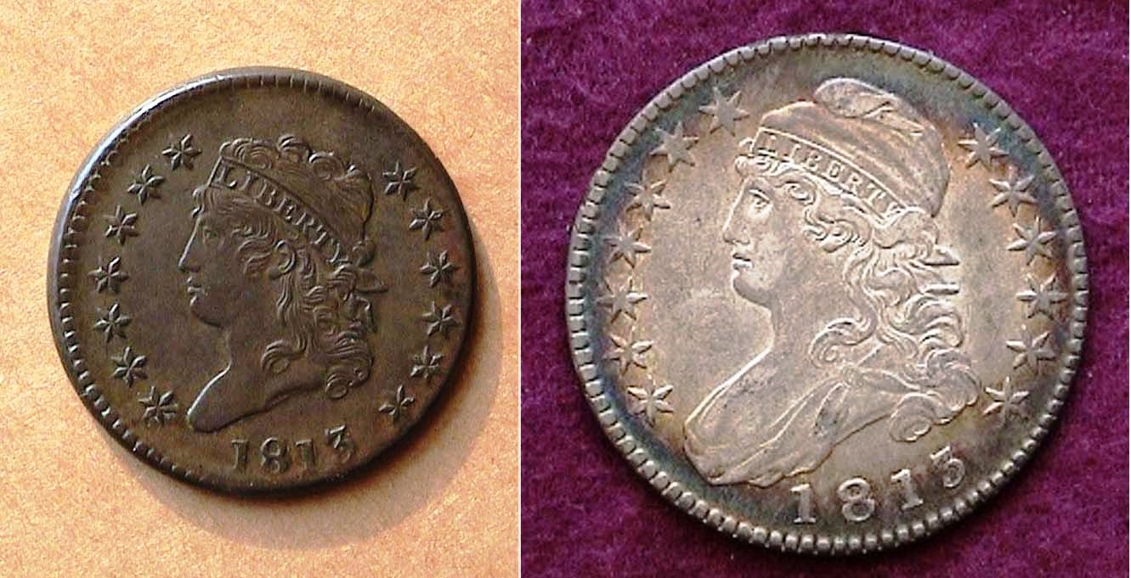

The obverses of an 1813 Year set (excluding gold)
An 1813 Classic Head Large cent and Capped Bust half-dollar
[Use 3 X glass or maximize page to 150% to view details.]

On March 4, 1813, James Madison started his second term as 4th President of the United States. This was in the midst of the “War of 1812” with Great Britain that began back on June 19, 1812. Battles were being waged at sea and in different parts of our country with many lives being lost on both sides. By mid 1813 our young nation was beginning to get a handle on the situation with victories over the British in Canada, Michigan, New York State and Ohio. One of the casualties of the war was our coinage program. As in the previous year, only three coins were struck out of the ten authorized denominations, one for each alloy. These included the copper large cent, the silver half dollar and the gold $5.00 half-eagle.

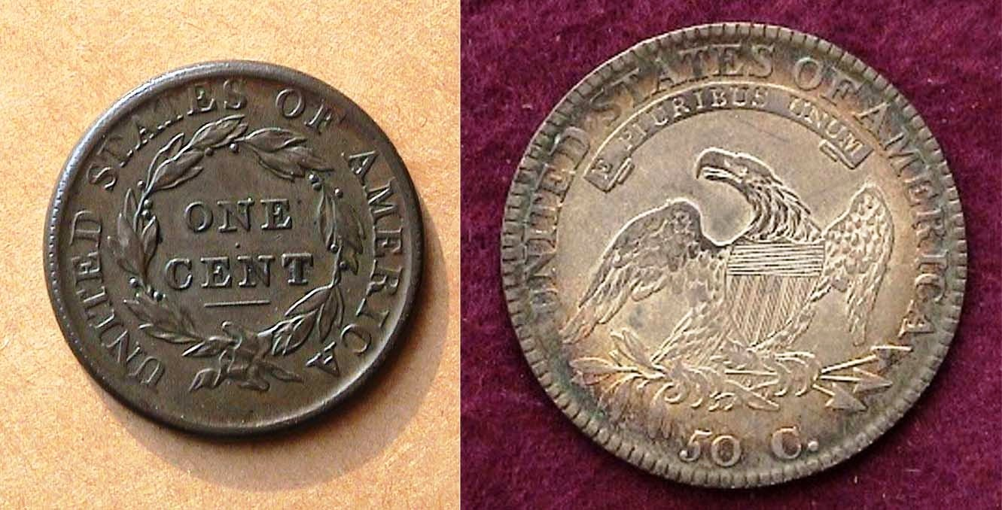

The reverses of an 1813 Year set (excluding gold)
An 1813 Classic Head Large cent and Capped Bust half-dollar
[Use 3 X glass or maximize page to 150% to view details.
______________________________________________________________________________________________
(Continued on page 2, column 1)

Collecting the US Coins of 1813: 200 Years Ago
(Continued from page 1, column 2)

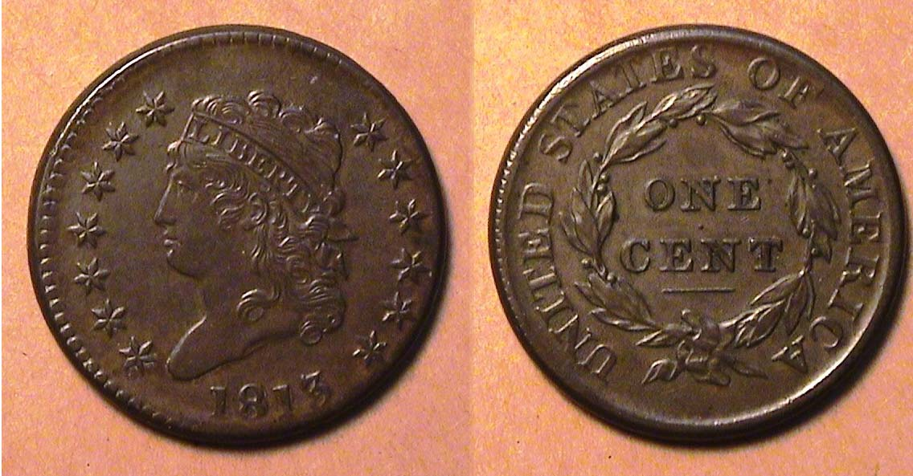

An 1813 Classic Head Large cent, S-292 grading XF-45
[Use 3 X glass or maximize page to 150% to view details.]

The Classic Head large cent was designed by Assistant Chief Engraver John Reich and was first struck by the US Mint in Philadelphia in 1808. During this period hostilities between England and the US increased and the Mint began to have difficulties obtaining quality copper blanks for the coining of and cents and half-cents with the latter being suspended after 1811. By 1813, the situation was becoming dire. Compared with over 1.4 million large cents minted in 1812, the reported mintage for all 1813 cents came to just 418,000. Many of the blanks arrived in a sorry state of preservation because of insufficient storage aboard ship or sabotage. Some were black while others were porous or corroded. The Mint needed every one of these planchets to strike the new cent coins, which is why so many survivors appear unsightly today. According to the 2013 Red book, an 1813 cent graded VG-8 is listed at $120. One in Fine condition is listed at more than twice as much at $265 while a VF-20 specimen is priced at $650. Locating a chocolate-brown porous-free copper 1813 Classic Head large cent regardless of the grade presents a challenge for the collector and when found, expect to pay a premium over average or scudzy pieces. In 1813, a cent had the purchasing power of 15¢.

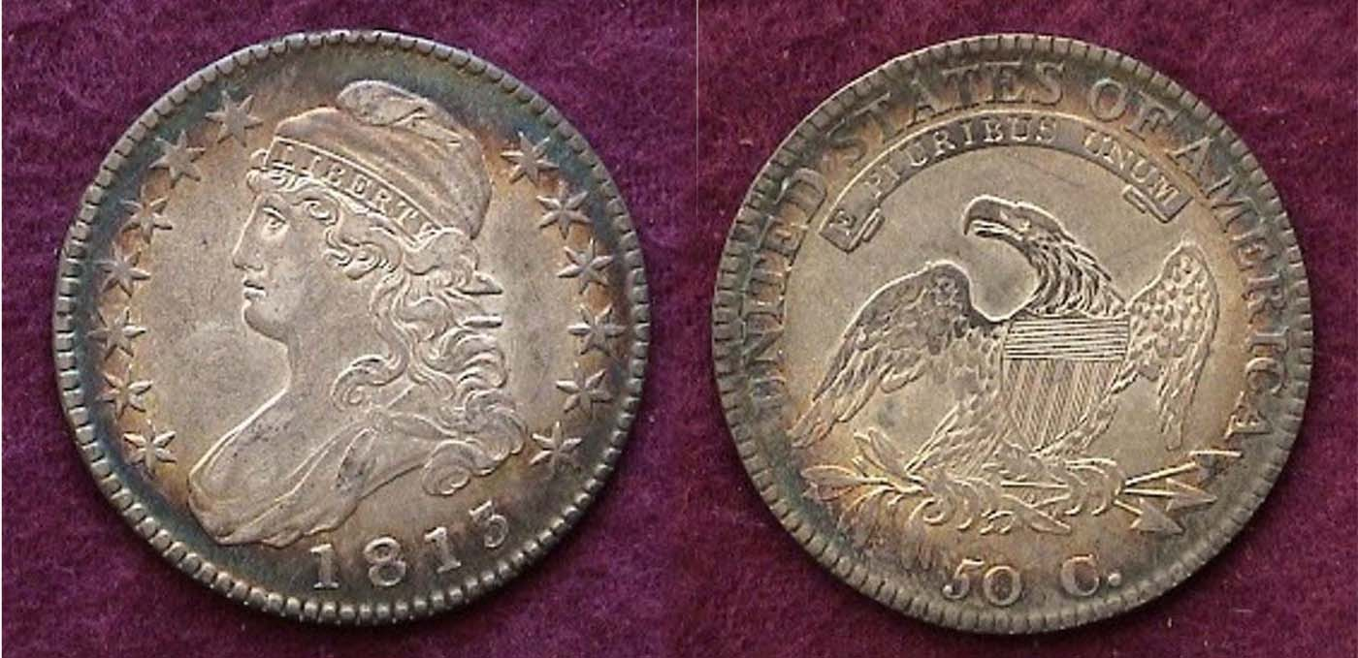

An 1813 Capped Bust Lettered Edge 50¢ O-103 R2, grading AU-55
[Use 3 X glass or maximize page to 150% to view details.]

The Capped Bust half dollar was struck from 1807 thru 1836 in every year except 1816 when a fire at the Philadelphia Mint in January, 1816 caused all coining operations to cease. The reported mintage for the 1813 Capped Bust half was 1,241,903. While these figures pale compared with those struck from 1824 on, the date is still available and affordable from Fine-12 thru XF-45 and is not considered scarce, let alone rare.

After the suspension of silver dollar coinage in 1804, the 50¢ denomination became the largest circulating silver coin and as such was used mainly as specie by the banking system to back business transactions. During the early 19th century, a half-dollar had the purchasing power of $7.25 and as such represented a coin of considerable value. Today however, the date is not as inexpensive as it once was. An 1813 Bust half in Fine-12 is listed in the 2013 Red Book at $110, $160, in VF-20 and at $265 in XF-40. Twenty years ago, the same`date was priced at only $37.50 in Fine-12, $60.00 in VF-20 and just $125.00 in XF-40. What brought about such a tremendous increase? The main answer lies in the large number of new entrants that joined the hobby of coin collecting after 1999, the year the Statehood quarters program began thereby reducing the supply of eye appealing Bust half specimens.

The Gold Coinage of 1813

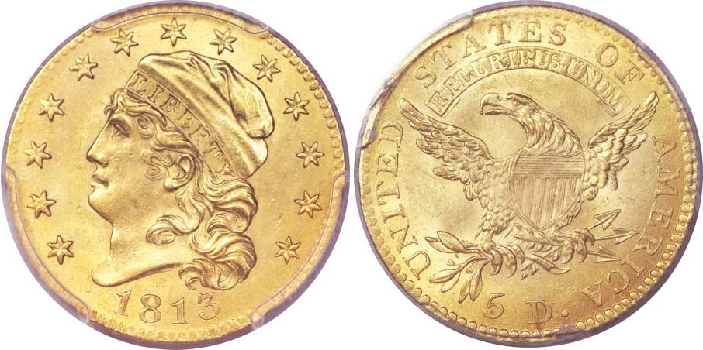

An 1813 gold Capped bust facing left $5.00 Half-eagle
Graded MS-64 by PCGS and CAC
(Courtesy of Heritage Auctions Archives]
[Use 3 X glass or maximize page to 150% to view details.]

In all probability, 99% of US coin collectors will not be able to acquire one of the 95,428 gold $5.00 half-eagles reportedly struck in 1813, let alone the gem BU example pictured directly above This specimen realized $47,000 at the Heritage Signature Auction concluded on August 3, 2012.

1813 is an important year regarding half-eagle coinage. In that year, Asst. Chief Engraver John Reich modified the design type he first created in 1807. Reich altered and enlarged the head considerably while placing the 13 stars in a continuous arc as opposed to the seven at the left and six at right that appeared the previous year. Regarding the reverse, the eagle appears to be larger thereby crowding the motto above and parts of the legend, UNITED STATES OF AMERICA surrounding it. One might argue that neither side was an improvement over the previous type.

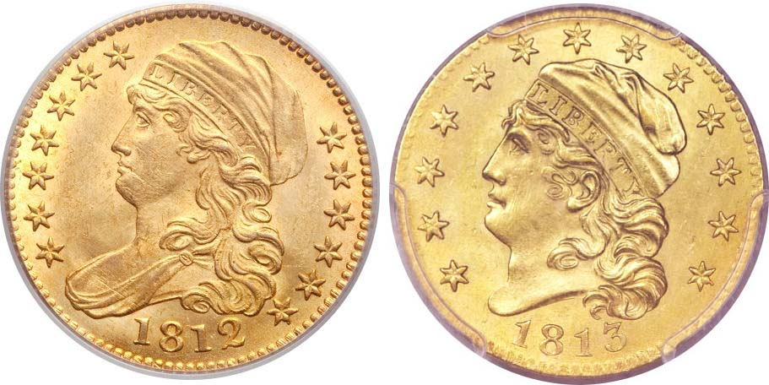
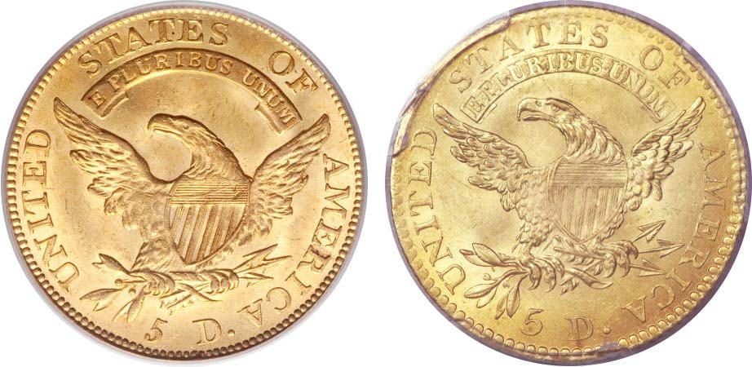

1812 & 1813 $5 compared
Each graded MS-64 by PCGS & CAC
(Courtesy of Heritage Auctions Archives]
[Use 3 X glass or maximize page to 200% to view details.]

For most collectors, this should not pose any concern as very few will be able add either half eagle type to their 1812 or ‘13 year sets, being content to acquire the nicest examples of the Classic Head cent and Capped But half-dollar they can afford.
__________________________________________________________________________________________________________________________________
Hard Times Tokens: (Article 3)

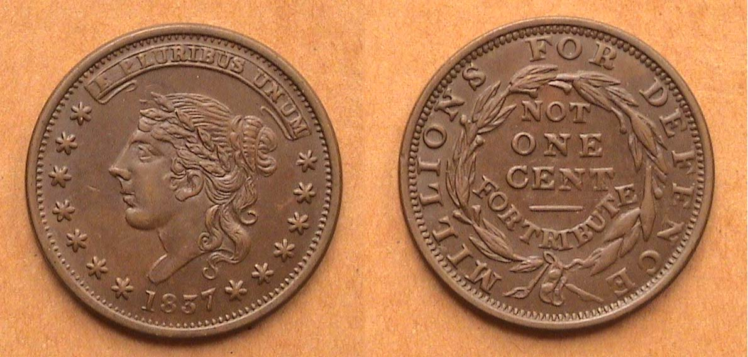

1837 Hard Times Token, HT-48, Low33 R1
Millions for Defense, Not One Cent for Tribute

The phrase, “Millions for defense but not one cent for tribute” was thought to be first used not in 1796 when Charles Cotesworth Pinckney of South Carolina, our Minister to France was not allowed to be received by the French Directory unless a bribe was paid. (AKA “the XYZ Affair”). What he actually uttered was, “Not one sixpence…”. The phrase was also supposedly used against the Barbary Pirates who were raiding our ships off the Coast of Tripoli, North Africa around the same period. In fact, the actual words were first used by Rep. Robert Goodloe Harper, Congressman from South Carolina and chairman of the Ways and Means Committee in Congress on June 18, 1798. Years later during the Era of Hard Times, the quote was placed on the reverse side of a number of Hard Times tokens not only to indicate the maker’s political position on US economic policy at the time but also as a means of stating that the so-called token was worth “NOT ONE CENT”. Most Americans did not pay much attention to the appearance of the large cent which featured the Coronet Liberty Head obverse design and a wreath on the reverse, so applying a cruder version of the same design on the tokens of this period required a disclaimer if merely to protect oneself from being accused of a fraudulent activity or worse, counterfeiting.

The1837 dated Hard Times token shown above is a common variety boasting a more attractive version of Miss Liberty than seen on some of the more amateurish and cruder realizations. It is roughly the same size of the Coronet large cent (1816-1839), about 28 to 29 mm in diameter. Some of these political HTs were valued at one-cent by merchants towards a purchase of an item in their shoppe but they are not coins, merely collectibles that today have a fairly strong collector following.

____________________________________________________________________________________________________________________________

More Club News

Our next meeting is scheduled for this coming Thursday, January 3, 2013 at the Aiken Public Library, early arrivals 6:15 PM, meeting to start at 6:45 PM. Due to the just ended extensive holiday period, the editor is unsure whether any arrangements have been made for a program, so it is advisable to bring in a numismatic Show & Tell item you may have received as a gift or acquired a while back that you would like to display. Thee will also be an auction.
The Florida United Numismatists (AKA FUN) Show usually held during the latter part of the first week in January is not starting until Thursday, January 10, the following week, so we should have a full compliment to ring in the new year.
________________________________________________________________________________________________________________________
Kindly Patronize our Dealers
