CSRA Coin Club of Aiken
P.O. Box 11
New Ellenton, SC 29809
Web site: www.sjcsracc.org
The SJ CSRA CC of Aiken, SC meets on the 1st Thursday of the month at the Aiken Public Library

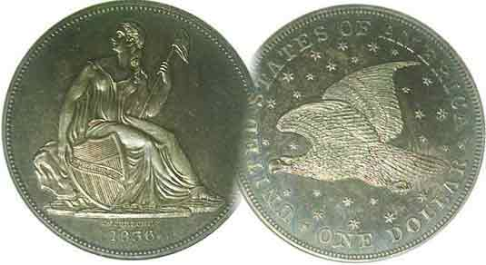
Pres. Steve Kuhl
V .P. Pat James
Sec. Jim Mullaney
Treas. Chuck Goergen
Sgt. in Arms: Jim Sproull

Programs: Pat James
ANA Rep.: Glenn Sanders
Show Chairman: Steve Kuhl
Photos: Steve Kuhl
Publicity: Pat James
Newsletter: Arno Safran
E-Mail: arnosafran@comcast.net
Auctioneer: Jim Sproull
Web site: Susie Nulty (see above.)

2018 Club Meeting Schedule
Volume 17, No. 1 the Stephen James CSRA Coin Club, Founded in 2001 January, 2018
Monthly Newsletter
Our next meeting is Thursday, Jan. 4, 2018 at 6:45 PM in the Aiken Public Library

The Strategy for Acquiring quality coins of value is the Internet
Jan. 4 Apr. 5 July 5 Oct. 4
Feb. 1 May 3 Aug. 2 Nov. 1
Mar. 1 June 7 Sept. 6 Dec. 13

__
When the editor first started seriously collecting coins back in 1976, the four venues for acquisition were becoming a local coin club member, the local coin shop, attending shows or sending mail-orders from coin publications. All coins were sold “raw” either housed in cardboard see-thru stapled holders or vinyl flips. While attractive for display, the chemical in the plastic tended to secrete verdigris on a coin’s surface, a green slimy substance that ate away a portion of the metal surface. Back then, the two main sources available to the coin buyer were the annual “Guide Book of US Coins”, The Red Book” which published suggested retail prices within specific grade levels or the Coin Dealer Newsletter (AKA, “The Gray Sheet”) which supposedly represented wholesale values based on grade.

To assist the novice collector there were a couple of grading books around with less than clear B&W photographs representing the Sheldon Grading Scale from a coin in basal state, Poor 1, a coin with barely any features and a partial date thru Gem Perfect Uncirculated, MS-70, the perfect specimen likely to be found only on a handful of US Mint sets. While this helped a little, the successful collectors were those who developed a “keen eye” for grading subtlety and spent sufficient time evaluating a coin’s condition and true rarity.

As we enter 2018, we now have both faster PCs and a high speed internet with unlimited sources of numismatic knowledge at our fingertips. Such web-sites such as PCGS’s COINFACTS can reveal to the collector not only the current suggested retail price of a coin within a specific grade but what the most recent auction prices have realized, often well below the suggested retail figures. The same site shows clear images of most coins that allow the observer to compare similarly graded coins and determine which has more or less eye appeal commensurate with the prices realized. This gives the collector some bargaining power when negotiating with the dealer a price for a particular item. So, why not make a New Year’s resolution to acquire a better date coin in 2018?
___________________________________________________________________________________________________________

America and the Coins of 1818 (200 years ago)
By Arno Safran

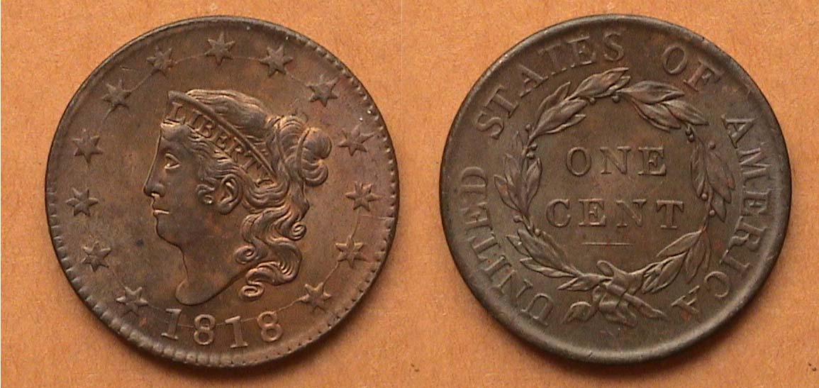

An 1818 Coronet large cent , N-10, R1 grading MS-62RB
[Enlarge to 200% to view details]

Back in 1983, the author submitted an article for publication to Numismatic News entitled “The Coins that Grandfather Used” and “by George”, the editor apparently liked it and published it. Encouraged by his initial success, the author submitted more articles over the next two decades to both Numismatic News and its monthly periodical, COINS Magazine. One of these published back on July 30, 1985 was titled, Coronet large cent reflects period of American history. In actuality, it had little to do with the Coronet large cent series (1816-1839) since the article’s major emphasis was on American culture and the US Coins of 1818.

The article began with the author reflecting on the attractiveness of the 1818 large cent he had recently acquired at a major regional show, describing its condition as being well struck with blemish free surfaces and attractive chocolate brown color. He considered that for a US coin collector, the 167 year old cent was hardly very old compared with the coins of the Classical Greece or the Roman Empire. However, it still possessed interest regarding the culture and the political climate of the United States had at that time, 100 years before the end of World War I, and 150 years before the nation witnessed two major assassinations along with violent student unrest in 1968.

In 1818, a cent had the purchasing power of 20¢. Wages ranged from 75¢ a day for farm hands which included free room & board to $1.86 daily for skill tradesmen. A full dinner meal at a country inn cost 15¢ which included a mug of grog to wash it down. A yearly tuition at Harvard cost only $300 a year.
___________________________________________________________________________________________________________
(Continued on page 2, column 1)
America and the Coins of 1818 (200 years ago)
(Continued from the previous page)
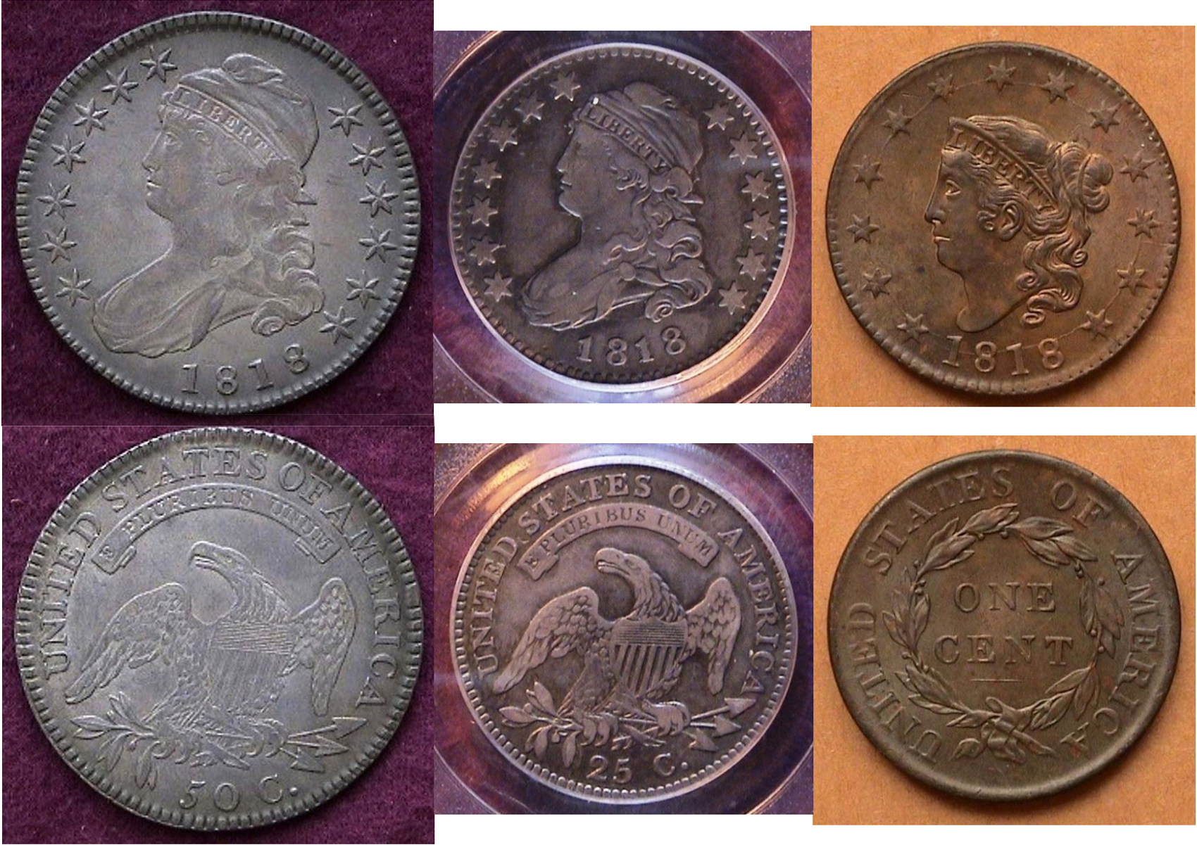
The collectible portion of the 1818 year set
From Left Capped Bust 50c, Large Capped Bust 25c $ Coronet cent
[Magnify images to fill monitor screen to view details more clearly.]

Shown directly above are the three collectable denominations struck in 1818 by the Philadelphia Mint, the Capped Bust lettered edge half-dollar, the large size Capped Bust quarter and the Coronet large cent. While the original US Coinage Act of 1792, authorized ten different denominations, two in copper, the half cent and cent, five in silver, the half-dime, dime, quarter, half-dollar and silver dollar, and three in gold, the $2.50 quarter eagle, the $5.00 half-eagle and the $10.00 eagle, the only year all ten were struck was in 1796. By 1818, five of the ten authorized denominations, the half cent, half-dime, silver dollar, $2.50 quarter eagle and $10.eagle had been suspended. The dime and quarter were not struck in every year leaving a number of years prior to 1818 with only three denominations coined, usually the large cent, the Bust half. and the $5.00 half-eagle, the latter coin, rare to extremely rare and expensive and beyond the means of most ardent collectors. In 1811 and 1817, only two denominations were produced.

The main source of silver coins used by Americans during this era were the Latin American silver Real worth 12½¢, the 2 Reales, a quarter sized silver coin referred to two bits and the 8 Reales, worth $1.00. These coins circulated in US commerce freely and would later be granted legal tender in the Coinage Act of 1834 before finally being demonetized in 1857.

An 1818 Coronet large cent , N-10, R1 grading MS-62RB

The reported mintage for the 1818 Coronet large cent was 3,167,000. The date is fairly common but this particular variety from the famed Randall Hoard is quite common even in the higher grades.

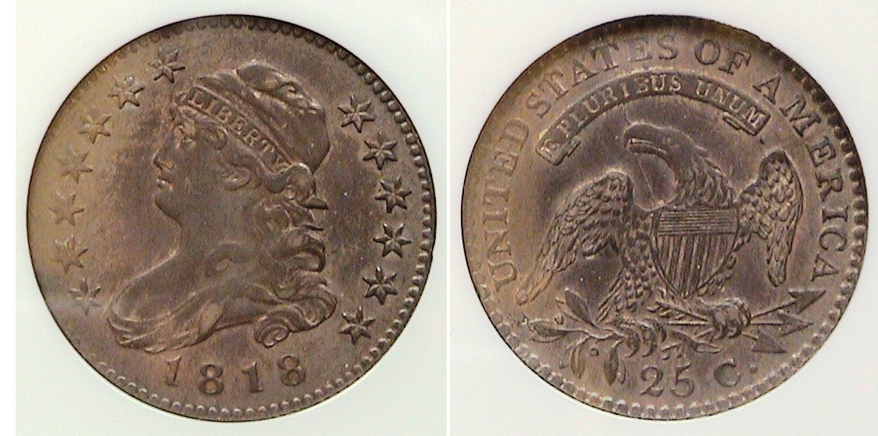

An 1818/5 Capped Bust quarter, B-1, R2 certified XF-45 by NGC
[Magnify image to fill monitor screen to view details more clearly.]

The large size Capped Bust quarter was the creation of John Reich, Asst. Chief Engraver of the US Mint from 1807 thru 1817. The domination was struck in .8924.silver and .1076 copper with an attracted diameter of 27mm. In 1818, the Mint struck a reported mintage of 381,174 large size capped Bust quarters, the largest of the entire series (1815-28) also having the most die varieties, ten. The first three varieties have the same obverse, 1818/5 but different reverses. A faint upward horizontal line is barely visible just under the upper curve of the second 8 in the date. The author acquired the coin shown above “raw” as an XF at a small commercial show held in Colts Neck, NJ back in April, 1999 and submitted it NGC in 2012 where it was graded XF-45. The original retail price has since tripled in value. According to the latest COINFACTS, only one example in this grade has surfaced in the past several years, so despite being considered a common variety, survivors of this quality have been relatively infrequent. of late.

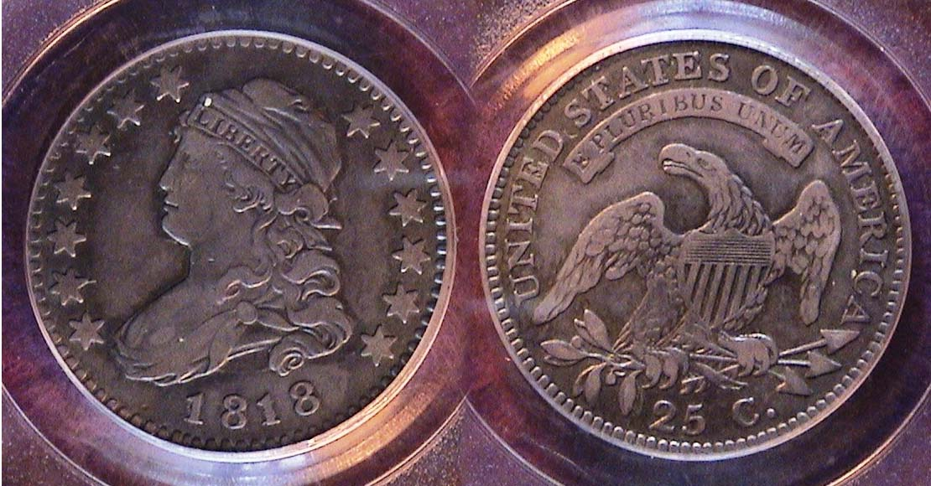

An 1818 Capped Bust quarter, B-8, R3 certified VF-35 by PCGS
[Magnify image to fill monitor screen to view details more clearly.]

The 1818 normal date, B-8, R3 shown here is an attractive example. It is also considered a common date and compared with the overdate shown above is far more plentiful according to the larger number of examples auctioned in the past few years, especially grading VF-35. The coin was acquired in 2013 from a national dealer over the internet and sold for what most prices realized pieces are today about $300 below retail value. In 1818, a quarter-dollar had the purchasing power of $4..87.

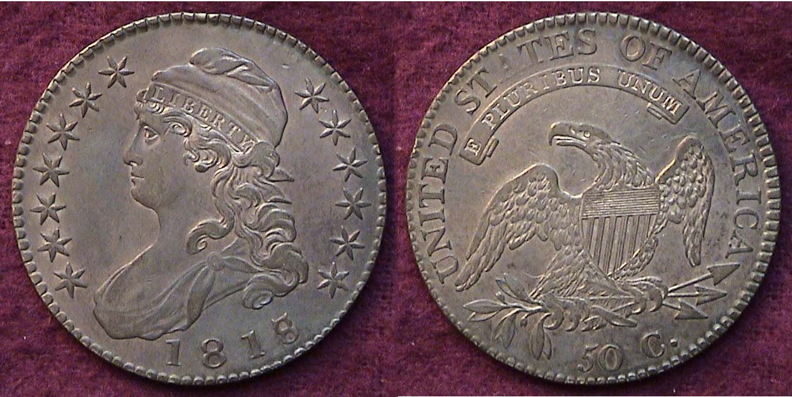

An 1818/17 Capped Bust half-dollar I-101, R1 grading XF-45

Except for the 1807, the key date 1815 and the 1820, all the remaining dates of the lettered edge Capped Bust half dollar
______________________________________________________________________________________________________________________
(Continued on page 3, column 1)
America and the Coins of 1818 (200 years ago)
(Continued from the previous page)

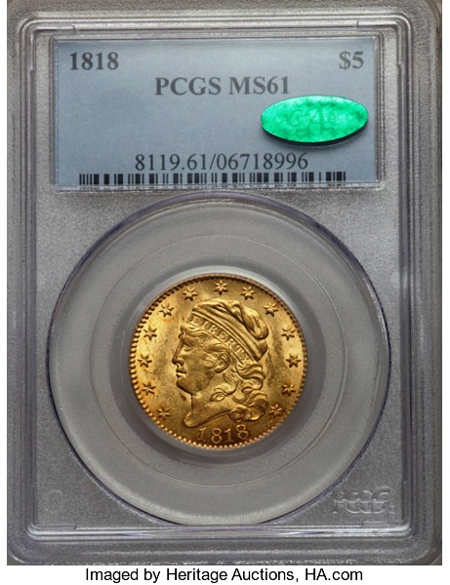
series coined from 1807 thru 1836 are extremely common with from one million to six million struck in a given year. As our largest circulating silver coin at the time, banks used the denomination much like the suspended and later Morgan silver dollar as specie, “hard money’. to back loans to various land speculators and investors with the result that many examples still survive averaging XF-40 thru MS-62.

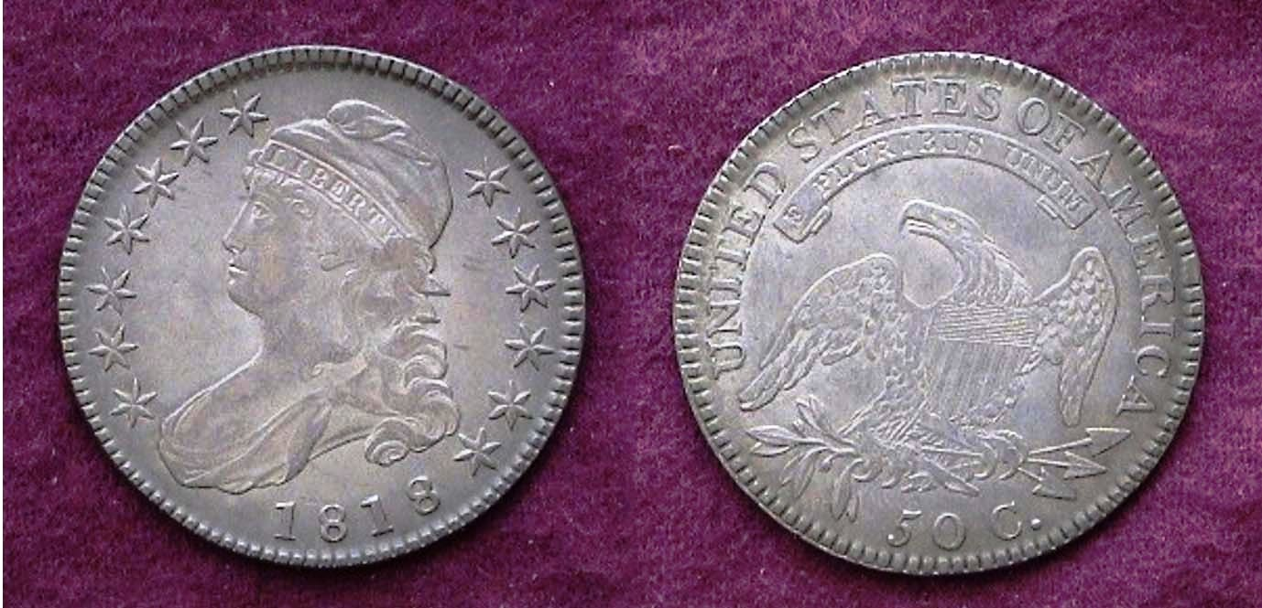

An normal date 1818 Capped Bust 50c O-106a R3 certified XF-45
[Magnify image to fill monitor screen to view details more clearly.]

The reported mintage for the 1818 Lettered Edge Capped Bust half-dollar was 1,960,322 for all varieties, which included fifteen for the year. It was the highest recorded mintage for the date since the fifty-cent’s debut in 1794 although it would be eclipsed the following year with over 2.2 million reported struck in 1819.

The letter O accompanying the variety attribution number stands for the late Al Overton, (1906-1972) a dealer who specialized in the series and author of United States Early Half Dollar Die Varieties (1794-1836) first issued in 1967. The current available 4th edition is by renowned Bust half-dollar collector Donald Parsley which includes all the additional varieties that have been discovered since the third edition of Overton’s tome. The two examples shown in this article are the 1818/7 overdate listed as O-101 on the bottom of the preceding page, common, and the O-106a shown directly above, less common. The 1818/7 overdate half is much more prominent than the 1818/5 Capped Bust quarter and a popular variety with collectors. Both coins are moderately priced thru X45.

In 1818, fifty-cents had the purchasing power of $9.73.

The elusive fourth denomination struck in 1818

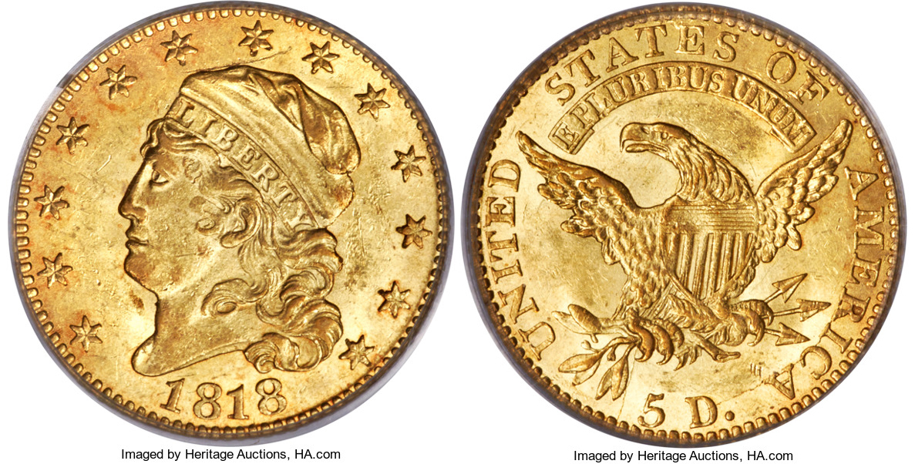

An 1818 $5.00 gold Half-eagle, BD-1, R5
graded MS-61 by PCGS, CAC approved
The coin realized $25,850 at the FUN Show in Jan. 2017
(Courtesy of Heritage Auction Archives)
[Magnify image to fill monitor screen to view details more clearly.]

What a gem of a coin the 1818 half-eagle design is! “Tis a pity” that most of the numismatic collecting fraternity are unlikely to obtain a specimen. The reported mintage for the 1818 Quarter eagle was 48,588 compared with the 95,428 recorded for the 1813 first year of issue for this type. While that may appear as a small number it would have been a sufficient mintage to provide modern day collectors an opportunity to acquire an example at a modest price if it weren’t for one unpredictable situation that kept arising during this period, the continual fluctuation of gold prices.

Since $5.00 back in 1818 had the purchasing power of at least $97.30 today, few citizens probably ever saw a $5.00 gold half-eagle during the early 19th century, let alone spent one. It is true that banks stored many of these coins as “specie” to sustain large business ventures such as investments and land deals but when the value of gold began to exceed the coin’s $5.00 face value, many specimens were either melted or shipped abroad by gold merchants for their larger face value, thus diminishing the supply available for later generations to collect.
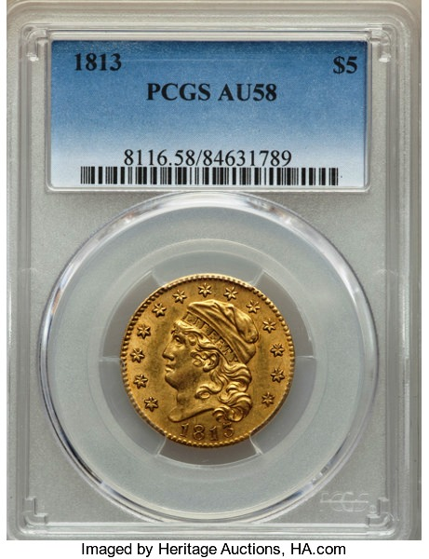
As a result, the 1818 $5.00 piece has a suggested retail price of $26,000 certified MS-61, a low mint-state grade not usually associated with strong eye appeal. Surprisingly, the specimen shown was a n exceptional example of an MS-61 and it realized over $25,000 in a Heritage auction held at the Fun Show a year ago, a figure well beyond the discretionary income for most modern day collectors. For those curious about the specific $5.00 gold design-type, the more common 1813 half-eagle certified AU-58 is currently listed at $12,000.retail with one such example having recently sold for just $8,700 housed in a PCGS-58 holder at a Heritage auction held this past November. That’s a once in a lifetime purchase for someone who was in the right place at the right time.
_____________________________________________________________________________________________________________________________________

Kindly Patronize our Advertisers
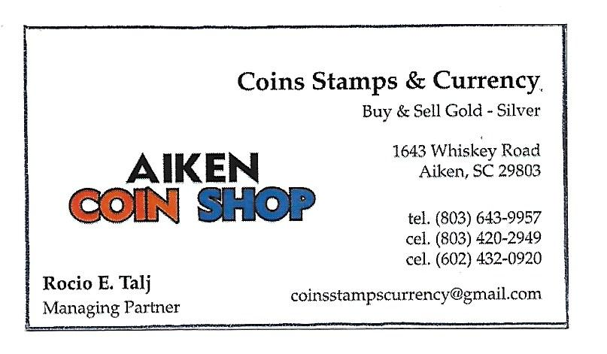
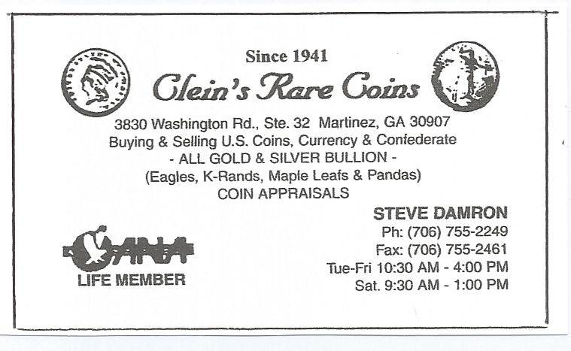
Kindly Support Our Advertisers

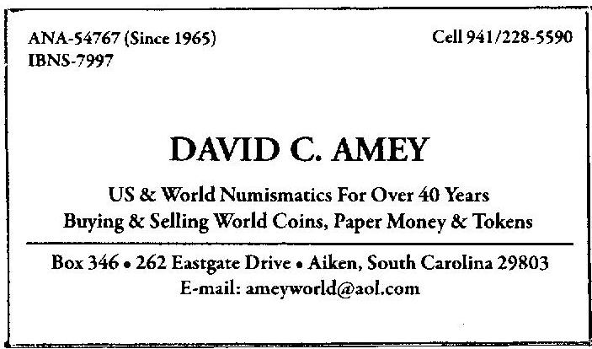

Kindly Patronize our Advertisers
