The Stephen James
CSRA Coin Club of Aiken
P.O. Box 11
New Ellenton, SC 29809
Web site: www.sjcsracc.org
The SJ CSRA CC of Aiken, SC meets on the 1st Thursday of the month at the Aiken Public Library

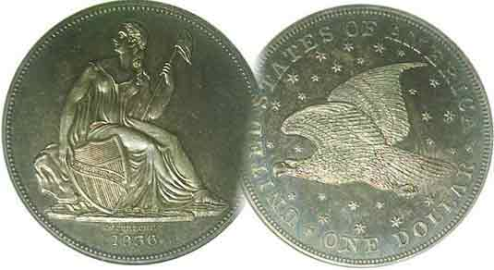
Pres. J.J. Engel
V .P. Pat James
Sec. Jim Mullaney
Treas. Chuck Goergen
Sgt. in Arms: Jim Sproull

Programs: Pat James
ANA Rep.: Glenn Sanders
Show Chair: Board members
Photos: Steve Kuhl
Publicity: Pat James
Newsletter: Arno Safran
E-Mail: arnosafran@comcast.net
Auctioneer: Jim Sproull
Web site: Susie Nulty (see above.)

Our first meeting of the year is on Jan. 2, 2020 at the Aiken Public Library, early arrivals, 6:15

2019 Club Meeting Schedule
Volume 19, No. 1 the Stephen James CSRA Coin Club, Founded in 2001 January, 2020
Monthly Newsletter
2020 Meeting Schedule may be altered do to new scheduling policy
Jan. 2 Apr. 2 July 2 Oct. 1
Feb. 6 May 7 Aug. 6 Nov. 5
Mar. 5 June 4 Sept. 3 Dec. 3

Dec. 5 dinner chalks up another success for our club

2019 was one of the most successful years since the club’s founding in 2001. Despite a resounding holiday party in Dec. 2018, we were unable to hold our annual show that year, a major club fundraiser. This could have had disastrous consequences for us had a similar setback occurred in 2019, but thanks to former President Steve Kuhl and his wife Chrissy, we were able to book the event at the Gym of the South Aiken Presbyterian Church of Aiken due to their active membership there. Thanks to the efforts of Show Coordinator and Club VP, Pat James along with assistance of former club Presidents Willie Simon and Steve Kuhl we sold 43 tables and had 198 guests, resulting in a record net profit. Many members helped out as well which included current president J.J. Engel and club archivist Marion Engel, Sgt. In Arms, Jim Sproull who supervised the set-up. Sharon Hanrahan provided the lunch packages to the dealers and members with Treasurer, Chuck Goergen and other members manning the Welcoming Desk.

Our 2019 pre Christmas dinner meeting was held back at the Columbus Club on Dec. 5 with a large number of members winning numismatic prizes.. It was another gala event. Add to this, we were winners of our second “Club of the year award’ from the South Carolina Numismatic Association.

Library sets meetings schedules at three month intervals

The 2020 meeting schedule posted atop this column is based on past annual schedules thru 2019 with the upcoming monthly meeting set in bold print, but starting in 2020, the Library is only scheduling meetings within a three month interval with the first two on Jan. 2 and Feb. 6. After that, it’s up to the club president and library official to set up the next trio of meetings .As we begin our 20th year, this could present some problems along the way but for now, there’s not much we can do about it.
_____________________________________________________________________________________________________________

Collecting the US Coins of 1920, 100 Years Ago
By Arno Safran

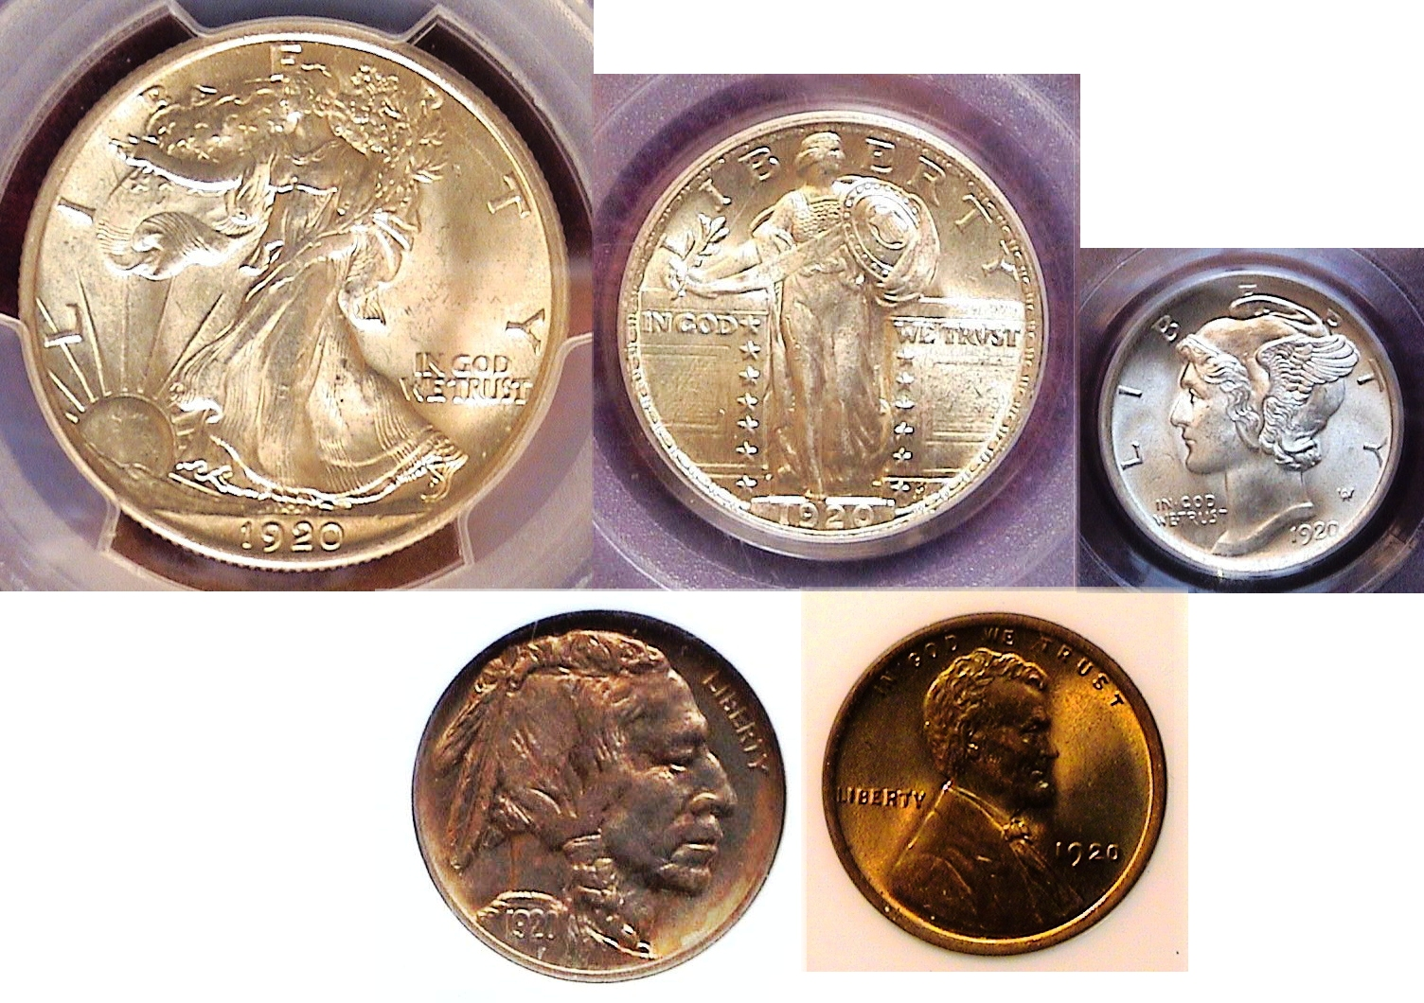
The obverses of a certified BU 1820 Year Set (sans gold)
[Enlarge page to fill monitor screen to view details.]

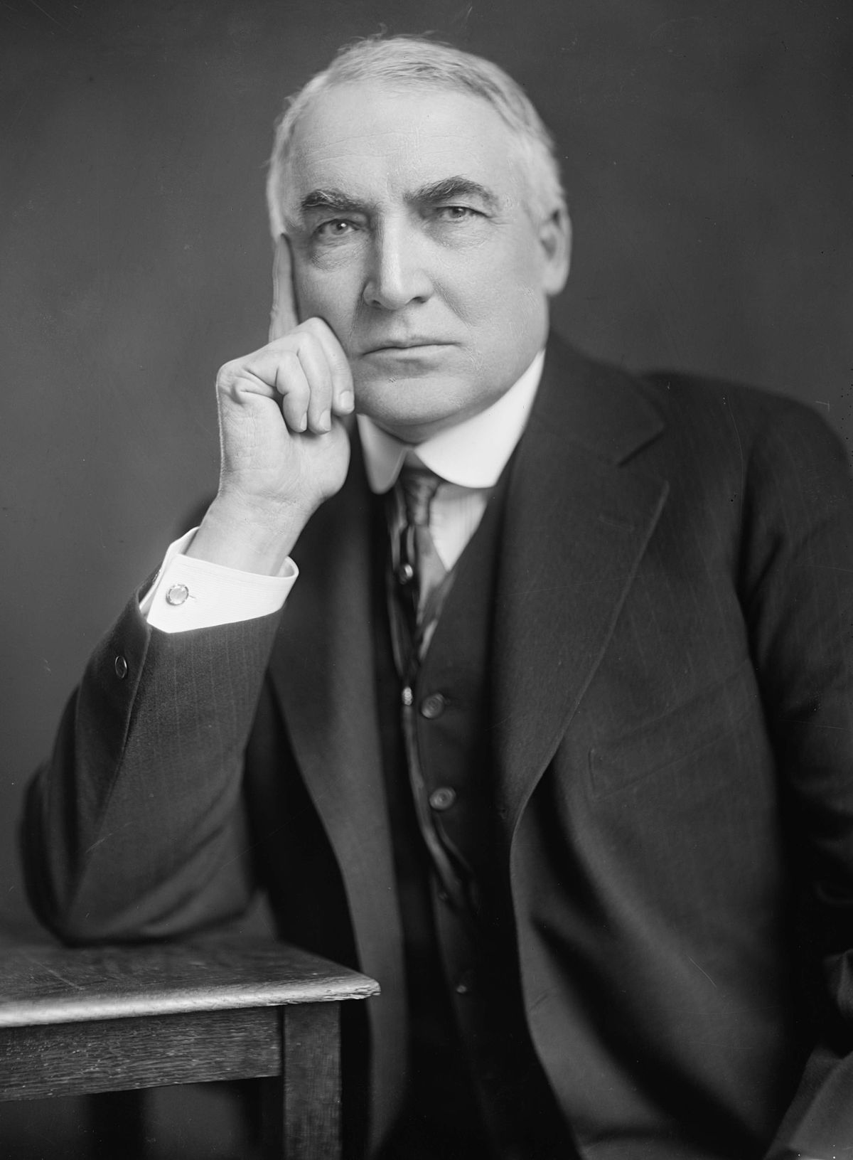
As a result of the passage of the 19th Amendment in August, 1920, the presidential election held in November of that year was the first that allowed American women the right to vote. Surprisingly, the fair sex came out in large numbers to vote for Republican Warren Gamaliel Harding and his running mate Calvin Coolidge who defeated Democrat, James M. Cox and his Vice presidential running mate, Franklin Delano Roosevelt by the largest landslide in American history up to that time.
Warren G. Harding
Despite President Woodrow Wilson’s post WWI popularity, the Americans were tired of the political infighting between the Democratic President--who had suffered a debilitating stroke in Oct. 1919--and the Republican majority in Congress regarding whether the nation should join the League of Nations and were more interested in enjoying life’s new pleasures which included the motor car, faster public transportation in the bigger cities, going to the silent movies and making whoopee at the speakeasies where illegal whiskey was sold.
(Continued on page 2, column 1)
Collecting the US Coins of 1920, 100 Years Ago
(Continued from page 1, column 2)

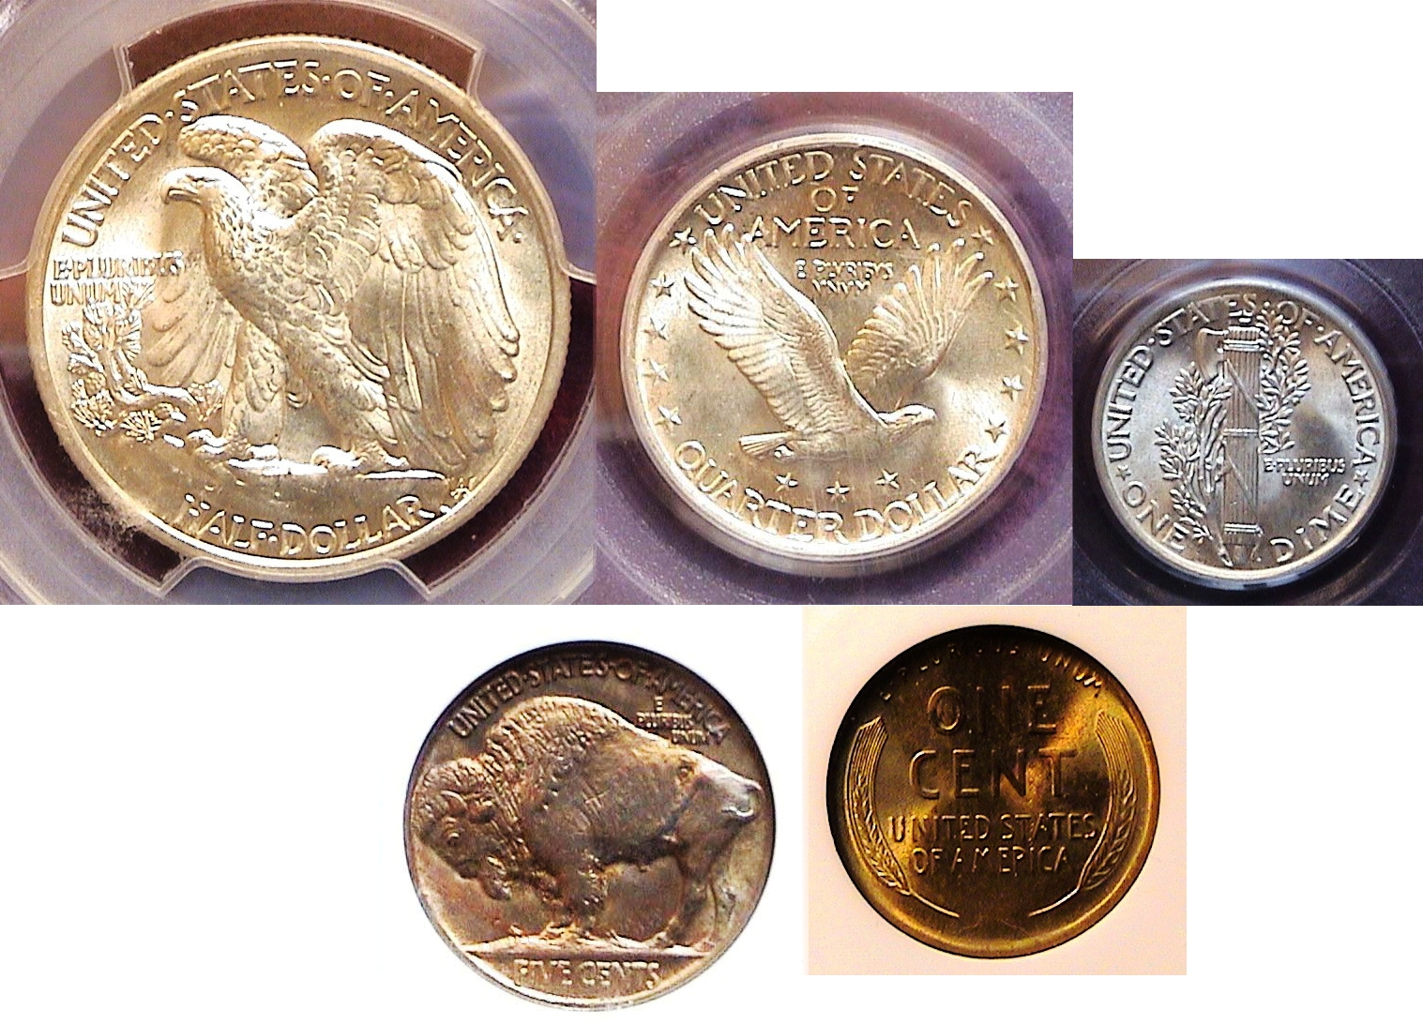
The reverses of a certified BU 1820 Year Set (sans gold)
[Enlarge page to fill monitor screen to view details.]

The one thing that nobody could complain about was the magnificent coinage that the United States was striking in 1920, thanks to the efforts of our 26th President, Theodore Roosevelt, (1859-1919) as all of our 19th century type denominations had been replaced with a fresh more noveau artistic style beginning in 1907 with the release of Saint-Gaudens’ magnificent Liberty Striding $20.00 gold double eagle, (to be discussed later in this article.) With the exception of the 1920 gold issue, the collector of modest means should have no difficulty acquiring an specimen graded XF-45 to as high as MS-65 (in some cases) if one chooses examples struck solely at the Philadelphia Mint.
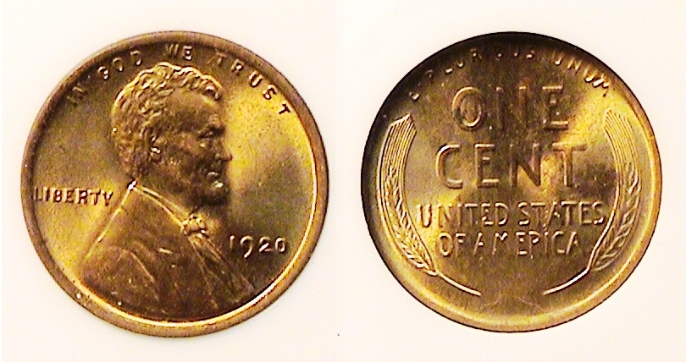
A 1920 Lincoln Wheat-back cent graded MS-63 Red by NGC
[Enlarge page to fill monitor screen to view details.]

In 1920, the Philadelphia Mint struck 310,165,000 Lincoln wheat-back cents, the second highest cent mintage up to that time compared with 49,280,000 at the Denver Mint--which began opened its doors in 1906--and 46,220.000 at the San Francisco facility. The 2020 Red Book lists the numismatic retail value for a 1920-P Lincoln cent graded MS-63 Red- Brown at just $28.00 compared with $110.00 for the 1920-D and $185.00 for the scarce 1920-S. In David W. Lange’s The Complete Guide to Lincoln Cents, (1996), he claims that while fully red examples of the date are plentiful, they show gradual deterioration on the obverse hub and as a result. lack the sharpness of the earlier issues struck from 1909 thru 1915. The example shown above looks far better than an MS-63, even when magnified to 500%, so it’s lower than expected certified grade could be due to author Lange’s commentary regarding the deteriorating of the hub. It was acquired “raw” as an MS-65 away back in 1983 for $25.00. Today, a certified MS-63 RB is listed at $35 on PCGS’ COINFACT.

In 1920, the cent had the purchasing power of 13¢.

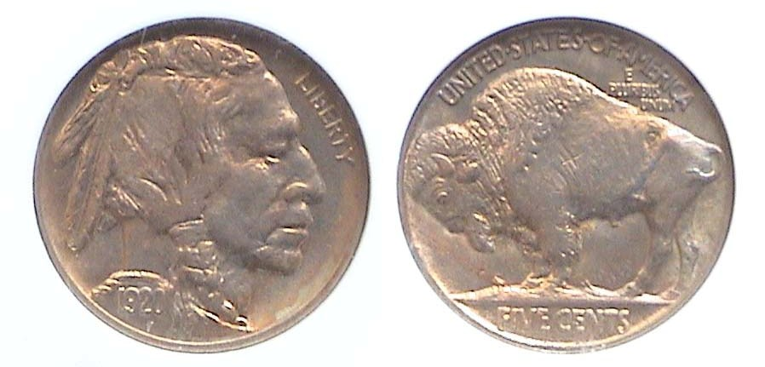
A 1920 Indian Head/ Buffalo nickel graded MS-64 by NGC
[Enlarge page to fill monitor screen to view details.]

The five-cent Indian Head/ Buffalo nickel coin was struck at all three mints in 1920 but compared with a mintage of just 9,418,000 for the 1920-D and only 9,689,000 for the 1920-S., only the 1920-P--with a mintage of 63,093,000, the fourth highest of the series --is affordable in mint-state all the way up through MS-64. Since both the branch mint issues are scarce to rare across the grading spectrum they can be pricey even in the lower grades although affordable thru VF-20 if one is putting together a complete set of Buffalo nickel set averaging that grade.

The particular example shown is slightly darker in toning and appears weekly struck. In his “The Complete Guide to Buffalo Nickels, (1992), also by David Lange, the author observes that the date along with the 1919 issue exhibits a softer strike compared with the surrounding dates due to the large mintages at the Philadelphia Mint in both years. Of all our coinage, sculptor James Earle Fraser’s Indian Head/ Buffalo nickel design is considered the most American of US coins. While it is not very likely that a collector of modest means can collect a complete set of all Buffalo nickels in uncirculated condition, it is possible to put together a complete date set grading as high as MS-64 that includes all Philadelphia Mint issues that were struck plus the 1931-S and the 1938-D.
In 1920, a nickel had the purchasing power of 63¢.

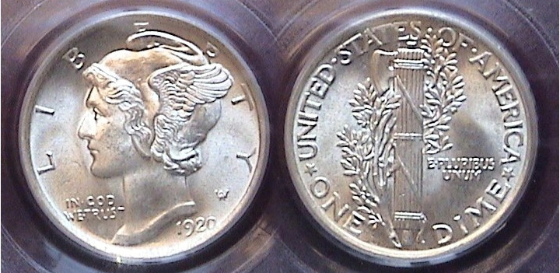

A 1920 Mercury dime graded MS-64 virtually Full bands by PCGS
[Enlarge page to fill monitor screen to view details.]

The Winged Liberty dime (AKA Mercury dime ) was struck from 1916 thru 1945 with the 1916-D, 1921-P and D and 1942/1-P & D being the key dates. The remaining P-Mint dates of the series are common with the branch mint issues struck in Denver and San Francisco scarce to rare prior to 1929.

In 1920, 59,030,000 Mercury dimes were struck at the Philadelphia Mint.. Only 19,171,000 were produced in Denver and a paltry 13,820,000 in San Francisco,. Today, the 1920-D & S are scarce to rare and very expensive in even the higher circulated grades thru Mint state.. According to numismatic scholar David W. Lange, in his third publication, “The Complete Guide to Mercury dimes”, (1996), the 0 in the 1920 date is very weakly struck, “a consequence of being placed too close to the border for proper medal flow.” When enlarged, the 1920 dime pictured above shows this and appears to have full bands in the reverse as well but the PCGS graders didn’t think so. In 1920, a dime had the purchasing power of $1.25.
____________________________________________________________________________________________________________________________
(Continued on page 3, column 1)
Collecting the US Coins of 1920, 100 Years Ago
(Continued from the previous page)

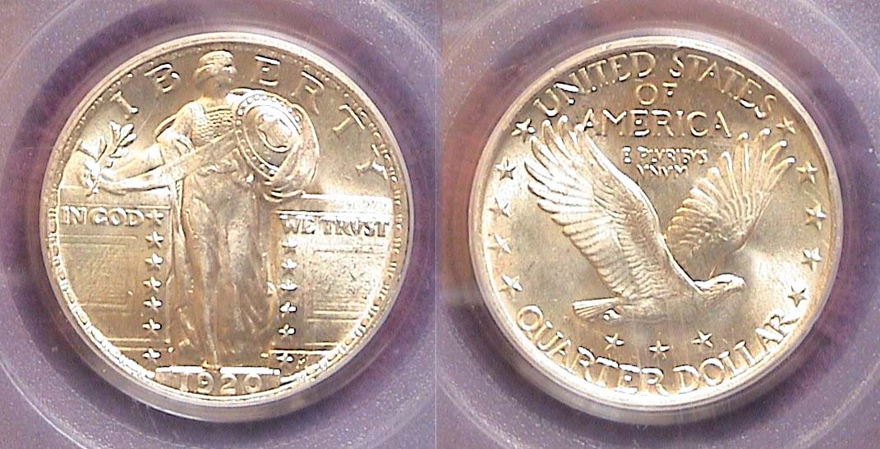

A 19209 Standing Liberty Quarter graded MS-64 by PCGS
Enlarge page to fill monitor screen to view details.]

In 1920, the Philadelphia Mint again led the way with a fairly large mintage of 27,860,000 compared with just 3,586,500 at the Denver Mint and only 6,380, 000 at the San Francisco Mint. The coin was struck from 1916 thru 1930 and engraved by Hermon McNeal one of the number of disciples of Augustus Saint-Gaudens who were chosen to engrave the early 20th designs on much of our coinage. McNeil’s quarter was issued in three sub-types,. the 1916 & ’17 type 1 which displayed a different hair coif and bare breasted Liberty figure compared with the 1917 Type two, struck thru 1924 showing a slight page-boy style hair-doo with a more covered Liberty and finally a third sub-type struck from 1925 thru 1930 that featured the recessed date thereby preventing the date from wearing out so quickly after being placed into circulation.
The beautiful example shown above was acquired at the Augusta Coin Club show held back on May, 2009. One has to magnify the page to 500% to discover why the piece was not graded MS-65 as it shows very light scraping across Miss Liberty’s leg and a tiny bit of spotting on the right wall. The MS-64 is a best buy and at $350, an 1920-P is a lot less costly than the $!,600 for the 1920-D and the $1,200 being charged for the 1920-S according to PCGS’s COINFACT.
In 1920, a quarter had the purchasing power of $3.13.

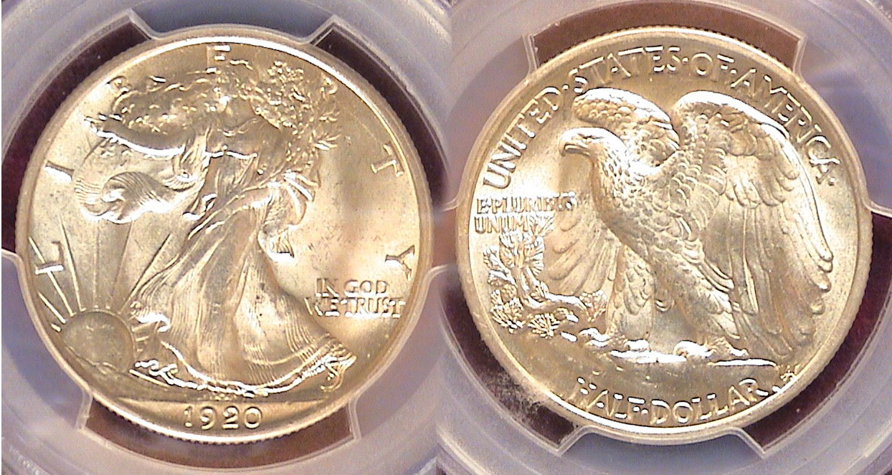

A 1920-P Walking Liberty Half-dollar graded MS-64+ by PCGS
.
With a mintage of 6,372,0000, the 1920-P Walking Liberty half dollar is considered one of the easier dates to acquire from the earlier portion of the Walking Liberty series. This magnificent coin type was designed by Adolph Weinman and was struck from 1916 thru 1947.. With the exception of the 1920-P, also the 1916-P and D, the 1917-P and the 1918-S, most of the early branch mint dates are scarce to rare especially in mint state since the half-dollar circulated heavily thru 1933. The 1920-P half is the last lower priced mint state date until 1934. The MS-64+ example shown is extremely well struck, quite lustrous and spot-free when magnified to 200%. At 500%, a few tiny spots show on the lower right side of Miss Liberty’s gown. In 1920, a half-dollar had the purchasing power of $6.27.
What About the gold Issues in 1920?

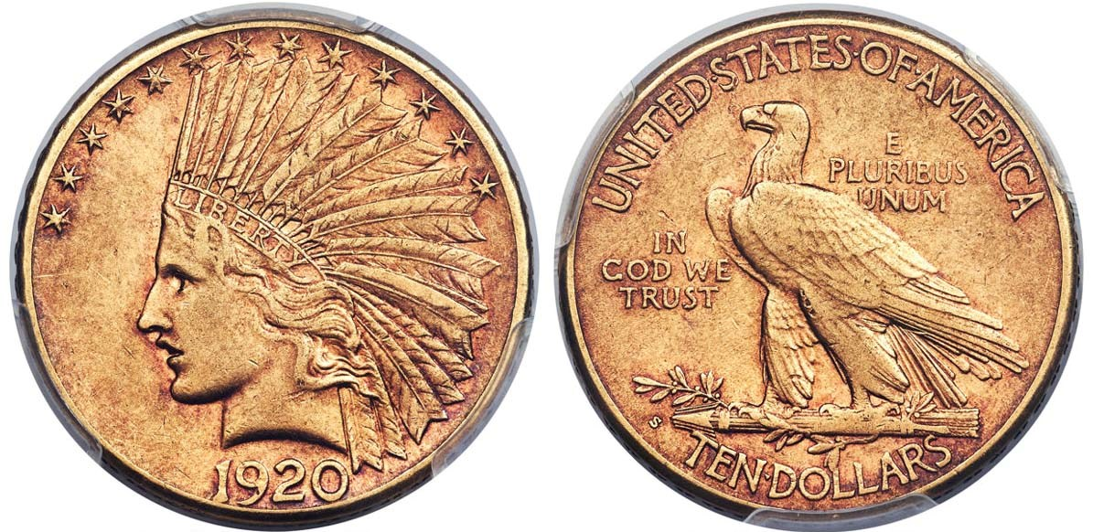

An 1820-S %10 Gold Eagle graded XF-45 by PCGS
Enlarge page to fill monitor screen to view details.]

After the United States entered the Great War still raging throughout Europe in 1917, no gold coinage was struck at any of the US mints the following two years. In 1920, the San Francisco mint coined 126,000 $10.00 gold eagles and 558,000 double eagles compared with just 228,250 Saint-Gaudens $20.00 gold pieces struck at the Philadelphia Mint. From the collector’s point if view these mintages meant nothing since most were either melted or sent to European banks after the US went off the gold standard in 1933. As a result, the 1920-S $10.00 eagle is very rare and is pricey in all grades. The coin shown above graded XF-45 by PCGS was the lowest certified example among all known specimens of the date yet still sold for over $25,000. Despite the larger mintage figures posted by the San Francisco Mint, virtually all of the 1920-S gold coins are scarce to extremely rare today compared with the lower mintage 1920-P double eagle shown directly below.

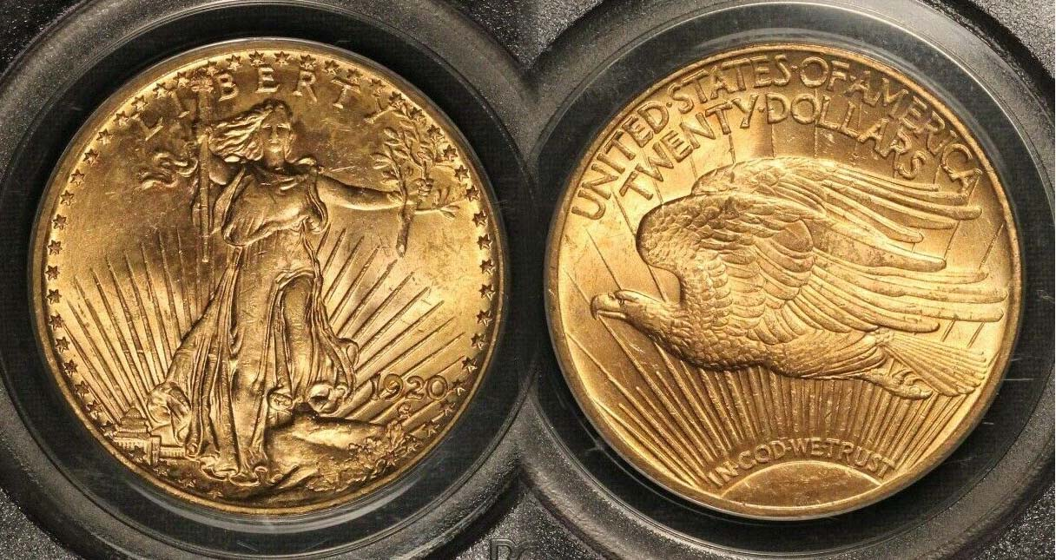T

A 1920-P Saint-Gaudens $20 Double Eagle graded MS-61

With a few exceptions, the majority of the Saint-Gaudens double eagles, especially those struck at the Philadelphia Mint, are considered common dates grading as high as MS-64. One of the few exceptions is the 1920-P. Despite its reported mintage of 220,250 pieces a specimen certified MS-64 sells for around $2,000 more than a common date issue in the same grade. When it comes to quality, the 1920-P Saints are not as lustrous or as well struck as the common dates of the series but are still available at a more reasonable price if certified MS-61 and 62. The coin above was graded only MS-61 but was housed in an older PCGS green labeled holder when grading was more stringent than it is today. It is a remarkable example of the date considering its low circulated grade. Up to now the author did not consider adding any gold coins to his 1920 year set especially with the 1920-S $10.00 eagle priced far above his discretionary income but based on recent research, it is entirely possible to save up for an attractive example of the 1920-P double eagle if one can locate an example similar to the coin shown above.
___________________________________________________________________________________________________________________
Coin of the Month

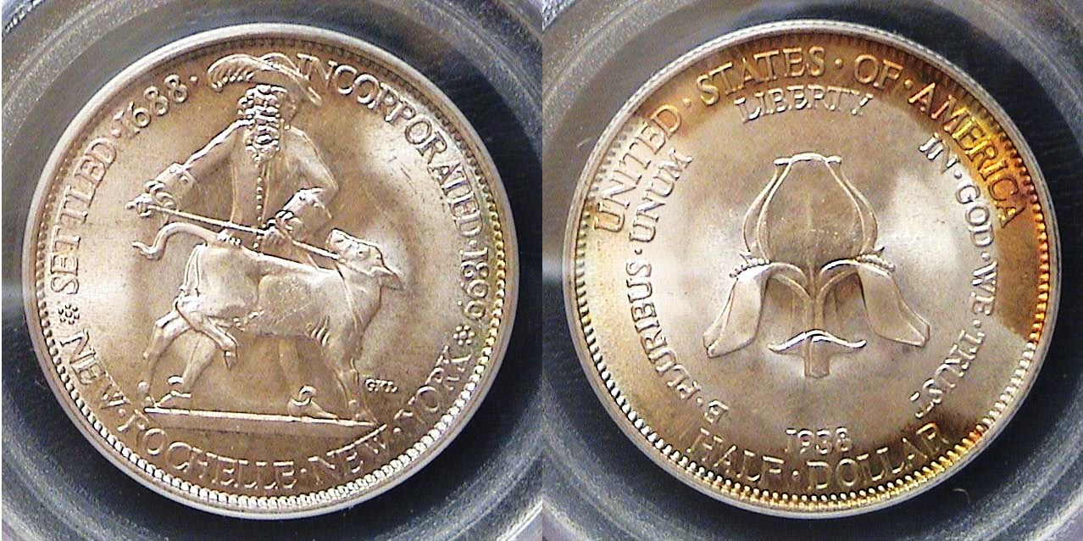

A 1938 New Rochelle 5ommebmorative Half-dollar
Certified MS-66 by PCGS
Enlarge page to fill monitor screen to view details.]

The city of New Rochelle, New York, in Westchester County, was founded by Huguenots in 1688 who hailed from La Rochelle in France.
The following year, Jacob Leisler, their agent, purchased from John Pell a tract of some 6,000 acres (2,400 ha) on which the city now stands. One of the conditions was that Leisler would give to Pell and his heirs "one fatte calfe" on June 24 of every year thereafter, if demanded.
Thomas Paine later owned land in New Rochelle, which was incorporated as a village in 1858 and as a city in 1899. It is a suburb of New York City.^{[4]}
The New Rochelle Commemorative half-dollar was struck to celebrate the 250th anniversary of the founding of the City of New Rochelle located in Westchester County of New York State. (Courtesy of Wikipedia)

The New Rochelle commemorative was dated 1938 but actually coined in 1937 and the last commemorative coin to be issued by the mint until the Booker T. Washington commemorative of 1946. The reported mintage was of the New Rochelle commemorative half-dollar was 15,266, one of the lower mintages of the commemorative series from 1892-1954..

Unhappy with the appearance of the originally proposed design, the commission in charge of the project decided to change the engraver to Gertrude K Lathrop, a renowned NY state sculptor based on her work on the Albany, NY commemorative that was struck two years earlier in 1936.

The obverse features Both John Pell and the fatte calf appear on the obverse and a large fleur-de-lis on the reverse. The legend bares the wording “Settled in 1688, Incorporated in 1899 dated 1938 with a the legend UNITED STATES OF AMERICA and both mottoes, E PLURIBUS UNUM and IN GOD WE TRUST with LIBERTY centered with the denomination HALF DOLLAR at the very bottom accompanied directly above by the date, 1838.

While the author has never been an avid collector of US commemoratives, both of the older set (1892-1954) or the newer ones (1982 to the present), the circumstances beyond his acquisition of the coin were primarily due to an excellent PowerPoint entitled “Brookgreen Gardens – SC Sculpture Trove with Numismatic Ties” presented before our club by club member and club secretary, James Mullaney at our October, 2018 meeting. I quote from the minutes.:

"This program provided a brief history of the gardens that were created around 1930 from the land of four adjacent rice plantations just down the coast from Myrtle Beach. Anna Hyatt Huntington and her husband originally planned to create the gardens to exhibit sculptures that Anna created, but quickly broadened the purpose to include works by sculptors from across the country. Jim displayed photos of works at Brookgreen Gardens from 17 artists including some who had a role in creating coins minted by the U.S. The artists ranged from those as well-known as Augustus Saint-Gaudens, Adolph Weinman, and James Earl Fraser and his wife, Laura Fraser to artists less familiar to numismatists such as Constance Ortmayer, Brenda Putnam and New York sculptress, Gertrude K. Lathrop who designed commemorative half dollars for 1936 Cincinnati and Cleveland/ Great Lakes and also the 1938 New Rochelle, respectively. “
A few days after the meeting the author was in Clein’s Rare Coins and spotted the example you see above on the top shelf of the counter.. This is why both the Show & Tells and programs are so important at local coin club meetings.
___________________________________________

Kindly Patronize our Advertisers

