The Stephen James
CSRA Coin Club of Aiken
P.O. Box 11
New Ellenton, SC 29809
Web site: www.sjcsracc.org
The SJ CSRA CC of Aiken, SC meets on the 1st Thursday of the month at the Aiken Public Library

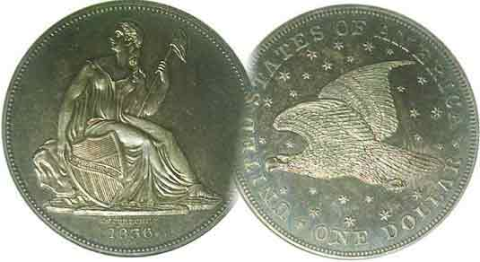
Pres. J.J. Engel
V .P. Pat James
Sec. Jim Mullaney
Treas. Chuck Goergen
Sgt. in Arms: Jim Sproull

Programs: Pat James
ANA Rep.: Glenn Sanders
Show Chair: Board members
Photos: Steve Kuhl
Publicity: Pat James
Newsletter: Arno Safran
E-Mail: arnosafran@comcast.net
Auctioneer: Jim Sproull
Web site: Susie Nulty (see above.)

Due to the Coronavirus, our upcoming Zoom Meeting will be held Thursday, January 7 at 6:45 PM
Meanwhile, wishing you all a Happy New Year!

2021 Club “Zoom” Meeting Schedule
Volume 20, No. 1 the Stephen James CSRA Coin Club, Founded in 2001 January, 2021
Monthly Newsletter
US Coins of 1801 not easy to acquire due to low mintages
Jan. 7 Apr. 1 July 1 Oct. 7
Feb. 4 May 6 Aug. 5 Nov. 4
Mar. 4 June 3 Sept. 2 Dec. 2

The early 1850s Coin Shortages and the $3 cent silver Trime

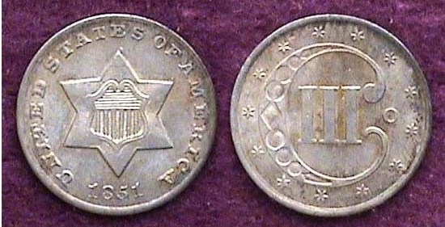

An 1851-O 3 cent silver denomination graded MS-62 by NGC
[Enlarge page to 200% to view details!]

After the discovery of gold at Sutters Mill near the American River in northern California in 1848, Americans of all walks of life living in the east and portions of the Midwest decided to get in on the action with whole families traveling “Westward ho!” to California via horses and covered wagons in 1849. Some of these “49ners”--as they were called--struck it rich but most did not. However, the “find” increased the nation’s westward expansion to the Pacific while the discovery of the precious metal affected the value of silver coinage which increased in relationship to gold. As a result 085 silver coinage began to be taken out of circulation since its their content was worth more than the value appearing on the coin. Many of the coin. both old and especially the new ones began to disappear as soon as they left the mint, being sold or melted for profit. In order to deal with the crisis, Congress authorized a three-cent coin with only 75% silver bonded to 25% copper and in 1851, 5,447,400 new three-cent silver pieces were struck at the Philadelphia Mint with 720,000 coined at the New Orleans Mint, ironically, the only year that coin was struck at a branch mint during its 23 year run which ended in 1873. It was the first coin designed by our fourth Chief Engraver James B. Longacre. The Treasury Department, nicknamed the tiny coin, “trime” which became the accepted term for the denomination.

The obverse of the trime features a large six-pointed star surrounded by the legend, UNITED STATES OF AMERICA with the date centered below. The reverse displays a large ornate C with a Roman numeral III at its center surrounded by 13 stars. The 1851-O mintmark appears at the middle-right on the reverse. The coin was mostly used for the purchase of 3¢ first class postage stamps and it circulated. An MS-62 specimen of 1851-O trime cost the author $170 back in 1995 but today it is valued at $900 according to PCGS’ COINFACT whereas the 1851-P is far less expensive at $2.60 in the same grade.
__________________________________________________________________________________________________________________

Collecting the US Coins of 1801 (220 Years Ago)
A supreme Challenge for the Collector
By Arno Safran

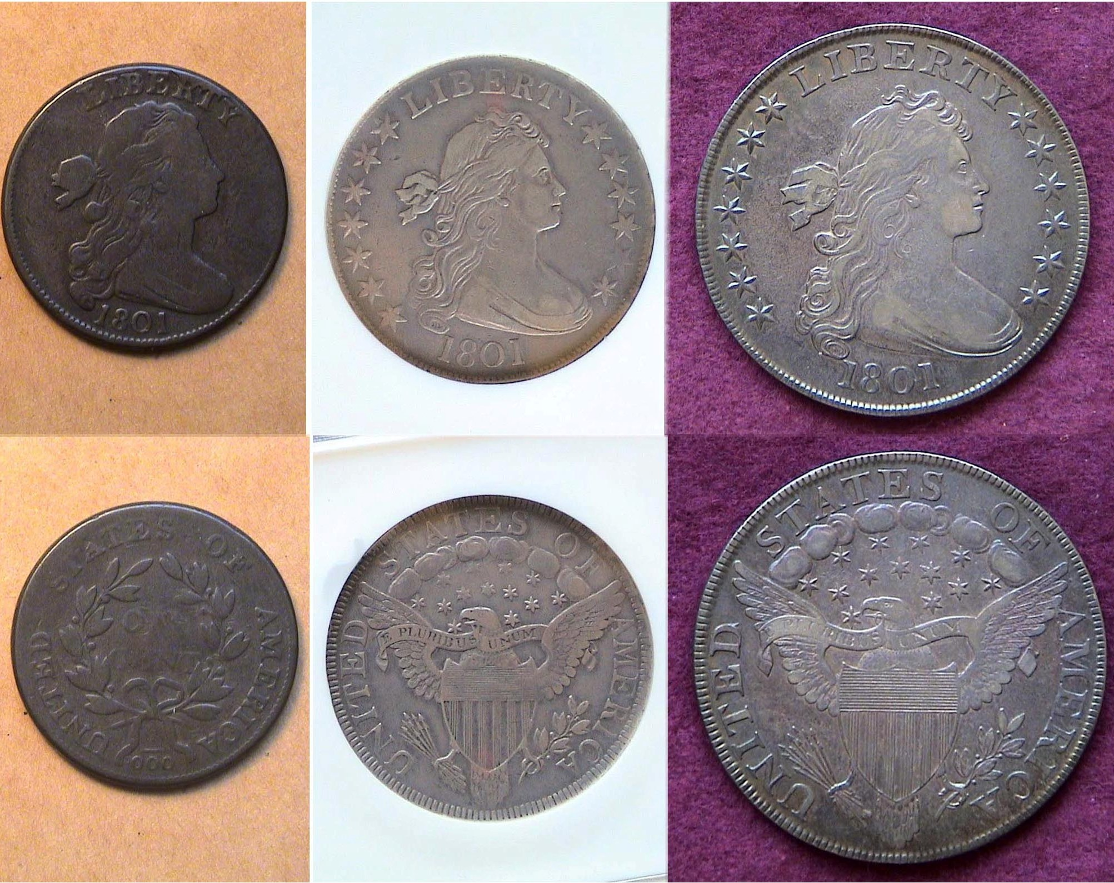

The three most collectable US coins of 1801;
The 1801 large cent, half-dollar and silver dollar
[Enlarge page to fill monitor screen (or 150%) to view details!]

The further one goes back in time regarding the collecting of US coinage, the more challenging it is for a collector of modest means to acquire them. The three denominations dated 1801 shown above were obtained by the author between 27 to 17 years ago and none of them exceed the certified grade of XF-40. Of the ten denominations authorized in our first Coinage Act of 1792, only six denominations were struck that year; the large cent, half-disme, disme, half-dollar, dollar and $10.00 gold eagle.. No half-cents, quarter dollars, $2.50 quarter eagles or $5.,00 half eagles were coined with 1801 date. Nevertheless, despite the lapses and rarity of all the coins shown above, the specimens appear attractive enough to display, if not equally balanced in grade.
(Continued on page 2, column 1)
Collecting the US Coins of 1801, (220 Years Ago)
Continued from page 1, column 2)

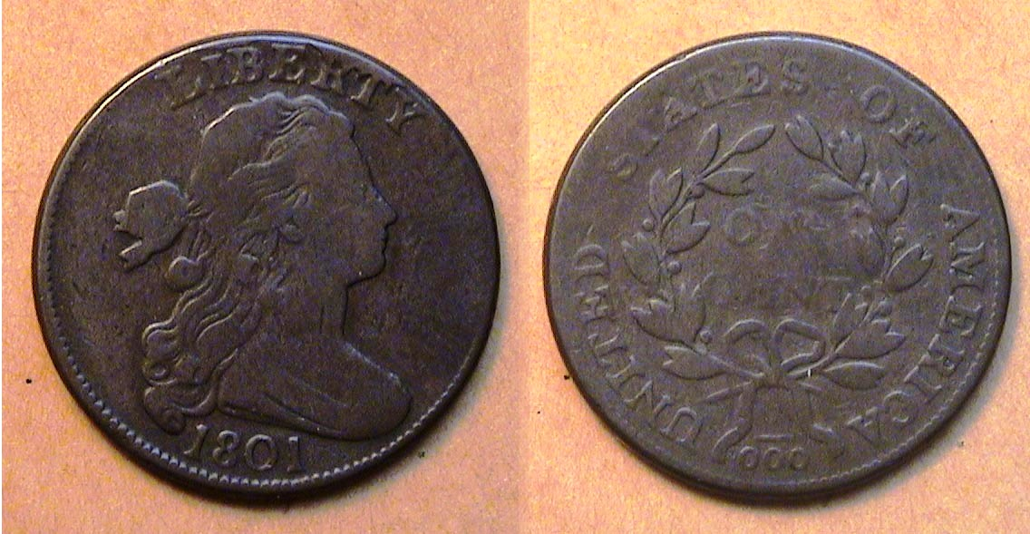

An 1801 Draped Bust large cent, S-223, R1 graded Fine-12
[Enlarge page to fill monitor screen (or 150%) to view details!]

As no half-cents were struck in 1801, the next highest denomination of interest is the large cent. The reported mintage for cents struck at the Philadelphia Mint in that year was 1,362,837, almost 146 million less than the number reportedly struck in 1800 yet it is lower priced than the 1800 issue, which had a record mintage of more than 2,800,000. However, if one looks closer to the denominator on the reverse of the 1801 example shown, they will see the fraction appearing as 1/000 instead of 1/100 and that little error is worth $675 instead of $575 or $100 more than the value of the normal fraction specimen, not shown. The cent was the workhorse of the economy in the early years of the 19th century and in 1801, it had the purchasing power of 21¢. The author acquired his example of the 1801 large cent away back in 1999 at the Garden State Numismatic Association Convention. It cost $160 at that time. Upon enlarging the coin’s image, the obverse appears slightly more attractive than the reverse because it is better struck with nicer brown color.

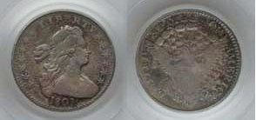

An 1801 Draped Bust half0-disme LM-2, R4 graded Fine-15 by PCGS The Coin realized $1,997.50 at the FUN. Show
held in Tampa, FL. in Jan. 2016 Courtesy of PCGS’ COINFACT
[Enlarge page to fill monitor screen (or 150%) to view details!]

The reported mintage for the 1801 Draped Bust half disme was just 27,760 pieces and it circulated with the result that even low graded survivors are quite expensive today. Originally, it was thought by earlier catalogers, that there were two obverse die varieties for the date but later research performed by more recent collectors of the series claim that there is only one with two major die states; with one of the die states showing a lump that covers part of the first two numbers in the date with the earlier die state showing full detail.
The tiny 1801 Draped Bust silver half-disme shown directly above is regrettably not part of the author’s collection but worth sharing with the reader because it is a fairly attractive example of the tiny coin considering it’s low grade; FINE-12. When substantially enlarged--(recommended)--the obverse of this specimen appears fairly well struck with attractive surfaces for a coin grading just Fine-12. It is the reverse that displays an uneven strike with portions of the shield blotted out. The 1801 Draped Bust half-disme is expensive in all grades as the winning bid of almost $2.000 confirms, which is why collectors who prefer higher grades may be reluctant to bid on one.
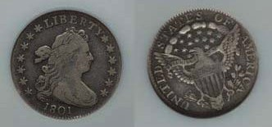

An 1801 Draped Bust/Heraldic Eagle disme graded VF-20 by NGC
The specimen sold for $3,220 in July, 2012
[Enlarge page to fill monitor screen (or 150%) to view details!]

In 1801, the Philadelphia Mint reported 34,640 Draped Bust/ Heraldic eagle dismes struck and while it is not as rare or as costly as the 1801 half-disme nor as expensive as the 1802, or the rare 1804 disme in the same grade, the 1801 disme it still listed at $3.200 on PCGS/ COINFACT and at even a higher figure of $3,750 according to the 2021 Red Book. The specimen shown above realized $3,200 back in July 2011 which occurred slightly over 8½ years ago and continues to be beyond the discretionary income of most coin collectors today which it is absent from the author’s year set.
Fortunately, through the world of cyber space the writer was able to find and display circulated examples of both the 1801 Draped Bust half-disme and disme. The spelling of the silver five and ten cent coins as dismes goes back to the various uses of the French “ten”. It was either pronounced “Deem” or simply “dime” with a silent S that may have enjoyed common usage during the 18th and early 19th centuries.

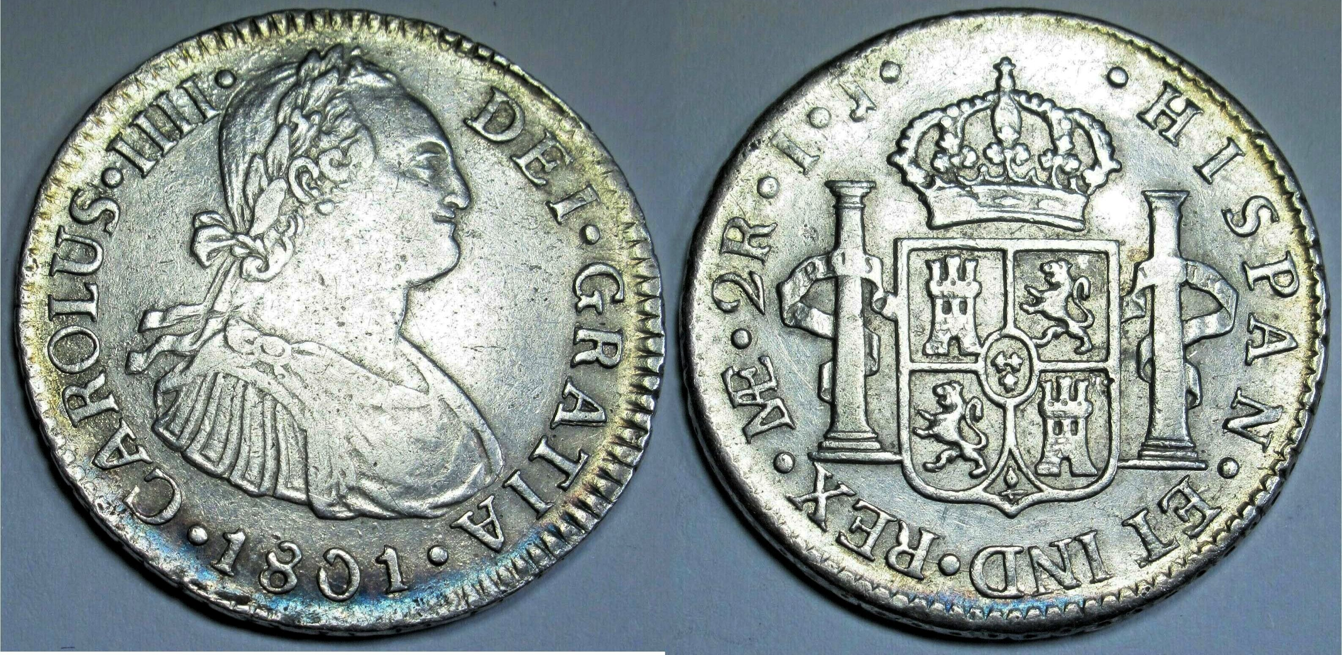

An 1801 quarter size 2 Reales struck at the Lima. Mint
[Enlarge page to fill monitor screen (or 150%) to view details!]

No quarters were struck with the Draped Bust design after 1796 until 1804, so collectors wishing to own an 1801 quarter-dollar that circulated in the USA might want to consider acquiring one of the Latin American 2 Reales silver coin which was similar in size to our Draped Bust quarter and circulated at the same value of 25¢ in the United States during that period. Instead of Liberty, it featured the Spanish King Charles IV engraved with IIII instead of IV. This particular specimen shown above is currently on sale for just $149.50 because the Latin American mintages were enormous at tat time.
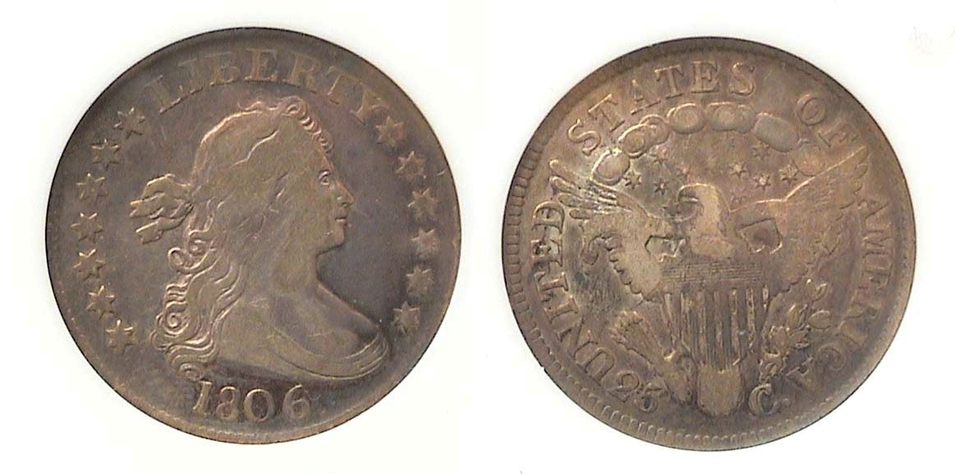
An 1806 quarter showing a similar design to the disme and half-dime certified Fine-12 by Anacs

The most common US quarters showing the Draped Bust design are the last three of the series, the 1805, 1806 and 1807. With a reported mintage of 206,124, the 1806 is the least expensive and the Fine-12 specimen the author chose from his collection looks comparable to the 1801 half-dime but is worth 55% less in price.
(Continued on page 3, column 1)
Collecting the US Coins of 1801, (220 Years Ago)
Continued from the preceding page))

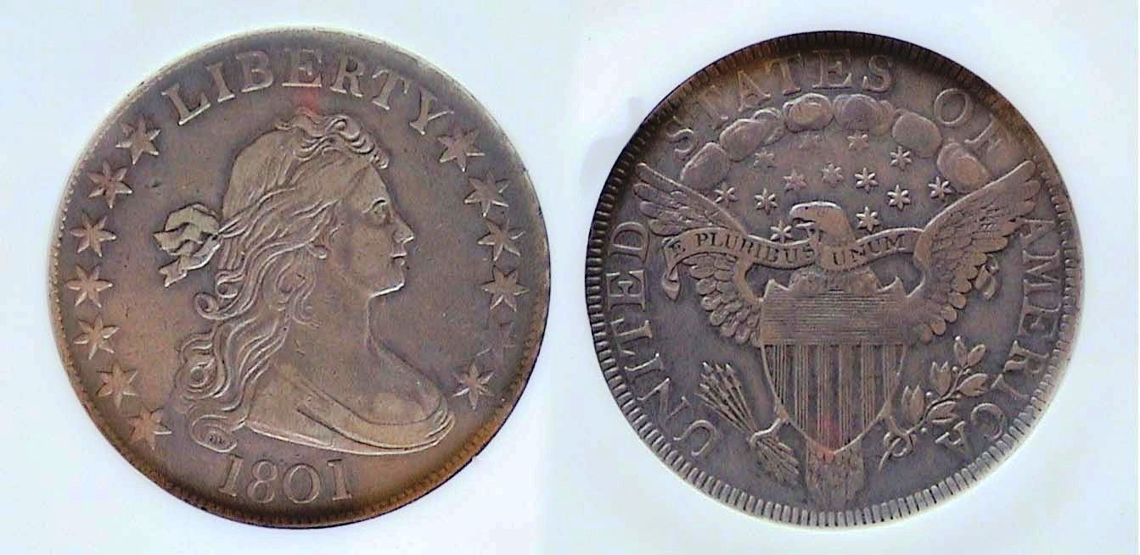

An 1801 Draped Bust/ Heraldic Eagle half-dollar O-102, R4
graded XF-40 by NGC
[Enlarge page to fill monitor screen (or 150%) to view details!]

During the early years of our nation’s coinage the only two denominations that received annual production were the large cent and the half-dollar although no half-dollars were coined in 1798 thru 1800. In 1801, after a three year hiatus, the Draped Bust half-dollar designed by our first Chief engraver, Robert Scot was resumed but with the majestic Heraldic eagle replacing the somewhat scrawny small eagle on the reverse. The reported mintage was just 30,289, actually 6,351 less than the disme because at that time, our half-dollars were still being coined in small numbers. It wouldn’t be until 1808, the second year of John Reich’s Capped Bust half dollar design when the fifty-cent piece would be struck in the in the millions of on a yearly basis.
The 1801 specimen shown above had only two die varieties, the example shown, being the second one but listed as a Rarity 4, meaning scarce. It was acquired at the ANA convention held in Pittsburgh, PA in the summer of 2004 and it was expensive but not as costly as the 1801 disme would have been in the same grade. The coin is softly struck but evenly so for an XF-40 grade with no distracting marks on the surfaces. From 1794 thru 1836, the diameter of the coin was 32.5 mm being reduced to 30 mm in latter part of 1836 when the first Reeded Edge Bust halves were coined.

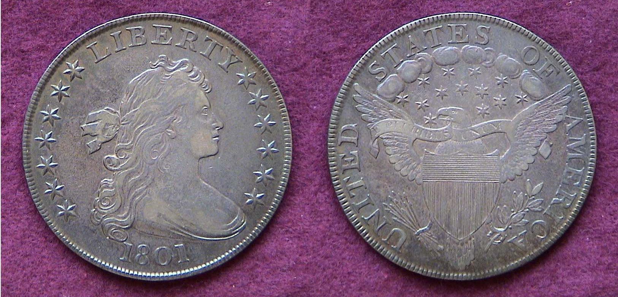

An 1801 Draped Bust/ Heraldic Eagle dollar, BD-214, XF-40
[Enlarge page to fill monitor screen (or 150%) to view details!]

Draped Bust dollars were struck from 1795 thru 1803; the first four years with a small eagle on the reverse and later in 1798 thru 1803, with the majestic Heraldic eagle. The reported mintage for the 1801 Draped Bust Heraldic Eagle silver dollar was only 54,454 which was the second lowest of the Heraldic eagle group. An XF-40 graded one is worth $4,000 today but the author acquired the coin back in January, 1994 when it cost just $800. It is a beautiful specimen and one of the author’s favorite.
NOTE: Draped Bust dollars were struck in 1804 but only with the 1803 date. Only eight known 1804 dollar specimens were said to be struck in 1834 with two known ones being sent as part of a complete 1834 US set as gifts to potentates of foreign countries that year. During the 1850s and ‘60s, a number of others were also produced called “restrikes” but none were actually struck for circulation Nevertheless, a collector desiring to acquire an original early US Draped Bust dollar can obtain one if they are willing to save up for it and the two easiest dates to find are the 1898 with Heraldic-eagle reverse and the 1799. Examples certified VF-30 or VF-35 are still affordable and attractive.

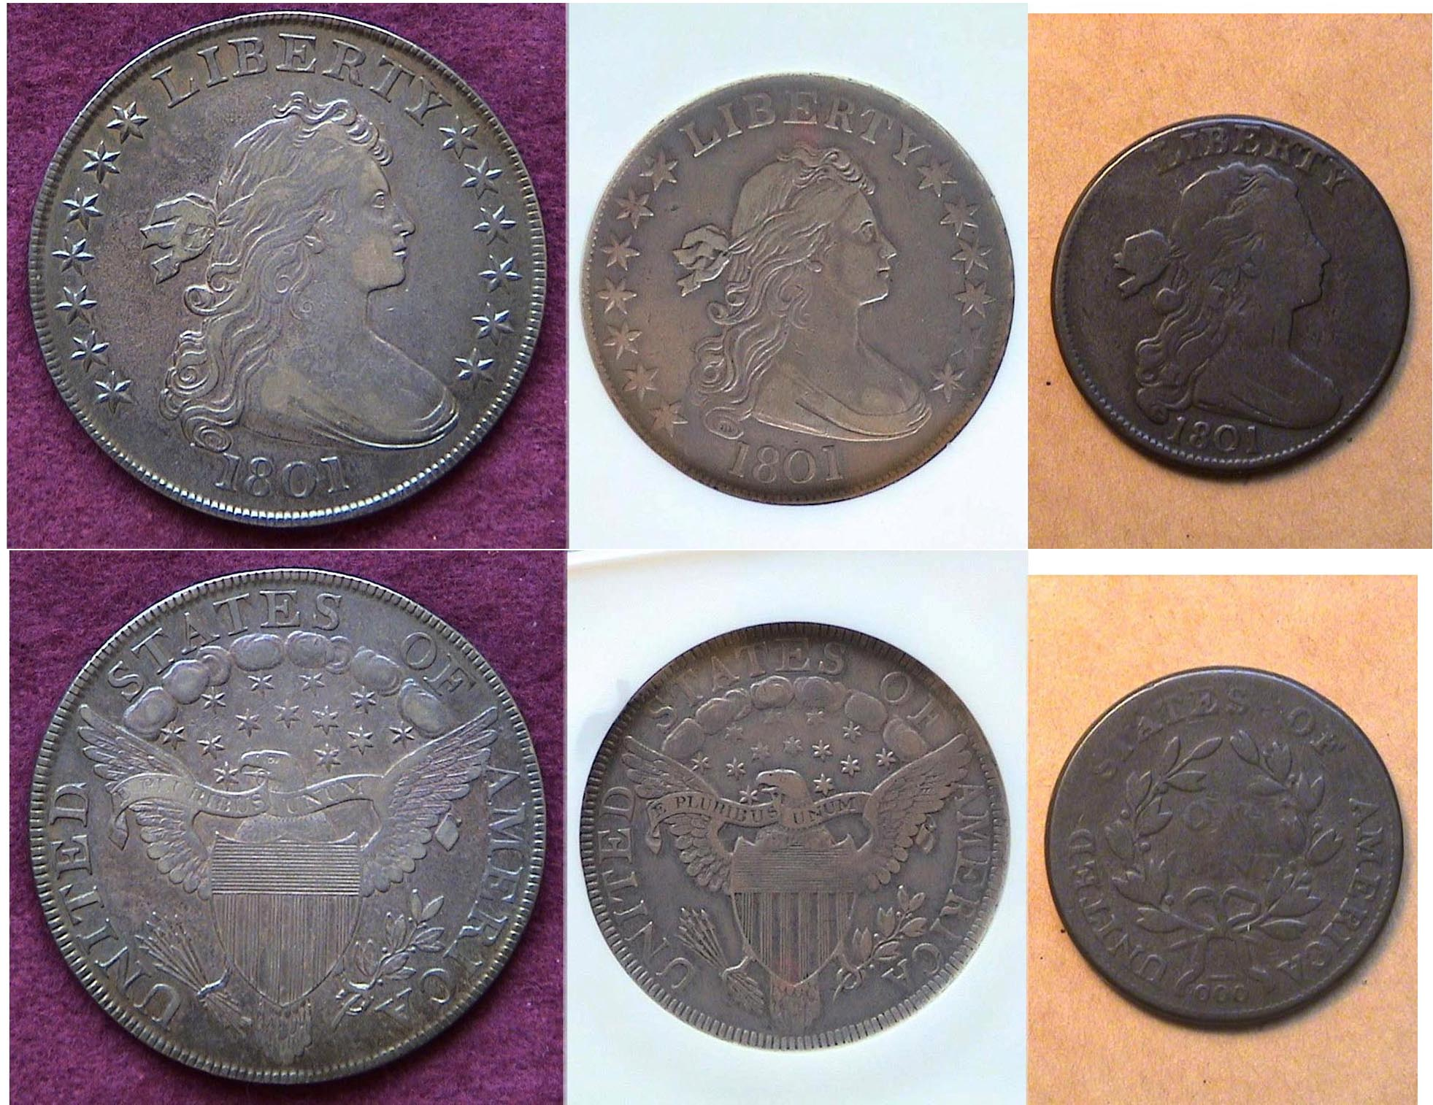

The three most collectable US coins of 1801;
The 1801 Draped Bust silver dollar, half-dollar and large cent
[Enlarge page to fill monitor screen (or 150%) to view details!]

When one thinks of all the responsibilities and challenges that had to be addressed by our founding fathers and their supporting wives during the early years of our nation, one of the remarkable accomplishments were the magnificence of our coinage designs. Our first Chief Engraver, Robert Scot set the standard for what was go come when he came up with the Draped Bust/ Heraldic Eagle design on our silver coins and Turban Head gold obverses that accompanied them.
The cost of living was much lower in price during the last decade of the 18th century and the first decade of the 19^{th,} which is why so many of the half-cents, cents, half-dimes, dimes and quarters are so rare today. Most of the mintages were low and they circulated!. The cent was the workhorse of the economy back then. Today, none of our coinage represents such a “title”
In 1801, the cent had the purchasing power of 21c, the dime, $2.10 and the dollar, ten times that at $20.70. Today when it comes to our paper money denominations, it is the $20.00 bill that is the most used when one drives up to the ATM and the it had the purchasing power of $415.00 back in 1801. Meanwhile, our six denominations from the cent to the brass dollar coin have no intrinsic metal value and can buy virtually nothing. Today we are the richest country in the world yet our coinage appears lackluster and unimaginative compared with the artistry of our engravers from the past going backwards in time to Adolf Weinman, a German immigrant and to Robert Scot, a Scotsman.
__________________________________________________________________________________________________________________
Stephen James CSRA CC
Minutes from the Dec. 2020 Zoom Meeting

Dr. David Cashin presented Part 2 of an excellent two-part power-point program on the coins of Northeast India, which included a history of the coins of Bengal.

In Part 1 of his program given during the October 1, 2020, coin club meeting, Dr. Cashin related that Northeast India is the easternmost region of India comprising eight states: Arunachal Pradesh, Assam, Manipur, Meghalaya, Mizoram, Nagaland, Sikkim and Tripura. The region shares an international border with the Tibet Autonomous Region, China in the north, Myanmar in the east, Bangladesh in the south-west, Nepal in the west, and Bhutan in the north-west. It comprises an area of almost 8 percent of India.

Dr. Cashin’s interest in coins of this region was sparked when he was a young missionary in Bangladesh. He would visit shops and buy silver coins destined to be melted down and made into jewelry, and he could purchase them for modest prices.

Almost all the coinage referenced in his presentations were comprised of about 93% to 95% silver along with approximately 3% gold and 2% copper, and were about the size of a US half dollar. Silver mines appeared from the 16th century in Northeast India. Usually the coins were round depicting a king or queen and commemorating a major event such as the date of the ruler’s coronation, successful battle or marriage. Much of the writing on the coins from Northeast India was in Sanskrit, but many of the coins had writing in Burmese, Arabic and Persian. The coinage reflected the changing Indian history.

In earlier periods Bengal was considered the “outback” region. Bengal had no source of silver or
copper, and most of its coinage was minted elsewhere and did not reflect the area’s history. The Pala Dynasty arose in Bengal in mid-8th century after period of anarchy. They established and promoted universities, built grand temples and monasteries, and their missionaries established Buddhism in Tibet. Their army was noted for its corps of war elephants and they also had an extensive navy.

The coinage used in this era was crude silver Drachms based on the Sasanian Drachm. Bengal was conquered by the Muslims early in the 13th century and had an independent Muslim country for about 250 years. Most of the early Northeast India area was comprised of Hindu tribes.

Dr. Cashin also showed coinage from Assam which was octagonal, produced in large quantities and was the only place with coinage with year to year dates. Dr. Cashin also showed a 95% silver coin from Jaintuipur with the readable date 1592 that was the size of a US half, and this coin was unusual in that there was no ruler’s name on it. He estimated it would have represented a week’s wages. Such a coin in nice condition sells on the current market for $1,000 or more.

Pat James, the Programs Chair, announced that member Garry Naples would present a program at the next coin club meeting in January, 2021.

Kelsey Forde won the members’ attendance door prize, a 2020 Silver Eagle, which Secretary Mullaney
will deliver to her.

President Engel reminded the members that the next “Zoom” meeting would be on January 7, 2021, and adjourned the meeting at 8:26 p.m.

Respectfully submitted,
Jim Mullaney, Recording Secretary
_____________________________________
.
When Mexico Went French

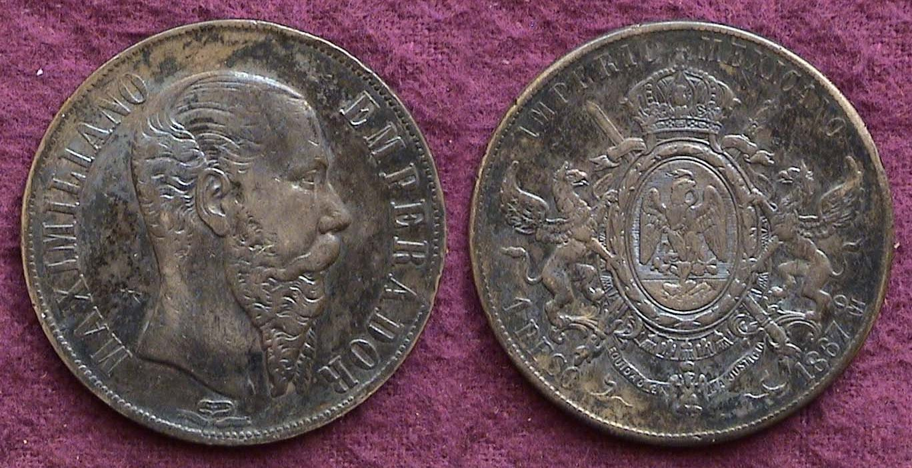

An 1867 Peso (8 Reales or $1.00) silver dollar

In 1861 Emperor Napoleon III of France sent troops to invade Mexico in December of that year in order to establish greater influence in the Latin American countries and in 1864 placed his Cousin, Archduke Ferdinand Maximillian of the Austrian Hapsburg Empire on the Mexican throne. In 1866 and 1867, the Eagle and Phrygian Cap Peso (8 Reales) was replaced by a new design type showing the portrait of Maximillian on the obverse and new coat of arms on the reverse. Circulated examples of the above sell for around $150 today but certified specimens grading AU- like the coin shown a or to MS-63 will be more expensive. After General William Tecumseh Shermanan assisted the Mexican army to rid themselves of the unpopular Emperor, Maximillian, he was ordered to be exiled and return to Europe but he steadfastly refused and was executed by the Mexican government.

The Educational Bank notes, Series of 1896
(First in a Series)

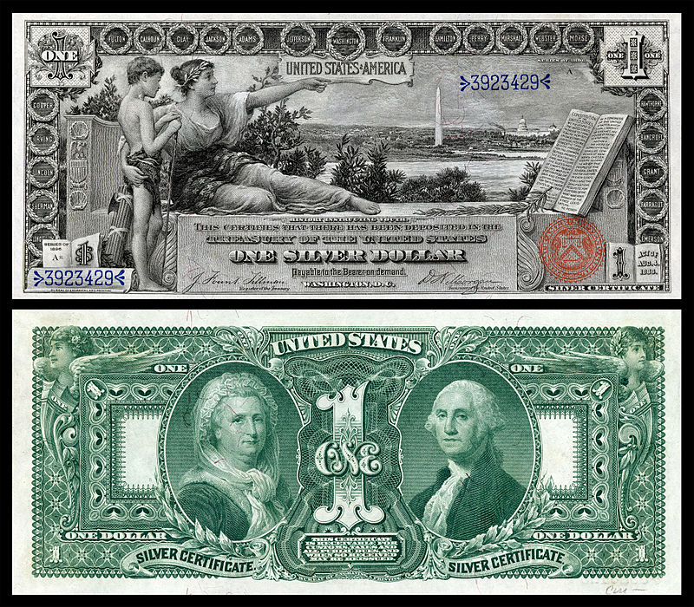

The $1.00 Educational Silver Certificate, Series of 1896
[Courtesy of Wikipedia) [Enlarge page to fill screen.]

US large size bank notes--first issued during the early years of the Civil War and lasting through the late 1920s--are another popular collectible with many numismatists. As with the vast number of certified obsolete US coins, many of these large size banknotes have found their way into certified holders submitted by dealers or collectors to PMG (Paper Money Guarantee) or PCGS, (Professional Coin Grading Service) as a means of guaranteeing their authenticity and grade.

In 1896, the Bureau of Engraving introduced a mew series of silver certificates called “The Educational Notes” that have become among the most popular with US paper money collectors. The silver certificate was first issued in 1878 as a banknote that could be redeemed in silver dollar coins, (e.g. Morgan dollars), the amount designated by the bank-note’s numerical value. The law remained effective thru 1967 and for one more year, in 1968 where such a note could be redeemed for silver bullion since no silver dollars had been coined since 1935, the last year of the Peace dollar. The Educational notes were issued in denominations of $1.00, $2.00 and $5.00.

The face of the $1.00 note was sub-titled, “History Instructing Youth” displaying a series of Washington DC landmarks in the background. The back of the $1.00 note shows portraits of Martha and George Washington. William Hickok Law designed the face of the note and Thomas F. Morris, the back. The vignette of Martha Washington was done by Charles Burt in 1878 and the vignette of George Washington was created by Alfred Seeley in 1867.

During the late 1980s thru 2000, the author collected large size US paper money and owned the three educational notes in circulated condition before selling his paper money collection. Today, even the $1.00 educational note is pricey but affordable in the lower certified circulated grades.
_________________________________________________________________________________________________________________
(Reprinted from the Augusta Coin Club Newsletter of May, 2019)

Kindly Patronize our advertisers

