Pres. Willie Simon
V .P. James Barry
Sec. Helen Barry
Treas. Pat James
Sgt. in Arms: J.J. Engel
Committees:
Auction: J.J. Engel
Programs: James Barry
Newsletter: Arno Safran
The Stephen James
CSRA Coin Club of Aiken
P.O. Box 1739
Aiken, SC 29802
Web site: www.sjcsracc.org
The Stephen James CSRA Coin Club Usually Meets on the 4th Thursday of the Month at the Aiken Public Library

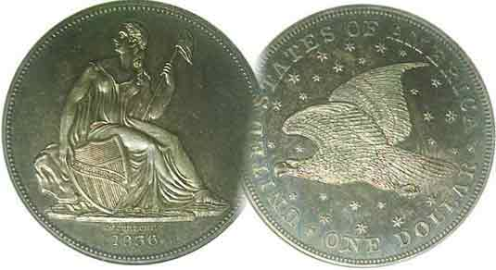

Volume 5, Number 2 the Stephen James CSRA Coin Club Monthly Newsletter February, 2006
February Meeting Moved to Early March
Newsletter Goes Digital
Due To Library Overbooking

Despite entreaties to the Aiken Public Library by our Vice President Jim Barry, the Executive staff there refuses to allow us a regular monthly meeting slot. When the Stephen James CSRA Coin Club was formed back in March, 2001, our Executive Committee was under the impression that we would hold meetings on the fourth Thursday of the month. This was done in consideration of the Augusta Coin club which holds their meetings on the third Thursday of the month. Starting in 2002, the Library launched a flexible policy allowing for other groups to share the evening spots. It appears that Tuesday and Thursdays are the most popular nights for such group meetings to occur with the result that the SJ CSRA CC has been bumped to other nights of the month with no guarantees. Each month, Jim has to go with hat in hand requesting a time spot for the fourth Thursday but is often told that only the fourth Tuesday or fifth Thursday (if there is one) is available. Up to now we have always been able to hold a meeting each month but not this year. With February being a short month, there is no fifth week and so, we have been bumped all the way into early March with the possibility we may actually hold two meetings; one on March 2, the other on the 30th.

Newsletter Goes Digital

After four years of working on a Windows 95 AmiPro Word Processor by Lotus—long defunct—your editor has decided it was time to join the 21st century and so he has. With this edition of the monthly newsletter--completed on a state of the art Windows XP using Microsoft Word--those with E-mail addresses will be able to receive the newsletter electronically. The newsletter will also be able to show color pictures of coins, bank notes, tokens and medals along with people and places.

The Upcoming Meeting’s Program

Our program director Jim Barry will be presenting a video at the March 2 meeting called “Making Ancient Coin Collecting Fun”. The video depicts famous personalities that appear on ancient coins and is designed for both the beginner and experienced collector. While most of us collect US coins, a number of members in recent months have expressed an interest in coins of antiquity. Some of our best US coin designs (like our letterhead for example) have taken their inspiration from Roman and Greek coinage.
____________________________________________________
(Club News continued on page 4, middle of column 1)
Our February Meeting is Thursday, Mar. 2, 2006 at the Aiken Public Library at 6:45 PM

America’s Large Cent
Part 2 of Two by Arno Safran
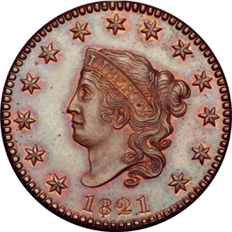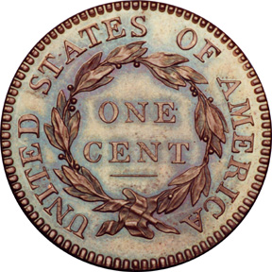

An 1821 Coronet Large Cent
One of the more desirable dates

In the first installment we covered the origin and design types of the large cent from 1793 to 1814. These are also referred to as the “Early Dates” and boast the widest collector base of those who collect Federal copper. No cents were dated 1815 due to the War of 1812 which lasted thru Christmas Eve, 1814 followed by the long time lag for the renewal of shipments of copper cent planchets from Boulton’s manufacturing plant in Soho-Birmingham, England. The cent was resumed in 1816 but with a new Coronet design.

The 2006 “Guide Book of United States Coins” (AKA the Red Book) edited by Kenneth Bressett has followed numismatic scholar Robert W. Julian’s lead by listing two possible engravers for the series. Originally, it was thought that the change in design type for the cent was the work of Robert Scot, our first Chief Engraver--since 1793--but Julian believes it was John Reich who came in as Assistant engraver in 1807 producing the beautiful Classic Heads who may have been the engraver for the arguably less attractive Coronet design. The new design’s obverse is often referred to as “Matron Head” while the reverse was virtually identical to Reich’s “Classic Head”. The Coronet as a design type lasted through 1839 with minor modifications starting in the 1830’s. Cents from 1816-1839 are referred to as the “Middle Dates” and are finding an increasing collector base as most years are more common and less expensive than the “early dates”.
_________________________________________________________________________________________________________________________________(continued on page 2, column 1)
America’s Large Cents (continued from previous page)

Reich called it quits in 1817 after working a full decade for $600 a year without receiving a pay increase. Julian believes his eye sight was failing which may have precipitated the decision. Scot continued working with the Coronet designs through 1823 when he retired. He was replaced by William Kneass who modified the lettering slightly along with the date sizes as Scot before him. After Kneass suffered a stroke in 1835 his assistant, Christian Gobrecht replaced him and began to tinker with the Coronet-head design itself, creating some interesting transitional (same date) sub types in the process. Thee included the cents struck in 1835, 1837 and especially 1839; the last year for the “Middle Dates” group.

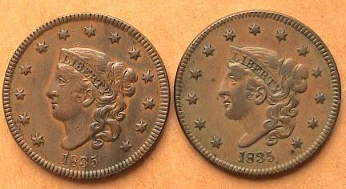

1835 Cents: N-5, Head of ’34 at left; N-7 Head of ’36 at right
Notice how Miss Liberty’s head and truncation of her neck
are smaller on the coin at right.

In 1837 Gobrecht created another pair of sub types, one known as the” Plain hair cord”, the other as the “Beaded hair cord.”

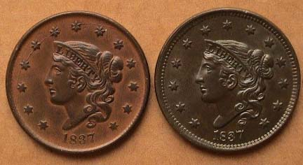

1837 cents, N-5 plain hair cord left. and N-11, beaded hair cord right
With a 3X magnifier one can observe these subtle differences better.

In 1839 Gobrecht produced no less than five different sub-type modifications; the 1839/6 (actually an inverted /9) which is quite rare, the Booby Head type and Silly Head; shown in the 2006 Red Book on page 105; also two normal types known as “Type of ’38 and “40. The 2006. Below are the Types of 1838 at left and 1840 at right AKA known as the Petite Head.

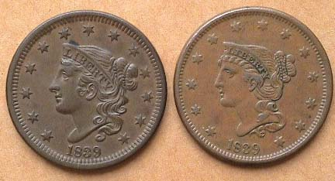

1839 Cents: N-2, Head of ’38 and N-4, Petite Head
The reader will see the letter N before a number in the examples pictured. Harold Newcomb was a collector and dealer of large cents back in the mid 20th century and for a long time, his book, “United States Copper Cents: 1816-1857” was the standard reference for attributing the many die varieties for both the middle and late dates of this long series. The N stands for the author and the number for the particular die variety Newcomb designated. Since then two more fine books have been published; “The Cent Book” by John D. Wright and a two volume work called simply, “US Large Cents” by William Noyes; the first for the Early Dates (1793-1814) and the second for the middle dates (1816-39).

The Late Dates

Most collectors of Large Cents classify the Late Dates as beginning with the Petite Head variety of 1840 thru 1857. To the novice, all the dates from 1816 to 1857 appear as one type. For many, the Late Dates are called the “Braided Hair” type because of the well defined hair styling Gobrecht perfected after the 1839 Booby and Silly head fiascos. Not quite satisfied with the more demure “Petite Head” version of the Coroneted Miss Liberty, Gobrecht modified the cent one more time in 1843. In addition to changing letter and date sizes, he repositioned Liberty in relation to the date. The “Petite Head” type dips downward towards the left facing the date at an angle. The “Mature Head” appears perfectly positioned above the date.

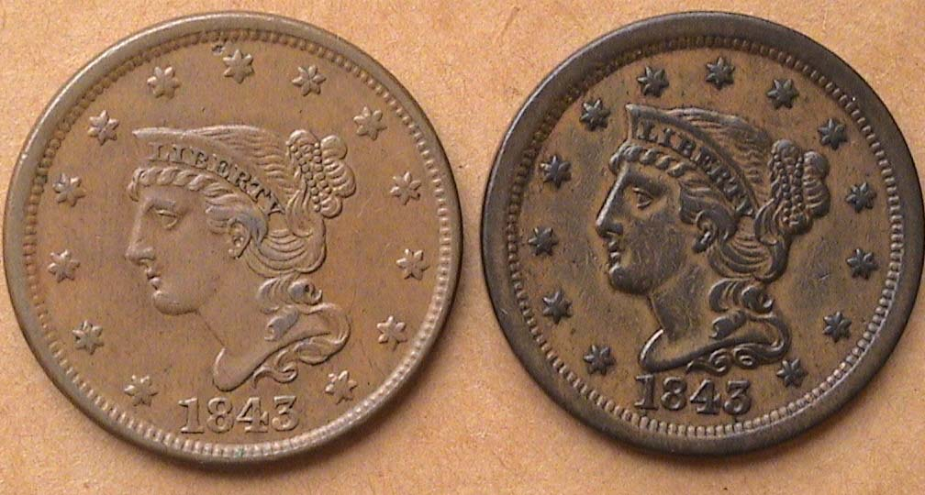

1843 cents, N-9 R3 “Petite Head” and N-16 R4 “Mature head”

Another subtle difference beginning with the 1843 large cent is the slight thickening of the planchet with a slightly reduced diameter and a wider rim.

From 1843 thru 1857, no significant sub type changes appeared. There are some interesting overdates such as the 1844/81 and the 1851/81; both scarce and popular varieties; also the slanted and upright 5’s in the very common 1855 and 56 dated cents. All of the late dates are extremely common. They were minted in huge numbers and by the 1850’s most Americans found their cents weighty and cumbersome; this despite the fact the denomination still had some value for inexpensive goods. Back in 1977, Choice AU specimens were selling for $25 with BU’s going for $50. Today an AU-50, (not a 58) is selling for $125 and MS-65’s are going for $1,000. Too much! These coins hardly circulated and like most Morgan dollars, they are extremely common even now. The only current major book on the late dates is Robert Grellman’s. If you should ever decide to collect this amazing series, you will want to acquire at least one book for each segment; the Early, Middle or Late dates; a truly wonderful series cherished by thousands.
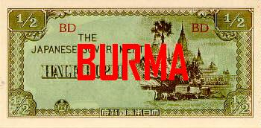

J.I.M. - Part 2 BURMA by Bill Myers

The Japanese invaded and took control of Burma in January 1942. Burma JIM is a short series. The series is noted by the letter "B" in red, block letters. There are no serial numbers. They are in the denominations of cents and rupees. Each denomination was also produced as specimen notes, which are the most expensive. These will not be listed below. There were also counterfeit Burma JIM, not printed by the Burmese
but by the United States and Great Britain. They were for use by
agents working in support of the allies. The British Special
Operations Executive (SOE) requested 1 million 10-rupee and 200,000 1-rupee counterfeit notes. The Office of Strategic Services (OSS) requested 25,000 10-rupee notes.
The fractional JIM notes of Burma come in the value of 1, 5, and 10 cents. The face has "THE JAPANESE GOVERNMENT", the denomination written out and in numeral form, and red block letters. The back has the numeral
denomination in the center and corners on an ornate design. The bills are lithographed.

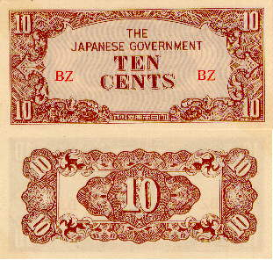

The varieties are: 1 cent - block letters
fractional block letters,
5 cents-block letters
fractional block letters
10 cents-block letters
fractional block letters

There are six different denominations of rupee notes. The face and back of the 1/4 rupee is designed like the fractional notes. The face of the ½ to 100 rupee notes continue to have "THE JAPANESE GOVERNMENT" and the denomination, spelled out and as a numeral, as well as a picture of the Ananda Temple at Pagan. Additional features on the face of the notes are as follows. The 1 rupee note has a breadfruit tree on the left with the temple on the right. . The 5 rupees has a coconut palm on the left and a pawpaw tree with the temple on the right. (See below, ed.)

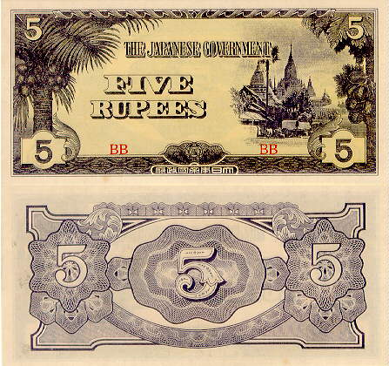

The 10 rupees note has a large Roman numeral "X" and a coconut palm on the left and a coconut palm and the temple on the right. The 100 rupees note has "100" and a coconut palm on the left and the temple on the right. The back of these bills have the denomination numeral repeated on an ornamental design, as on the fractional notes as shown below.

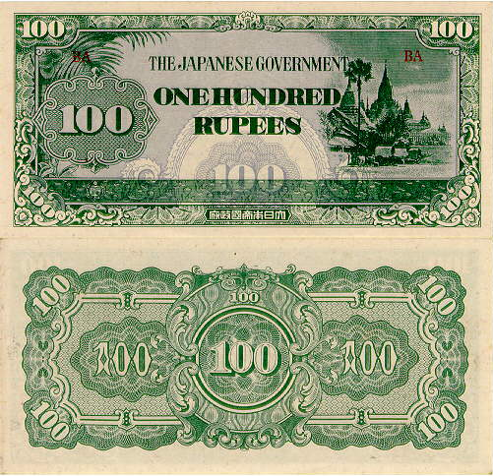

The 100 Rupee Note Front and Back

In addition, the 10-rupees note has the denomination spelled out at the center. A quatrefoil (flower with four petals) watermark is found on these notes, except where noted below.

Burma J.I.M. Notes (continued from previous page)
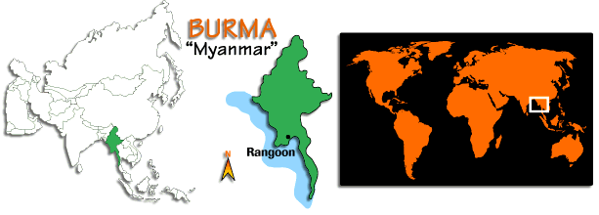 Map of Asia with Inset of Burma at center; world map at right

The varieties that you will find are as follows:
¼ rupee - block letters only, no watermark;
½ rupee - block letters only;
1 rupee - blocks 75 mm apart; - SOE counterfeit, blocks 75mm apart, no watermark; - blocks 78 mm apart;
5 rupees- block letters only;
10 rupees-block letters 8 mm wide and 67-74 mm apart;
-SOE counterfeit, block letters, no watermark;
-OSS counterfeit, block letters, watermark, no line in design; -OSS counterfeit, block letters-orange, 7.5 mm wide, 72 mm apart, watermark, no line in design -block letters 6.75 mm wide, 67-69 mm apart, no watermark, silk threads in paper.

-to be continued-

More Club News (continued from page 1, column 1)

A fine crowd was on hand for our first meeting of the New Year. President Willie Simon called the meeting to order at promptly 6:45 PM and welcomed everybody back from their holiday recess. The Minutes so meticulously taken by our Recording Secretary Helen Barry were waived and put on file and our treasurer, Miss Pat reported that after all expenses, the current balance is $788.33. VP Jim Barry reported that the only available meeting night the Library could give us for February was the 16th; the third Thursday. Unfortunately that evening conflicted with the Augusta Coin Club. As some fifteen-- possibly more--members belong to both clubs, the only other date would be the fifth Thursday but as there are never any fifth Thursdays in February excepting a Leap Year, the next available date was March 2, a first Thursday. No one seemed to have a problem with that, so March 2nd it is. See you all then. Jim is hoping to arrange fore two meetings in March four weeks apart which could mean we might meet on a fifth Thursday after all; March 30th. Stay tuned!

Jim also mentioned the second annual club Road Show would be coming up on Saturday March 4, but just before the newsletter went to press, he informed the editor that the date has been changed to the fourth Saturday in April; , April 22 to be precise; at the Library from 12:00 noon until 3:00 PM. The Road show is patterned after the PBS Antique Road show program where so-called experts place a value on various items. In our case the items would be strictly numismatic in nature and the so-called experts would be culled from the members of our club. This can be a lot of fun and in certain cases prove to be an unexpected bounty for an area resident.

The Attendance prize drawing;--a 2005 silver eagle-- was held and the winner was Vilma Safran. No! The editor did not participate in the drawing. The winner of the 50/50 drawn later in the evening was Grady McWaters. He won $25.00. Congratulations Vilma and Grady!

There were two Show & Tells: Bill Myers displayed medals and plaques he received for his two exhibits he set up at the F.U.N. show in Orlando earlier in the month. He took 2nd Prize in the Foreign Coins category and 1st Prize in the Tokens and Medals category for his exhibit on P.O.G.S, the subject of Bill’s talk here some months ago. He also received “Best in Show” for that exhibit and with it comes an all expenses paid week at the ANA’s Summer Seminar to be held in Colorado Springs next July. This includes a round trip flight, room and tuition. Way to go, Bill and congratulations! Bill followed this with a short talk on the art of exhibiting.

Chuck Braun does a lot of traveling and always returns with an interesting numismatic item from places he’s been. This time it was Ethiopia and Chuck displayed a Birr; a unit of currency he acquired there.

Jim Barry then presented a video program on the Dahlonega Mint that featured background information on the lovely Piedmont area Georgia town. This included the gold museum in the town hall there where many examples of the rare Dahlonega gold coins are on display. After gold was discovered in the region a US Mint facility was built and opened in 1838 producing only gold coins until the early 1860’s when the War Between the States caused it to be shut down. Most of the gold coins struck there are extremely rare today. Years after the mint closed folks still enjoyed panning for gold in the area. Thanks,
Jim for sharing this interesting video with us.

After a short break to view the auction lots, our erstwhile auctioneer, J.J. Engel conducted the auction in which some spirited bidding occurred over some type coins, a couple of obsolete bank notes and auction catalogues. The meeting concluded at 8:45 PM.

The 1809 “Circle Inside Zero” Half Cent
By Greg Heim
Reprinted from the April, 2005 issue

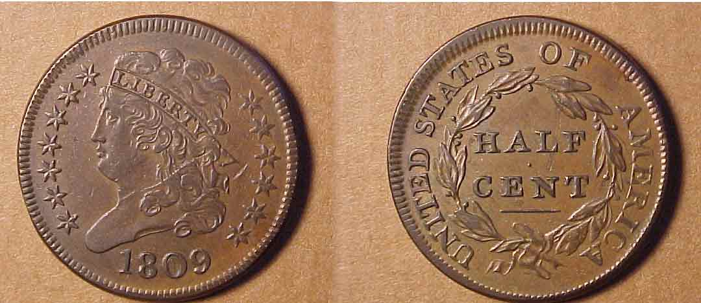

1809 Classic Head ½¢ circle in circle variety (actual size)

In today’s hot market, it is getting harder to find coins that are underrated. Such is the case with the 1809 “Circle inside Zero” Half Cent. The moniker for this coin comes from the Late Roger Cohen, whose nomenclature is used to identify United States Half Cents by die variety. In reality, it is actually a repunched zero over a smaller zero.

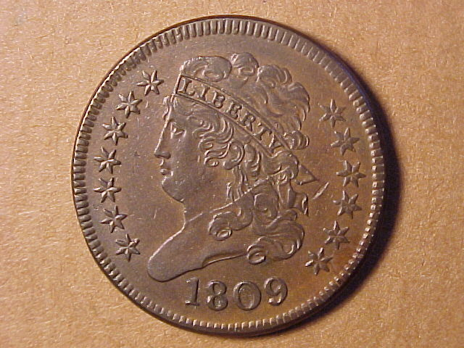
WANTED
CHINESE PANDA 1 oz. COINS
DATES NEEDED: 1982-1986 and 1988
MERLE DAVIS (803)-644-4636

Enlargement of obverse

To Half Cent experts, the die variety is a Cohen-4, an R3 (scarce). When the repunching is not obvious, all one needs to do is to identify the reverse characteristic of the highest leaf being well past the second S in STATES, almost to the O in OF.

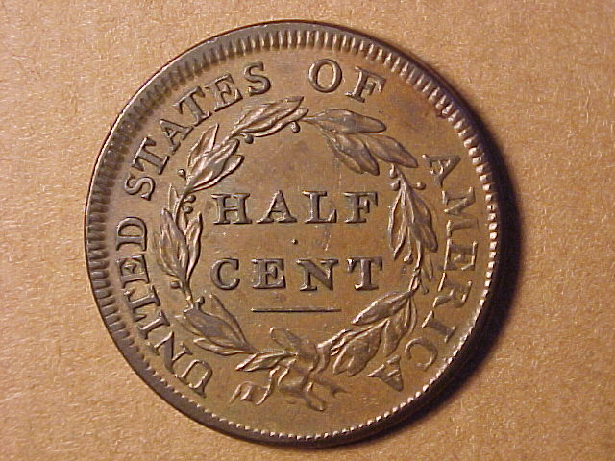

Tony’s Coin Shop

Buying & Selling Coins
Proof Sets and Mint Sets
Bullion and Rare Coins

Tony Fulmer
1631 Whiskey Road (next to Hearing Center)
Aiken, SC 803-648-1388

Enlargement of reverse

The rarity rating of this coin does not tell the entire story. Coins in Fine-12 and lower are not difficult to locate. Coins in Fine-15 to Very Fine-30 are challenging but available in the market for small premiums. However, coins in Very Fine-30 or better will prove to be quite a challenge and they will cost you a premium over Coin World “Trends” or “Grey Sheet Quarterly I” levels. Having collected Half Cents for over 10 years, we have seen very few quality pieces offered at auction or in dealer’s inventories. When they do surface the pricing is very strong, especially for coins with nice color and surfaces.

As a matter of fact, the specimen that we own was purchased at the 2003 Early American Coppers Club Sale in Cincinnati, Ohio. By commercial grading standards it was an AU50 with superb color and surfaces. We ended up butting heads with another collector until we outlasted him, paying too much for the coin at the time. Needless to say we are thrilled to own the coin today as it is one of the cornerstones of our collection.

The 1809 Cohen-4 is a perfect example of knowing your series. Sometimes a coin need not be blatantly rare for it to be difficult. Advanced collectors know this all to well, and that knowledge can make acquiring such a coin very challenging and rewarding.
_________________________________________________________________________________________________

For the serious and casual collector

COINS, STAMPS & CURRENCY

P.O. Box 1738 143 York Street, S.E.
Aiken, SC 29802 Aiken, SC 29801
(803)- 643-9957

More Show & Tells and Ads Encouraged
Augusta Coin Exchange
Fine Rare Coins

Buying US Coins, Currency, Gold and Silver Bullion

4015 Washington Rd. Suite L Martinez, GA 30907

Larry Lucree ANA Member # R-21285
PH 706-210-5486 Tues-Fri. 10:30 am – 4:30 pm
Evenings 706-339-7275 Sat. 9:00 am - 3:00 pm

E-mail: coolhandcoins@comcast.net

Newsletter goes Digital: Glitches to Still Be Worked Out

President Willie Simon keeps encouraging folks to bring in some coins, tokens, medals, bank notes or scrip, US Foreign or Ancients, or anything else numismatic that you fancy. He also has suggested that members run a free BUY, WANT or SELL ad in the newsletter. (See Merle Davis’ atop page 5.) And while were at it, why not take the time to patronize our dealers who support our club by advertising each month in our newsletter and thanks in advance.

Not everyone likes to do something they haven’t done before and your editor ought to know because he has finally gotten around to working out most of the bugs on digitalizing the newsletter, thanks to some help from a neighbor and Xavier Pique, Treasurer of the Augusta Coin Club. To receive the monthly letters via E-mail, please send the editor your E-mail address to arnosafran@comcast.net. From time to time the editor will take the liberty of reprinting articles that were clouded due to the poor quality of the black and white photos. Notice how improved the half cent pictures appear in Greg Heim’s article, “the Circle in the Zero”; also the bank notes in Bill Myers’ article on “Japanese Invasion Money from Burma”.
_____________________________________________________________________________________________

Holiday Party Pics
(Courtesy of Bill Myers)

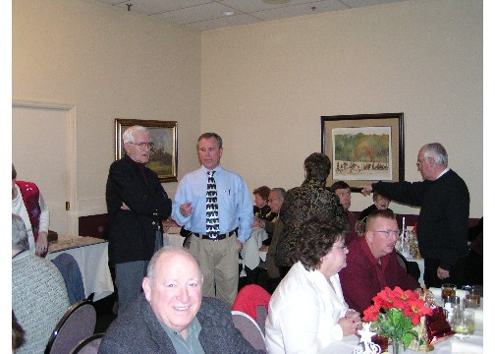

Jack Seech with a wide grin with Jim and Willie in the background

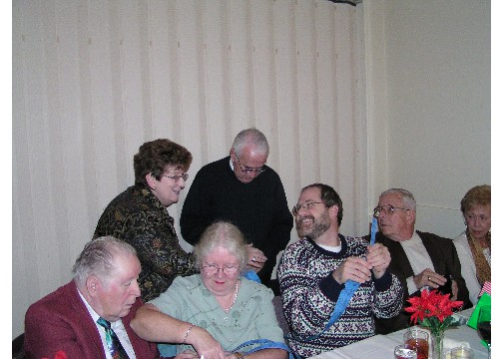

Steve Kuhl appears amused at something Miss Pat and Mr. Glenn are examining while the Riggins converse

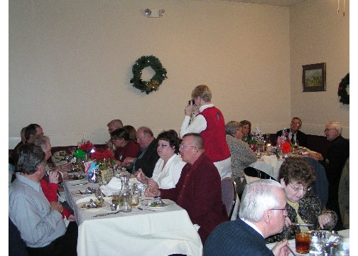

Miss Helen shooting the wall as the Black’s
and fellow members enjoy their dinner

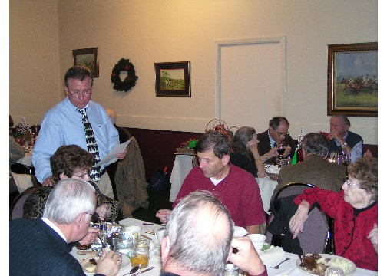

Willie checking in with Miss Pat who bought all the prizes while
Mark Headquist, Miss Kate and Glenn Sanders look on

Thanks, Bill for making these photographs possible. Now that the newsletter has gone digital, feed us your pictures of club related activities; even coins you admire from your collection and we’ll put them on the web. Hope to see you all on Thursday, March 2nd.

