Pres. Willie Simon
V .P. James Barry
Sec. Helen Barry
Treas. Pat James
Sgt. in Arms: J.J. Engel
Committees:
Programs: James Barry
Newsletter: Arno Safran
Show Chairman: JJ Engel
The Stephen James
CSRA Coin Club of Aiken
P.O. Box 1739
Aiken, SC 29802
Web site: www.sjcsracc.org
The SJ CSRA CC Now Meets on the 2nd Thursday of the Month at the Cedar Creek Community Center in Aiken, SC

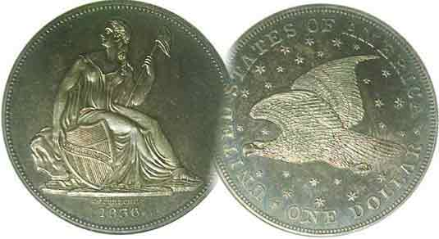

Volume 6, Number 2 the Stephen James CSRA Coin Club Monthly Newsletter February, 2007
Members see PCGS Grading Presentation I
Our next meeting is on the 2nd Thursday of the month, February 8, 2007 at 7:00 PM
2007 Club Meeting Schedule - 2nd Thursdays at 7 PM Jan. 11 Apr. 12 July 12 Oct. 11
Feb. 8 May 10 Aug. 9 Nov. 8
Mar. 8 June 14 Sep. 13 Dec. 6
Club Show: Sat. Sept. 15, 2007
_____________________________________________________________________________________________________________________________

How Coins Are Graded by PCGS- Part One
Subject of Jan. 11 Meeting Program

At the Jan. 11 meeting Vice President Jim Barry played the first half of a VCR tape describing the philosophy and approach to third party coin grading by the Professional Coin Grading Service, (PCGS). The emphasis was unfortunately, not on the circulated grade ranges of obsolete type coins that most collectors can afford but on Uncirculated coins (MS-60 to 70) that most collectors cannot. The tape began with a lengthy discussion of why it was necessary to start professional grading companies followed by a demonstration of the care and filing of data given each coin submitted to PCGS. This was followed by a large number of coin pictures from the Morgan dollar series showing how each coin was supposed to look from MS-70 (meaning an absolutely perfect coin) down to MS-60; (an uncirculated coin showing little luster, perhaps weakly struck, having lots of contact marks such as scratches, swatches, discoloration and digs along with possible minor rim damage.)

Of the higher grade Morgans shown, (e.g., MS-65-69) PCGS chose those particular dates that were known for their spectacular strike, brilliant luster and proof-like characteristics such as the 1880-S issue. Most dates were minted in the tens of millions and remained in mint sewn bags with the result that a vast number of these large silver cartwheels never entered general circulation. The series was so heavily promoted during the 1970’s that many unscrupulous dealers began selling over graded examples which eventually led to the need for professional grading services for all US coin types. At large regional coin shows, slabs upon slabs of these large silver coins may be seen; most of them grading MS-65 or better but are they? The experience of many seasoned numismatists admonishes the collector to still “grade the coin before you buy the slab.” The PCGS program did nothing to suggest otherwise.
______________________________________________________________________________________________________________________________
(More club News continued on page 4, column 1)
Collecting Circulated coins on a Budget
Part One by Arno Safran

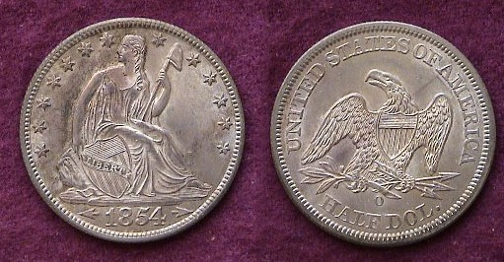

An 1854-O Liberty Seated Half Dollar with arrows at date
(From the author’s collection)

The coin pictured above has an interesting tale to tell. It looks uncirculated and perhaps it is but it was offered to this collector as a Choice AU (Almost Uncirculated). I had attended a meeting of a small coin club located in central New Jersey. A dealer by the name of Dave Wilson with whom I had been doing business for about two years used to set up at a number of coin clubs in NJ and eastern PA and every so once in a while, would have some spectacular coins in his case that were reasonably priced and affordable for one on a teacher’s budget. At one such meeting, I saw this 1854-O Liberty Seated half dollar with arrows at date. The New Orleans specimen for this date is extremely common with a recorded mintage of over 5 million but as a two year popular variety is in strong demand. The problem for me was that the meeting occurred on a Thursday and I didn’t get paid until the following day. Dave told me that he was setting up at a two day show on Sat. & Sun about 75 miles away and would hold the coin for me until 11:00 AM. After that, all bets were off because he was sure the coin would sell before noon. On Saturday I left early enough to get to the show but ran into unexpected traffic in north-central NJ; a highly industrialized section of the state. I arrived around 10:59 AM and Dave greeted me with a big smile on his face for he had already received a number of inquiries on the coin but true to his word, he held it and sold it to me at the agreed price. Sadly, last week I learned that Dave had passed away.
____________________________________________________________________________________________________________________________
(Continued on page 2, column 1)
Collecting US Type Coins on a Budget
(Continued from page 1, column 2)

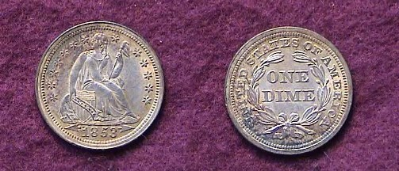

An 1853 with arrows Liberty Seated Dime
From the author’s collection
Sold to him as an Choice AU by dealer Dave Wilson
Magnify up to 200% to see details.

Most novice coin collectors start out by being tentative when making purchases, so finding a dealer whom one can trust is an essential factor in a collector’s numismatic development. The late Dave Wilson was one such dealer. Back in 1982 Dave retired from Corporate America to go into business for himself as a coin dealer. He had loved collecting coins as a youth and wanted to earn a living doing something he enjoyed. He could not have picked a worse time. The coin boom, energized by the Hunt Brothers’ attempt to corner the bullion market in 1979-80, had crashed. During this period many moderate income collectors had been forced out of the hobby due to unrealistic high prices. An even greater number of investors discovered that their MS-65 common date Morgan dollars, Walking Liberty and commemorative halves were downgraded to MS-63’s or worse, AU’s when they decided to sell.

Dave had a wife, a daughter and son, so the adjustment must have been difficult for all at first. Living in a small state geographically but with the highest density population in the nation enabled Dave to join a number of area clubs spanning only 50 miles. There were commercial shows in different regions of NJ and eastern PA held on Sundays and the usual annual club shows as well. After refining his grading skills he re-studied the Red Book varieties along with building up his personal numismatic library. He made one important rule for himself and that was not to collect what he sold which meant giving up coin collecting personally. He never deviated from that vow. He made another rule for his clients. He would offer what he felt was a fair price below what appeared on the coin holder. You either accepted it or moved on. His grading was extremely accurate overall with the result that most buyers seldom haggled. The 1853 with arrows dime pictured above along with the 1854-O with arrows half dollar on page 1 are just two examples of what are referred to as “sliders”; (i.e., AU-58 coins that could pass for today’s MS-63). In those days there were larger price spreads between AU-50 and MS-60. Dave would tend to charge closer to AU than Unc which enabled the collector to acquire coins with eye appeal at a modest price.

When one is contemplating building a type set, most reliable dealers have advised their clients to buy the highest grade specimen you can afford. With common date coins an AU-58 is the logical choice. With scarcer pieces, one has to try to find lower grade coins that still have retained their eye appeal despite an increased amount of wear. Therein lays the challenge.
At a meeting of one of the four NJ clubs I once belonged to, Dave showed me an 1810 Classic Head large cent. He had graded the coin VF and except for a darker brown spot on a slightly off center planchet the coin appeared pleasing with nice surfaces. He offered it to me at a very reasonable price but I hadn’t brought my check book or sufficient cash. At the time, the club met in the finished basement of a Bank building that had an ATM in a foyer that was accessible when the lobby was closed. Within minutes, I returned to complete the transaction. Classic Head cents were issued from 1808 thru 1814. Regrettably, most Classic Head cents surface with problems due to corroded surfaces or having been struck on dark planchets. Finding a Classic head cent that is free of porosity and discoloration has never been easy. While the coin pictured below is not a choice example, it still has enough eye appeal as a VF-30 to satisfy most collectors of this series.

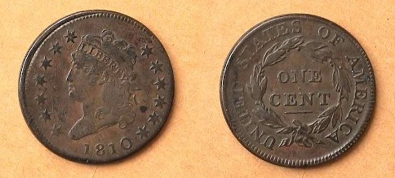

An 1810 Classic Head Large Cent, a Sheldon 283 variety

Half cents have never been all that popular with collectors. Of the five obverse types, the Classic Head-half cent (1809-1836)--unlike the large cent--is usually the most available and least expensive. Strangely, the late dates (1849-57) known as the Braided Hair Coronet type have some low mintage issues that are not all that expensive. One of these is the 1849 with a recorded mintage of just 39,864. In 1990, I received a phone call from Dave saying he had acquired a Choice AU specimen that was original. The next day, I drove over to his house where he sold me the half cent. While there I had an opportunity to peruse what else he had that might be of interest. I noticed he had a gorgeous “raw” 1924 Saint Gaudens $20.00 Double Eagle which he graded just MS-63. He told me that back in 1980 it was bid at $1,200 but now I could have it for just $550 due to the collapse of the market. So, in one day, I acquired attractive specimens of the lowest and highest US denominations. Several years later I sold the gold coin but still retain the half cent.

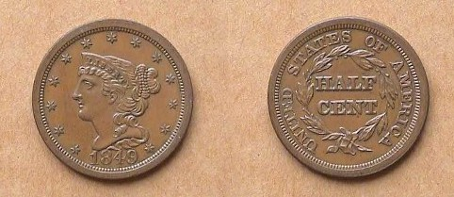

An 1849 Braided Hair Half Cent acquired from the late Dave Wilson

These are just some of the interesting type coins Dave made available to me over the years. The man was highly respected for his knowledge, decency, fairness and above all, his honesty. He will be missed.
____________________________________________________________________________________________________________________________
-to be continued-
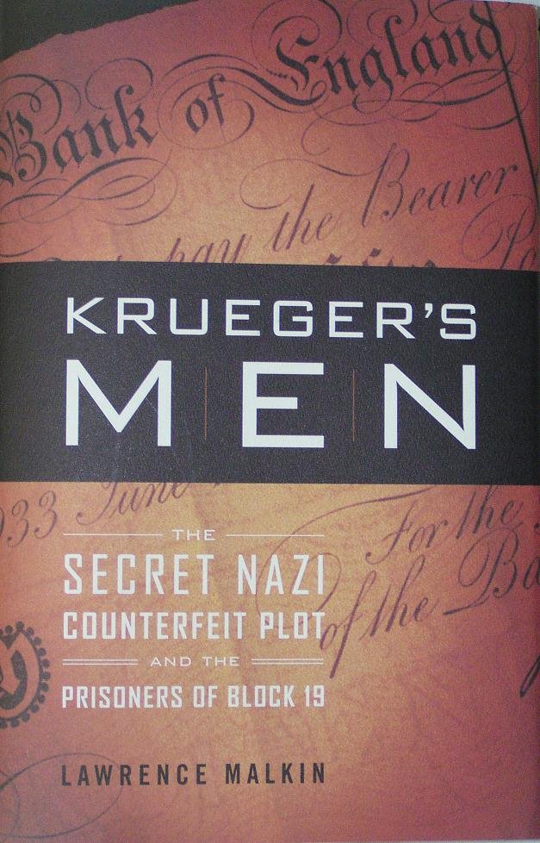

KREUGER’S MEN
The Secret Nazi Counterfeit Plot
And the Prisoners of Block 19
By Lawrence Malkin
Little, Brown and Company, New York, Boston, London 2006 287 pages

Book Review by Bill Myers

On Sept 18, 1939 with WWII about 2 weeks old, the Germans had a discussion on counterfeiting British banknotes to destabilize the British economy. Reinhard Heydrich was fascinated by counterfeit schemes and Operation Andreas was launched. Dr. Albert Langer built the operation from the ground up reproducing paper, watermarks and images. The operation released some counterfeit notes but failed because of the Nazi bureaucracy.

Counterfeiting the currency of the enemy was not just a German idea. In 1939 Winston Churchill proposed counterfeiting German marks and dropping them over Germany to destroy the economy. The plan was not carried out due to fear of retaliation and the fact that it was not felt appropriate for the British, even though they counterfeited US colonial notes during the revolutionary war. John Steinbeck brought Dr. Melvin Kinsley to FDR to suggest the German mark counterfeiting plan and the idea, again, did not meet approval. It was felt that scarcity in Germany was due to rationing, not lack of money. Gen. Douglas MacArthur requested and received 10 million counterfeit pesos in Philippine JIM.

Bernhard Krueger, an obscure SS officer who later called himself “the greatest counterfeiter the world has ever known” was trained as a mechanic and engineer. He was accepted into the Nazi party and SS in 1931. In July 1941 he was placed in charge of the SS Foreign Intelligence Services Forgery Department (foreign passports and identity papers) Section VIF-4. In 1942, Kreuger was given the assignment to set up a secret printing plant at KZ (concentration camp) Sachsenhausen and choose workers from amongst the Jewish prisoners. It was named Operation Bernhard and set up in Block (Barracks) 19. Krueger picked prisoners with printing experience. To complete his task he had to duplicate the paper and watermark, identify the coded numbering system and identify the secret mark that the British used on their notes. There were over 150 different marks used over the years and they varied after each run (100,000 notes). But Krueger was successful and at the peak from mid 1943 to mid 1944 his team was producing 650,000 notes per month in denominations of 5, 10, 20 and 50 pounds. Nine million notes with a value of 132 million pounds were produced. The operation was so secret that when two of the guards from Block 19 were on leave in Berlin and bedded the lonely wives of officers at the front and boasted about their work, they were arrested by the Gestapo and one was shot and the other received a 15-year prison term or transfer to the Russian front.

The notes then had to be distributed and this job fell on Friedrick Paul Schwend. He set up a team that would exchange the notes for items to help the Reich’s war effort. He received at least six million pounds ($24 million). A large number passed through Swiss banks and they got stuck with over 1 million Bernhard notes.

Elyesa Bazna was an Albanian Turk who was the valet to Sir Hughe Knatchbull-Hugessen, the British Ambassador in Turkey. He managed to copy the keys to the ambassador’s safe, and he photographed and copied 130-150 secret documents which he sold to the Franz von Papen, the German ambassador in Turkey who paid 300,000 pounds for them. Most of the copied money was Bernhard counterfeits. Fortunately for the Allies, no critical information was sold by Cicero.

Operation Bernhard notes equaled 13% of the 1 billion of real pound notes in circulation. After D-Day, work in Block 19 was focused on counterfeiting US dollars. Since US notes are made by the intaglio method it would take months to learn the technique and engrave plates that a technique called “photo type of collotype” was used. Others were recruited in this effort including notorious Russian counterfeiter Smolianoff. The “Dollar Group”, as they were known, did their best to delay the production of the notes. Due to fears that block 19 would be bombed, the equipment and personnel were moved to Mauthausen for a few weeks then moved to Redl-Zipf in Austria, which is where V2 rockets were assembled. Late April 1944 was the last time they saw Kreuger and when he drove off that was the end of Operation Bernhard. The printing equipment and a large amount of the currency were dumped into lakes Traunsee and Toplitzee. The prisoners were moved to a concentration camp at Ebensee to be executed, but the camp was liberated prior to that happening. The epilogue in the book describes the post war lives of some of the key players.

Lawrence Malkin did extensive research (42 pages of footnotes) and did a great job of separating fact from fiction. I found the book to be fascinating reading as it incorporated my interest in WWII and numismatics. It will be a keeper in my numismatic library.
________________________________________________________________________________________________________________________

More Club News
(Continued from page 1, column 1)

The PCGS video did offer some important safeguards for the numismatist. Any coin certified by them has to be authenticated as genuine. PCGS does authenticate and grade circulated coins as well. The narrator on the tape boasted that he was able to grade a coin accurately with the naked eye. A number of club members viewing the presentation questioned this bit of bravado as most graders require a magnifier anywhere from 3X to 5X to a loupe with 7X to 10X power capability. Part Two will be shown at a later date. The club thanks Jim Barry for sharing this video with us.

In other club news President Willie Simon welcomed guest Gary Butler. He also expressed delight in seeing his favorite type coin series featured in the January newsletter (Willie is a strong collector of Barber Half Dollars). He encouraged more members to submit articles, classified ads for the newsletter such as Buy, Sell or Trade which are free and encouraged members to bring in Show & Tells. Finally, President Simon proposed that we explore the idea of adding some attractive obsolete coins to the club drawings in addition to the attendance and 50/50 raffle; an idea that received positive responses from the members present.

Treasurer Pat James reported a balance of $825.96 after all expenses for the pre Christmas dinner party that was about $40 above the total at this time a year ago. Thanks, Pat. Dues will not be due until April and they still remain only $10 a year. Vilma Safran won a 2006 silver eagle for the door prize and Dick Lasure won the 50/50. Congratulations to the winners.

For Show and Tell, Jim Barry displayed the newly issued Libertas Americana medal replica from the Paris Mint based on the design of the Bronze medal first issued in 1782. Jim described his silver version as showing a Bust of Liberty facing left with a Phrygian cap atop a pole protruding diagonally towards the upper right on the obverse with the date JUL. 1776 shown below the exergue. He told the members that it was this obverse that became the model for our 1793 Chain and Liberty Cap large cents. The allegorical reverse depicts Minerva with arrow and shield (representing France) at left, watching over the infant Hercules (lower center) while fending off the British lion at right. Jim had acquired the medal at the recently held FUN Show in Orlando.

Member Glenn Sanders mentioned that the nation’s Panel for Consumer Products recent survey revealed that the number one national pastime was Flower Gardening with Coin
Collecting rated number two. Hobby investments represented 20% of American’s discretionary income earmarked for saving.

At the meeting member Doug Moody set up with a number of his attractive Year sets and proof sets for sale; some going back to the 1950’s that were housed in Capital Lucite holders. In the absence of J. J. Engel, who had to attend another engagement, Glenn Sanders served as auctioneer with some spirited bidding on a number of lots. Thanks, Glenn.

The next meeting will be held on Thursday, February 8 at the Cedar Creek Community Center. Hope to see you then!
______________________________________________________________________________________________________________________________
Bill Myers Receives Award at FUN Show

Member Bill Myers continues to amaze. In the past, he has won numerous prizes for his exhibits, including Best in Show at FUN but this year, unable to attend the annual show because he is serving in Iraq, Bill still managed to take another prize at this major hobby event. He was the recipient of the Charles B. Fine Literary Award for 2006 for his article on AAFES POGs. SJ CSRA CC members will remember his past articles and the marvelous slide-program Bill presented on this subject before our club in 2005. Congratulations, Bill!!
___________________________________________________________________________________________________________________________________

Kindly Patronize Our Advertisers
