Pres. Willie Simon
V .P. James Barry
Sec. Helen Barry
Treas. Pat James
Sgt. in Arms: Glenn Sanders
The Stephen James
CSRA Coin Club of Aiken
P.O. Box 1739
Aiken, SC 29802
Web site: www.sjcsracc.org
The SJ CSRA CC meets on the 2nd Thursday of the Month at the Cedar Creek Community Center in Aiken, SC

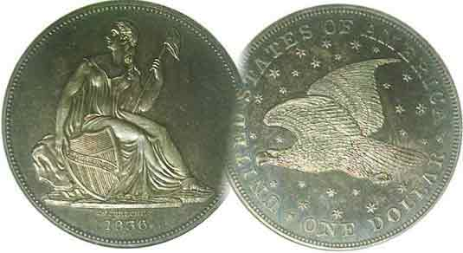
Committees:
Programs: James Barry
Show Chairs: The Barry’s
Newsletter: Arno Safran
E-Mail: arnosafran@comcast.net
Auctioneer: Glenn Sanders

2009 Club Meeting Schedule
Volume 8, Number 2 the Stephen James CSRA Coin Club, Founded in 2001 February, 2009
Monthly Newsletter
Next Road Show Sat. Feb. 21 at Aiken Library
Our next meeting is Thursday, Feb. 12, 2009 from 6:15 to 9:00 PM
Jan. 5 Apr. 9 July 9 Oct. 8
Feb. 12 May 14 Aug. 13 Nov. 12
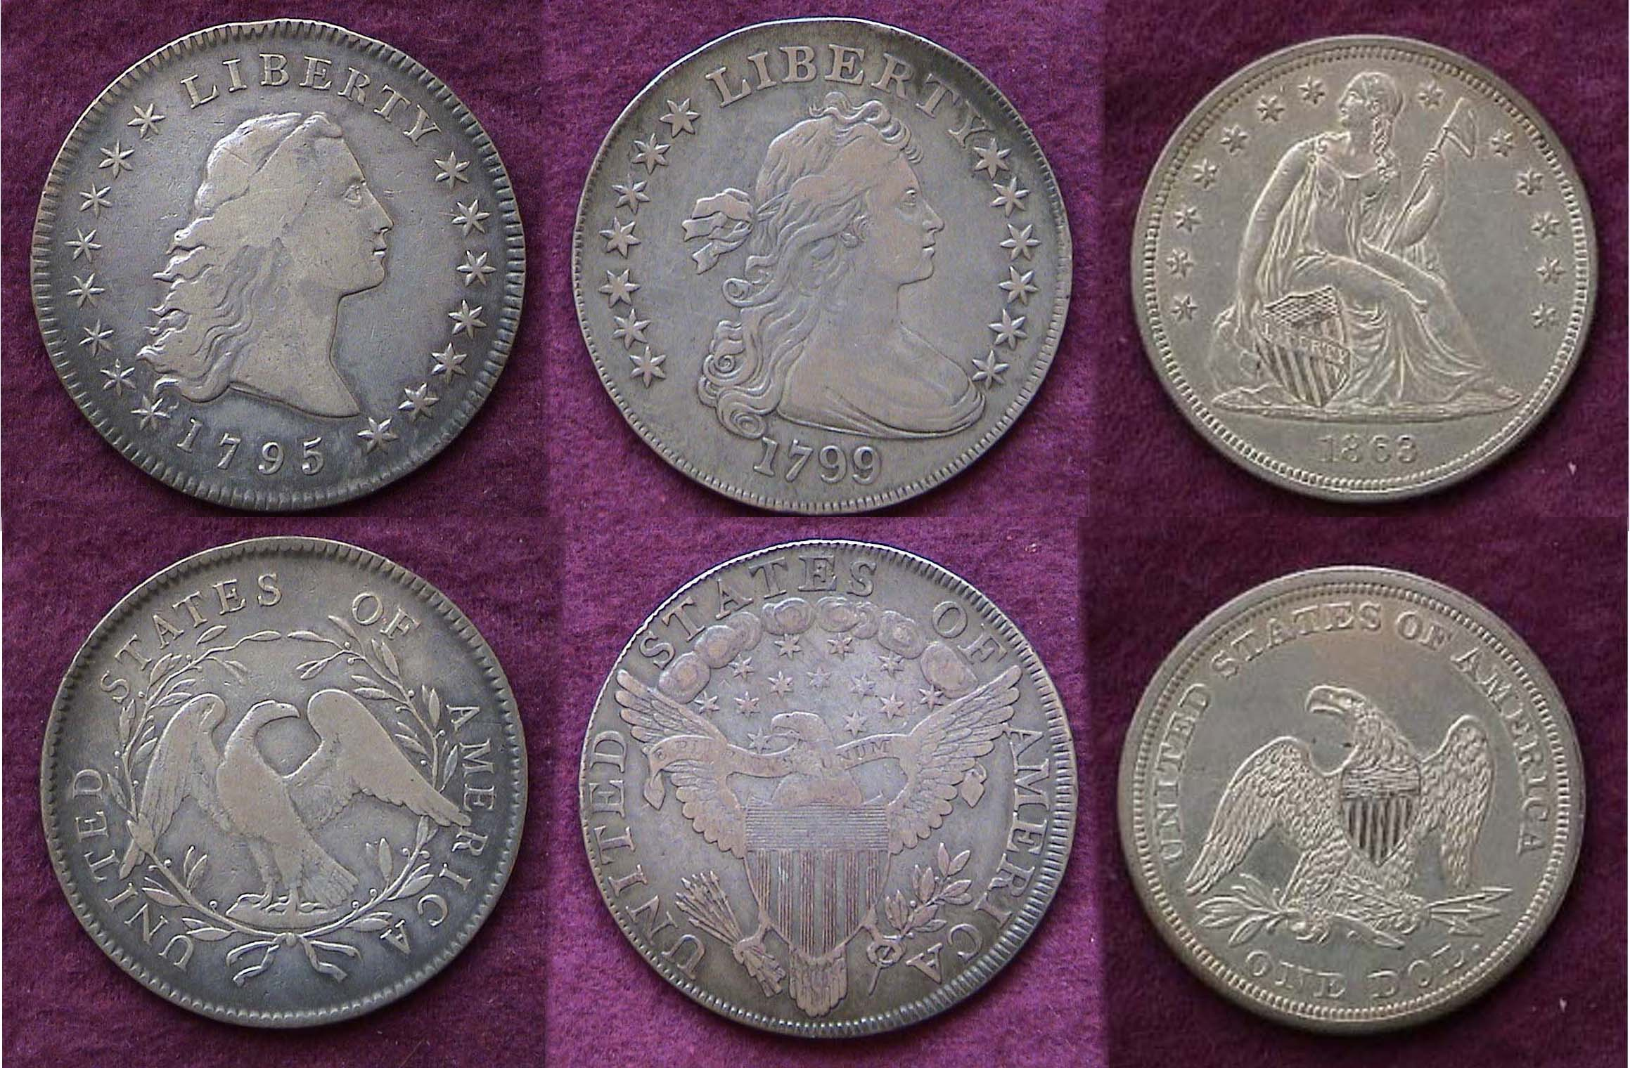
Mar. 12 Jun. 11 Sep. 10 Dec. 3
___________________________________________________________________________________

Club Road Show like PBS’s “
Antique Rainbow”?

For the past five years, our club has held a numismatic “Road” show at the Aiken Public Library. The event usually takes place on a Saturday between 12 noon and 3:00 PM in March, April or May but this year it has been moved up to February 21 in the hope that more people will attend. This is not an event for club members per se but more of a service to the people residing in the Greater Aiken and surrounding communities. Our Road Show is structured along the lines of the PBS TV Network’s successful “Antique Rainbow” program, but instead of evaluating antiques, persons are invited to bring in domestic or foreign coins, tokens, medals, paper money or scrip for appraisal. The appraisers are made up of SJ CSRA CC volunteer members that have in the past included President Willie Simon, VP Jim Barry, Glenn Sanders, J.J. Engel, Arno Safran and Bill Myers. In the first two years the Road Show was held, people were waiting outside the door as early as 11:45 AM in order to have their coins appraised. Attendees started to drop off in 2007 and especially in 2008 before it were evident that the economy was deteriorating rapidly. With the economy now in a serious downturn, it is possible that more people may be rummaging through their dens and attics to see if any of their family air looms have value and quite often, a jar or box of old coins are uncovered under such circumstances. If you know pf anyone in your family, or friends who may have old coins lying around please let them know about this upcoming event.
____________________________________________________________________________________________________________________
(More Club News continued on page 4, column 1)

Collecting Short Sets by Denomination:
US Silver Dollars by Arno Safran

1795 Flowing Hair, 1799 Draped Bust & 1863 Liberty Seated $1.00s
The first three collectible US silver dollar types [Magnify to 150%]

Of all the US denominations, the silver dollar, once considered too large and unwieldy to use in daily commerce has become one of the most popular series with today’s collectors. A major reason for this has been the Morgan dollar; a coin that saw very little circulation during its run (1878-1921) but unlike its forbearers was struck in the multi millions and later heavily promoted. In assembling a Short set of silver dollars one should begin with the Flowing Hair type issued in 1794 and 1795. Only 1,758 pieces were coined in 1794 and these are expensive but in 1795 the reported mintage was increased to 160,295 making this date more accessible and affordable. Collectors wishing to complete a short set of silver dollars should seek a certified example grading Fine-12 to Fine-15 like the one shown above.
_________________________________________________________________________________________________________________________
(Continued on page 2, column 1)
Assembling a Short Set of US Silver Dollars
(Continued from page 1, column 2)

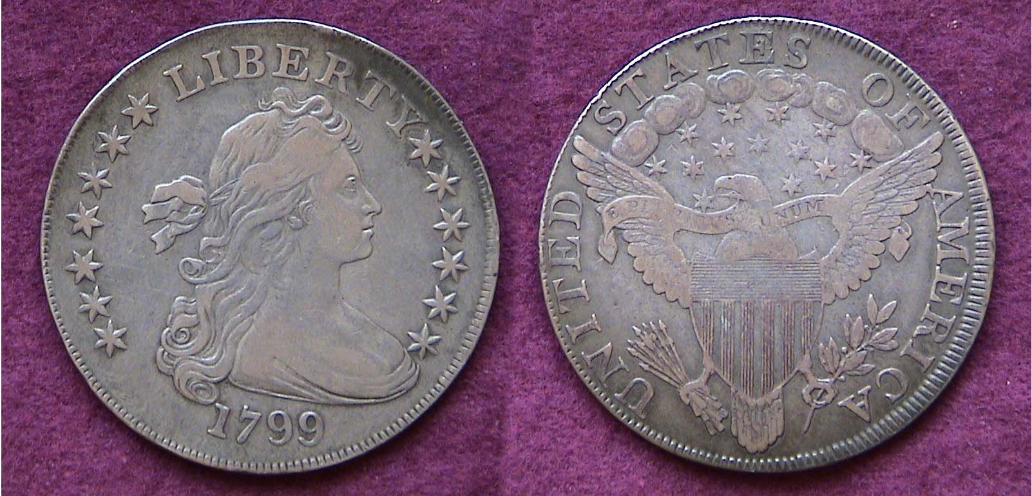

A 1799 Draped Bust Heraldic Eagle Silver dollar grading VF-35
With a reported mintage of 423,515, this is one of the most common dates.

According to numismatic scholars including Q. David Bowers, author of “Silver Dollars & Trade dollars of the United States” the Flowing Hair design of our first Chief Engraver Robert Scot was not very popular with the result that three artists collaborated to create the resplendent Draped Bust design that first appeared in mid 1795 on the dollar. The model was the beautiful Philadelphia socialite, Ann Bingham, nee Willing and the wife of Pennsylvania’s first Senator, William Bingham and the three artists included renowned portrait painter Gilbert Stuart, John Eckstein of Rhode Island who fashioned plaster models for our first Chief Engraver Robert Scot to use. The small eagle concept was slightly altered for the new Draped Bust dollar reverse, but in 1798, Scot adapted the Great Seal of the United States which displayed the eagle’s wings fully spread bearing a large patriotic shield in a sea of stars. This became known as the Heraldic Eagle reverse type, improving the overall design in the opinion of most numismatists.

At the time the author began assembling his collection of early US type, the 1799 dollar (graded by Anacs as VF-35) pictured above was fairly inexpensive. Unfortunately, during the first decade of the 21st century, prices have quadrupled for virtually all early US type (1793-1839). If one has the resources to acquire Draped Bust/ Heraldic Eagle dollar, the 1798 or 1799 Heraldic Eagle are the most common dates and certified examples from VG-10 to Fine-12 are still moderately priced.

In the early 1800’s the population of the United States was around 6 million. The silver dollar had tremendous purchasing power and was only used for large business tractions. Due to the severe shortage of silver for planchets, the denomination was suspended in 1804 with the final coinage of Bust dollars showing the 1803 date; not the famed 1804 rarity. The actual 1804 dated Bust dollars were made from new dies engraved by Chief Engraver William Kneass in 1834 to be included as part of a complete set of US coinage for foreign potentates.

In 1835, Mint Director Robert Maskell Patterson decided to resume dollar coinage because if the US was to assume monetary respect from the European countries, it should produce a crown size silver coin and he asked William Kneass to develop a design based somewhat on the Britannia model. After many trials which involved Kneass, painters Thomas Sully and Titian Peale and finally Asst. Mint Engraver, Christian Gobrecht, a new Liberty Seated design—to be known as the Gobrecht dollar—became reality at the end of 1836 and early 1837 when 1,600 proof issues were released into circulation. Alas, the new dollar didn’t prevail. Between 1837 and 1840, further tinkering with Gobrecht’s seated Liberty design continued on all five silver denominations; the half dime thru the dollar and in 1840 the finalized version of the dollar was completed and released.

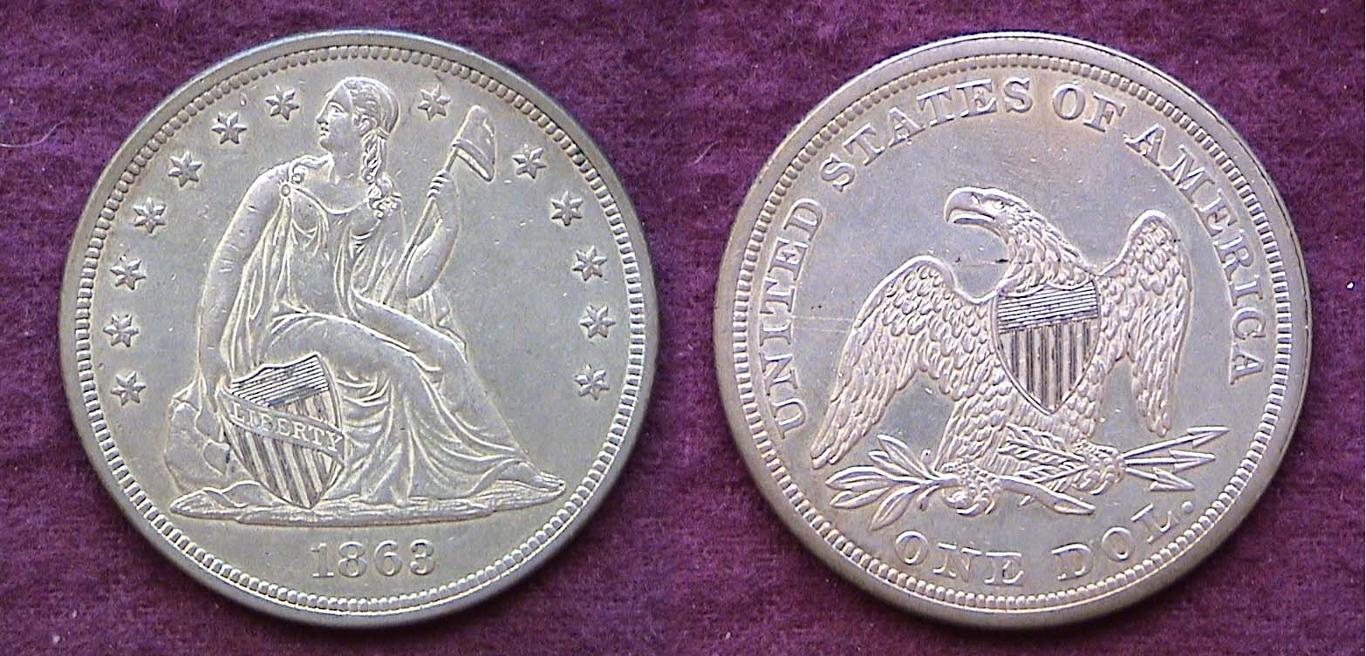

An 1863 Liberty Seated no motto silver dollar grading AU-50
The type was reduced from 39-40 mm (Bust dollars) to 38.1 mm.

In 1840, the US population reached 17,069,000 almost three times that of the Bust dollar era and by the end of the Civil War it had gone well above 30 million yet the overall annual mintages for the Liberty seated dollar were generally far lower than the previous series when the population was smaller. The series comes in two sections; the no motto, (1840-1865) and with motto for IN GOD WE TRUST (1866-1873). The common dates from the no motto portion of the series are the 1842, 1843, 1847, 1849, 1859-O, 1860-O. [The 1863 issue shown above had a mintage of just 27,200 but as a date it is not scarce, let alone rare and can be acquired at a still moderate figure in the higher circulated grades.] The common dates for the with motto portion of the series--all Philadelphia Mint issues--are the 1870, 1871 and 1872. Up through AU-50, these are still moderately priced. Liberty Seated dollars that are certified as mint state, (i.e., MS-60 and higher) are considered rare and expensive.

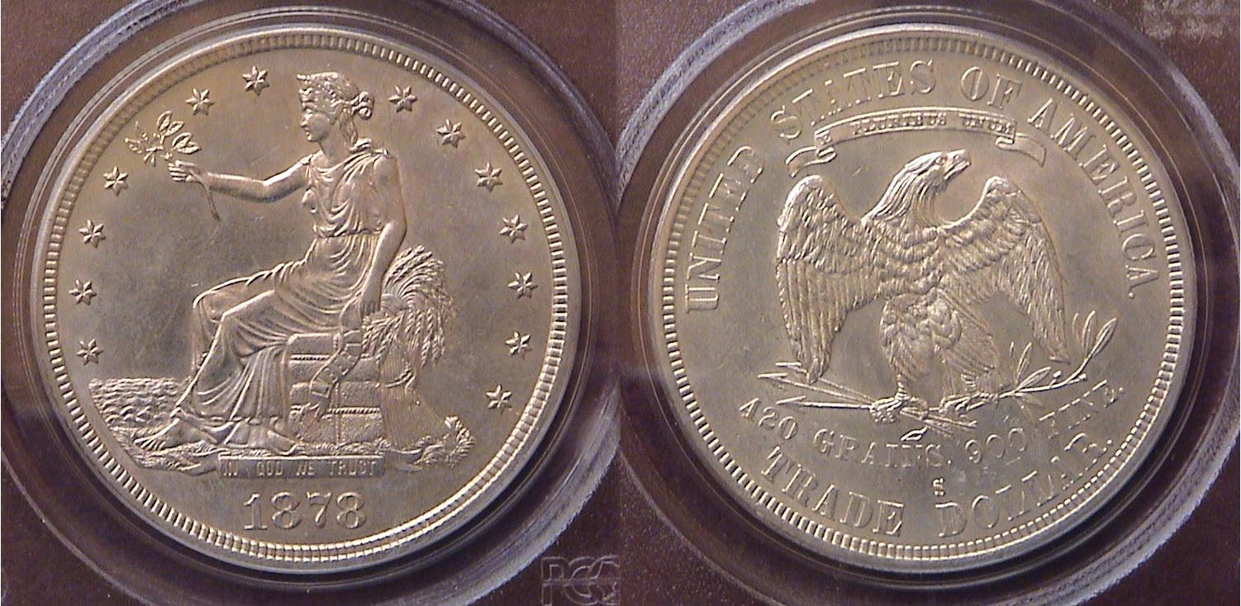

An 1878-S Trade dollar graded AU-58 by PCGS

In 1873, a new coinage law was passed eliminating several denominations that included the 2¢ copper, 3¢ silver, 5¢ half dime, and silver dollar. It also increased slightly the silver weight in the dime, quarter and half dollar. Replacing our circulating dollar coin was the Trade dollar which was issued ostensibly for trade with the Orient. Many citizens called this, “The Crime of ‘73”.
__________________________________________________________________________________________________________________
(Continued on page 3, column 1)
Assembling a Short Set of US Silver Dollars
(Continued from the previous page)

The new Trade dollar was granted legal tender status but only up to $5.00. Struck at the Philadelphia, San Francisco and in Carson City Mints, the San Francisco Mint coins are the most common and least costly up through AU-55 as most S dates exceeded several million. The designer was William Barber who became the Chief Engraver upon the death of James Barton Longacre in 1869. From 1879 on, the Trade dollar was struck just at the Philadelphia mint and in Proof only. By then the Morgan dollar was being produced. The Trade dollar may never have quite enjoyed the popularity of the other silver dollar types but it is an attractive coin. Certified pieces are recommended.

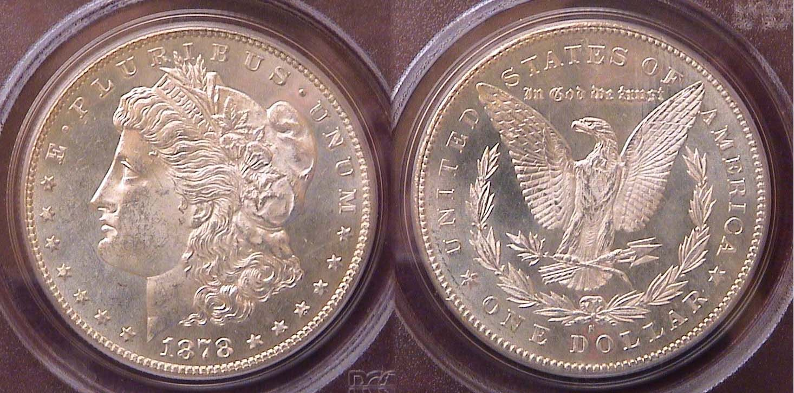

An 1878-S Morgan dollar, first year of issue; a common date

Despite being one of the most popular numismatic collectibles a collector interested in procuring a specimen of the Morgan designed silver dollar for our “short set” needs but one for type. The coin pictured above was graded only MS-63 by PCGS yet has great eye appeal and as an extremely common date is very moderately priced. The author acquired it for only $23.00 back in the 1990’s. Today it would sell for around $35 to $40. There are many others. Unlike the lower mintage Liberty Seated dollars that were held back from being put into circulation the Morgan dollar mintages were huge sometimes as many as 10 million for a date from a single Mint, yet these were stashed away in Mint sewn bags for most of the coin’s long tenure. So, despite the several key dates not withstanding, this type will be the easiest to fill for your short set of silver dollars.

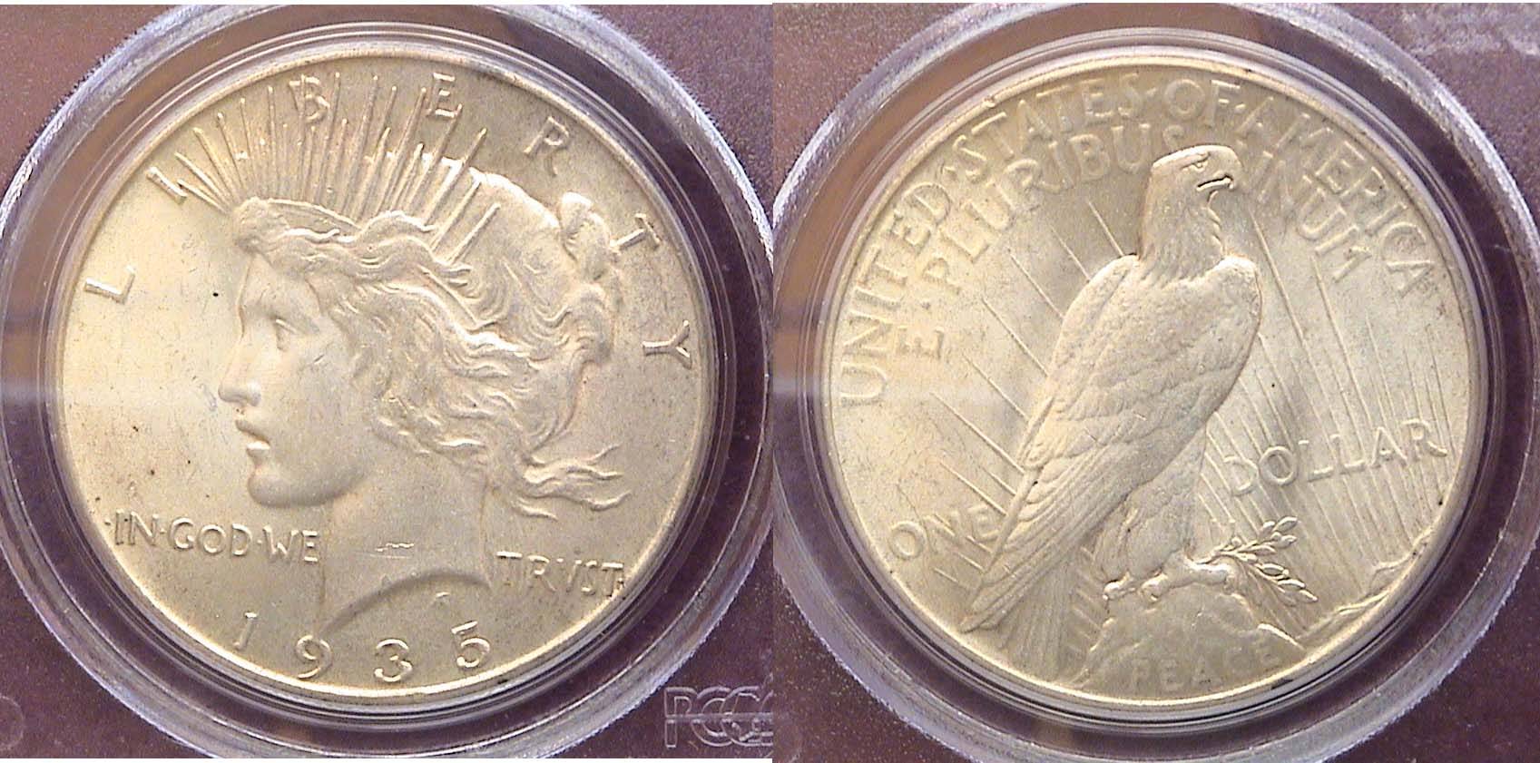

A 1935 Peace $1.00 graded MS-62 by PCGS

The Peace dollar series (1921-1935) has a number of common dates, the 1922-24-P being bar far the most common and least expensive. The 1935-P shown above was acquired at one of our local club shows for a very modest price. The date represents the last actual silver dollar intended for circulation.
____________________________________________________________________________________________________________________________

Acquire Quality Coins
By Harry Garrison

The purpose of this article is not to “win friends” but encourage collectors to rethink their collecting habits and strategy. What follows is based on my experience with uninformed collectors over the years. Some collectors may choose not to agree with my observations but in many cases the coin club member reading this may be you and here’s why.

As a dealer for over twenty-five years I have bought and apprised hundreds of collections. While occasionally I get to work with the collectors themselves, in most cases I buy from their heirs. They know little to nothing about the coins except that they might have some value. Being an ethical person I always try to be as fair as possible, especially knowing that the sellers are unaware of whether the collection is worth $750, $7,500 or $75,000.

When evaluating a collection, (generally in ten seconds), I am aware of whether the individual who formed the collection was a serious collector or just another run-of-the-mill accumulator. If the coins are housed in inexpensive blue holders it can still be an excellent collection, but chances are it is liable to be just more “junk”.
So, what am I looking for? Simply put, it is better dates and/or better grade coins. Lots of collections used to be taken out of circulation, especially before the clad era when one could still receive silver in change, but even today one can acquire interesting and better date material if they have a strategy and not just stuff coins in a hole. Another problem is coming across accumulations of many miscellaneous items having no relation to each other or purpose. Such collections indicate impulse buying made by someone who had some extra cash, attends a show or goes to a coin shop and feels compelled to make a purchase rather than return home empty handed. Every collector should have a purpose and goal along with an ongoing process of review and upgrading.

When evaluating a collection I search for key dates and higher grade coins. Finding these demonstrates that the collector recognized that there were better coins available. If, on the other hand, I see coins with stains, corrosion, rim nicks, holes or even worse, a counterfeit, I realize that I am dealing with another uninformed individual who acquired a lackluster collection of little value.

Now, I’m not saying one has to be well-heeled to have a good collection. We all have our financial limits. But if you collect “junk”, it will always be “junk”. On the other hand, if you work within your budget, remain focused with a specific collecting plan; both you and your heirs will be much happier when the collection is liquidated.

So, the next time you have to make a choice between a so-so uncirculated or near uncirculated coin priced at $10 or a Gem Uncirculated coin for $50, spend the extra dollars. A few extra bucks more for a nicer coin will have a bigger impact on the value of your collection with its final disposition.
______________________________________________________________________________________________________________
Harry Garrison is President of the Trenton, NJ Numismatic Club and the proprietor of Colonial Valley Rare Coins. The article first appeared in the June, 2008 issue of the TNC Club Newsletter, Evan Greenberg, editor.
Club News
(Continued from page 1, column 1)

While the club usually meets on the second Thursday of the month, the January meeting was moved up to the first Monday which fell on January 5 allowing for a some of our active club members to attend the Florida United Numismatists (FUN) Show in Orlando, Florida on January 8-.11. Treasurer Pat James reported a treasury balance OF $1,278.71 with all expenses paid. VP Jim Barry announced the Road Show will be held earlier than usual, Sat. Feb. 21 in the hopes that more of the public will bring in coins for appraisal than last May’s similar event. President Willie Simon asked members to submit ideas for club activities that they would like and to submit articles for the newsletter or a simple Buy, Trade or Sell ad which is free.

There were two Show & Tells. Jim Barry brought in a 1754 Pillar dollar (8 Reales) recovered from the sunken French ship, Le Auguste that was sunk by the British during the French and Indian War and later recovered in 1777. Arno Safran brought in a complete year set of 1939 P, D & S Brilliant uncirculated US coins that were issued 70 years ago; each group consisting of five coins that included the long obsolete Mercury dime and Walking Liberty half dollar housed separately in P, D & S Lucite holders.
The Program

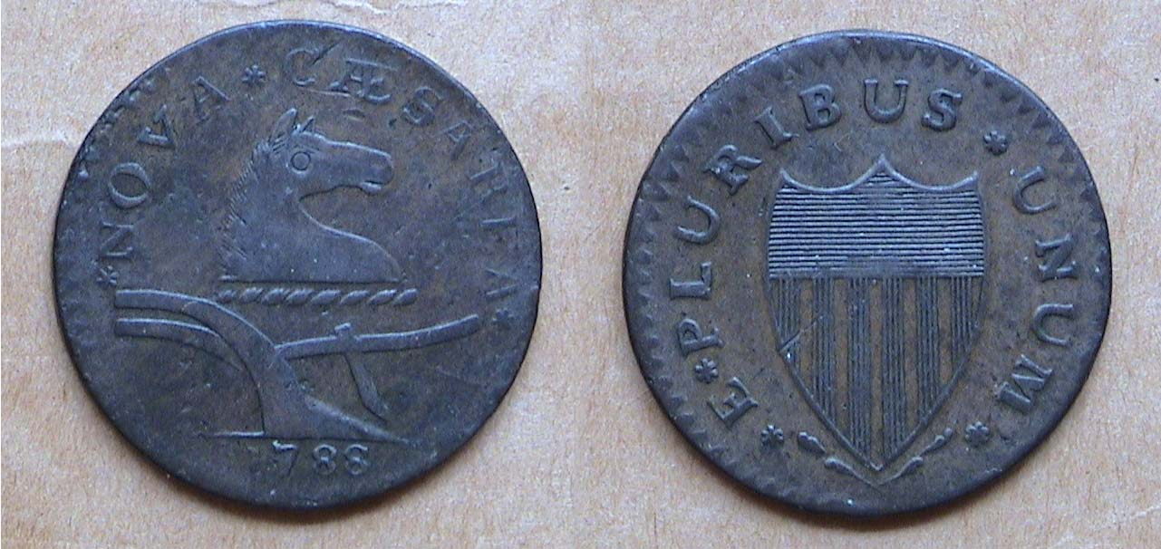

A 1788 dated Jersey Copper Maris M-67v

The Show & Tell was followed by a wonderful program on US Colonial coppers presented by Jim Barry. Jim explained that when the second Continental Congress ratified the Articles of Confederation (1782-89) the newly named United States had to deal with a $200 million cost of the Revolution which was equivalent to $1 trillion today. Much of the commerce existed as barter trade and state coinage was needed. The Articles provided for the production of Federal and State coinage. Of the original thirteen colonies five began issuing half-penny size copper “cents”. These included:

Connecticut (1785-88) which was inscribed “Independence and Liberty”. The obverse design displayed a Laureate head, the reverse, the Goddess of Liberty. Most coins were crudely struck.

New Jersey (1786-88) which was inscribed “Nova Caesarea” (going back to the Caesar’s Isle after Julius Caesar’s visit; later renamed Isle of Jersey meaning Caesar). The design featured a horse’s head above a plow on the obverse with a shield on the reverse. These were struck in Rahway, NJ and Morristown, NJ as well as Machin’s Mills, near Newburgh, NY and Elizabethtown, NY.

Massachusetts (1787-88) issued both cents and half cents and was inscribed Commonwealth of Massachusetts showing an Indian standing with bow & arrow with a spread eagle on the reverse. Many of the coins come well struck.

Vermont (1785-88) issued several design types; the most common showing the sun rising behind trees atop the Green mountains over a plow. Both the engravings and manufacturer were crude.

New York – 1787 – These were inscribed Nova Eborac and featured a Laureate Bust on the obverse with seated figure in the style of Britannia on the reverse. This coinage was never officially authorized.

Jim passed around examples from his own collection representing each state, no mean feat since virtually all US colonials are scarce to rare and difficult to acquire in problem-free condition. All of Jim’s pieces were attractive within grade.

21 members and 1 guest attended the January 5 meeting. The prize winners were Helen Barry who won the door prize, a 2009 silver eagle and Marjorie Simons who took the 50/50 - $27.00. Congratulations go out to our two winners. At our upcoming Feb. 12 meeting member Walter Kubilius will present a PowerPoint program on “The coins of Italy”.
_____________________________________________________________________________________________________________________

Kindly Patronize Our Advertisers

