Pres. Steve Kuhl
V .P. James Barry
Sec. Helen Barry
Treas. Sharon Smoot
Sgt. in Arms: Glenn Sanders
The Stephen James
CSRA Coin Club of Aiken
P.O. Box 11
New Ellenton, SC 29809
Web site: www.sjcsracc.org
The SJ CSRA CC now meets on the 1st Thursday of the month at the Aiken Public Library

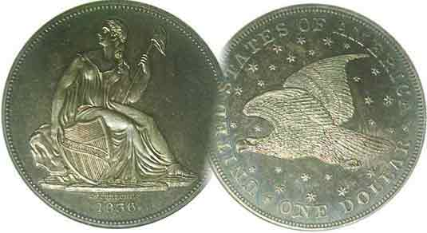
Committees:
Programs: James Barry
2010 Show Chairs: ?
Newsletter: Arno Safran
E-Mail: arnosafran@comcast.net
Auctioneer: Glenn Sanders

2010 Club Meeting Schedule
Volume 9, Number 2 the Stephen James CSRA Coin Club, Founded in 2001 February, 2010
Monthly Newsletter
Jan. Meeting Attendance good despite FUN Show
Our next meeting is on the first Thursday, Feb. 4, 2010 from 6:00 to 8:45 PM

Jan. 7 Apr. 1 July 1 Oct. 7
Feb. 4 May 6 Aug. 5 Nov. 4
Mar. 4 Jun. 3 Sep. 2 Dec. 2
James Barton Longacre served as Chief Engraver of the US Mint from 1844 until his death in 1869, a quarter of a century. He is credited with designing more US coins than any other Chief Engraver yet remains a controversial figure even today among numismatic scholars. His detractors thought his designs were mediocre at best while his supporters admire his fortitude and productivity. One could assemble a short set that would include all nine of his obverse designs.

____________________________________________________________________________________________________________

F.U.N. Show in Orlando Draws SJ CSRA CC Members

According to Sgt. in Arms and Club auctioneer Glenn Sanders, there were around eighteen members present at the January 7 meeting of the SJ CSRA CC. Considering that the meeting coincided with the annual FUN Show held in Orlando drawing a number of club members there, the figure of 18 represents a good showing for the club, especially on a night that the temperature fell bellow freezing.

What makes the FUN show so important to numismatists? There are a number of things. If you are looking for rare, scarce or better date US coin there is no better venue than a large regional show in which to find them. If you are seeking to add to your obsolete paper money collection there will be more dealers who specialize in US and foreign banknotes at such an event than you are ever to find locally. If, like a number of SJ CSRA CC members, you are inclined towards Ancient coinage, a large numismatic event such as FUN will bring dealers from all over the world as well as the US who display a wide inventory of such items. What about tokens and medals? The same rationale applies, for there are more token and medal dealers who set up at FUN than you will find at any South Carolina or Georgia show.

F.U.N. is the acronym for Florida United Numismatists. The state organization currently puts on two shows a year; the big one in early January usually at the Orange County Convention Center in Orlando and an a smaller one in West Palm Beach which draws fewer attendees because most avid numismatists opt to attend the World Money Show sponsored by the American Numismatic Association (ANA) during the summer. There is a saying that “if you cannot find the coin you are looking for at FUN, it probably no longer exists.”

There are other reasons to attend FUN besides just adding to your collection. Educational programs are given by numismatic scholars on a variety of subjects. Meetings are held by specialty collector clubs such as Early American Coppers (no relation to the police), Liberty Seated Collectors, Barber Collectors (nothing to do with haircuts) and collectors of early US silver coinage. Finally there are the wonderful exhibits. Former member Bill Myers took a first place for his exhibit on Foreign Coins struck by the Philadelphia Mint” at this year’s FUN. He sends his regards to everybody in the SJ CSRA CC and wishes the coin clubs in the Tucson, AZ area were as active as ours.
__________________________________________________________________________________________________________________
(More Club News continues on page 4, lower portion of column 2)
James Longacre’s Coins
By Arno Safran
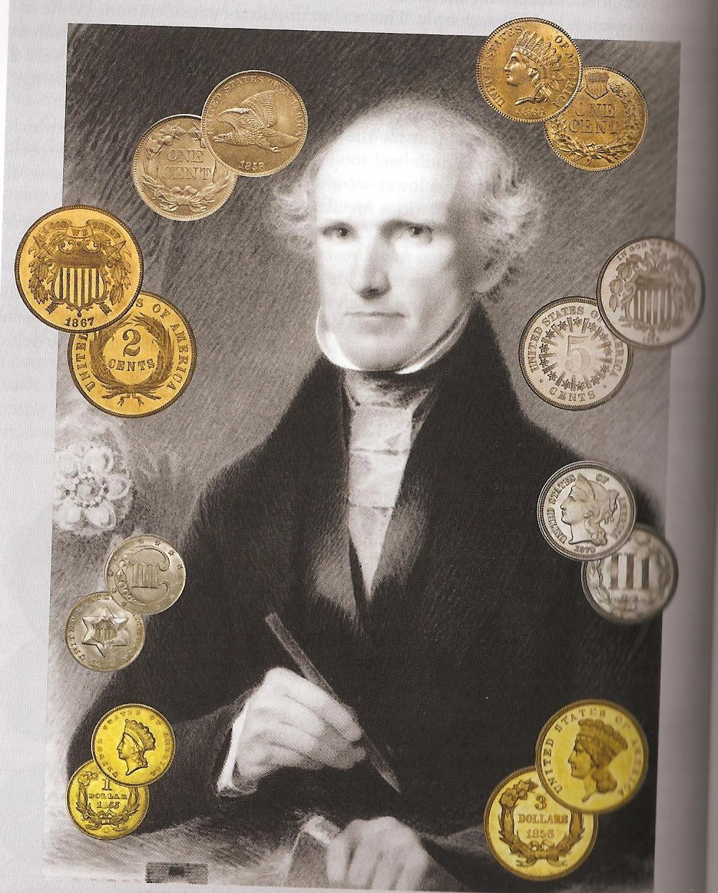

Collecting a Type Set of Longacre’s Coinage Designs

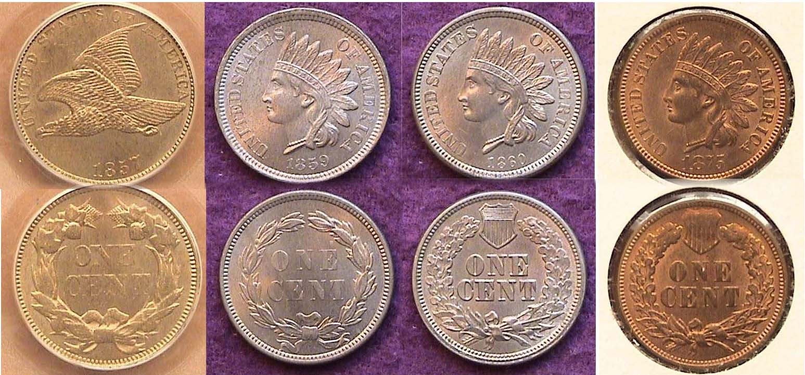

1857 Flying Eagle, 1859 & 1860 CN Indian, 1875 Bronze Indian
[Use 3X glass or magnify to 200% to view details.]

While the cent was not the first denomination Longacre was to design, both the Flying Eagle and Indian Head types are arguably his most popular with collectors. All four cent types shown above are actually the same size, 19 mm in diameter. The Flying Eagle cent at left was the first of Longacre’s approved cent designs. It lasted three years (1856 thru 58) before giving way to the Indian Head design in 1859, a one year sub-type. In 1860, the Laurel wreath was replaced by the Oak wreath with Shield. In 1864 the alloy was changed from copper-nickel to bronze where it remained through 1909. All types are collectible.
________________________________________________________________________________________________________________
(Continued on page 2, column 1)
Collecting Longacre’s Coins
(Continued from page 1, column 2)

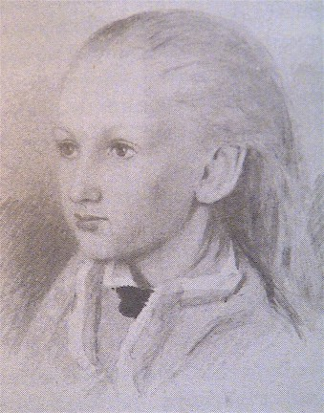
For years, it was believed that Longacre’s daughter, Sarah at age 12 posed in an Indian headdress for the Indian Head Cent but since Sarah was born in 1828 she would have turned 31 in 1859, the year the cent was first issued.
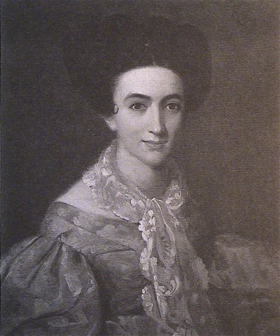
Sarah Longacre at 12

On the other hand, there is a painting of Longacre’s wife Eliza that dates from 1835 which could have served as the source used for the Indian Head cent and the earlier gold coins.
Eliza Longacre in 1835

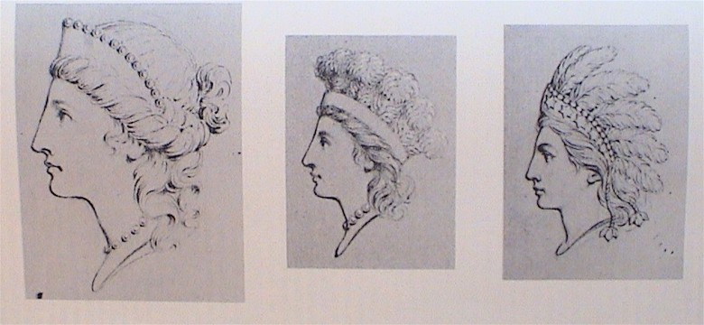

Longacre’s sketches for the gold coins and Indian Head Cent
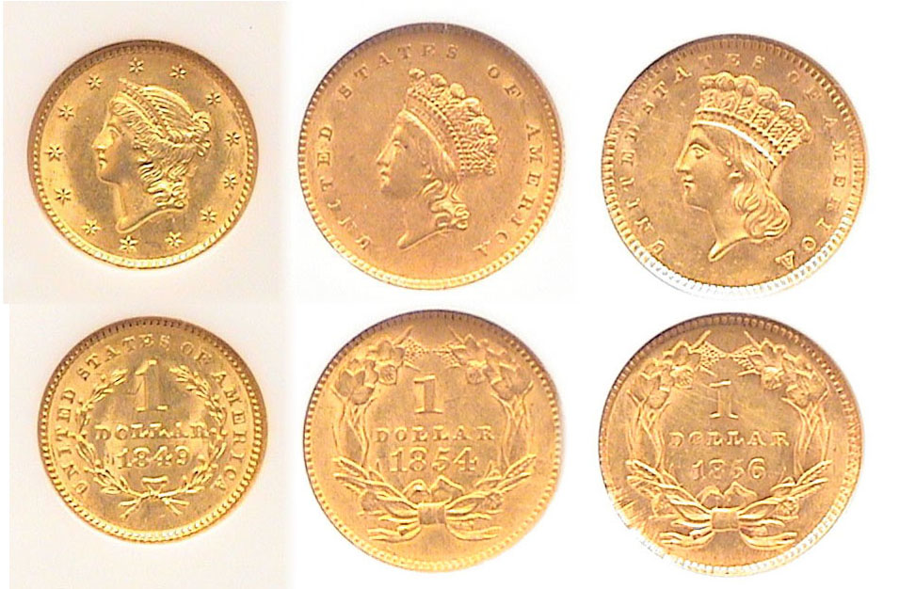
1849 (I), 1854 (II) & 1856 (III) $1.00 gold coin types
Shown in actual sizes
[Use 3x power glass or magnify to 200% to view details.]

The earliest of Longacre’s coinage designs was the $1.00 gold piece first issued in 1849. This was the Coronet Liberty Head design and the smallest US coin ever produced, having a diameter of just 13 mm. That same year a single $20.00 gold piece or Double Eagle with ostensibly the same Coronet Liberty obverse was struck. (Sufficient numbers of the $20.00 gold coin were produced for circulation the following year, 1850). The 1849 $1.00 gold coins produced at the Philadelphia Mint are fairly common. The second type was issued in 1854 and was slightly larger in diameter, 15 mm and known as the Indian Princess “small head” type. The third type was produced two years later in 1856 and is referred to as the “large head” type. The coin has the same diameter but due to the greater ornamentation around the head may appear larger to the eye. The Philadelphia Mint issues of the three dates shown are available to collectors.

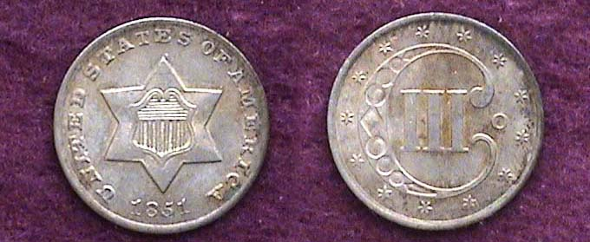

An 1851-O 3¢ silver piece graded AU-55 shown in actual size
[Use 3x power glass or magnify to 200% to view details.]

After gold was discovered at Sutter Mill, not far from Sacramento, CA in 1848--and the subsequent gold rush that followed--the value of silver rose in relation to gold. As a result the silver in our silver coinage made the coins more desirable as bullion than their face value. Soon silver coinage began to disappear from circulation. To fix the problem the government authorized a 3¢ silver coin with a ratio of 75% silver and 25% copper as opposed to the 90% silver and 10% copper that had been the standard. The post office had recently reduced the price of first class mail from five cents to three cents, so the idea seemed practical. The new “trime”--as it later came to be called--was first issued in 1851 at both the Philadelphia and New Orleans Mints; the only year it would be issued at the Louisiana facility and coined through 1873. At 14 mm (just one millimeter more than the type I gold dollars), it represented the smallest US silver coin ever produced. The design was simple enough. The obverse had a six pointed star with a shield in the center surrounded by the legend UNITED STATES OF AMERICA and the date below. The reverse had a large ornate C with a Roman numeral III for 3¢ surrounded by thirteen stars. Aesthetically the type is not very artistic but the coin temporarily provided change until Congress could act anew in 1853 by reducing the amount of silver weight in the half dime, dime, quarter and half dollar

Another Gold Issue

The Act of February 21, 1853 also authorized a new denomination; the $3.00 gold piece. The rationale for this proviso was to facilitate the purchasing of one hundred 3¢ postage stamps with the new coin. The first $3.00 pieces were released in 1854.

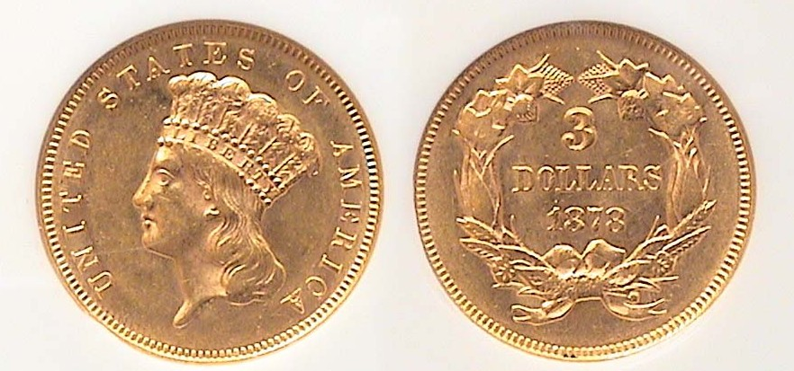

An 1878 3¢ Gold Piece graded AU-58 by NGC sown in actual size
[Use 3x power glass or magnify to 200% to view details.]

For the new denomination, Longacre introduced the same obverse that he would later use on the Type III $1.00 gold coin of 1856. Though never very popular, the denomination would go on to have a fairly extensive run (1854-1889). Only three dates are common, 1854, 1874 and the 1878 shown with most dates having mintages within three or four figures. As with the three $1.00 gold pieces, the $3.00 coin was the only other US coin intended for circulation to have the date on the reverse.
________________________________________________________________________________________________________________
(Continued on page 3, column 1)
Collecting Longacre’s Coins
(Continued from page 2, column 2)

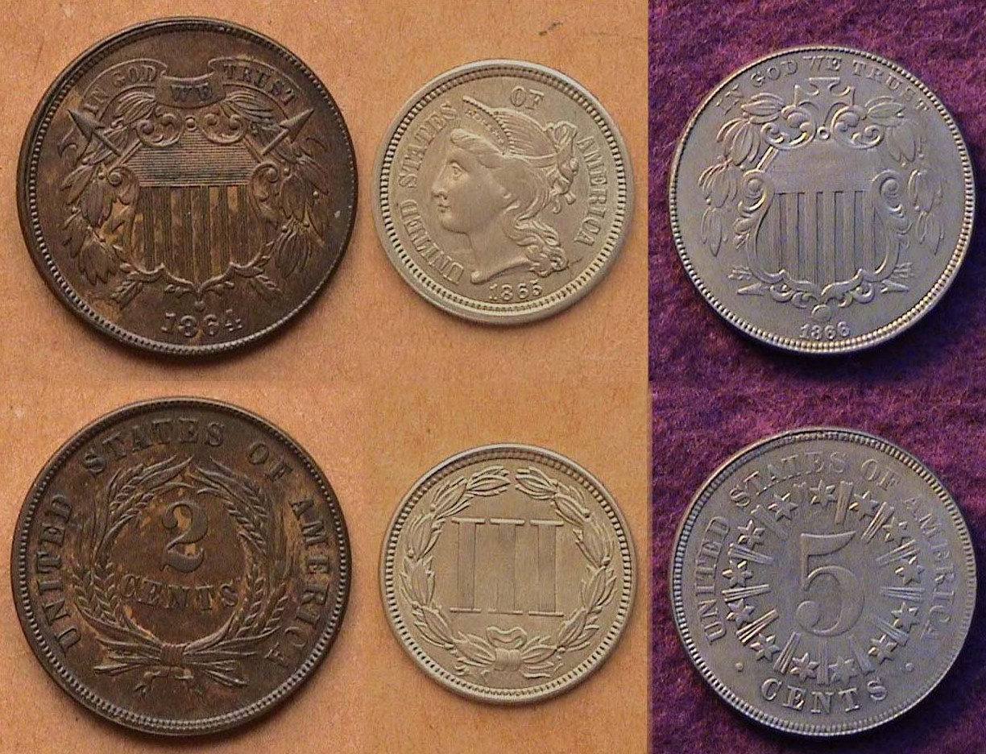

A 1864 2¢, 1865 3¢ nickel & 1866 Shield nickel 5¢
Actual sizes [Use 3x power glass or magnify to 200% to view details.]

During the War Between the States (1861-65) silver coinage became extremely scarce. To make available change, private minters began manufacturing 1¢ size bronze Civil War tokens dated 1863, many with Indian Head type obverses. These adversely affected the bone fide copper nickel Indian Head cents (1860-64). Something had to be done.

In 1864 all copper-nickel cents were replaced by Bronze issues thus driving out the Civil War tokens. The same year a new 2¢ coin was introduced. Due to the extensive lobbying by nickel magnate Joseph Wharton, Congress also authorized two new nickel alloy coins; a 3¢ nickel struck in 1865 (in addition to the 3¢ silver coin) and the first 5¢ nickel in 1866.

Chief Engraver Longacre became busy once again and produced relatively ordinary coinage designs for the new issues back to back to back; a Coronet Liberty for the 3¢ nickel piece--somewhat reminiscent of his 1849 $1.00 and $20.00 coin--but not nearly as attractive. For the 2¢ and 5¢ pieces, he produced a Shield obverse. The motto, IN GOD WE TRUST was placed above the Shield on the 2¢ and 5¢ coin but not on the 3¢. The three coins were initially successful in overcoming the coinage shortage although it was primarily the fractional small size banknotes ranging in value from 3¢ to 50¢ first authorized in 1862 that substituted for coin in making change until the mid 1870’s when silver coinage began to circulate freely once again. The initial dates of the 2¢ and 3¢ coins shown above are fairly common, but if you are looking for a Shield nickel that is inexpensive the earliest common date is the 1867 without rays on the reverse.

Longacre’s majestic $20.00 Gold double Eagle

One can not discuss Longacre’s output without mentioning the $20.00 gold double eagle, the new denomination that was first coined for circulation in 1850 with more than one million struck. The obverse design portrays Miss Liberty looking left wearing a Coronet stylized crown surrounded by thirteen stars. It is very similar to that of the type I 1849 thru 1854 $1.00 coin. What gives the Double Eagle its majesty is the reverse showing the Great Shield amidst a resplendent eagle linked by ornate scrolls housing the motto E PLURIBUS UNUM. Above the eagle’s head are thirteen stars positioned in a wide oval with rays emanating upward. The upper half of the reverse is surrounded by the legend UNITED STATES OF AMERICA with the denomination spelled out below. The highest denomination $20.00 gold coin is unquestionably Longacre’s greatest achievement as Chief Engraver and while not as magnificent as the Saint-Gaudens double eagle that succeeded it in 1907 is arguably one of our better coinage designs.

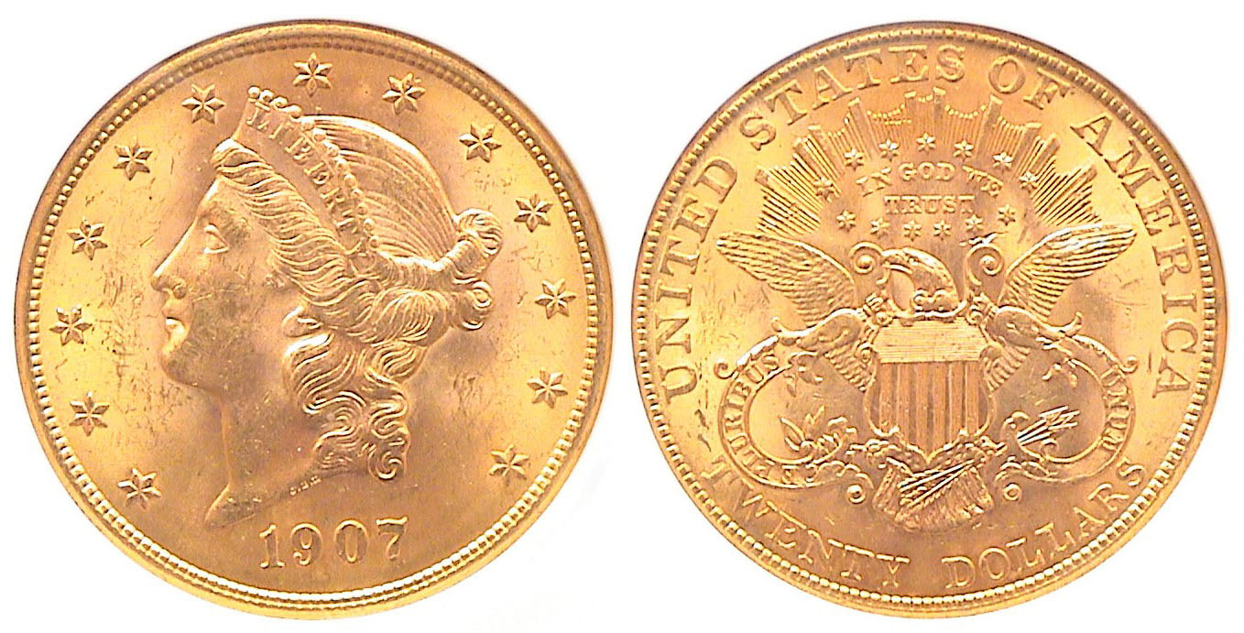
A 1907 Coronet $20.00 Double Eagle (actual size)
[Use 3x power glass or magnify to 200% to view details.]

During its 58 year lifespan (1850-1907) Longacre’s $20 coin underwent three modifications, all on the reverse. From 1850 through 1866-S, the denomination was engraved as TWENTY D; from 1866 through 1876, the motto, IN GOD WE TRUST was inserted below the rays inside the thirteen stars above the eagle and from 1877 to 1907, the denomination was spelled out as TWENTY DOLLARS. With the price of gold around $1,100 an ounce today, the $20.00 and the $3.00 gold coins may be above the discretionary income of many collectors. If one wishes to merely assemble a complete obverse type set of Longacre designed coins, these are more affordable over time.

A Chronological Listing of Longacre’s Coinage Designs
-Affordable major obverses are highlighted in bold type-

1849 $1.00 gold piece, Coronet design 13 mm
1850 $20.00 Double eagle, Coronet o, Eagle/ shield r 34 mm
1851 3¢ silver piece, six pointed star .750 silver, .250 copper
1854 $1.00 gold Indian Princess small head, 15 mm
1854 $3.00 gold Indian Princess, large head, 20.5 mm
1856 $1.00 gold Indian Princess, large head, 15 mm
1857 1¢ Flying Eagle, o, wreath of four items, r, copper nickel, 19 mm
1859 1¢ Indian Head o, Laurel wreath r, copper nickel, 19 mm
1860 1¢ Indian Head o, Oak wreath & shield r, copper-nickel
1864 1¢ Indian Head, Bronze
1864 2¢ Shield o wreath r, Bronze 23 mm
1865 3¢ Coronet o, wreath III r, nickel, 17.9 mm
1866 5¢, Shield o, 5 inside circular bars, rays r, nickel 20.5 mm

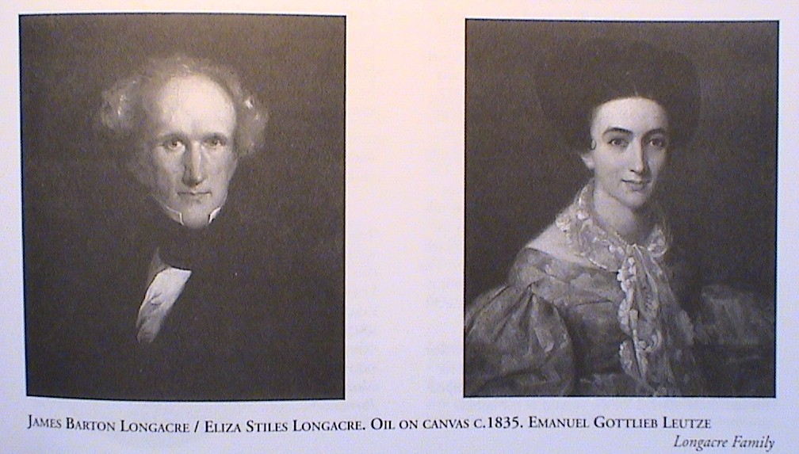

The Longacre’s [Use 3x glass or magnify to 200% to see details.]
__________________________________________________________________________________________________________________________

Unusual Community Scrip
By Bill Myers

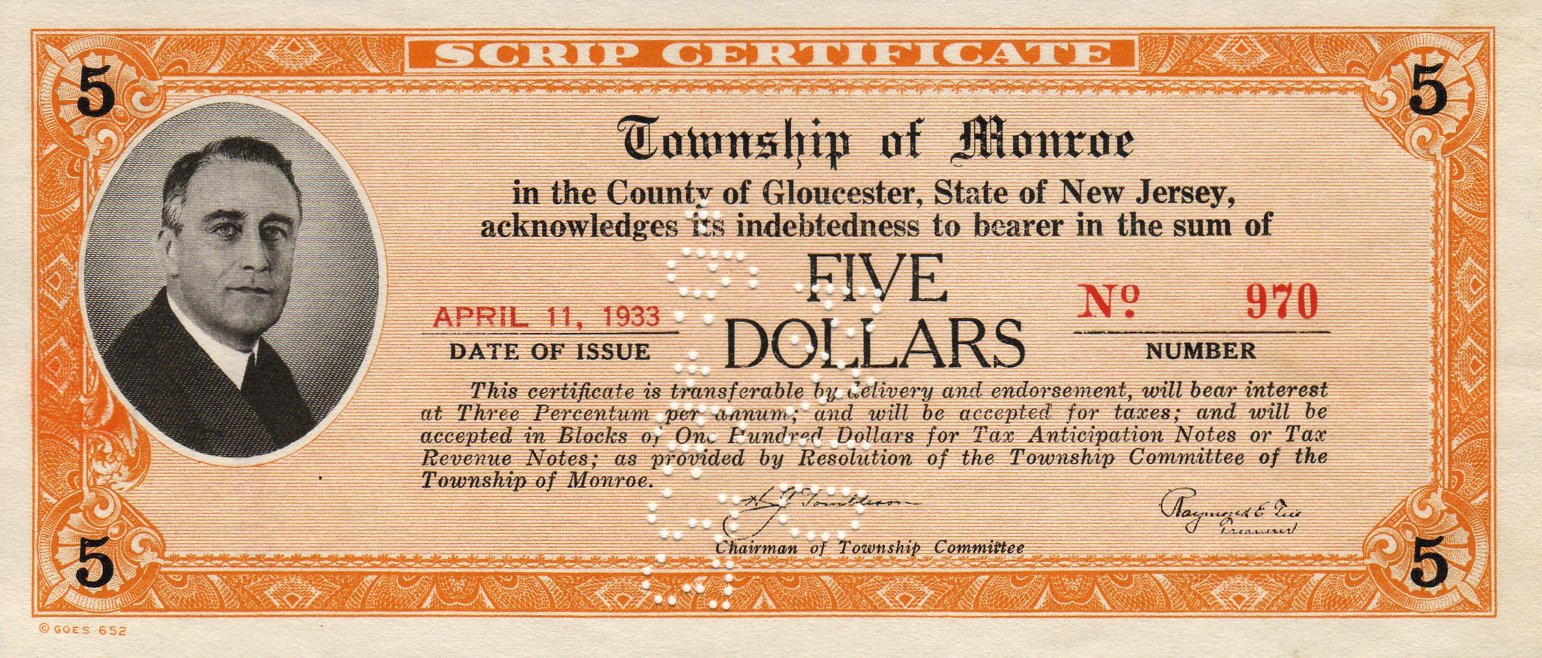

1933 Depression Scrip showing President Franklin Roosevelt at left
A $5.00 note issued in April, 1933 a month after FDR’s inaugural in Monroe Township, Gloucester County, New Jersey
[Use 3x glass or magnify to 200% to see details.]

Scrip is a term used to describe a substitute for currency. Scrip has been issued for many years, but there have been certain times when there was significant number of issues. The Depression era, for example, produced a large variety of scrip. Scrip was often created due to the lack of circulating currency available in an area, but has also been used to pay employees and to promote community unity. Companies, such as mining and logging companies, have paid their employees in scrip, which forced the workers to buy their goods at the company store, as the scrip had no value elsewhere. Recently communities have issued scrip to encourage support of community businesses as the scrip is only valid in stores in the community where issued. Ithaca, NY issued scrip that is very well known. Salt Spring Island in Canada has issued some very beautiful notes.

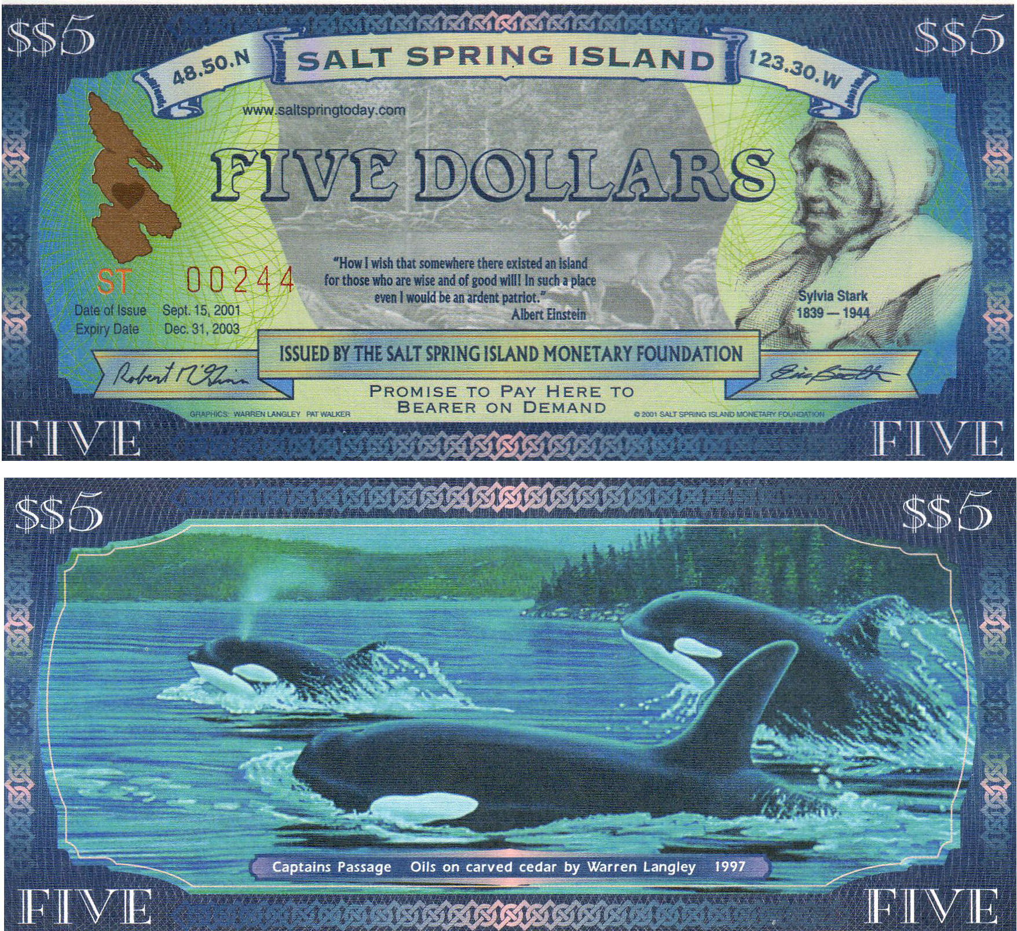

Canadian $5.00 scrip issued by Salt Spring Island
From Sept. 15, 2001, through Dec. 31, 2003
[Use 3x glass or magnify to 200% to see details.]

Most of the scrip issued is in the form of paper notes, but metal, wood and even seashells have been used. These varieties are collected by many numismatists.

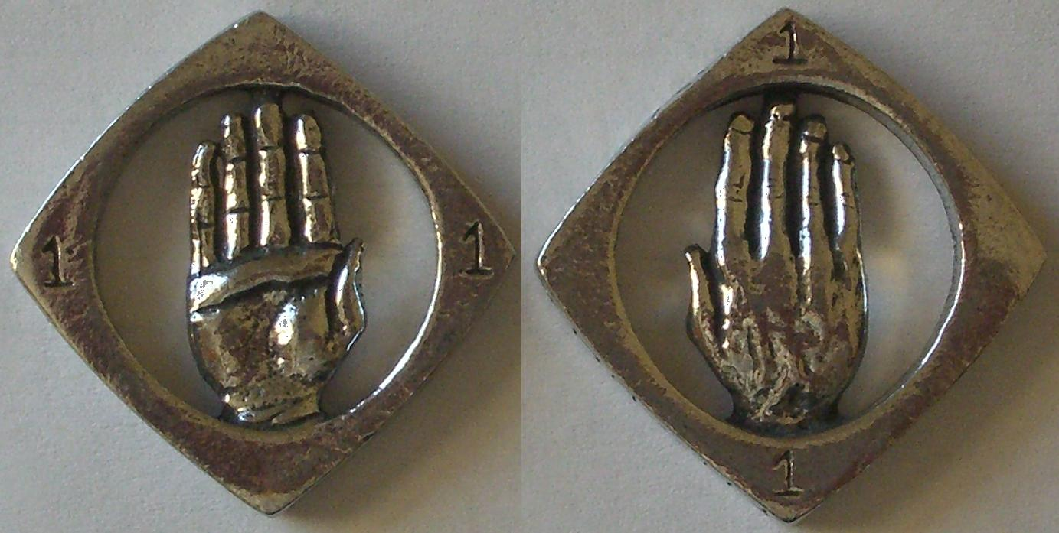

Metal Scrip showing Hands in the amount of $1.00
Issued on Independence Day, 2009 in Phoenix, AZ
“In Art We Trust”

I recently came across a very interesting issue of community scrip. It was issued on July, 4, 2009 in Phoenix, AZ. It was created by Joey Grether and is called “PHX BUX” and at least 25 businesses accept it. It is composed of metal and has a hand in the center of it. Around the edge is “IN ART WE TRUST PHX BUX”. It has the value of one dollar.

Detail showing edge lettering on token
“IN ART WE TRUST PHX BUX”.
[Use 3x glass or magnify to 200% to see details.]

The tokens are cast in a tree of 10 tokens which are then cut off and finished. Initially 2000 were released but a second batch of 2000 has since been produced.

The scrip interested me for a variety of reasons. It was an interesting numismatic item. It fitted into my topical collection of numismatic items featuring hands and the area where it was released is only a 1 ½ hour drive away from where I now live.

This is just another reminder that there are an infinite number of ways for numismatists to collect, and even on a small budget there are many interesting items out there.
_______________________________________________________________________________________________________________________
Thanks, Bill for another superb little “gem” of an article, ED.

Important Club News

President Kuhl reported that as of the December, ’09 Board Meeting, the Barry’s announced that they will be stepping down from the Executive Committee at the end of the current term which ends March 31, 2010. This means that the Club Nominating Committee will have to find members who are willing to run for the offices of Vice President and Recording Secretary between now and the March election. As everybody knows, both Jim and Helen have been extremely vital to the SJ CSRA CC in a number of capacities. These include arranging for all our meeting programs, the annual Club Road Show, the pre Christmas holiday dinner, recording the club proceedings and membership and the running our annual show. In addition Jim has just completed a two year term as President of the South Carolina Numismatic Association and Helen, who received a national award from the ANA when editor of the Scanner, the SCNA journal, has now been elected to serve on the SCNA Board. So, after eight years on the Executive Committee of our club, the Barry’s have decided to take a well earned rest. Now it is time for other members to pitch in and run for the Board.
________________________________________________________________________________________________________________________
(Club News continues on page 5, column 1)
More Club News
(Continued from the preceding page)

Show & Tell: At the Jan. 7 meeting Howard Hillman brought in a complete Mercury dime set (1916-1945). He related a few stories on how he acquired some of the ‘keys’ such as the 1916-D (Real or unreal? That is still the question!). The ’21-D he traded a gold coin to an Oregon collector in order to get it. A ’25-D he received in answer to a solicitation from Coin World. The ’31-D he purchased from the renowned numismatist, author and major dealer Q. David Bowers. He plucked the scarce 1931-D from a roll of dimes and the 1942/1 from another roll back in the 1960’s.

The Program: President Kuhl ran an American Numismatic Association video with ANA Past President and Red Book editor Ken Bressett speaking on “Consumer Affairs”. Bressett highlighted the differences between advertising accuracy and misrepresentation of numismatic items. Our next program will be on National Bank Notes by guest speaker Robert Moon.

The Treasurer’s Report prepared by Sharon Smoot was read. After expenses for the dinner and prizes presented, the club started 2010 with a balance of $1,397.44. Thank you, Sharon.

The Prize Winners and Auction: Winners at the Jan. 7 meeting were Liz Goergen won the door prize, a silver eagle and YN Austin Kuhl won the 50/50; $15.50 which he used in his successful bids at the club auction. Glenn Sanders ran the auction which received some spirited bidding on a number of items pleasing both the winners and sellers.
_________________________________________________________________________________________________________________

Results of the Club Suggestions Survey

President Kuhl has published the results of the Survey. 15 members or about 3/4 of our average monthly meeting attendees participated; a healthy sign for our club. Here are some of the results: The annual show is among the most popular as are the programs, newsletter and auction at our monthly meetings. The pre Christmas holiday dinner is very enjoyable as an event but should be priced to members at under $15. Dues should be increased slightly and the meetings should be more publicized. Some of the suggested club activities included a “Bring a Kid Night”, a "Seller’s Table night” and a "Wine and Cheese Night” to bring in more members. There were other fine suggestions. Now all we need are a VP, Secretary and Show Chairperson.
______________________________________________________________________________________________________________

Kindly Patronize Our Advertisers
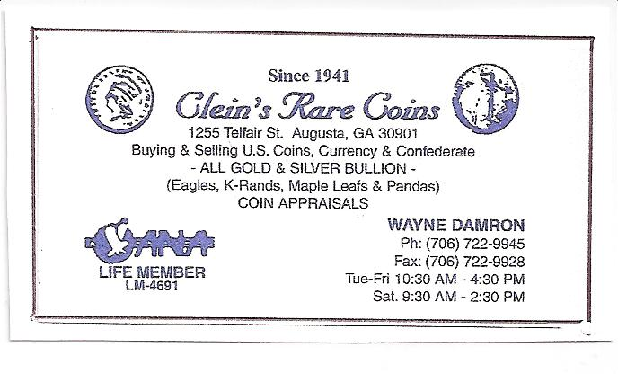
Kindly Patronize Our Advertisers

