Pres. Steve Kuhl
V .P. Arno Safran
Sec. Jim Mullaney
Treas. Sharon Smoot
Sgt. in Arms: Glenn Sanders
The Stephen James
CSRA Coin Club of Aiken
P.O. Box 11
New Ellenton, SC 29809
Web site: www.sjcsracc.org
The SJ CSRA CC of Aiken, SC meets on the 1st Thursday of the month at the Aiken Public Library

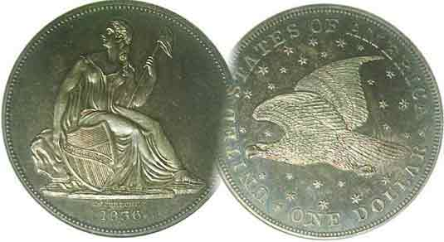
Committees:
Programs: Arno Safran
2010 Show: Jim & Helen Barry
Publicity: Jim Clapp
Newsletter: Arno Safran
E-Mail: arnosafran@comcast.net
Auctioneer: Glenn Sanders

2011 Club Meeting Schedule
Volume 10, Number 2 the Stephen James CSRA Coin Club, Founded in 2001 February, 2011
Monthly Newsletter
Show & Tell Sessions Inspire Other Collectors
Our next meeting is on Thursday, Feb. 3, 2011 from 6:45 to 8:45 PM

Jan. 6 Apr. 7 July 7 Oct. 6
Feb. 3 May 5 Aug. 4 Nov. 3
Mar. 3 Jun. 2 Sep. 1 Dec. 1

____________________________________________________________________________________________________________

Important Aspects of Coin Club meetings: Part One
The Show & Tell

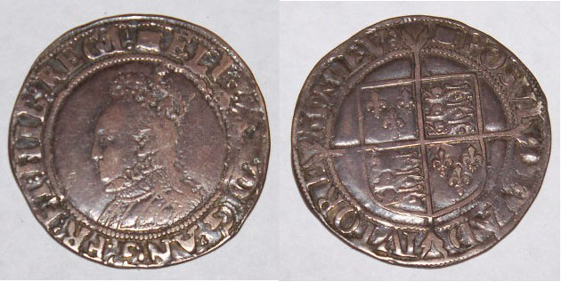

An Elizabeth I Shilling (1858-1603) displayed by Jim Barry
[Use 3X glass or magnify to 200% to see details.]

Shown above is an example of a recent Show & Tell Jim Barry brought in to one of the area club meetings. It is a significant coin historically because under Elizabeth I, the first shillings were supposed to have been struck. My first experience with Show & Tells occurred back in 1983, when I was asked to give a program at a distant coin club. As I entered the hall I noticed long rectangular tables set up with ten chairs positioned around them. I soon learned that this arrangement was designed to allow the members to bring in some of their coins to display and tell the group something about them. After I presented my program, I remained to see what the members brought in. Of the 40 persons present, at least 15 people displayed everything from obsolete type coins to tokens and medals. I was impressed.

A year later, I joined another club that devoted almost their entire meeting to an extensive Show & Tell. Through such experiences I learned about US colonials, die varieties of early US coins, ancients including Byzantine, and later-foreign coins. As a result, I soon began to assemble Latin American coin sets that were once legal tender in the US, eventually moving into collecting obsolete Latin American currency. Collecting these different types of numismatic items would never have occurred to me had I not seen some of them displayed at the various Show & Tell sessions at these clubs. I think coins such as the one pictured above from our own members represent a positive development for our club. At our upcoming Feb. 3 meeting member Rick Owen plans to bring in a special Show & Tell.
__________________________________________________________________________________________________________________________
(Club News continued on page 2, column 1)
The US Coinage of 1816: 195 years ago
By Arno Safran

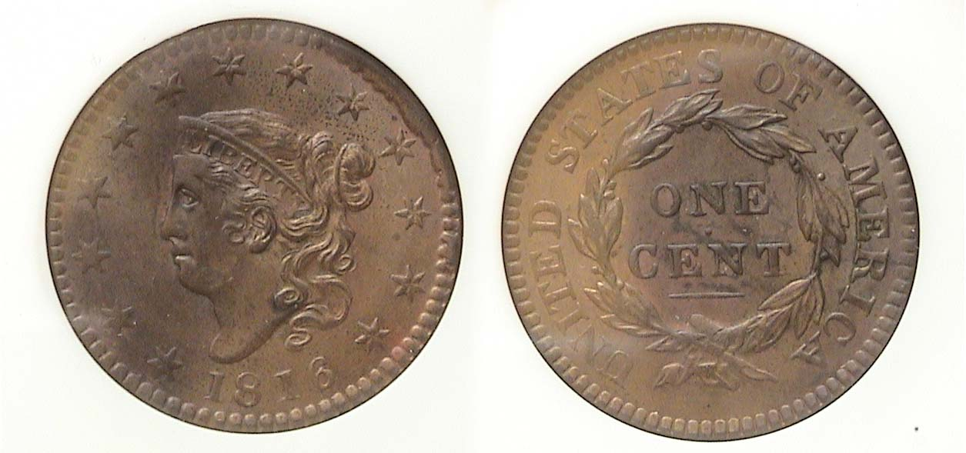

An 1816 Coronet Large cent (First year of issue) graded MS-64 by NGC
[Use 3X glass or magnify to 200% to view details.]

Pictured above is a complete 1816 year set of the US coins. Only one denomination? How was this possible? Anyone familiar with the US history of this period will recall that between June 1812 and Dec. 24, 1814 (when the Treaty of Ghent was signed), the US became embroiled in another armed conflict with Great Britain. Up until the start of war, the US Mint in Philadelphia was obtaining its copper blanks with which to strike large cents and half cents from the firm of Matthew Boulton that was located in Soho-Birmingham, England. Before the War of 1812 it took weeks for the shipments to arrive but once the hostilities broke out all shipments ceased. By 1815, the supply of copper planchets had dried up. No 1815 dated cents were made for the only date break between 1793 and the present year. The only coins the US Mint struck that year were the new Capped Bust type Quarter, dormant since 1807, the half dollar and the $5.00 half eagle of which only eleven pieces are known.

.The first shipment of copper planchets from Boulton’s firm arrived in December of 1815 and the Mint immediately began striking cents but with the new Coronet obverse design now believed to be by the Asst. Chief Engraver John Reich (according to numismatic scholar, Robert W. Julian). Since it was so late in the year, the Mint decided to put the next year’s date, 1816 on the obverse. The reported mintage for the 1816 cent was 2.8 million and is moderately priced from VG-8 to AU-58. In January of 1816, a fire broke out at the Mint that destroyed much of the machinery with the result that technically no US coins were actually produced in that year.
____________________________________________________________________________________________________________________

Club News of the January 6 Meeting

According to Secretary Jim Mullaney, President Steve Kuhl gaveled the meeting to order at 6:50 PM. Sgt. in Arms Glenn Sanders reported that 12 members were present (11 adults and 1 Junior). There were also six guests, Steve Nix, recently installed President of the Augusta Coin Club, Joe Dyches, Sonia Hillman, Ken Lake and Jack and Carrie Cooksey which boosted the total to 18. It was nice to see the additional people inasmuch as several regulars had to miss the first meeting of 2011 in order to attend the Florida United Numismatists (FUN) Show in Tampa. Along with the American Numismatic Association’s “Worlds Fair of Money Show held during the summer, the FUN show is the largest of the Winter. For serious collectors, it has been said that if you cannot find the numismatic item you are looking for at FUN, it probably no longer exists. The Treasurer’s Report revealed that as of the end of 2010, the SJ CSRA CC balance was $2,016.52, a nice healthy figure. President Kuhl reported that the December Club pre-holiday dinner was very well attended and enjoyed by all.

For Show & Tell, Howard Hillman brought in some German tokens issued by the Weimar Republic. The program, “Odds and Ends – The Non Statehood Quarters of 2009” was presented by member Todd Starbuck. Todd was the sixth member to present a program during the club’s still ongoing fiscal year which runs through March 31, 2011. Dues of $12.00 will be due starting on April 1; no fooling.

The prize winners were Marjory Simons who won the door prize and Glen Sanders who received $21 as the 50/50 winner. YNs Austin Kuhl drew a 1968-S Jefferson nickel from the Junior grab bag and Jack Cooksey drew a 1911 cent. Congratulation to all the winners.

The Editor would like to thank Secretary Jim Mullaney for supplying him with this report. Our next meeting is Thursday, February 3, starting time 6:45 PM although early arrivals may enter the library meeting room by 6:15. Remember to please bring in something for Show & Tell. Arno Safran will present a PowerPoint program on Small size Mexican Banknotes produced for the Bank of Mexico by the American Bank Note Company. Most of the notes feature some of the principle figures related to the Mexican War of Independence (1810-22) which occurred a century earlier than the Mexican Revolution..
_________________________________________________________________________________________________________________________

Kindly Patronize our Advertisers

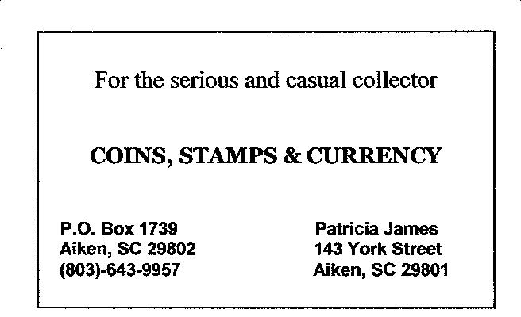
The Copper Corner

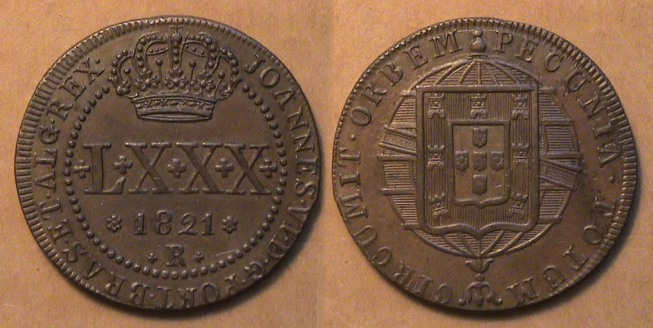

An 1821 80 Reis copper coin of Brazil struck at the Rio Mint
[Use 3X Magnifying glass or magnify page to 200% to see details.]

During the reign of King Joao VI of Portugal, at least four regular copper denominations were struck in Brazil, the 10 Reis, 20 Reis, 40 Reis and 80 Reis. None of these pieces, even in grades of EF to AU are unduly expensive. The 80 Reis shown, about the size of a Morgan dollar is a handsome coin. The R below the date signifies the mintmark for Rio de Janeiro. In 1821 the coin had the value of close to 8½¢ in US coinage.
_____________________________________________________________________________________________________________________________
