Pres. Steve Kuhl
V .P. Pat James
Sec. Jim Mullaney
Treas. Sharon Smoot
Sgt. in Arms: Glenn Sanders
The Stephen James
CSRA Coin Club of Aiken
P.O. Box 11
New Ellenton, SC 29809
Web site: www.sjcsracc.org
The SJ CSRA CC of Aiken, SC meets on the 1st Thursday of the month at the Aiken Public Library

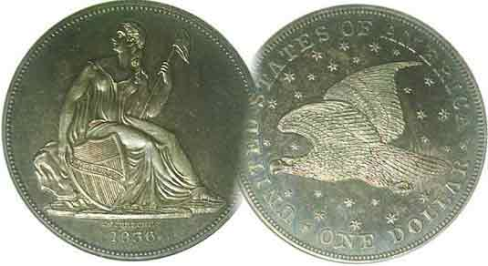
Programs: Pat James
Show: by Committee
ANA Representative: Jim Barry
Publicity: Jim Clapp
Newsletter: Arno Safran
E-Mail: arnosafran@comcast.net
Auctioneer: Glenn Sanders
Web site: Susie Nulty (see above.)

2012 Club Meeting Schedule
Volume 11, Number 2 the Stephen James CSRA Coin Club, Founded in 2001 February, 2012
Monthly Newsletter
A Coin’s Condition is not the same as its Grade
Our next meeting is on Thursday, February 2, 2012 at the Aiken Public Library

Jan. 5 Apr. 5 July 5 Oct. 4
Feb. 2 May 3 Aug. 2 Nov. 1
Mar. 1 Jun. 7 Sep. 6 Dec. 6

______________________________________________________________________________________________________

Grade vs. Condition: An Editorial

Since a collector’s discretionary income affects one’s decision-making process when it comes to buying a coin, the old adage, “Buy the highest grade coin you can afford” has often been suggested. That said a coin’s grade alone does not automatically represent its true value unless its “condition” is taken into consideration. Let us say you are seeking a particular coin type to add to your collection. In a dealer’s case, you find three examples. One is graded Fine, another, VF and a third, XF. Logically, the dealer wants the most money for the XF but is it the most attractive of the three? This happened to me a while ago when I was seeking to add one of the key dates of the Barber Half dollar series to my collection; the 1904-S. This date is considered one of the toughest to find in Fine or better. It was back in 2003 at the SCNA convention held in Greenville, SC. A dealer who specialized in the series had not one but three “raw” 1904-S Barber halves in his case, one atop the other. Naturally, the highest graded specimen was on top. It was graded XF and priced accordingly, very expensive. The problem was the coin looked washed out from an old cleaning intended to make it look lustrous. The middle coin was graded VF and while it looked more “original” it had some distracting marks on the surface with a rim nick to boot. The bottom coin was graded Fine. It had a natural gray appearance commensurate with its age and decent surfaces. All seven letters in LIBERTY were visible, if barely, yet the overall characteristics of the coin matched the assigned grade. It was priced well below the other two yet had the nicest appearance of the three, and so, after ten years of searching, I finally found a Fine-15 specimen.

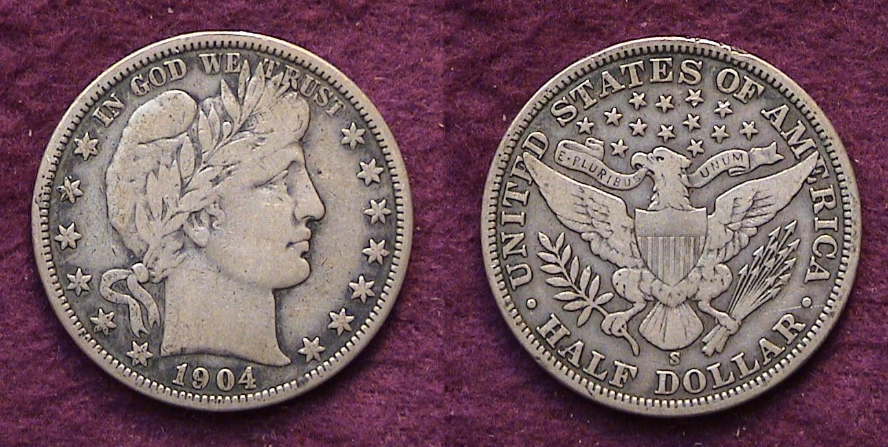

A 1904-S Barber Half-dollar graded Fine-15
[Use a 3X magnifying glass or magnify page to 500% to view details.]
____________________________________________________
The Case for Buying Certified Coins: Part 2
Quarters: By Arno Safran

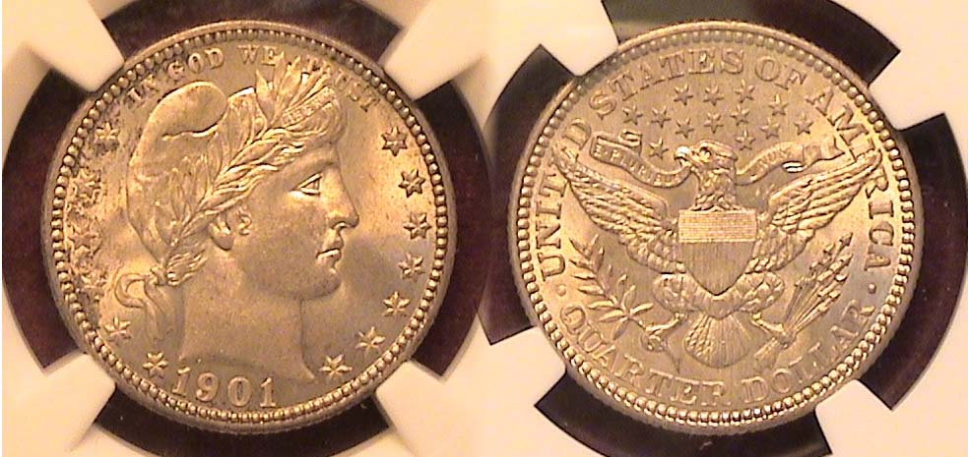

A 1901 Barber Quarter graded MS-64 by NGC
[Use a 3X magnifying glass or magnify page to 200% to view details.]

Make no mistake about it. Attractive obsolete type coins can be expensive, especially if they are uncirculated. Not all uncirculated coins are “problem free” or without some blemishes and with third party certification, the collector is supposedly assured that when he or she acquires a Barber quarter grading MS-64 like the one show above the coin should have fairly clear surfaces, original luster and possibly a better than average strike. The coin pictured has beautiful smooth surfaces, an extremely sharp strike and wonderful natural color. Then why wasn’t this coin graded MS-65? Upon magnification to 200%, one will observe a thin greasy film toning at the upper left stars into the motto IN GODS WE TRUST. This coin could have been graded either way, a 64 or a 65 depending on who examined it. Some like toning. Some do not. This specimen of the 1901 Barber quarter was acquired at the FUN Show in Orlando, FL earlier this month, but suppose this was not 2012 but 1982, some four years before the age of professional third party certification and was offered “raw” by the dealer as a MS-65 or even higher because it looked so pleasing to the eye. A collector who had it certified years later would not only be disappointed at the MS-64 grade but could have lost some money in the process. Despite explicit books on grading approved by the ANA, the grading of coins has always been and still is considered an art, not a science. While there are a number of certified coins that both dealers and collectors alike have considered to be overgraded, it is far better to buy a slightly under graded certified coin than a “raw” overgraded one. If a coin is $200 or more however, choose a certified specimen.
_____________________________________________________________________________________________________________________
(Continued on page 2, column 1)

The Case for Buying Certified Coins: Part 2 – Quarters
(Continued from page 1, column 2)

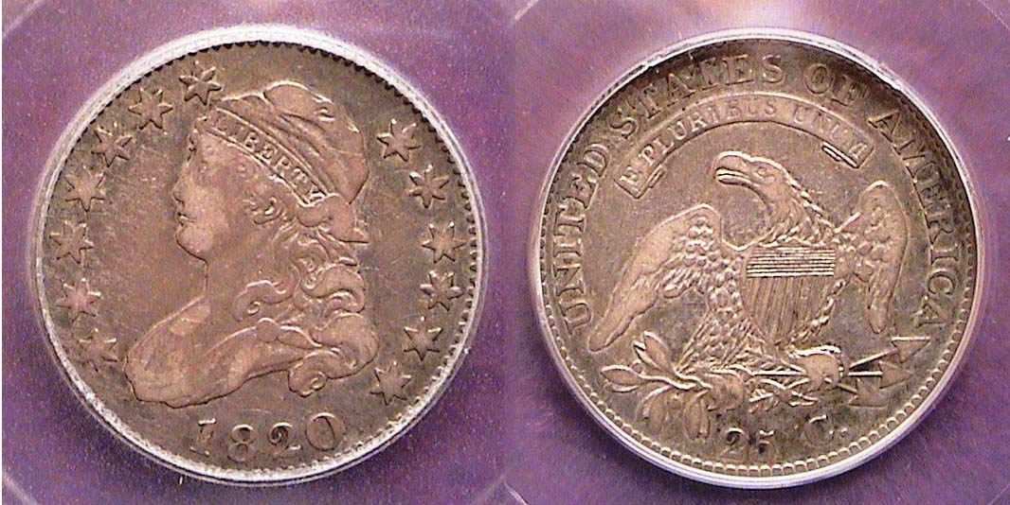

An 1820 large size capped Bust Quarter B-3 R3 certified VF-20
[Use a 3X magnifying glass or magnify page to 200% to view details.]

The 1820 Capped Bust quarter pictured above was acquired “raw” via the Internet from a reputable firm. It was graded VF-25 by the dealer who also attributed the coin as a scarcer variety. The B-3 die variety (for Browning, who wrote an early treatise on Bust quarter varieties) is briefly characterized as having large stars, a medium size zero in the date and the lowest star at the right as below the beginning the curls. It used to be categorized as a Rarity 4 (very scarce with only 76-200 known) but in the latest source, “Early United States Quarters: 1796-1838) by Steve Tompkins (2008) it is now deemed a R3 (scarce with 201 to 500 pieces known). I considered this an important enough variety to add to my collection and although it was uncertified, it appeared original and problem-free and graded accurately. Still, I wanted to make sure, so I sent it out for certification and it came back a VF-25. While certification does not “improve” a coin’s appearance regardless of the grade assigned, it provides the collector with more financial security when it comes time to sell.

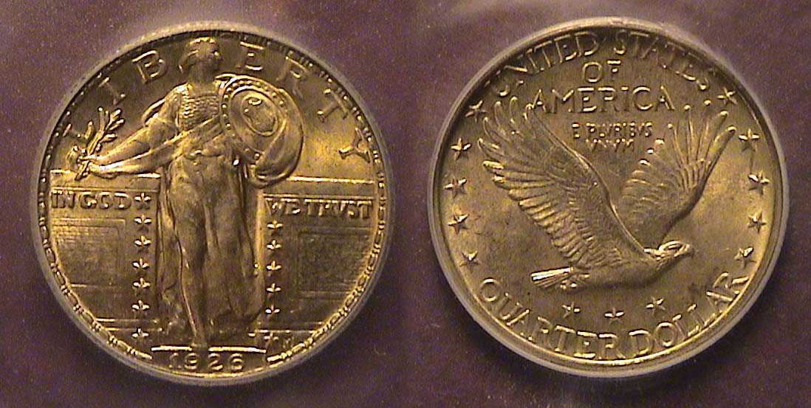

A 1926 Standing Liberty Quarter certified by ICG as a MS-64
[Use a 3X magnifying glass or magnify page to 200% to view details.]

The Standing Liberty quarter (created by Hermon MacNeil and coined from 1916 thru 1930) is arguably one of our most beautiful coinage designs. The 1926 example pictured above was acquired at the Blue Ridge Numismatic Association show held in Dalton, GA last August. It was housed in a stapled flip and graded MS-64 yet priced as a common date (despite surfacing far less often than the ’26-D). The coin appeared attractive due to its original, if slightly darker toning. At the show, it was submitted for certification to ICG and came back graded MS-64. Many SL quarters appear blast white--indicating that these specimens may have come from old rolls of uncirculated coins and “dipped” at one time--so finding one that is “original” is not easy.

The Liberty Seated quarter series has been thought to be underrated by collectors compared with other denominations. It was initially designed by Christian Gobrecht and had a considerably lengthy run (from 1838 thru 1891). During its 54 year, tenure the design underwent a variety of minor changes. Before 1854, it was struck at both the Philadelphia and New Orleans (O) Mints, after 1854 at the San Francisco Mint (S) and from 1870 thru 1878 at the Carson City Mint (cc).
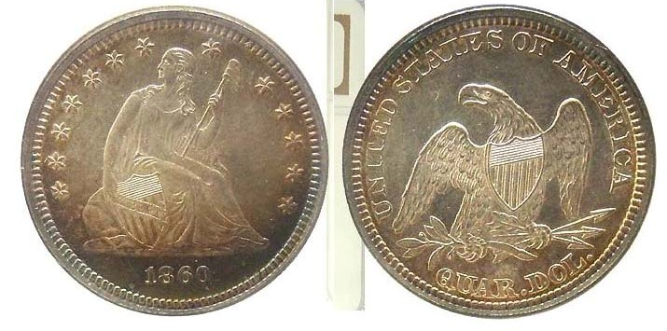
An 1860 Liberty Seated “no motto” quarter graded MS-63 by NGC
[Use a 3X magnifying glass or magnify page to 200% to view details.]

With a mintage of 804,400 the 1860-P Liberty Seated Quarter could hardly be called a scarce date, let alone rare, but it isn’t as common as any of the seven preceding dates` struck at the Philadelphia Mint which were issued well in the millions. Still, it is priced as a common date. This certified MS-63 example shown above was found on the web site of a national dealer. Although it was imaged, I wanted to see it up close and personal and was fortunate to find it still available at the 2011 FUN show held in Tampa, FL little over a year ago. To my pleasant surprise, the coin looked exactly as it was pictured displaying reflective surfaces along with its original toning and subdued luster. Its eye appeal was the main factor in adding this example to my certified US quarters type set.

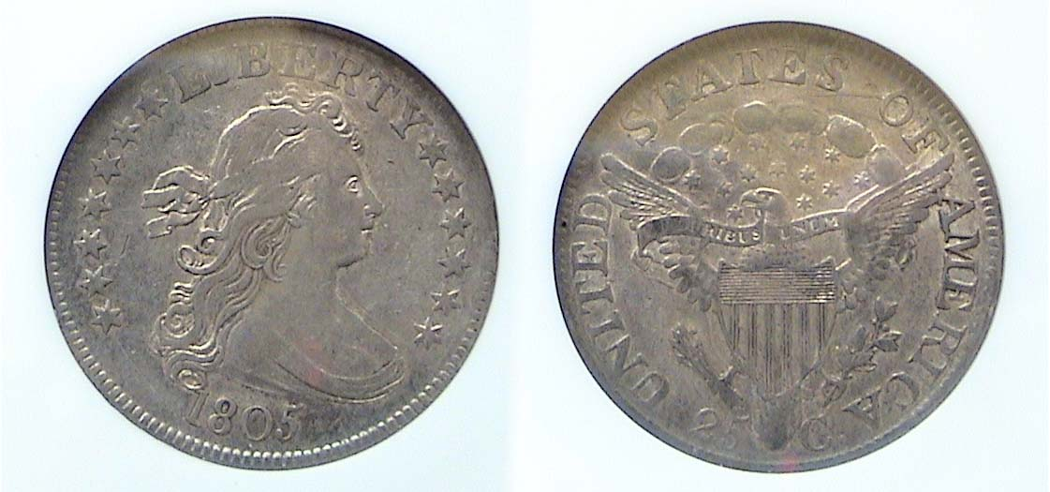

An 1805 Draped Bust Quarter graded XF-45 by NGC
[Use a 3X magnifying glass or magnify page to 200% to view details.]

Early US type coins are becoming less and less available and during the past ten years, since the 1805 Draped Bust quarter was acquired the price has tripled in value. To buy a coin like this “raw” in today’s market is taking a big risk. Many examples of Draped Bust coinage were harshly cleaned, some artificially retoned, others slightly bent due to their thin planchets, still others retooled to improve its sharpness, so it pays to locate a certified example that looks original and has eye appeal for the grade.

During the period this type was issued the diameter of the quarter was 27.5. The larger size planchets were thinner than the later types. The Draped Bust quarter series was suspended after the 1807 issue. When it was resumed in 1815 with the new Capped Bust design of John Reich the diameter was slightly reduced from 27.5 mm to 27 mm. The 1820 quarter shown atop column 1 is such an example. In 1831, the Capped Bust quarter was reduced to its current size of 24.3 mm in diameter (about one inch) with the flan thickened accordingly.

The reported mintage for the 1805 Draped Bust Heraldic Eagle reverse quarter was 121,394, extremely small by today’s standards. Yet the date is not considered rare when compared with the 1804, with just 6,738 reported and the 1796, with only 6,146. Those are rare and extremely expensive, each priced at well over a $1,000 in AG-3, the lowest grade listed in the Red Book for the series. Nonetheless, an 1805 grading XF-45 is costly and certified examples are definitely recommended.
__________________________________________________________________________________________________________________________
STEPHEN JAMES CSRA COIN CLUB
Minutes of the Regular Meeting
Aiken County Library - January 5, 2012
President, Steve Kuhl, called the regular meeting of the club to order at 6:45 p.m.
Glenn Sanders reported that there were 11 members present (10 adults, 1 junior). There was one visitor, Johnny Johnson. (15 regular members needed to conduct the business of the club.)
Glenn announced information concerning several upcoming coin shows in the vicinity.
Chuck Braun won the door prize.
Since a quorum was not present, reading of last meeting’s minutes was deferred until next month.
The treasurer’s report was not available.
No Show and Tells were presented this month.
The program consisted of a series of videos:
- Money, from the History Channel on the production of bank notes by the Bureau of Printing and Engraving (2nd half)
- Production of a 100 kilogram gold coin ($1,000,000 face value) from the Royal Canadian Mint, 7-minute video from the internet – 2007
- Production of a One Tonne (1000 kilogram – 2205 pounds) gold coin from the Perth Mint, Australia, 4 ½ minute video from the internet – 2011
Paul Simon won the 50/50 ($13).
Austin Kuhl pulled a 1919-S cent from the junior grab bag.
Respectfully submitted,
Jim Mullaney, Secretary

Addendum:

The program for the Feb. 2 meeting will be a PowerPoint presentation by Arno Safran on “The Coinage created By Chief Mint Engraver James Barton Longacre”: (1844-1869)

Plans for September, 2012 Show Released

President Steve Kuhl has scheduled out next annual club show for Saturday, Sept. 8, 2012 at the H. Odell Weeks Activity Center. The hours will be from 9:00 AM tom 4:00 PM. The show is usually held in conjunction with Aiken – Makin’ Day weekend and open to the public at no charge. Those interested in taking tables should contact Steve at 803-645-1769. The fee is $40 for each table, $75 for two tables and $110 for three. Only six-foot tables are available.
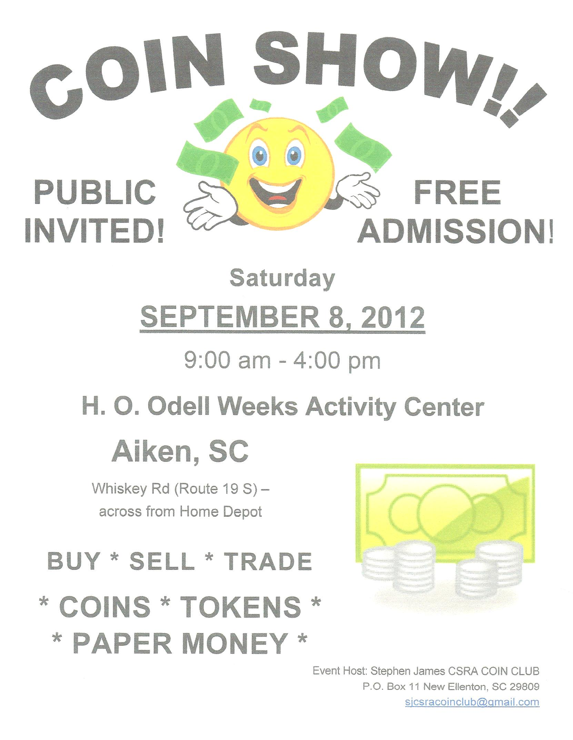

_________________________________________________

Kindly Patronize our Advertisers

