1CSRA Coin Club of Aiken
P.O. Box 11
New Ellenton, SC 29809
Web site: www.sjcsracc.org
The SJ CSRA CC of Aiken, SC meets on the 1st Thursday of the month at the Aiken Public Library

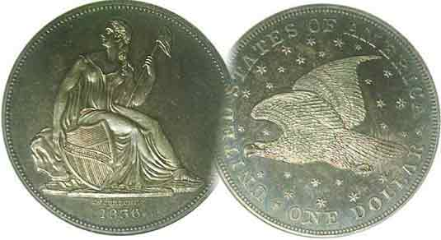
Pres. Steve Kuhl
V .P. Pat James
Sec. Jim Mullaney
Treas. Chuck Goergen
Sgt. in Arms: Jim Sproull

Programs: Pat James
ANA Rep.: Glenn Sanders
Show Chairman: Steve Kuhl
Photos: Steve Kuhl
Publicity: Pat James
Newsletter: Arno Safran
E-Mail: arnosafran@comcast.net
Auctioneer: Jim Sproull
Web site: Susie Nulty (see above.)

2018 Club Meeting Schedule
Volume 17, No. 2 the Stephen James CSRA Coin Club, Founded in 2001 February, 2018
Monthly Newsletter
Our next meeting is Thursday, Feb. 1, 2018 at 6:45 PM in the Aiken Public Library

Is now the time to get on board the Franklin Half?
Jan. 4 Apr. 5 July 5 Oct. 4
Feb. 1 May 3 Aug. 2 Nov. 1
Mar. 1 June 7 Sept. 6 Dec. 13

Franklin Halves, the dormant collectible
For advanced age collectors it may be hard to believe that the Benjamin Franklin half dollar is turning 70 years old this year. The coin was designed by Chief Mint Engraver John R. Sinnock and was based on a sketch by John Frederick Lewis. The new design-type was originally intended to be struck for twenty-five year period but as a result of the assassination of President Kennedy on Nov. 22, 1963, the coin-type was replaced by the martyred president in 1964 after a period of only sixteen years.

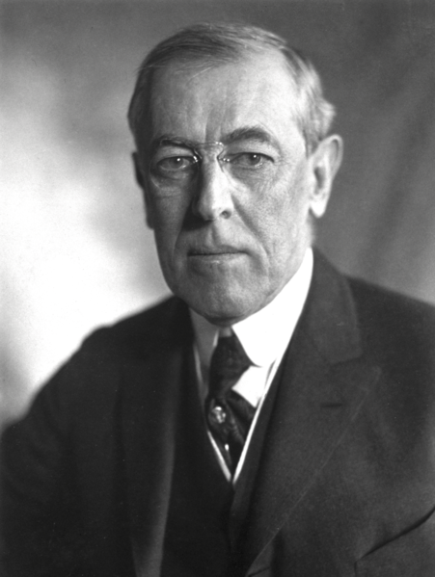
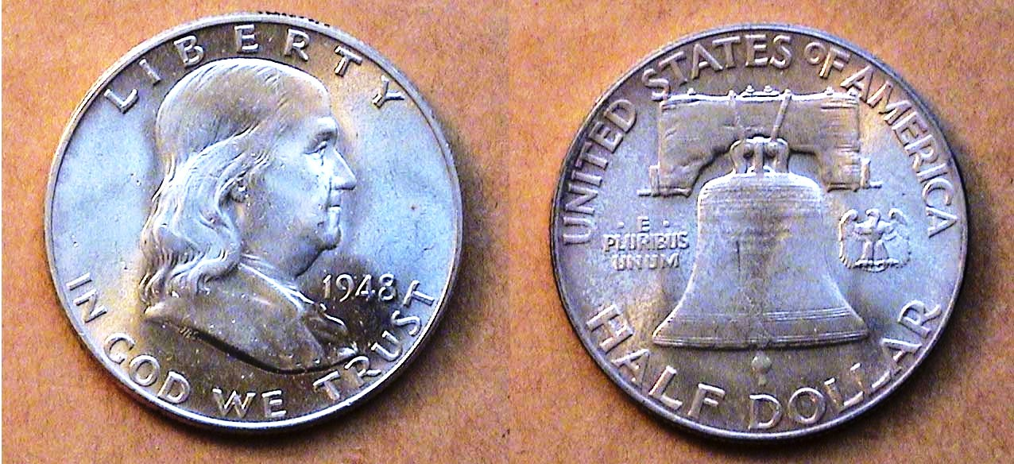

An 1948-P Franklin Half-dollar grading MS-64
[Enlarge page to fill screen to view details of each coin .]

The Franklin half is sometimes considered the “Barber half” for today’s young collectors since it represents an obsolete .900 fine 50c silver coin. But there are wholly different circumstances regarding the two. For one thing, the Barber half circulated heavily during its twenty-four year tenure with most dates being collected out of circulation by youths during the 1930s thru the early ‘60ths in grades as low as AG-3 to VF-20. By contrast, the Franklin half was struck in the multi millions each year and saw little circulation during its entire short run. For another, the majority of the survivors grade AU-50 to 63, with most dealers charging on average $20 to $25 for a 63 although its silver value is currently around $7.65, the figure dealers will pay. The key to future profit is acquiring specimens that will certify MS-64 to 65 with full bell lines on the reverses and unblemished clear surfaces on both sides of the coin .
______________________________________________________________________________________________________________________

Collecting the US Coins of 1918, 100 Years Ago
By Arno Safran

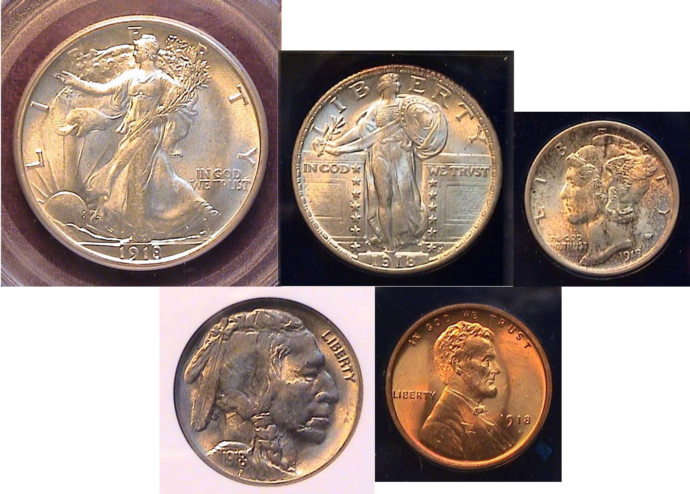
The obverses of a certified Uncirculated 1918 Year Set
[Enlarge page to fill screen to view details of each coin .]

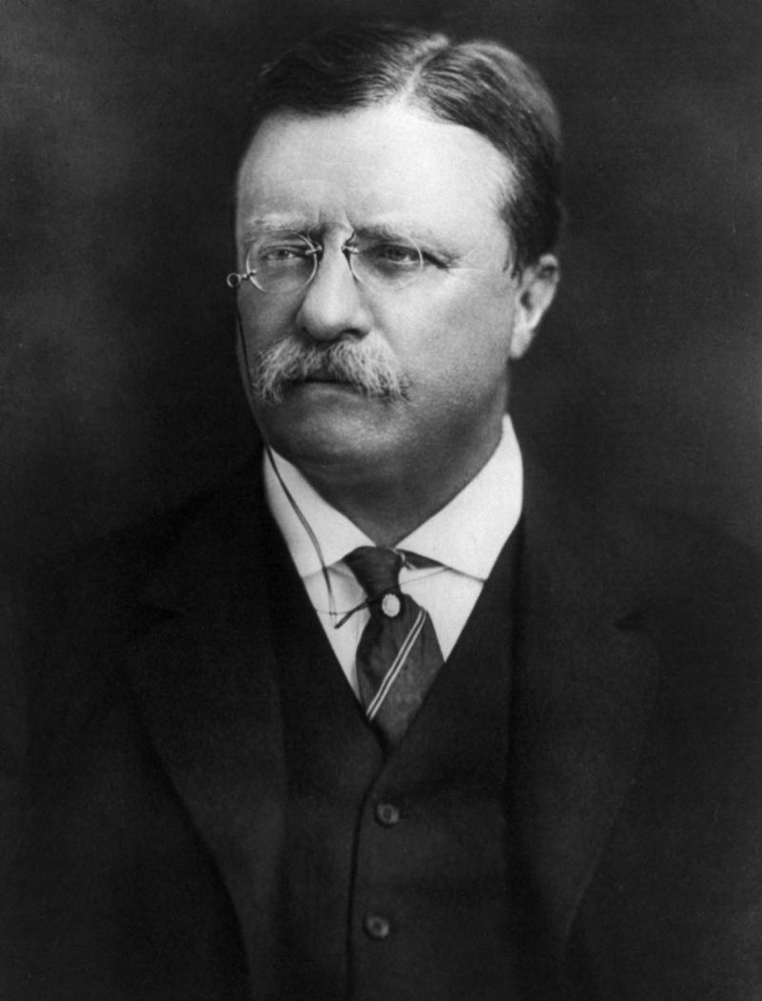
Woodrow Wilson, our 28th President had won reelection in 1916 on the motto, “Reelect Wilson! He kept us out of war”. Despite the Germans’ sinking of the passenger ship, the Lusitania in 1915, Wilson manifestly still believed that this was not America’s war, but as things grew steadily dire overseas, President Wilson on Apr. 2, 2017 in a speech before Congress said, “The World must be made safe for democracy” and congress agreed to his request to declare war on Germany on April 6. Anyone who has viewed the Ken Burns three part documentary on WW I knows that “The War to End all Wars” was devastating as millions of lives were lost. The Armistice that we celebrate every Veterans Day goes back to Nov. 11, 1918 when the hostilities ceased. Thanks to our 26th president, Theodore Roosevelt, the artistic quality of our coinage was at an all time high in 1918 and the mintage was plentiful although no gold coins were struck in 1917 or 18 due to the war.
___
_________________________________________
(Continued on page 2, column 1)
Collecting the US Coins of 1918, 100 Years Ago
(Continued from page 1, column 2)

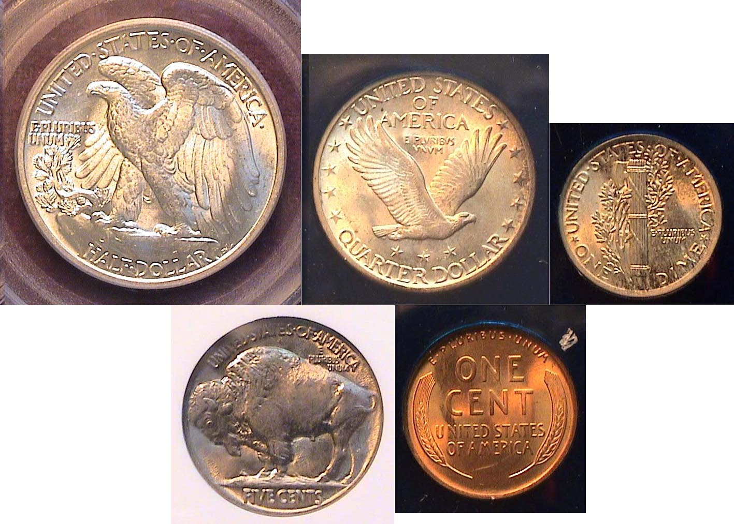
The reverses of a certified Uncirculated 1918 Year Set
50c, 25,c & 10c over 5c and 1c
[Enlarge page to fill screen to view details of each coin .]

Of the current ten authorized dominations, the dollar had been suspended in 1905 and with no gold coin made for the second year in a row, the collector wishing to complete a set of 1918 US coins requires only five.

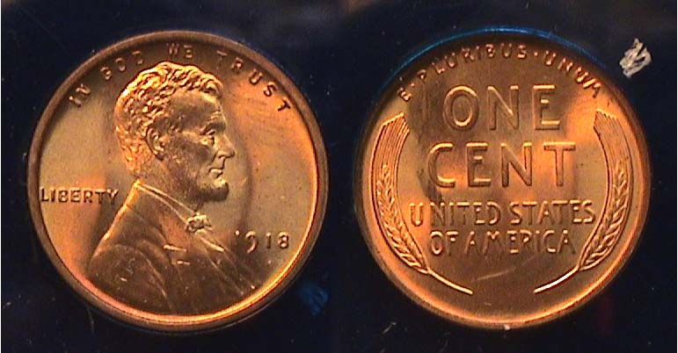

A 1918-P Lincoln Wheat back cent certified MS-65 RD by PCGS
[Enlarge page to fill screen to view details of this coin .]

In 1918, the Philadelphia Mint struck a then all time record 288,104,634 Lincoln Wheat-back cents while both the Denver Mint with 47,830,000 and the San Francisco Mint with 34,680000 finished a distant second and third respectively. Since the record would be surpassed the following year, this is of little importance. What is of interest however is the resumption of the engraver’s initials VDB for Victor David Brenner being placed just above the rim under Lincoln’s shoulder (at left) after it was removed in the latter part of 1909 from the reverse. The engraver’s initial--almost microscopic in size--would remain on the obverse from 1918 on.. The resumption of the VDB in its new position also provided a significant diagnostic tool to determine whether the key date 1914-D Lincoln cent wais legitimate or not since Brenner’s initials do not appear anywhere on a genuine 1914-D cent

The 1918-P cent shown above was acquired “raw” in 1978 as an MS-65 at a cost of $25.00. It was certified MS-65 Red by NGC in 2012. Today PCGS’s COINFACT web site’s suggested retail price for a MS-65 Red example is $325. Recent auction figures range from the low $200s to $300 but the specimens at the lower end do not appear as Red, sharply struck or blemish free as the example shown here. Similarly certified graded examples of the scarcer 1918-D are $4,500 today while an MS-65 Red specimen of the 1918-S is priced at $11,500.
In 1918, a cent had the purchasing power of sixteen cents.
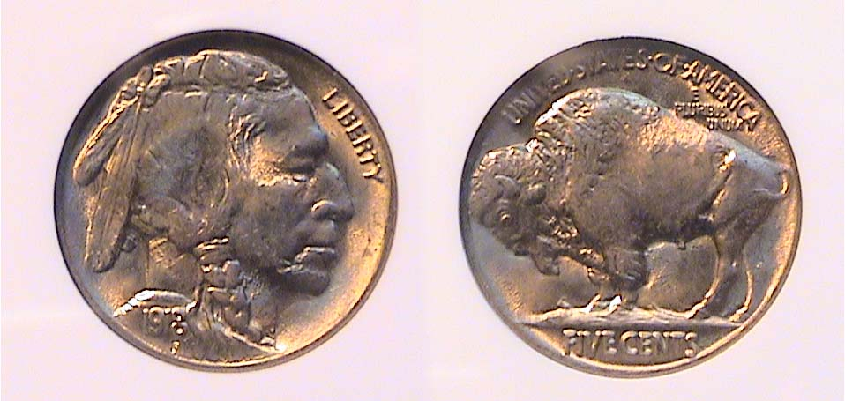

A 1918 Indian Head/ Buffalo nickel graded MS-64 by NGC
[Enlarge page to fill screen to view details of this coin .]

The Indian Head-Buffalo nickel is considered the “Most American of all US Coins”. It was designed by James Earle Fraser and released in 1913, first with the reverse showing the Bison standing on a mound (AKA Type 1) and later in the year on a straight line, also referred to as the Exergue, (AKA Type 2). The coin type was struck from 1913 thru 1938, the final year at the Denver Mint only. According to most collecting sources, the 1918-P Buffalo nickel is the scarcest of the P Mint issues coined between 1913-1937. No five-cent pieces were struck in 1922, 1932 and 1933.

The example shown was acquired already certified MS-64 by NGC at the Augusta Coin Club show held in May, 2008. The retail price has since increased by $100.00. In 1918, five cents had the purchasing power of 80¢ but the author suggests the figure is closer to $2.00 based on such factors as the cost of public transportation in some of the major US cities and daily newspapers.

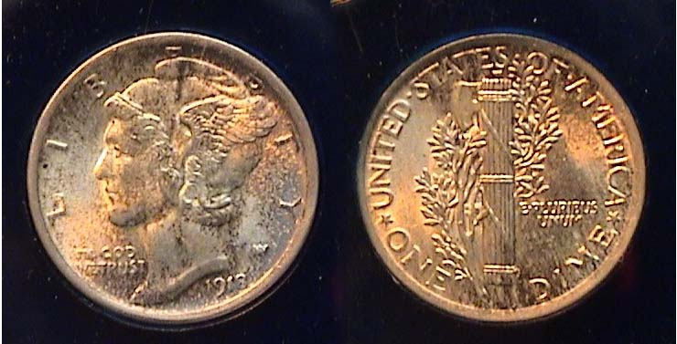

A richly toned 1918 Mercury dime graded MS-64 Full Bands by NGC
[Enlarge page to 500% to view details of this coin .]

The Winged Liberty dime (AKA Mercury dime) replaced the Barber dime in 1916 and in 1918 was struck in fairly large numbers in all three Mints although the Philadelphia Mint--with a total of 26,600,000--has the most survivors and is the least expensive to obtain in uncirculated condition, especially in certified grades MS-63 or higher. The example shown was acquired “raw” way back in May, 1984 at a local club show for $60.00. In 2012, it was certified MS-64 with full bands by NGC. The location of this feature appears at the center of the fasces on the reverse and usually commands a premium, especially in the higher grades.

Today, the 1918-P Mercury dime has increased dramatically in price since the author acquired his specimen. With Full Bands, a 1918-P Mercury dime certified MS-64 is currently listed at $400 retail according to COINFACTS with most recent auction prices-realized ranging from $319 to $356 compared with only $185 for a certified MS-64 example without that feature. Small details can be the difference in “big bucks”.

In 1918 a ten-cents had the purchasing power of almost $2.00. One could buy a lot of items for a dime. Today, it will get you virtually nothing.
________________________________________________________________________________________________________________
(Continued on page 3, column 1)
Collecting the US Coins of 1918, 100 Years Ago
(Continued from the previous page)

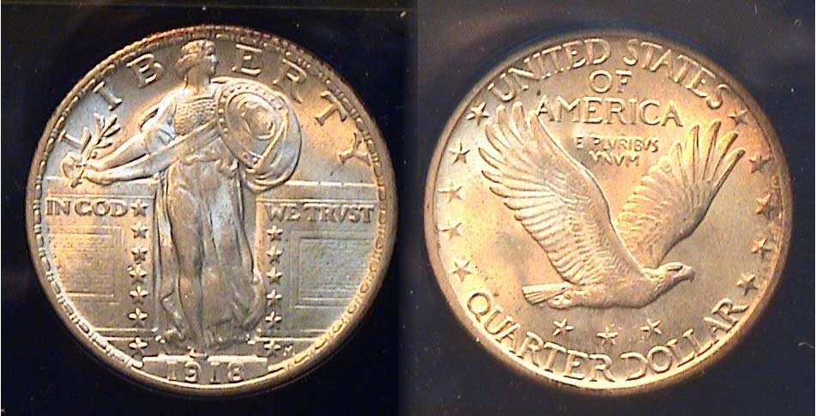

A 1918 Standing Liberty quarter graded MS-62 by NGC
[Enlarge page to 500% to view details of this coin .]

The Standing Liberty Quarter designed by Hermon MacNeil is considered by many to be one of the more attractive designs for the quarter although the 1916 & ’17 Type One version allegedly aroused considerable controversy when it first arrived on the scene. It was thought by a number of citizens to be rather risqué since it appeared to expose Miss Liberty’s features in a less than acceptable manner. When the Type 2 subtype version was issued in mid 1917, the design features, while similar, had been subtly changed portraying a more culturally correct if stiffer image of the Standing Liberty figure, especially in the areas of the head and shield on the obverse.

As with most denominations of that period, the Philadelphia Mint struck the most quarters in 1918, 14,240,000 compared with 11,072,000 for San Francisco and 7,380,000 for Denver. Most of the higher grade survivors are Philadelphia Mint issues which explains their lower price levels compared with the other two branch mints.

The 1918-P Standing Liberty quarter shown above was originally acquired ”raw” back in 1984, graded MS-64 by the dealer who the collector respected. When the author submitted the coin to NGC for certification in 2012, he was surprised that it came back housed in an MS-62 holder. The coin is lustrous displaying almost a full head and he believed it should have been graded at least MS-63. Upon magnification however, one will observe the dots along the center to lower left side of the shield on the obverse drop off while on the reverse, the eagle’s wings are somewhat softly struck. After checking out some of the recently sold examples on the COINFACTS web site and comparing it with some of the images graded MS-62, 63 and 64, he found those specimens graded MS-63 and 64 were more sharply struck although not necessarily more attractive.

In 1918, a quarter had the purchasing power of $4.00.

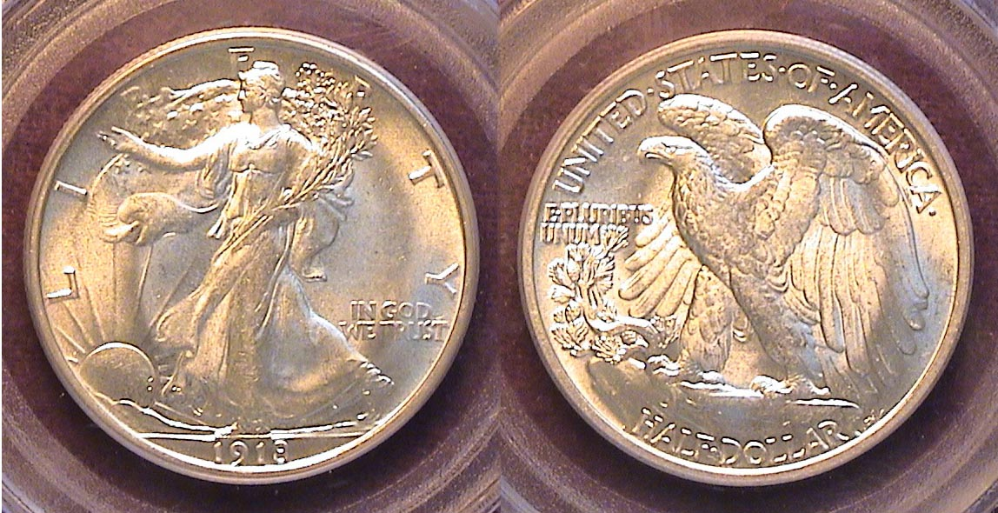

A 1918 Walking Liberty half-dollar graded MS-62 by PCGS
[Enlarge page to 200% to view details of this coin .]

The Walking Liberty half-dollar is arguably our most beautiful half-dollar design and one viewing the certified MS-62 example shown may also wonder why it wasn’t considered to be certified in a higher grade. The difference here is that the author acquired the piece already housed in the MS-62 holder and paid less than MS-63 money for it from a dealer set up at the GNA Show in April, 2012. Just as some certified AU-58 coins look like MS-63s, some certified MS-62’s can appear to the viewer as MS-64s, although most graded MS-62 usually display a few minor tics or scrapes on the surfaces. This coin shows none!

In 1918, the Philadelphia Mint struck 6,6 million half-dollars, the Denver Mint 3.8 million and the San Francisco facility just under 10.3 million. While specimens from the last named are the least expensive thru MS-60 today, the WL halves struck at the Philadelphia Mint become less costly from MS-62 or higher. Survivors of the 1918-D issues are the most expensive of the three Mints across the entire grading spectrum.

Among the pre 1921 thru 1933-S issues of the Walking Liberty half, the author believes that the 1918-P is an underrated date compared with the more common 1916- P or D and 1917-P issues and worth considering by those who wish to acquire an early date specimen from the series. In 1918, fifty-cents had the purchasing power of almost $8.00.

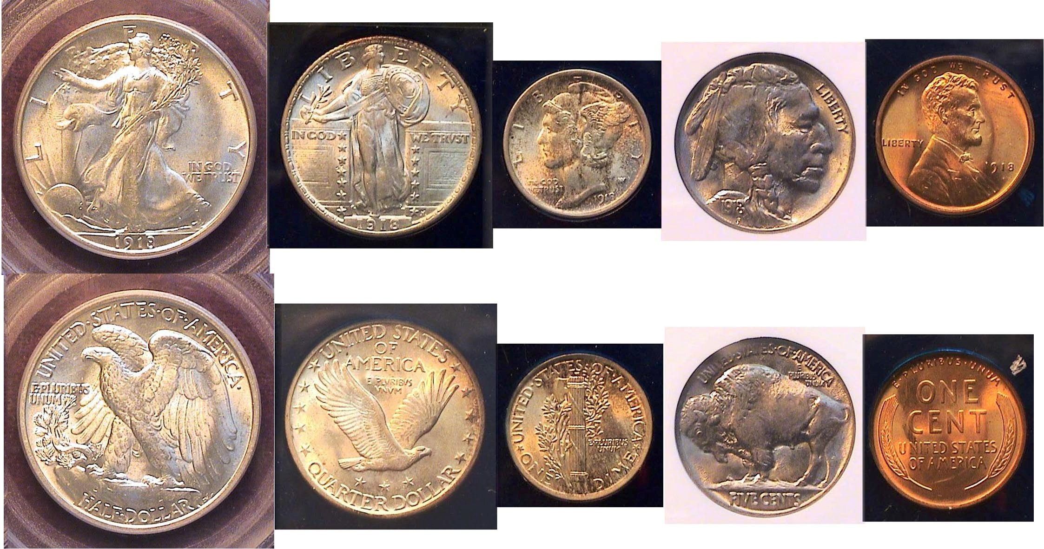

A certified BU set of 1918-P coins displayed in line (reduced in size)
[Enlarge page to 200% to view details of the five coins.]

The certified set shown directly above is one of the few early 20th century dates that is attainable for middle class collectors and in the author’s view, underrated as an investment.

The Pittman Act of 1918

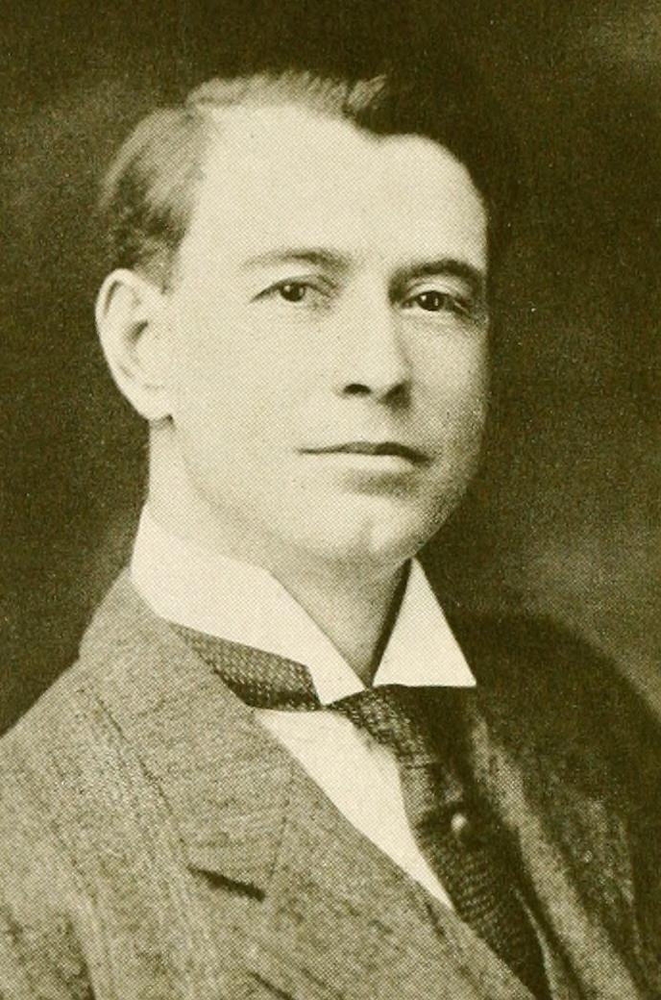
On April 13, 1918, six months before the end of World War I, The Pittman Act drafted by Senator Key Pittman of Nevada was enacted into law. 270,232,722 Morgan dollars were melted in an effort to prop up our gold value and at the same time help Great Britain and its allies, (AKA, The Triple Entente), resupply their silver treasuries to avoid depression brought on by the cost of the war. In exchange, the US received planes and munitions from England with some of the silver our government had exported. There are numerous theories regarding which Morgan dollars dates may have been affected. The Act also provided for the renewing of the striking of Morgan dollars in 1921 accounting for their huge mintages and the Peace dollars that followed that same year and into the ensuing years from 1922 thru 1925.
STEPHEN JAMES CSRA COIN CLUB
Minutes from the Regular Meeting held January 4, 2018,
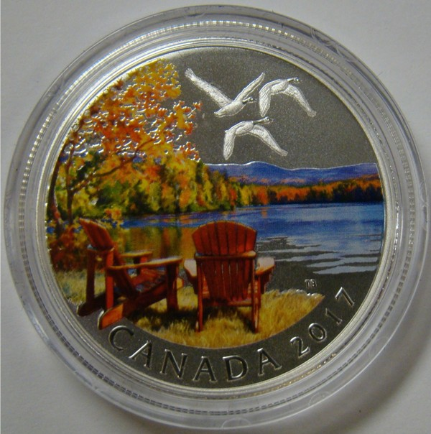
at the Aiken County Library

Willie Simon called the regular meeting of the club to order at 6:45 p.m.

Jim Sproull reported that there were 14 members present and no guests. Jim announced information concerning several upcoming coin shows in the vicinity.

Ken Bailey won the drawing for the members’ door prize, a 2016 U.S. Silver Eagle.

A motion was made by Glen Sanders, seconded by Sharon Smoot, and passed to dispense with the reading of the November 2017 minutes. A copy will be on file with the other club records, and a copy has appeared in the club newsletter.

Treasurer Chuck Goergen reported that the Club’s bank current balance was $2457.19.

The club’s Holiday Dinner was on December 14th at the Columbus Club. We had 29 members and guests attend and everyone enjoyed the evening. Thanks to Chuck Goergen, Pat James, and everyone else who helped to make the dinner a success.

Jim Mullaney requested that all club members who are also ANA members email their ANA membership number to the club. This will reduce our club’s cost of ANA membership.

Pat James discussed obtaining equipment to tape the programs that our club enjoys, so we could have them for future use and also share with nearby clubs and the ANA library.

Extended Show & Tells replaced the program at the January meeting.
John Kolmar shared some coins he had recently obtained from the Canadian mint. He appreciates the wide variety of coins produced by Canada each year. John brought a $10 silver coin that featured a colorful fall scene and a $3 silver proof coin for Libra in the zodiac series that featured crystals.

Chuck Goergen shared an ancient Stator from the island of Thasos off Thrace. The coin was produced 500 – 480 BC and featured a satyr carrying off a nymph on the obverse, with a simple incuse square on the reverse.

Jim Mullaney shared a 3-coin set from 1988 that commemorated the most recent America’s Cup yacht race. The set had been produced for Samoa by the Singapore Mint and included a 5-oz silver coin as was as a quarter-oz gold coin.

Jim Sproull shared an 1847 large cent that was in good condition. Jim had obtained this coin when he was 7 years old for 1 cent from a gas station owner in his neighborhood who had encouraged his early interest in coins.

Arno Safran shared a 1948 year set (P-D-S) which he has held for about forty years. (See page 1 inset of 1948 Franklin half.)

Chuck Georgen won the 50-50 drawing, $15
Following the auction, Willie Simon adjourned the meeting.

Respectfully submitted,
Jim Mullaney, Secretary
Show & Tells Presented at the Jan. 4 Meeting
Photos taken by Secretary James Mullaney

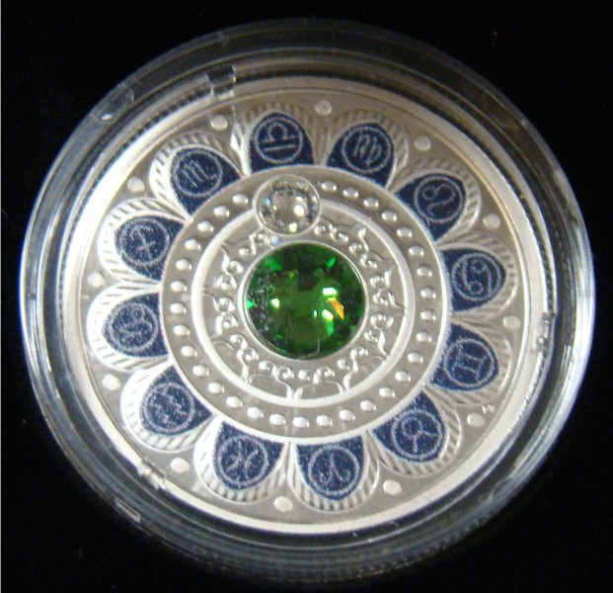

Canadian $10.00 silver Canadian $3.00 silver
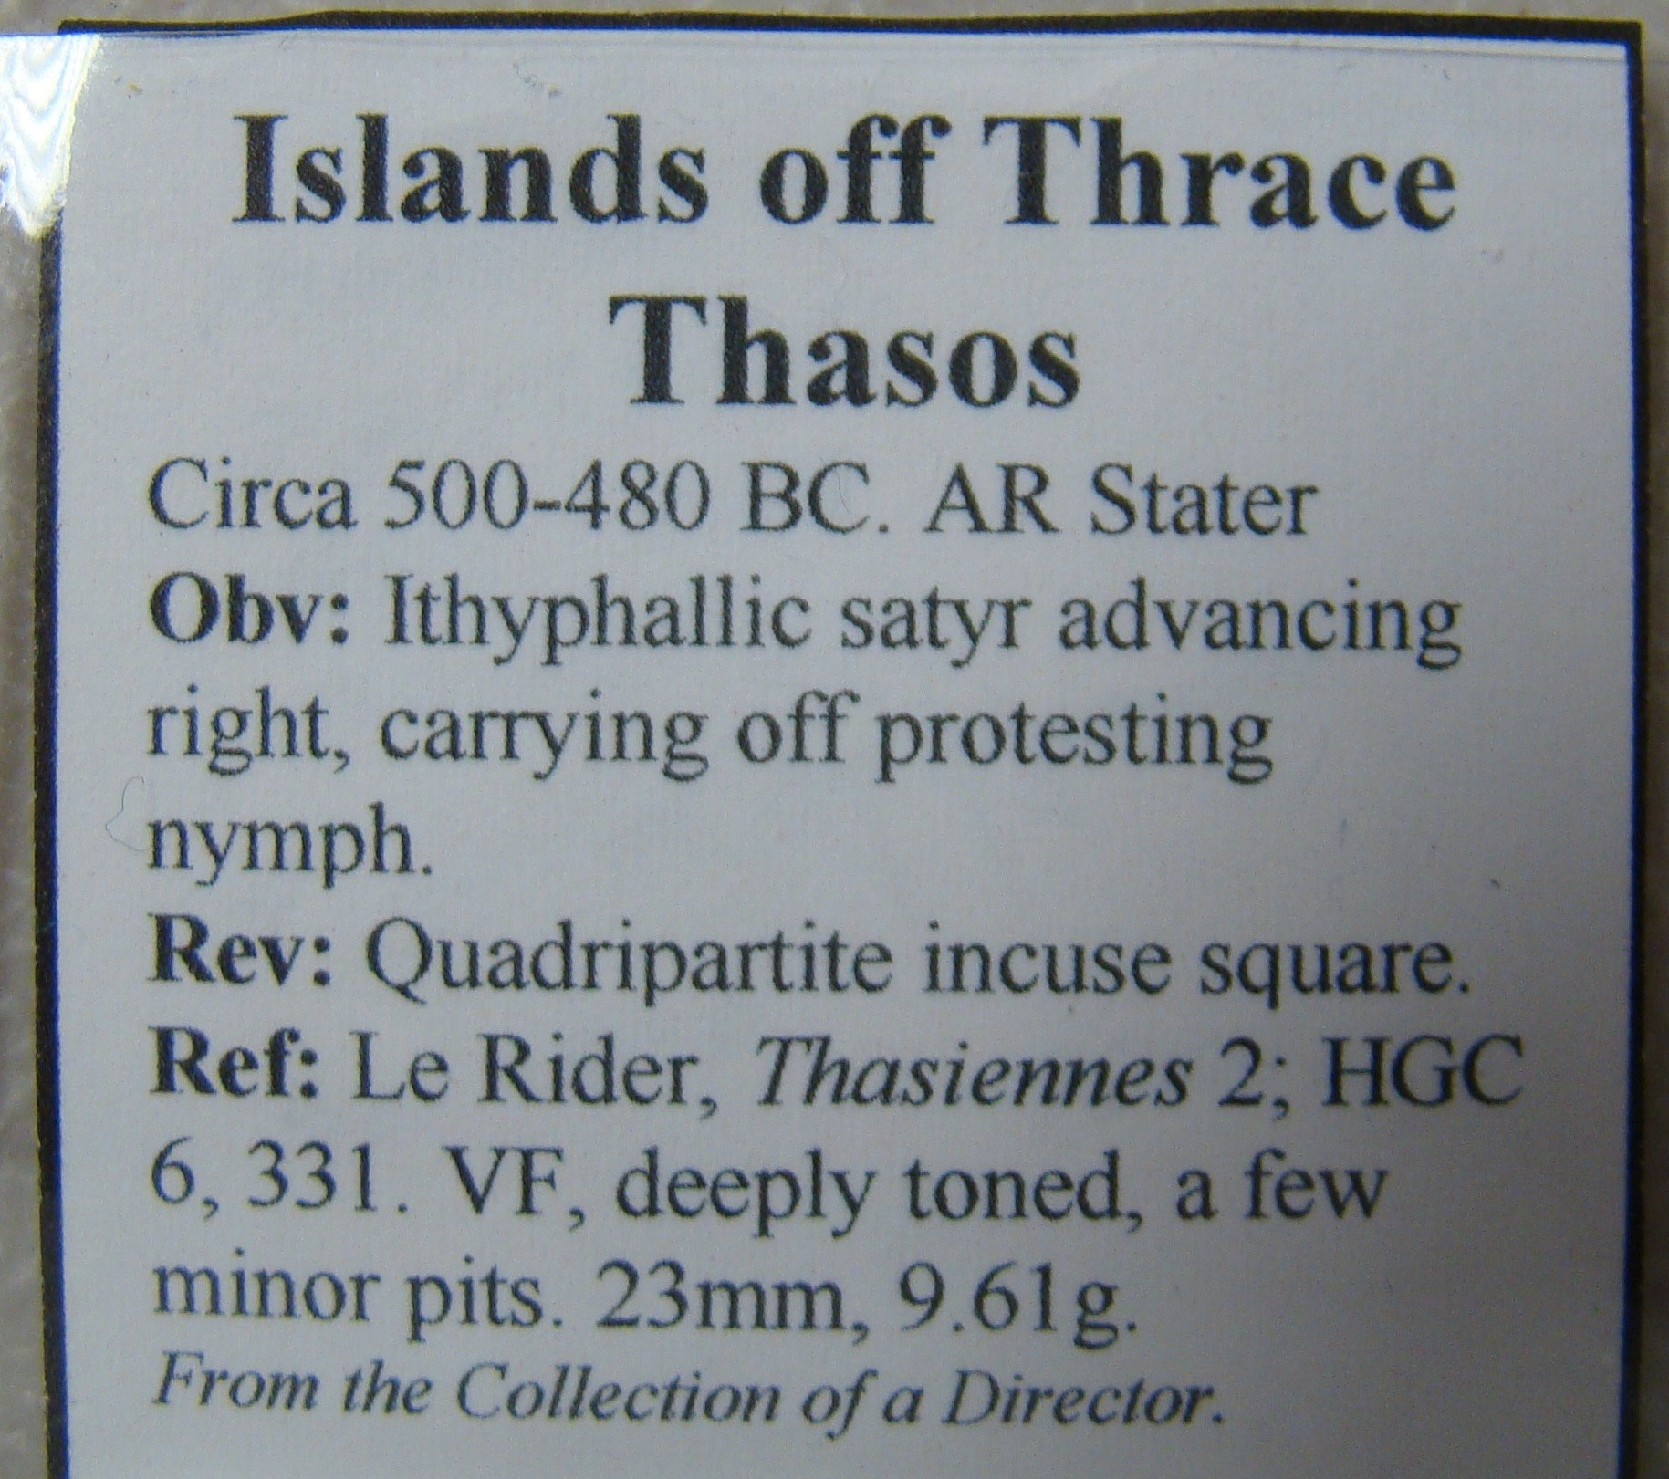

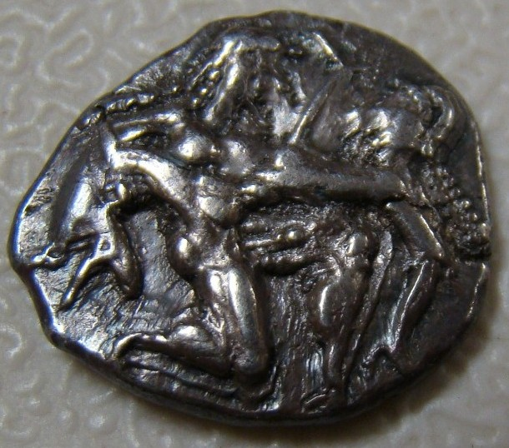

540-480 BC Stator of Thrace

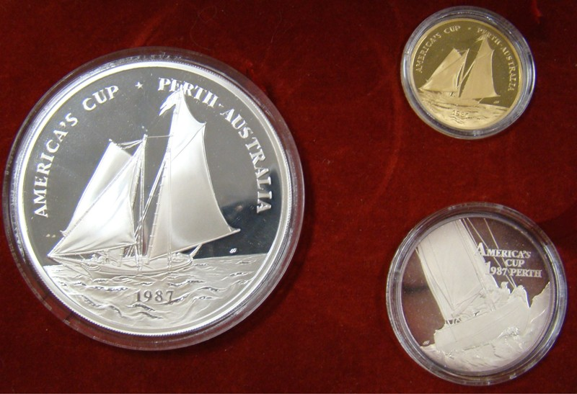

A 1988 3 coin set commemorating America’s Cup Yacht race
Produced in Samoa by the Singapore Mint
_____________________________________________________________

Articles for the Newsletter Requested

The editor wants members to consider submitting articles on what they like to collect. It can be a single column, a full page or two pages long. If possible, try including a photo image of the numismatic item or items the individual wishes to describe.

All one has to do is submit an article in the form of a word.doc and the photo as a jpeg image with the .jpe suffix. Articles must be submitted at least two weeks in advance of the upcoming meeting and sent to the editor at arnosafran@comcast.net.
________________________________________

Kindly Patronize our Advertisers
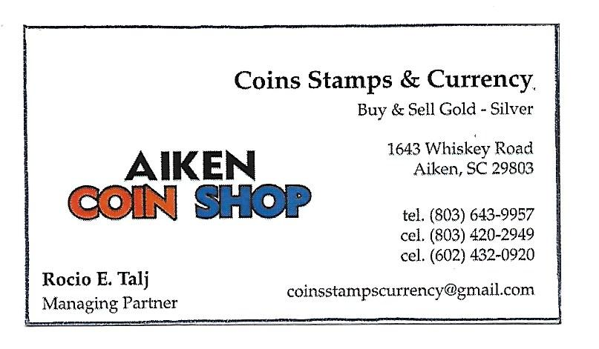
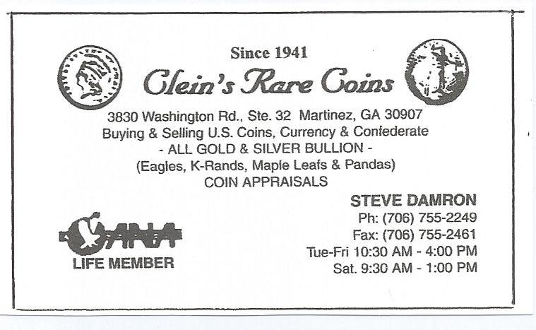

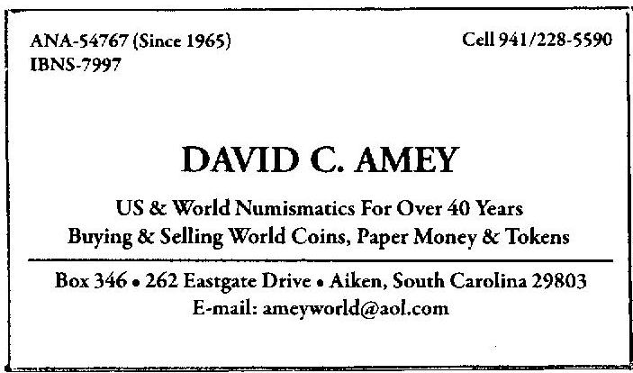

Kindly Patronize our Advertisers

