CSRA Coin Club of Aiken
P.O. Box 11
New Ellenton, SC 29809
Web site: www.sjcsracc.org
The SJ CSRA CC of Aiken, SC meets on the 1st Thursday of the month at the Aiken Public Library

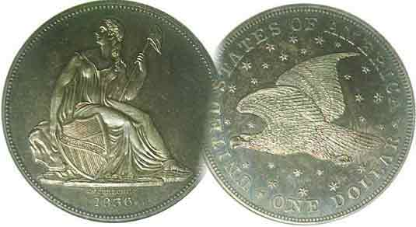
Pres. Steve Kuhl
V .P. Pat James
Sec. Jim Mullaney
Treas. Chuck Goergen
Sgt. in Arms: Jim Sproull

Programs: Pat James
ANA Rep.: Glenn Sanders
Show Chairman: Steve Kuhl
Photos: Steve Kuhl
Publicity: Pat James
Newsletter: Arno Safran
E-Mail: arnosafran@comcast.net
Auctioneer: Jim Sproull
Web site: Susie Nulty (see above.)

2019 Club Meeting Schedule
Volume 18, No. 2 the Stephen James CSRA Coin Club, Founded in 2001 February, 2019
Monthly Newsletter
Our next meeting has been moved up to Tuesday, Feb. 5 due to a conflict on the 7th

An interesting obsolete Chilean coin can heightened a collector’s interest
Jan. 3 Apr. 4 July 11 Oct. 3
Feb. 5 May 2 Aug. 1 Nov. 7
Mar. 7 June 6 Sept. 5 Dec. 5

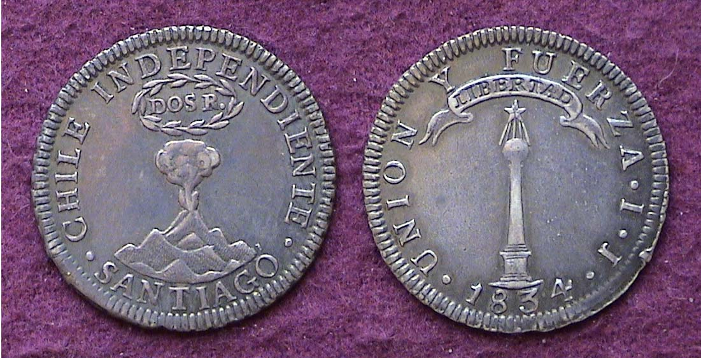__

An 1834 Chilean 2 Reales Volcano-Monument graded XF-45
[Enlarge page to 200% to view details]
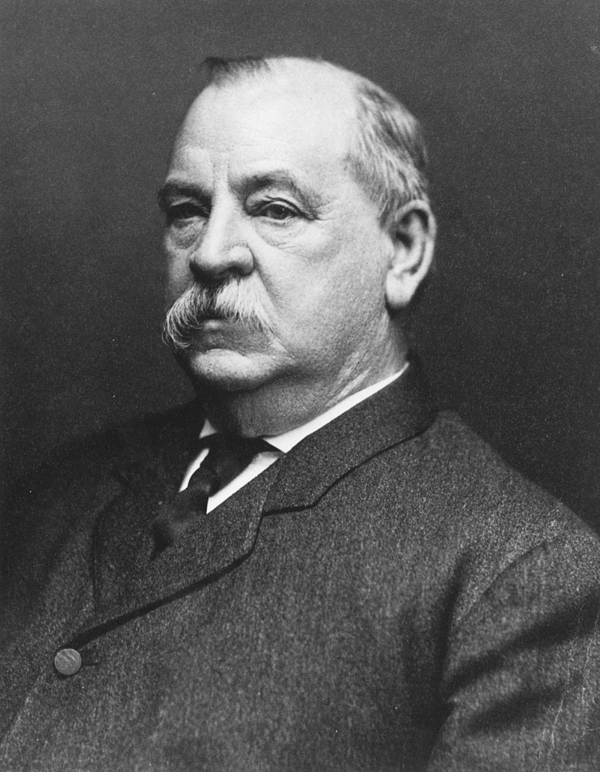
The Volcano/ Monument design type of this fascinating Chilean silver coin was first struck on the dollar size Peso in 1817 a year before Chile officially became independent from Spanish rule due to the successful military efforts of Bernardo O’Higgins. The unusual surname was the result of Bernardo’s mother having married a native of Ireland. The peso (shown below) was struck from 1817 thru 1834. The minor silver denominations were not coined until the end of its run with the 6¼¢ half-real struck in 1833 and ’34, the 12½¢ silver real only in 1834 along with the quarter-size 2 reales (shown atop) with a reported mintage of just 3,740 and an undisclosed mintage in 1843. The author believed that the 1834 2 reales was an underrated date due to its especially small mintage, so when an example came up in a mail order auction that specialized in foreign coins back in 1998, he placed a bid of $140 which turned out to be successful. In 2018, he was proven correct when his specimen sold for $900. The reported mintage of the first US 1796 Draped Bust small eagle quarter is 6,148 and is listed in the current Red Book in XF-40 at $47,500 due to far greater demand.

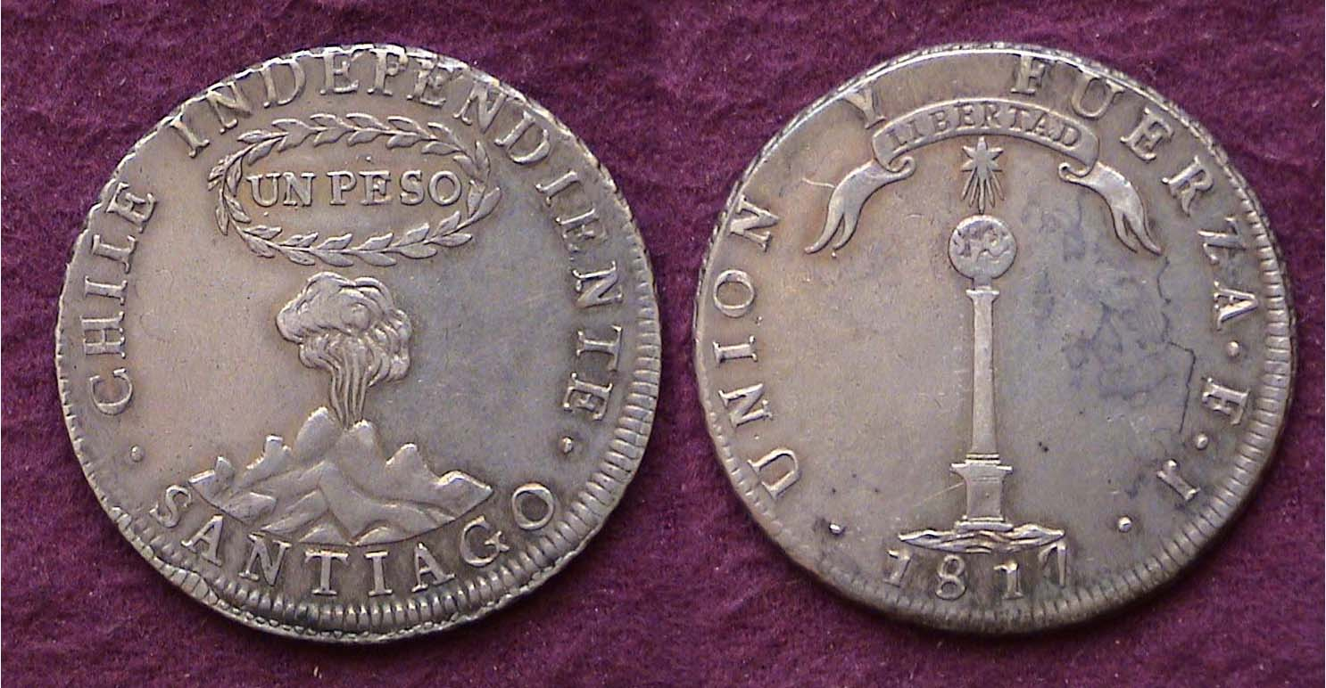

An 1817 type 2 Chilean Volcano/ Monument Peso graded VF-35

Collecting the US Coins of 1896 (excluding gold)
By Arno Safran
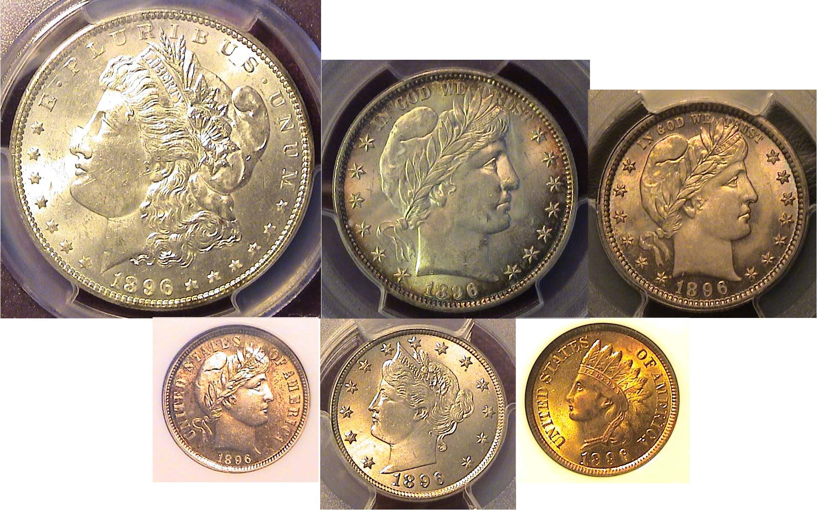
The obverses of an 1896 certified BU Year set
From left: Morgan dollar, Barber half-dollar and quarter
Over the Barber dime, Liberty nickel and Indian head cent
[Enlarge page to 200% to view details]

The collector of US coins wishing to acquire a year set of 1896 US coins (excluding the gold issues) will find the Philadelphia issues of the silver coinage to be the more common and least costly across the grading spectrum. 1896 was an election year and our outgoing president Grover Cleveland was completing his second unattached term as 24th president.
Grover Cleveland
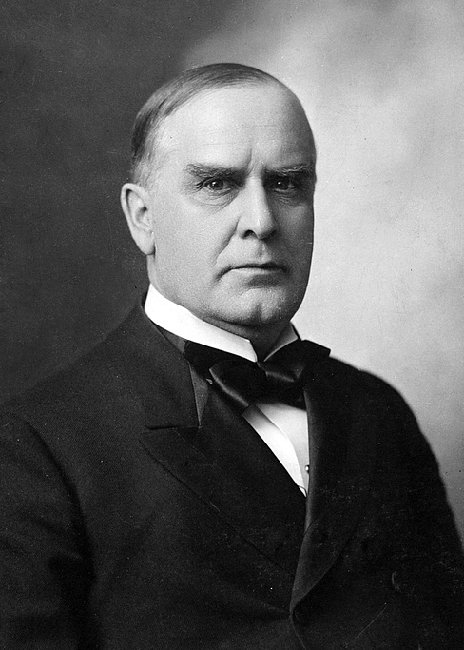
Ever since 1873, the far western territories and states lobbied for the silver mining interests as opposed to the eastern states which preferred our monetary system be based on the gold standard. The general election of 1896 would determine which view the nation would support, William Jennings Bryant, who argued against the gold standard or William McKinley who supported the gold standard. McKinley won becoming our 25th president. William McKinley
________________________________________________________________________________________________________________
(Continued on page 2, column !)
Collecting the US Coins of 1896 (excluding gold)
(Continued from page 1, column 2)

The reverses of an 1896 certified BU Year set
From left: Morgan dollar, Barber half-dollar and quarter
Over the Barber dime, Liberty nickel and Indian head cent
[Enlarge page to 200% to view details]

During the three years prior to 1896, the production of Morgan dollars at all mints dropped to all time lows but by 1896 the dollar was once again being churned out at all three mints in the multi-millions, usually at the expense of the lower denominations such as the key date 1896-S Barber quarter. As with most dates of the decade, the Philadelphia Mint struck the most coins resulting in more survivors than the New Orleans or San Francisco mints and easier and less expensive to acquire in all grades, even those in mint state (MS-60 to MS-64) depending on the denomination.

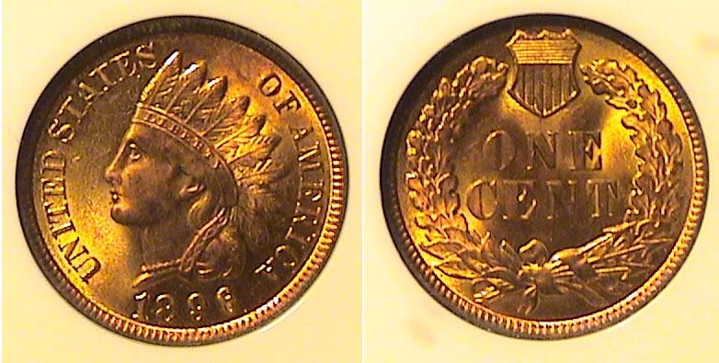

An 1896 Indian Head nickel graded MS-64 Red by NGC
[Enlarge page to 200% to view details]

The mintage for the 1896 Indian Head cent was 139,055,431 and is considered a fairly common date. It usually comes brilliant and well struck like the MS-64 Red specimen shown directly above. As a rule, the author prefers a MS-64 Red-Brown specimen because the price is a lot less than one certified MS-64-Red, especially if the piece displays far more red than brown. This would be the preferred “Best-buy” from Indian Head cents dated 1879 thru 1909, the end of the run.

Most of the Indian Head cents that predate 1879 are fairly expensive even in as low a grade Fine-12 brown to dark brown, so finding circulated attractive pieces may have to be considered.. At the time the author was interested in obtaining an 1896 Indian Head cent, no MS-64 RB pieces that had “eye appeal” were available except the MS-64 Red example shown. The coin was acquired at a Heritage on-line auction held in January, 2018. In 1896, a cent had the purchasing power of thirty-cents.

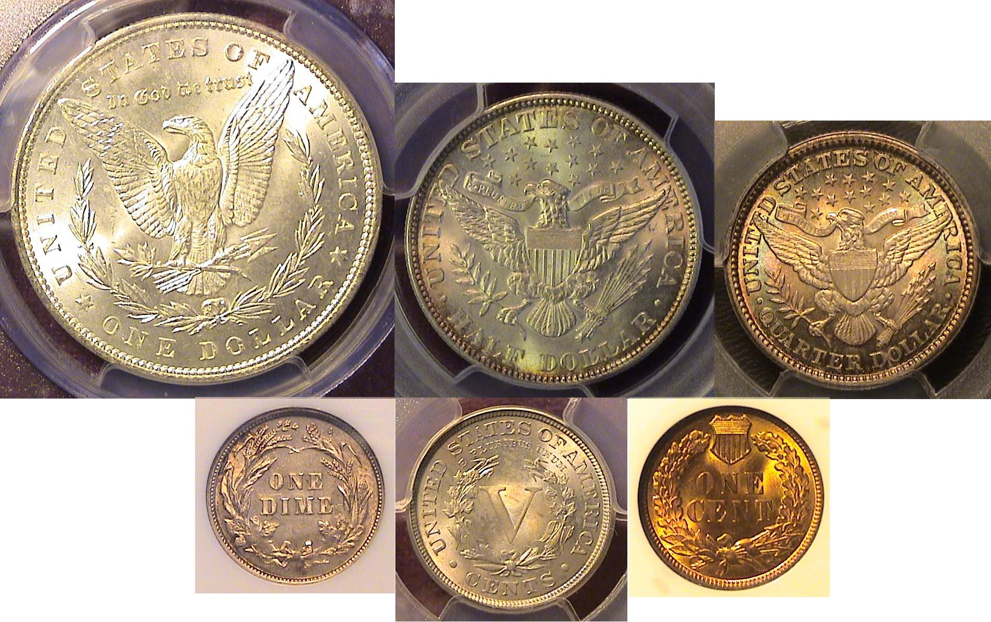
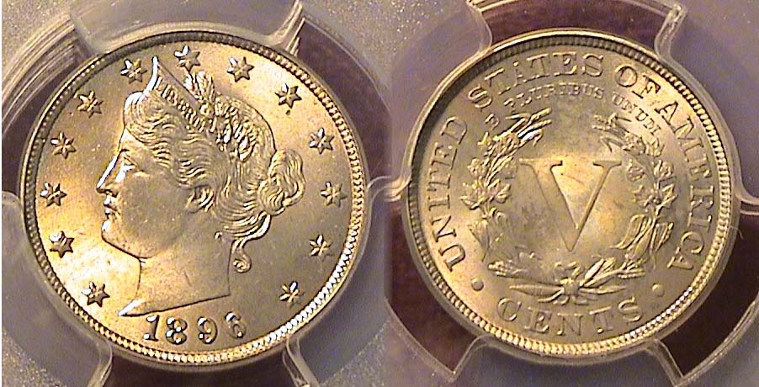

An 1896 Liberty “V” nickel graded MS-64 by PCGS
[Enlarge page to 200% to view details]

The 1896 Liberty nickel coin shown directly above was acquired on line from a well known national dealer in March of 2017. It has a good strike with lovely light toning highlighting its overall eye appeal. In 1896, the reportage mintage for the Liberty nickel was 8.841,058, the third consecutive year that less than 10 million pieces were struck, presumably due to the recession that began in 1893.
The first and last year of series (1883-1913) are significant and tells two unrelated tales. In 1883, a newly designed Liberty Head nickel by Chief Engraver Charles Barber was placed into circulation with the Roman numeral “V” positioned inside a wreath on the reverse, but “V” what? Not long after their release, some of these Liberty head type nickels began to be gold plated since they were somewhat similar in design-type and size to the $5.00 gold half-eagles of the period. As a result, Barber added the denominator CENTS directly under the “V” which successfully thwarted some of the numerous scam artists who were pawning five cents into five dollars .
The five 1913 Liberty “V” proof nickels which emerged at the 1919 ANA convention have authoritatively been recognized as unauthorized proofs that were surreptitiously ordered to be made by the then outgoing Philadelphia Mint coiner, Samuel Brown, whose alleged plot was not discovered during his lifetime. He later became the mayor of Albany, NY.
As for the actually true key dates of the series, the 1896--which had the seventh lowest mintage--is alas, not one of them. The true key dates are--in order of rarity, the 1885, 1886, and 1912-S followed by the 1912-D which is far less scarce than the three preceding.
In 1896, a nickel had the purchasing power of $1.51.

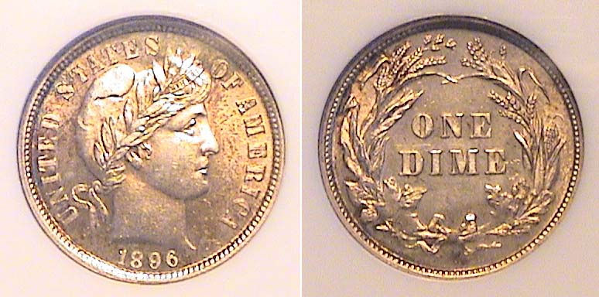

An 1896 Barber dime certified MS-63 by NGC
[Enlarge page to 200% to view details]

Exactly 2 million Barber dimes were struck at the Philadelphia Mint in 1896 compared with 610,000 at New Orleans and just 575,056 at the San Francisco facility. The current Red Book retail prices for each are commensurate with the respective mintages, $350 for the 1896-P, $2,000 for the 1896-O and $1,100 for the 1896-S. The Branch mints of those years also saw greater circulation in proportion to Philadelphia’s output which further explains the much higher premium enjoyed by the 1896-O and 1896-S survivors receive over the 1893-P dimes. The Philadelphia Mint issues tend to ne well struck.
In 1896, a dine had the purchasing power of $3.01.
________________________________________________________________________________________________________________________
(Continued on page 3, column 1)
Collecting the US Coins of 1896 (excluding gold)
(Continued from page 2,, column 2)

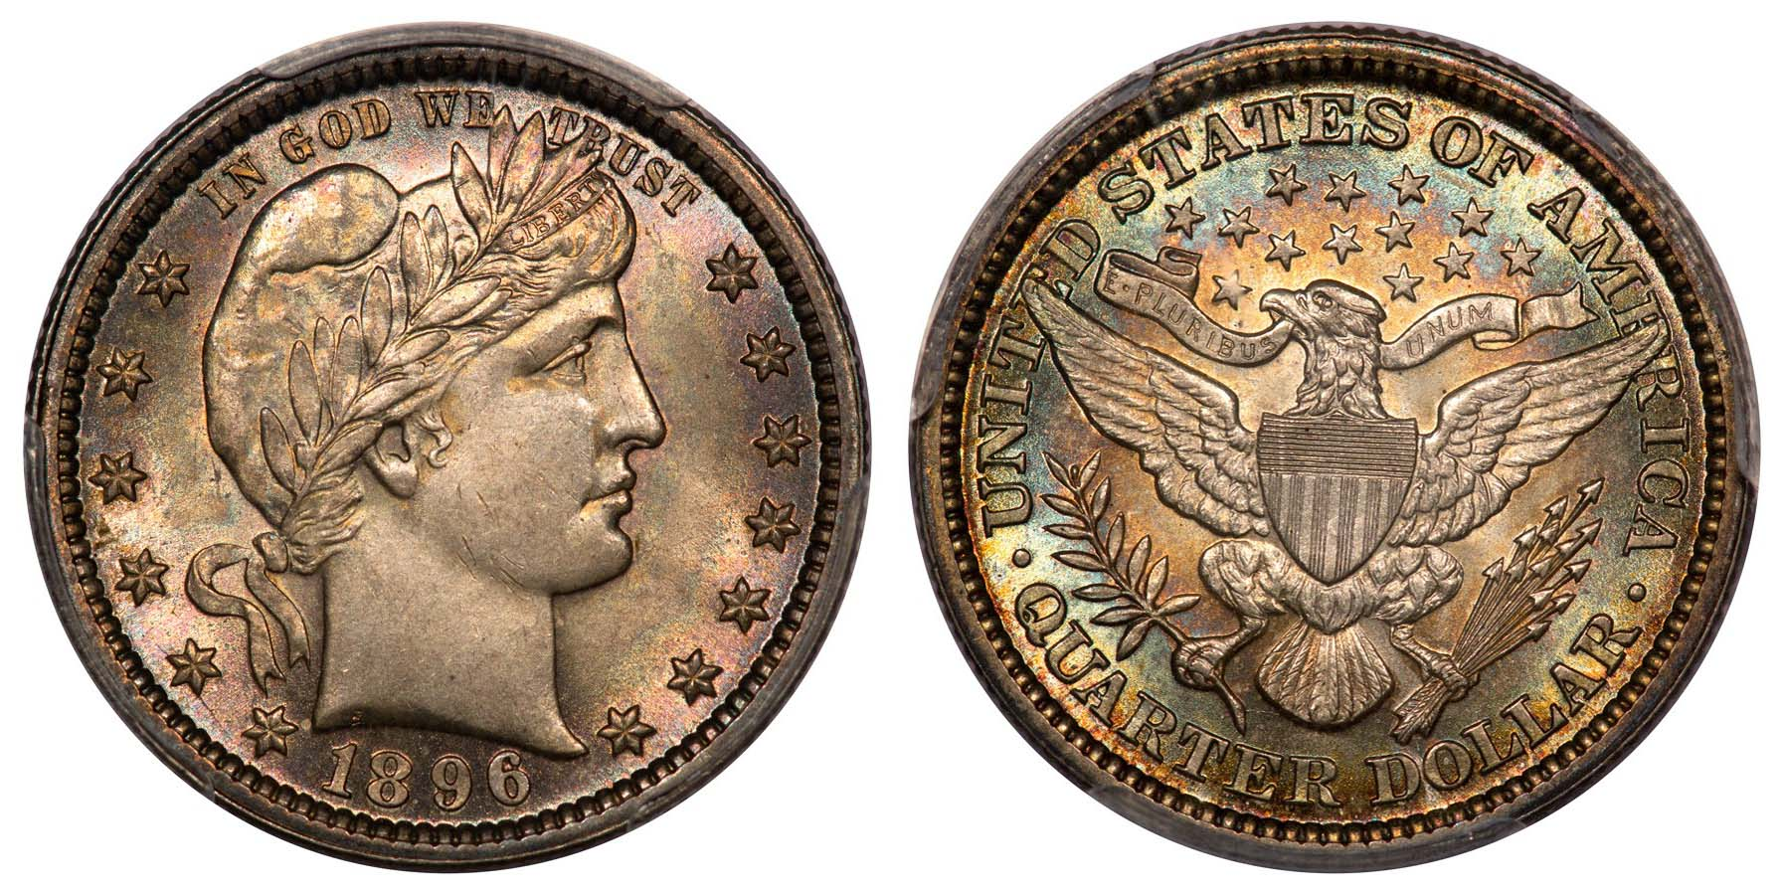

A beautifully toned 1896 Barber quarter graded MS-64 by PCGS
[Enlarge page to 200% to view details]

There is something about a beautifully toned coin that just registers with the collector the way a great painting is admired by an art connoisseur. This specimen of the 1896 quarter was discovered off the internet posting on the web site of a national coin dealer company that prides itself in specializing in beautifully toned coins, ergo their name, “Eye Appealing Coins”. The author has dealt with this company since he discovered a nice certified PCGS XF-45 example of an 1837 Liberty Seated no stars half dime awhile attending the ANA Convention held in Philadelphia back in August of 2012. Since then he had picked up a small number of Barber quarters all graded MS-64 from their web site with the 1896 being the most recent. and possibly the nicest of the group.

In 1896, 3,874,00 quarters were struck at the Philadelphia Mint,, 1,484,000 in New Orleans with just 188,039 at San Francisco, the last, one of the three “stoppers” in the Barber quarter series (1892-1916). For some reason, most of the numismatic publications omit the MS-64 column between MS-63 and 65 which is a shame because the big price jump of many rare US coin types occurs between MS-64 and 65 and not below.
While the MS-63 grade is less expensive than an MS-64, it often displays more unattractive blemishes while the a many MS-64 graded examples tend to appear more closely aligned in eye appeal with an MS-65 which falls under the “gem” class of obsolete coinage. Also, the price between MS-64s ad 65s can be quite explosive. To obtain an example of the 1896-O Barber quarter at the same price as the MS-64-P shown atop the page, one would have to settle for a 1896-O certified VF-35 and an 1896-S grading a paltry AG-3 of which neither would probably satisfy the collector aesthetically.

In 1896, a quarter had the purchasing power of $7.53.

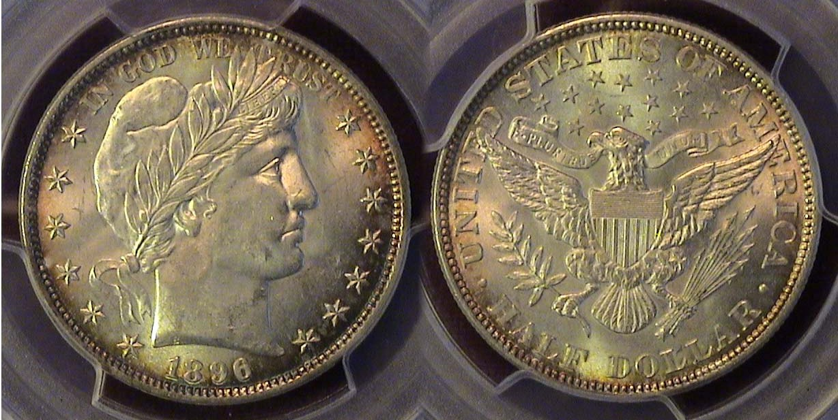

An 1896-P Barber half-dollar graded MS-63 by PCGS
[Enlarge page to 200% to view details]

This is another exceptional find in the writer’s opinion since the 1896-P Barber half dollar displayed was only certified MS-63. In 1896, the Philadelphia Mint struck less than a million halves, 950,000 to be precise compared with 924,000 at New Orleans and 1,140948 at San Francisco. Nevertheless, it is still valued at a much lower price than either the scarce 1896-O with slightly lower a mintage and a much higher mintage of 1,140,948 for the 1896-S. According to PCGS COINFACTS , numismatic scholars such as the late David Akers and corroborating PCGS contributor Ron Guth, the 1896-P Barber half-dollar is the scarcest Philadelphia mint issue of the decade and a lot scarcer than some of the branch mint Barber half issues of other years. The coin was recently acquired by mail order off a national dealer’s web-site on June, 21018. It is sharply struck with flashes of subtle toning.

In 1896, only a small proportion of the urban population could put away a brand new Barber half -dollar as a souvenir because its purchasing power was huge, around what $15.10 could buy today. A laborer earned less than $5.00 a week back then, working six days a week, and most of the earnings went for rent, transportation, clothing and food. Unlike contemporary times where none of the half-dollars hardly enter circulation, the fifty-cent pieces of the 1890s circulated heavily which is why during the pre clad coin issues, so many halves that appeared worn down to below VG and lower grades.

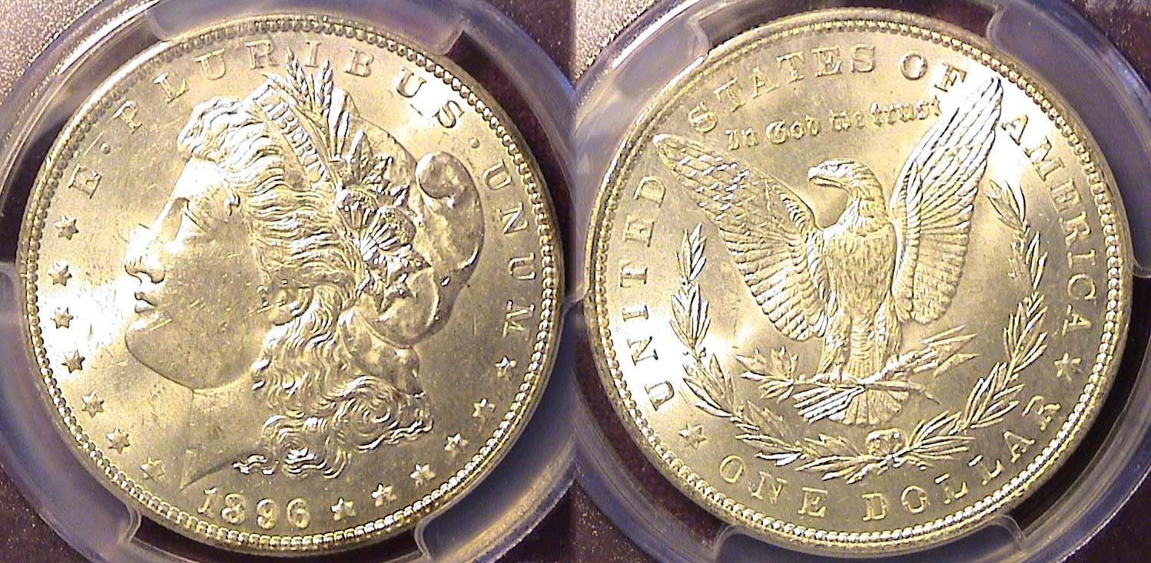

An 1896 Morgan dollar graded MS-63 by PCGS
[Enlarge page to 200% to view details]

In 1896, Morgan dollars were struck in large numbers at all three mints. The mintage for the 1896-P was 9,976,000, for the 1896-O, 4,900,900 and the 1896-S, 5,000,000. One would think that today’s collector could obtain a certified MS-63 or 64 specimen at a modest price with ease from any of the three mints but this has turned out not to be the case.

During the Morgan dollar era, most people living east of the Mississippi River probably never saw one because they were stored in bank vaults as specie to back large business ventures. West of the Mississippi, from New Orleans where the 1896-O was coined and San Francisco, where the 1896-S was produced, the Morgan dollar circulated heavily in commerce but also as chips in Casinos. What happened to the mint state pieces then? It is strongly believed that the uncirculated 1896-O and 1896-S Morgan dollars became victims of the Pittman Act of April 23, 1918 which authorized hundreds of millions of an undisclosed number of dates to be converted into bullion that probably included the 1896 branch mint pieces. Most of the bullion was sold to England for $1.00 an ounce. So, if one desires to acquire an 1896 Morgan dollar certified MS-63 like the one shown above, it will be a P Mint issue which retails at just $60.00 today, the least expensive denomination of the set.
__________________________________________________________________________________________________________________________

Kuhl Named Editor of SCNA’s SCanner™ Magazine

SJCSRACC’s President Steve Kuhl was recently appointed as Editor of The SCanner™, a periodical published by the South Carolina Numismatic Association (SCNA). Kuhl’s appointment is effective with the February 2019 issue which was issued at the end of January, 2019. Kuhl was elected to the SCNA Executive Board of Directors in 2018, and becoming the SCanner’s™ Editor increases his contributions to this statewide organization.

Said Kuhl: “In 2018 I was offered the opportunity to broaden both my knowledge and contributions by becoming a member of the Board of Directors of the South Carolina Numismatic Association. And now, I have been granted a further avenue to contribute to the world of numismatics as the SCanner™ Editor. I am truly grateful and excited!”
Kuhl continued by relating that as a lover of history, he truly enjoys researching and writing about coins, currency, tokens, and exonumia, but most especially he cherishes meeting, learning from, and writing about the interests and endeavors of his fellow numismatists. Said Kuhl “the involvement of people - the sharing of their knowledge and interests - is what makes this hobby so interesting to me, and it is why this is such a great hobby to be engaged with.”
The current edition of the SCanner™ contains informative articles on Collection Proof Franklin Half-Dollars; Collecting the Silver Certificates of 1899; and a summary of the special events which happened at the 46th annual Convention last October. In addition to carrying educational articles, the SCanner™ routinely presents information on:

- SCNA events, such as the annual statewide Convention (the largest show in the state each year)
- events and activities of the member Clubs (the SJCSRACC is a member of SCNA)
- Young Numismatist events and topics
- Information on upcoming coin shows in the southeast region
- And other topics of numismatic interest.
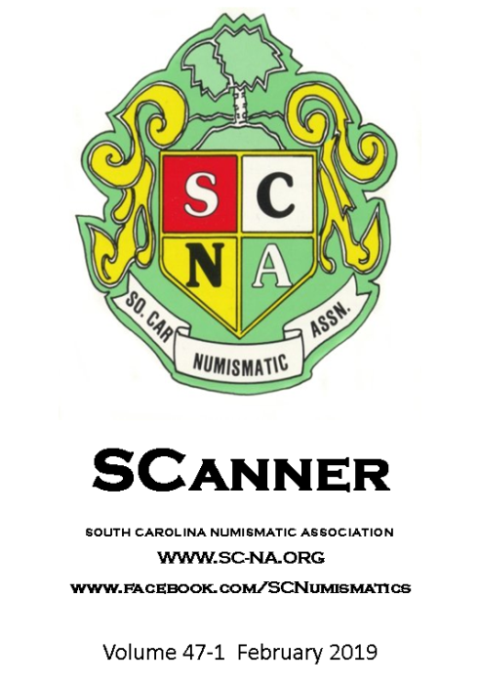
Members of SCNA receive a copy of the SCanner™. Those that are interested in supporting their state organization by joining SCNA (dues for adults are $12 per each calendar year) can find an application at their website SC-NA-org.
In his initial Letter from the Editor, Kuhl remarked that he looked forward to meeting fellow numismatists and hearing their stories. He expressed his hope that those he meets and those that read the SCanner™ will be willing to share their knowledge and insight and grant him the opportunity share their information with the SCNA family!
He also noted that guest articles are welcomed to be submitted, even if the author is not a member of the SCNA. He indicated that he will try to publish as many as possible space permitting. Items for consideration may be sent to Steve at: scnanewsletter@gmail.com.

Remember – Officer Elections are at the March 2019 Club Meeting. Do your part for the Club by serveing as an Officer. Current needs are for Club President and Bourse Chair.

UPCOMING COIN SHOWS
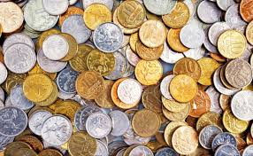

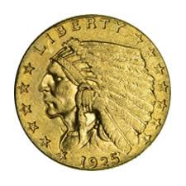

TOUR THE ANA’S MUSEUM & LIBRARY – VIRTUALLY!
©By Stephen Kuhl, 2019

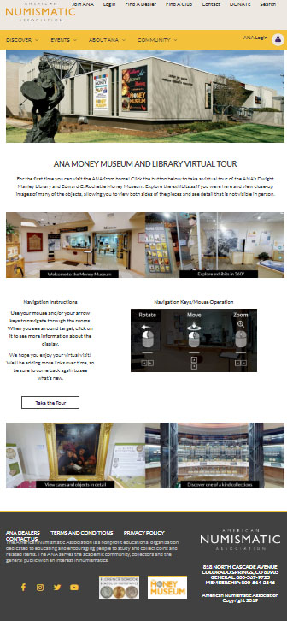
Have you heard? The American Numismatic Association (ANA) recently brought their museum and library online and you can take a virtual tour of these facilities and their numismatic rarities? With a click of your mouse you can be inside exploring the Dwight Manley Library and the Edward C. Rochette Money Museum!
ANA Virtual Museum Home Page: https://www.money.org/money-museum-virtualtour

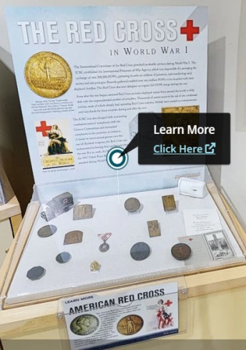
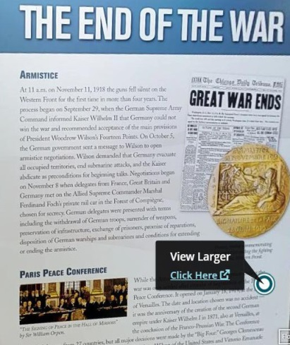
The ANA has done a wonderful job in building this capability because it brings numismatic history to your fingertips – you don’t have to travel to Colorado – and they do it in such a way as to maximize your experience.
Views of the “Learn More” and “View Larger” links

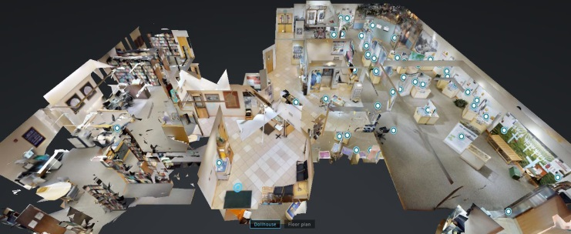
If you have ever been to a museum that displays numismatic items you will most likely recall from your experiences that there was a huge limitation to the displays – in almost all cases the viewer can only see one side of the object, typically because it is lying on a shelf or is attached to a wall.
“Dollhouse” view of Museum

You won’t experience that limitation with the ANA’s virtual museum – their software allows the viewer to see BOTH sides of the object!
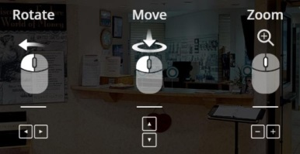
Additionally, you can zoom in and get a nice close view to see detail as if you were examining the item with a magnifying glass (certainly something you cannot do in person at a museum.)

The initial page of the tour provides an overview of the facility via two different views – an overhead floor plan and a “dollhouse” floor plan. Navigation through the museum is intuitive and easy – it is similar to how one navigates when using the GoogleMaps™ street view function. As your “stroll” through the facility you will notice items on display which have a circle on them. This circle provides different functionality depending on the object.
In some cases clicking on the circle brings up a “Learn More Click Here” link; in other cases it brings up a “View Larger Click Here” link.
When the author followed the “learn more” link on the Red Cross display (shown above) it took me to a web page which provided great detail about the subject, in this case to a web page which discusses the actions of the Red Cross in World War One (top left image). Also on the page was a photo of many items from this period (top right) which the viewer could click on and see an enhanced detailed view (bottom right). And this is not all! The page provided alternate views of the presented information with additional graphical content (bottom left).
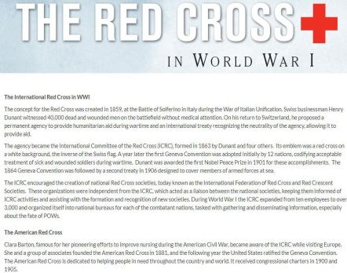
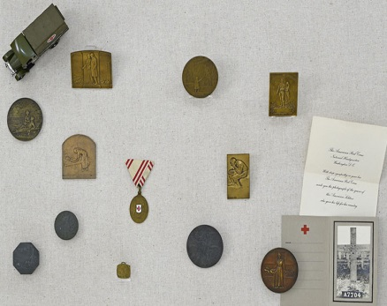
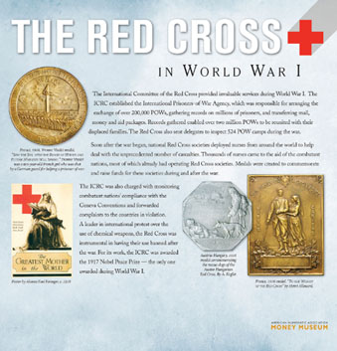
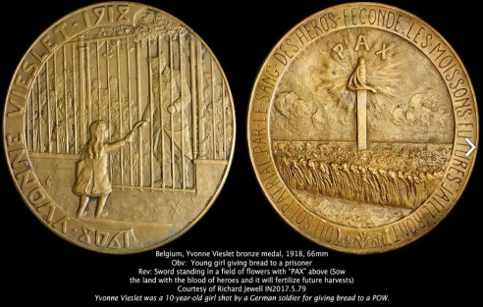
Views of the various display pages as one navigates deeper into the information available in the tour
This website and the embedded content and functionality is extremely well done! It allows the Reader to explore at their own pace, which is important especially if you are the type (as I am) who likes to read everything on the displays! The website indicated that they will continue adding more links to explore, so they encourage the Viewer to come back often. Navigate to these webpages and take the tour for yourself!
- https://www.money.org/money-museum-virtualtour
- https://www.money.org/money-museum#virtual

Following this link: www.money.org / Discover / Money Museum brings up a menu of the museum’s exhibits, which currently includes the following exhibits:
- World War 1
- Virtual Exhibits
- 360 VR Tour
- Tales from the Vault
- The History of Money
- The Harry W. Bass Gallery
- The Money Museum Collection
- Kids Zone at the Money Museum
- The Money Bus
- The Mini-Mint
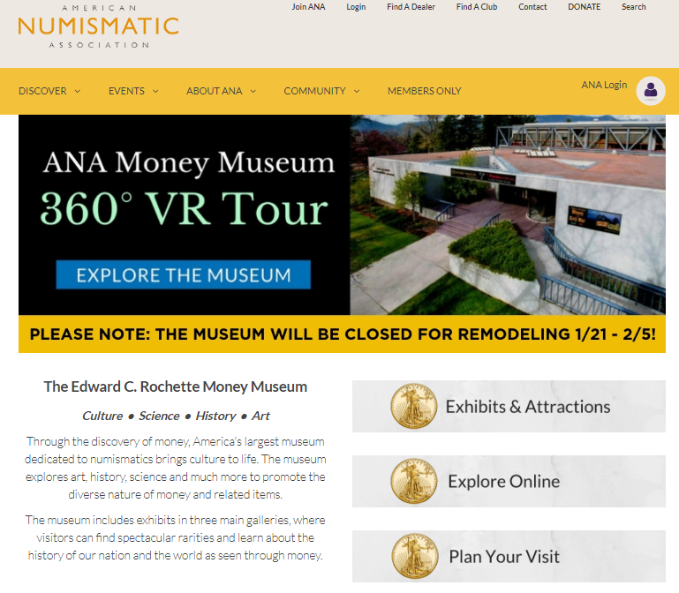
- Edward C. Rochette Fact Sheet

The ANA has done a superb job with this and they deserve accolades for the efforts of their staff and management in putting this tool together for all of us to use. CONGRATULATIONS and THANKS, ANA!
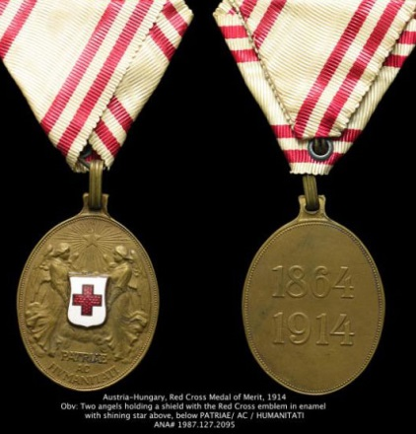

The American Numismatic Association is a nonprofit educational organization dedicated to educating and encouraging people to study and collect coins and related items. The ANA serves the academic community, collectors and the general public with an interest in numismatics.

STEPHEN JAMES CSRA COIN CLUB
Regular Meeting January 3, 2019,
Aiken County Library

Treasurer Chuck Goergen called the regular meeting of the club to order at 6:55 p.m. Jim Sproull reported that there were 19 members present. Jim announced information concerning several upcoming coin shows in the vicinity. Willie Simon won the members’ door prize, a 2018 Silver Eagle.

A motion was made by J. J. Engel, seconded by Jerry Lipsky, and passed to dispense with the reading of the November 2018 meeting minutes. A copy will be on file with the other club records, and a copy will appear in the club newsletter.

The treasurer’s report for January showed a balance of $1,283.44.

Arno Safran reminded the members that the next meeting of the Augusta Coin Club was scheduled for Thursday, January 17 at the Sunrise Grill located in the West-Town Market Square on Washington Road, in Martinez, GA starting at 7 PM. The program will be on “the Discovery in 2013 of the Saddle Ridge Gold Hoard” by Jim Mullaney.

Last month our coin club’s festive Christmas dinner was held on Wednesday, December 5th at the Red Pepper Grill in Aiken..

Old and New Business:
The club discussed the outlook for an annual coin show in 2019 and the need for a new bourse chairman. Jim Mullaney presented some information on what dates were currently open for the Odell Weeks gymnasium. Arno Safran raised the option of using the same location as the Augusta Coin Club over in Columbia County, Expo center in Grovetown, GA and considering expanding to a two-day show vs. the one-day shows our club has had to date. No final decisions were made concerning the show, however a motion was made and passed for the board to reserve the Odell Weeks gym for Saturday, September 28th, or another date in 2019, possibly in late August that the board considers appropriate. Any deposit made for Odell Weeks is refundable up until about a month prior to the reserved date.

Show & Tell Session:
Several members including Chuck Goergen, John Kolmar, and Arno Safran presented items in the Show and Tell.

The Program: for the Jan. 3 meeting:
Arno Safran presented a program on” The Modern Coins of Nicaragua”. This covered the period from when Nicaragua formed from the dissolution of the Federal Republic of Central America around 1840 with the modern era beginning in 1912 thru the 1970s.. It was interesting how certain elements of the coin design evolved, but remained recognizable over the many decades. Arno reminded us how some interesting foreign coins were readily available at prices far below the prices of U.S. coins of similar age and condition.

Ken Bailey won the 50/50 drawing - $6.00. Following the monthly auction , the meeting was adjourned at 8:45 pm.

Respectfully submitted,
Jim Mullaney, Secretary.

Kindly Patronize our Advertisers
