The Stephen James
CSRA Coin Club of Aiken
P.O. Box 11
New Ellenton, SC 29809
Web site: www.sjcsracc.org
The SJ CSRA CC of Aiken, SC meets on the 1st Thursday of the month at the Aiken Public Library

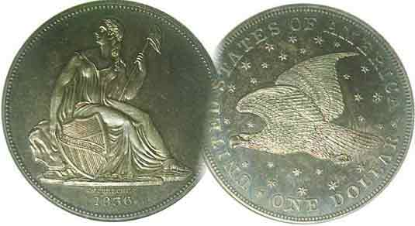
Pres. J.J. Engel
V .P. Pat James
Sec. Jim Mullaney
Treas. Chuck Goergen
Sgt. in Arms: Jim Sproull

Programs: Pat James
ANA Rep.: Glenn Sanders
Show Chair: Board members
Photos: Steve Kuhl
Publicity: Pat James
Newsletter: Arno Safran
E-Mail: arnosafran@comcast.net
Auctioneer: Jim Sproull
Web site: Susie Nulty (see above.)

Due to the Coronavirus, our upcoming Zoom Meeting will be held Thursday, February 4 at 6:45 PM

2021 Club “Zoom” Meeting Schedule
Volume 20, No. 2 the Stephen James CSRA Coin Club, Founded in 2001 February, 2021
Monthly Newsletter
Collecting the US Coins of 1811 (Excluding gold)
Jan. 7 Apr. 1 July 1 Oct. 7
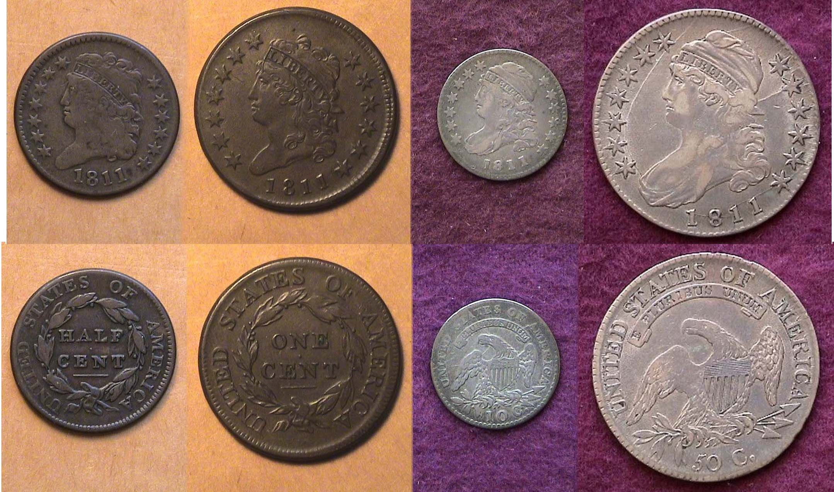
Feb. 4 May 6 Aug. 5 Nov. 4
Mar. 4 June 3 Sept. 2 Dec. 2

An Attractive Portuguese copper coin

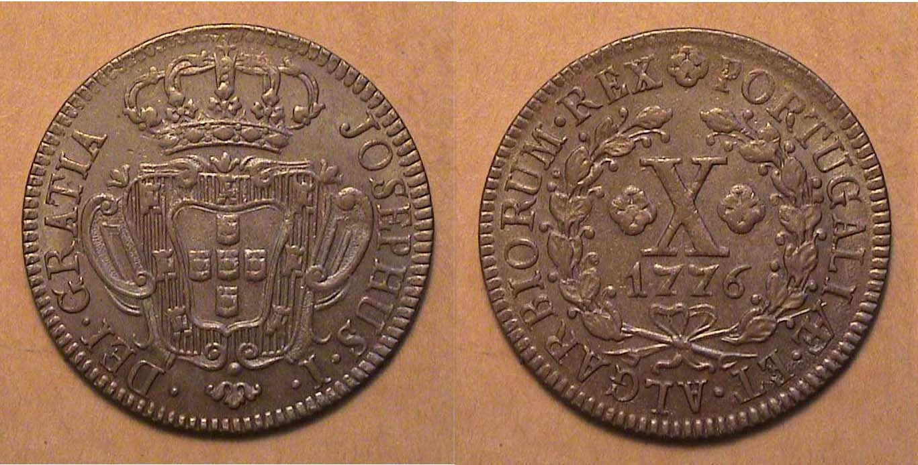

A 1776 Portuguese 10 Reis copper coin, KM-243.2 grading AU-50
[Enlarge page to view details more clearly!]

1776 was an important year in United States history, but in Portugal, the date represented the final year this 10 Reis, ½ Vinten large copper coin was struck. The type was first coined during the reign of King John in 1723 and later under the auspices of the King Joseph I who ruled Portugal from 1750 to 1776. Milled coinage had been struck in Portugal since 1683 and if one studies the early copper coinage of Brazil, the numerous copper denominations coined there represent a number of gorgeous specimens as well. Over the centuries, the numismatic artistry of both the Portuguese and Brazilian copper coinage has been highly ignored and underrated not only by collectors worldwide, but even by the Brazilians.

Years ago, the author became interested in Latin American coinage and discovered a plethora of obsolete denominations and types that were valued at a small fraction of US coins from the same period The Portuguese large size copper coin was 31 mm in diameter, slightly smaller than our early Bust silver halves which were 32.5 mm. Our early US large cents--which were 28 to 29 mm in diameter and are quite expensive in grades from XF-45 and higher while the Portuguese 10 Reis copper coinage--like the example displayed above--is twenty times less expensive and probably underrated.

Assembling a 210 year old set of US coin from 1811
By Arno Safran

A circulated 1811 US Year Set With Eye appeal (excluding gold)
[Enlarge page to view details more clearly!]

During the earlier years of our republic, our coins were struck in far smaller numbers due to our much lower population along with a low supply of copper, silver and gold planchets on hand. Our copper planchets were obtained from Birmingham, England and were delayed by long sea voyages. Silver was in short supply which in our early years were provided by a small number of wealthy citizens of the period. While most of the silver and gold was discovered by Columbus and later other explorers from Spain and Portugal in the West Indies, Mexico and South America, there was apparently enough gold on hand during the early years for the Philadelphia Mint to strike a small number of gold coins each year. Due to their even smaller mintages than the copper and silver coinage however, survivors are very expensive today.
As to the other four coin denominations that were produced in 1811; well circulated specimens are available but at a far higher price especially since the author obtained the four cons shown above; these being the 1811 copper half-cent and large cent followed by the disme and the half-dollar.
(Continued on page 2, column 1)
Assembling a 210 year old set of US coin from 1811
(Continued from page 1, column 2)

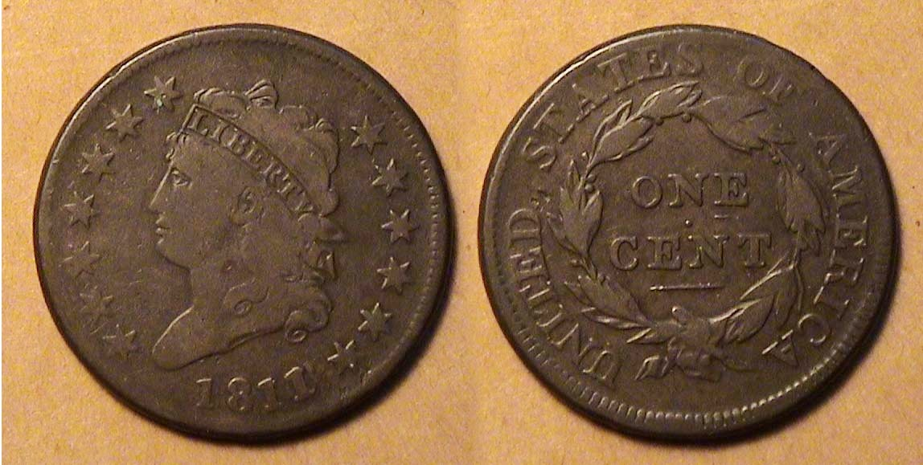

An 1811 Classic Head half-cent, C-2, R3- graded VG-8
[Enlarge page to view details more clearly!]

In 1807, newly appointed Asst. Chief Engraver, John Reich was asked to redesign all of Robert Scot’s Draped Bust type coinage and began replacing it with the Capped Bust/ Spread eagle design on the silver and gold coinage and the Classic Head design on the two copper denominations,

The Classic Head half-cent was 23.5 mm in diameter and was struck from 1809 thru 1836 although not in every year. After 1811, the denomination was suspended until 1825 where it was coined as business strikes sporadically thru 1835 with the final date, 1836, struck as a proof only.

The 1809 is common, the 1810, less so and the 1811, with a mintage of only 63,140 is considered the key date of the series (although the 1831, with a reported mintage of just 2,200 was once thought to be a proof only but some business strikes supposedly exist and are extremely rare.) There are only two die varieties for the 1811 half-cent, the first showing the 1 & 8 in the date further a part and the second, closer together. The coin shown is the second die variety which is a tad more common. Over the years this particular example circulated, it appears to have worn evenly on both sides of the coin without any distracting marks or scratches. It was acquired for only $250 at the Garden State Numismatic Association Show held in Cherry Hill, NJ back in June, 1991 and valued at around $700 today.

An 1811/0 Classic Head Large cent, S-286, R3 grading VG-8
[Enlarge page to view details more clearly!]

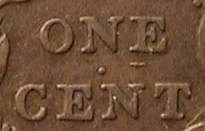
Unlike the half-cent series, the Classic head Large cents--with a diameter of 29 mm--were struck in seven consecutive years from 1808 thru 1814 with only 19 die varieties. The 1811 issue has two die varieties; the first, an over date, designated 1811/0, that is rayed scarce to rare the higher the grade, and the normal date which is less scarce. The majority of the 1811/0 large cents are more common in VG-8 to VG-10 than Fine-12 or higher and can be identified by looking at the reverse where a tiny horizontal line appears under the left side of the E in ONE of one-cent.
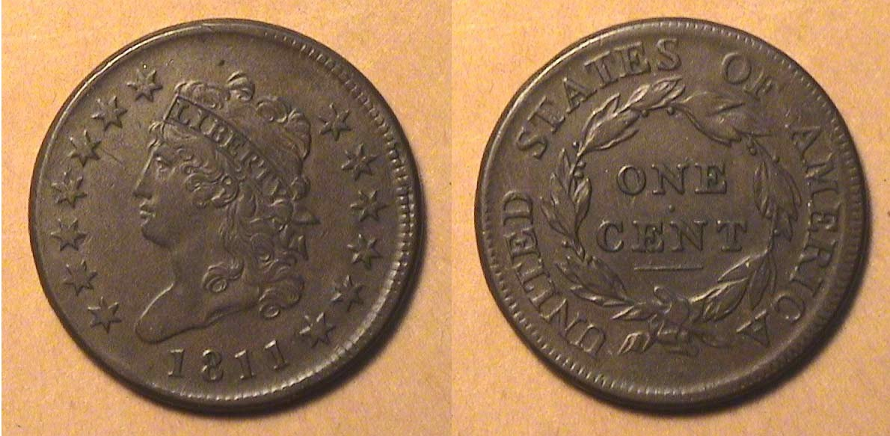

An 1811 Classic Head large Cent, S-287, R2 graded VF-35
[Enlarge page to view details more clearly!]

The 181l with the normal date is the second scarcest of the series and the specimen shown above is a real “beauty” with attractive color and surfaces. The coin was acquired back in September, 1994 at a major coin show held in northern New Jersey from a major dealer who specialized in early American copper coinage. It was fairly expensive at the time but since then has more than doubled in value. The surfaces and color are even with some wear showing on Miss Liberty’s hair.
The reported mintage for the 1811 cent was just 218,025, the lowest of the series. The 1809, with slightly more at 222,867, had fewer survivors accounting for its current ranking as the “key date” of the series.
By 1811, tensions between Great Britain and the USA had grown considerably due to the British raiding of US ships claiming deserters were aboard while as a response, the US were placing blockades on other British ships. As a result, it was becoming more difficult for Mint Director, Robert Patterson to obtain copper planchets from Mathew Boulton’s factory in Birmingham, England. The planchets were often left in the holds of British ships that over time, became damp and porous with the result that many appear discolored with the result that when the coins were struck, a large number appeared grayish instead of the lovely chocolate brown color shown on the cents in this article. A year later, in July of 1812, the second war with Great Britain began and did not end until the signing of the Treaty of Ghent in Belgium on Christmas Eve, 2014.

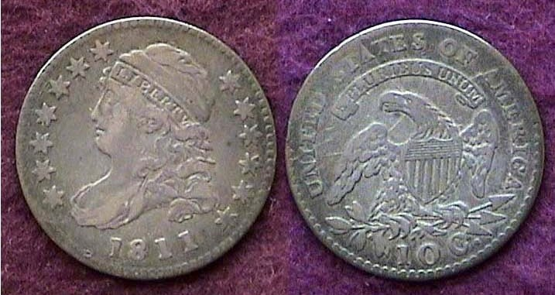

An 1811/9 Capped Bust disme graded VF-25 by PCGS
[Enlarge page to view details more clearly!]

In 1811, the reported mintage of dismes at the Philadelphia Mint was listed at 65,180. No dismes were struck with the 1810 date but apparently there were enough leftover from 1809 to strike the 1811/9 which accounts for the over-date issue, but whatever the reason, the 1811 dime is considered almost as scarce as the 1809. Our first dismes were the Draped Bust variety engraved by Robert Scot and were struck on thin silver planchets with a diameter of 19mm. When Asst. Chief John Reich struck hi Capped Bust disme design-type in 1809, the planchet size reduced to 18.8 mm and slightly thickened accordingly.

The author obtained the 1811/9 disme “raw” shown directly above at a cost of only $150 back in 1988 from a fellow-member at the Ocean County Coin Club located in Brick Twp. NJ just a few miles west of the Atlantic Ocean. The member was planning to move to the Gulf Coast of Florida and decided to sell his collection beforehand. Over the next several months, this same individual was the source of a number of early US coins that the author acquired. The member was an excellent grader because when the author decided to certify the coins that he bought from him 25 years later in 2013, the 1811/9 dime came back in a PCGS holder graded VF-25 and today is valued at $1,350.
________________________________________________________________________________________________________________
(Continued on page 3, column 1)
Assembling a 210 year old set of US coin from 1811
(Continued from page 1, column 2)

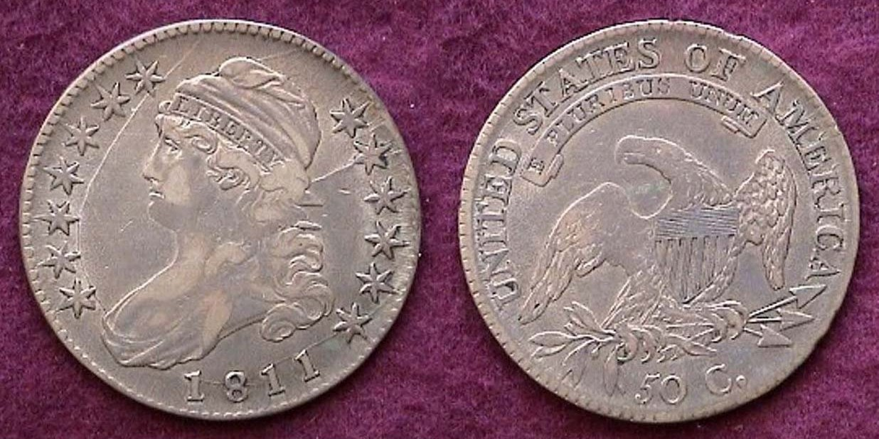

An 1811 Lettered Edge Capped Bust half-dollar, O-112a sm. dt
Graded VF-35 by ICG at the GNA Coin Convention
[Enlarge page to view details more clearly!]

Aside from the 1807, the first year of issue, the low mintage, 1815/2 and the 1820, the Lettered Edge Capped Bust half-dollar--with a diameter of 32.5 mm diameter--were struck in the multi-millions thru 1836. With the suspension of the silver dollar in 1804, the coin became the highest silver denomination and was needed as “specie” to back investments with the result that Capped Bust half-dollars saw less circulation than any other denomination with most dates surviving in higher grades compared to the lower denominations.

The reported mintage for the 1811 Capped Bust half-dollar was 1,203,644. but a number of examples of this variety are scarce. The coin pictured above was graded only VF-35 but its variety is what makes it a desirable acquisition due to its numerous die cracks on the obverse. These are not scratches but actual break-ups in the die and while the date itself is considered common the variety is listened between a Rarity 4 and 5, indicative of a scarce to rare coin as a collectible. The author acquired the coin at the Atlanta ANA World Money Show convention held back in 2001, the first full year that the author was residing in the Central Savannah River Area. Aside from the various die striations, the coin is evenly worn with no undesirable problems and was fairly inexpensive, and since its acquisition it’s value has risen.

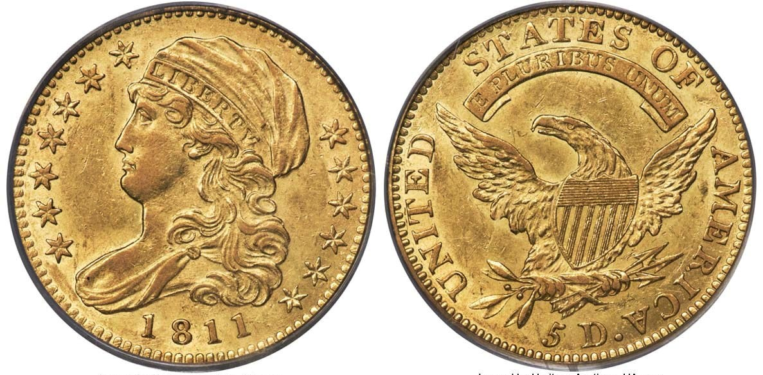
An 1811 $5.,00 gold half-eagle, BD-2 , R3 graded AU-58 by PCGS
[Enlarge page to view details more clearly!]

Our early US Gold coins were works of art but unfortunately for most collectors, even ardent ones, they tend to be very expensive and beyond the means of most due to their low survival rates. In 1811, the Philadelphia Mint struck a reported 99,581 half-eagles featuring John Reich’s Capped Bust design type and it is considered one of the more common dates of the Capped Bust gold $5.00 series but the price-tag for early US gold coins has always been fairly high and today, a certified AU-58 example like the one shown above is priced in the neighborhood of $10,000 whereas twenty years ago, such a coin grading similarly sold for $5,000 or half that price; still a prohibitive price-tag for the vast majority of collectors. Nevertheless, one has to observe the artistry of Reich’s design, as both sides of the coin are beautifully balanced within a classical artistic style that was in vogue during this time frame commensurate with the period.
Despite the exorbitant pricing of our early US gold coins, if one wanted to acquire the coin shown on the preceding column it would be a lot less costly as an AU-58 than a MS-60 specimen, which despite being the first designated uncirculated grade, usually lacks the eye appeal due to various abrasions on the surface which a number of AU-58s and even 55s don’t display. So, if a collector on a upper-middle-class discretionary income desired to acquire such a coin, he or she might consider the following options; 1. Sell in order to buy! In other words, sell a number of coins already housed in your collection and use the extra cash plus your available funds to acquire the coin; 2), Save up over a period of months until you have enough to afford the coin or 3) Use that portion of an unexpected inheritance; Ha! Ha! Ha! Nevertheless, if one were attempting to acquire all five examples of US coins dated 1811, a $5.00 gold half-eagle, especially one grading AU-58 would be very tempting indeed. Returning to reality; suffice it is to say, for most collectors, the 1811 set would look more like the coins shown directly below.

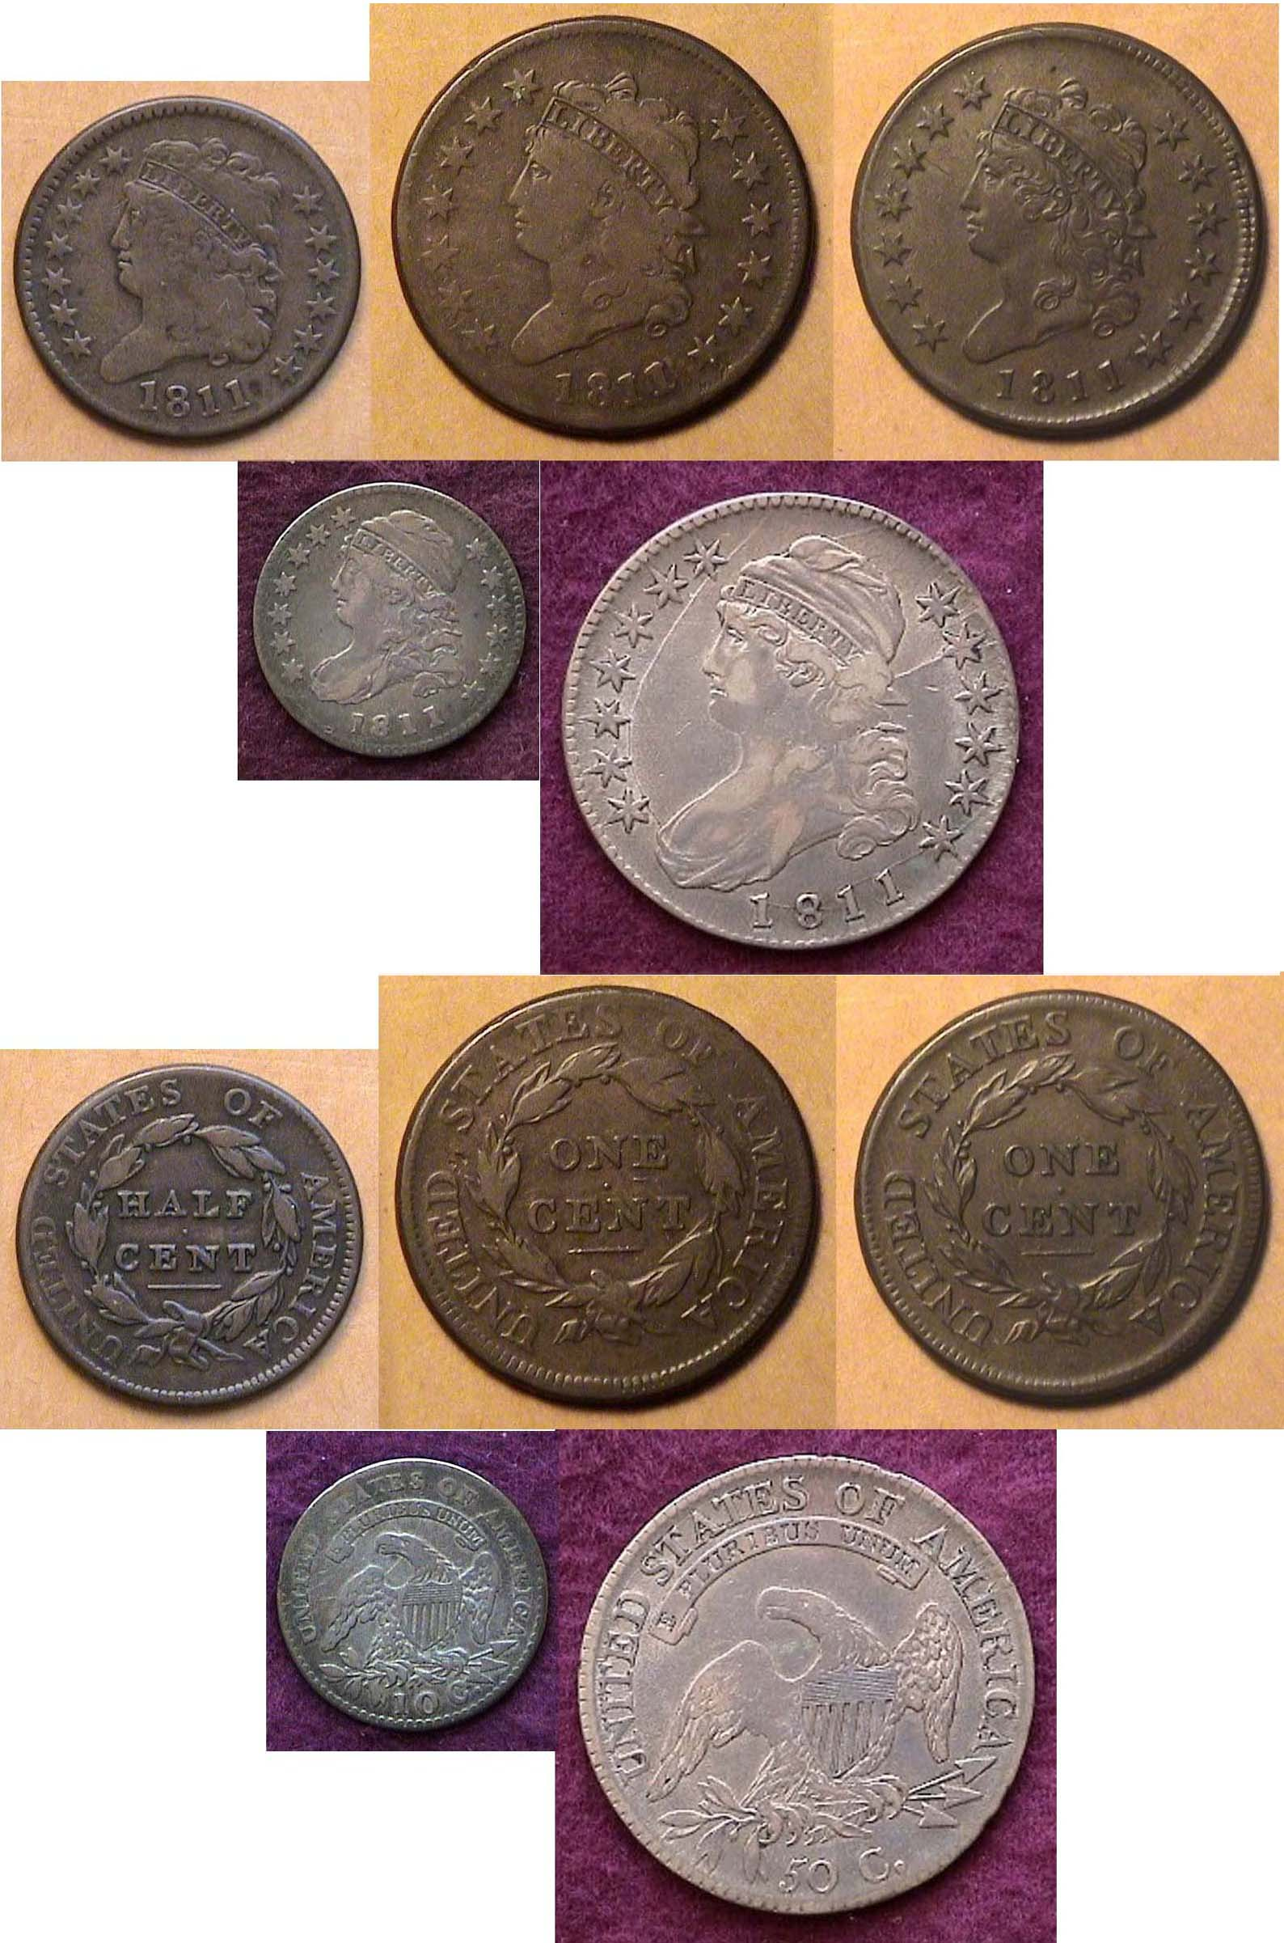

The affordable portion of an 1811 Year set shown above,
From, left to right and below; the 1811 Classic half-cent, the 1811//0 Classic Head large cent, and the 1811 normal date large cent over the 1811/9 Capped Bust disme and 1811 half-dollar
________________________________________________________________

Minutes of the STEPHEN JAMES CSRA COIN CLUB, Regular Meeting Thursday,
January 7, 2021 VIA Zoom

The Club held the January 7, 2021, meeting via a Zoom session arranged by Club Secretary, Jim Mullaney.
President J.J. Engel called the regular meeting to order at 6: 45 p.m. There were 15 members who joined the Zoom session.
A motion was made by Willie Simon, seconded by Chuck Goergen, and passed to dispense with the reading of the December 2020 meeting minutes. A copy of the minutes will be on file with the other club records, and a copy will appear in the club newsletter.
Treasurer Chuck Goergen did not report any change in the Club’s December 2020 bank balance of $1,108.39. Chuck said that member Tony Chibbaro’s book on South Carolina tokens, purchased by the club last Fall, had been presented to the Aiken County Library.
President Engel updated the members regarding the situation with the Aiken Library and said there was an indication from the Library they might be able to make a Meeting Room available for coin club meetings in November or December of 2021, so our coin club meetings will continue to be online until the Covid-19 situation changes. JJ indicated that there was still discussion with Jim Mullaney about his suggestion that in- person meetings at Jim’s horse farm, which had both a suitable barn and large patio area, that might be considered for meeting starting in April with warmer weather. Furthermore, they had discussed the desirability of the meetings also continuing to be presented via Zoom for those not wanting to attend meetings in person just yet.
President Engel stated the annual audit is due in May and asked for suggestions. He noted that member Garry Naples had done the audit last year, and Garry volunteered to do it again this year. Treasurer Chuck Goergen will make arrangements with Garry to get him the records for the audit.
President Engel reminded members that the annual election of club officers is scheduled with nominations made in February, elections in March and installation in April. He reported that the present office-holders had agreed to continue in their offices; however, they were open to stepping down if anyone else was willing to sign on for one of the offices for the coming year. He asked that anyone interested in serving please contact him or another officer, or send an email to the club, sjcsracoinclub@gmail.com, and Jim Mullaney would monitor these messages.
Steve Kuhl also inquired if the club would like an announcement in the SCanner of the club’s meetings being currently held via Zoom with an invitation from the club for the public at large to join the Zoom meetings. Steve pointed out it would be a way for the three-time Club of the Year to expand its educational mission by promoting numismatics in an innovator manner during the Coronavirus pandemic.
Jim Mullaney said he could devise an appropriate response to emails so those interested can connect to the meetings. The Board members supported this suggestion from ex-President Kuhl.

Show & Tells:
​ Chuck Goergen shared his purchase by auction of a Norse-American Medal struck in 1925 by the Philadelphia Mint for the 100th anniversary of the voyage of the ship Restoration bringing Norwegian immigrants to the United States. The medal was sculpted by James Earle Fraser, the designer of the Buffalo nickel, and depicted a standing Viking figure on the obverse and a Viking long ship on the reverse. The medals were produced in gold, silver and bronze, and in thick (2 mm) and thin (1.6 mm) sizes. Chuck’s medal was one of the silver 33,750 medals produced and graded by PCGS as “Thick. ”Chuck also shared as a mini-grading exercise three beautiful Morgan dollars he had won in the auction: 1882 O graded AU-58, 1884 O graded MS-64, and 1885 O graded MS-63.

Kelsey Forde shared an article discussing and celebrating the 50Hh 75th and 100TH anniversaries occurring in 2021 of various coins.

The Program:
Garry Naples presented a program on
“My Favorite Chicago World’s Fair Elongates,”
which included the interesting history of elongated coins and background on the 1933 and 1934 Chicago World’s Fair. Garry related that the mission of the Fair was to demonstrate the significance of scientific and technological discoveries and showcased modern advancements in art, literature, and architecture from across the globe. Exhibits from all over the world included new automobile designs. There was also international carnival entertainment at the Fair, including the Sky ride, a cable-suspended people mover higher than any building in Chicago. The Fair opened in May of 1933 and closed in November of 1933; however, because of its popularity, the Fair reopened in May of 1934 and had its final closing on October 31, 1934. The extension of the Fair resulted in over thirty-nine million admissions. Garry explained that an elongated coin (or pressed penny) is one that has been flattened or stretched, and embossed with a new design. Such coins are often used as commemorative or souvenir tokens, and it is common to find coin elongation machines in tourism hubs, such as museums, amusement parks, and natural or man-made landmarks. Elongated coins are also categorized as exonumia. The first elongated coins in the United States were created at the1893 Chicago Columbian Exhibition, a tribute to the 400 years since the arrival of Columbus. Several designs were issued to commemorate the fair. Garry related that in America, one cent coins are most commonly used in these vending machines, as they are thin, easy to emboss, and are the smallest denomination of American money, although other denominations have also been used.
(Minutes continued on page 5, column 1)
Minutes of the STEPHEN JAMES CSRA COIN CLUB, Regular Meeting Thursday,
January 7, 2021 VIA Zoom
(Continued from preceding page)

Garry said that he had been collecting elongated coins for 25 years and he has managed to obtain 137 of the 159 varieties of elongated coins from the 1933-1934 Chicago World’s Fair. He showed many of the coins from his collection beautifully commemorating the scenes at the Fair and explained that they ranged in price from $25 to over $200. Garry also displayed examples of elongated nickels, dimes and quarters.

Collecting elongated coins has long been popular in numismatics, and there are many internet sites and groups to support collectors, as well as sales in internet auctions. The members in the audience expressed their appreciation for Garry’s excellent program.

VP Pat James announced that the program for the February 4, 2021, meeting would be presented by member, Tony Chibbaro, and is entitled “A Numismatic Stroll Down Aiken’s Laurens Street.” Pat also said that member Steve Kuhl agreed to present his program on South Carolina Blue Ridge Rail Road Scrip at the March 4, 2021, coin club meeting.

Respectfully submitted
James Mullaney, Recording Secretary

________________________________________________________________________________________________________________

TELEPHONE TOKENS USED AS MONEY By Bill Myers
In times of coin shortages many alternatives have been used to substitute for coins. I am going to discuss the use of telephone tokens as a substitute for coins.
I have found brass and bronze tokens in junk boxes that have an image of a phone between two grooves. The other side has a center groove with GETTONE above it and TELEFONICA below it and an oval with 4 numbers in it. Some tokens have a mintmark in a box above GETTONE. The numbers are the date, the first two are the year and the last two are the month. It is a public telephone token from Italy. Gettone means token. The telephone tokens were introduced in Italy in 1927 and were in use until the lira was replaced by the euro in 2001. In 1976, phone cards were introduced and the decision to stop producing tokens was made in 1983 but collectors do not need to worry, 600 million tokens were produced. There are several varieties of the token,

Telephone tokens can be considered a numismatic item but there is another connection to numismatics. When there was a shortage of coins, the tokens had the accepted value of 50 lire. In 1980, it was valued at 100 lire and in 1984 the value was 200 lire which was stable until 2001. The value of the token was based on the cost of a phone-call at that time.
World War II created a coin shortage in Croatia so a zinc 4 kune telephone token circulated as currency. It is 1 mm thick and the diameter measures 23.56 mm top to bottom and 23.9 mm from left to right. The token has no date but it is reported to be produced in 1941. Once source notes it was demonetized on 25 September 1942.

I have found two countries that used telephone tokens as a substitute for coins and I would suspect there are other examples.
__________________________________________________________________________________________________________

References:
Telephone Token - Gettone Telefonico at https://en.numista.com/catalogue/pieces133685.html
Gettone at https//enWikipedia.org/wiki/gettone
The Italian Gettone Telefonico: A token that has become a Coin at GETTONE_ENG.PDF (wisardcoin.altervista.org)

Bill Myers is a former member of our club and a retired Army Colonel who currently resides in Tucson, AZ with his wife, Kathy. (ED.)
__________________________________________________________________________________________________________________________

The Educational Bank notes, Series of 1896
(Second in a Series)

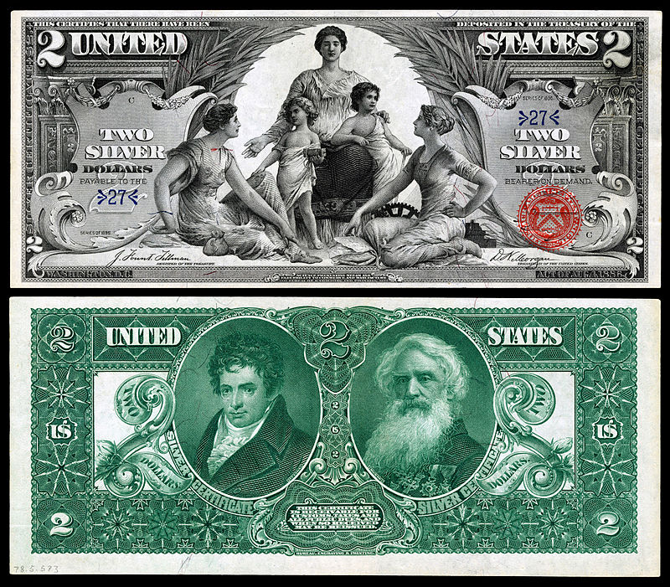

The $2.00 Educational Silver Certificate, Series of 1896
[Courtesy of Wikipedia) [Enlarge page to fill screen.]

The $2 note represents Science presenting steam and electricity to Commerce and Manufacture

The face of the $2.00 Series of 1896 silver certificate displays an allegorical picture of three mature women clad in classical Greek dress style. The woman atop at the center represents Science with Commerce and Manufacture being the females at the sides while the two lightly-clad youths represent steam and electricity. The back of the $2.00 educational note portrays inventor Robert Fulton who invented the Steam ship away back in 1807 and Samuel F. B. Morse who invented the telegraph in 1844. The artists who were involved in the Bureau of Engraving’s efforts to create the lovely $2.00 bank note were E.H. Blashfield, Will H. Low, S Reinhart and Walter Shirlaw.

Today virtually all our paper money denominations are Federal Reserve notes but back in the 19th century, our paper money was not only issued in large size dimensions, but also in many more denominations with a variety of exquisite artistry. They also provided a wider variety of categories and conditions, such as 1) Demand notes, used to pay soldiers during the Civil War, 2. Legal tender notes (except for paying foreign debts), known as Federal Reserve notes today, 3) interest baring notes, (like a short term savings bond), 4) national bank notes, 5) silver certificates permitting the bank teller to change your $2.00 silver certificate for two-dollars in silver coinage and also 6) gold certificates intended for larger business transactions where one could receive gold coins in change.

The $2.00 Educational silver certificate shown above was probably used a little more than a regular Federal reserve $2.00 bill is used today, a pity because both types are attractive works of art as compared with the still current $1.00 bill.

Acquiring a n example of this note is another matter as the survival rates are quite low while the design type is extremely popular with collectors of large size US banknotes. The price tag for one graded just VG-8, “quite worn with numerous folds” is listed at $600 while one certified FINE-12 is around $900. with a VF-20 listed at $1,500, so unless one is an ardent collector of the series and has the financial wherewithal to add an example to their collection, the next best thing is to acquire a Souvenir Card version which are available at very low price for all collectors who like the design. Starting in 1970, the ANA World Money show offered a popular large size banknote replica. The Souvenir Banknote Society was formed for just those collectors.
___________________________________________________________________________________________________________________
To be continued!

Kindly Patronize our advertisers

