The Stephen James
CSRA Coin Club of Aiken
P.O. Box 11
New Ellenton, SC 29809
Web site: www.sjcsracc.org
The SJ CSRA CC now meets at the South Aiken Presbyterian Church at 1711 Whiskey Road

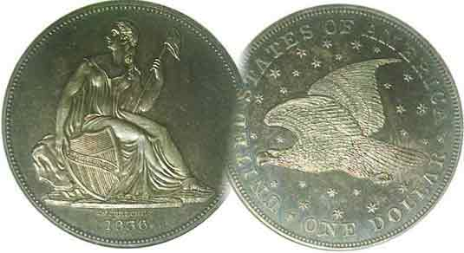
Pres. J.J. Engel
V .P. Pat James
Sec. Jim Mullaney
Treas. Chuck Goergen
Sgt. in Arms: Jim Sproull

Programs: Pat James
ANA Rep.: Glenn Sanders
Show Chair: Board members
Photos: Steve Kuhl
Publicity: Pat James
Newsletter: Arno Safran
E-Mail: arnosafran@comcast.net
Auctioneer: Jim Sproull
Web site: Susie Nulty (see above.)

Our next will be on Thursday, February, 3 at 6:45 PM in the South Aiken Presbyterian Church Gymnasium
Due to the Omicron variant of Covid -19, please wear a face mask inside the building

2022 Club Meeting Schedule
Volume 21, No. 2 the Stephen James CSRA Coin Club, Founded in 2001 February, 2022
Monthly Newsletter
Collecting the U.S. Coins of 1889 an interesting challenge
Jan. 6 Apr. 7 July 7 Oct. 6
Feb. 3 May 5 Aug. 4 Nov. 3
Mar. 3 June 2 Sept. 1 Dec. 1

US Commemorative Coin of the Month

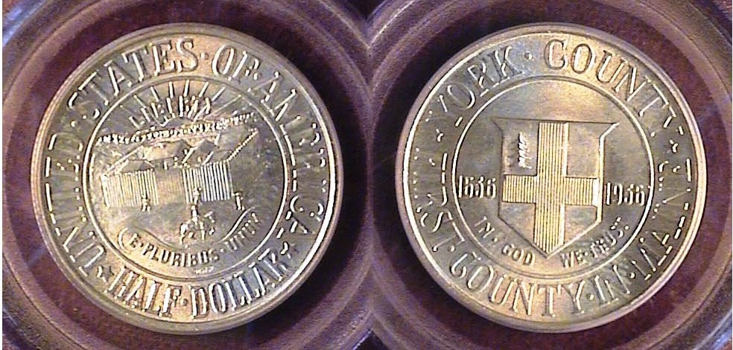

A 1936 York Commemorative half-dollar graded MS-65 by PCGS
[Enlarge page to 150% or fill monitor screen to view details.]

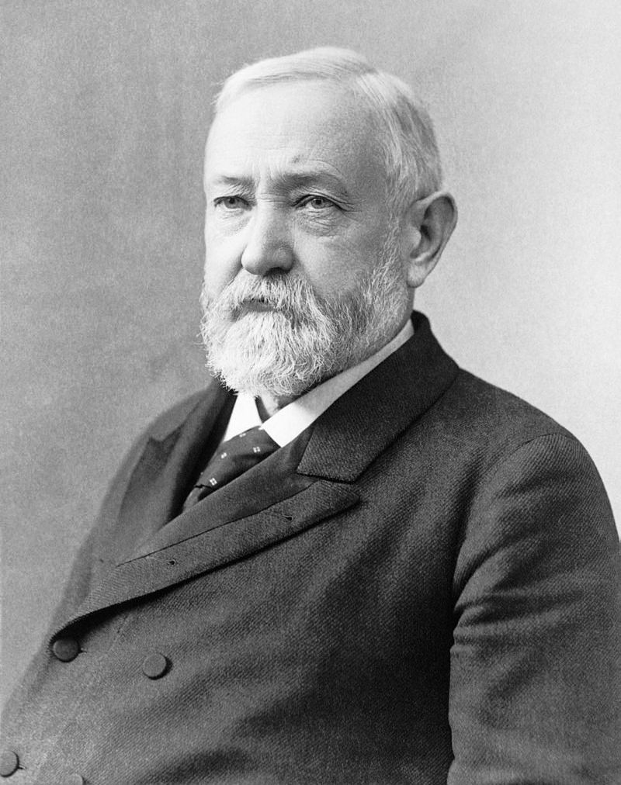
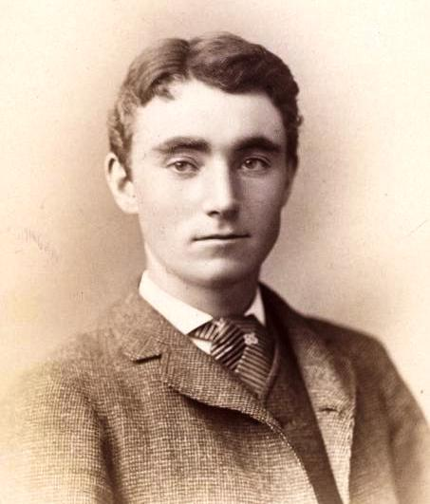
The York, County commemorative silver half-dollar was created to celebrate the 300th anniversary of the founding of York County, Maine, which borders the Atlantic Ocean just north of a slice of New Hampshire jutting out to the sea. The coin was designed by artist Walter H. Rich (1867-1948) of Portland, Maine. The obverse displayed a Stockade with the sun rising beyond with a barely noticeable horseback rider in front while the reverse displays the county’s coat of arms showing a large cross in the center and a miniscule pine tree in the upper left corner. 20,015 coins were released at a price of $1.50 each. Today the commemorative ranges in price from $150 grading MS-63 to $175 in MS-65, so it pays to obtain an MS-65 example. The “slabbing” companies tend to reverse the sides of the coin as shown below.

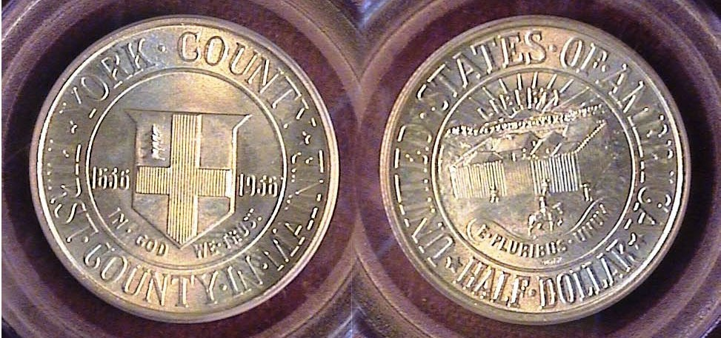

[Enlarge page to 150% or fill monitor screen to view details.]_

Collecting the US Coins of 1889 (excluding gold)
By Arno Safran

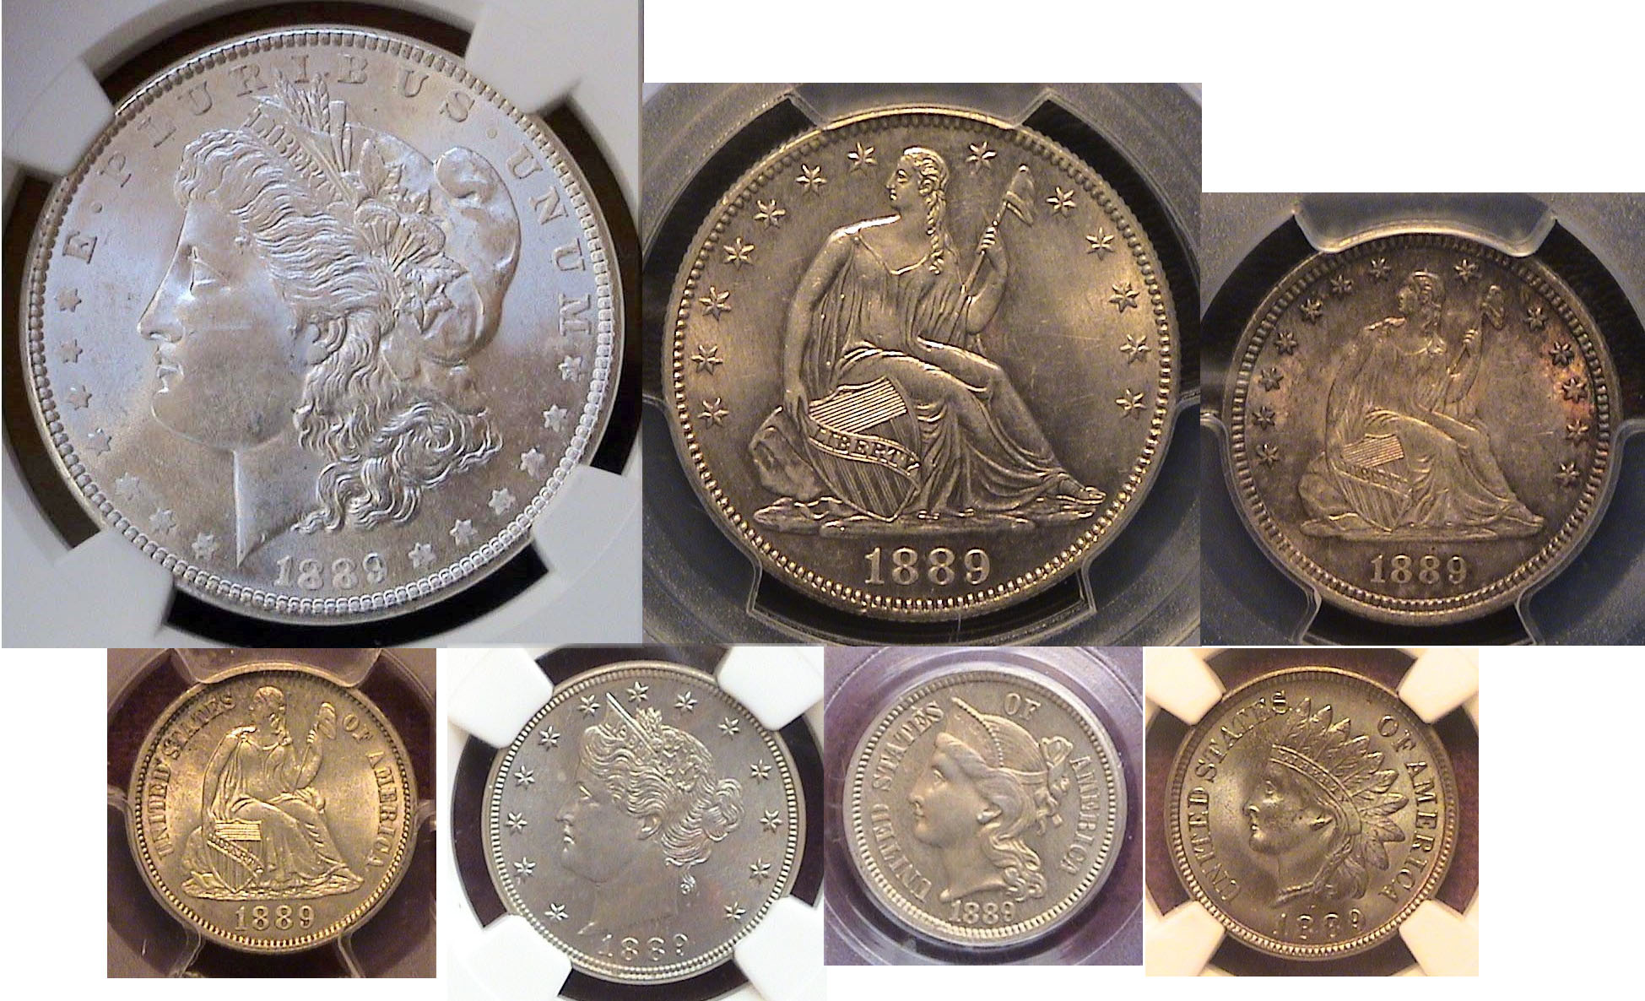

The obverses of an US 1889 BU set showing the $1.00, 50c & 25c above the 10c dime, 5c nickel, 3c nickel & Indian Head cent

I889 was an unusual coin year in our nation’s history as it was the final year the Mint struck the 3c copper-nickel piece and the $1.00 & $3.00 gold pieces, the latter two not shone above. As for the other denominations shown, since 1878, Morgan dollars were struck in the multi millions at the four mints but aside from being used at gambling joints and out in the far west where the coin was preferred over paper dollars, the coin hardly saw the light of day in the large cities east of the Mississippi river. The quarter and the half-dollar were struck in very small numbers, from 5,000 to 14,000, leaving only the dime, five-cent nickel and “penny” to be used as “money” in which to buy things. Fortunately, the nickel was the workhorse of the economy during the late nineteenth century because many necessities cost far less back then.

At the time, Benjamin Harrison--who defeated Grover Cleveland in the Electoral college if not the popular vote--was our newly elected president. Neither figure was considered controversial during their respective tenures.
Benjamin Harrison
The author considers the decade of the 1880s, if not jubilant, interesting from a numismatic view due in part to the “sleepers” it holds for the coin collector. (Continued on page 2)
Collecting the US Coins of 1889, (excluding gold)
(Continued from page 1, column 2)
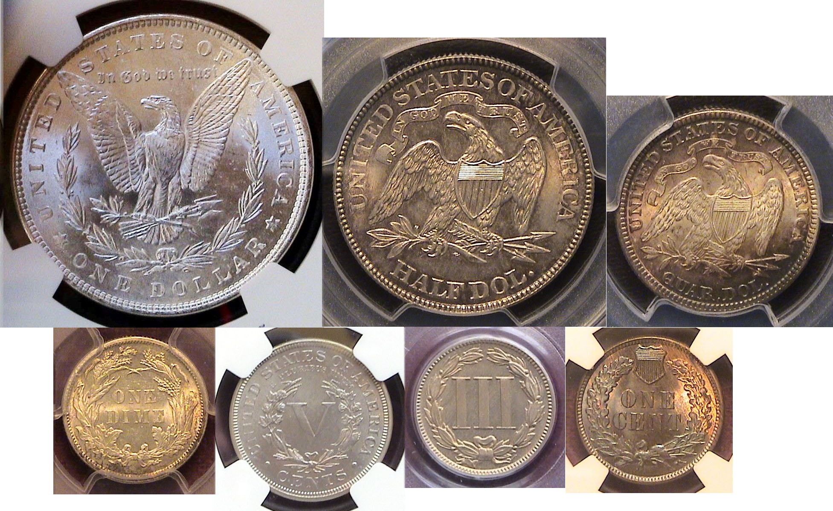
The reverses of an US 1889 BU set showing the $1.00, 50c & 25c above the 10c dime, 5c nickel, 3c nickel & Indian Head cent

The reason for the lower mintages for the quarter and half-dollar were due to the Bland Allison Act of 1878 which reversed the previous Act of 1873 by reinstating silver dollar coinage in order to favor the western silver mining interests and since there were ample quarters and halves in circulation, congress did not feel the need was to strike large quantities of those two denominations. During the 1880s, there were four Mints operating in the United States. These included those at Philadelphia, New Orleans, San Francisco and Carson City,
all striking Morgan dollars in the millions to the multi-millions.
Nevertheless, the 1889 dated coins shown in this article all have interesting stories to tell.

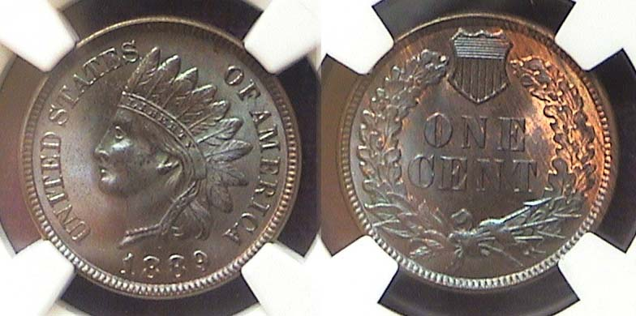

An 1889 Indian Head cent graded MS-65 Brown by NGC
[Enlarge page to 150% or fill monitor screen to view details.]

The lovely Indian Head cent shown directly above was acquired by the editor at our club’s last coin show which took place at our new location back in September, 2019. No one knew then that it would be three years in the future before our next show would be scheduled since the Coronavirus known as Covid-19 didn’t arrive on our nation’s shores until March, 2020.

Indian Head cents--which have always been popular with collectors--can be divided into three phases, the Copper nickel group, from 1859 thru 1864, the early dates of the bronze group beginning later in 1864 up thru 1878 that are scarce and the last thirty years of the series from 1879 thru 1909 being the more common dates of the series and the most affordable grading as high as MS-65 Red-Brown.

The 1889 cent had a fairly large mintage for its time; 48,866,025, but it was not the highest of the series which went all the way back to 1863 when 49,840,00 copper-nickel issues were struck, but the later coin is nevertheless far less expensive than that predecessor. It is an interesting date since many have survived certified MS-65 Brown that are extremely well struck with a much smaller number displaying red-brown or full red color. Renowned numismatic specialist and dealer of both the Flying Eagle and Indian Head cents series, Richard Snow, concluded that the 1889 coin was struck with a mixed alloy of tin and zinc which caused the copper to appear more darkish than reddish. As a result, finding a full red 1889 Indian cent is quite rare and expensive. In 1889, a cent had the purchasing power of 28 cents.
_
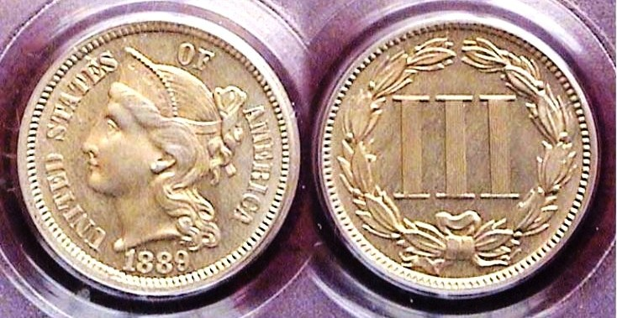

An 1889 three-cent copper-nickel piece graded Proof-64 by PCGS
[Enlarge page to 150% or fill monitor screen to view details.]

At the end of the Civil War in early 1865, our coinage was virtually non-existent with the result that a new 3 cent piece was issued that contained..750 copper bonded to .250 nickel as part of an effort by congress to stimulate commerce and the economy. The new coin was created by our 5th Chief Engraver, James Barton Longacre in 1865. It displayed a Coronet Liberty with attractive tresses behind her head while the reverse shows three columns with a wreath surrounding it, yet--unlike the 1883 Liberty nickel without cents—the nickel 3c piece never caused any confusion regarding its denomination. The Coronet Liberty 3c piece was 17.9 mm in diameter, the same as the dime but that too never resulted in anyone confusing the coin with the dime during its entire lifetime the way the 1875-76 twenty cent piece did due to its similarity with the Liberty Seated quarter.

In 1877, 1878 and 1886, the three cent nickel coin was struck in proof only. With the exception of the low mintage and rare 1883, ’84 and ‘;85 and possibly, the 1887, virtually all of the other dates are considered common and affordable thru grades MS-63 and 64. With the exception of the 1877 and 1878 proof only examples, all the other proofs grading up thru MS-64 are also affordable with some being far less expensive. In a long running coin type, a collector will opt for a proof issue at a show when a business strike example of a particular date is not available, which s how the coin shown directly above became part of the author’s 1889 year set. The author doesn’t recall his grandfather mentioning using a copper-nickel three-cent piece. In 1889, a Coronet 3 piece had the purchasing power of 87¢.

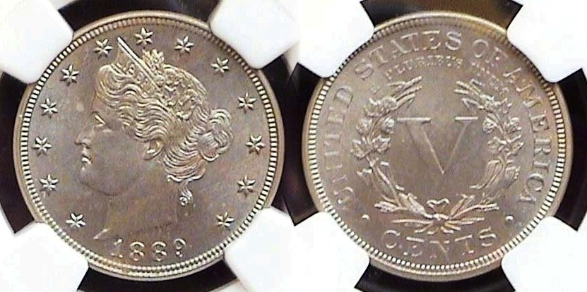

An 1889 Liberty nickel graded MS-64 Proof by NGC
[Enlarge page to 150% or fill monitor screen to view details.]

When it comes to the five cent denominations, the 1889 Liberty nickel with a mintage of 15,878,025 is considered a common date. Back in 2010,when the author was attempting to complete the 1889 year set, (excluding gold) he was unable to find a business strike example that he liked certified from AU-58 thru MS-65, but in late October while attending the South Carolina Numismatic Convention held in Greenville, SC, he came across the attractive proof version shown above certified MS-64 by NGC, which was very reasonably priced. Despite the low mintages, proofs seldom circulated, so, it is very possible that more examples grading MS-63 thru 64 proofs exist than business strikes for the same year simply because a nickel had the purchasing power of $1.50 and circulated heavily. As a youth, the author remembers coming across Liberty Head nickels with the features and dates of the coin barely visible.
(Continued on page 3, column 1)
Collecting the US Coins of 1889, (excluding gold)
(Continued from page 2, column 2)

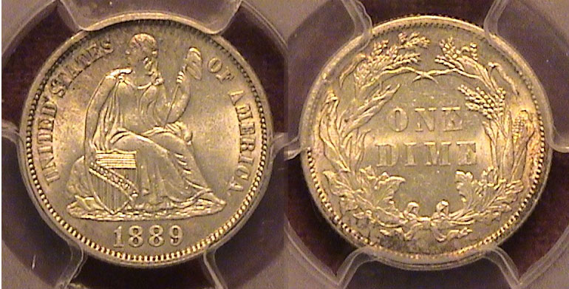

An 1889 Liberty Seated dime graded MS-62 by PCGS
[Enlarge page to 150% or fill monitor screen to view details.]

In 1889, the Liberty Seated dime was struck at the Philadelphia Mint with a mintage of 7,380,000 and at the San Francisco Mint with just 972,678 coined. The New Orleans Mint, which reopened in 1879, did not strike any dimes until 1891, the final year of the Liberty Seated series. As for the two Mints that did, the difference in price between the 1889-P and 1889-S grading MS-63 is enormous, between $250 for the 1889–P and $1,000 for an 1889-S according to the 2022 Red Book. The coin shown above however, was certified slightly lower as a MS-62 by PCGS at a price of just $175 when it was acquired at the Augusta Coin Club spring show in May, 2019. With the dime’s size being only 17.9 mm, the difference in eye appeal between a MS-62 and MS-63 is infinitesimal, and since the date is not considered rare why pay a grade-rarity price for an higher grade piece. According to the latest COINFACT retail price chart, an 1889-P dime is listed at $200 for an MS-62, $250 for an MS-63, $450 for one certified MS-64 and $600 for one certified MS-65. Upon enlarging the coin shown above, it appears fairly attractive as a MS-62; a factor to be considered when one is attempting to complete a denominational set excluding gold. In 1889, a dime had the purchasing power of $3.00.

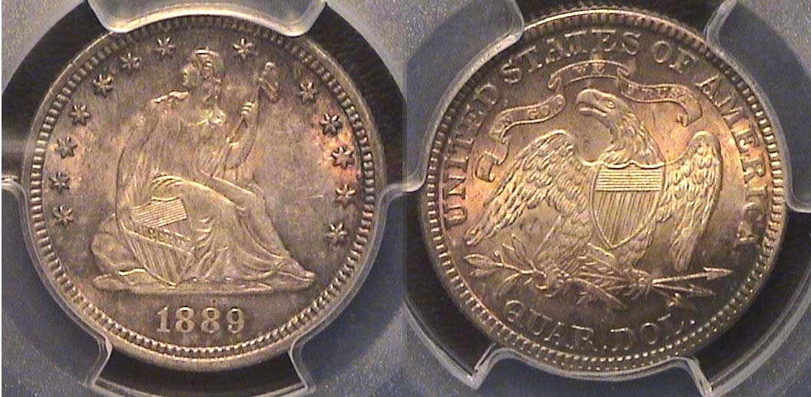

An 1889 Liberty Seated with motto quarter graded MS-62 by PCGS
[Enlarge page to 150% or fill monitor screen to view details.]

From 1879 thru 1890, the Liberty Seated quarter was struck in very small numbers as a result of the Bland Allison Act of 1878 which authorized the striking of millions of Morgan dollars while reducing the amount of business strikes of quarters and half-dollars for the next twelve years to no higher than 15,200 annually as a bone to collectors. Unlike proofs which also were struck for collectors although in far smaller numbers, a goodly percentage of the business strikes did eventually enter circulation, so obtaining a specimen of any of the dates struck during that period--while not extreme rarities--are still considerably challenging to obtain for the collector aiming to complete a year set from this period. The coin shown above was acquired on line in December 5, 2020 from a national dealer who specialized in Liberty Seated coinage. It is well struck with russet toning and appears more attractive upon enlarging the page.
In 1889, a quarter had the purchasing power of $5.00.

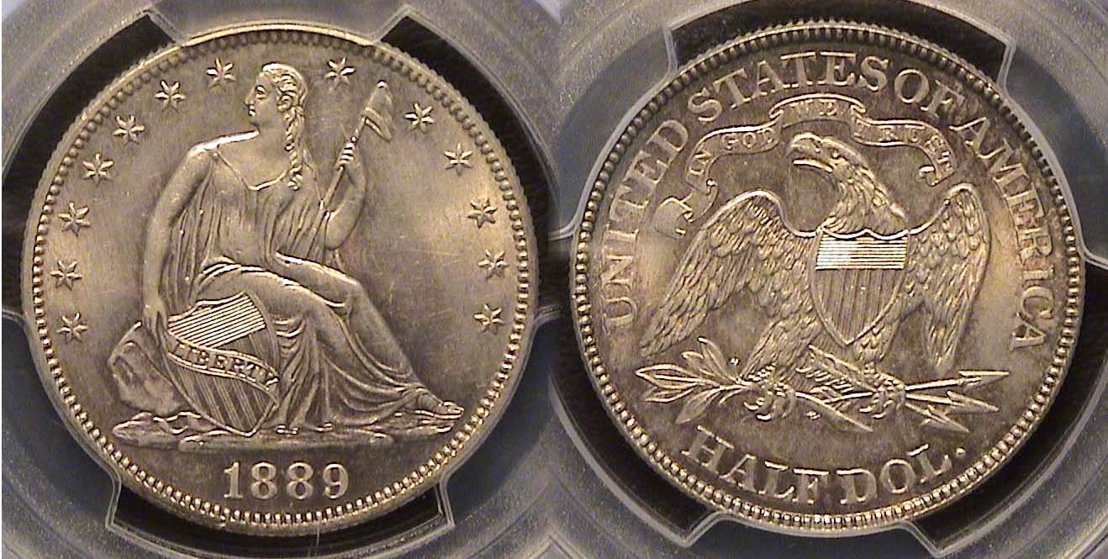

An 1889 Liberty seated with motto 50c graded MS-63 by PCGS
[Enlarge page to 150% or fill monitor screen to view details.]

The 1889 Liberty Seated half-dollar with motto on reverse had a mintage of just 12,000 compared with 8,418,800 in 1876 and 8,304,000 in 1877 and like many of the others struck from 1879 thru 1889 is far more expensive to acquire than those earlier common dates in the same grade, in fact, the most pricey of the set. This specimen is particularly attractive and choice for the grade. Upon enlarging the photo of the coin, the coin has clear mark-free clarity in the spaces between the design and lettering on both sides and is well struck. Look at the clarity of LIBERTY on the shield on the obverse and the motto, IN GOD WE TRUST on the reverse. The coin was acquired at the Augusta Coin Exchange back on December 4, 2020, the same period as the 1889 Liberty Seated quarter.

In 1889, a half-dollar had the purchasing power of $10,00.

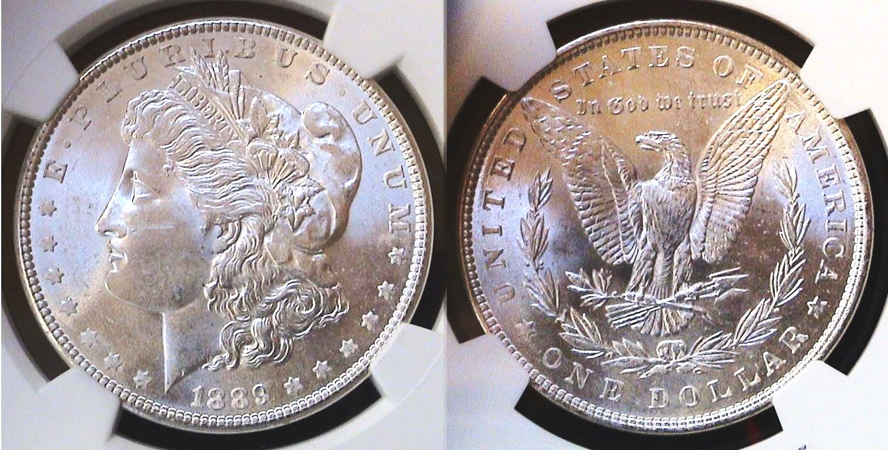

An 1889 Morgan dollar graded MS-64 by NGC
Enlarge page to 150% or fill monitor screen to view details.]

In 1889, the Morgan dollar was struck at all four mints then in operation. A whopping 21,726000 were struck at the Philadelphia Mint, 11,875,000 at the New Orleans facility, 700,000 at San Francisco with only 350,000 coined at the Carson City Mint, the key date business strike of the entire Morgan dollar series. Since the author was interested in acquiring a complete set of BU coins dated 1889 (excluding gold), he quite naturally opted for the lovely 1889-P Morgan dollar specimen certified MS-64 which he found at Clein’s here in Martinez priced at only $60.00 at the time. For those collectors who wish to acquire a complete set of Morgan dollars from all five mints that were struck between 1878 and 1921, the 1889-CC in the same MS-64 grade is currently listed at $70,000. The 1895-P Proof only Morgan dollar with only 880 known is similarly priced. The author’s maternal grandfather never handled a Morgan dollar nor did he know it existed along with many urban dwellers living east of the Mississippi. during their lifetime. In 1889, a dollar had the purchasing power of $20.00.
_______________________________________________________________________________________________________________________
(continued on page 4, column 1)
Collecting the US Coins of 1889, (excluding gold)
(Continued from page 3, column 2)

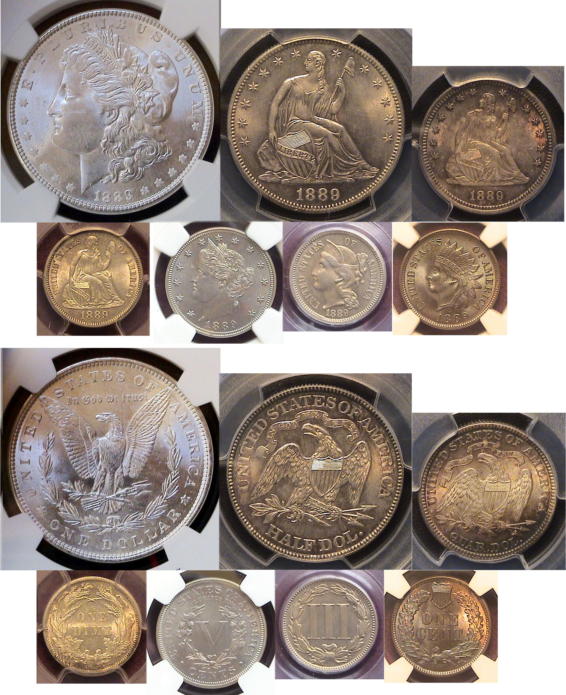
The seven US Coins of 1889 excluding gold featuring the
Morgan dollar, Seated Liberty half-dollar, quarter and dime, plus Liberty Head nickel and Indian Head cent
_________________________________________________________________________________________________________

The non-acquired six Gold denominations of 1889

When it comes to the six gold denominations issued in 1889, most of them are expensive either due to their low mintages or just the value of gold in the upper denominations with gold currently selling for around $1,800 an ounce. All of the images below are courtesy of PCGS’ COINFACTS and/or Heritage Auction Archives.

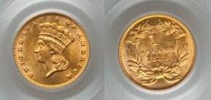

An 1889 Indian Princess type $1.00 Gold Piece graded MS-62

In 1889, the tiny 15 mm Indian Princess $1.00 gold type coin was struck for the last time with 28,950 coined. Designed by our filth Mint Engraver, James Barton Longacre in 1856, it was seldom struck in mintages above four to five figures with most dates expensive today. From 1862 on it was struck only at the Philadelphia Mint. The example shown above realized $480 at a Heritage auction in Sept. 2021.
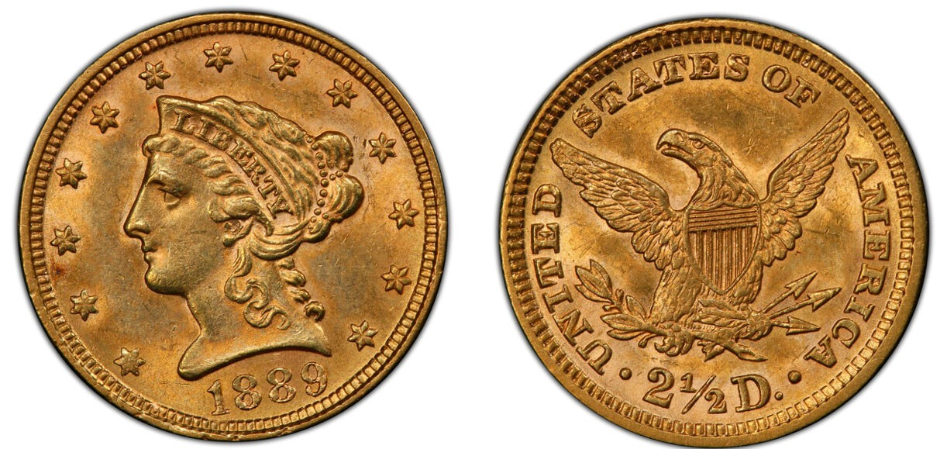
An 1889 $2.50 Liberty Head Quarter-Eagle grading MS-62 by PCGS

The 1889 quarter eagle had a mintage of just 17,600 and in 2018 the MS-62 specimen shown on the bottom of the previous column sold for $750 due to the rise in gold at a Heritage auction in held in Oct., 2020. Before the upswing in 2018, the price for MS-62 was $550.

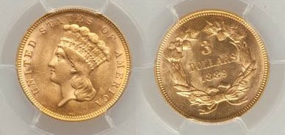

An 1889 $3.00 gold piece graded MS-63 by PCGS
[Enlarge page to 150% or fill monitor screen to view details.]

As with the Longacre’s designed Indian Princess $1.00 gold, his $3,00 coin, first released in 1854 was also terminated with the 1889 issue but unlike the $1.00 piece, with a mintage of just 2,300 pieces struck at the Philadelphia Mint, the coin is quite rare and expensive. For some reason, the $3.00 coin--despite its low mintages-was hardly used and all dates are rare except 1874,1874 and 1878.

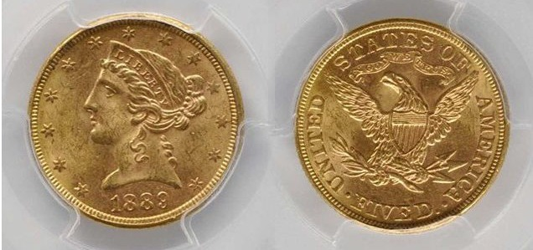

An 1889 Liberty Head $5.00 half-eagle certified MS-62 by PCGS
The $5.00 half-eagle with a mintage of just 7,240 is very expensive and beyond the means of most collectors.

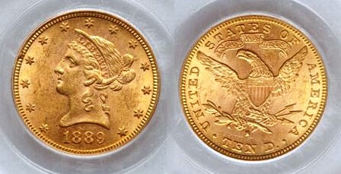

An 1889-S $10.00 Eagle graded MS-62 by PCGS

This attractive 1889-S $10.00 Eagle with a large mintage of 425,500 shown above compared with just 4,440 for the 1889-P $10.00 gold coin (not shown) is affordable as high as MS-63.

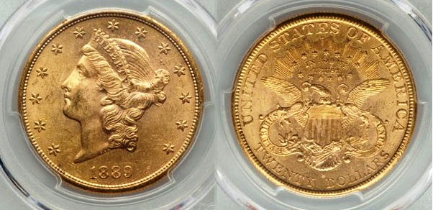

An 1889 $20 $20 Coronet double Ea graded MS-62 by PCGS

Finally, James Baton Longacre’s 1889-S $20.00 Coronet Liberty Head double eagle with a mintage of 774,700, the largest by far of the three mints striking gold coins that year, is actually possible for those ardent collectors to acquire due to the high gold content in the coin and therefore affordable if one subtracts the gold value from the total purchasing price. The foregoing said, it is unlikely that many of us can obtain all thirteen denominations although it is enjoyable to muse over it due to their artistry by our great engravers of the past.
____________________________________________________________________________________________________________________

STEPHEN JAMES CSRA COIN CLUB
Regular Meeting Thursday, January 6, 2022

The Club held the January 6, 2022 meeting at the SAPC gym. President J.J. Engel called the regular meeting of the club to order at 6:45 p.m. There were 12 members and one guest who joined the Zoom session. A motion was made by Steve Kuhl, seconded by Sharon Smoot, and passed, to dispense with the reading of the November 2021 meeting minutes. A copy of the minutes will be on file with the other club records, and a copy will appear in the club newsletter.

Treasurer Chuck Goergen was not available at the meeting, but JJ indicated Chuck provided info that the Club’s bank balance is slightly over $900. JJ and Steve Kuhl provided info on upcoming coin shows in the region taken from the SCNA website.

Show & Tells
John Kolmar shared a 1955 double-die that he bought last summer “raw” the he and the dealer priced as a VF. John had the coin slabbed and it graded as AU-55. It is a good-looking cent in a case that John’s daughter gave him as a birthday present, and the coin came back from a prolonged grading on Dec 23 rd , just in time for Christmas.

Kelsey Forde shared a 2021 “Carson City” Morgan Dollar she had obtained at the recent
Augusta Coin Show. She pointed out how the coin contained a “CC” privy mark in addition to the standard mint mark and commemorated the hundredth anniversary of the last Morgan dollars. Also, Kelsey announced that her company, Parvati, had donated a 1-year Zoom account to our coin club, which we are very grateful for.

The library may be available for our coin club meeting beginning in June of this year, however the library is currently under reduced hours and closes at 7pm on Thursdays – so meetings at the library may not be practical for us.

Steve Kuhl indicated his church where we currently meet has a room available that may be better situated to club meetings than the gym we have been meeting in. The board will keep you informed of any updates in meeting locations.

Club President, JJ Engel noted that the annual Audit of the club’s books is due between April 1st and 30th . He also noted that Club officers are nominated and elected at the March meeting each year, and sworn in at the April meeting. We welcome any member interested in serving as an officer to contact any of the current officers or email the club account. J.J. indicated that he will be stepping down as President because of health concerns.

Sharon Smoot noted that the holiday party last year was very well done, delicious, and fun. Thanks to Pat for handling the gifts.

The Program: The club’s program for January was by Steve Kuhl on his experience at the February 2020 ANA National Money Show in Atlanta GA. Many seminars were available at the show, along with dozens of numismatic exhibits. Steve described how as part of the show he was able to attend a concentrated 2-day version of the ANA coin grading seminar that is presented in a week-long format in the summers. After the seminars Steve enjoyed exhibits brought to Atlanta from the ANA museum, including quite a few of the rarest US coins in existence. Of special regional interest was a complete set of the 68 coins minted at Dahlonega known as the Aurania Collection, assembled by Mr. Joe Gaines over more than 21 years. Everyone enjoyed Part I of Steve’s presentation on his experience at the ANA National Money Show and looks forward to Part II in the near future.
​
President Engel reminded the members that the next meeting would be on February 3, 2022, and adjourned the meeting at 8:25 p.m.
Respectfully submitted,
Jim Mullaney
Recording Secretary
____________________________________________________________________________________________________________________

Kindly Patronize our advertisers
