Pres. Willie Simon
V .P. James Barry
Sec. Helen Barry
Treas. Pat James
Sgt. in Arms: J.J. Engel
The Stephen James
CSRA Coin Club of Aiken
P.O. Box 1739
Aiken, SC 29802
Web site: www.sjcsracc.org
The Stephen James CSRA Coin Club Usually Meets on the 4th Thursday of the Month at the Aiken Public Library

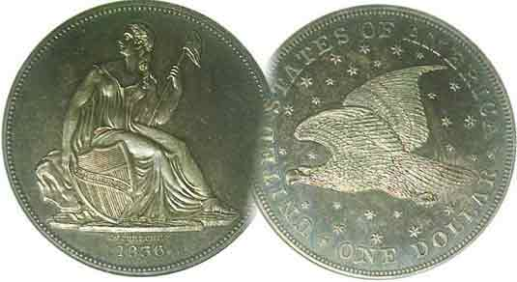
Committees:
Auction: J.J. Engel
Programs: James Barry
Newsletter: Arno Safran
Club Show: J.J. Engel

Volume 5, Number 3 the Stephen James CSRA Coin Club Monthly Newsletter March, 2006
Augusta CC and ANA Shows Coming Up Fast

Augusta CC To Hold Two Day Show Mar. 31 & Apr. 1

It’s that time of the year when spring blooms and coin shows increase. The upcoming ACC show is just around the corner, starting on Fri. Mar. 31, the day after our next meeting and running through Sat. Apr. 1. (No April fool!) It will be held at the Augusta Inn and Conference Center (formerly Holiday Inn) at 1075 Stephen’s Creek Road; just around the corner from its former site, (America’s Best Value Inn, (formerly the Guest House Inn). Hours are 9 to 5 both days and admission is free. Directions from Aiken: Take I-20 west to (Exit 199) Washington Rd. Go towards Evans and make first right at the Raceway Gas Station on to Stephen’s Creek Road. Site is about ¼ mi. On left.

ANA To Hold Three Day Convention in Atlanta Apr. 7-9

It is almost as rare as a key date coin when a major numismatic convention is held regionally but the weekend after the Augusta Coin Club Show; the American Numismatic Association will be holding a three day convention at the Cobb Galleria in Smyrna, GA, (a suburb of Atlanta) Friday thru Sunday, Apr. 7-9. It’s a little less than a three hour drive but worth it because you will be dazzled by what you will see among the vast array of numismatic items on display.
Directions are simple: Take I-20 west to Atlanta into I-75/85 northbound. At the big “split” continue northwest on I-75 exiting at #258 towards Cumberland Boulevard. Turn left on Cumberland B’lvd SE, then right onto Cobb Parkway; then slightly right again onto Galleria Parkway SE to enter the convention area.

It’s Masters Week but lots of area folks take to the hills then, so why not take yourselves to Atlanta for a coin show you will never forget.
Club News

Our next scheduled meeting comes on the fifth Thursday of the month; March 30. That in itself is not as unusual since our club has been forced to meet on fifth Thursdays in the past. What is unusual is that in the SJ CSRA CC’s almost five year history, this will be the first time it will be holding two meetings in a single month. With 31 days, March is as ideal a month as any and one supposes we should be grateful to the Aiken Public Library for permitting us this opportunity after denying us one in February.

Despite this constant juggling around, 26 members still managed to show up for the March 2 meeting though the auction was “a little thin”. For Show & Tell, Merle Davis displayed his collection of the Mint’s recent offerings of Lewis & Clark collectibles. These included not only those coins from the Westward Journey Jefferson nickels series but the 2004 commemorative silver dollars as well.
_____________________________________________________________________________________________________
(Club News continues on page 5, column 1)

America’s Small Cent
Part 1 of Two by Arno Safran

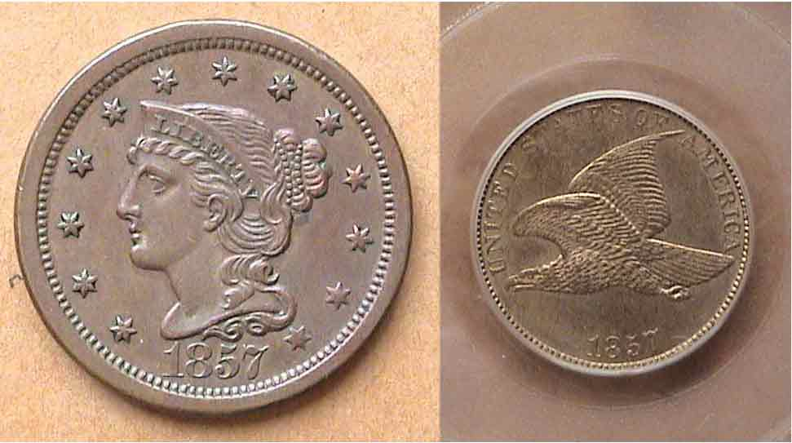

The 1857 Braided Hair lg. 1¢ makes way for the 1857 FE sm. 1¢

With the rising cost of copper and the unpopularity of the rather cumbersome large cent, Mint Director James Ross Snowden decided to produce a smaller coin containing less copper. Proposals to change the alloy of the cent began back in the late 1830’s but it was the nickel magnate Robert Wharton, a friend of Snowden’s with strong ties to Congress that eventually led to the changeover. In 1856, Snowden asked chief Mint Engraver James Barton Longacre to prepare dies for the new cent. It was to have the diameter of 19.1mm (¾ inch), be composed of 88% copper and 12% nickel and feature former Chief engraver Christian Gobrecht’s Flying Eagle (originally used on the 1836-1839 silver dollar reverses) but flying in a horizontal plane instead of soaring. Longacre chose his own wreath reverse from the 1854 $3.00 gold piece. Some 2,000 were struck (including business strikes and proofs) and today the date is one of the more popular keys.

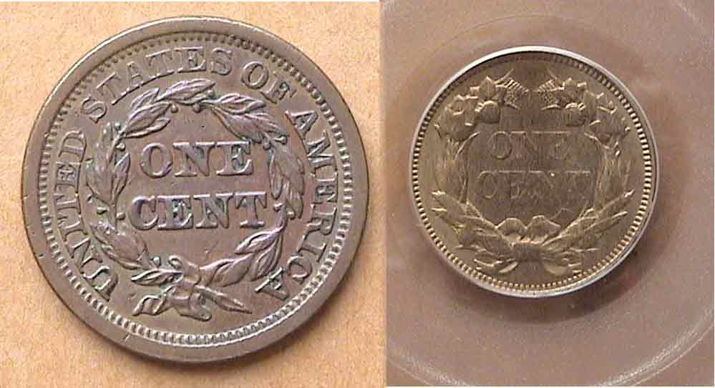

Reverses of the 1857 Braided Hair lg. 1¢ & FE sm. 1¢
showing the different styles of wreaths
___________________________________________________________________________________
(continued on page 2, column 1)

The Flying Eagle Cent (continued from page 1, column 2)

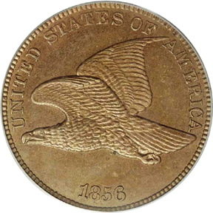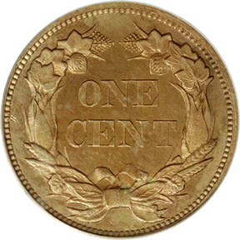

The 1856 Flying Eagle Cent; valued at $6,000 in G-4; 20K in MS-63

The result of Wharton’s lobbying coupled with Mint Director’s Snowden’s efforts paved the way for the Coinage Act of Feb. 21, 1857. Among its many provisions were the elimination of both the large cent and the equally unpopular half cent along with the authorization of the striking of record numbers of Flying Eagle cents. 17,450,000 were minted in 1857, so there are plenty to go around. For the collector of transitional dates, (i.e., two different design types with the same date), both versions of the 1857 are available at modest prices (unlike the rare 1856 pattern Flying Eagle cent) and shouldn’t provide any obstacles to forming a matched set. (as shown by the images seen on page 1.)

In 1858, an even grater number of Flying Eagle Cents were coined; 24,600,000; again in the “white metal”. Originally, these pieces were colloquially referred to as “nickels” despite the fact that the amount of nickel in the alloy comprised no more than 12%. There are three interesting varieties for this date; large letters (obv.) in which the A & M in AMERICA touch at the bottom; small letters, in which they do not, and the scarce 1858/7 overdate. The Red Book provides more diagnostics on these variations.

Despite a lovely design, the coin did not strike up very well and Mint Director Snowden asked Longacre to come up with alternative designs. The genesis for the Indian Head obverse dates from Longacre’s interest in Greco-Roman art; in particular “Crouching Venus” which the engraver had seen in the Philadelphia Museum. (Source, Walter Breen, Encyclopedia…) The inspiration led to the first $1.00 & $20.00 Liberty gold types in 1849, and later, the Indian Princess designs on the 1854 $3.00 and Type 2 $1.00 gold pieces. For the 1859 cent obverse, Longacre modified the headdress further and replaced the cereal wreath with a laurel wreath on the reverse. [The oft told story of young Sarah Longacre posing for her father with an Indian Headdress is now considered a myth.] 20,566,00 Indian Head copper-nickel cents were struck in 1859 yet despite its being a one year type, the date does not command the prices in the higher grades that the Flying Eagle type receives.

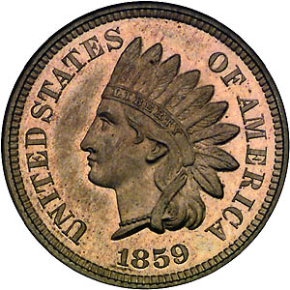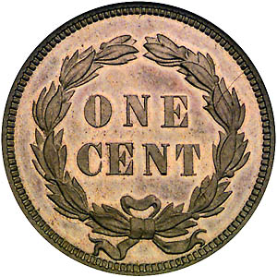

Longacre’s 1859 Indian Head Cent with Laurel Wreath reverses
a one year type; (courtesy of Superior Galleries)

In 1860, the reverse was changed again. An oak wreath replaced the thinner laurel garland and a shield was added at the top separating the ends of the circlet.
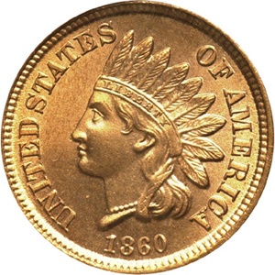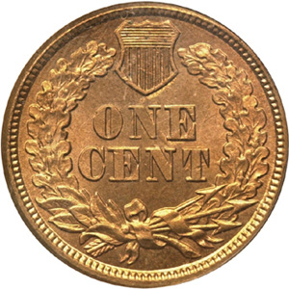

1860 copper-nickel Indian Head Cent with Oak Wreath and Shield

Through the middle of 1864, the Indian Head copper nickel cent remained unchanged and may have continued that way had it not been for the War Between the States. Early in the conflict, the government began facing a severe coin shortage. Silver coins had vanished. Even the silver 3¢ piece could not be found in circulation. By 1863 Civil War tokens with many featuring the crude likeness of Longacre’s Indian Head design glutted the market. Something had to be done. As early as 1862, the Government began to print Greenbacks (Banknotes valued at $1.00 or higher) and Fractional currency; (smaller banknotes valued at 3¢ to 50¢.) The new paper money was legal tender for goods and services. To drive out the bogus bronze Civil War tokens; the government authorized a change in the cent alloy from copper-nickel cent to bronze; (.950 fine copper, .050 tin and zinc). According to the Red book, 20,566,000 copper nickel cents were struck in the first part of 1864. A record 39,233,714 of the bronze cents would follow and out of these, a smaller number of would contain the almost microscopic engraver’s initial of L for Longacre, placed sideways across the lower portion of the ribbon of the headdress. As a result, the serious collector of transitionals has the opportunity to collect three sub-types; all bearing the date 1864.

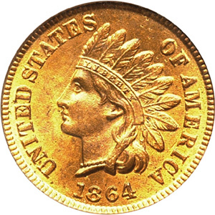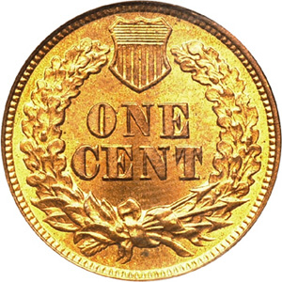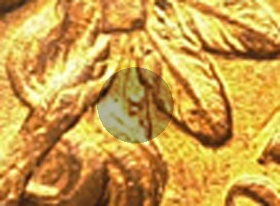

At left, 1864 Bronze Indian Head Cent (with L); At right; close-up!

From 1864 to 1909, the Indian Head cent remained ostensibly the same, though in 1886 there was a slight repositioning of the last feather from between the I & C in AMERICA (Type 1) to between the C & A (Type 2). In 1908, and 1909, cents were struck at a branch mint for the first time; San Francisco but in vastly smaller numbers than Philadelphia. The S mint-mark was centered under the wreath. With only 852,500 struck, the 1877 issue remains the key in both demand and price but the 1909-S bears the lowest mintage of 309,000. Dates from 1866 thru 1872 are scarce to rare as well. The 1873 comes with a closed 3 and an open 3; the former, the scarcer of the two. Other varieties are the 1869/9 and 1888/7 and 1894 double date. Common dates among the bronze issues are the 1864 (no L), 1865, and 1881-1909-P.

The Indian Cent type has long been a favorite with many of the current older generation of collectors as a result of coming across a well worn example in their youth. The writer was in his early teens when his father showed him an 1857 Flying Eagle and he’s been “hooked” more or less ever since.
_____________________________________________________________________________________________________________________

The Two Cent Legacy: In God We Trust
By Rich Baker

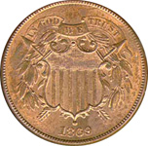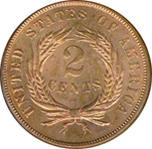

An 1869 2¢ Piece
(Courtesy of Heritage Auctions)

After completing most of my circulated sets for the 20th Century, I have started a quest of the collection of two cent pieces; a very interesting series with dash of history that can be obtained quite modestly. Very few people outside the coin collecting community realized that a two-cent piece was ever created; mind that this short-lived coin was the first to include the motto, “In God We Trust”. Two-cent coins were minted for circulation between 1864 and 1872 with proof issues minted every year including 1873. The coin displays a simple shield with crossing arrows, a branch with leaves and berries, a banner with the motto above and the date below. The reverse consists of the denomination surrounded by a wheat wreath with United States of America circling it. The coin was made of a bronze alloy containing 95% copper and 5% tin/zinc, weighing 6.22 grams with a diameter of 23 mm; just slightly smaller than the quarter.
A couple of early attempts to authorize the two cent coin came and went. In 1806, Representative Uri Tracy (Dem, NY) sponsored a bill to produce a two cent coin made of billon. (The metal is comprised of an alloy of silver with a high percentage of copper that is often used in making tokens and medals.) Mint Director Robert Patterson provided an example of the two cent coin with a brass button to Congressman Tracy to illustrate how easy the button could be substituted for the coin. The bill died and so did the coin. In 1836 another bill was introduced to include the 2¢ piece but this too failed. Mint employee Gobrecht’s design had an obverse of a small eagle, its wings spread on a cloud with a reverse of 2¢ inside a wreath.

The Civil War brought about two key factors leading to the reconsideration of the 2¢ coin. One was the hoarding of small denomination specie coins and the public acceptance of non-specie Civil War merchant tokens to be used as money. A second factor was an increase in religious feeling by leaders of the religious community to pay homage to the Almighty God on our coins. A plea from a Pennsylvania minister Rev. Watkinson in 1861 to Treasury Secretary Salmon Chase added fuel to this concept. Sec. Chase instructed Mint Director James Pollock to prepare a motto “…without unnecessary delay…expressing the fewest and tersest words possible for this national recognition.”
In December, 1863 Pollock submitted to Secretary Chase two designs for the 2¢ coin at double the weight of the cent. Chief Engraver James Longacre created one consisting of a Bust of George Washington facing right with the 1863 date below and the motto GOD AND OUR COUNTRY above. The other showed a shield and arrows crossing with the motto, GOD OUR TRUST.
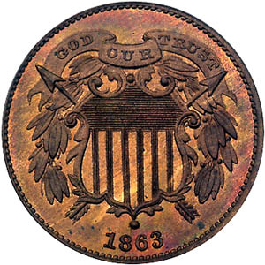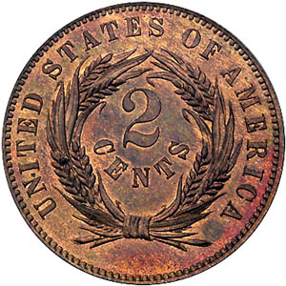

1863 2¢ Pattern Design – Motto reads GOD OUR TRUST

The reverse was similar to Gobrecht’s design but with a more oval wreath surrounding the numeral 2¢ instead of Two Cents spelled out. Pollock preferred the Shield with arrows design shown above.

In December, 1863, Sec. Chase approved the mottos, changing them slightly. On the Geo. Washington pattern, he changed it to “Our God and Our Country”. On the Shield design, he altered it to “In God We Trust”. Noted scholar, the late Walter Breen theorized that the motto’s final form was inspired by Secretary Chase’s alma mater (Brown University), “In Deo Speramus” or “In God We Hope”. Chase also preferred the Shield design but in order to replace devices and mottos as prescribed by the Coinage Act of 1837 another law would have to be passed by Congress. On April 2, 1864 Congress authorized the two cent piece with the new motto and Shield/arrows design.

Approximately 20 million 2¢ pieces were minted in 1864. The coin took hold quickly, combined with a large number of Bronze one cent coins. However, the mintage dropped of each year until 1872 when only 65,000 were minted. Most collectors normally obtain one piece for their type collection. A coin in XF condition can be obtained for less than $50. All 2¢ pieces were struck in Philadelphia. Of the business strike portion (1864-72), the two key dates are the low mintage 1872 and the 1864 small motto of which only a few thousand are known to exist which were coined from a prototype master hub. The master hub was changed and all subsequent coins have the large motto.
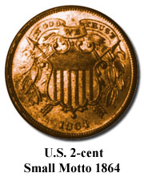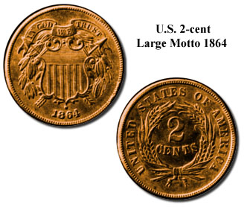
Photos courtesy of coin World

One of the key grading points is the “WE” in the motto though it can appear weakly struck in some specimens. A complete business strike set (inc. the 1864 small motto) will sell for about $550 in VG-8 and for around $3,300 in MS-60. An excellent source for research into 2¢ varieties is Kevin Flynn’s book, ‘Getting Your 2 Cents Worth” Another is Myron Kidman’s “The Two Cent Piece and Varieties”
______________________________________________________________________________________________________________________
Rich Baker recently became a member of our club and collects US type coins.

J.I.M. Part 3: Malaya
By Bill Myers

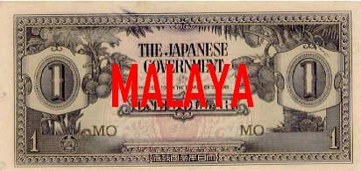

A J.I.M. $1.00 note issued for Malaya during WW II

Malaya fell to the Japanese in December, 1941. The Japanese issued their own currency for Malaya. Printed in denominations of cents and dollars, these notes were once advertised as money the Japanese printed in preparation for invasion of the United States, but this was not true. The series letters are “M” and the block letters are black unless otherwise noted. There are varieties both with and without a quatrefoil (flower with four petals) watermark as noted below. Most are lithographed but some of the higher denominations have engraved faces.

The Fractionals

The $1¢, 5¢ and 10¢ notes have “THE JAPANESE GOVERNMENT” with the denomination spelled out and in numeral form on the face and repeated in numeral form in an ornate design on the back. These notes have no watermark.

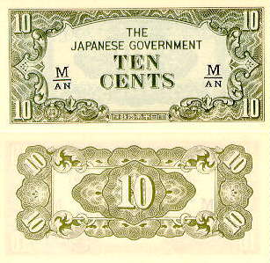

A Ten Cent J.I.M. Malaysian note of W.W. II

The 50¢ notes have the addition of “PROMISES TO PAY THE BEARER ON DEMAND” and a fan palm on the right added to the face. Varieties for these Fractionals are as follows:
1 cent – block letters; fractional block letters
5 cents – block letters; fractional block letters
10 cents – block letters; fractional block letters
50 cents –block letters MA, MB, no watermark;
Block MC-MT; with watermark

The Dollar Notes
There are five denominations of dollar notes and most are engraved. The face has “JAPANSE GOVERNMENT” and “PROMISES TO PAY THE BEARER ON DEMAND” (except for the second issue of the $100 note.) The denomination is spelled out and in numerical form. The back of the $1 and $5 have the denomination in numerals as an ornate design. The $10, $100 and $1000 have a vignette along with the repeated denomination in numerals.

The authentic $1 notes have a breadfruit tree on the left and a coconut palm on the right of the face. (See example at left.) The face of the $5 notes has a coconut palm at left and a pawpaw on the right. The authentic $10 notes have bananas, breadfruit and coconuts pictured in the center of the face. There are two styles of $100 notes. On the first style, there is a hut under palms on the face and a man with buffalos in the river on the back.

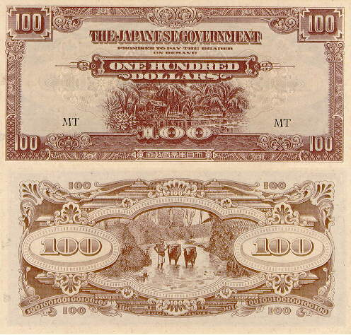

A J.I.M. Malaya $100 Note First style

The second style note has a rubber plantation on the right side of the face and native houses and seashore on the back.
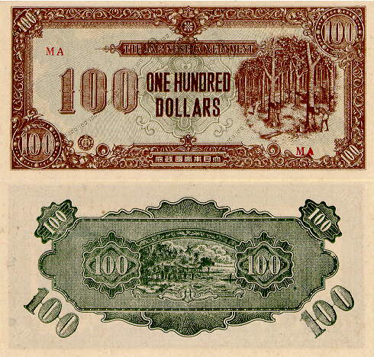

A J.I.M. $100 Malaya Note Second Style

The final note of the series is the $1000. The face has two buffalos pulling a cart and the back is like the $100 (I)
_______________________________________________________________________________________________
-To be continued-
More Club news

Vice President Jim Barry ran a video program on “Collecting Ancient Coins” produced by the American Numismatic Association, (ANA). Jack Schulz won the door prize; a Gem BU silver eagle and Helen Barry won the 50/50 drawing. Congratulations Jack and Helen. President Willie Simon asked members to come up with ideas and goals to continue to improve our club including programs for 2006.

At the March 30 meeting Bill Myers will present a program on Japanese Invasion Money or “J.I.M. notes. His ongoing series on the topic has been appearing in the newsletter. (See page 4, Ed.) In April, Arno Safran will present a slide-talk on “Latin American Coinage that Was Legal Tender in the US until 1857”. Also in April, the club will hold its second annual “Road Show” on Saturday, Apr. 22 at the Aiken Public Library from 12 to 3 PM.

Club Passes 100 Mark in members Joined

Since its founding in March, 2001, 102 persons have become members of the SJ CSRA CC. The most recent to join is Michael Turner. Michael with his wife Tonya and their children are also members of the Augusta Coin Club. We welcome Mike to the SJ CSRA CC. With two local clubs thriving in the CSRA, the Coin Collecting pastime has attracted almost 200 persons within the past four years. The three shows a year by area clubs has to be a factor. Another is the opportunity to visit four different dealers’ shops within the CSRA alone. When the editor arrived in the CSRA in late 2000, there was only one coin store and no area shows. The South Carolina Numismatic Association (SCNA) is another big factor and three of our members are very active in the state club; Helen Barry, editor of the SCanner (Journal of the SCNA), Jim Barry, a member of the SCNA Board and Tony Chibbaro, a past SCNA President and current General Show Chairman for the 80+ dealer show SCNA puts on in late October in Greenville.

2006 Club Dues Is Now Due

Though our club was founded in March, 2001, its fiscal year-2006 begins in April. Club dues is still $10 for Srs. and $5.00 for Jrs. (under 18) but since we’re meeting on March 30 why not get a jump on the situation and take care of business right then and there before the ides of April when Federal and State income taxes must be reported.

The editor continues to welcome articles from members and wishes to thank the following for contributing articles to the newsletter over the past four years: Members, Willie Simon, Jim Barry, Jim Marshall, Tony Chibbaro, Bill Myers and Rich Baker; also Xavier Pique, Treasurer of the Augusta Coin Club, and from out of the area, Chris Connell (the Byzantine Bits Series; Remember those?); Greg Heim (on Half cents) and Dave Bailey’s ongoing “The Lion’s Tale” (British tokens).

If you would like to add to the list of contributors, please send copy to me via E-mail to arnosafran@comcast.net and thanks in advance and please consider patronizing our display ad advertisers that appear in the newsletter each month.

Receiving the Newsletter as an E-Mail Attachment

At present, thirty-eight members of our club are listed in the E-mail directory. If you have Windows 98 (2nd ed.), a Millennium or Windows XP, your PC should be equipped to receive newsletter attachments either as a word.doc or formatted as a PDF file. Among the advantages are:
1. Seeing all the images in brilliant color.
2. being able to magnify up to 200% in order to see clearer detail including the actual dates on coins.
3. Printing double sided color copies directly.
If you desire to have your name added to the E-mail list, please contact the editor by E-mailing arnosafran@comcast.net.

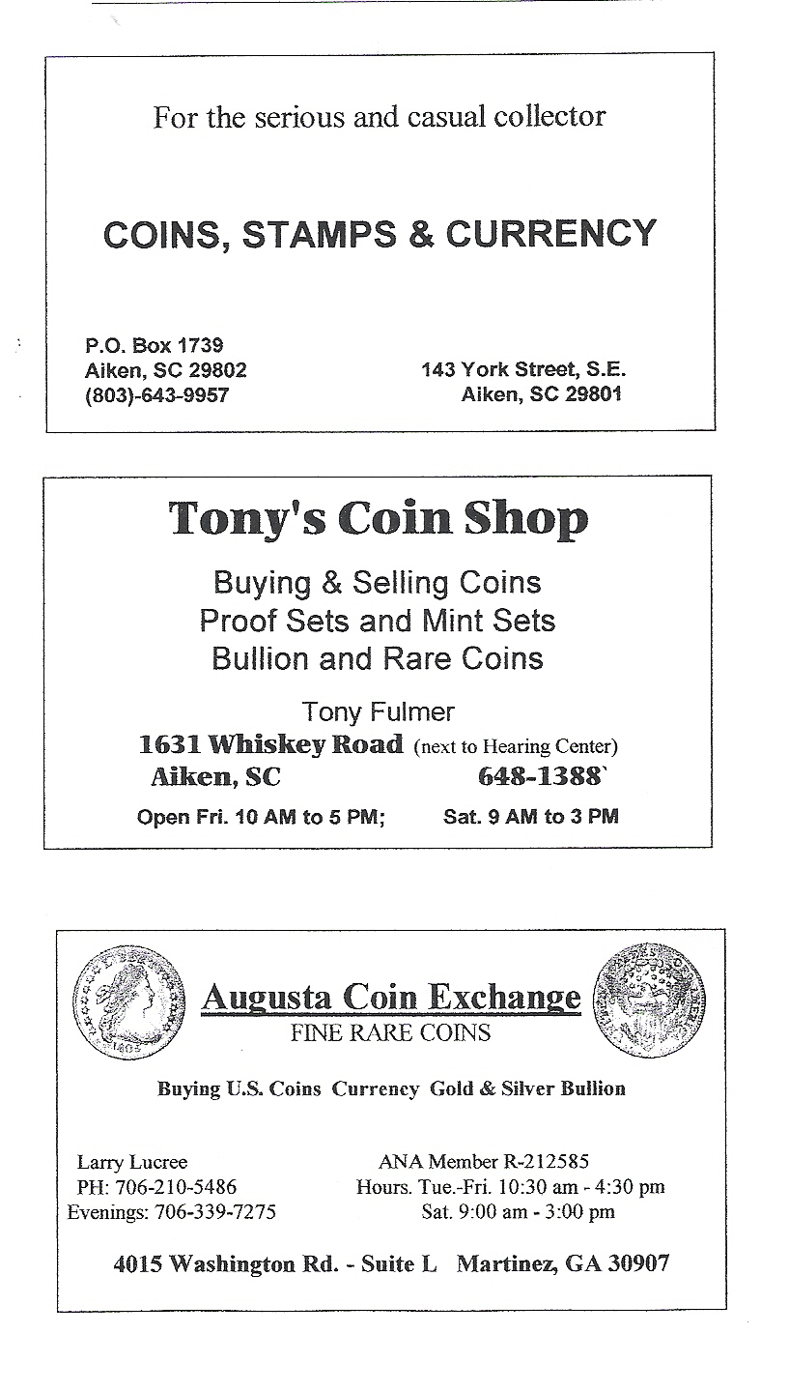
Look forward to seeing you all on March 30th.

