Pres. Willie Simon
V .P. James Barry
Sec. Helen Barry
Treas. Pat James
Sgt. in Arms: J.J. Engel
Committees:
Programs: James Barry
Show Chairman: JJ Engel
Newsletter: Arno Safran
E-Mail: arnosafran@comcast.net
The Stephen James
CSRA Coin Club of Aiken
P.O. Box 1739
Aiken, SC 29802
Web site: www.sjcsracc.org
The SJ CSRA CC Now Meets on the 2nd Thursday of the Month at the Cedar Creek Community Center in Aiken, SC

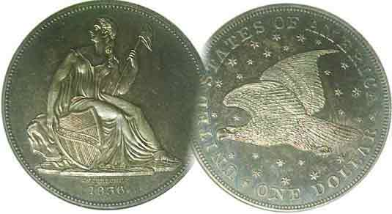

Volume 6, Number 3 the Stephen James CSRA Coin Club Monthly Newsletter March, 2007
Members see PCGS Grading Presentation II
Our next meeting is on the 2nd Thursday of the month, March 8, 2007 at 7:00 PM
2007 Club Meeting Schedule - 2nd Thursdays at 7 PM Jan. 11 Apr. 12 July 12 Oct. 11
Feb. 8 May 10 Aug. 9 Nov. 8
Mar. 8 June 14 Sep. 13 Dec. 6
Club Show: Sat. Sept. 15, 2007
_____________________________________________________________________________________________________________________________

How Coins Are Graded by PCGS- Part Two

On the heels of the previous month’s club get together, Vice President Jim Barry played the second half of a VCR tape at the February 8 meeting describing the philosophy and approach to third party coin grading by the Professional Coin Grading Service, (PCGS). This time the emphasis was on the $20.00 Saint-Gaudens Double Eagle type. Various slides were displayed beginning with the MS-67 grade down to MS-60 with commentary by the speaker describing the various criteria in which PCGS defines each grade. These were essentially reduced to the four features of a coin; its luster, surface, color and strike. For a coin to be graded MS-65 or higher, it should display brilliant luster, natural color, few contact marks and be well struck. In MS-63 and 64, a coin may show less brilliance, show more minor distracting contact marks in the field but still retain its overall eye appeal. From MS-62 to MS-60, a coin’s luster should appear further diminished with an increase in the number of distracting contact marks, scrapes and digs.

Unfortunately the lighting used in photographing these coins did not always show them consistent with their certified grade. For example, the MS-62 specimen looked more brilliant than the MS-65. In some other pictures one could not make out the date on the coin. Since the VCR tape was made before a live audience, most of the presentation was photographed from a single angle projecting second generation photos of the coins with amateur sound quality overall. One taped questioner asked how many coins the graders examined in a working day. The speaker responded between 600 and 900. This seemed dubious to SJ CSRA CC members viewing the presentation. Some wondered when tedium began to affect the grader’s judgment. Another questioner on the tape wanted to know the ratio of higher grades to lower grades received from resubmissions. Resubmitted coins tended to do better according to the speaker.
___________________________________________________________________________________________________________________
(More club News continued on page 4, column 1)
Collecting US Type Coins on a Budget
Dave Wilson’s Legacy: Part Two by Arno Safran

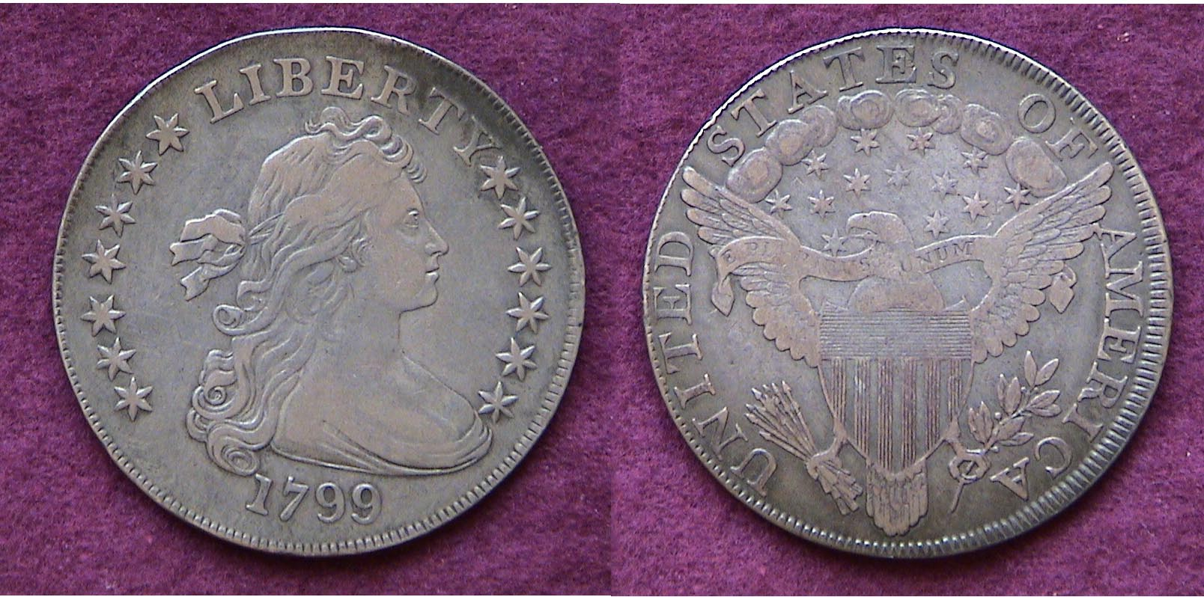

A 1799 Bust Dollar, B-13, R6 acquired from the late Dave Wilson
From the author’s collection

One of the essential aspects in building a coin collection--besides knowing what you wish to collect and in what grades--is finding dealers who are reliable and trustworthy. The late Dave Wilson was such a dealer. To be successful in the coin business a dealer has to continually build up a stock that encompasses a fairly wide range of numismatic items. To do this requires making contacts with other dealers and collectors. Coin markets run in cycles and sometimes dealers can have trouble maintaining a supply of quality material but during the last two decades of the 20th century Dave was able to put his clients into some truly wonderful coins and many were fortunate to be able to take advantage of these opportunities.

The item pictured above is one such example. At a meeting of the Trenton Numismatic Club (NJ; not SC), in June, 1992, Dave was fiddling with a small pen knife trying to remove a 1799 Bust dollar graded VF-35 from its ANACS holder. In the dimly lit large meeting hall, almost impaling himself in the process, he explained that he wanted to get a better look at the coin to see if it was a rare die variety. Not having a Bust dollar, I asked what he wanted for it and he quoted me the latest published Coin Dealer Newsletter VF-20 Bid price of $550 but told me to check back the next day because if it were a scarce variety, he would have to charge more.
______________________________________________________________________________________________________________________
(Continued on page 2, column 1)
Collecting US Type Coins on a Budget
(Continued from page 1, column 2)

When I arrived home from my classes the following afternoon, I gave Dave a call. “Well, Dave, what did you find out?” “Arno, I’m afraid the coin is going to cost you more than my original quote. It’s a Bolender-13 variety, a Rarity 6; Very few known.” (M. H. Bolender was a noted dealer and specialist in the series and attributed all known die varieties in his book, “The United States Early Silver Dollars from 1794 to 1803”.) I shuddered to think, “How much more; $300, $500?” Dave continued, “I can let you have it for $650. “Done!” I responded and drove over to his place just ten minutes away from where I lived. $650 was a lot of cash out of a teacher’s salary back then but the additional $100 seemed very reasonable considering the coin’s rarity. After sixteen years in the hobby, I had learned not to look a gift horse in the mouth.

The following Monday evening, I drove up to Madison, NJ Public Library near the campus of Drew University where the New Jersey Numismatic Society held their monthly meetings. The distance was 75 miles from my home but the drive was worth it because as a member since 1984, I had come to know how exceptional this club was. Virtually every member was a serious collector; each with a particular specialty; Ancients, Foreign, Large and half cents; early US silver coins, tokens and medals, large US bank notes and so forth. Every meeting consisted of a program and Show and tell. I showed my new acquisition to the members and a good buddy of mine who collected Bust dollars by die variety exclaimed, “Do you know what you have here? I’ve been looking for a 1799 Bolender 13 for over ten years. Will you take $1,500 for it?!” Some folks would have taken the quick profit but I happened to like the piece aesthetically; a pleasing original specimen with its attractive rendition of Liberty. Despite being a rare die variety, the 1799 is considered the most common date of the Bust dollar series with a reported mintage of 423,515 struck; but as it was my only example of this type, I was not about to part with it.

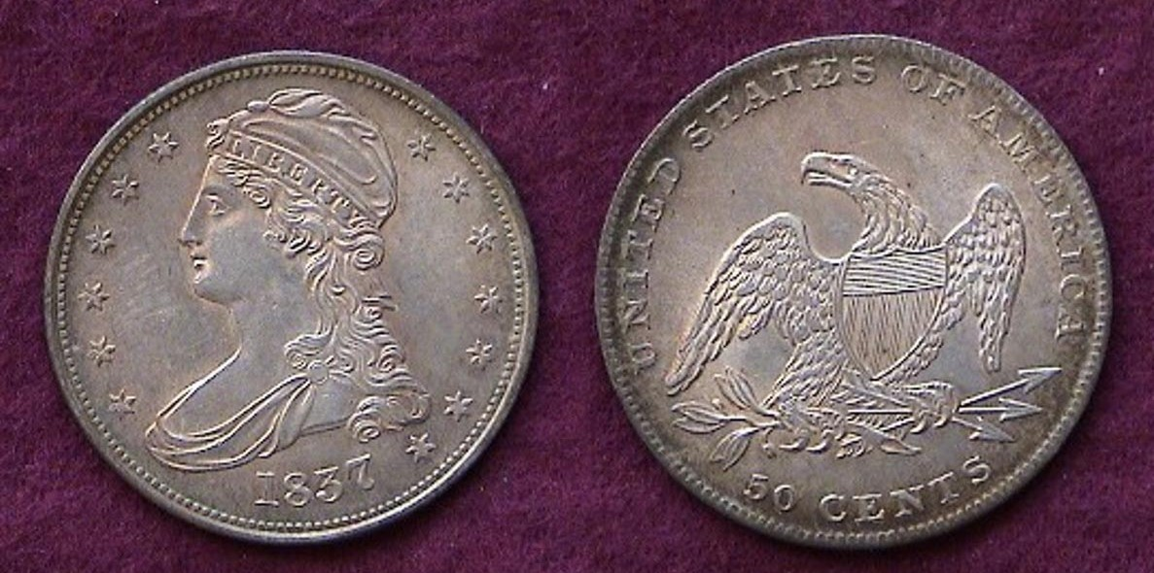

An 1837 Reeded Edge Half Dollar
From the author’s collection

One day, I received a phone call from Dave inviting me to look at a nice 1837 Reeded Edge half dollar he had acquired. Unlike the 1836 RE 50¢ which is rare having a reported mintage of just 1,200, the 1837 is common with well over 3.5 million struck. Still, the coin Dave showed me had the eye appeal of an MS-65 but he was only asking AU-50 money, claiming there was a tiny bit of friction on some of the high points. Many dealers do just the opposite. They will ask closer to the next higher grade; sometimes above the next higher grade. Not Dave! He simply charged what he thought the coin was worth.

In addition to setting up at four different coin clubs, Dave did a large number of area and regional shows and sold coins from his home to locals. He would phone his good customers when he acquired something rare or unusual such as this 1916 Standing Liberty quarter he once showed me housed in an MS-62 holder. Dave was asking $4,500 for this renowned 20th century rarity. Remember, this was back in the early 1990’s when the coin market was “soft”. Here was a case where I just didn’t like the coin all that much for it appeared somewhat lackluster, had a light olive green tint and was weekly struck. This was a shame, for in light of today’s market--what with VG-8’s now retailing for 6K--one could have quadrupled his money and put it towards a pristine MS-64, but who knew back then?

In what might be referred to as a silver lining, a few months later Dave invited me over to look at some new lots he had just bought and among them were these two fairly evenly matched fully lustrous 1917 Types I & II Standing Liberty Quarters grading MS-63. Both are common yet priced at a mere fraction of the 1916, so it didn’t take long for them to find a new home in that portion of my transitional sub-type collection.

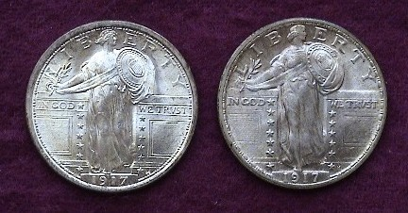

Obverses of the 1917 Type 1 (l) and 2 (r) Standing Liberty Quarters

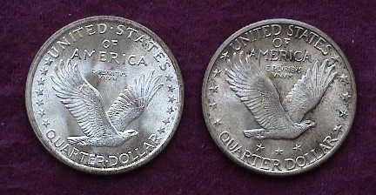

Reverses of the 1917 Type 1 (l) and 2 (r) Standing Liberty Quarters

Dave first started setting up in the Trenton Numismatic Club in 1984. He always had an eye for quality copper. At one meeting I saw a late date large cent in his case that looked for all the world as a brown unc. It was dated 1856 with the slanted 5 variety instead of the upright 5, yet Dave was grading it Very Choice AU and sold it for AU money.

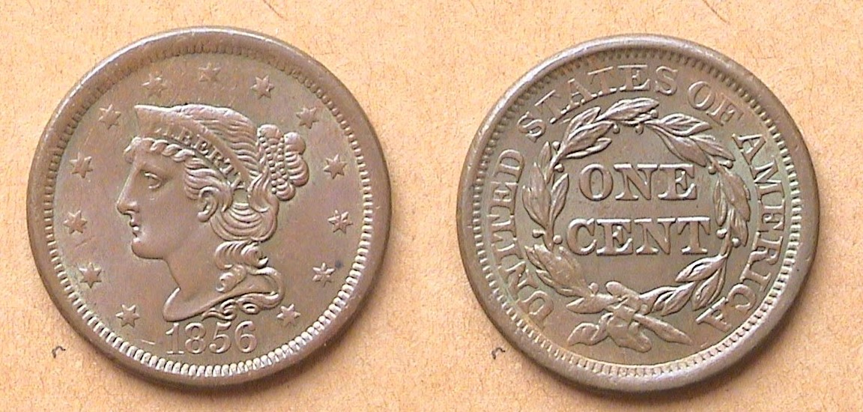

An 1856 Braided Hair Large Cent, N-18, slanted “5” R3
from the author’s collection

As a collector I have been fortunate to know many honorable dealers and Dave Wilson was one of the best!
____________________________________________________________________________________________________________________________
New Offerings from the US Mint for 2007
A Boon for the Collector or a Boondoggle for the Mint
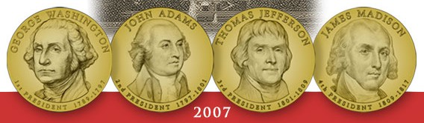

Actual size Obverses of the first four Presidential dollars
From left to right, Washington, Adams, Jefferson and Madison
(All photos, courtesy of US Mint)

The United States Mint is offering a bounty of numismatic goodies in 2007 that may rival the spate of 16 commemoratives that were produced in 1936. The most significant will be the chance to collect a $1.00 coin for every President from George Washington to George W. Bush and beyond. These will be issued four times a year at three month intervals in the chronological order each served. The George Washington $1.00 went on sale February 15 and will be followed by John Adams in May. The Presidential dollar coins will be struck in the same size (26.5 mm), alloy (cupro-nickel) and color (golden) as the Sacagawea dollar. That said, there have been reports that the new Presidential dollar rolls do not fit into the plastic tubes designed for the SBA and Sacagawea dollars.
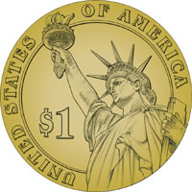

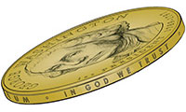

The reverse of the new Presidential series will feature a rendition of the Statue of Liberty with the legend, UNITED STATES OF AMERICA extending clockwise from the lower left rim with the denomination $1 shown prominently beneath the torch. If one looks at both sides of the projected coin the observer will wonder what happened to the date. In a remarkable bit of innovation, the date appears on the edge of each coin along with both mottos, E PLURIBUS UNUM and IN GOD WE TRUST. [The angle taken of the edge in the Mint photo above right shows the motto but not the date]. Some of the banks in our area already have the Philadelphia Mint Washington $1.00 coins which can be purchased at face value or by the roll of 25 coins for $25.00.

First Spouses to Appear on $10.00 Gold Pieces

In addition to the Presidential dollar series, the Presidents’ wives are being offered quarterly as well but on a 24 karat .999 fine one-half ounce gold piece with a legal tender value of $10.00. The initial two first spousal coins will be Martha Washington and Abigail Adams. As Jefferson’s wife died before he became President there was no first spouse as such, so the Mint issued a crude replica of our first chief engraver Robert Scot’s fillet head (AKA Draped Bust) seen on our early large cents between 1796 and 1807. James Madison’s wife, the charming Dolley Madison served as hostess during a portion of Jefferson’s administration and Madison’s.
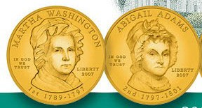

The obverses of the 2007 $10 gold pieces honoring
Martha Washington (left) and Abigail Adams (right)
(Courtesy of US Mint)

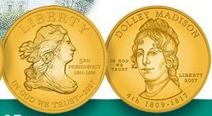
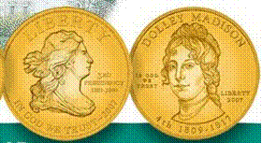

The obv. of the 2007 $10 gold honoring Jefferson with a Draped Bust version of Liberty (at left) and Dolley Madison (at right).
(Courtesy of the US Mint)

Unlike the Presidential dollar series which bears a single reverse for all issues, each first spouse coin will feature an individual reverse.

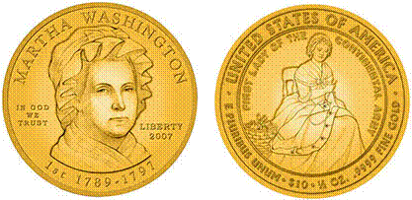

The 2007 $10.00 gold Martha Washington Coin showing obv. & rev.
(Courtesy of the US Mint)

The Presidential and First Spouse series are wonderful ideas conceptually, but why should the collector have to be bear the burden of the extravagant cost of the $10.00 First Spousal gold bullion coin? With the price of gold hovering around the $650 an ounce level, each first spouse coin will have a bullion value of close to or more than $325 before the additional charges for manufacture and distribution are passed on to the collector. If one adds the various 2007 commemoratives, not to mention the annual proof sets, mint sets and the usual bullion offerings, there won’t be any money left in a collector’s budget for the historic, artistic and scarcer obsolete coins of real value.

Finally, if the Government doesn’t retire the dollar bill, these Presidential dollars are not likely to circulate anymore than the dollar coins of the past did, creating yet another debacle due to bureaucratic stubbiness, incompetence or both. The Mint with tacit congressional support continues to be a bit too cavalier in the way they treat the numismatic community.
________________________________________________________________________________________________________________________
More Club News
(Continued from page 1, column 1)

Around 23 members turned out for the February 8 meeting. Treasurer Pat James reported a balance of $823.17 with all expenses paid. President Willie Simon made reference to the January newsletter which showed not only the pictures of the club members at the dinner but also a picture showing fellow member Bill Myers sitting on a tank in Iraq. VP Jim Barry reported that as a result of Bill’s fine review of James Clifford’s book, “Double Daggers”, the author sent two dozen copies of his book directly top Bill’s regiment in Mosul. Speaking of Bill, his article on “Challenge Coins” will appear in the April, 2007 issue of the Numismatist, monthly journal of the American numismatic Association. The subject was Bill’s first presentation before our club back in 2003.

The club’s fiscal year officially begins in April when $10.00 dues will be due. At the March meeting the club will hold its annual election of officers. The Board appointed a nominating committee that included Doug Moody, Glenn Sanders and Arno Safran. If you would like to run for any office for the 2007-08 fiscal year, please contact one of these members. Willie asked members to bring in some nice type coins for the Young Numismatist (YN) Grab bag.

Show and Tell: Young numismatist Justin Kuhl displayed a Gem BU 1962 Lincoln Memorial cent and it was a beauty. He also displayed a 2002 $1.00 silver eagle bullion coin that was enamel-coated in red, white and blue. Dick Lasure showed a 1806 Draped Bust/ Heraldic Eagle half dollar. He also brought in a complete set of Barber halves housed in a Library of Coins Album; one of the more desirable hard cover coin albums, alas no longer being produced. The 73 piece circulated set had every date and branch mint (1892-1915-S) and was evenly matched in appearance. This was no easy task as there are at least ten difficult dates that are hard to find in any grade. Finally, Arno Safran displayed a five piece set of US type coins dated 1825 (excluding gold) that consisted of the Coronet large cent, Classic Head half cent, Capped Bust dime, Quarter and half dollar. He provided some statistics on wages and prices for that period when John Quincy Adams took over the reigns from outgoing James Monroe as 6th President of the United States.

Prize Winners: Jim Barry won the silver eagle door prize and Austin Kuhl won the 50/50 drawing. Congratulations winners!

Our next meeting is Thursday, March 8. The program will be a fascinating PowerPoint presentation by Xavier Pique; Treasurer of the Augusta Coin Club entitled “Counter-Stamped Coins through the Ages”. The topic covers over two millennia of coinage history from the Classical Greeks to the late 19th century and beyond. You won’t want to miss this one.

ANA to Hold Three Day Show in Charlotte, NC Mar. 16-18

The American Numismatic Association is holding another big three day show in the south east. Last April, 2006 it was Atlanta and one week after our next meeting, they will be meeting at the Charlotte Convention Center, Fri. thru Sun. Mar. 16-18, 2007. The 2¾ hour drive is worth it just to see the world Mints and exhibits that are set up around the floor.
________________________________________________________________________________________________________________________
Coin of the Month

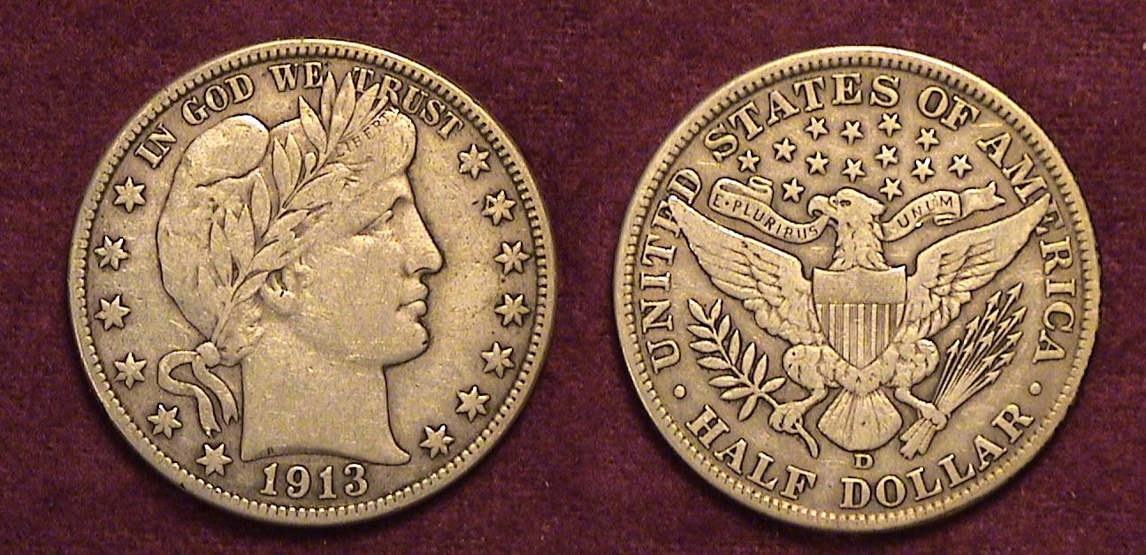

A 1913-D Barber Half Dollar grading F-VF
With a mintage of only 534,000 it is ranked the seventh lowest out of 73.

The 1913-D Barber half dollar is bid at only $28 in Fine-12; $75 in VF-20 but has one of the lowest mintages of the series.

Kindly Patronize Our Advertisers
