Pres. Willie Simon
V .P. James Barry
Sec. Helen Barry
Treas. Pat James
Sgt. in Arms: J.J. Engel
Committees:
Programs: James Barry
Show Chairs: The Barry’s
Newsletter: Arno Safran
E-Mail: arnosafran@comcast.net
The Stephen James
CSRA Coin Club of Aiken
P.O. Box 1739
Aiken, SC 29802
Web site: www.sjcsracc.org
The SJ CSRA CC Now Meets on the 2nd Thursday of the Month at the Cedar Creek Community Center in Aiken, SC

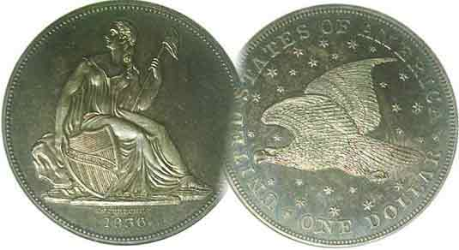

Volume 7, Number 3 the Stephen James CSRA Coin Club, Founded in 2001 March, 2008
Monthly Newsletter
Club Begins its 7th Fiscal Year – Dues Due
Our next meeting this month only is on the 2nd Thursday Mar. 13 at 7:00 PM

2008 Club Meeting Schedule
Jan. 3 Apr. 10 July 10 Oct. 9
Feb. 14 May 8 Aug. 14 Nov. 13
Mar. 13 June 12 Sep. 11 Dec. 4 dinner

_____________________________________________________________________________________________________________________________
Club Fiscal Years Begins With April Meeting
Annual Dues Still $10 for seniors, $5.00 for juniors

Our club was founded in March, 2001 but held its first meeting in April of that year. So, officially that’s when dues are due but any member can renew earlier and the March, 13 meeting should be as good a time as any. With prices rising all over the place $10 annual dues is still a bargain, unchanged since 2001. The club will accept cash or checks. Should you opt for the latter, make it out to Pat James our excellent Treasurer, PO Box 1739, Aiken, SC 29802 and thanks in advance.

At our February 14 meeting, the Barry’s, Jim and Helen each had an interesting Show & Tell to share with the members. Helen displayed an unusual Hobo Nickel Club artifact accompanied by her recitation of if an anecdote having to do with a stick of dynamite used as a fishing pole. Jim brought in a recent acquisition from Classical Greece that showed Antiochus IV on the obverse of a tetradrachm with a seated Zeus holding Nike on the reverse. Jim acquired the coin from dealer Jonathan Kern. It is classified as Sear #6928.

The program featured a Video entitled “Tokens Tell a Story” which revealed the story of commerce in the city of Baltimore circa 1820 and beyond. It was taped in conjunction with the 1993 American Numismatic Association Convention that was held in Baltimore that summer. Many of the tokens were rare and in a low state of preservation. Most advertised businesses and associations that flourished in Baltimore during the 19th century. The video displayed transportation and brewery tokens along with local political tokens and counter stamped tokens. Maps of Baltimore from the time pointed to the locations of these businesses, bars or meeting halls. The video revealed a colloquial portrayal of Baltimore’s past. This summer the city of Baltimore will again host to the ANA’s World Fair of Money at the Baltimore Convention Center.
______________________________________________________________________________________________________
(Club News continued on page 4, column 1)

Collecting Odd US Type Coins
By Arno Safran

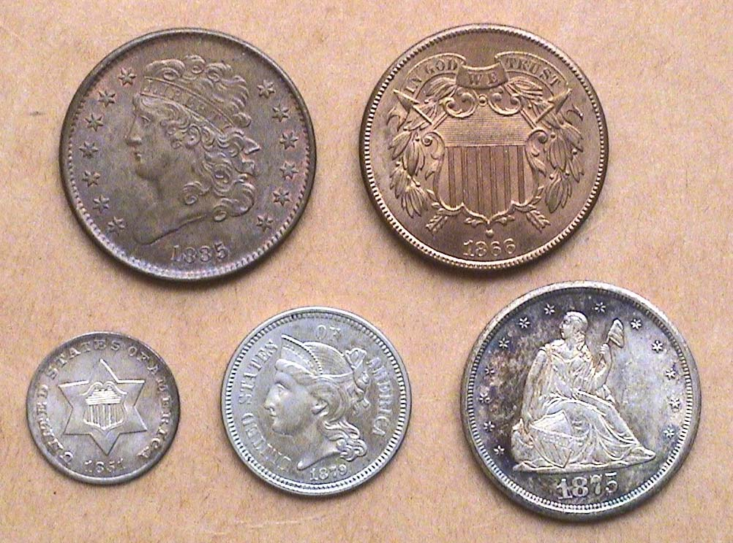

The obverses of an Odd Denominations Type Set
From l to right: top 1835 ½¢, 1866 2¢
Bottom: 1851-O 3¢ silver, 1879 3¢ nickel & 1875cc 20¢
[Magnify page to 200% to see coin details more clearly.]

When Thomas Jefferson’s envisioned our ten denominational coinage system the smallest denomination, the half cent had the purchasing power of 12½¢ today. Our largest silver coin, the dollar could buy about $25.00 worth of goods and our largest denomination, the $10.00 gold eagle was equivalent in value to what $250.00 is now. From the early years of our republic to the late 1960’s our pocket change was more functional since the lower value coins down to the cent could actually purchase something. In 1857, the half cent was discontinued because even then it had little purchasing power, was unpopular and made unnecessary once the Hispanic Real (12½¢) along with the rest of the foreign coins were demonetized. Today, the cent, nickel, dime and quarter can buy virtually nothing. The quarter can be used in a parking meter and for not much else. The half dollar might get you the daily newspaper but that’s about it and for a dollar coin, one can buy a candy bar or soda but no one uses the coin. So, why are they still around? The coins pictured above represent denominations that once were originally thought to serve a purpose but were eliminated because they were no longer functional. These have become the “odd coins types” upon which this article is based.
______________________________________________________________________________________________________________________________
(Continued on page 2, column 1)
Collecting Odd US Type Coins
(Continued from the previous page)

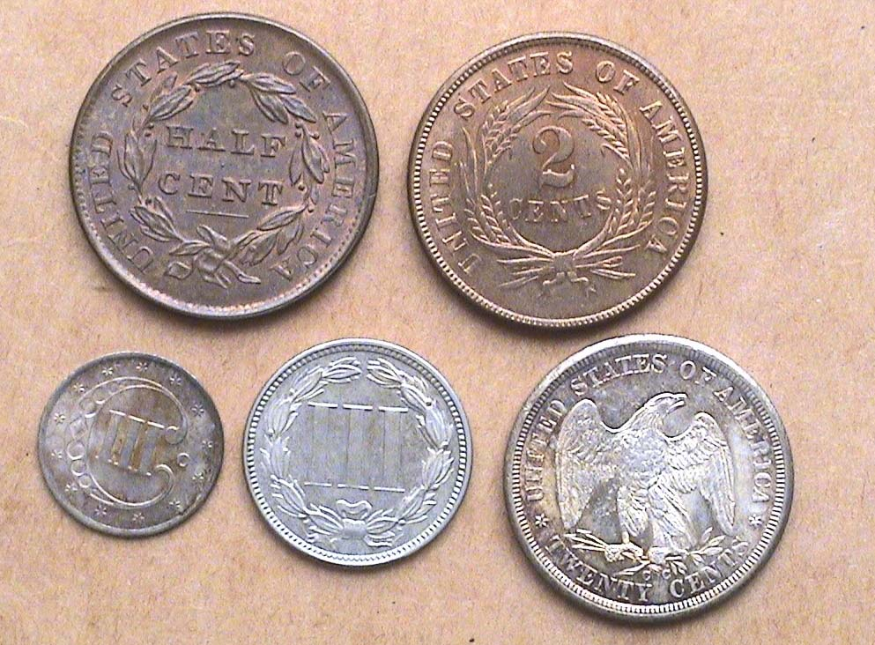

The reverses of an Odd Denominations Type Set
From l to right: top 1835 ½¢, 1866 2¢
Bottom: 1851-O 3¢ silver, 1879 3¢ nickel & 1875cc 20¢
[Magnify page to200% to see details more clearly.]

In the early years of our republic our fledging Mint in Philadelphia was unable to acquire sufficient copper, silver and gold to strike enough coins. While many Hispanic silver coins circulated here legally, a large number of properly weighted copper tokens were accepted in trade for goods as well. The half cent may have been designated for providing change for the silver Spanish American Real; a silver coin worth 12½¢ that was close in size to our early Draped Bust dime. For collectors seeking a specimen for type, the 1835 Classic Head ½¢ is one of the most common dates of the entire series with even mint state specimens such as the MS-63 shown priced moderately. The coin was 23.5 mm in diameter.

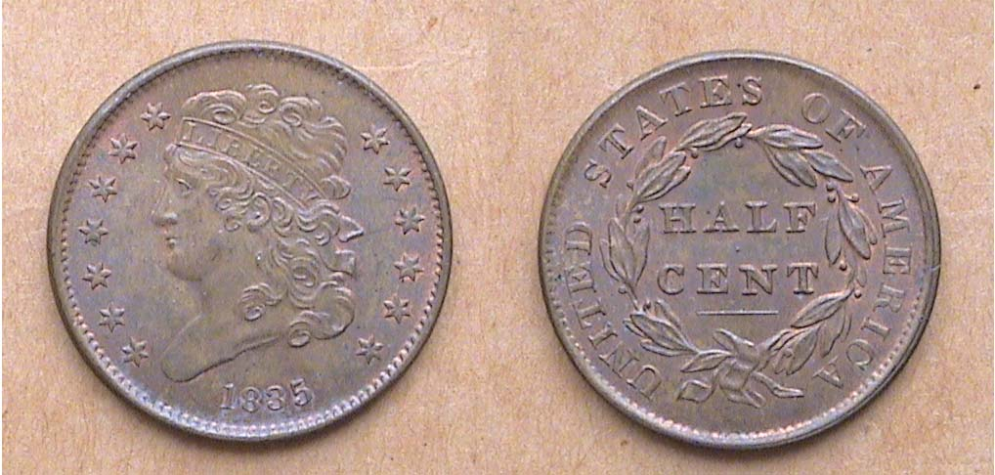

An 1835 Classic Head Half Cent, Cohen-1 variety

The 2¢ piece came into being as a result of the severe coin shortage brought about by the War Between the States, (aka, the Civil War -1861-1865). It was a bronze coin almost the same size of the half cent (23 mm) and the first to display the motto, IN GOD WE TRUST. It was struck in consecutive years from 1864 thru 1873. At first, the coin was successful in providing some relief to the coin shortage as 2¢ had between 25¢ and 30¢ purchasing power (in today’s values) during the immediate post Civil War period.

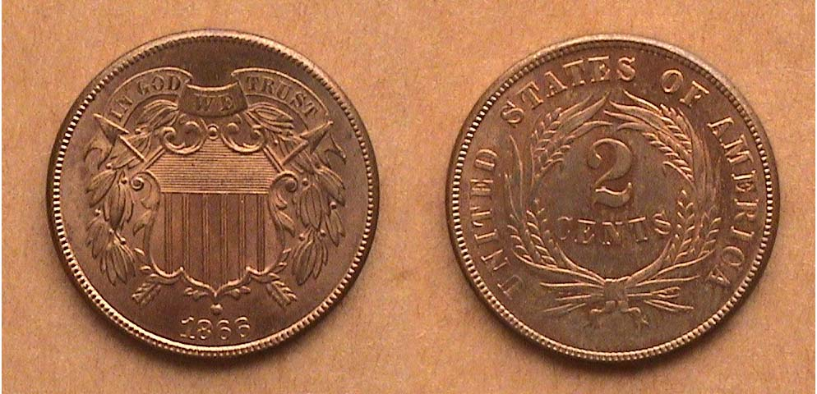

The 1866 2¢ Piece had a mintage of 3,177,000 and is fairly common.
[Magnify page to200% to see details more clearly.]
From 1864 through 1869 mintages for the 2¢ piece were well over 1 million but from 1870 to 1872, its popularity waned and mintages dropped precipitously with only 65,000 being issued in 1872. The 1873 is a proof only issue with a total of only 1,100 known. The first year, 1864 offers two versions of the motto, the small (scarce) and the large (common).

In 1851, the price of a first class postage stamp was reduced from 5¢ to 3¢. Silver coin was already in short supply as the amount of silver in the half dime, dime quarter and half dollar exceeded its actual silver value in relation to gold. This was due to the discovery of large deposits of the yellow metal in 1848 at Sutter’s Mill near Sacramento, California. The problem of finding silver coins in circulation would worsen during the next two years but for the time being Congress passed a bill authorizing the striking of a new 3¢ denomination composed of .750 fine silver bonded to .250 copper, good for the purchase of one postage stamp. The coin was tiny, only 14.3 mm in diameter and sliver-thin. It was struck in ample mintages at the Philadelphia Mint during the first three years. The new 3¢ coin circulated and proved successful. During its 23 year run (1851-1873), the trime (as came to be called) was struck only once at a branch mint in 1851-at New Orleans. In 1863 during the Civil War, mintages dropped to the low five figures and finally the low four figures after 1866. In the Coinage Act of 1873, the 3¢ silver piece was terminated along with the two cent coin, the half dime and Liberty Seated dollar.

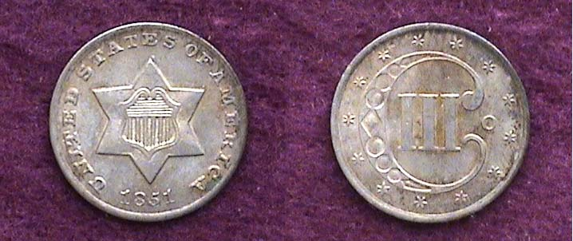

An 1851-O 3¢ silver piece with a mintage of 720,000.
It was the only year the coin was struck at a branch mint.
[Magnify to 200% to see the details more clearly.]

In 1865 a second 3¢ denomination coin was introduced, not in silver, but in a copper-nickel alloy. Like the previous issue, the coin was authorized in an attempt to stimulate circulation which had virtually ceased to exist during the Civil War years. Over 1 million were struck in each of the first six years and the coin helped to stem the coin shortage. After 1876, the mintage began to subside and except for a one year resurrection of a whopping 1,077,000 struck in 1881; the 3¢ nickel died a gradual death and was terminated in 1889.

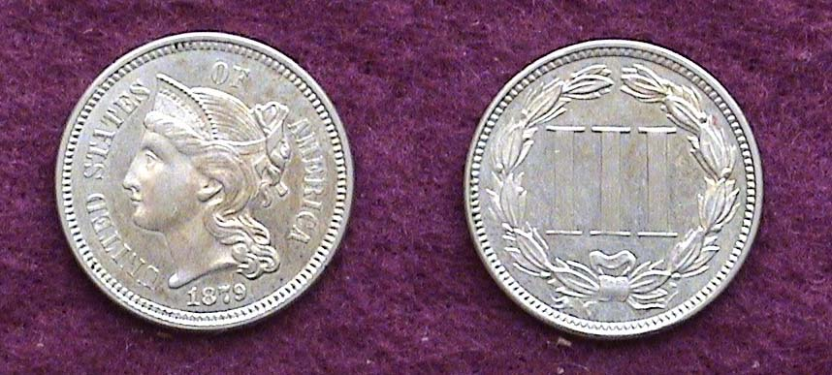

An 1879 3¢ nickel piece
Despite a mintage of only 38,000, the date is not rare.
[Magnify to 200% to see the details more clearly.]

The 20¢ piece was originally authorized because westerners preferred silver coin to nickel or copper. With the termination of the silver half dime in 1873, merchants had a difficult time making adequate change from a quarter since many items back then were priced at 10¢ or 15¢.
_____________________________________________________________________________________________________________________________
(Continued on page 3, column 1)
Collecting Odd US Type Coins: The 20¢ Piece
(Continued from the previous page)

From our earliest coinage, a tradition had developed of placing the same obverse design type on all US denominations of a specific alloy and this of course included the five authorized silver denominations; the half dime, dime, quarter, half dollar and dollar coins. By 1875, the Liberty Seated obverse design of Christian Gobrecht had been in place, so after the new 20¢ piece was approved by Congress the custom was not about to be changed; this despite the fact that the new coin would have a diameter of 22 mm as opposed to 24.3 mm for the quarter. The engraver at the time was William Barber who had replaced James Barton Longacre after the latter’s death in 1869. Barber had been the designer of the new Trade dollar in 1873 that included a different version of the spread eagle reverse; arguably a marked improvement over John Reich’s pterodactyl-like rendition going all the way back to 1807. Barber now chose this reverse for the 20¢ piece but as instructed, employed the same Gobrecht Liberty Seated design for the obverse. One modification was to raise the word LIBERTY on Miss Liberty’s Shield which naturally wore off more quickly.

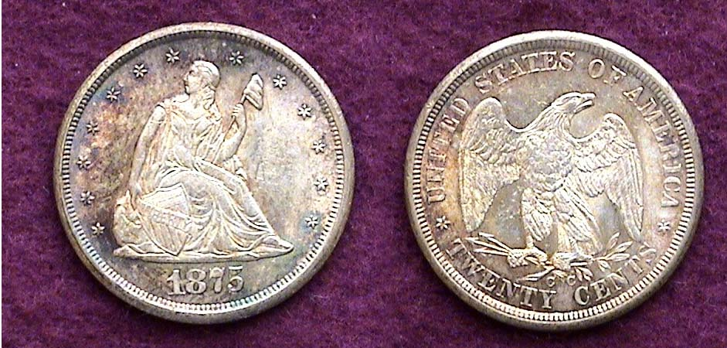

The 1875 cc 20¢ piece had a mintage of 133,290
The new denomination had the same purchasing power as $4.00 today.

In 1875, the 20¢ piece was struck at three mints, Philadelphia (35,910), Carson City (133,290) and San Francisco (1,155,000), the latter being the most available and affordable for type. In 1876, only 14,640 were struck at the Philadelphia facility and despite a reported 10,000 struck at the Carson City Mint, less than 20 survivors are known making the 1876 cc one of the great rarities. Because of the similar obverse to the other five Liberty seated denominations and its proximity in size to the quarter, the 20¢ piece failed miserably. In 1877 it was decided to mint only Proof versions for collectors of which only 350 proofs were made and in 1878 some 600 proofs were produced before the 20¢ coin was terminated.

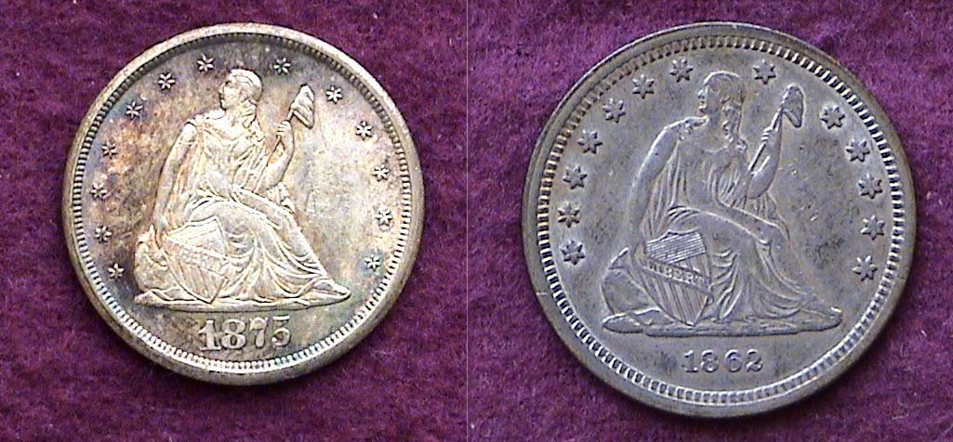

The obverses of an 1875cc 20¢piece and 1862 quarter

Some years ago the Capital Plastics Company created a five piece Lucite holder to house these five odd US denominations and for those who were active collectors during the pre slab era, many have opted to insert them in this attractive setting after they completed their set. For these collectors, “odd” was beautiful.
____________________________________________________________________________________________________________________

IT MAKES SENSE TO CHECK CENTS
By Bill Myers

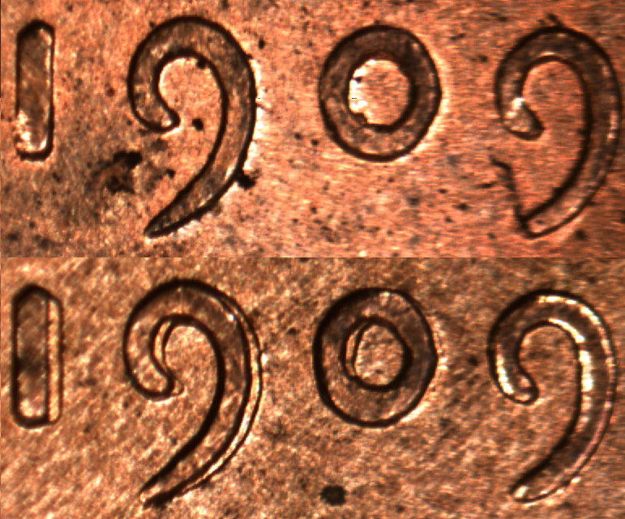

I had the fortune to inherit a metal tin with a few hundred Lincoln cents in it. A significant number were wheat cents of which some were red-brown, uncirculated 1909 VDB cents. I studied each cent with a loupe and one of the 1909 VDB cents had doubling of the RTY of LIBERTY and 190 of the date. I did some research and discovered it is one of two obverse double dies known on 1909 VDB cents. The other double die shows thickening of the 909 of the date. The latter is less common then the one I have, but it is also less desired, as the one with the doubling of the letters and numbers has more eye appeal. My coin is classified as Class IV doubling which is caused by an offset of the dies between hubbings. It is listed as Breen 2054 and Fivaz Stanton (FS) 012.

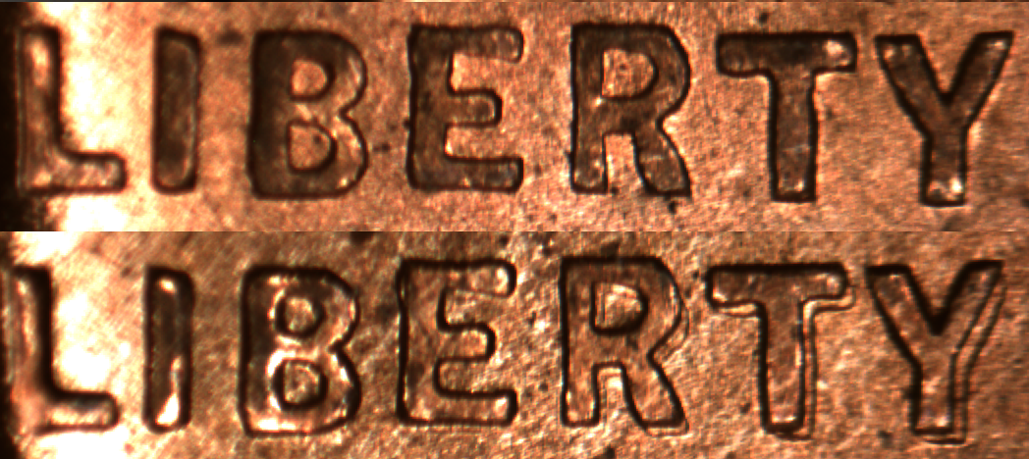

The 1955 obverse double die Lincoln cent has to be the most famous double die, as even non-numismatists are aware of it. But there are hundreds of different double die cents throughout the Lincoln cents series. The first one occurred with the first Lincoln cents to be struck. Since cents account for a majority of the coins minted at the U.S. Mints they require more dies and thus the greater chance of errors occurring. The discovery of double die Lincoln cents seems to happen every year, but on the recently minted cents it is extremely minor doubling compared to the doubling on the 1909 VDB cent.

By taking a little time to study the cents in the tin, I made an interesting find and determined that the 1909 VDB double die cent can be worth up to ten times more then the normal cent in the same grade.
__________________________________________________________________________________________________________________

References:
Breen W. Complete Encyclopedia of U.S. and Colonial Coins. Doubleday. 1988. P228.
Fivaz B, Stanton JT. The Cherrypickers’ Guide to Rare Die Varieties. Volume One. Stanton Books and Supplies, Inc. 4th Ed. 2000. p90.
Myers W. Double Dies. Scanner. Vol. 33-3. Oct 2005. Pp10-15.
Taylor S. The Standard Guide to the Lincoln Cent. 4th Ed. 1999. Pp62-63.
__________________________________________________________________________________________________________________________

More Club News
(Continued from page 1, column 1)

Over the years our redoubtable President Willie Simon has encouraged more member participation by asking those present at our meetings to suggest ways we can continue to improve what our club can offer its members. He added that these can take the form of Show & Tells, specific programs they would like to see, placing Buy, Sell or Trade ads in the newsletter or contributing short articles based on personal coin collecting experiences to the monthly newsletter. On the latter he has suggested such topics as , “My Favorite Coin” or “My Favorite Coin Type,” My Best Buy”, “My Worst Buy”, “The One That Got Away” etc. At the February meeting, Willie repeated some of the foregoing.

Treasurer Pat James reported a club balance of $834.93 with all expenses paid. Thanks, Pat! Jim Barry is seeking to finalize a date for the club’s spring annual Road Show scheduled for a Saturday between 12 noon and 3 PM at the Aiken Public Library. The best date on the docket seems to be Saturday, May 17. Those members who would like to participate as appraisers please let Jim know if this is all right by the March meeting. Member Bill Myers announced that the Georgia Numismatic Association (GNA) will be holding their three day coin show at the Dalton Convention Center April 18-20 and the Augusta Coin Club’s annual spring show is set for May 2 & 3 at the Belair Conference Center off Exit 194 of I-20.

Prize winners at the Feb. 14 meeting were Sharon Smoot who won the silver eagle door prize and Glenn Sanders who took the 50/50. Congratulations Sharon and Glenn. Our next meeting is Thursday, March 13. (Hope to se you there!, Ed.)
______________________________________________________________________________________________________________________

Erratum

In the February edition the editor erroneously reported that the 1946 Hungarian inflation note, the Szazmillio B-Pengo portrayed in Bill Myers’ appendage to his article, “Who Wants to Be a Millionaire” was valued at “only” 100 million pengo when he was informed by the author that the B actually represented 1 billion more thereby adding twelve more zero columns to the note’s value. Thus it was legal tender for 100,000,000,000,000,000,000 Pengo or One quintillion Pengo at the time of issue. And yet, the note had an exchange rate of only 20¢ in USA monetary value. Unbelievable but true but then, what could a single pengo have been worth? [Is it time to remove the cent, the 5¢ nickel? Ed.]

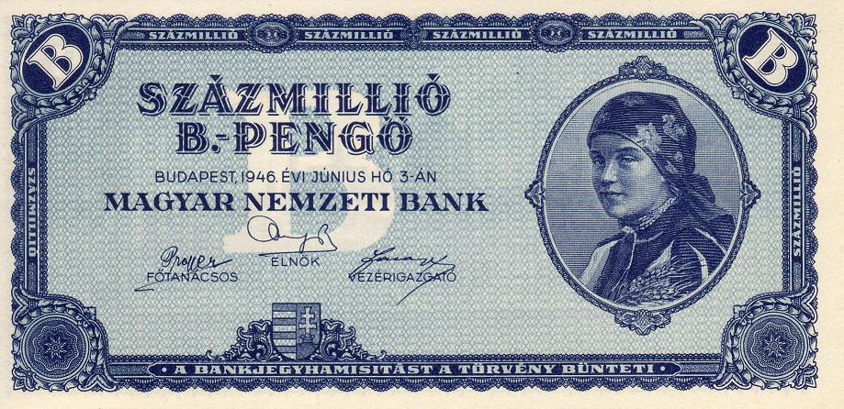
The Face of the 1946 Hungarian Szazmillio B – Pengo note
It was Hungarian legal tender for 100 Quintillion Pengo at the time.
_________________________________________________________________________________________________________________________
Coins of the Month

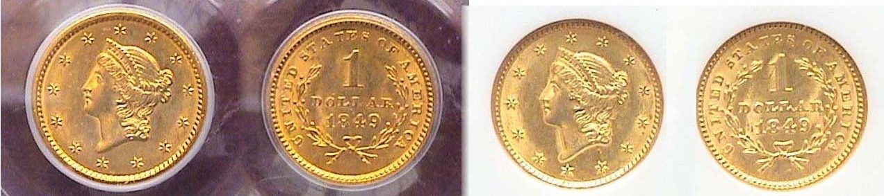

1849 $1.00 gold Liberties showing open and closed wreath reverses
Both were graded MS-61 by PCGS and NGC respectively.
[Magnify page to 200% to see coin details more clearly.]

The two 1849 P $1.00 gold coins shown above were acquired a month apart in 2005 when gold was trading at $425 an ounce. With gold approaching the $1,000 mark these two coins have remained around the same price. 1849 was the first year $1.00 gold coins were struck and they were issued at all four Mints; Philadelphia (688,567), New Orleans (215,000), Dahlonega (21,588) and Charlotte (11,634). The last two Mint specimens are rare and expensive; the New Orleans less so but both Philadelphia issues are available and affordable. The reverse comes in two varieties, open wreath and closed wreath.
______________________________________________________________________________________________________________________

Kindly Patronize Our Dealers
