Pres. Willie Simon
V .P. James Barry
Sec. Helen Barry
Treas. Pat James
Sgt. in Arms: Glenn Sanders
The Stephen James
CSRA Coin Club of Aiken
P.O. Box 1739
Aiken, SC 29802
Web site: www.sjcsracc.org
The SJ CSRA CC meets on the 2nd Thursday of the Month at the Cedar Creek Community Center in Aiken, SC

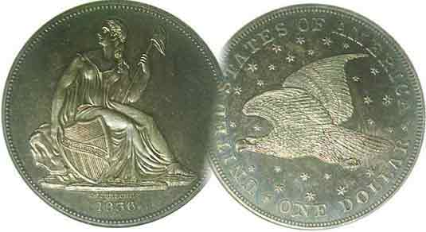
Committees:
Programs: James Barry
Show Chairs: The Barry’s
Newsletter: Arno Safran
E-Mail: arnosafran@comcast.net
Auctioneer: Glenn Sanders

2009 Club Meeting Schedule
Volume 8, Number 3 the Stephen James CSRA Coin Club, Founded in 2001 March, 2009
Monthly Newsletter
Outstanding Program on Coins of Italy Presented
Our next meeting is Thursday, March. 12, 2009 from 6:15 to 9:00 PM
Jan. 5 Apr. 9 July 9 Oct. 8
Feb. 12 May 14 Aug. 13 Nov. 12
Mar. 12 Jun. 11 Sep. 10 Dec. 3
___________________________________________________________________________________

Member Walter Kubilius Presents Program
“Coins of Italy” at Feb. 12 Meeting

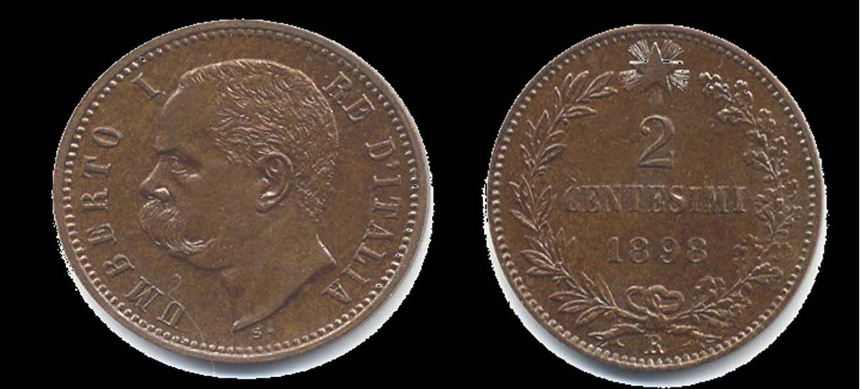

An 1898 copper 2 centesimi of Umberto I
[Magnify to 200% to see details.]

Eighteen members and five guests were present at the February 12 meeting of the Stephen James CSRA Coin Club and were treated to one of our finest presentations. The speaker was member Walter Kubilius who presented a PowerPoint program entitled “The Coins of Italy”. The program incorporated 73 slides featuring time frames, maps, coats of arms and coin motifs and their significance as well as portraits of key statesmen and monarchs. Walter divided the presentation into four periods: 1. Pre 1861 Italy as separate states, 2. 1861-1922 as a constitutional monarchy, 3. 1922-1943 Fascist Rule under Benito Mussolini and 4. the Republic, 1946 to date.

Illustrated motifs on the coins and bank notes shown included Victor Emanuel II, (1861-1878), Umberto I (shown above), (1878-1900), Victor Emanuel III (1900-1946) and a variety of allegorical female figures representing Italia (Liberty), for example, four horses pulling a chariot signifying a winged Liberty also political symbols such as the fasces (“a bundle of wooden rods tied together with rope”) symbolizing strength through unity under classical Greek times but with the added feature of an axe representing force, law and order and party loyalty under Mussolini’s Fascist rule. Interestingly, Il Duce’s portrait never appeared on any of his coins which instead featured King Victor Emanuel III and other allegorical figures.
______________________________________________________________________________________________________________________
(More Club News continued on page 4, column 1)

Collecting Short Sets: US Gold Coins
Part One: The Gold Liberties by Arno Safran

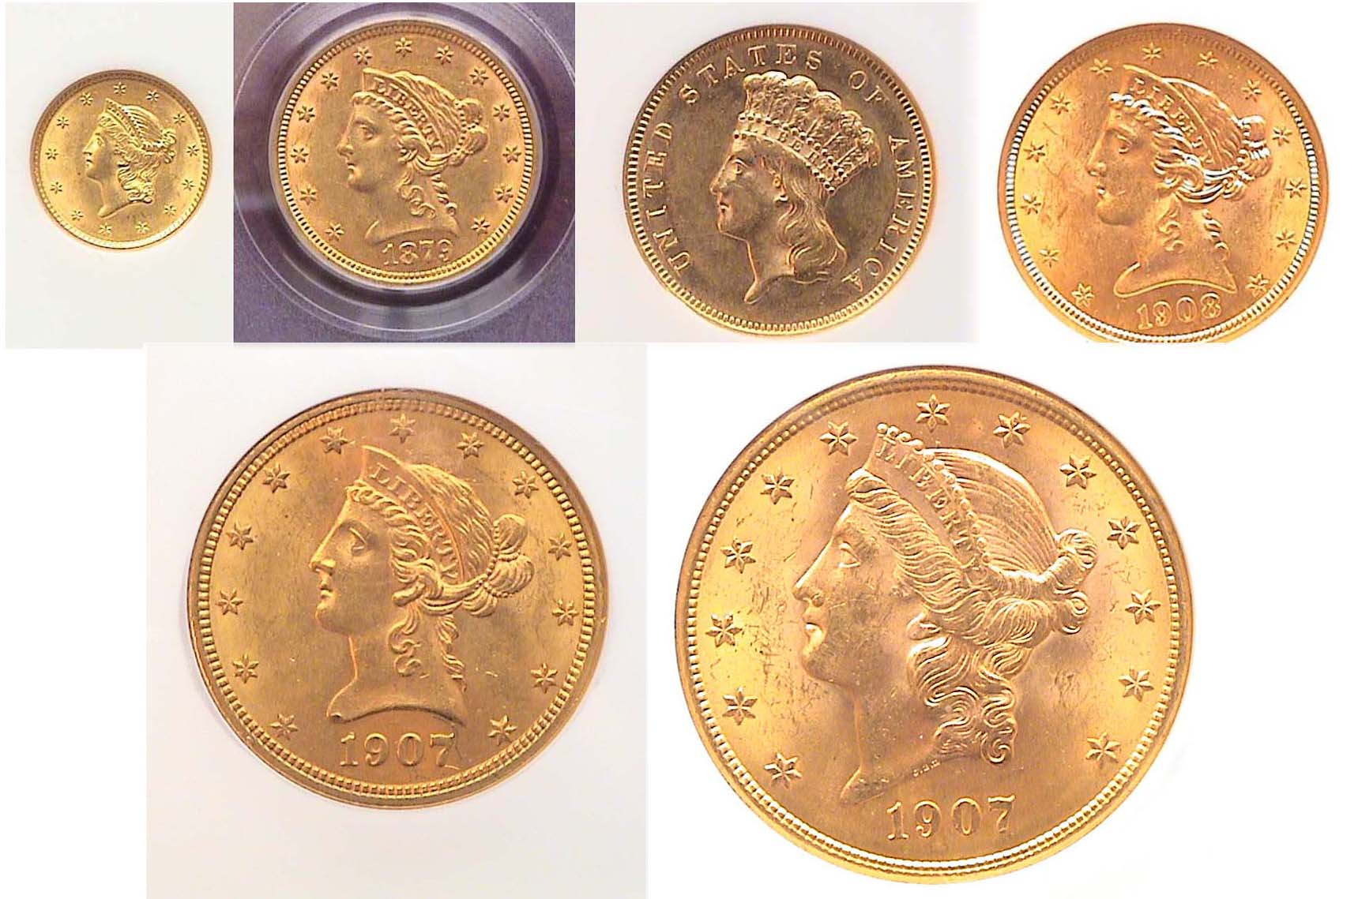

The obverses of a Liberty Gold Type Set
Top: 1850 $1, 1879 $2.50, 1878 $3.00 and 1908 $5.00,
Below: 1907 $10.00 and 1907 $20.00
[Magnify to 200% to observe details.]

Our U.S. gold coinage was first issued in 1795 with the release of the $5.00 half eagle and the $10.00 eagle. In 1796, the $2.50 quarter eagle was issued. After 1804 the $10 eagle was suspended until 1838. The vast majority of the early dates (1795 thru 1838) are rare and prohibitively expensive. In 1849, a tiny $1.00 gold coin was issued and in 1850, the $20 double eagle was struck for circulation. In 1854, a $3.00 denomination was added to be used by businesses for the purchase of one hundred first class postage stamps which cost 3¢ apiece at the time. The $1.00 and $3.00 pieces lasted through 1889. During the height of the Great Depression in 1933 all gold coinage intended for circulation was terminated and the yellow metal has only been used in striking commemoratives or bullion coins since. Despite the rise in the price of gold during the past two years, collectors interested in assembling a basic US gold type set can still seek out certified examples at a modest cost above melt grading AU-58 through MS-62. In this issue we will cover the most affordable of the six Liberty gold types.
___________________________________________________________________________________________________________________
(Continued on page 2, column 1)

Collecting Short Sets: US Liberty Gold Coins
(Continued from page 1, column 2)

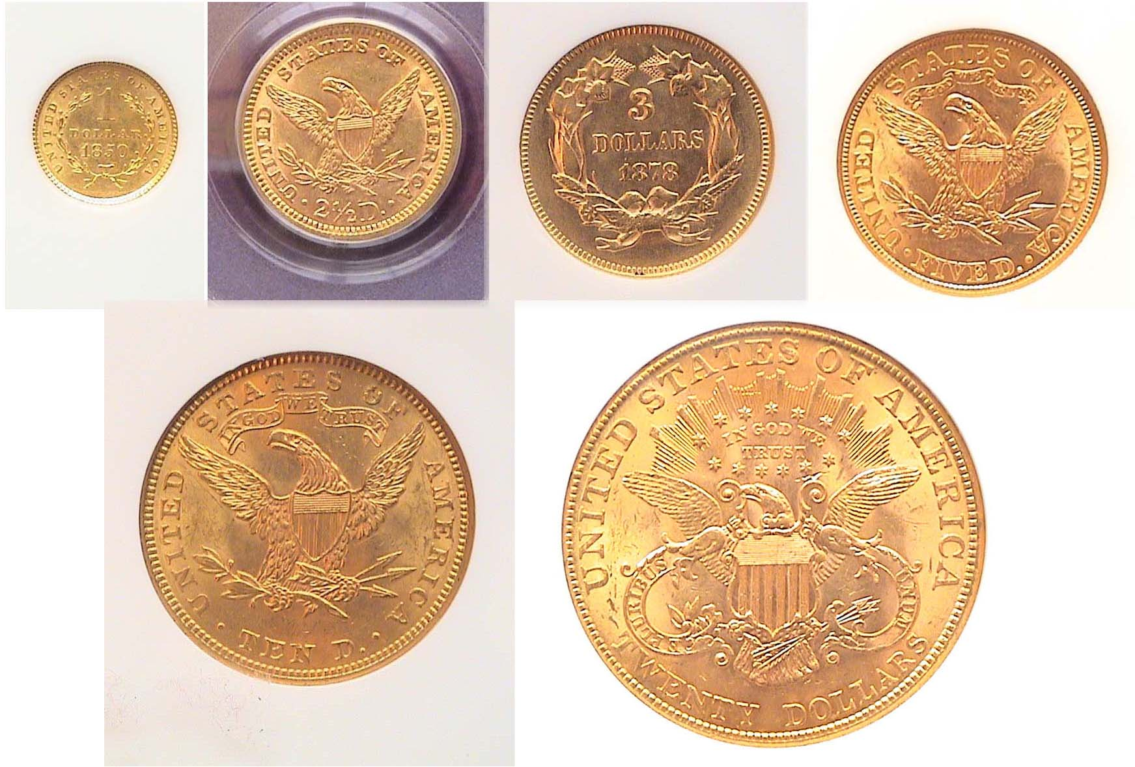

The reverses of a Liberty Gold Type Set
Top: 1850 $1, 1879 $2.50, 1878 $3.00 and 1908 $5.00,
Below: 1907 $10.00 and 1907 $20.00
[Magnify to 200% to observe details.]

The certified Liberty Gold type set shown atop pages 1 and 2 comprise six denominations; the $1.00, $2.50 quarter eagle, $3.00, $5.00 half eagle, $10 eagle and $20.00 double eagle. All of these examples represent common dates and are priced as such within the more affordable grades of AU-58 through MS-63 depending on the denomination. The least expensive issue is the $1.00 coin and the most costly, the $3.00 gold piece. These two types were designed by James Barton Longacre who served as Chief Mint Engraver from 1844 thru 1869, a total of twenty-five years. Longacre, who is best known for his Indian Head cent type first issued in 1859, created more US coin designs than any US Chief engraver before or since.

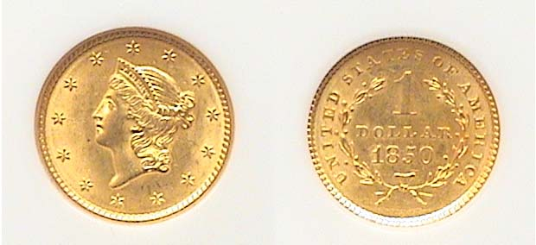

The 1850 $1.00 Gold piece had a mintage of 481,953.
This specimen was graded MS-62 by NGC [Magnify to 200%.]

California was not a US territory, let alone a state when gold was discovered at Sutter Mill along the American River near Sacramento in January of 1848. The discovery brought out the Argonauts who were made up of Californian settlers, Mexicans and some Hawaiians. In 1849, the Gold Rush was well underway with the arrival of the “forty-niners” from all over the United States and Europe. The many gold discoveries raised the value of silver in relation to gold. So, with silver coin being either hoarded or sold for bullion Congress authorized a new $1.00 gold coin with passage of the Act of March 3, 1849. Even back in the late 1840’s the silver dollar was unpopular due to its cumbersome size. In 1850, the Mint decided to reduce the mintage of silver dollars striking only 40,000 at the New Orleans facility and just 7,500 at the Philadelphia Mint. In that same year the Philadelphia Mint struck almost 500,000 gold dollars, 481,953 to be precise, which is why one can acquire an 1850 gold dollar in mint state today for only a tiny fraction of a Liberty Seated dollar in the same grade.

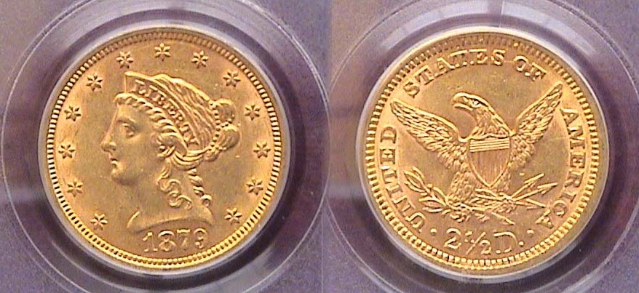

An 1879 $2.50 Quarter eagle graded AU-58 by NGC
The mintage was 88,960. [Magnify to 200% to observe details.]

Another fairly inexpensive coin is the Liberty $2.50 quarter eagle. The coin was struck from 1840 through 1907 with virtually no changes to the design yet there ere are enough common dates available from AU-58 thru MS-62 that are priced moderately. The pleasing 1879 $2.50 graded AU-58 shown above is one such an example. Not all AU-58’s are the same and even certified grades will show A+ coins for eye appeal and B- coins lacking this important feature. So, when perusing certified examples, remember the adage, ‘Grade the coin, not the slab!”

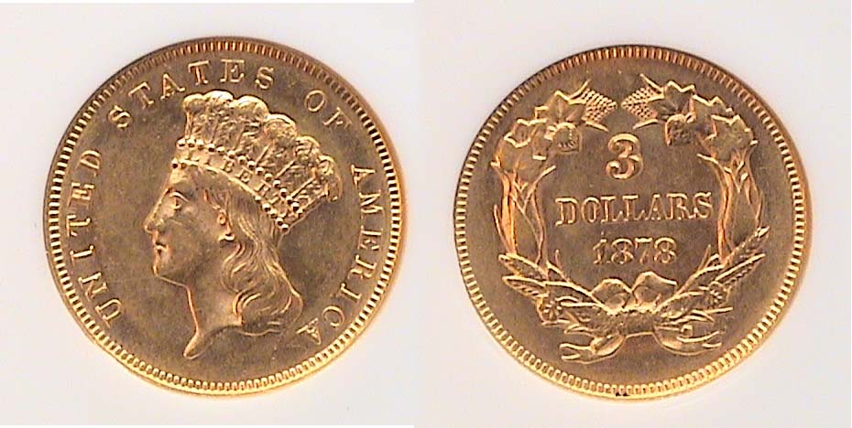

An 1878 $3.00 gold piece graded AU-58 by NGC.
This is one is the second most common date.
[The coin is 20.5 mm in diameter. Magnify to 200% to observe details.]

The first $3.00 gold pieces were coined in 1854. Longacre’s design known as the “Indian Princess” was akin to the third $1.00 type struck two years later in 1856. The three largest mintage dates are the 1854, (138,615) 1874 (41,800) and the 1878 (82,304) and are by far the most common with most of the other dates having been struck in the four figures or only hundreds, yet even the common dates are priced higher than one might expect due to strong demand from collectors who are attracted to “odd” denominations. Despite the coin’s initial purpose the $3.00 was not used much for postage as intended, It hardly circulated resulting in a plentiful supply of survivors.
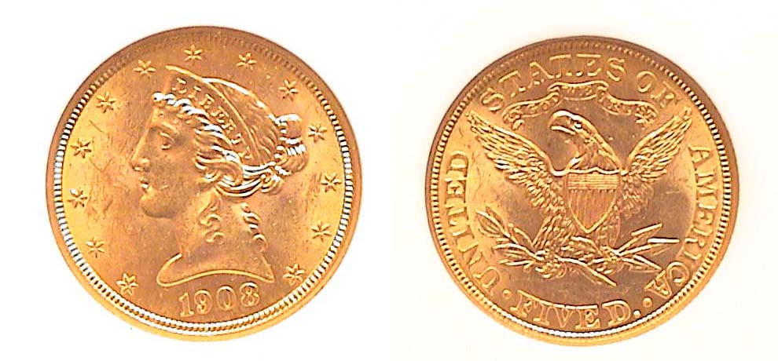
A 1908 Liberty $5.00 half eagle graded MS-61 by NGC
This was the final year of the series that began in 1839.
421,874 were minted. [Magnify to 200%]

Before gold started its gradual rise from $425 an ounce to almost $1,000, a collector could obtain an attractive AU specimen of a common date of the $5.00 gold Liberty for under $200. AU-58’s now wholesale for around $325 with an MS-61 coin like the one pictured above selling for only $25 more at $350. The $5.00 Liberty has been the common man’s gold coin collectible. It had tremendous purchasing power during the late 19th and early 20th centuries; around $132.25. At 21.6 mm it was only slightly larger than its contemporary, the 5¢ Liberty nickel (21.2 mm). Check the Red Book for the common dates.
____________________________________________________________________________________________________________________
(Continued on page 3, column 1)

Collecting Short Sets: US Liberty Gold Coins
(Continued from page 2, column 2)

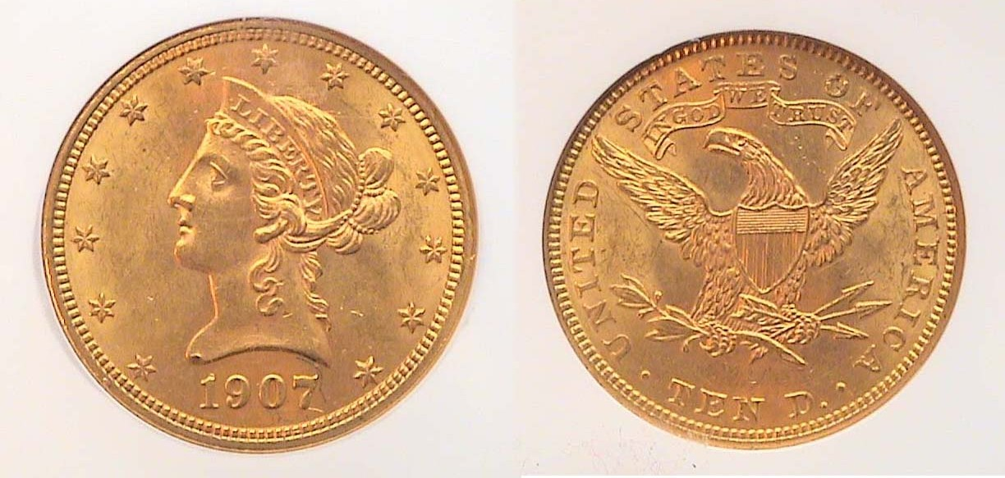

A 1907 $10.00 Gold Liberty graded MS-62 by NGC
The mintage was fairly large; 1,203,899 for a final year issue.
[Magnify to 200% to observe details.]

From its first year in 1838 through the Civil War years and into the 1870s, mintages of Liberty $10 gold eagles for most dates and branch mints seldom exceeded four and five figures. Oddly, many of these low mintage issues are not all that expensive in VF-20 and XF-40 but unlike copper and silver issues, gold coins have a tendency to look drab and spongy below AU-55. For most gold issues AU-58 thru MS-61 are the ideal grades for the collector on a modest budget, and within that grade range one has to seek a common date. 1880 was the first year the denomination went over one million. In fact, during its entire run of seventy years the $10.00 gold eagle exceeded a million in a single year just eleven times, the 1907-P shown above being one of them. Certified specimens are recommended. At the turn of the previous century a $10.00 gold piece had the purchasing power of $236.34.

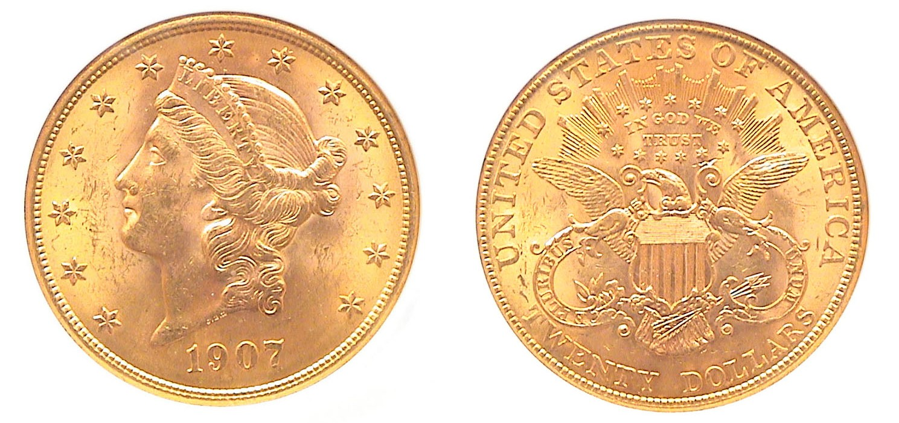
A 1907 $20 gold Liberty double eagle graded MS-63 by NGC
[Magnify to 200% to observe details.]

After a single pattern struck in 1849, over 1.1 million double eagles were released at the Philadelphia Mint in 1850 with 141,000 struck at the New Orleans facility. Despite these relatively large mintages, the prices of the early dates of the series are more expensive than from the mid 1870’s on. The coin underwent three minor design modifications on the reverse during its fifty-eight year tenure (1850-1907); The first is referred to as. the no motto above Eagle (1850 thru 1865). The second displays the motto IN GOD WE TRUST placed directly above the eagle (1866-1907). In 1877 the denomination TWENTY D. was changed to TWENTY DOLLARS (1877-1907) providing for the third sub-type. As our largest circulating coin, the double eagle weighed almost one ounce while containing 90% gold. With gold once again flirting with the $1,000 an ounce level, even common date $20 Liberties like the 1907 shown above has increased to $2,000 wholesale when you factor demand and numismatic value into the equation during these uncertain economic times. $20 in 1907 had the purchasing power of $475.
_________________________________________________________________________________________________________________________________
-to be continued
In last month’s issue we published in this very column an article entitled “Acquire Quality Coins” by Harry Garrison, a noted dealer and numismatist. This month we print a story that expresses another point of view. Please read on:

The Millionaire Bottom Feeder
By Greg Heim

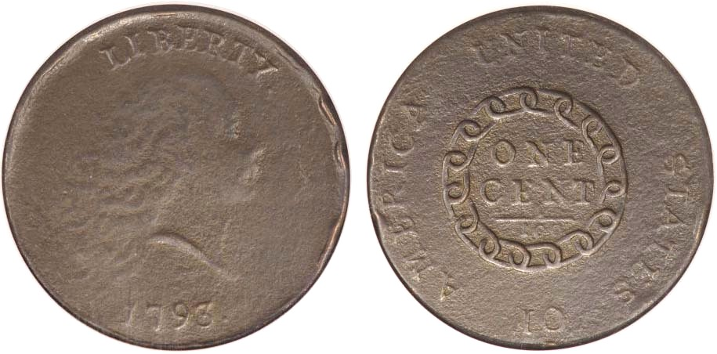

A 1793 Chain cent, with Rim Bumps and serious corrosion
Years ago such a coin might have been found in a dealer’s junk box.
[Magnify to 200% to see details.]

The following story is true and only the names have been changed to protect the innocent.

There was a guy named “Joe” who I knew for many years – ever since I was a boy. Joe was a guy who was always looking for a bargain. To top it off, he was a real shrewd negotiator/haggler when it came to doing business. Many times he rubbed people the wrong way but most of the dealers loved Joe because he always had a wad of cash to spend.

Joe was not what one would call a numismatic scholar. But he was definitely a first-class numismatist. Well versed in the regular US issues listed in the Red Book, he used his knowledge to good advantage by applying it in the marketplace.

What made Joe unusual as a collector was his expertise in buying problematic coins. It gave him a ton of leverage. To top this off, Joe was an ardent cherry picker of important varieties by purchasing junk lots, then plucking out the rarities. I remember one time he showed me an 1893-S Morgan dollar in AG condition that had the initials, “RN” scratched across Liberty’s face. So what? The dealer needed cash and Joe made him an offer. Problem or not, I almost had a coronary when Joe told me how little he paid for it at the time. The same held true for a horrid 1793 Chain cent. It had VG details but was corroded to death with a gash across Liberty’s neck. It was part of a bulk lot of 100 large cents which he bought for $2.00 a piece!

Sadly, Joe’s life was cut short at the age of 72 from lung cancer (he was a two pack a day chain smoker). His heirs were well aware of Joe’s collection and the nature of it and they told the dealer who handled the estate to take the coins on consignment as they were not hard up for cash. I turned out that after examining all of the records, the net proceeds from Joe’s holdings after the dealer’s commission was slightly over one million dollars! Joe paid less than half of that for the material as he kept accurate records of everything he bought.

The moral of this story is that quality alone is not always a guarantee for profit and that knowledge along with good negotiating skills can be paramount factors for success.
__________________________________________________________________________________________________________________________
Editor’s note: Greg Heim is a half cent collector and member of the “Early American Coppers Club” (EAC), a national coin collectors organization devoted to the collecting and attributing of varieties of U.S. large cents, half cents and colonial copper coinage. The article originally appeared in Penny-Wise, the bi-monthly journal of EAC, Harry E. Salyards, editor.
____________________________________________________________________________________________________________________________
More club News (Continued from page 1, column 1)

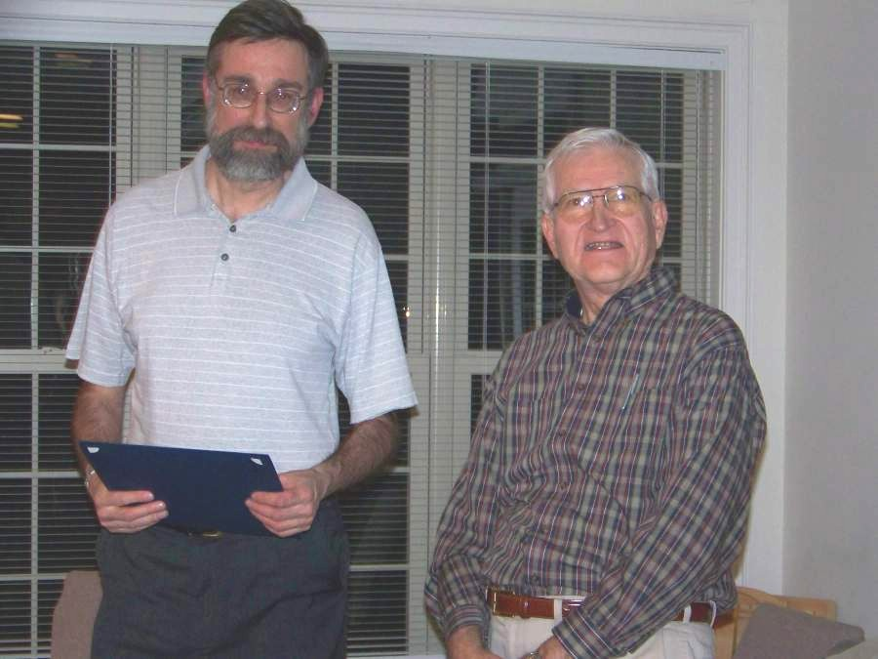

Walter Kubilius (left) receiving Appreciation Award from
VP Jim Barry (right) for his presentation, “Coins of Italy”
[Photo, courtesy of Helen Barry]

President Willie Simon appointed a Nominating Committee for this year’s upcoming elections. They consist of members Glenn Sanders, Chairman, Jack Seech and Arno Safran. Nominations will be announced by the Committee at the March 12 meeting when other nominations from the floor may be tended followed by the election. Our fiscal year begins with the installation of the new officers at the April 9 meeting. Dues of $10 will be due on that date as well or payable on March 12.

In other Club News, Treasurer Pat James reported a balance of $830.43 after expenses. VP Jim Barry reported on a new numismatic publication and course published by the American Numismatic Association called “the ANA Coin Study Book”. It covers US, Foreign and Ancient coins along with tokens and medals. At the end of each chapter is a quiz. The book is well written and a useful tool for collectors wishing to increase their numismatic knowledge. The price of the book along with the course is $39.95. The student must be an ANA member to enroll.

For Show & Tell, Arno Safran brought in a sixty year old Brilliant Uncirculated five piece denominational set of US coins dated 1949-S that included a Franklin Half dollar with full bell lines. Our next meeting on March 12 will feature a special ice cream treat and instead of a program, Show & Tells from our members. Please bring in something from your collection.

The prize winners at the Feb. 12 meeting were Glenn Sanders who won the 2009 silver eagle and John Attaway who took the 50/40 - $16.00. Congratulations gentlemen.
_____________________________________________________________________________________________________________________

Coin of the Month

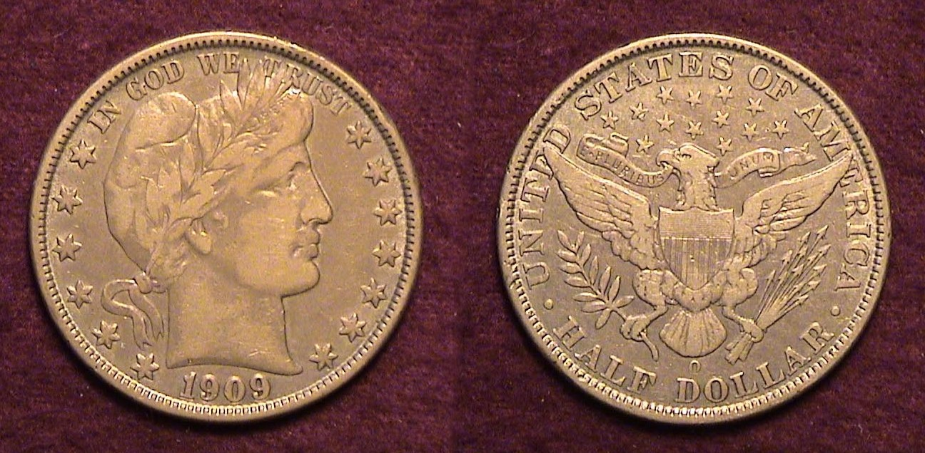

A 1909-O Barber half dollar grading VF. [Magnify to 200%]
The coinage year of 1909 was not only significant for the end of the Indian Head cent era (1859-1909) and the birth of the now century old Lincoln cent. It also represented the end of an important coining facility; the New Orleans Mint. 100 years ago the New Orleans Mint struck four denominations, the Barber, dime, (2,287,000), quarter, (712,000) and half dollar, (925,400), and the low mintage Indian Head $5.00 gold Half eagle (just 34,200). That rarity was a “last hurrah” for “the Big O” ending a period of more than seven decades interrupted by the Civil War and its aftermath until 1879 when the minting of coinage was resumed. The 1909-O $5.00 gold piece is expensive in all grades but the 1909-O Barber half shown at the bottom of the preceding column is available at modest prices including the VF specimen shown.
__________________________________________________________________________________________________________________________________-
Kindly Patronize Our Advertisers

