Pres. Steve Kuhl
V .P. James Barry
Sec. Helen Barry
Treas. Sharon Smoot
Sgt. in Arms: Glenn Sanders
The Stephen James
CSRA Coin Club of Aiken
P.O. Box 11
New Ellenton, SC 29809
Web site: www.sjcsracc.org
The SJ CSRA CC now meets on the 1st Thursday of the month at the Aiken Public Library

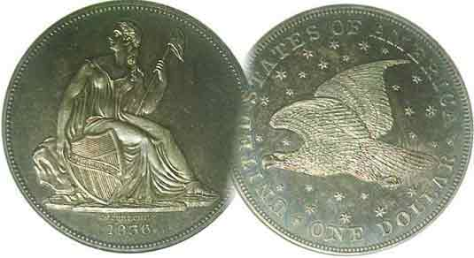
Committees:
Programs: James Barry
2010 Show Chairs:
Newsletter: Arno Safran
E-Mail: arnosafran@comcast.net
Auctioneer: Glenn Sanders

2010 Club Meeting Schedule
Volume 9, Number 3 the Stephen James CSRA Coin Club, Founded in 2001 March, 2010
Monthly Newsletter
Revised By-Laws Vote & Elections this Meeting
Our next meeting is on the first Thursday, Mar. 4, 2010 from 6:00 to 8:45 PM

Jan. 7 Apr. 1 July 1 Oct. 7
Feb. 4 May 6 Aug. 5 Nov. 4
Mar. 4 Jun. 3 Sep. 2 Dec. 2

____________________________________________________________________________________________________________

Revised By-Laws and Elections on Agenda

After eight years of serving as VP and Secretary respectively, Jim and Helen Barry have decided to step down and will not be seeking reelection. Last year, former President Willie Simon and Treasurer Pat James chose not to continue in their respective positions having served for seven straight years. Many hobby clubs go through periods where after a number of years of service, the founders decide it is time to retire from their leadership roles allowing others to become more active and run the organization. At the moment we are fortunate to have as President, Steve Kuhl who has guided the SJ CSRA CC through the first stage of this transition. Sharon Smoot took on the Treasurer’s position and has done a wonderful job “following in the footsteps of her illustrious predecessor”, Miss Pat, and Glenn Sanders has continued in office as both Sgt. in Arms and our very able auctioneer. All three have served our club with distinction. At our upcoming March 4 meeting nominations will be placed for all five positions. If you are interested in serving at this crucial time in our club’s history, now is the time to make your intentions known simply by contacting one or more of our fellow members to have your name placed in nomination for one of the offices.

By now every member should have received a copy of the proposed revised by-laws accompanied by President, Steve Kuhl’s cover letter. All of the proposed changes are highlighted and explained in red. As Mr. Steve has written, some of the suggested changes may be controversial while others are merely a change in language to deal with the way our club has evolved since its founding. It is important that you try to find the time to read the document carefully in order that we may proceed with the discussion in a timely fashion on which items to approve or to reject. Nominations for club officers for the fiscal year 2010-11 and the subsequent election will follow. Due to the amount of club business our program will consist of Show & Tells.
_________________________________________________________________________________________________________________
(Continued on page 4, column 1)

Collecting Charles Barber’s Coins
By Arno Safran

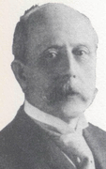
Over time Charles Barber has become one of our more controversial Chief Engravers. An assistant engraver along with George Morgan during the 1870’s, he was appointed Chief Engraver after the death of his father, William Barber who had served as Chief Engraver from 1869 through 1879; this despite Morgan’s successful dollar type of 1878. Charles Barber designed four regular US circulating coins, the Liberty “V” nickel in 1883 along with the three Liberty Head silver pieces, the dime, quarter and half dollar in 1892. He also created the commemorative Columbian half and Isabella quarter among several others as well as a number of patterns.

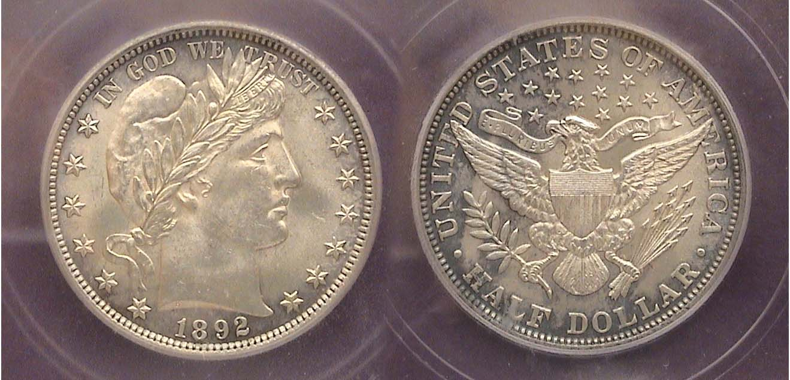

An 1892 Barber Half Dollar graded MS-62 by IGC
[Use 3X glass or magnify to 200% to see details more clearly.]

Between 1892 and 1916 Charles Barber’s silver coins dominated the numismatic landscape of America. Oddly, the Morgan dollar, one of the most popular collectibles today, hardly circulated during its creator’s lifetime but Barber’s Liberty Head dime, quarter and half dollar did; so much so, that finding Choice AU through high-end uncirculated specimens--represents a considerable challenge for the many avid collectors who want to add an attractive specimen to their collection. Most of the Barber branch Mint issues (especially those struck at the San Francisco Mint and a number from the New Orleans Mint) surface in lower grades of About Good through Very Good. Philadelphia Mint specimens are more plentiful in Fine to Very Fine but beyond that, even the so-called common Philadelphia Mint dates are scarce from Extra Fine and higher.
_________________________________________________________________________________________________________________________
(Continued on page 2, column 1)
Collecting the coins of Charles Barber
(Continued from page 1, column 2)

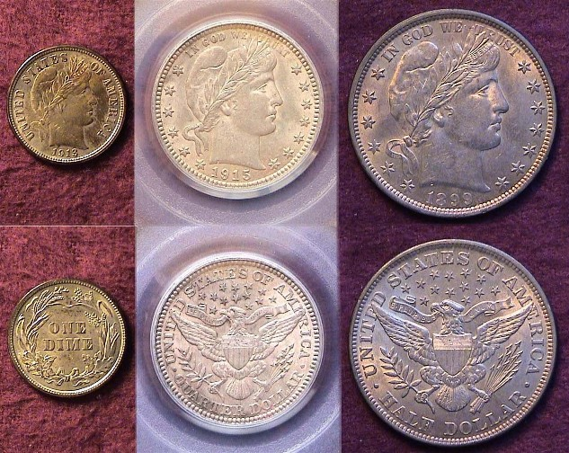

An attractive 1913 10¢, 1915 25¢ and 1899 50¢; all Choice AU’s
[Use 3X glass or magnify up to 200% to see details.]

The three coins shown above were all purchased as Choice AU’s (i.e., AU-58 grade) during the late 1980’s and early 1990’s and appear as a nicely matched set. Even back then, MS- 63 thru 65 examples were much more expensive than attractive AU’s and today that gap has widened even more.

Before 1965 a collector could occasionally come across a Barber dime, quarter or half in pocket change grading anywhere from AG-3 (About Good) to VF-20 (Very Fine). Naturally finding one, especially a half dollar in Fine-12 thru VF was extremely unlikely but on rare occasions it did happen to some lucky collector. When the Coinage Act of 1965 replaced our circulating silver with clad copper-nickel coinage it became virtually impossible for the collector to find desirable older silver types in circulation. As a result, collectors would now have to purchase Barbers from AG up to whatever grade they could afford. The Coinage Act of 1965 however doesn’t explain why so many Barber coins are found in such low grades.

Between 1870 and 1925 millions of immigrants entered the US and swelled the ranks of the labor force. Despite long working hours and a six day week, competition for jobs was fierce. Barber silver coinage was struck when the wave of immigration from Europe was at its strongest. During this period laborers often received their wages in coin in tiny manila envelopes and on the odd chance that a new Barber half dollar was in one of them, the recipient never thought twice about putting one aside for future gain as every coin earned was needed to pay for basic goods. While the cost of food, clothing and housing were priced at a fraction of today’s figures, wages were lower still. A laborer earned from 8¢ to 9½¢ an hour 10½ hours a day, six days a week. In 1900 a dime had the purchasing power of $2.75 a quarter $6.65 and a half dollar a whopping $13.25. With basic food goods priced from 10¢ to 18¢ a pound and rent in a cold water tenement flat costing $15.00 a month, saving a silver coin in any grade was out of the question.
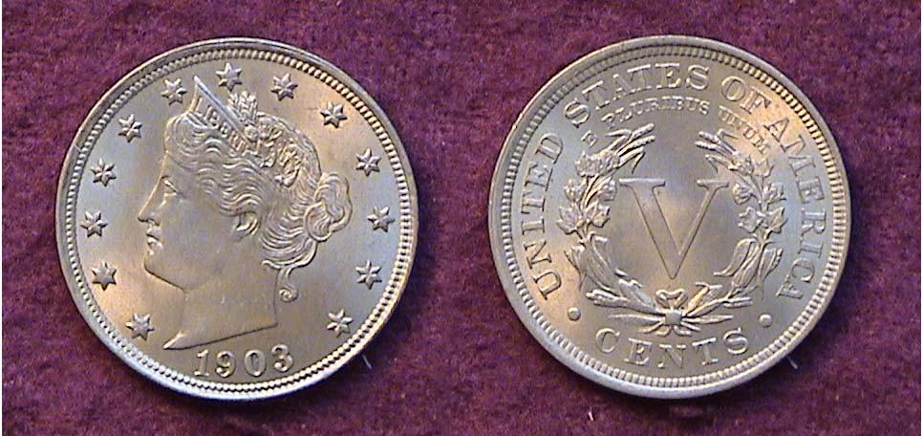

A 1903 Liberty “V” 5¢ nickel grading MS-62
[Use 3X glass or magnify to 200% to view details.]

Long before Charles Barber began working on the silver coinage he was asked to redesign the 5¢ nickel coin. The first trial patterns were expressly done at the request of then Mint Director Col. A. L. Snowden in 1881. Snowden wanted our three minor coins; the Bronze 1¢, 3¢ and 5¢ nickel pieces to appear with the same obverse and reverse design in an alloy of copper nickel. Barber created patterns allowing for the size differentials engraving an obverse similar to what would eventually appear on the Liberty “V” nickel but with the legend UNITED STATES OF AMERICA instead of the thirteen stars. Congress was not interested in altering either the cent or the 3¢ Coronet nickel design but eventually approved Barber’s design change for the 5¢ nickel. By the time the order for the new coin was approved in 1883, 1,451,000 Shield nickels had already been released into circulation. The new authorization also increased the diameter of the 5¢ coin from 20.5 mm on the outgoing Shield nickel to 21.2 mm for the new 1883 Liberty Head coin. 5,474,300 Liberty nickels were produced before word reached the Mint and Congress that people were known to be gold-plating the new V nickels which did not have the word CENTS anywhere on the coin, then passing them off as $5.00 gold half eagles. Since the word CENTS did not appear on the 3¢ Coronet nickel why did this become a problem? Size! The diameter of the nickel was only slightly smaller than the $5.00 half eagle which was 21.6 mm, just 0.4 mm wider. To remedy the oversight the word CENTS was placed below the large V on the reverse. Another 16 million “with cents” nickels were added, thus creating three transitional dates for 1883 five cent pieces.

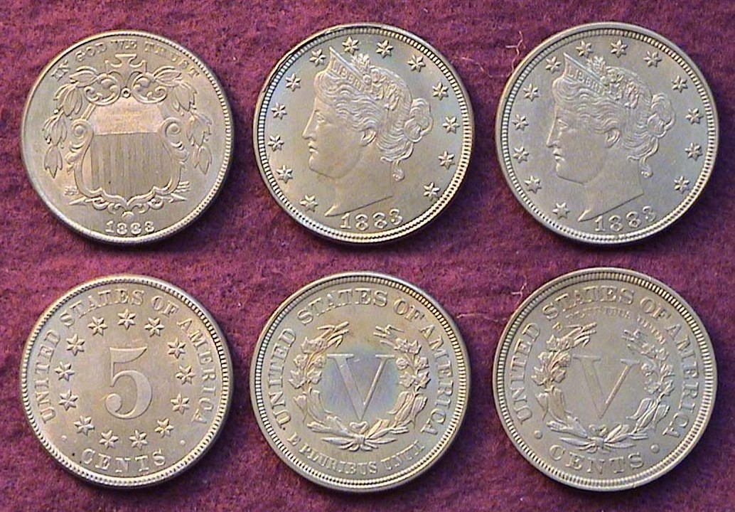

The transitional 5¢ nickel pieces of 1883
Shield, Liberty no cents and with cents
[Use 3X glass or magnify to 200% to view details.]

Of the several commemorative coins Charles Barber designed it was the quadricentennial celebration of Columbus’ discovery of American in 1492 that resulted in the first two officially designated US commemoratives; the Columbian half dollar of 1892 and 1893, and the Isabella quarter of 1893.
______________________________________________________________________________________________________________________
(Continued on page 3, column 1)
Collecting the coins of Charles Barber
(Continued from preceding page)

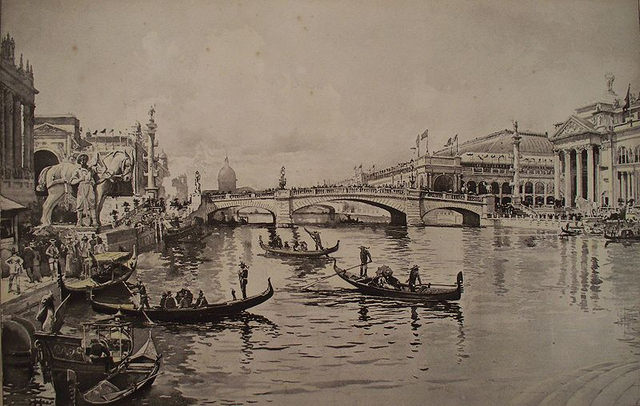

Sketch of the Canal of Venice along the Chicago River at
The Columbian Quadricentennial Exposition in Chicago in 1893
[Use 3X glass or magnify to 200% to view details.

In August of 1892, Congress authorized the coinage of five million Columbian half dollars to commemorate Columbus’ discoveries of the New World. Originally, the task of preparing the design was given to sculptor U.S.J. Dunbar who made a cast from an early 16th Century painting of Columbus by Lorenzo Lotto, but Barber--who could be very manipulative when it came to securing control of Mint undertakings--found a way to get the project assigned to him by using a Bust of Columbus supposedly created by Chicago sculptor Olin Warner. Barber’s coin design was approved and placed into circulation shortly after May 1, 1893 the date the Columbian World Exposition opened. Some 950,000 Columbian halves were struck with the 1892 date. Over 3 million were issued dated 1893.

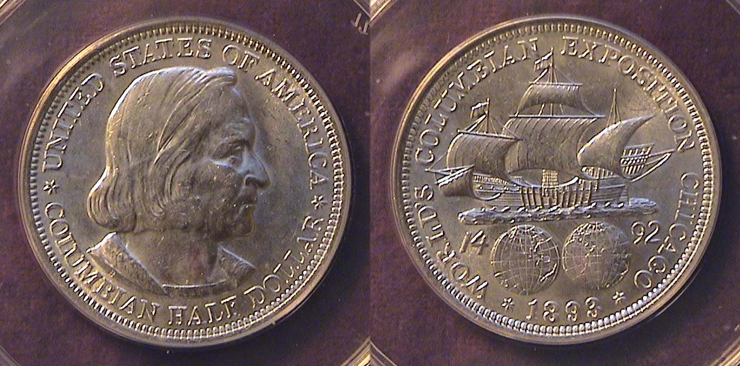

An 1893 Columbia half dollar graded MS-62 by PCGS
[Use 3X glass or magnify to 200% to view details.]

The coins were sold for $1.00 each (or double their face value) but as this represented a day’s wages for most of the attendees, many remained unsold with over 2.5 million being melted. Despite this, the 1893 Columbian half is still among the most common of the US Commemoratives. From XF-40 to MS-63 the coin ranges in price from $9.00 to $60.00. (The example shown cost $38.)

The Isabella Quarter

The origin of the Isabella quarter represents an important segment of American history. By the time plans were being made for the Chicago Quadricentennial Exposition, the Women’s suffrage movement was beginning to gather steam. Two women played an important roll in the new movement, Susan B. Anthony, who by 1890 was speaking on behalf of a woman’s right to vote. The other woman was Bertha Honoré Palmer. Still in her 40’s, she was the attractive wife of Potter

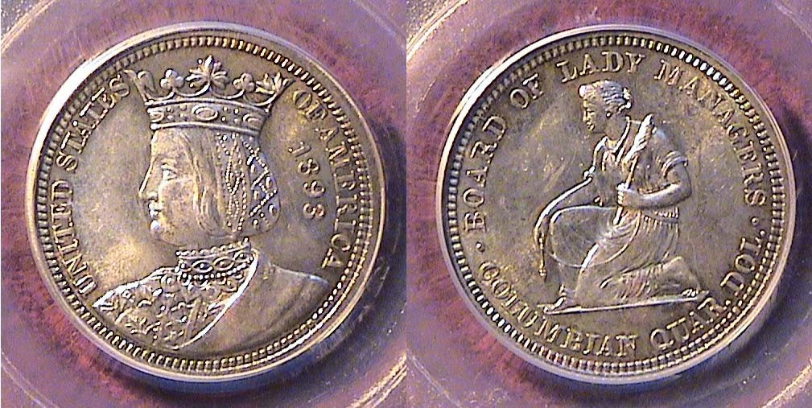

An 1893 Isabella quarter graded MS-62 by PCGS
[Use 3X glass or magnify to 200% to view details.]

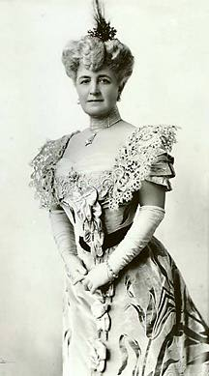
Palmer, the renowned Chicago Real Estate entrepreneur and multi millionaire. Bertha was skilled in foreign languages, a fine writer, a talented musician who also possessed administrative skills and political moxie. She supported a number of causes; among them public kindergartens, the Arts and Women’s Rights. She engineered her being appointed as President of the Board of Lady Managers for the Columbian Quadricentennial Exposition and insisted that women be represented in the various aspects of the fair from architectural construction to exhibiting their art.

When it was announced that a commemorative half dollar was to be coined honoring Christopher Columbus, she proposed that a quarter be struck honoring his patron, Queen Isabella of Spain and it was approved. She didn’t win every battle however. When Charles Barber learned that Mrs. Palmer had proposed a female sculptor and student of Saint-Gaudens named Caroline Peddle to prepare the design, he became irate and used his post as Chief Mint Engraver to select Kenyon Cox to do the preliminary sketches. This was long before Theodore Roosevelt became President when Barber’s position still carried the day. Nevertheless, the Isabella quarter may be the most attractive coin Barber ever produced although the reverse depicting a kneeling woman could be called into question.

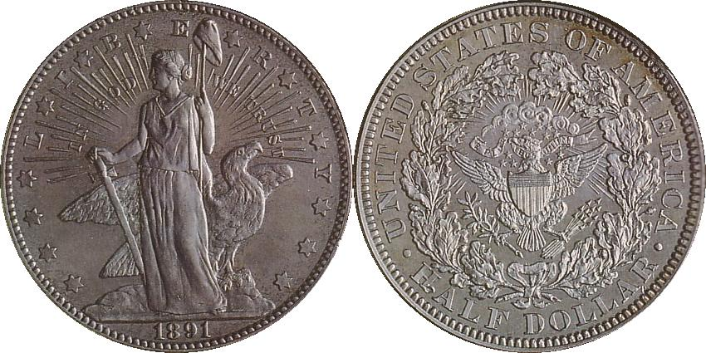

1891 Pattern half dollar Judd #1766 designed by Charles E. Barber
[Use 3X glass or magnify to 200% to view details.]

This is one of Barber’s pattern coins made in preparation for a new half dollar type to replace the Liberty Seated design of Christian Gobrecht (1839-1891). The obverse portrays a standing Liberty holding a pole and sword surrounded by rays with the 13 stars. The reverse shows a tiny eagle in wreath surrounded by the legend, UNITED STATES OF AMERICA. It is arguably an artistically over indulgent and unimaginative coin. Fortunately, the approved Liberty Head version was far superior.
_______________________________________________________________________________________________________________________

More Club News
(Continued from page1, column 1)

According to Sgt. in Arms Glenn Sanders’ count, 22 members and 5 visitors attended the February 4 meeting. President Steve Kuhl announced that the Executive Committee was in the process of revising the club by-laws which will be sent to the members in advance of the March 4 meeting when a vote to approve or modify portions of the revision will occur. He also mentioned that there will be two open spots on the Executive Committee to fill and asked members to consider running for Vice President and Secretary. While Jim and Helen Barry will continue as co-Bourse chairpersons for 2010, they have decided not to serve a ninth year as VP or Secretary. (See page 1, column 1, ED.) Treasurer Sharon Smoot reported a current balance of $1,359.13. Thank you Sharon.

VP Barry made a strong pitch encouraging our members to consider joining the American Numismatic Association (ANA). The annual dues is $41 for seniors (over 65); $28 if one opts to receive all ANA materials such as the monthly magazine, The Numismatist digitally and only $14 if you are a young numismatist under 18 years of age. The benefits include access to the ANA’s vast library holdings which include not only books on coins, engravers, artists and historical accounts but numerous DVDs on all aspects of Coin Collecting; the aforementioned monthly, The Numismatist along with information on coin shows, conventions, coin dealers and coin clubs all over the USA and the world. Another reason to join is to keep the club’s annual ANA membership cost down which is based on the local group’s individual ANA membership.

The Program: VP Barry also arranged for a new guest speaker, a gentleman by the name of Robert Moon who is a collector and dealer in National Currency now residing in Greenwood, SC. In his opening remarks Mr. Moon related that he had been a collector of National Bank notes for more than 30 years and a member of the ANA since 1976. He has written numerous articles on paper money which have appeared in Bank Note Reporter, (the Krause monthly newspaper devoted to paper money in the way Numismatic News is based on coins.). He mentioned an important book on the subject, Friedberg’s Paper Money of the United States, long considered the Bible for collectors of paper money.

Mr. Moon explained that US National Bank notes originated as a Federal remedy to maintain the reliability of charted state and local banks which prior to the legislation used their depositors’ funds often in reckless speculative ventures without sufficient specie to back their investments. He presented an in depth history of the development of National Bank notes in our country, also displaying a number of rare notes from his own personal collection as well as replicas of great rarities from the collections of other notable numismatists. Some of his own more recent acquisitions were National Bank notes from Greenwood, Spartanburg, Abbeville and Wagoner, SC.

Space does not permit one to include all the important points Mr. Moon made regarding this extensive topic but his presentation before the members of the SJ CSRA CC was professional and entertaining as well as extremely informative.
__

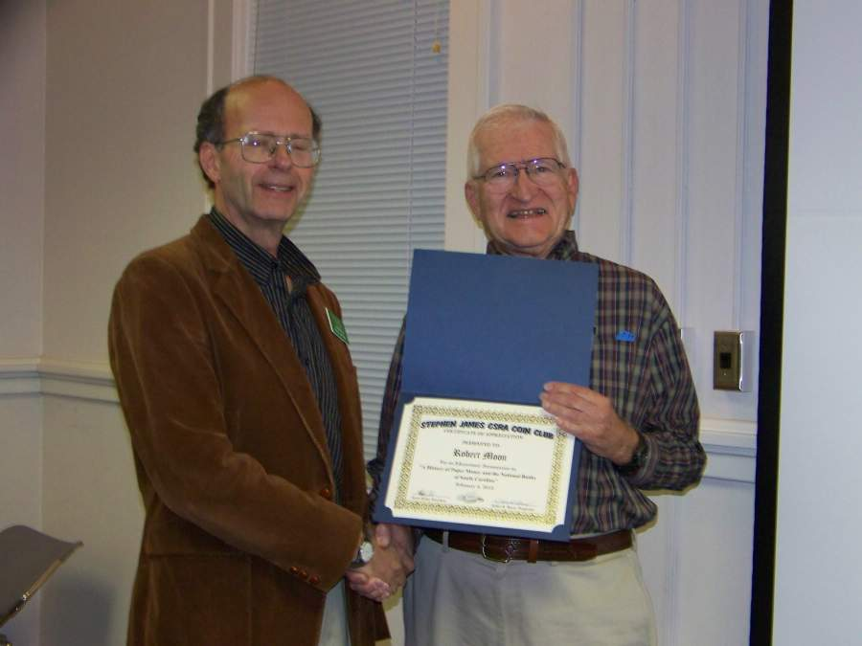

Guest speaker Robert Moon being presented with an
Awards Certificate by Vice President James Barry
[Photo, courtesy of Helen Barry]

The Prize Winners at the February 4 meeting were Pat James who won the Attendance drawing; a silver eagle and Helen Barry who garnered $20.00 in the 50/50 drawing. Congratulations ladies! The agenda for our next meeting is set for Thursday, March 4 at the Aiken Public Library starting time moved up to 6:30 PM because of the amount of business to be covered. Please bring in a numismatic Show and Tell, look over the revised By-laws carefully and consider running for the Board. (Hope to see you all then, ED.)
_____________________________________________________________________________________________________________________

Transitional Date Coin Pairings of the Month

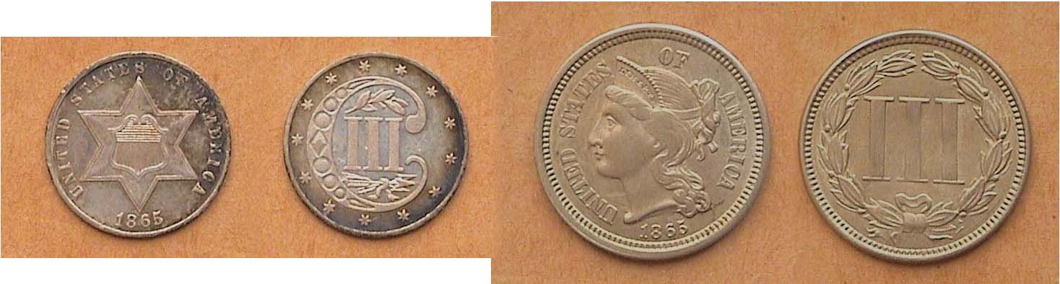

1865 3¢ piece types; silver (left) and copper-nickel (right)
[Use 3X glass or magnify to 200% to view details.]

The 3¢ denomination has never been terribly popular with collectors but they did serve a purpose when each type was in use during the middle of the 19th century. Designed by Chief Mint Engraver James Barton Longacre, (the subject of last month’s feature article), the first of the two types was the 75% silver coin placed into circulation in 1851. It was only 14 mm in diameter and weighed .80 gram. The coin had a dual purpose, to be used to purchase one first class postage stamp which had been reduced from 5¢o to 3¢ and more importantly, to encourage circulation of small denominational coinage during the coinage crisis that was brought about by the increase in the value of silver in relation to gold. By 1854 the crisis had ended and the silver ratio to copper was increased to 90%, in line with the other silver coins. As a result of the Civil War, silver coins again vanished from circulation. By 1865 only 8,000 3¢ silver trimes were struck along with just 500 proofs making the date difficult, though not impossible to find. To partially restore minor coins into circulation the Government authorized another 3¢ coin in 1865; this one in copper nickel about the size of the dime and it circulated. 11.3 million 3¢ nickels were struck thereby creating a transitional date for the same denomination.
_____________________________________________________________________________________________________________________________

The Copper Corner

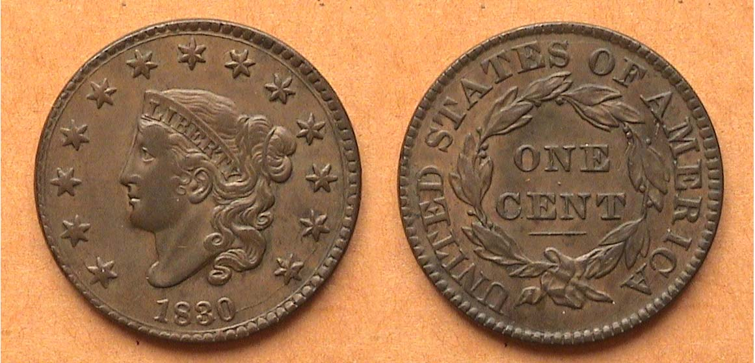

An 1830 Coronet Large Cent, N-4 R1 grading AU-50
The coin is shown about actual size when printed.
[Use 3X glass or magnify to 200% to view details.]

If you are only a casual collector or one that has become fascinated by obsolete US or Foreign coins, the purpose of this column is to introduce the reader to the wonderful world of US copper coinage as well as some of the copper coins of other nations. Pictured above is an 1830 large cent, a coin that celebrates its 180th birthday this year. The type is known as the Coronet Liberty Head or Matron Head and was struck from 1816 through 1839. Once thought to be the work of our first official Chief Engraver, Robert Scot, numismatic scholar Robert Julian now believes it to have been conceived by John Reich who was Scot’s assistant from 1807 through 1817. The Coronet cent was struck in pure copper weighing 10.89 grams with an approximate diameter of between 28 to 29 millimeters and had a plain edge.

If you are receiving the newsletter digitally and own a Windows XP computer, try magnifying the page by clicking the arrow alongside the right of the 100% menu bar atop the page and then click on 200%. Now look at the same coin again and see how much more of the 1830 cent’s character comes to light. The coin appears chocolate brown with only the slightest amount of wear along Liberty’s hair. The stars are well struck and the planchet fields are free of unsightly blemishes. All seven letters of LIBERTY in her tiara are sharply defined as are her curls. A curved die crack may be observed rising from the 0 in the date up through the second star from the bottom on the right. The reverse looks equally attractive. The large letters in UNITED STATES OF AMERICA and the ONE over CENT along with the wreath and ribbon below it all appear sharp. One will notice a tiny center dot between one and cent and a horizontal line beneath CENT. The reported mintage for this date was 1,711,500 for all varieties. In 1830, a cent had the purchasing power of a quarter dollar. That was considerable back then.

The reader will also notice that the 1830 cent is identified as N-4 R1. The N stands for Harold Newcomb, cent collector, dealer and author of United States Copper Cents 1816-1839. The 4 represents the fourth die variety out of the eleven known at the time and the smaller number R represents the rarity factor with 1 being the commonest.
___________________________________________________________________________________________________________________

Kindly Patronize our Advertisers

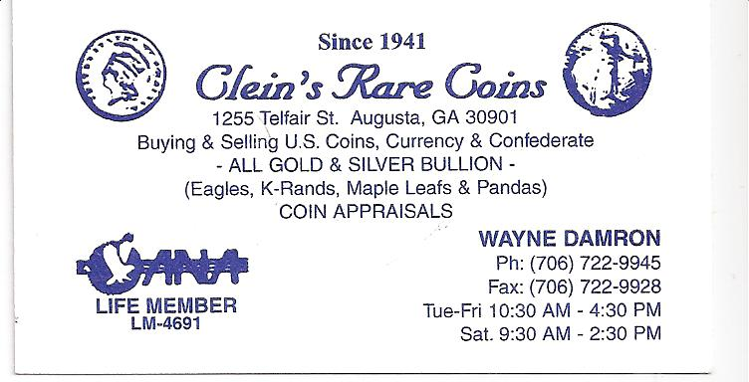
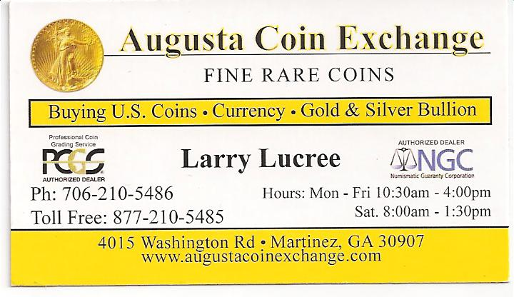
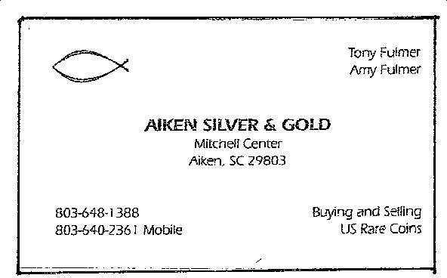
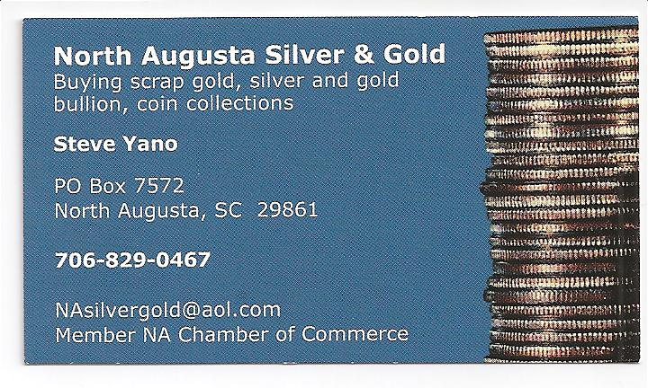

For the serious and casual collector

COINS, STAMPS & CURRENCY

P.O. Box 1739 Patricia James
Aiken, SC 29802 143 York Street
(803)-643-9957 Aiken, SC 29801

