Pres. Steve Kuhl
V .P. Arno Safran
Sec. Jim Mullaney
Treas. Sharon Smoot
Sgt. in Arms: Glenn Sanders
The Stephen James
CSRA Coin Club of Aiken
P.O. Box 11
New Ellenton, SC 29809
Web site: www.sjcsracc.org
The SJ CSRA CC of Aiken, SC meets on the 1st Thursday of the month at the Aiken Public Library

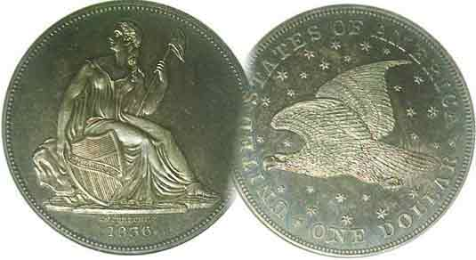
Committees:
Programs: Arno Safran
2010 Show: Jim & Helen Barry
Publicity: Jim Clapp
Newsletter: Arno Safran
E-Mail: arnosafran@comcast.net
Auctioneer: Glenn Sanders

2011 Club Meeting Schedule
Volume 10, Number 3 the Stephen James CSRA Coin Club, Founded in 2001 March, 2011
Monthly Newsletter
1900-1916 Proof Sets, Highlight of Feb. Meeting
Our next meeting is on Thursday, March 3, 2011 from 6:45 to 8:45 PM

Jan. 6 Apr. 7 July 7 Oct. 6
Feb. 3 May 5 Aug. 4 Nov. 3
Mar. 3 Jun. 2 Sep. 1 Dec. 1

____________________________________________________________________________________________________________

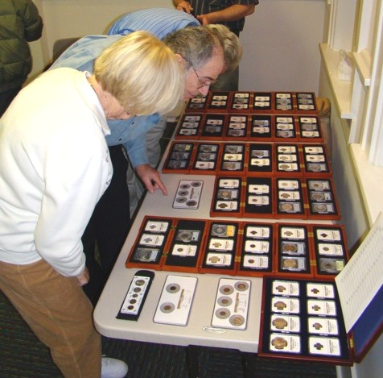

Helen Barry and Arno Safran looking at Rick Owen’s display of United States Proof Sets struck from 1900 through 1916
Also included in lower left corner is the 1936 Proof Set

Many collectors of US coins enjoy collecting the latest proof set released by the Mint. A newcomer entering the hobby can still acquire most of the proof sets struck from 1957 to date at a reasonable price but as one attempts to go further back in time the prices of the earlier proof sets begin to exceed one’s budget. Before 1950, the Philadelphia Mint issued five coin proof sets from 1936 thru 1942 that included such obsolete coin types as the Mercury dime and Walking Liberty half dollar. All of these are costly today as mintages were low, a number having been damaged over time while others were broken up during the Great Depression to make expenses. Imagine being able to acquire Proof Sets from the early 20th Century. Rick Owen has done that as a collector of quality US coinage by studying the mintages, considering their investment potential from the prices realized at past auctions and bidding carefully at major auctions. At our Feb. 3 meeting, he exhibited the entire 1900-1916 run of proof sets certified by NGC and PCGS plus the 1936 Proof set before the members of the Stephen James CSRA Coin Club. These were amazing specimens.
__________________________________________________________________________________________________________________________
(Club News continued on page 2, column 1)
1873: The Most Amazing Year in US Coinage-138 Years ago
By Arno Safran

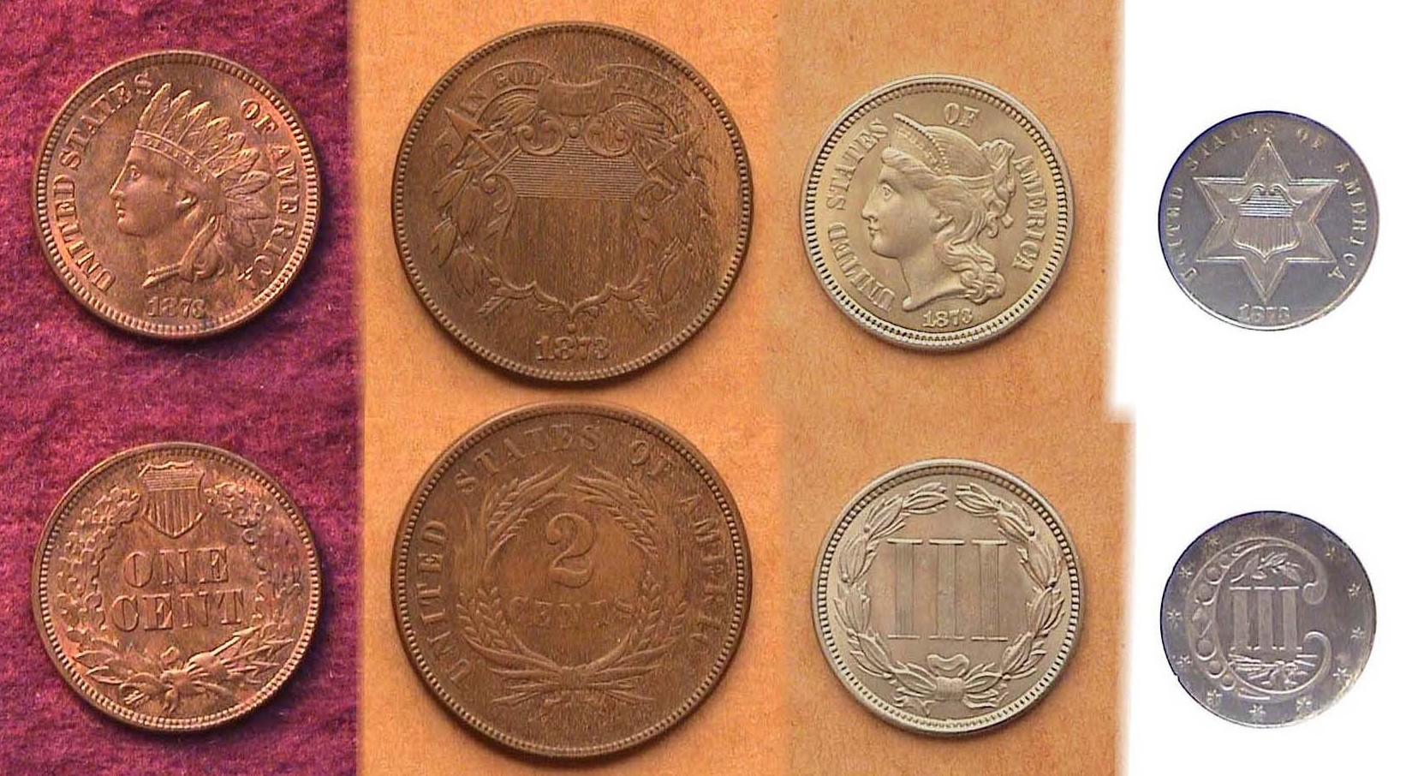

- 1¢, 2¢, 3¢ nickel and 3¢ silver coinage
[Magnify to 200% to see details more clearly.]

If 1816 is the low water mark in our U.S. coinage history, (The Coronet cent being the only denomination coined with an 1816 date), then 1873 represents the high water mark. A total of seventeen denominations were struck that year, two in copper; (the cent and two cent piece), two in nickel; (the 3¢ and 5¢ piece); seven in silver, (the 3¢ silver trime, half-dime, dime, quarter, half dollar, Liberty Seated dollar and the Trade dollar) and six in gold; (the Gold $1.00, the $2.50 quarter eagle, $3.00 gold piece, $5.00 half eagle, $10.00 eagle and $20.00 double eagle). If one concentrates on just the Philadelphia Mint issues struck that year, it may just be possible to assemble an 1873-year set (excluding gold) depending on one’s discretionary income.

In 1873, some important coinage legislation was passed in Congress and signed into law by President Ulysses Simpson Grant. Ostensibly, the law placed our nation on the gold standard. Disgruntled citizens of that period referred to the law as “The Crime of ‘73”. As part of its provisions, the 2¢, 3¢ trime, half-dime and Liberty Seated dollar were terminated, the latter being superseded by a new trade dollar intended to be used most notably in China. Despite containing more pure silver--.7874 oz. compared with .77344 oz.--for the Liberty Seated dollar, the new coin was Legal tender here only up to $5.00.
_________________________________________________________________________________________________________________________
(Continued on page 2, column 1)
Collecting the Coins of 1873: 138 years ago
(Continued from page 1, column 2)

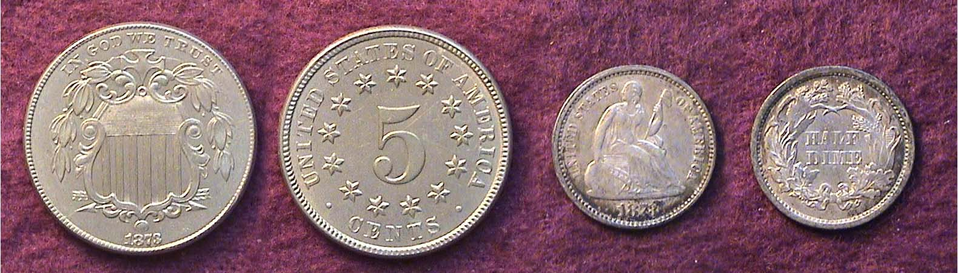

An 1873 Shield 5¢ nickel and silver half dime]
[Please magnify using 3X glass or up to 200% to see details.]

In 1873, the Mint struck a number of same denominational pairings including two 5¢ coins (the Shield nickel, the Liberty Seated silver half dime) pictured above. Up to AU grade, neither coin is particularly expensive. It would be the final year for the Bronze 2¢ and 3¢ silver pieces as well as the half dime, a silver denomination going all the way back to 1794.

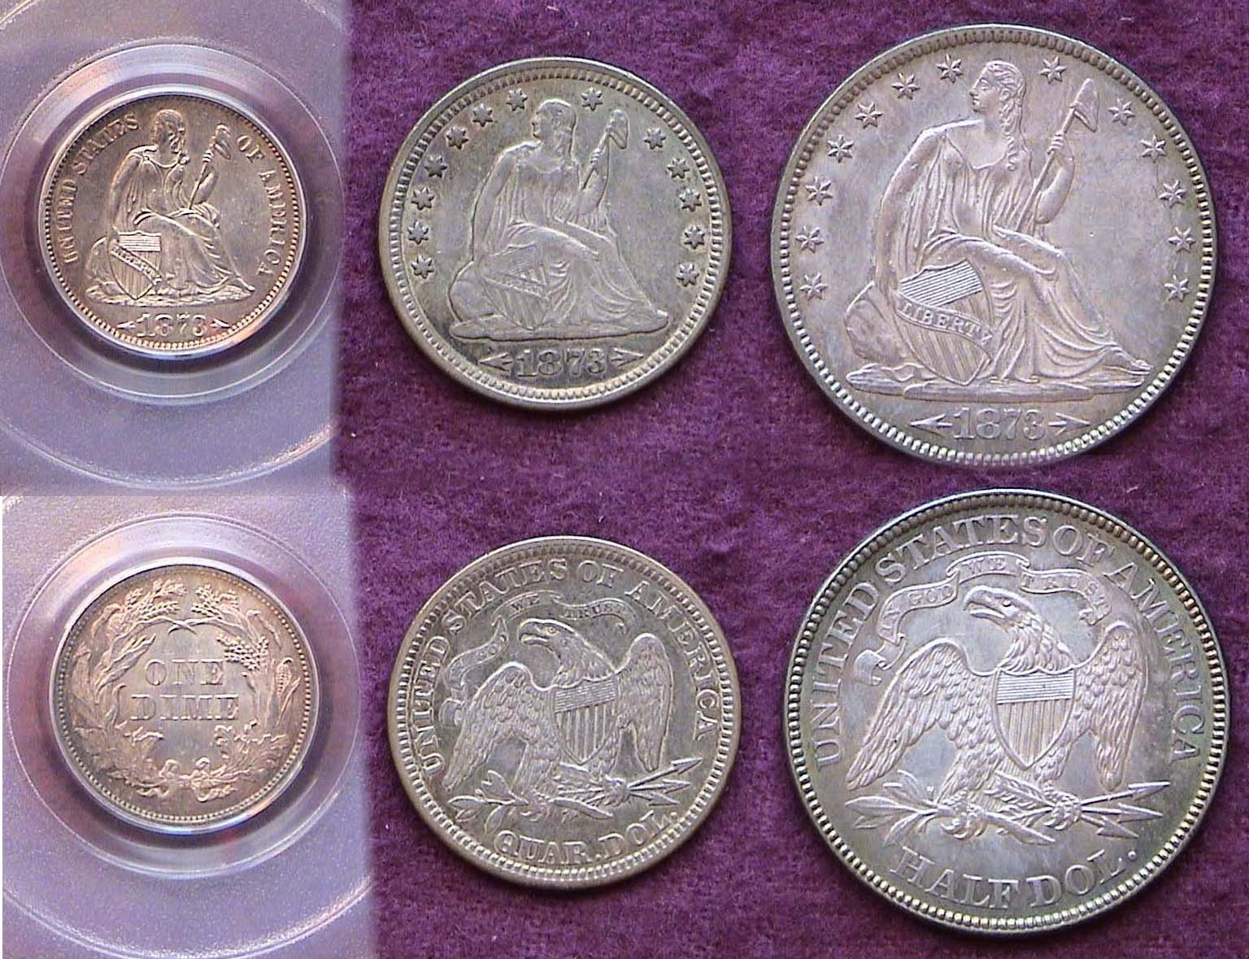

An 1873 with arrows Liberty Seated with motto 10¢, 25¢ & 50¢
[Please magnify using 3X glass or up to 200% to see details.]

In 1873 two transitional subtypes were produced for the dime, quarter and half dollar, the no arrows and with arrows varieties. During the year the government authorized a slight increase in the silver weight for these three denominations. As in 1853, ‘54 and ‘55, arrows were placed alongside the date to indicate the change. The with arrows sub-type remained through the coinage of 1874 before being removed.

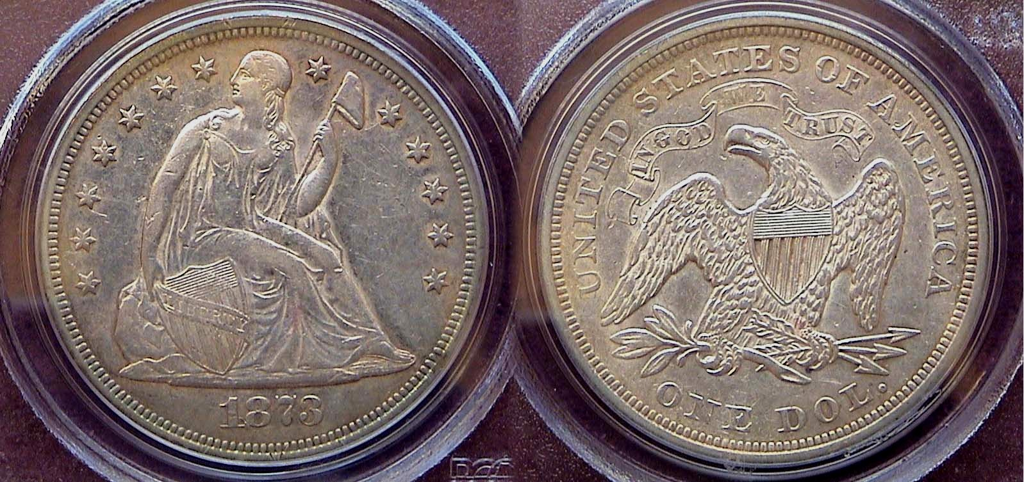

An 1873 Liberty Seated dollar with motto (no arrows)
[Please use 3X glass or magnify up to 200% to see details.]

This would also be the final year of the Liberty Seated design type on the silver dollar. One of the byproducts of the coinage Act of 1873 resulted in taking our nation off the bi-metal standard in favor of gold. Less silver was needed for coinage thereby increasing the amount of silver world wide in relation to gold. The value of silver in relation to gold dropped precipitously which angered the western silver mining lobby. In 1873, the US created a new silver dollar type known as the Trade dollar. William Barber was the engraver. The coin was intended for trade in the Orient and not as a circulating coin here even though it was granted legal tender status up to $5.00.

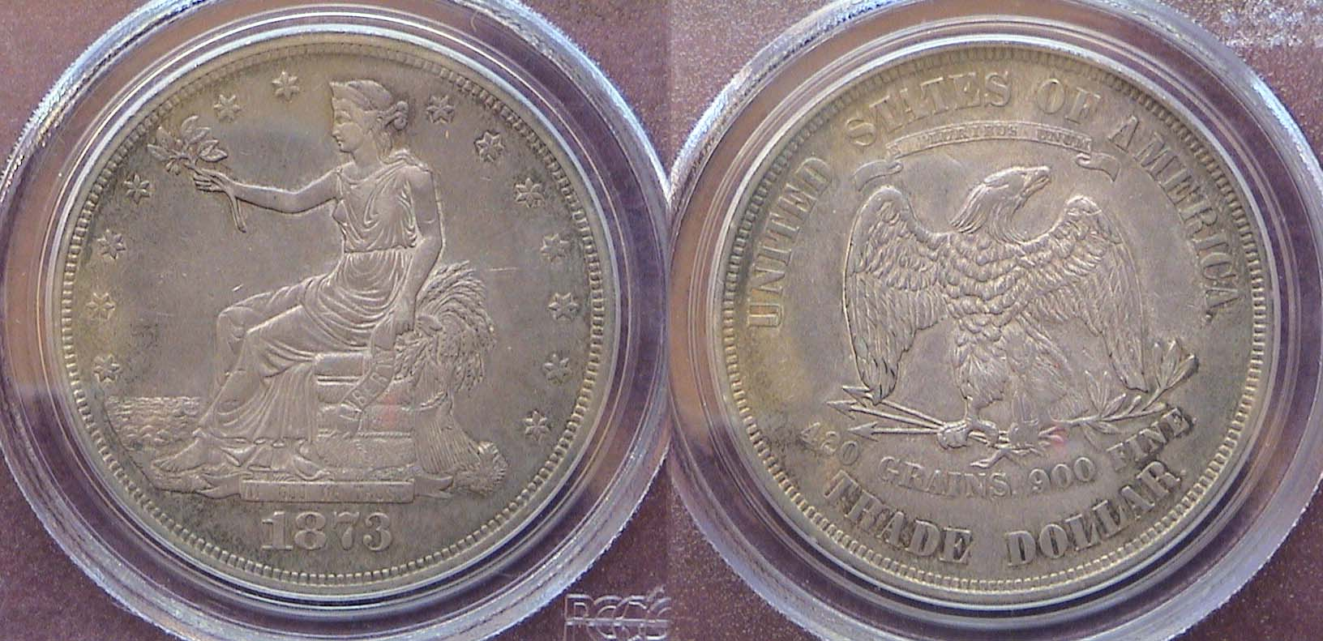

An 1873 Trade dollar certified XF-45 by PCGS
[Please use a 3X glass or magnify up to 200% to see details.]

As the value of silver decreased, those attempting to use Trade dollars in the states found many merchants refusing to accept them at face value, offering no more than 80¢ on the dollar, this despite the Trade dollar having a greater silver weight than the Liberty Seated dollar.

The 1873 With Arrows and No Arrows subtypes
& closed vs. the Open 3 date varieties

The original striking of the 1873 date displayed a closed 3, which could be confused, with an 8 and so it was decided to replace the closed 3 punch with an open 3. This resulted in two more sub-types, some scarce to extremely rare depending on the denomination. For example, the 1873 2¢ piece, struck only in proof, has a reported mintage according to the Red Book of 1,100. The Red Book estimates that of these, 600 were struck with the closed 3 and 500 with the open 3. Walter Breen’s Encyclopedia of Colonial and United States Coins believes the “Open 3” represents only 10% of the total and is much rarer. On the other hand it is the “Closed 3” that is the scarcer of the two on the Indian Head cent, 3¢ nickel, also the 5¢ Shield nickel and Liberty Seated no arrows quarter.

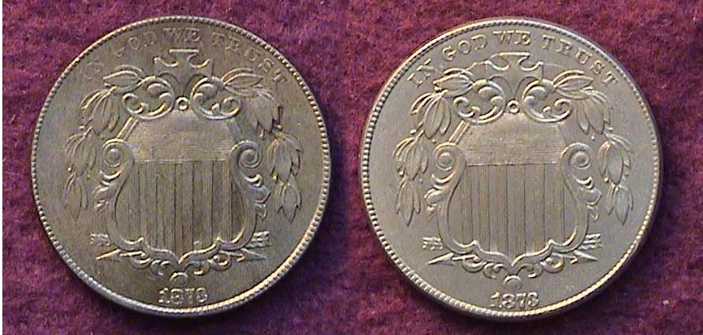

1873 “Closed 3” ” & “Open 3” Shield nickel obverses
[Magnify up to 500% to see date or view enlarged detail below.]

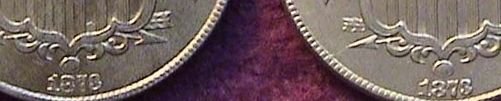

Detail of “Closed 3” and “Open 3” on the Shield nickel obverses
_________________________________________________________
(Continued on page 3, column 1)
Collecting the Coins of 1873 – 138 Years Ago
Including the With Arrows and No Arrows subtypes
Along with the Closed vs. the Open 3 date varieties
(Continued from previous page)

During the 1980’s and 1990’s this writer came to know a very knowledgeable Philadelphia collector who prided himself on beating dealers at their own game. He related the story of how he purchased a 1873 no arrows Liberty Seated half dollar at a suburban Philadelphia commercial show for $25.00 and took it over to a couple of dealers who were doing the show.

“What will you give me for this coin”, he asked. “$20.00. It’s a dog!” bellowed the more obnoxious dealer of the two. He showed it to the other dealer. “He’s right!” said the other man supporting his buddy. “It’s at best a VF-20! “Take a closer look at the coin,” said the collector. “I don’t see anything!” the loud mouth responded. “So, it has no arrows! That a’int anything special,” he boomed. “ Exasperated, the collector took out his Red Book and pointed to the 1873 half dollar page and howled, “You dolts!” Take a closer look! There it read plain as one could see, “1873 no arrows 50¢; closed 3 Fine = $65; open 3, Fine = $5,000.” Both dealers gasped. “How much did you pay for it” asked the more bellicose dealer of the two? The collector replied, “That my good buddy you will never know.” and moved on.

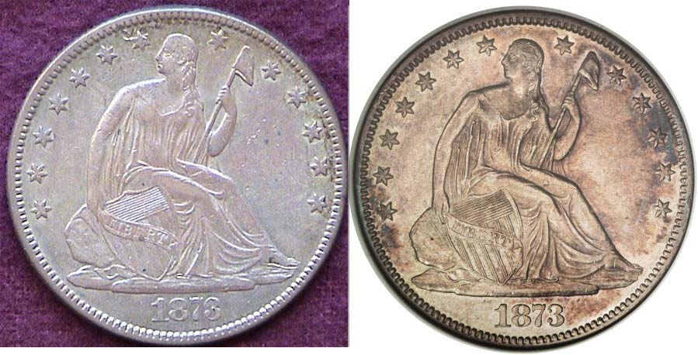

Obverses of the no arrows 1873 50¢ “Closed 3” and “Open 3”
(The AU-50 Open 3 is shown at right, courtesy of Heritage Auctions Archives where it realized $10,925 at a the Central States Auction held April 15, 2008)

[Magnify to 200% to view date details or see enlarged detail below.]

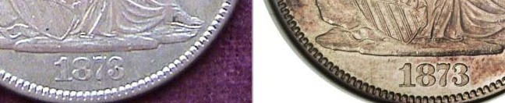

Detail showing the 1873 no arrows Liberty seated half dollar
Closed 3 in date at left; the rare open 3 in date variety at right

With a little knowledge and tenacity; also a little luck, one can acquire the scarcer 3 variety in the 1873 for all denominations except the no arrows Open 3 half dollar.
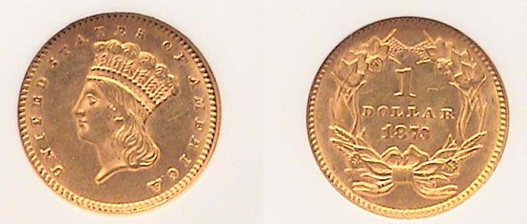

An 1873 gold $1.00 open 3 in date variety certified MS-61 by NGC
The coin was acquired at an Augusta Coin Club show.
[Magnify to 200% to view details.]

When it comes to the 1873-P gold issues the $1.00, $2.50 and $5.00 with the “Open 3” in date are more affordable than the other denominations. Certified specimens grading AU-58 to MS-61are recommended. Below AU, most gold issues look “spongy” as the contrast between relief and surface diminish. Yes indeed! 1873 was an amazing coin year in the America.
_______________________________________________________________________________________________________________
The Liberia 1833 Cent by Bill Myers
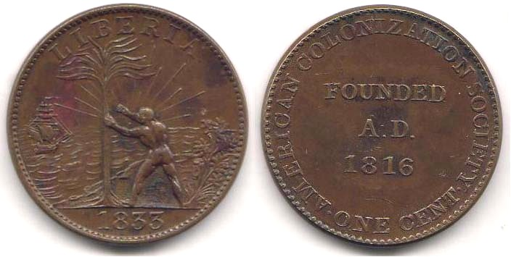

An 1833 Liberian Cent
[Magnify to 200% to view details.]

Coins that represent a “first” hold an allure to numismatists. These include the 1909 Lincoln cent, 1938 Jefferson five cents and 1964 Kennedy half dollar to name a few. Then there is the first coin minted by the United States, the 1792 half disme, which is unobtainable for most numismatists (I will not delve into the debate as to what truly is the first U.S. coin minted). However, there is another first for the U.S. Mint, which is obtainable for most collectors.

The Act of January 29, 1874 authorized the United States Mint to produce coins for foreign countries. Interestingly, the first foreign item produced at the US Mint was actually a token and it was produced before this act allowed the mint to produce foreign coins. It is a copper 1-cent token for Liberia dated 1833. The obverse features a “freed Negro” next to a palm tree with a ship in the distance. The reverse has American Colonization Society, One Cent, Founded A. D. 1816.

The American Colonization Society was founded by Robert Finley in 1816, its purpose was to transport freeborn blacks, and emancipated slaves back to Africa. The reasons were twofold. One was to provide slaves and their descendants an opportunity to return to Africa, which was advocated, by philanthropist, clergy and abolitionist. The other was to expel free people of color as the slave owners feared them and felt they could not assimilate into white society.

On December 21, 1816, the American Colonization Society was established at the Davis Hotel in Washington, DC. Those attending included Robert Finley, John Randolph, Richard Bland Lee, James Monroe, Bushrod Washington, Andrew Jackson, Francis Scott Key, Daniel Webster and Henry Clay presiding. The Society was able to raise enough money to send the first ship, the Elizabeth, to West Africa in January 1820. The colony declared independence in 1847 and became the country of Liberia. By 1867 more then 13,000 emigrants had been sent to Liberia by the Society.

The token was struck at the U.S. Mint. As this was the only facility available in the United States at that time that was able to strike large medals, producing a token is in line with their business practice. There are 6 varieties listed with a slight premium placed on those with a large ship over those with a small ship. The token is not commonly found in dealers stock but some token dealers have examples and they are also available on E-bay. A worn example will cost about $50 and about uncirculated will run $150. This token has a lot of history and is an obtainable first to add to your collection.
______________________________________________________________________________________________________________
(From Arizona, our 48th State, we welcome another interesting article
from former club member Bill Myers; Ed.)
More Club News (Continued from page 1, column 1)

How was Rick able to achieve this feat? Many people invest in Stocks or Bonds; others in Real Estate. What they receive is a stock certificate, bank statement or title, none of which is particularly interesting to view. But suppose one is interested in investing in items of value that are also nice to look at such as objects of art, rare coins or obsolete paper money with their beautiful vignettes. For the astute collector such acquisitions not only become important financial assets but artistic treasures to contemplate and exhibit, with some being historically significant as well. The study of Numismatics provides opportunities to acquire pieces of artistic magnitude especially if one is a focused collector, budgets carefully and is not merely an accumulator. Congratulations, Rick!

Show and Tell Presenters

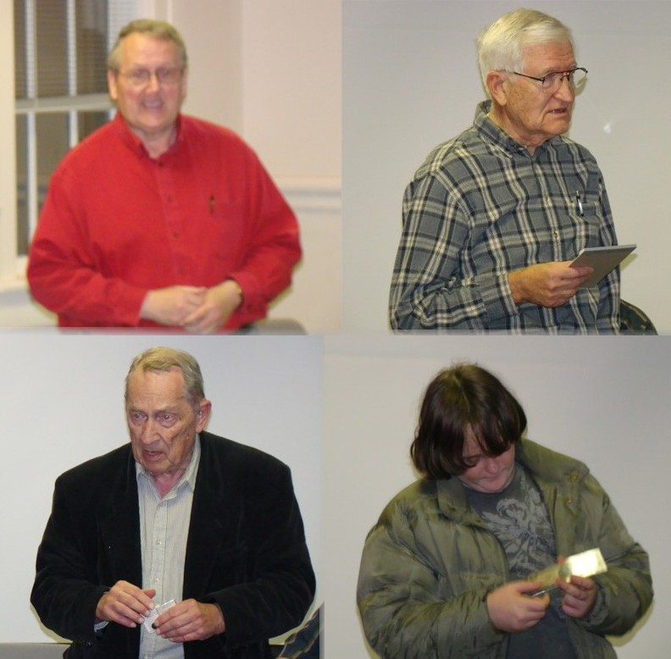

Shown counterclockwise from top,
Rick Owen, Chuck Braun, Austin Kuhl and Jim Barry

In addition to Rick’s Proof sets, Chuck Braun brought in two coins from his Ancients collection, The first was an Ionian Greek First Century BC bronze piece-showing Athena on the obverse in addition, a springing Lion on the reverse. The second coin was from Corinth. It had a head of Helios on the obverse and Poseidon on the reverse. YN Austin Kuhl displayed an 1845 Braided Hair large cent and a $5.00 National Currency note from the Federal Reserve Bank of Chicago. Jim Barry displayed a large Russian Bronze 5 Kopek piece issued by Catherine, the Great. These were passed around the room for the members to get a better look at them. Thanks go out to each of you.
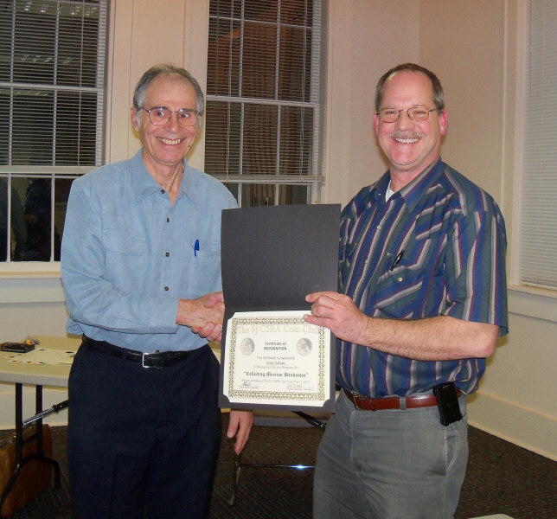
For the program, Arno Safran gave a PowerPoint presentation on the small size Bank notes of Mexico engraved by the American Banknote Company for the Bank of Mexico. He displayed a complete denominational set that included the $1 peso, $5, $10, $20, $50, $100, $500, $1,000 and $10,000 pesos issued between 1959 and 1978. Many of the vignettes showed portraits of the martyrs of the
War of Independence (1810-21). Arno Safran (l) receiving an award
of appreciation from Pres. Kuhl (r)
____________________________________________________________________________________________________________________
Sgt. in Arms Glenn Sanders reported an attendance of 24 members and 1 guest at the Feb. 3 meeting. Inasmuch as the current club’s fiscal year will end on March 31, President Kuhl addressed a number of important topics in his opening commentary. He emphasized that some club decisions needed to be made by March 3, the date of our next meeting. These included 1) members seriously consider running for office, 2) members serving on a committee of five to run the 2011 show slated for September, 2011, 3) needing a volunteer to conduct the annual financial audit and 4). suggesting club members consider joining the SCNA and ANA, the last named because in addition to the wide range of services the American Numismatic Association provides collectors, it reduces the annual Club ANA membership dues of $74 by $5.00 for each ANA member who belongs to our club. Treasurer Sharon Smoot reported a balance of $2.016.52. Thank you, Sharon.

The prize winners at the Feb. 3 meeting were Vilma Safran who won the door prize, a 2010 silver eagle and Rick Owen who took the 50/50 - $22.00. Congratulations to Vilma and Rick.
__________________________________________________________________________________________________________________________

Coin of the Month

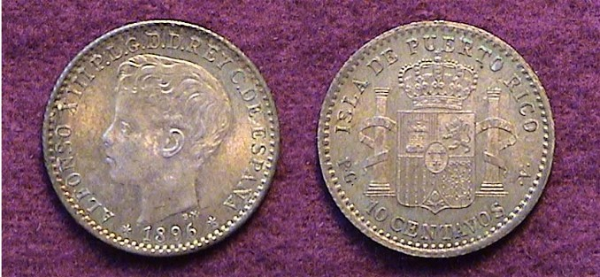

An 1896 10 centavos silver coin struck for Puerto Rico, KM-21
[Use 3X glass or magnify by 200% to see details.]

In 1895 and 1896, Spain struck five silver coins for its Puerto Rico possession in denominations of 5 centavos, 10¢, 20¢, 40¢ and 1 Peso. All but the 5¢ piece featured the boy king Alphonso XIII on the obverse. The reverse displayed the twin pillars and Bourbon Coat of Arms that had adorned Spain’s colonial coinage through 1825. The dime sized 10 centavos is the most common and the least expensive.
__________________________________________________________________________________________________________________________

Please Patronize Our Dealer Advertisers
