Pres. Steve Kuhl
V .P. Pat James
Sec. Jim Mullaney
Treas. Sharon Smoot
Sgt. in Arms: Glenn Sanders
The Stephen James
CSRA Coin Club of Aiken
P.O. Box 11
New Ellenton, SC 29809
Web site: www.sjcsracc.org
The SJ CSRA CC of Aiken, SC meets on the 1st Thursday of the month at the Aiken Public Library

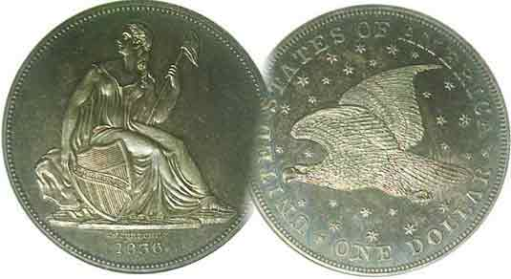
Programs: Pat James
Show: by Committee
ANA Representative: Jim Barry
Publicity: Jim Clapp
Newsletter: Arno Safran
E-Mail: arnosafran@comcast.net
Auctioneer: Glenn Sanders
Web site: Susie Nulty (see above.)

2012 Club Meeting Schedule
Volume 11, Number 3 the Stephen James CSRA Coin Club, Founded in 2001 March, 2012
Monthly Newsletter
Not all MS-64 Certified Coins look the same
Our next meeting is on Thursday, March 1, 2012 at the Aiken Public Library

Jan. 5 Apr. 5 July 5 Oct. 4
Feb. 2 May 3 Aug. 2 Nov. 1
Mar. 1 Jun. 7 Sep. 6 Dec. 6

______________________________________________________________________________________________________

Grade vs. Condition involving Certified Coins

In last month’s column, the discussion focused on eye appeal as a factor in a coin’s condition vs. its grade as regards to “raw” coins. Are the same criteria in play when it comes to certified coins? Pictured below are two 1913 Barber dimes graded MS-64, one by PCGS, the other by NGC. These were taken off a dealer’s website. One would expect an MS-64 coin to have lots of eye appeal and both of these do, but on scrutiny each are remarkably different from the other.

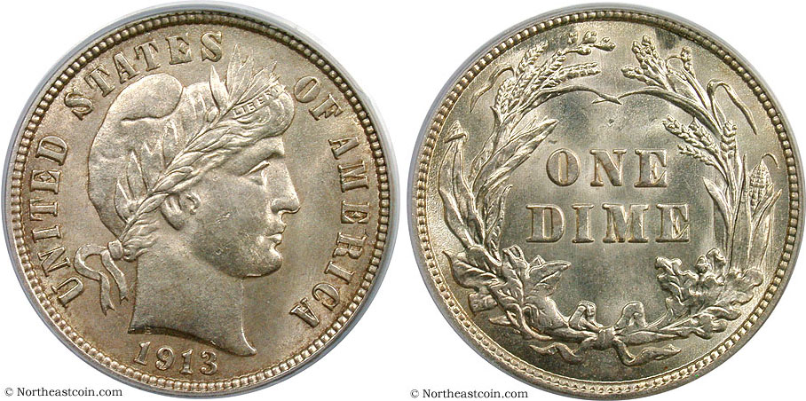

A 1913 Barber dime graded MS-64 by PCGS
[Use a 3X glass or magnify page to 200%, then 500% to view details

Upon 200% magnification the coin shown directly appears slightly more original in color whereas the one below appears brilliant but slightly lackluster and not as original..

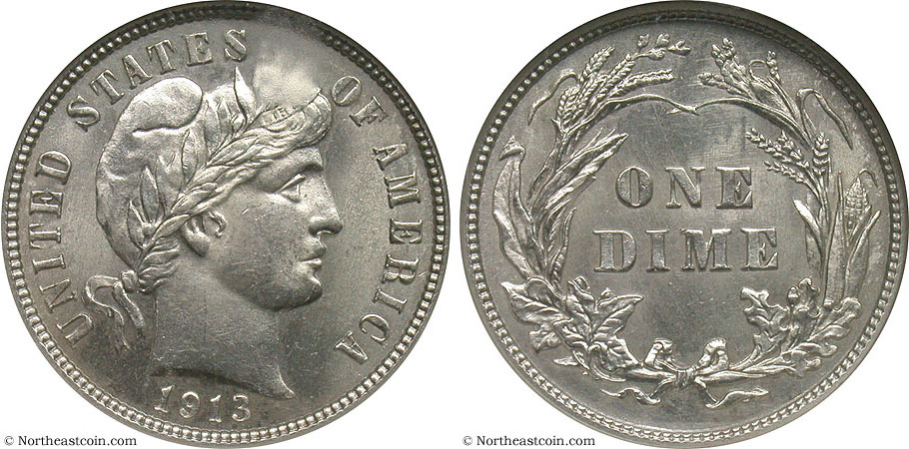

A 1913 Barber dime graded MS-64 by NGC
[Use a 3X glass or magnify page to 200%, then500% to view details

Now if one increases the magnification to 500% you can observe a few tics on the cheek on the PCGS graded specimen while the NGC example has less obvious distractions on the obverse because they are lighter and more scattered. The reverse is freer of marks as well. The choice between the two pieces comes down to the number of distracting marks vs. the greater originality in appearance of the PCGS-64 specimen. If neither please the viewer enough, one is advised to keep looking.
__________________________________________________________________________________________________________________

The Case for Buying Certified Coins: Part 3
Dollars: By Arno Safran

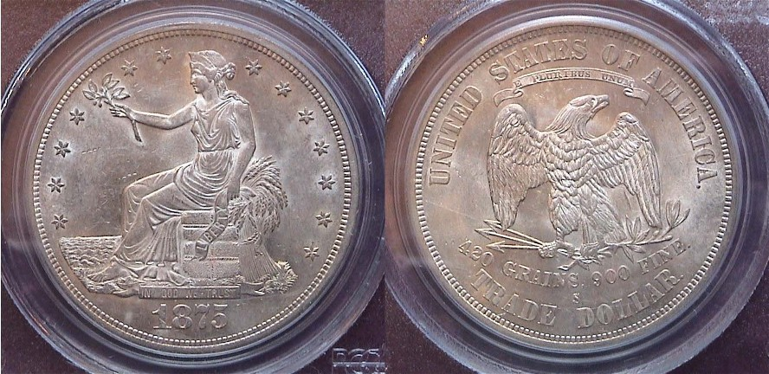

An 1875-S Trade $1.00 certified MS-61 by PCGS
[Use a 3X magnifying glass or magnify page to 200% to view details.]

Most large coins graded MS-61 are fraught with bag marks or scuffing across the surface but the specimen shown above has only a few minor hits in the left field above Miss Liberty’s right knee and even upon greater magnification, their presence is dwarfed by the coin’s sharp strike and beautiful lightly toned coloring. The Trade dollar was struck between 1873 and 1885. From 1873 thru 1878 business strikes were numerous, especially from the San Francisco Mint as these coins were coined mostly for trade with the Orient and not intended for domestic circulation. They were legal tender up to five dollars and despite containing more silver than, the previous Liberty Seated dollar type, the Trade dollar was` often undervalued by 20% below face when people wished to redeem them for paper dollars at the time of issue. From 1879 thru 1885, they were coined only as proofs. The 1873-78 business strikes often surface with unsightly chop marks that lower its numismatic value. Many Trade dollars have been cleaned or altered, or worse, counterfeited, so acquiring a certified specimen is highly recommended. The Trade dollar was designed by William Barber, Chief Engraver of the Mint from 1869 through 1879. Some collectors consider the Trade dollar and improvement over the Liberty Seated obverse as modified by Robert Ball Hughes from Gobrecht’s original design and John Reich’s spread eagle design type seen on the reverse.
___________________________________________________________________________________________________________________________
(Continued on page 2, column 1)

The Case for Buying Certified Coins:
Part 3 - Dollars
(Continued from page 1, column 2)

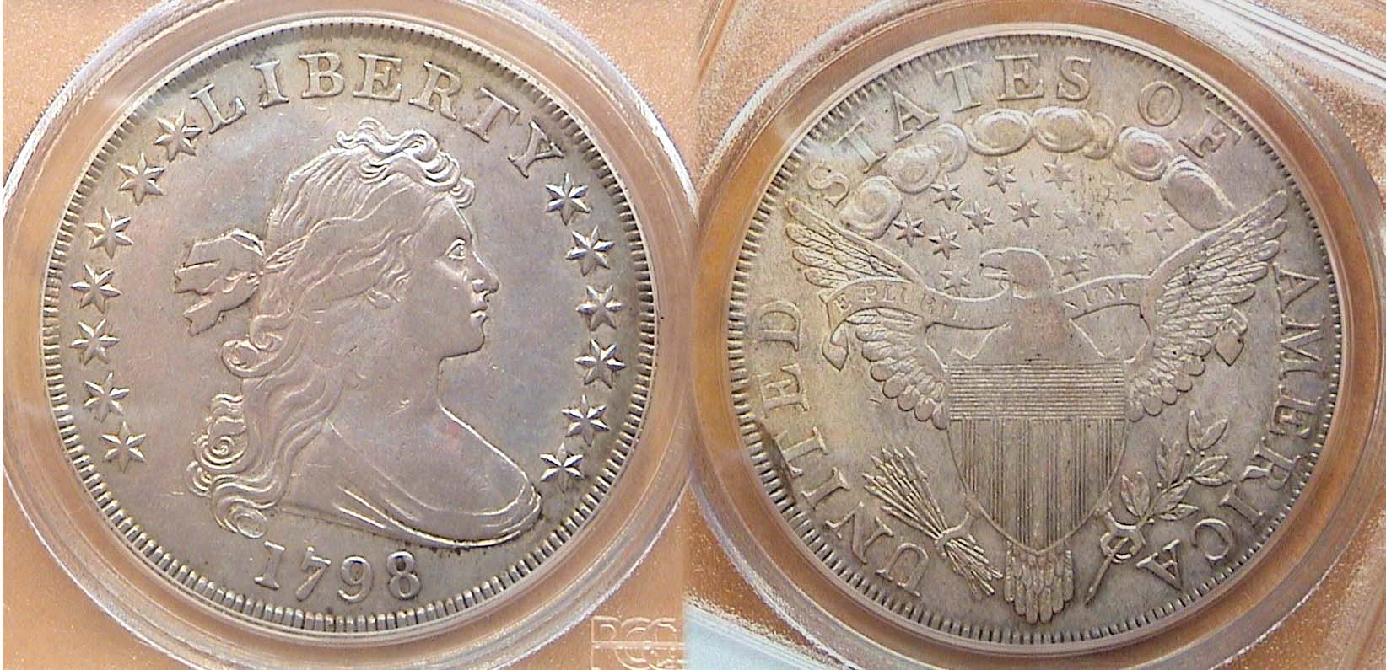

A 1798 Draped Bust $1.00 B-15, R2 graded XF-40 by PCGS
[Use a 3X magnifying glass or magnify page to 200% to view details.]

The Draped Bust dollar was struck from the years 1795 through 1804 and dated 1795 thru 1803, then officially suspended until the year 1836. No Draped Bust dollars were actually dated 1804 during that period. The reported fifteen original dated 1804 dollars were coined in 1834 and intended as presentation pieces to world leaders.

Robert Scot was appointed as our first Chief Mint Engraver in 1793 and in 1795 engraved the obverse design based on a sketch by renowned portrait painter Gilbert Stuart of Lady Anne Bingham, nee Willing, the wife of Pennsylvania Senator William Bingham. The first Draped Bust dollars used a small eagle reverse. These were coined between 1795 and 1798 inclusive and are scarcer and more expensive than the large eagle (AKA Heraldic Eagle) reverses fashioned later in 1798 and struck through 1803. Examples of this sub-type are more numerous and less expensive but still high priced due their relatively low mintages. Both the 1798 and 1799 have the largest reported mintages of the series yet the mintage for each was 327,536 and 423,515 respectively. Compare either of those two figures with the more than 10 million Morgan dollars struck in a given year and you will realize why Draped Bust dollars cost more than $1,000 apiece in grades as low as VG-8. Because of its large size, 39 to 40mm in diameter, even a VG specimen can appear attractive if it looks original and has few distracting marks. Only certified specimens are recommended and while most examples of the 1798 or 1799 appear in VF thru XF-45, certified pieces grading VG or Fine surface from time to time. Beware of “raw” specimens that have attractive toning as the colors may have been artificially induced, a probable reason why they are not certified.

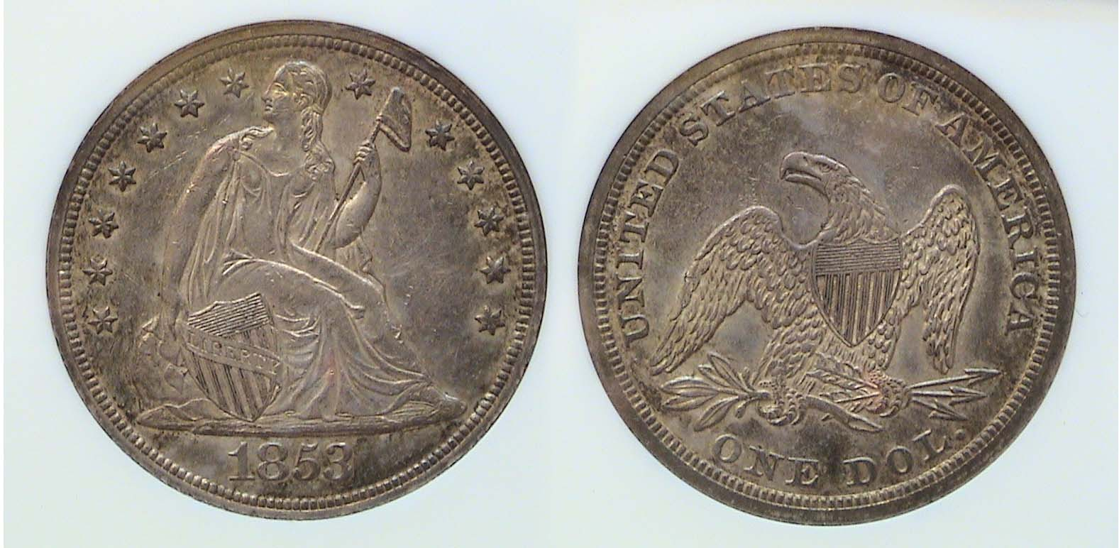

An 1853 Liberty Seated $1.00 graded AU-58 by NGC
[Use a 3X magnifying glass or magnify page to 200% to view details.]

While Liberty Seated dollars were coined over a greater number of years (1840-1873) compared with the nine-year tenure the Bust dollar series, the yearly mintages for most dates rarely exceeded five figures. The 1853 shown had a mintage of only 27,200. Only twice, near the end of the run, did the mintages in a given year exceed one million. Since the Liberty Seated figure is more slender than the Draped Bust portrait of Miss Liberty, attractive examples are less likely to be found in coins grading bellow XF-40. According to the 2012 Red Book, common dates in that grade range from $450 to $675 and in AU-50 from $825 to $1,100. An AU-58 will cost a lot more. This is why it is advisable to a acquire certified specimen and not simply take a dealer’s word that the coin’s grade is what he says it is.

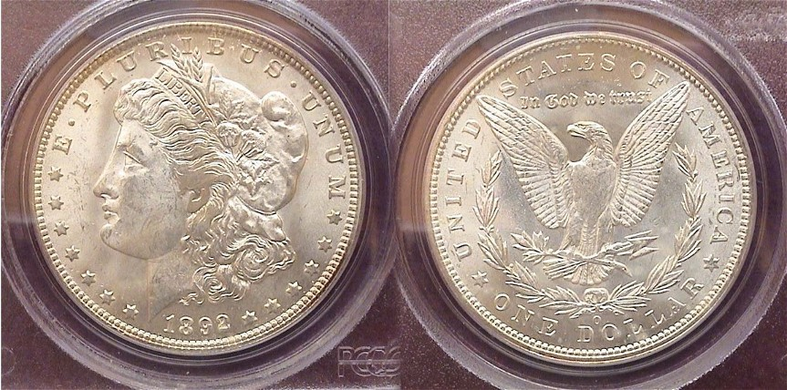

An 1892-O Morgan $1.00 graded MS-63 by PCGS
[Use a 3X magnifying glass or magnify page to 200% to view details.]

Back in 2005 when silver was still trading at around $5.00 an ounce, one could pick up a “raw” specimen of a common date Morgan dollar grading MS-63 for as little as $25.00 to $35.00, so opting for a certified specimen was not all that crucial. With silver trading at over $30.00 an ounce, that same common date grading MS-63 is now retailing for $55 to $65 with MS-64s starting at around $70 to $80.00. At those prices, collectors may find it more prudent to select a certified example..

The 1892-O Morgan pictured above was certified MS-63 but displays very little of the scuffing or bag marks` usually found on Miss Liberty’s cheek or in the open field to her left. Since the MS-63 1892-O Morgan dollar is priced at five times what a common date 1885-O would cost, locating a premium quality certified MS-63 is worth seeking. Even with certified coins it is essential to always grade the coin before buying the “slab”.

Despite all of the foregoing remarks encouraging collectors to certify their coins there can be some drawbacks involved with certification. The writer decided to certify a number of his “raw” coins acquired before third party certification came into existence; (i.e., prior to 1986). While most of them passed muster and received the grades at or close to what he thought them to be, a small number were deemed to be artificially toned or cleaned. The good news is that NGC, ANACS and ICG will grade a coin with a problem listing it on the label of the holder, (e.g., “Cleaned”, AU-55 details). The bad news is that PCGS won’t and they are the #1 leader in coin certification. They merely label the holder “GENUINE”, coding it with a number that explains the reason for not grading the coin; (e.g., “Questionable color”). Since it is extremely difficult to sell a coin labeled as “GENUINE”, the only option is to crack open the slab, remove the coin and reinsert it in a Mylar flip.
________________________________________________________________________________________________________________________________
My Two Cents Worth
By Rich Baker

In January 2006, I ventured on my latest collection, “the two cent piece.” You all told me, to know the coin before I buy the coin. Therefore, I researched the series and even wrote an article for our club’s newsletter “The Two Cent Legacy: In God We Trust” (March 2006). Since then, I have been assembling my collection, mainly looking for better grade coins at a reasonably price at coin shows in the three state area as well as on E-bay. I recently obtained the last two key coins for my collection, 1872 and 1864 Small Motto. Here are some facts and my tale for the last two acquisitions.

1872: The 1872 coin is one of the key dates to the business strike series of two-cent coins. It was the last year of circulation for the series. Every year following the initial two-cent striking in 1864, the minting quantities dwindled from 14 million, to 1 million in 1870, to 721,250 in 1871 and eventually to 65,000 in 1872. There were proof only coins struck in 1873. This reduction in the 1870’s may have been attributed to the copper shortage and the need for copper for the 3-cent nickel and Indian head cent coins. In 1871, Congress authorized the redemption and melting of large cents, half cents and two-cent pieces for the production of Indian Head cents. There were over 17.5 million two-cent pieces turned in to the government to be melted between 1871 and 1881. The price is directly related to supply and demand, due to the low mintage, the coin can be obtained at a good bid value of around $350.

I received an early Christmas present this year. The 1872 came from a flea market vendor who really did not know what he had in his possession. I ventured into a merchant’s booth that had some coins in a display case for sale. After a quick glance at the case, I asked if he had any older type coins like two-cent pieces. He took out a couple of small coin books from the back. I looked through unorganized books and came upon the 1872 in a 2 x 2, which did not have a price on the coin. I pulled it out of the book and set it aside. While continuing to look through the book of low-grade common type coins, I asked about his knowledge level of coins. He mentioned that he did not know much and that he was selling his brothers collection – most of the coins already had prices on them. He did say that the coins were selling much better than any other merchandise in his storefront. After about 15 minutes of idle banter back and forth, I asked him the price on the coin. He looked through the coin book of assorted type coins and said $20. Without hesitation or bartering on my part, I pulled out a $20 and the transaction was final. Little did he know that the 1872 2-cent coin, which had just sold me (graded strong G-4), had a grey sheet bid value of $335. Not a bad $20 Christmas gift to myself.

1864 Small Motto versus Large Motto
Is it a small motto or not? A word to the wise, there are a few E-bayer’s that do not know the difference between a large motto and small motto – some even refer to it as a small date. Here are some tell tale facts of the small motto:
The most common area to look at is as the name variety name implies the motto. I always look at GOD and TRUST on the motto, the WE is normally weakly struck and there are no distinguishing differences in the WE between the two varieties to my knowledge. 1) The G is slightly rotated to the left on a small motto, while the G on the large motto is more upright. 2) The D is shorter and fatter on a small motto, and conversely, the D is longer and skinnier on a large motto. With regards to the TRUST, 3) the T is really close to the ribbon curl on a small motto. The large motto has the T a good distance away. 4) The U is fatter and higher on the banner on the small motto. The large motto has the U close to the banner’s edge and is skinny.
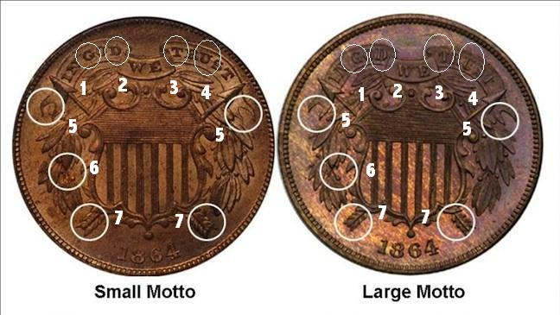
If you have a rough example and cannot read the motto due to wear and tear, then here are some other signs of a small motto coin.
5) The both sides of the banner upper tips have distinct curls downward on the small motto. The large motto has tips that are more flatter.
6) There are two berries shown on the lower left side of the shield about 8:00 position on the small motto. The large motto only has one showing.
7) The number of feathers on the arrow ends at the 4:00 and 7:00 position can provide a sign. Table below illustrates that point.
Position | Small Motto | Large Motto
Left Arrow Top | 3 | 3
Left Arrow Bottom | 5 | 4
Right Arrow Top | 4 | 3
Right Arrow Bottom | 5 | 4

If you really want to ensure that you have a true piece, read Flynn's book, "Getting to Your Two Cents Worth," there are about five other distinguishing differences between the small motto and large motto.
Over the last 6 years, I have bought many 1864 2-cent coins on the slim chance it may be a small motto from an unknowing seller. However, until now, all I have purchased was large mottos. As I wrote back in March of 2006, “….the 1864 small motto of which only a few thousand are known to exist were coined from a prototype master hub.” Since I was down to my last coin in the collection, I thought a trip to the coin show in Perry, GA was necessary. By the way the show was also near my finance’ sisters house so she could visit. At the show with over 100 dealers, I could only find three examples of the small motto, a slabbed MS-63, which was out of my price range, a slabbed fine example, a little rough and overpriced and a raw VF example, which was at the right price and condition for me. I would recommend a coin in this condition or better to illustrate the small motto features. Therefore, that is my two two cents worth.
____________________________________________________________________________________________________________________________
(The editor thanks Rich Baker for contributing this interesting article on one of America’s forgotten coin denominations. More submissions are welcomed.)

Club News

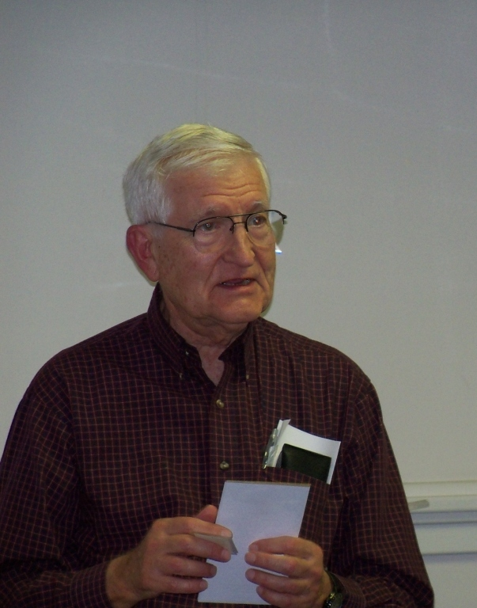
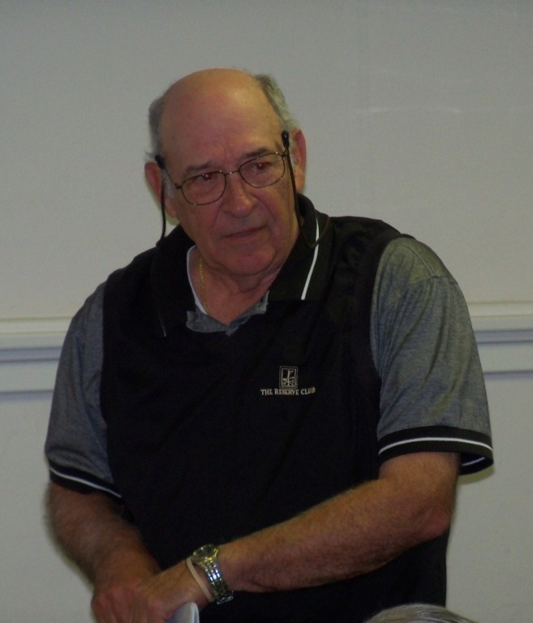
The meeting was called to order at 6:49 PM by President Steve Kuhl. Glenn Sanders reported that there were 24 members present (23 adults, 1 junior). A new member joined the club, Johnny Johnson. There was also one guest, Sonia Hillman. Glenn announced information concerning several upcoming coin shows in the vicinity. The treasurer’s report was read. The balance as of 1/31/12 was $1798.20. Rick Owen shared experiences at recent coin shows (FUN and Perry, GA). Rick also described home security technology that has recently become affordable, including video cameras that can be viewed via smart phones over the internet.
President Kuhl stated that elections would be held at next month’s meeting. Jim Barry is heading a nominating committee, with Arno Safran, so anyone interested in serving as an officer should contact Jim or Arno. So far, the nominees who have offered to run are: For President, Steve Kuhl, For VP, Pat James, For Secretary, Jim Mullaney, For Treasurer, John Meinhardt and for Sgt. And Arms, Glenn Sanders (who will also serve as auctioneer.)
Pat James announced that the March program would be on the Coins of Fort Sumter, by Tony Chibbaro.
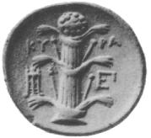
There were three Show and Tells. Jim Barry shared an ancient Cyrenian coin from the area of modern-day Libya that had Apollo on the obverse and the plant silphium on the reverse. Silphium (now extinct) was used in antiquity as a rich seasoning and as a medicine. Silphium was the essential item of trade from Cyrene, and was so critical to the Cyrenian economy that most of their coins bore a picture of the plant. David Amey shared a set of rare banknotes from Indochina. He described how he developed an interest in these banknotes while he was serving in the area, flying C-130s in 1966-67. Rick Owen displayed a 1937-D 3-legged buffalo nickel certified MS-61. (It was nicer than that!, ED/)
The Program included a PowerPoint presentation by Arno Safran on “the Collecting the Coins of James Barton Longacre” who served as Chief Engraver of the US Mint from July, 1844 thru Jan. 1, 1869. During his almost quarter of a century tenure Longacre produced more new coinage designs than any other US official to hold that post. Arno displayed Longacre’s designed coins based on the chronological order they were issued, Other slides in the presentation included photos of Longacre, his wife Eliza and daughter Sarah along with sketches for some of the various cent and gold coin designs.

The prize winners were Johnny Johnson who won the door prize drawing and Helen Barry who won the 50/50 - $27.00. Congratulations, Johnny and Helen. Our next meeting is scheduled at the Aiken Public Library for March 1. Bring in a numismatic item for Show & Tell. The auction will follow. See you there!

Show & Tell Presenters
(Photos by Helen Barry)

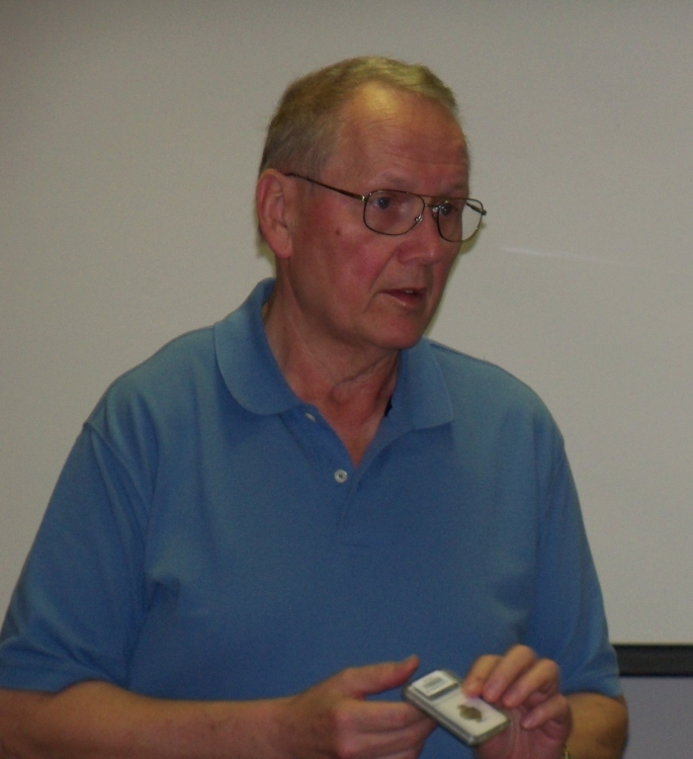
Jim Barry David Amey and Rick Owen
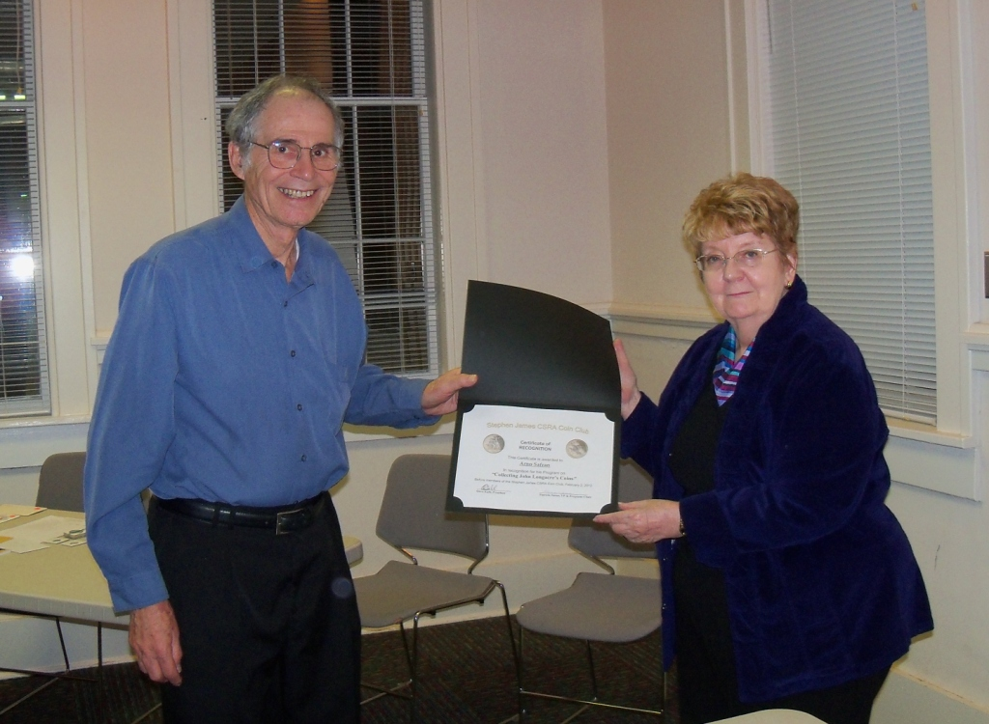
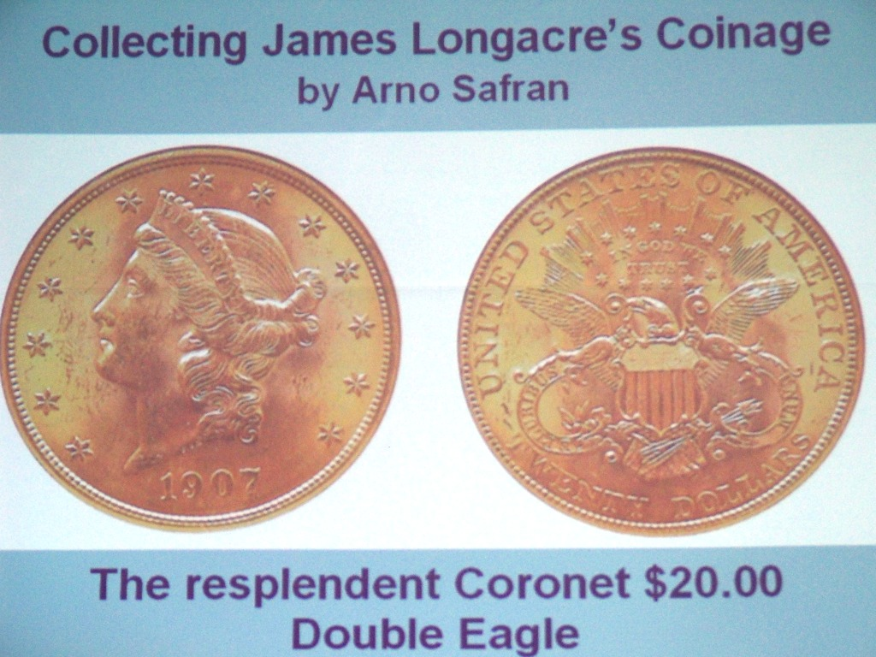
Program Title frame Arno receiving award from Pat James
______________________________________________________

Kindly Patronize our Advertisers

