The Stephen James
CSRA Coin Club of Aiken
P.O. Box 11
New Ellenton, SC 29809
Web site: www.sjcsracc.org
The SJ CSRA CC of Aiken, SC meets on the 1st Thursday of the month at the Aiken Public Library

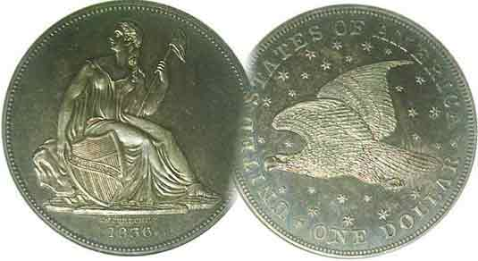
Pres. Steve Kuhl
V .P. Pat James
Sec. Jim Mullaney
Treas. Chuck Goergen
Sgt. in Arms: Jim Sproull
Programs: Pat James
ANA Representative: Jim Barry
Photos: Helen Barry
Publicity: Pat James
Newsletter: Arno Safran
E-Mail: arnosafran@comcast.net
Auctioneer: Jim Sproull
Web site: Susie Nulty (see above.)

2014 Club Meeting Schedule
Volume 13, No. 3 the Stephen James CSRA Coin Club, Founded in 2001 March, 2014
Monthly Newsletter
Our next meeting will be held on Thursday, March 6, 2014 at the Aiken Public Library

ANA Show at Atlanta Shows a Disturbing New Trend
Jan. 2 Apr. 3 July 3 Oct. 2
Feb. 6 May 1 Aug. 7 Nov. 7
Mar. 6 June 5 Sept. 4 Dec. 4

Atlanta ANA Show held in Attractive Setting

In addition to the summer World Money Show, the American Numismatic Association schedules a series of three day shows in different geographical venues of the nation. The first of these in 2014 was recently held in the Atlanta Galleria Convention Center from Feb. 27 thru Mar. 1. The Atlanta Galleria may not be as huge as the Orange County Convention Center in Orlando (where the FUN Show is held every January) but it is an attractive place with mall-like stores and eateries within its boundaries. This year the ANA Board decided to reduce to length of the convention from three full days to two and a half. The opening day Thursday was split with a morning session for dealers-only followed by an afternoon session beginning at 1:00 PM open to the public. The bourse was divided into ten rows comprising 350 dealer tables which also included a section for exhibits. Outside the bourse area various rooms were reserved for educational programs and auctions. The large bourse permitted collectors to view and purchase coins struck from as far back as 600 BC to the present time. There were type coins, paper money, tokens and scrip from many countries and even special ANA exhibits of great rarities.

There was one noticeably disturbing trend at this show. With gold and silver having declined since its 2011 highs, a large number of dealers were touting extremely common 20th Century US coins certified MS-66 thru 68. Peace dollars, long neglected in favor of the more popular Morgan dollar were being displayed in mega grades at unbelievable prices Most of these coins were struck in the multi-millions and hardly circulated having remained in mint-sewn bags for decades. After seeing a large number of these so-called wonder coins at different tables I decided to ask one of the dealers what he wanted for a particular 1922-P Peace dollar that was certified MS-67 by PCGS, CAC approved. He responded, “$900.00!”, this for a coin with a record mintage of 51.7 million struck; in the writer’s view, an example of grade rarity at its worst.
______________________________________________________________________________________________________________________

.The 1928 Peace Dollar
By Arno Safran

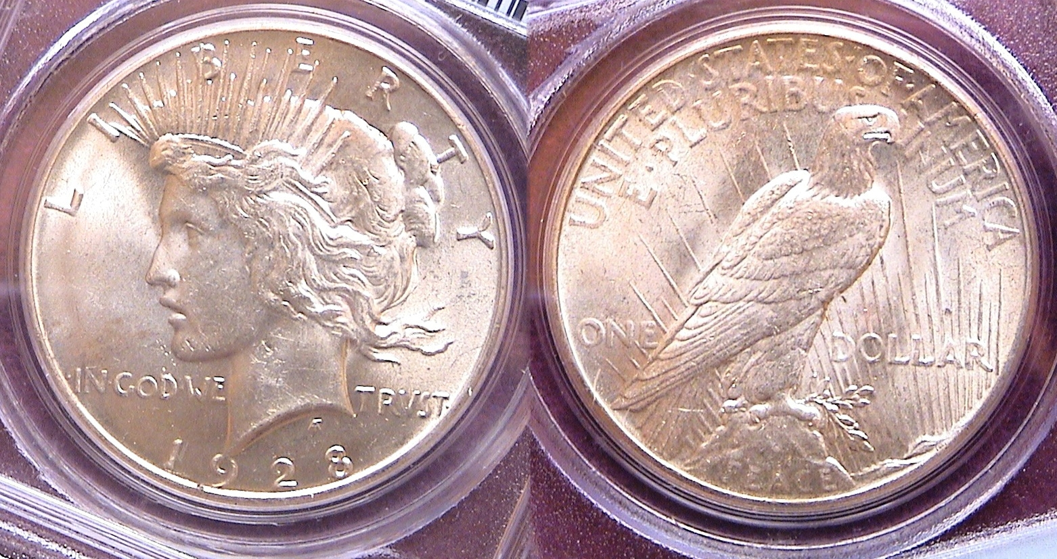

A 1928-P Peace dollar graded MS-63 by PCGS
The key date of the series
[Use 3x magnifying glass or enlarge page to 150%]

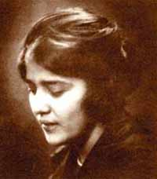
As a crown-size US type coin, the Peace dollar until recently has been neglected by collectors, that is until now. After WW I ended in 1918, there were cries for a new dollar coin emblematic of peace. Anthony de Francisci designed the Peace dollar using his wife, Theresa as the model. The coin was struck from 1921 thru 1935 with the exception of 1929-1933 during the first four years of the Great Depression. The Philadelphia Mint produced the Peace $1.00 every year the coin was issued. With the exception of the initial low mintage 1921-P issue, the San Francisco Mint struck Peace dollars from 1922 thru 1928 inclusive to be resumed in 1934 and 1935. At the Denver Mint, Peace dollars were struck only in 1922, 1923, 1926, 1927 and in 1934. The two main key dates have always been the 1928 (mintage, just 360,649) scarce in all grades and the 1934-S, (mintage 1,011,000) but scarce only in mint state. Both the 1927- P and 1927-S have mintages well below one million but these dates become pricey in MS-65.

Many uncirculated 1928 Peace dollars surface grading MS-62 but seem drab in appearance. MS-63s appear more lustrous, are much harder to find and are on the cusp of affordability for serious collectors. The key date 1928 graded MS-63 shown above cost far less than the extremely common 1922 graded MS-67 alluded to at the bottom of column one.
_______________________________________________________________________________________________________________________

SOMETIMES FINGERPRINTS ARE NOT A BAD THING by Bill Myers

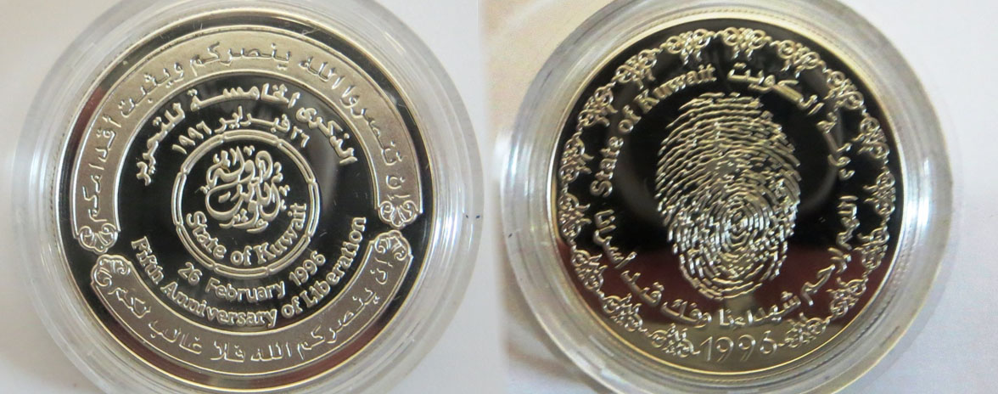

A Kuwait 5 dinar 5th Anniversary Commemorative 0.925 silver Coin
[Use 3x magnifying glass or enlarge page to 200%]

I am currently deployed to Kuwait for the summer. I am working at Camp Arifjan at the hospital. It is essentially a spot in the middle of the desert. I have managed to still pursue my numismatic interest. They have a bazaar here on Sundays and there is a guy who comes to the base from Kuwait City to sell numismatic items. Most of what he has is too touristy for me. I did find two items of interest and they have at least two things in common. One is they celebrate the anniversary of the liberation of Kuwait from the Iraqi occupation (26 February 1991) and the other is they have fingerprints on them. The latter is, interestingly, intentional and not from poor handling. As I explain the items I purchased this will become clear.

The first item is a 38.61 mm 0.925 silver coin. I was told it is a 5 dinar coin but it does not have the denomination on it. I was told its value is implied. I have not found it in the Catalog of World Coins, but that is not always up to date. On the obverse it has Arabic and English text and has the STATE OF KUWAIT in the center with 26 FEBRUARY 1996/5TH ANNIVERSARY OF LIBERATION under it. The reverse has a large finger print in the center with the Arab text and the English text that reads STATE OF KUWAIT 1996.

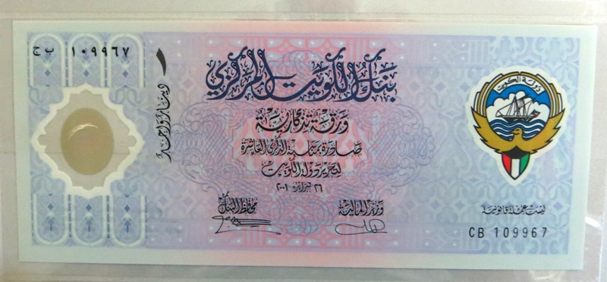

The face of the Kuwait 10th anniversary note
The second item is a commemorative polymer 1 dinar note from Kuwait. In the Standard Catalog of World Paper Money it is listed under Kuwait as CS2. The face has the coat of arms of Kuwait on the right and Arabic writing in the middle and on the left is a window with a fingerprint on it. The Arabic writing states “Central Bank of Kuwait/Commemorative Banknote/Issued in the event of the 10th Anniversary/The Liberation of the State of Kuwait/26th February 2001”. The serial number is in Arabic numbers on the upper left and western numbers on the lower right.
On the back is a Kuwait soldier holding the national flag on the left, then moving right there is a harbor scene with the traditional Dhow (boat) and buildings from Kuwait City. On the right of the harbor scene is a girl drawing 4 doves on a wall that signifies peace. On the far right is the window with the fingerprint. The window is an "Optically Variable Device" that when angled to the light shows the colors of the Kuwait flag (black, green, white and red). On the lower left there is the statement,”Not a Legal Tender”.

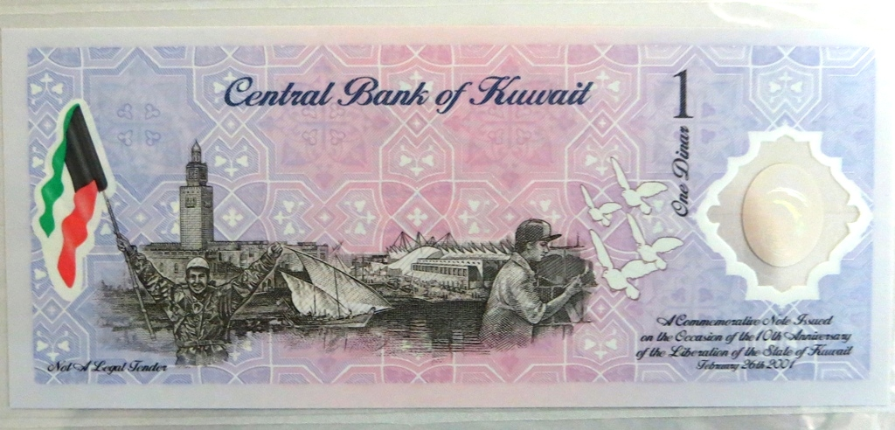

The back of the Kuwait 10th anniversary note

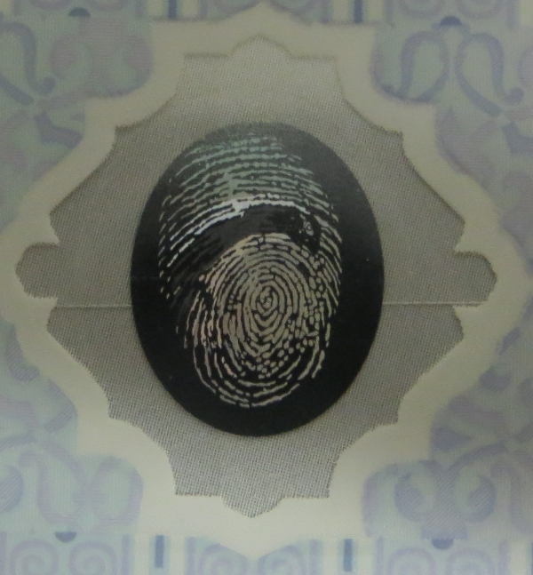

As I said before the one thing these items have in common is the fingerprint. It is known as the Martyr’s Mark. In Kuwait it represents those that fought against the Iraqis during the invasion and had been killed, captured and/or executed. I have researched about why the fingerprint was chosen but have not been successful. The Kuwaiti who sold me the note said it is because the Iraqis took fingerprints of the Kuwaitis but I cannot confirm this.

There are many commemorative coins as well as another note (commemorating the 2nd anniversary and is Krause #CS1) celebrating the liberation of Kuwait. I am not trying to assemble a collection of these numismatic items but was attracted to these because of the fingerprint. Since I am a hand surgeon I collect numismatic items with hands on them so collecting items with fingerprints is not too much of a stretch. For me there was an added bonus of learning something about the liberation of Kuwait.
_________________________________________________________________________________________________________________________________
References:
Kuwait at http://www.polymernotes.com/kuwait.html
CBK gallery at http://www.cbk.gov.kw/www/gallery_issues.html#
________________________________________________________________________________________________________________

(Bill Myers is a Colonel with the US Army Medical Corps and has served twice in Iraq and is currently deployed in Kuwait. He is an orthopedic surgeon but also a serious numismatist who collects numismatic items relative to his military experiences and his orthopedic specialty, ‘hands”. He was a member of the SJ CSRA CC and a past President of the Augusta Coin Club having served in that capacity until the fall of 2008 , Thanks, Bill for sharing more of your numismatic experiences with our members., ED.)
____________________________________________________________________________________________________________________________

Minutes of February 2014, SJ CSRA Coin Club Meeting
]
President Kuhl opened the meeting at 6:58 p.m. With the Aiken County Library elevator still inoperable; the venue of the meeting was changed to the Aiken County Council building on West Richland Avenue. Sgt at Arms, Jim Sproull reported there were 20 members and 10 guests in attendance. Jim also related information about the upcoming coin shows in the area. Arno Safran won the attendance door prize. A copy of the January 2 minutes appeared in the Club Newsletter and is on file. Treasurer Chuck Goergen reported that the Treasury balance was $1,870.81.

President Kuhl reported that the Club’s coin show this year would be held on Saturday, September 6, 2014. The Club has made the down payment to secure the hall at the O’Dell Weeks Center. 75 letters have been sent to the area dealers with bourse applications, and flyers for the Show were available for folks to take and distribute.

President Kuhl announced that elections for the Club’s officers would be held at the March 6 meeting. Steve advised that after five years, he was standing down and invited anyone interested in that office or any other office contact him. He said that the other current officers were willing to serve again.

There were five Show and Tell presentations. Garry Naples brought a 1910 cent in mint state condition. Jim Sproull exhibited an eight real pillar dollar minted in Mexico in 1754 and carried on the French ship the Auguste when it was sunk in 1761 after sailing from New Orleans headed for France. The Auguste was a casualty of the French and Indian War. Mac Smith shared some Buffalo nickels that he had bought in an auction, to include three 1913 Variety 2 nickels. Arno Safran shared three Barber halves that he had bought some years ago and recently sent to PCGS for certification. The halves, a 1913, 1914 and 1904 S, were returned to Arno with higher grades than he had anticipated. Jim Barry brought an ancient silver coin from Bithynia, which was an ancient kingdom and Roman province in the northwest of Asia Minor, north of present day Turkey. It was a half-dollar sized silver coin with the god Zeus depicted on one side and a king of Bithynia on the other side.

The evening’s program was a presentation by YN Zach Richardson on the NORFED Liberty Dollar. The Liberty Dollar was a private currency issued in minted metal rounds, gold and silver certificates and electronic currency, "warehouse receipts" for real gold and silver owned by the bearer. There were about 250,000 holders of Liberty Dollar certificates from 1998 to 2009. Until July 2009, the Liberty Dollar was distributed by Liberty Services (formerly known as "National Organization for the Repeal of the Federal Reserve and the Internal Revenue Code" (NORFED), based in Evansville, Indiana, created by Bernard von Nothaus, who was the co-founder and mint master of the Royal Hawaiian Mint Company. Von Nothaus wanted there to be a currency backed by silver and gold in existence not a government promise as an answer to inflation. In November of 2007, the government raided the facilities of von Nothaus and confiscated huge amounts of silver, gold and platinum. In May 2009, von Nothaus and others were charged with federal crimes in connection with the Liberty Dollar. On March 18, 2011, von Nothaus was pronounced guilty of making, possessing, and selling his own currency. counterfeiting and mail fraud. To date he has not been sentenced. Zach passed around several examples of the coins and currency.

The 50/50 drawing was won by Chuck Goergen - $20. Sgt at Arms Jim Sproull conducted the club auction.
Respectfully submitted,

Jim Mullaney, Secretary

________________________________________________________________________________________________________________________

Show & Tell Images Photos by James Mullaney
[Digital readers magnify images to 200% to view details]

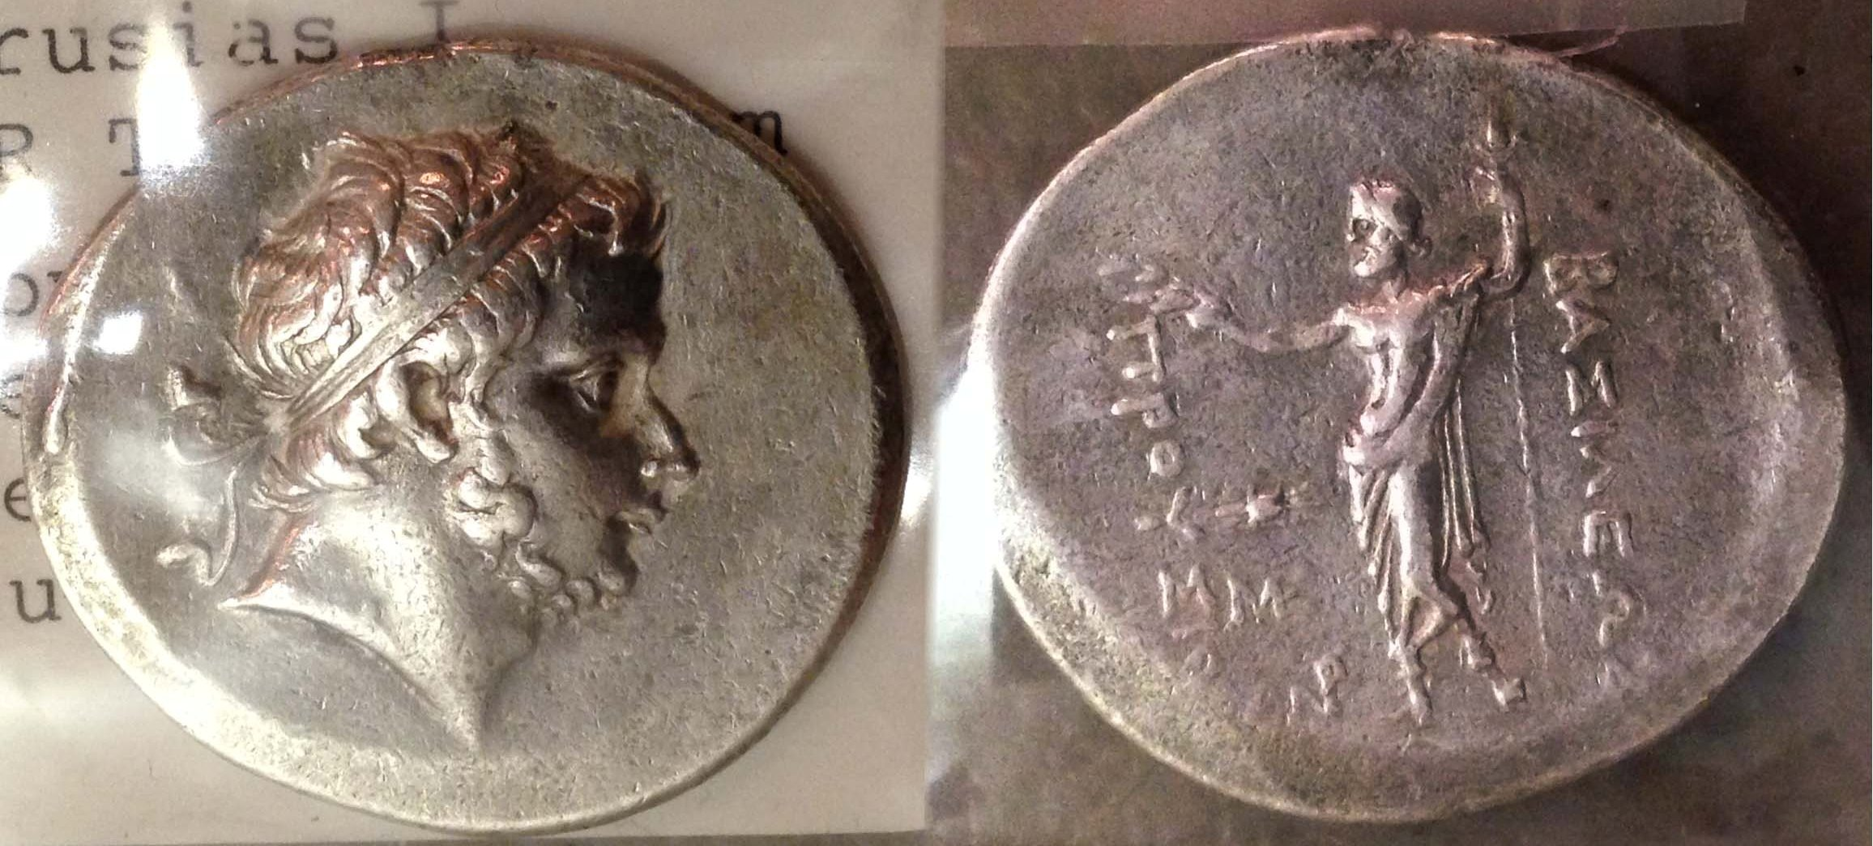

An ancient silver coin from Bithynia displayed by Jim Barry

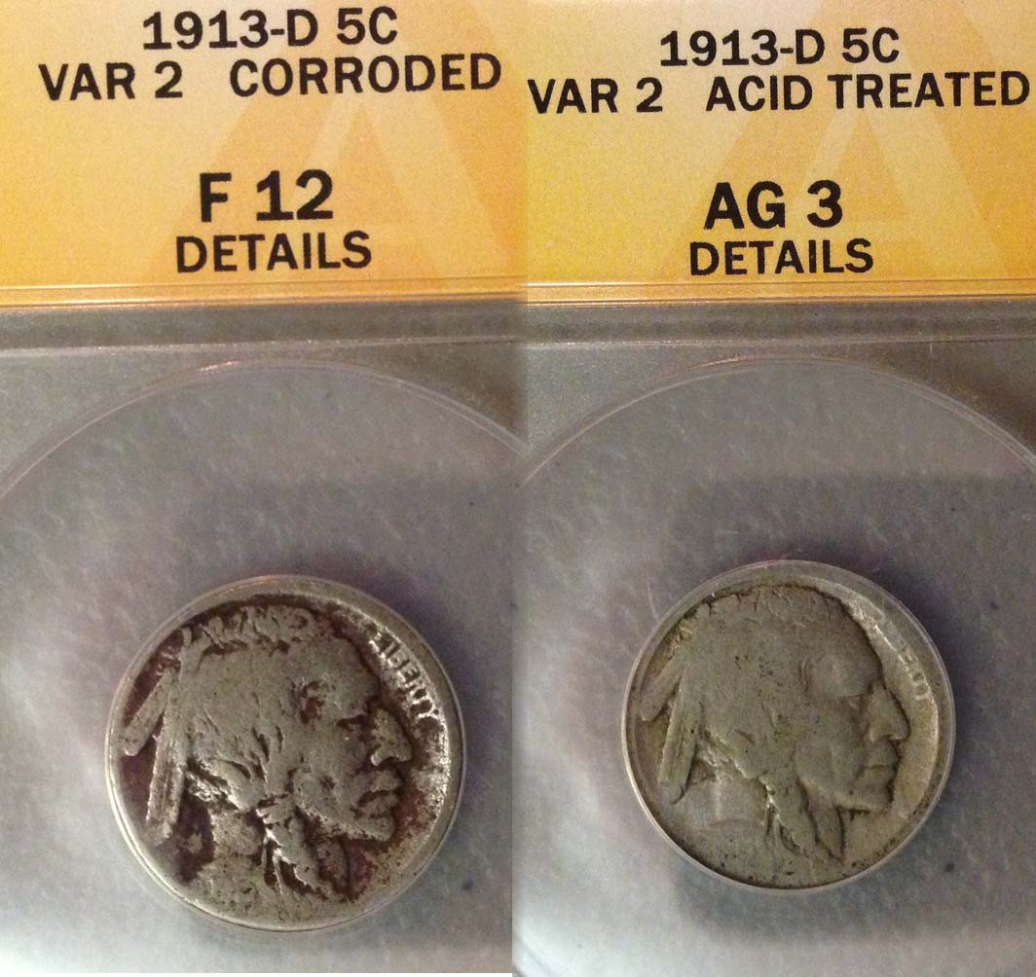

1913-D Type 1 & 2 Buffalo nickels obv cherry picked by Mac Smith

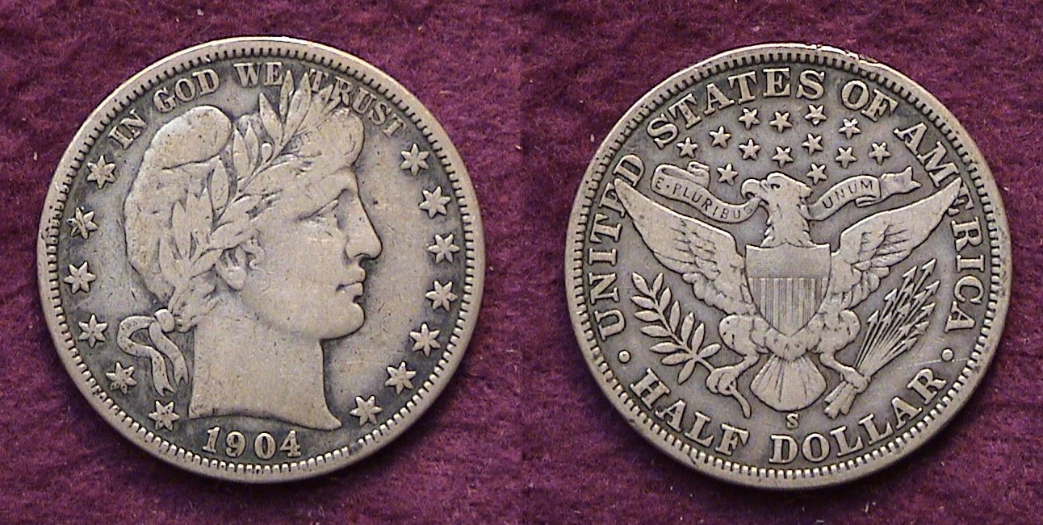

This “raw” 1904-S acquired as a Fine-12 was graded VF-20 by PCGS
displayed by Arno Safran
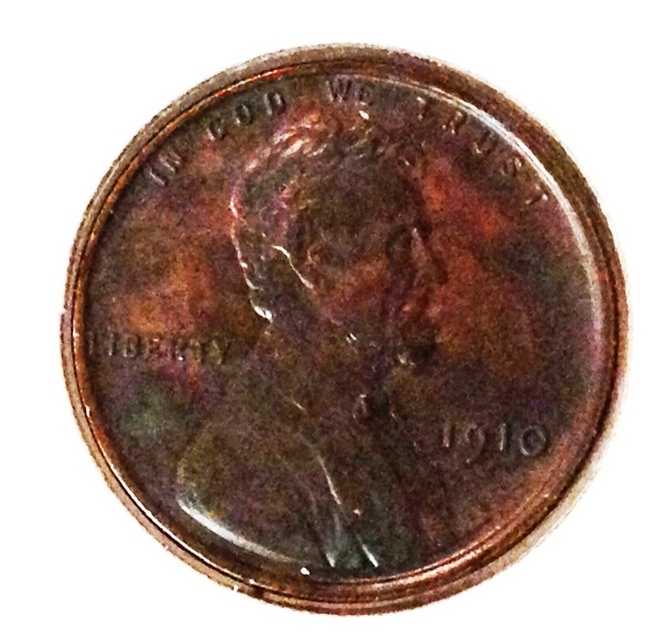

This 1910 Lincoln cent was acquired by Garry Naples

\_____________________________________________________________________________________________________-__________

The editor is seeking more numismatic articles from members. Simply E-mail to arnosafran @comcast.net two weeks prior to the meeting.

Your monthly newsletter is only as good as its contributors. The publication is now in its thirteenth year and has won national recognition from the American Numismatic Association thanks to articles and photos submitted by members

Please consider writing an article. Length can be anywhere from one full column to two full pages.
Accompanying photos are also welcomed.

Kindly Patronize Our Advertisers

