The Stephen James
CSRA Coin Club of Aiken
P.O. Box 11
New Ellenton, SC 29809
Web site: www.sjcsracc.org
The SJ CSRA CC now meets at the South Aiken Presbyterian Church at 1711 Whiskey Road

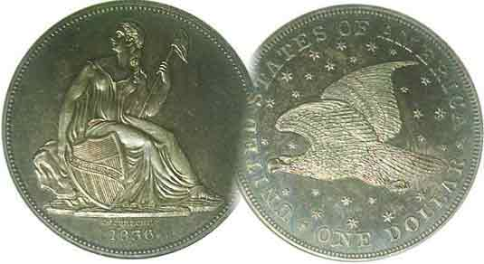
Pres. J.J. Engel
V .P. Pat James
Sec. Jim Mullaney
Treas. Chuck Goergen
Sgt. in Arms: Jim Sproull

Programs: Pat James
ANA Rep.: Glenn Sanders
Show Chair: Board members
Photos: Steve Kuhl
Publicity: Pat James
Newsletter: Arno Safran
E-Mail: arnosafran@comcast.net
Auctioneer: Jim Sproull
Web site: Susie Nulty (see above.)

Our next will be on Thursday, March, 3 at 6:45 PM in the South Aiken Presbyterian Church Gymnasium
Due to the Omicron variant of Covid -19, please wear a face mask inside the building

2022 Club Meeting Schedule
Volume 21, No. 3 the Stephen James CSRA Coin Club, Founded in 2001 March, 2022
Monthly Newsletter
Collecting the U.S. Gold $5.00 Half-eagles thru the ages
Another interesting challenge
Jan. 6 Apr. 7 July 7 Oct. 6
Feb. 3 May 5 Aug. 4 Nov. 3
Mar. 3 June 2 Sept. 1 Dec. 1

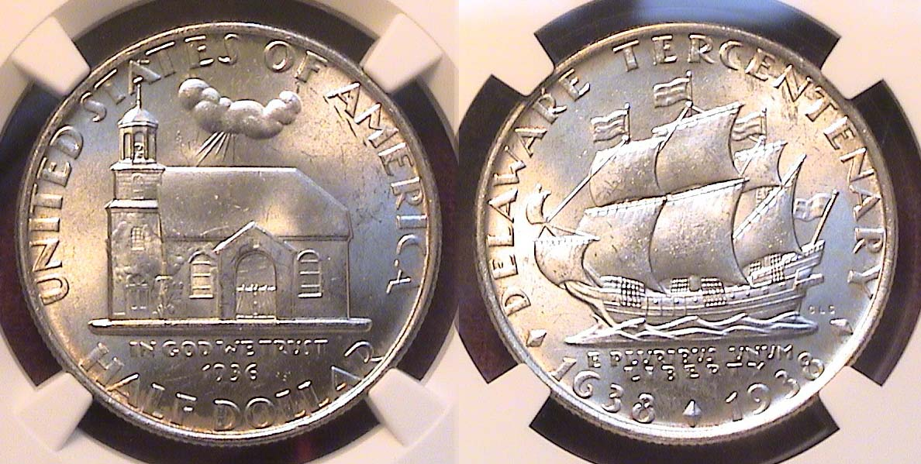

A 1936 Delaware Tercentenary Commemorative Half-Dollar
[Enlarge page to 150% or fill monitor screen to view details.]

The first series of US commemoratives that were struck from 1892 to 1954 were not only artistically creative, but also historical effective in their efforts to remind Americans of later generations that people from many different nations, mostly from Europe, became colonists who did not necessarily speak English. The commemorative half-dollar shown above celebrates the 300th anniversary of a large contingent of Swedish people arriving in America on a ship called the Kalmar Nyckel from Goteborg, Sweden in 1638. The reason for the earlier date of 1936 was due to the Delaware Swedish Tercentenary Commission, who in their enthusiasm, decided to move on the completion in 1936 instead of 1938. They held a contest payable of $500 to the winning artist who designed the commemorative which turned to be Carl Schmitz who was a sculptor actually born in France despite his German sounding surname. The obverse of the coin depicts the original Old Swedes Church that still exists in Wilmington, DE and holds services there. Just below the date in small print is the motto, IN GOD WE TRUST and in even tinier numerals, the date, 1936, indicating the coin’s date of authorization. Circled above the top is the legend, UNITED STATES OF AMERICA. The reverse of the coin depicts the ship, the Kalmar Nyckel that brought the Swedish emigrants to the site of Wilmington; Delaware’s largest city. Below--in small letters-- appears the motto. E PLURIBUS UNUM, also LIBERTY in slightly smaller letters and in larger numerals, the date 1638 & 1938. Circled across the top is DELAWARE TERCENTENARY. 25,000 pieces were originally struck and priced at $1.75 each.
____________________________________________________________________________________________________________________
Collecting a US $5.00 gold type set
By Arno Safran

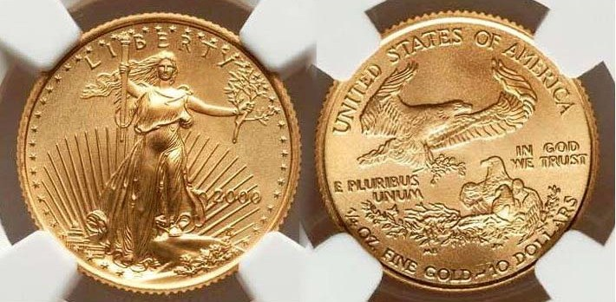

A 2020 one-tenth ounce $5.00? half-eagle
[Enlarge page to 500% or fill monitor screen to view details.]

When the attractive 1/10th ounce gold Saint-Gaudens type bullion coin was released in 1986, it was never intended for circulation, this, despite the denomination FIVE DOLLARS appearing on right side of the bottom of the reverse. The coin’s value varies based on what 91% or slightly more of one-tenth of an ounce of gold is priced at the time of purchase allowing for the seller’s profit or loss at the time of transaction.

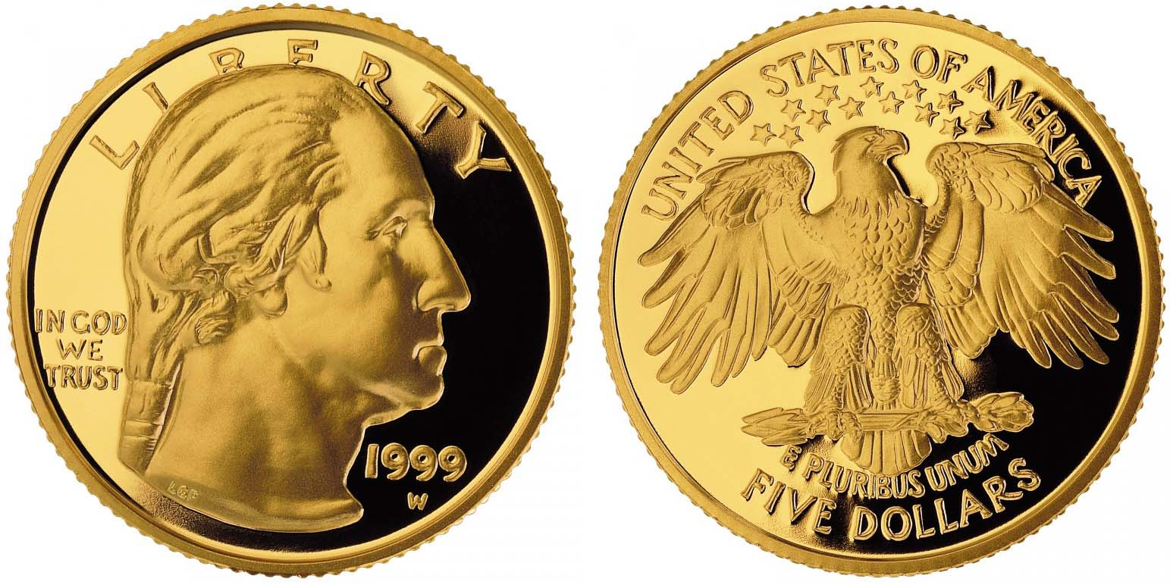

A 1999 $5.00 Business strike gold coin commemorating
the 200th anniversary of George Washington’s death

The commemorative $5.00 gold coin originally designed by sculptor Laura Gardin Fraser for the Washington quarter in 1932--but not chosen--appeared on the coin above in 1999 commemorating the 200th anniversary of the death of George Washington. As artistic as Fraser’s design is, the coin was never intended for circulation either and worth far more than the $5.00 value that appears below the eagle on the reverse. Despite the beauty of both coins shown above, their significance are purely related to the price of gold at the time of acquisition. When it comes to collecting a specimen of each US $5.00 gold coin type struck from 1795 thru 1929 intended for circulation, each coin when released had a value of $5.00 and increased in worth as a collectible only after a number of generations.
____________________________________________________________________________________________________________________
(Continued on page 2, column 1)
Collecting a US $5.00 gold type set
(Continued from page 1, column 2)

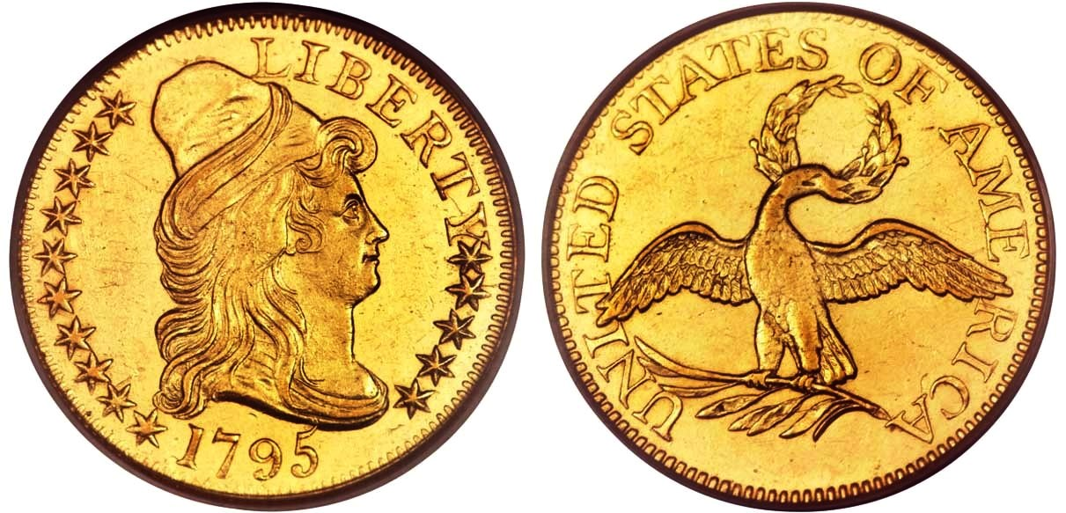

A 1795 $5.00 Draped Bust half-eagle graded MS-61 by PCGS
[Enlarge the coin to fill the page in order to view details.]

Our $5.00 half-eagles were engraved by Robert Scot, our first official chief engraver of the US Mint. The obverse featured the Draped Bust design supposedly based on a portrait of Lady Anne Bingham of Philadelphia by Gilbert Stuart which Scot later placed on the obverses in one form or another on all US coinage during the first fifteen years of his tenure. Originally, there were only thirteen stars on our early coins, seven on the left and six on the right but when Maine and Tennessee entered the Union and still later Kentucky, the amount of stars sometimes increased to 15 or 16. The number of stars appearing on the 1795 quarter eagle are fifteen. Only 8,706 half-eagles were struck in 1795 and the coin shown above certified MS-61 by PCGS sold for $79,500 at a Heritage auction. From 1795 thru 1797, Scot’s reverse design displayed a small, almost scrawny looking eagle holding a wreath in its beak with the legend, UNITED STATES OF AMERICA centered around it. Today, this classic coin is incredibly scarce and expensive due to its low mintage and popularity and affordable only by collectors of considerable means.

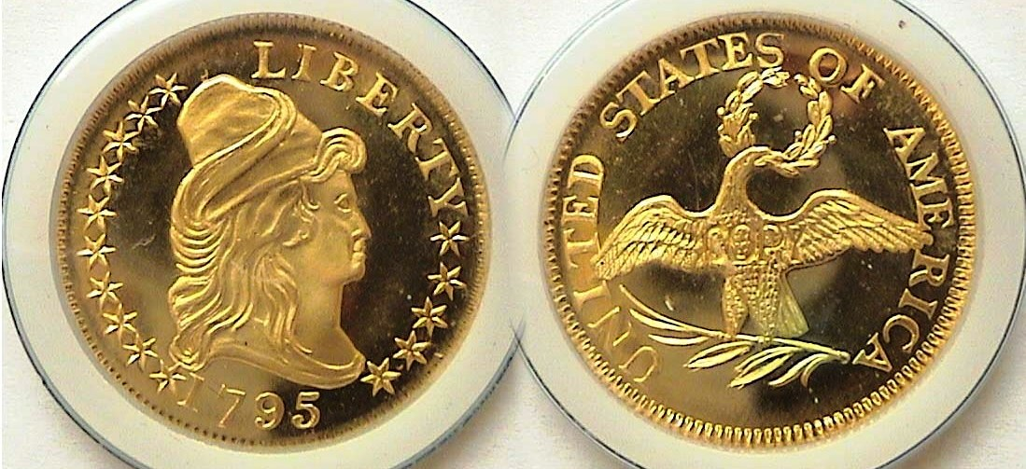

A replica of the 1795 $5.00 Draped Bust half-eagle
Created by Ron Landis of the Gallery Mint in 1995
[Enlarge the coin to fill the page in order to view details.]

The only way the author could obtain an example of this type which had the appearance of the original better than any other copyist, was to acquire this superb copy created back in 1995 by engraver, Ron Landis of the Gallery Mint, which was located in Eureka Springs, Arkansas, that alas, no longer exists. What Landis and his associates did were to build a screw press similar to the original used at the first Philadelphia Mint. Landis carefully checked the exact size, weight, and thickness of the original including the ratio of gold and copper which in 1795 was .9167 fine gold bonded by .833 copper with the weight, 8.75 grams in which to make the dye that would produce the duplicate. When completed and finally struck, the finished product looked almost identical to Scot’s original except for the word COPY subtly place on the reverse. The cost to the recipient back in 1995 was just $150.00. During that period an ounce of gold was trading around $300. At around $1,900 today, the coin shown directly above is worth quite a bit more, so its acquisition turned out to be a good investment.
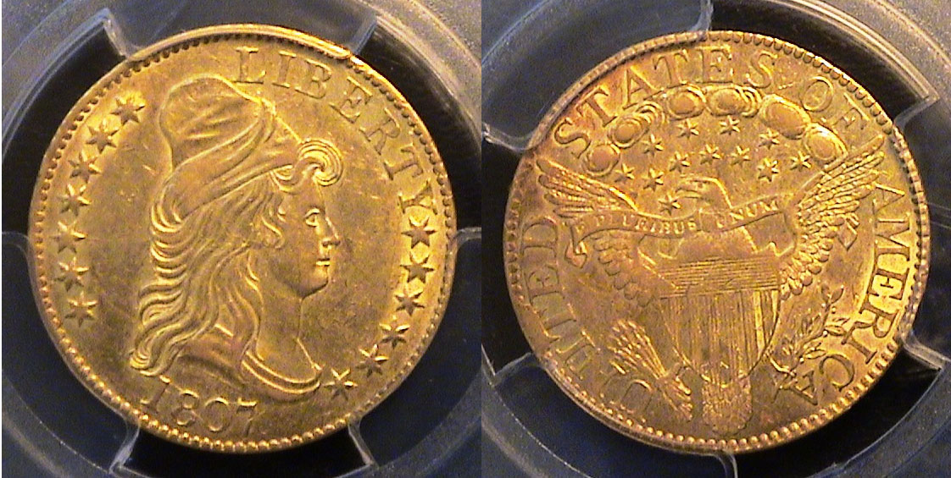

An 1807 Draped Bust $5.00 half-eagle graded AU-55 by PCGS
[Enlarge the coin to fill the page in order to view details.]

` Between 1795 and 1807, Scot’s Draped Bust facing right design prevailed on the $5.00 half-eagle. For a while there was some confusion as to why a variety showing the 1795 dated half-eagle appeared with a Heraldic Eagle reverse which technically didn’t emerge until 1797, but it turned out to be an unused die that was later merged with a die displaying the new Heraldic eagle reverse that was struck in very small numbers.

The 1807 $5.00 gold coin shown above had a reported mintage of 32,488 and although far from the highest mintage of the series--which was in the 50,000 plus range--it is priced about the same as the other dates. This particular specimen is a nice original looking coin which the author acquired in 2019 from a national dealer who specializes in early US gold coinage. How he was able to afford it is in itself another story!

If the reader magnifies the page sufficiently and looks at the stars between the clouds and the Heraldic shield on the reverse, then counts the stars inside the space, he or she will observe that the thirteenth star just to the right at the back of the eagle’s head is very weekly struck. Note, there is no denomination on the coin on the reverse nor anywhere else.

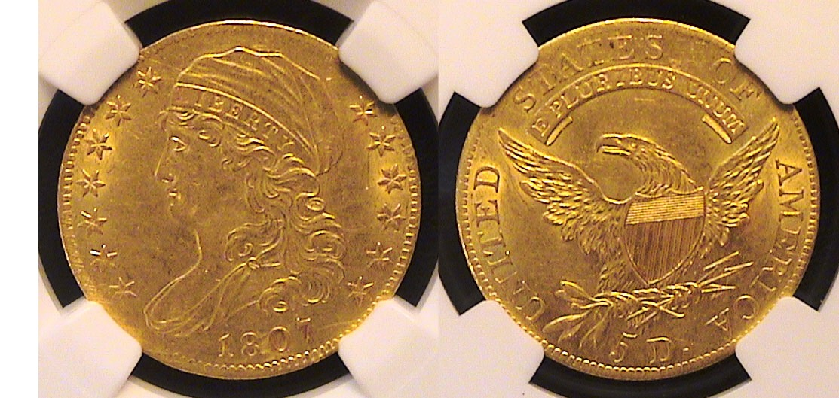

An 1807 Capped Bust $5.00 half-eagle graded AU-58 by NGC
[Enlarge the coin to fill the page in order to view details.]

In 1807, John Reich was hired at the Philadelphia Mint to assist Robert Scot as Asst, Chief Director but in fact was asked to redesign all our coin denominations. In that first year, Reich struck a new deign type for the half-dollar and the $5.00 half eagle known as the Capped Bust type which now faced left with the word LIBERTY curving under the cap of Liberty’s hair. The reverse on the gold coin displayed a slightly larger eagle facing left as well with its wings spread upward showing a shield at its center, his claws resting on a sprig of olive leaves with three arrows pointing outward to the right. Surrounding the central device on reverse appears the legend, UNIUTED STATES OF AMERICA and underneath appears in Latin, the motto, E PLURIBUS UNUM. At the very bottom, the denomination, 5 D appears for the first time on our gold coinage.
The reported mintage of the 1807 was 51,605 and released later in the year with a much higher mintage than its processor and therefore is slightly less expensive certified AU-58 than the Draped Bust example graded AU-55.
____________________________________________________________________________________________________________
(Continued on page 3, column 1)
Collecting a US $5.00 gold type set
(Continued from page 1, column 2)

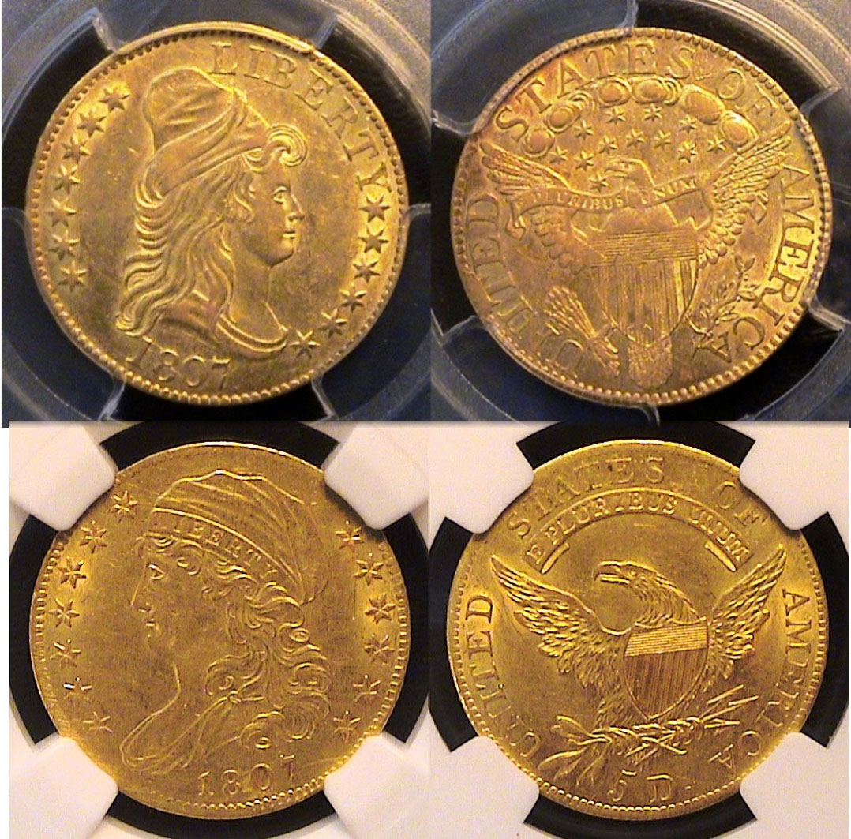

The 1807 Draped Bust over Capped Bust $5.00 half-eagle
[Enlarge all coins in this article to sufficiently to view details.]

Going back to the 1990s, the author yearned to be able to acquire and early US gold $5.00 half-eagle like the two coins shown directly above, but even then, such coins graded AU-55 thru AU-58 were selling in grades around the $5,000 mark which was still well above a college professor’s income even then.
As it turned out, the author uncovered a double E Bond that his wife purchased for him away back in 1991 which had never been cashed, so in 2018, when he rediscovered it in her filing cabinet shortly after his wife’s passing, he took it to his local bank to find out its current value, which had increased sufficiently for him to acquire both 1807 transitional date half-eagles by adding a little more from his own savings. So, on June 15, 2019, when gold was trading around $1,325 an ounce, upon going on line, he found both coins shown directly above to be available from two different dealers. The author connected with each of them by phone and easily came to agreement regarding the price and within a week, he received them in the mail, looking exactly as they appeared on each dealer’s web site.

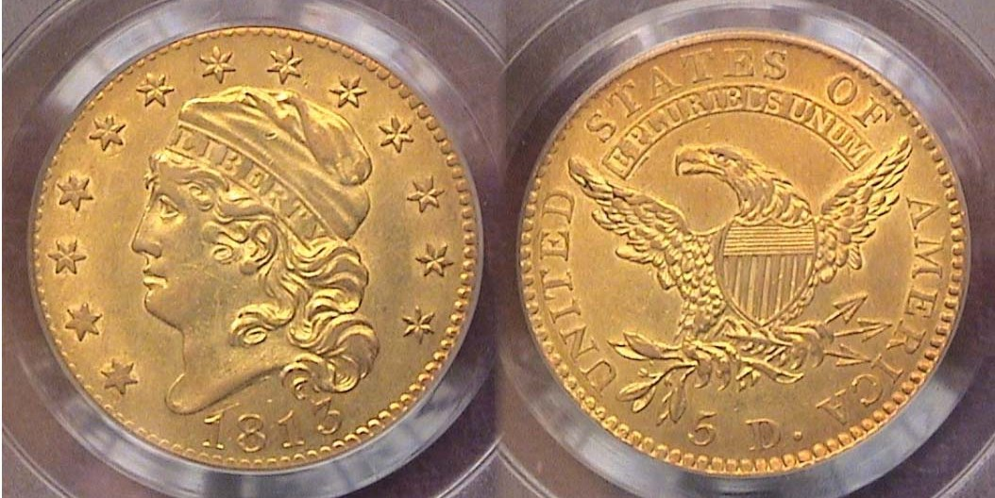

An 1813 Capped Head $5.00 gold half-eagle graded AU-55 by PCGS
[Enlarge the coin to fill the page in order to view details.]

The 1813 Capped Head variant of John Reich’s original Capped Bust design still remains something of a mystery since it is not known why Reich made the alterations he did. It is the author’s belief that this newer version should be considered a new design type because there are a considerable number of different aspects between the two types if one observes them side by side. The newer type was struck from 1813 through 1829, then reduced in size from 25 mm to 23.8 mm when the close color was installed into the screw press in 1829. By then, Reich was long gone, Scot had died and William Kneass had been installed as our second Chief engraver. The coin was continued to be struck in the smaller size until 1834 when it was replaced by the Classic Head type.

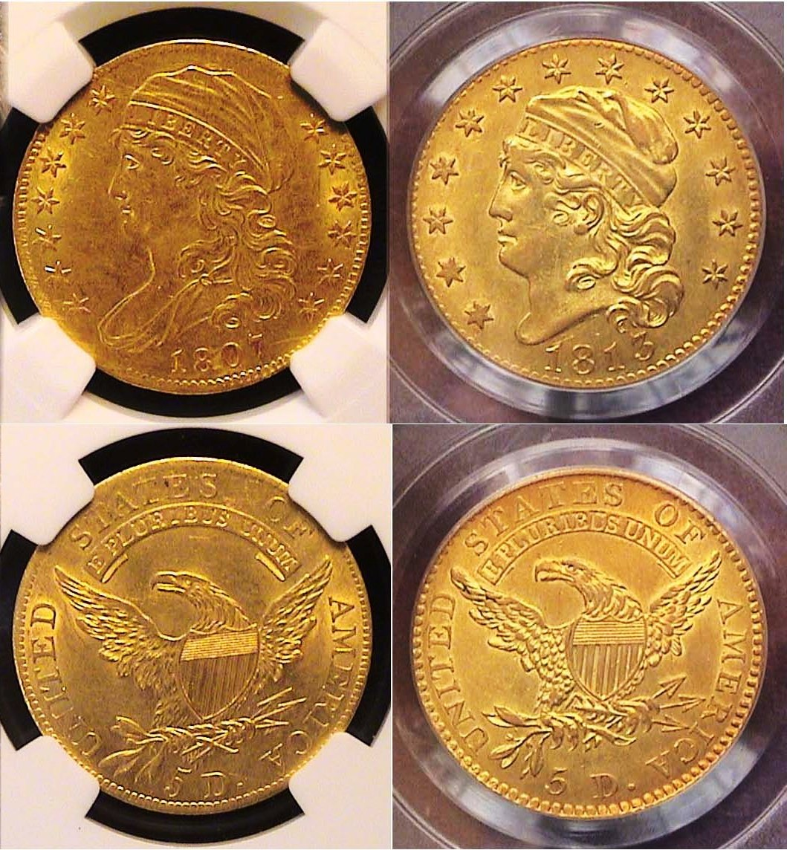

Examples showing the differences between the Capped Bust type at left and Capped Head type at right $5.00 gold coins
[Enlarge the page to fill the monitor screen to better observe the coins while reading the written descriptions below.]

1.A thinner, more lengthy figure A wider, more truncated figure
2. Liberty’s neck collar shows Bust of Liberty ends at neck
3. Stars on obverse are small Stars, larger and surround figure
4. Liberty’s face more serene Liberty’s face wider, more bold
5. Liberty’s cap longer, graceful Liberty’s cap wider, shorter
6. Eagle’s feathers more tapered Eagle’s feathers more jagged
7. Extension of scroll, shorter Extension of scroll longer
8. Eagle’s beak further from scroll Eagle’s beak closer to scroll

The author acquired the 2013 Capped Head $5.00 gold half-eagle at the American Numismatic Association Regional coin show held in Atlanta in late February, 27, 2020 at the Cobb Galleria Convention Center. It would be the last show anyone would be attending for a while since shortly afterwards, Covid 19 struck! It turned out that half a year earlier, author was the under bidder of the same coin at a Heritage auction but paid only a slight bit more than the wining bidder paid.

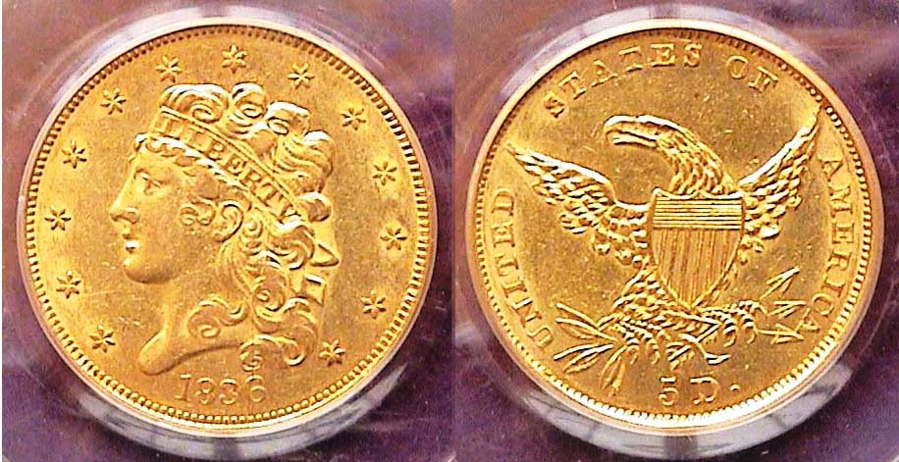

And 1836 Classic Head $5.00 half-eagle graded XF-45 by PCGS
[Enlarge the coin to fill the page in order to view details.]

In 1834, the reduced size Capped Head half-eagle was replaced by Kneass’s Classic Head type which was reduced in size even further from 23.8 mm to 22.5 mm. The coin appears to display far less alterations than the preceding type than the Cap Head had from the Cap Bust type. The Classic Head type was struck from 1834 through 1839 with the 1836 date considered the most common date having a reported mintage of 553,147 and is the least expensive. The author acquired the coin back in September, 1993 at a Convention held in northern New Jersey when Gold was trading at just $340 an ounce. Grading was far more stringent then since the coin looks closer to an AU-53.
_________________________________________________________________________________________________________________________________(Continued on page 4. column 1)
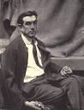
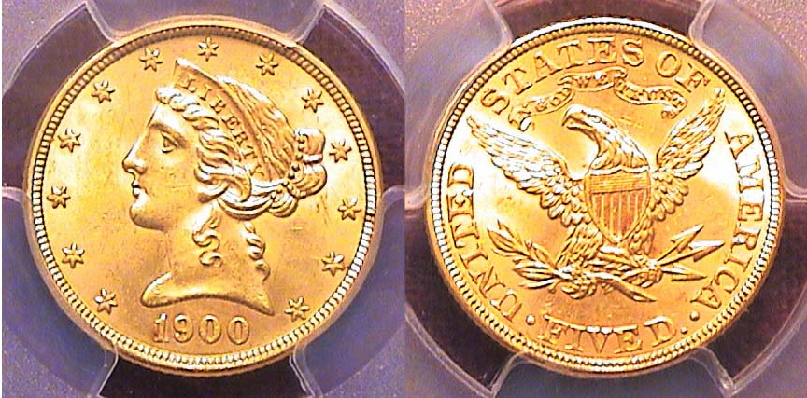

A 1900 Liberty Head $5.00 gold half-eagle certified MS-64 by PCGS
[Enlarge the coin to fill the page in order to view details.]

Unlike all the preceding US $5.00 gold types, the Liberty Head type--designed by our third Chief Engraver, Christian Gobrecht--was struck from 1839 thru 1908, a total of 70 years. The only change that occurred during its tenure was the addition of the motto, IN GOD WE TRUST appearing above the eagle on the reverse side of the coin in 1866. With a mintage of 1,405,000, the seventh highest of the series, the 1900 issue is extremely common and comes well struck. It is relatively priced and available in MS-64 grades like the one shown above.
The coin was acquired in Dec. 2018 via a mail order and received in less than a week.

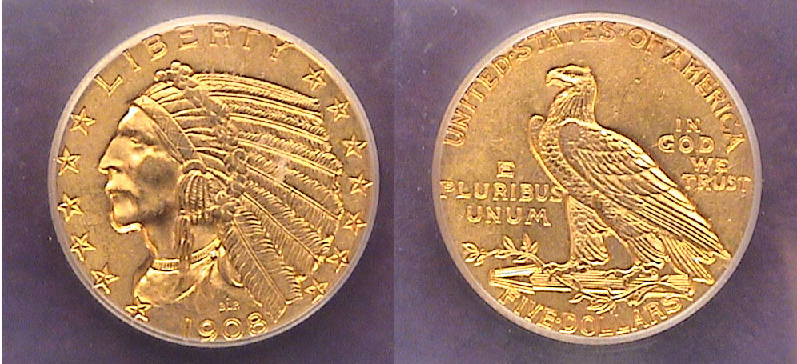

A 1908 $5.00 gold half-eagle graded MS-61 by PCGS
[Enlarge the coin to fill the page in order to view details.]

Due to the influence of President Theodore Roosevelt who became our 26th president upon the assassination of William McKinley in 1901, he started a campaign to modernize the appearance of our coinage. He contacted Augustus Saint-Gaudens, our most famous sculptor of the period, who drew up the plans for the $20.00 and $10.00 gold pieces that would be released in 1907 followed over the next two decades by many of his disciples; one of them being a lesser known sculptor named Bela Lyon Pratt, from Massachusetts. He is best known for creating the bust of a native American chief facing left for both the $5.00 half-eagle and $2.50 quarter eagle by creating an intaglio striking of the central devices on the planchet. Instead of the coin’s surface appearing smooth, it’s design is “incuse”, i.e., inserted into the metal surface. As a result, over time, the coin wears much more slowly. The new coin was released in 1908 with a mintage of 577,845 but not before 421,874 Liberty Head examples of the older version were struck. As a result a collector has the option to acquire an attractive transitional pairing for his or her collection. The author obtained both the 1908 pieces at the FUN Show held in Orlando, FL in 2008.

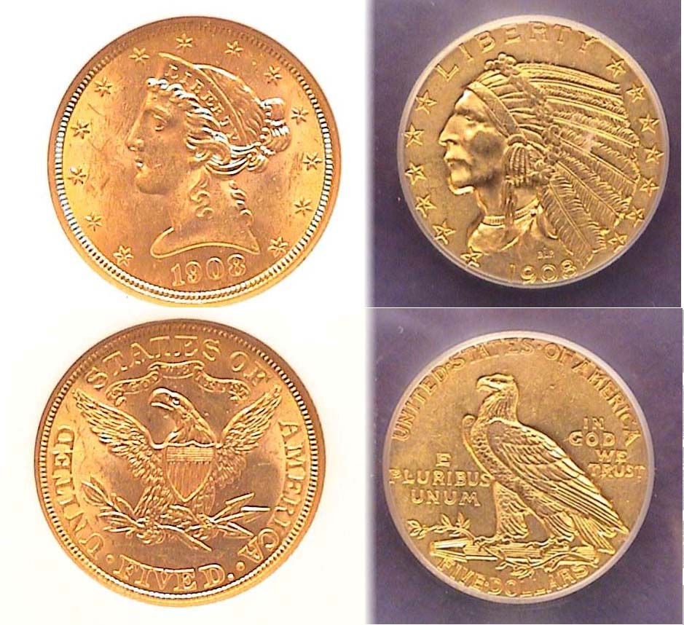

1908 Transitional $5.00 types both certified MS-61
Pratt’s $5.00 gold coin type was struck from 1908 thru 1916 in consecutive years at both the Philadelphia and San Francisco Mints while the Denver Mint produced the coin from 1908 thru the key date 1911-D issue. After 1916, the coin was suspended until 1929 when the Philadelphia Mint produced 662,000 for one last hurrah.

Bela Lyon Pratt
There is an irony regarding the first two half-eagle gold types and the final two half eagle gold types because both were created as transitional dates since they were struck in the same year; the Draped and Cap Bust in 1807 and the Liberty Head and Indian Head in 1908. After 1933, the United States went off the gold standard and no more gold denominations were struck for circulation.
___________________________________________________________

STEPHEN JAMES CSRA COIN CLUB
Minutes from the Regular Meeting
Thursday, February 3, 2022

President J.J. Engel, called the regular meeting of the club to order at 6:50 p.m. The Club members enjoyed attending at the gym of the South Aiken Presbyterian Church (SAPC). There were 19 members and two guests in attendance, and one member joined the meeting via Zoom.

Glenn Sanders won the member door prize drawing, a 2017 ¼ oz silver Mexican Libertad. Steve Kuhl reported the upcoming area coin shows. A motion was made by Glenn Sanders and seconded by seconded by Andrew Goslin, to dispense with the reading of Minutes of the January 2022 meeting.

Treasurer Chuck Goergen reported the Club’s bank balance was $619.56.

Old Business
: 1. President Engel reported the Aiken County Library had told him that when a Meeting Room becomes available for the coin club’s use, the Library will be closing at 7:00 p.m. which makes the room impractical for our meetings. Steve Kuhl said he believed SAPC had a room smaller than the gym that might be more suitable for the coin club meeting and he would explore the club’s possible use of it.

2. Coin Show Coordinator Pat James said she was ready to move forward with the early stages of a 2022 coin show to be held the first Saturday following Labor Day in September, providing all the workers at the 2019 Coin Show were willing to contribute the same support, and those of the workers present indicated they would.
____________________________________________________________________________________________________
(Club Minutes continue on page 5, column 1)
STEPHEN JAMES CSRA COIN CLUB
Regular Meeting Thursday, February 3, 2022
(Continued from preceding page)

3. President Engel reminded the members that Officer elections would be held in March and anyone willing to serve should contact any of the current officers, who have been serving a long time and would welcome a change.

4. President Engel also reminded the members that the $15 club dues would be due in April and could be paid any time.

New Business:
The March program will be Part 2 of Arno Safran’s “Contemplating the Beauty of our Early US Gold Coins from 1795 to 1839."

Show and Tells:
JJ Engel shared the award he had received for his Exhibition at the South Carolina Numismatic Association’s annual coin show in 1985.
Arno Safran brought in a beautiful 1947 Mint set in a Capitol holder. Chuck Goergen’s eye was caught by a 1901 Indian Head Cent for sale on eBay, and he purchased the coin and brought it to the meeting. He thought the grade was AU and it was beautiful with a lot of luster.
John Kolmar shared his new light for optimal viewing and grading coins.

New member Rick Raffone won $10 in the 50-50 raffle.

The Program:
The February meeting’s program,
"Treasures at the National Money Show Part 2,”
was given by Steve Kuhl as a follow up to Part 1 that he gave in January. The informative power point
program was about the Collector Exhibits. Steve explained the categories and awards given by the ANA. The exhibits ranged from one table to six table presentations and included fact sheets with the
surrounding history. Some of the exhibits were of popular with well-known items, such as the Coca Cola money and medals and some on lesser known subjects such as slave badges and Jewish medallions.

President Engel thanked Steve for his interesting presentation.

It was a notable coincidence that JJ had
brought in his 1985 award for an exhibit at a SCNA coin show.
With the Sgt at Arms and club auctioneer, Jim Sproull being unable to attend, President Engel handled the monthly club auction assisted by Steve Kuhl. The auction was quite active with silver items, particularly silver eagles, going for good buying prices.

President Engel reminded the members that the next regular meeting would be at 6:45 p.m. on March 3, 2022, at South Aiken Presbyterian Church, and adjourned the meeting at 8:35 p.m.

Respectfully submitted,
Jim Mullaney, Secretary
_______________________________________________________________________________

Kindly Patronize our advertisers
