Pres. Willie Simon
V .P. James Barry
Sec. Helen Barry
Treas. Pat James
Sgt. in Arms: J.J. Engel
Committees:
Auction: J.J. Engel
Programs: James Barry
Newsletter: Arno Safran
The Stephen James
CSRA Coin Club of Aiken
P.O. Box 1739
Aiken, SC 29802
Web site: www.sjcsracc.org
The Stephen James CSRA Coin Club Usually Meets on the 4th Thursday of the Month at the Aiken Public Library

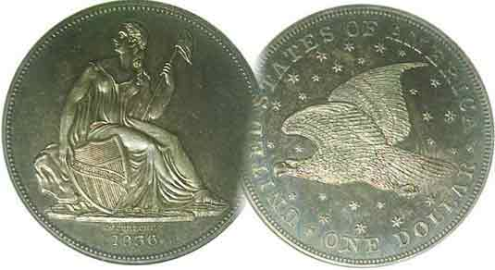

Volume 5, Number 4 the Stephen James CSRA Coin Club Monthly Newsletter April, 2006
Club Plans To Change Its Meeting Location
When Push Comes To Shove
Our Next Meeting is a 3rd Tuesday, Apr. 18, 2006 at the Aiken Public Library at 6:45 PM

Since the Stephen James CSRA CC was formed in March of 2001, the Aiken Public Library’s policy has been to allow it to use their meeting room by arrangement but only on a month to month basis. At first this did not present a problem but with more and more retirees and their various organizations vying for the space, the library—more than ever—has been unwilling to lock us in for the same day of each month for a full year. Since it is only open two evenings a week; Tuesday and Thursday; we have already reached the point where we can no longer be guaranteed a meeting from one month to the next. At the March 30 meeting, the members listened to the three options available to the club known at that time. These were 1. To move to a room at the U. of S.C.-Aiken for a $50 a month rental; 2. To move to the Club House at Cedar Creek where we would have an even nicer facility with the same available technical equipment at no charge on the second Thursday of the month for a full year or 3. Remain at the library and take our chances. However, despite some of the benefits; the downsides had to be considered. Regarding option 1, renting a University room, there would not be enough money to afford a rental fee which could be increased after the initial year ended. For option 2, meeting at the Cedar Creek Club House, most members would have to travel a longer distance to attend as Cedar Creek is located in the New Ellenton area. Regarding 3. remaining where we are; the prospects were simply too unreliable to consider. A vote was held and of the twenty-five members present; all voted to move to Cedar Creek. At the upcoming meeting on Tuesday, Apr. 18 those members—unable to attend the Mar. 30 meeting--will be given an opportunity to voice their views and present other options perhaps unknown to the rest of us.

Review of the March 30 Meeting

The Minutes, taken by Helen Barry were filed for review and our treasurer, Pat James reported the balance in the club’s treasury at $572.38. Member Mark Headquist will be performing the club’s annual audit. Thanks Mark. President Willie Simon again encouraged more members to consider sharing their numismatic experiences either by writing a short article for the newsletter or at the monthly Show & Tells. Coleen Reed, Chairperson of the nominating committee reported that the current officers have agreed to serve for another year if elected though nominations for others would be entertained at the April 18 meeting; at which time the election will be held.
_____________________________________________________________________________________________
(Club News continued on page 4, column 2)

Honoring Abraham Lincoln on America’s Small Cent
Part Two of Two by Arno Safran

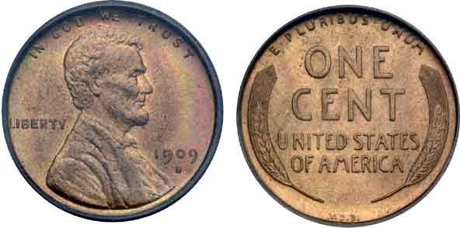

The 1909-S VDB Lincoln Cent
(Courtesy of Ira and Larry Goldberg Collectibles)

It was Theodore Roosevelt—perhaps more than any other US President—who recognized the importance of artistry on our nation’s coinage. By 1907 he had arranged for the change over in all of our gold denominations; the $2.50 and $5.00 Indian Heads by Bela Lyon Pratt and the $10.00 Indian Headdress and $20.00 Striding Liberty by renowned sculptor Augustus Saint-Gaudens. While still in office Roosevelt had posed for a portrait by Victor David Brenner in 1908 when plans for a new cent type honoring Lincoln’s centennial were underway. Brenner had produced a plaque honoring Lincoln in 1907 looking much like our current cent obverse. The President had seen this and was impressed. Roosevelt may have already discussed a new design for the cent honoring Lincoln with Mint Director Frank A. Leach recommending Brenner to him. By early 1909 Brenner was already at work on the new coin even though 1909 Indian Head cents were being produced at Philadelphia and San Francisco. After a number of minor alterations, the new cent was ready for production. By this time, Roosevelt’s protégé William Howard Taft, our 27th President had succeeded him. On May 12, 1909 some proofs were struck and after some more revisions which included the insertion of the motto, IN GOD WE TRUST, the new coin was approved by Treasury Secretary Franklin MacVeagh on July 14. The insertion of the motto was originally thought to be the recommendation of Taft but has since been discounted as there is no evidence that the new President was ever involved in the production. When the new coin was released, its design was highly praised except for the inclusion of the engraver’s initials VDB on the reverse.
______________________________________________________________________________________________________
(Continued on page 2, column 1)
The Lincoln Cent (Continued from page 1, column 2)

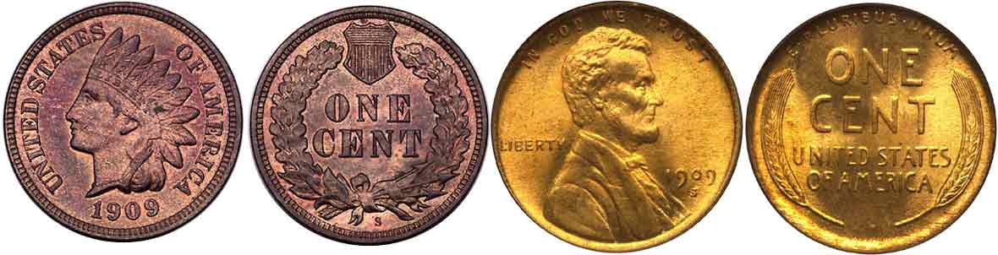

1909-S Indian Head and Lincoln Wheat Cents
1909 was another transitional Year.

By the time the Lincoln cent entered circulation in 1909, some 14,368,000 Indian Head cents had been struck at the Philadelphia Mint along with 309,000 at the San Francisco Mint. That was well below the 1877 mintage (852,500) but a greater proportion of the 1909-S Indians were saved. Meanwhile Lincoln cent production for 1909 was even larger. At first, Brenner engraved his three letter initials VDB on the reverse centered just above the rim. 27,995,000 1909 VDB cents were minted in Philadelphia but just 484,000 of the 1909-S VDB cents were struck at San Francisco. To this day, the 1909-VDB is among the most common Lincoln cent in mint state while the 1909-S VDB is considered the absolute “key date” of the series. Sufficient pressure by critics forced the removal of the Brenner’s initials with the result that later that year, an even greater number were struck without the VDB; 72,702,618 in Philadelphia and the much lower 1,825,000 at San Francisco. Apparently not nearly as many of the latter were saved and while 1909-P is fairly common in mint state, they surface less frequently than the VDB issue. The 1909-S Lincoln on the other hand is considered one of the lesser keys and is also in demand. There is even a variety featuring a 1909-S over a horizontal S. In 1918, Victor David Brenner’s initials were reinserted; this time in tiny letters on the truncation of Lincoln’s Bust.

Assembling a 1909 Transitional Date Set

One could spend quite a lot of money just putting together a complete set of Indian Head and Lincoln cents dated 1909 alone, especially if graded MS-65. For most collectors, the least expensive paring of the three transitional dates would include the 1909-P Indian, the 1909-P VDB Lincoln and the 1909-P Lincoln. Even in MS-63–with enough Red color remaining–these three coins would appear quite attractive as a transitional date set.

Options for Collecting this lengthy Series

Lincoln cents may be divided into two major groups; 1909-1958 (or wheat back reverses) and 1959 to date (known as the Lincoln Memorial reverses). There are many ways to collect this series. The most ambitious would be as a complete date and branch mint set (1909 to date including proofs from 1975-S on for the Memorial cent issues); challenging to say the least in any grade. A second would include only the Wheat back portion. A third and less expensive would include only the Memorial cents from 1959; including the proof issues beginning with the 1975-S issue. A fourth option might be to simply attempt to collect one for each date choosing the most common by year. Another would be to collect one for each sub-type.

Collecting Lincolns by Sub Type

There are ostensibly six subtypes for the Lincoln Cent Series. Four of these are observable. These include: 1. the VDB on reverse; (1909 only) 2. The absence of the VDB anywhere on the coin (1909-1917), 3. The VDB in small letters on the truncation of the Bust (from 1918 on), 4. The steel cents (1943), 4. The gun metal cents (1944 and 1945); unobservable, 5. The Memorial reveres (1959 to date) and 6. The change over to Zinc coated copper (from 1982); also unobservable for the most part. This would be the collector’s least costly option and affordable up to mS-65.

The Keys

There are a number of rare dates among the Wheat back portion of the series. These are sometimes referred to as the” Big Five” because sooner or later, most collectors discover these are the hardest holes to fill in the set; especially if you are attempting to complete the set out of circulation. First there’s the 1909-S VDB and 1909-S followed by the 1914-D; then the 1922-D (or Plain; i.e. with the D missing) and the low mintage 1931-S (866,000). The last date however despite its low mintage was saved in sufficient numbers as word got out beforehand and has always been available for a price.
[The 1914 D has been counterfeited. One replica shows a wider than normal space between the 1 and the 4 which suggests a 1944-D specimen was filed at the date. What the counterfeiter overlooked was the tiny VDB initials on the Bust below which was absent on all Lincoln cents until 1918].

Lincoln Wheat back cents were struck for most years at all three Mints; Philadelphia, Denver and San Francisco. In 1922, cents were struck only in Denver, a low mintage year with only 7,160,000 minted. According to David W. Lange, author of “The Complete Guide to Lincoln Cents”:

“The no-D variety…resulted when normal dies came together with no planchet between them, leaving both dies with shallow and inverted impressions of one another. The obverse die was then abrasively polished to remove these clash marks, leaving it without a mintmark and with several low-relief elements (including the date) noticeably weakened. The reverse die was removed altogether and replaced by a fresh one.”

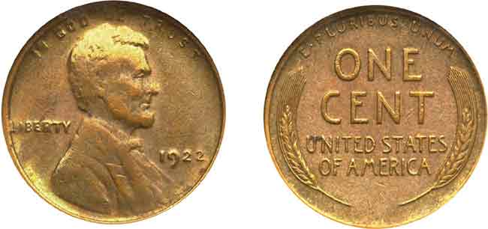

A 1922 Plain Lincoln Cent
Notice the “spongy” strike and overall lack of clarity
(Courtesy of Superior Galleries)

In 1975 the San Francisco Mint struck only Proof Lincolns which meant that collectors wishing to continue acquiring S Mints–heretofore struck as business strikes—would now have to buy the more expensive proofs. This caused a brief run on the first year of the Bicentennial Proof sets which have since retreated in price.

Is the Lincoln cent type the longest running type coin in US history? The answer is, Not exactly! There is one coin that was struck with the same device type for a longer period; the $5.00 half eagle gold reverse from 1807 through 1908.
_______________________________________________________________________________________________-

Netherlands East Indies Japanese Invasion Money
By Bill Myers

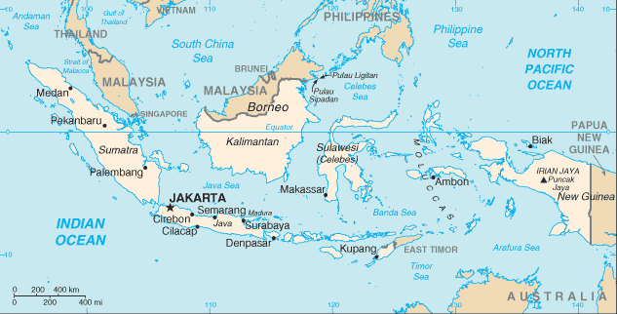

The Netherlands (or Dutch) East Indies, now known as Indonesia, were conquered by the Japanese in March 1942. The JIM from this area is the most varied. For this series of JIM the block letter is “S”, for Sumatra. There are specimen notes for most of the denominations and they will not be mentioned below. Counterfeit notes are post-war products.
The first series fractional notes have “DE JAPANSCHE REGEERING”, instead of “THE JAPANESE GOVERN- MENT”, on the face. The notes also have the denomination spelled out on the face and the numeral denomination repeated on an ornamental design on the face and back. The fractional notes come in one, five and ten cent (this is not a typographical error-it is cent, not cents). They are lithographed and have no watermark. Block letters are black.
The varieties are:
1 cent – block letters and fractional block letters
5 cent- block letters and fractional block letters
10 cent-block letters and fractional letters
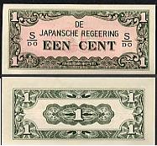

A one cent JIM note from the Netherlands East Indies

The half gulden note has the addition of a fan palm on the right of the face. The varieties are:
½ gulden – block letters, no watermark
- block letters, with watermark

The gulden notes have an engraved face and lithographed back. The block letters and serial numbers are black. The denominations are 1, 5 and 10 gulden. The face has “DE JAPANSCHE REGEERING”, “BETAALT AAN TOONDER” (pays to bearer) and the denomination both spelled out and as repeated numerals. The back of the 1 and 5 gulden have the numeral repeated on an ornate design. The back of the 10 gulden has the addition of a vignette of a ship on the horizon. All notes have a quatrefoil (flower with four petals) watermark, unless noted otherwise.

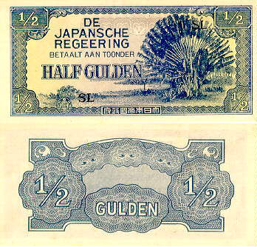

A ½ Gulden JIM note from the Netherlands East Indies

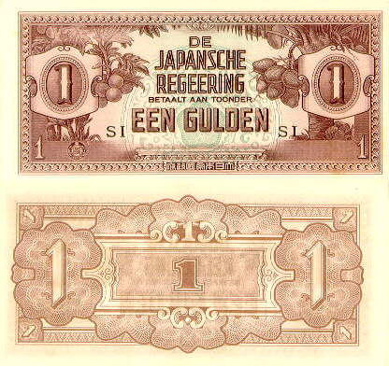
A One Gulden JIM note from the Netherlands East Indies

The 5 gulden note has a coconut palm on the left and a pawpaw on the right. The varieties are:
5 gulden – block letters, serial number- block letters only
The 10 gulden has bananas, breadfruit and coconuts in the center of the face. The varieties are:
10 gulden – block letters, serial number
- block letters only
- block letters only, on woven quadrille paper
- block letters only, on horizontal quadrille paper

The Japanese determined there was a need for higher denomination notes. At the time, anti-Dutch sentiment was prevalent in the Netherlands East Indies. The Japanese took advantage of this and changed the denomination on these notes to “roepiah”. They were issued as 100 and 1,000 roepiah.
______________________________________________________________________________________________
(Continued on page 4, column 1)
Netherlands East Indies J.I.M. (Continued from previous page)

There are many deceptive recent replicas of the roepiah denomination notes. These are slightly larger than the original reopiah notes and have staining on the edges. The staining is identical on all of the notes as it was part of the printing plate. The silk threads are printed on the paper, so they, too, are identical on each note. The ½ reopiah has an ornamental design on the face and back. The varieties are:
½ roepiah – block SP
-unfinished note: no block letters
The 1 reopiah note shows workers in a field on the face and a banyan tree in the center on the back. The varieties are:
1 roepiah – block SN
Unfinished note: no block letters-replica

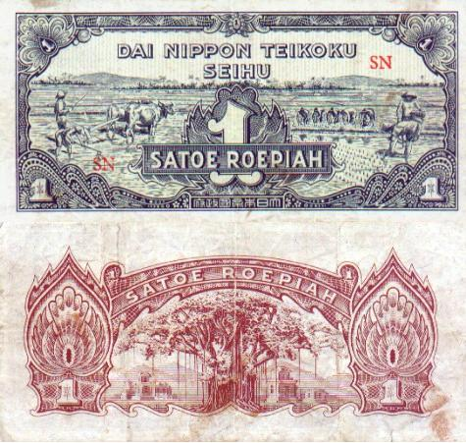

A One ROEPIAH Netherlands East Indies replica J.I.M. Note
Showing Workers in a field on the face; banyan tree on the back.

The face of the reopiah has a native home on the left of the face. The back has a Buddha and native temple on each side and an oriental design in the center.
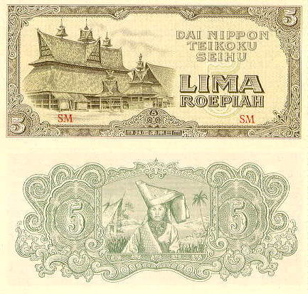
The 5 roepia; a beautiful note!
________________________________________________________________________________________________________

More Club News (continued from page 1, column 1)

The Program and Upcoming Program

Bill Myers presented an excellent slide-talk on his ongoing series of J.I.M. notes appearing in this newsletter. He displayed a virtually complete set of Japanese Invasion Money from all five countries, Burma, Malaya, the Netherlands East Indies, British Oceana and the Philippines pointing out the many varieties. If you missed this talk you will have another opportunity on Thursday, Apr. 20 at the Augusta Coin Club meeting at the America’s Best Value Inn (formerly Guest House Inn) on Washington Road, just above I-20, Exit 199. At the upcoming meeting Arno will present a slide talk on Latin American coinage that was legal tender in the US until 1857.

Club to Hold Second Road Show

Our club will be holding its second annual Road Show at the Aiken Public Library on Saturday, Apr. 22 from 12:00 noon to 3:00 PM. If you know some people who have coins or banknotes that they would like to determine their value, bring them in to show one of our several club members who will be on hand to appraise them.

The winner of last month’s door prize was Jack Seech and the 50/50 winner was Gary Bailey. Congratulations gentlemen. Remember, the next meeting is still at the library but coming up fast, Tuesday, April 18. Hope to see you all there.
____________________________________________________

Kindly Patronize our Advertisers
