Pres. Willie Simon
V .P. James Barry
Sec. Helen Barry
Treas. Pat James
Sgt. in Arms: J.J. Engel
Committees:
Programs: James Barry
Show Chairman: JJ Engel
Newsletter: Arno Safran
E-Mail: arnosafran@comcast.net
The Stephen James
CSRA Coin Club of Aiken
P.O. Box 1739
Aiken, SC 29802
Web site: www.sjcsracc.org
The SJ CSRA CC Now Meets on the 2nd Thursday of the Month at the Cedar Creek Community Center in Aiken, SC

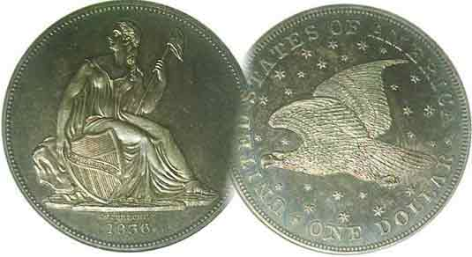

Volume 6, Number 4 the Stephen James CSRA Coin Club Monthly Newsletter April, 2007
Program on Counter-stamped coins Given
Our next meeting is on the 2nd Thursday of the month, April 12, 2007 at 7:00 PM
2007 Club Meeting Schedule - 2nd Thursdays at 7 PM Jan. 11 Apr. 12 July 12 Oct. 11
Feb. 8 May 10 Aug. 9 Nov. 8
Mar. 8 June 14 Sep. 13 Dec. 6
Club Show: Sat. Sept. 15, 2007
_____________________________________________________________________________________________________________________________

Guest Speaker Xavier Pique Presents Program on
“Counter stamped Coins through the Ages”

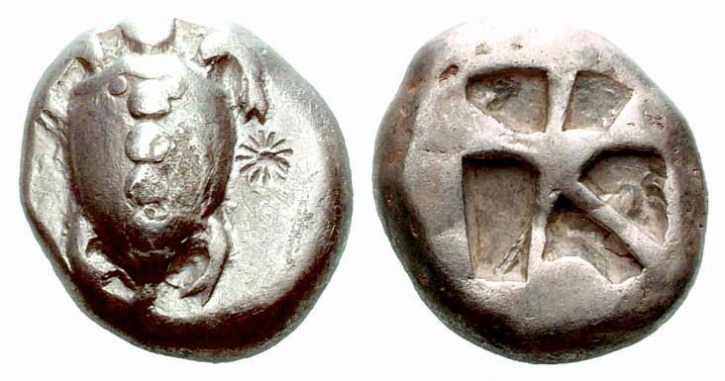

Aegina – Archaic Greek – Turtle with counter-stamp
From 6th Century BC to 479 BC

At our March 8 meeting, Xavier Pique, Treasurer of the Augusta Coin Club and author of numerous numismatic articles gave a PowerPoint presentation entitled, “Counter stamped Coins through the Ages”. The slides spanned more than two millennia going back to Classical Greek coinage, progressing through Roman, Byzantine, late Renaissance Hispanic coinage, Colonial British to the United States Trade dollar and into the 20th century.

Xavier defined counter stamping as the marking impressed on a coin after minting. He explained the various rationales for counter-stamps on coins: 1 .to denote an independent state, 2. to satisfy a coin shortage, 3. as a political or economic measure, 4. as a status symbol of ownership and 5. As an assayer’s mark indicating the coin’s silver or gold fineness and weight falls within acceptable standards. One of the earliest known counter-stamped coins originated in Aegina, an island in the Aegean Sea off the coast of Greece. It shows a turtle with a counter-stamp to its right. The speaker explained how counter-stamped Roman coins traced the Roman Legions across Europe and is of great historical value. This was a most fascinating program and the club thanks Xavier for sharing this topic with us.
_________________________________________________________________________________________________________________
(More club News continues on page 4, column 1)
In Numismatics, Ignorance
Isn’t Always Bliss but Knowledge IS Power
By Arno Safran

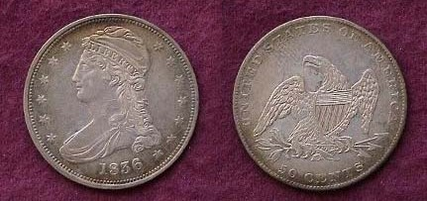

The current retail price of an 1836 Lettered Edge Capped Bust half dollar grading XF-40 is $140 according to the latest Numismatic News’ monthly summary, Coin MARKET, but is the specimen pictured above that coin? At the annual show of a local Coin Club I belonged to in central New Jersey some years ago a dealer thought so and sold a similar graded example as such. Soon a line began forming in front of his table that almost stretched out the door. Other dealers and collectors wanted to see what else they might pick out at this incredible bargain, for the dealer carelessly or ignorantly thought the coin he had just sold looked like the example shown below.

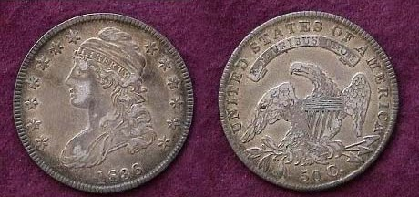

An 1836 Lettered Edge Capped Bust Half Dollar, O-103 R4
The mintage was 6,545,000, the largest of the 30 year run.

The coin at the top of the column is in reality an 1836 Reeded Edge 50¢ piece. The reported mintage of this new Capped Bust type struck late in the same year was a scant 1,200 with a current XF-40 value of $2,800 according to the same source.
__________________________________________________________________________________________________________________________________ (Continued on Page 2, column 1)
Ignorance Isn’t Always bliss but Knowledge is Power
(Continued from page 1, column 2)

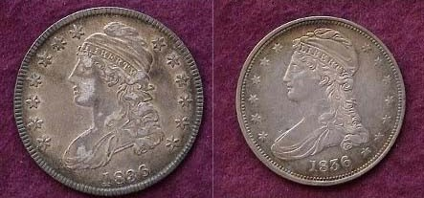

The obverses of the 1836 Lettered and Reeded edge halves

In anticipation of the installation of the new Steam Press, Mint Director Robert Maskell Patterson asked Christian Gobrecht, the new Chief Engraver to prepare a modified design of the Capped Bust half dollar. The coin would have a smaller diameter; 30 mm as opposed to 32.5 mm and be struck in a close collar allowing for uniformity in size with thicker reeded edges. On the minus side, the close collar rendered it impossible to have lettered or engraved edges.

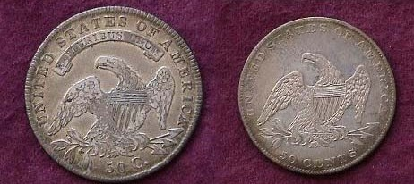

The reverses of the 1836 Lettered and Reeded edge half dollars

Looking at the reverses the differences between the two types are perhaps even more apparent. The motto E PLURIBUS UNUM has been removed; the eagle is smaller allowing for greater space in the field. The lettering above is smaller and the denomination 50 CENTS is spelled out on the smaller coin. The reader may wonder how a dealer could not know the difference between the two. Some of us who were present at the incident are still wondering.

More Subtle Sub-type coin Varieties

This writer recalls another incident in which a collector used his knowledge to acquire a coin of great rarity and again it was with the 50¢ denomination; this time, a Liberty seated half dollar.
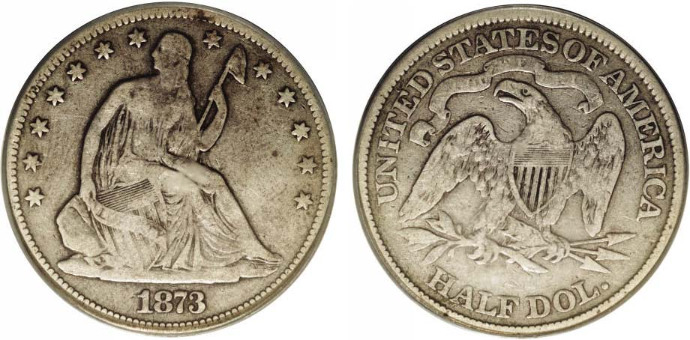
The coin above was cherry-picked by a collector from a dealer’s case at a small commercial show in Eastern Pennsylvania about 25 miles north of Philadelphia. The specimen shown of the no arrows 1873 Liberty seated half dollar (at the bottom of column 1) is not particularly attractive. It is graded no better than a Fine-12 and looks as if it has been cleaned at one time but is beginning to tone back. As a common date, such a coin had a wholesale value of $25 back in the mid 1980’s but was this a common date? At this show, the collector asked the dealer how much he wanted. “$30.00”, he replied. The collector, attempting some good natured haggling responded, “Will you take $25? That’s bid”, (referring to the Coin Dealer Newsletter’s wholesale price.) “$30.00, take it or leave it. I’m not in this business to play Santa Claus.”, the dealer snapped back. “OK! OK!” the collector acquiesced and parted with his $30 cash while receiving his “pick” of a lifetime. Spotting two of his dealer buddies on the other side of the bourse, he tweaked, “What will you pay me for this coin?” $20.00 scoffed the first one. It’s a dog!” The other one frowned and responded more politely, ‘It’s not very attractive.” “Why don’t you look at it more closely?” the collector suggested. The two dealers studied it again, turning the coin in all directions and the arrogant one bellowed, “It’s still a dog and I don’t know what you’re talking about. Are you trying to tell me that the 1873 no arrows is rarer than the with arrows?” (This was a reference to the Mint increasing the silver weight from 12.44 to 12.50 grams; then placing arrows along side the date to indicate this in 1873 and again in 1874.).

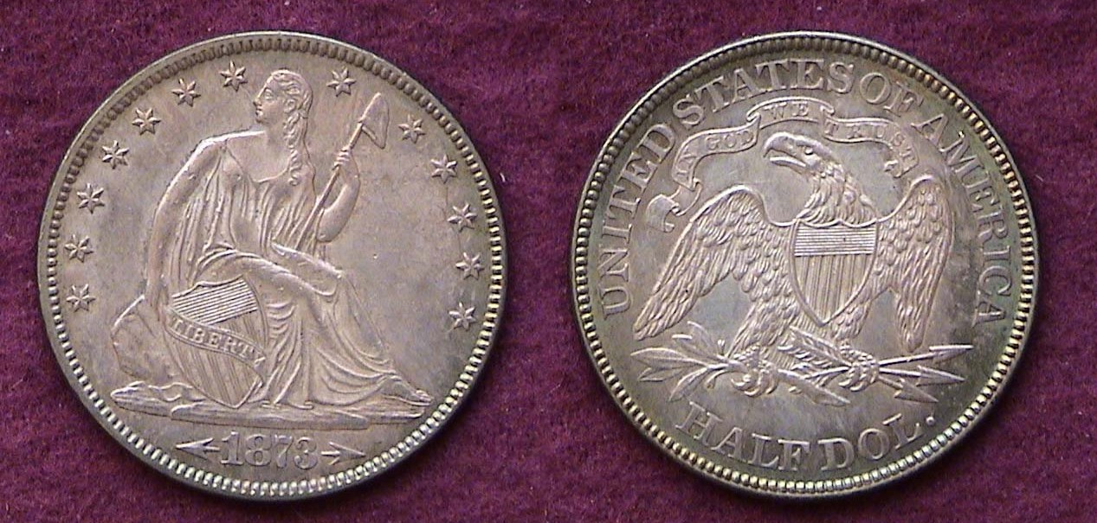

An 1873 Liberty seated half dollar with arrows at date
Denoting the slight increase in silver weight from 12.44 to 12.50 grams.

The collector now advised them to look at the date. Realizing both dealers still hadn’t a clue, he took out his Red Book and turned to the page showing the two no arrows varieties for the 1873 Liberty seated half dollar. It showed both a closed “3” and an open “3” and next to the latter, the value of $3,000 listed in the Fine-12 column. “Look at the date again. It’s has an open 3.” (The Closed 3 in the date was changed to an open 3 because it resembled an 8. In the half dollar’s case, less open 3’s were struck but very few have survived.)

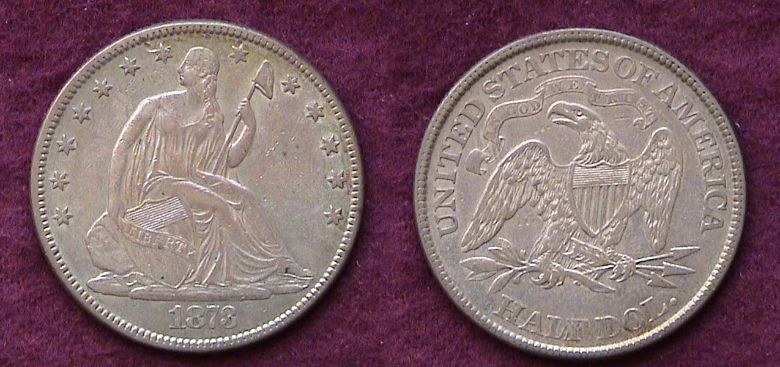

An 1873 Liberty seated half dollar with closed 3, no arrows.
The coin at the lower left is the rare open 3 no arrows version. It recently sold for $4,313.50 at the Heritage Auction April 26, 2006.

The above tales are true and indicative of many incidents that demonstrate Knowledge as Power.
_________________________________________________________________________________________________________________________________
SPECIAL INTEREST COLLECTING
By Bill Myers

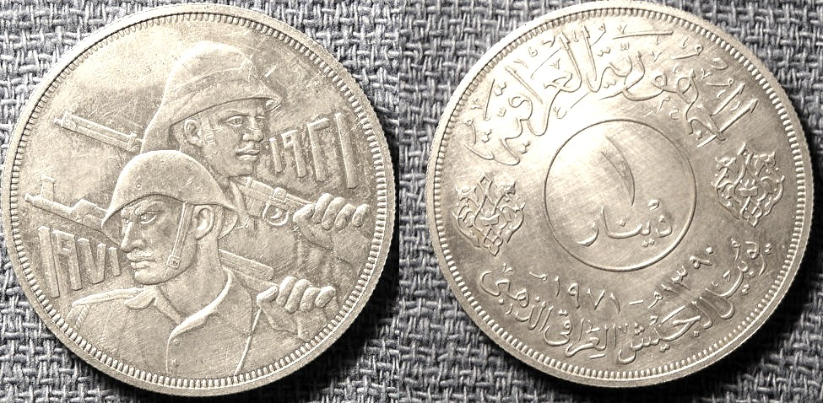

A 1971 Iraqi Dinar showing soldiers’ hands grasping riffles; KM-133

Numismatics offers an unlimited variety of ways to collect. One of my pursuits is to collect numismatic items with hands on them. I have acquired a number of coins, paper notes and medals. I have not let my deployment to Iraq prevent me from pursuing this area of my numismatic interest and have managed to find four items with hands on them. The first is a coin. It is a 1971 Iraqi one dinar coin listed as KM # 133 in the Standard Catalog of World Coins from 1901 to the Present; edited by Chester Krause and Clifford Mishler. It is a silver 1 dinar piece celebrating the 50th Anniversary of the Iraqi Army. The obverse features two soldiers holding weapons on their shoulders and the left hand on each soldier is clearly visible.

The next item is a silver piece the same size as the previous coin. The salesman said it was also a 1 dinar coin but I believe it is a medal as there is no denomination on it and the edge is smooth and without reeding that is present on the coins. It celebrates the 10 th Anniversary of the Iraqi Republic. On the obverse are four hands doing various activities. It was something I had to have for my collection. It took about 30 minutes of bartering to get it at a reasonable price.

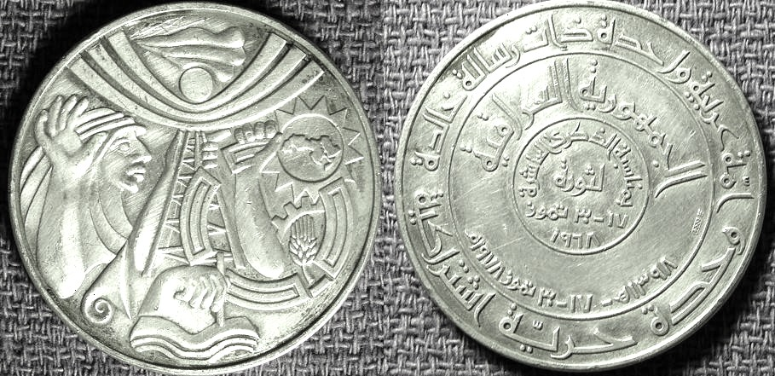

An Iraqi Medal celebrating the 10th anniversary of the Republic

The next piece is a military challenge coin made as a souvenir. One side says the Green Zone and the other has the International Zone. They both refer to the US area in downtown Bagdad. It has a hand holding a sword which is modeled after the crossed swords monument in the Green Zone that Saddam built to celebrate the Iran-Iraq war. The hands on the monument are modeled after Saddam’s own hands.
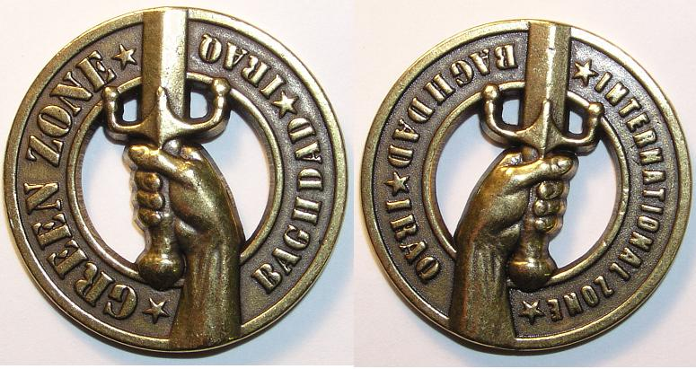

A Baghdad Green Zone military challenge coin

The last item is a 1991 100 dinars note (P-76) that has the hands holding the crossed swords on the back.

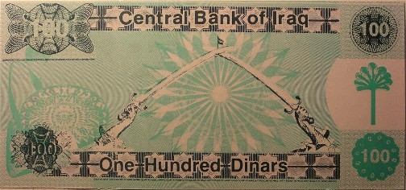

The back of a 100 dinars Iraqi note issued in 1991

Thus, I have managed to add four more pieces to my collection in the war zone of Iraq. In Iraq my interest in numismatics sometimes has to take a back seat but it is never far away.
______________________________________________________________________________________________________________________________

Member Bill Myers’ article on “Challenge Coins among the Military” will appear in the upcoming April, 2007 issue of the Numismatist, monthly journal of the American Numismatic Association. Congratulations, Bill!
________________________________________________________________________________________________________________________________

2007 Dues Now Due

The SJ CSRA CC begins its 7th fiscal year this month. The newsletter was started towards the end of the club’s first fiscal year in January 2002. That year turned out to be an auspicious beginning as the club won the “Best Coin Club in the State” award from the South Carolina Numismatic Association at their annual Convention and the newsletter took third place behind the Atlanta and the Las Vegas Coin Clubs in the ANA’s annual Outstanding Club Publications contest. Many coin clubs are run rather informally with no regard for Robert’s Rules of Order and offer no educational programs, Show & Tells or any other form of member involvement. In addition to the regular monthly auction, the SJ CSA CC offers all of the above plus a big show in September and we are currently meeting in a very attractive and commodious facility with a state of the art audio-visual set up allowing for VCR, DVD video and PowerPoint programs. Quite a number of members have already renewed ahead of the due date. Thank you! Dues is $10 for adults; $5.00 for juniors under 19. Checks are payable to Pat James, P.O. Box 1739, Aiken, SC 29802 and thanks.
__________________________________________________________________________________________________________________________
Club News
(Continued from page 1, column 1)

About 21 members and 1 guest, the speaker Xavier Pique were present at the March 8 meeting. Doug Moody set up a table with coins for sale. Doug specializes in uncirculated United States year sets from 1950 on. A number of these sets are attractively housed in Capital Lucite holders. Glenn Sanders, Paul Simons and Jim Barry contributed coins to the junior grab bag. Thanks gentlemen on behalf of the club. Show Chairman J.J. Engel reported that the club contracts have been mailed out. The Flyers are done and one major dealership, Carolina Gold has already sent in their check. President Willie Simon encouraged members to bring in guests and more young people to our meetings citing the attractiveness of the meeting facility, the agenda and good fellowship enjoyed by all. Besides, starting with the April 12 meeting a prize will be awarded at year’s end to those with perfect attendance during the fiscal year. It was reported that some members consider the location too far from the previous centrally located library venue but quite participants drive all the way from Augusta and Columbia County, GA along with several from N. Augusta because they derive much pleasure from the meetings. Treasurer Pat James reported a balance of $722.21 with all expenses paid. Jim Barry reported on the progress of our club web site; www.sjcsracc.org mentioning that our photo gallery has been brought up to date along with a link in which readers can the on line version of the Asylum by clicking e-sylum@binhost.com.

The Election

Glenn Sanders, chairman of the Nominating committee mentioned that all the current members of the Executive Committee would serve if nominated and as no new nominations came forth from the floor, a motion was made to close the nominations. This was seconded and unanimously approved. Glenn then asked for a motion to have the secretary cast one ballot for the current offices. This too was made, seconded and approved unanimously. Reelected were Willie Simon, President, James Barry Vice President, Helen Barry, Secretary, Pat James, Treasurer and J.J. Engel, Sgt. in Arms. These people have done an outstanding job and their efforts have long been appreciated by the members.

Show & Tell: Arno Safran displayed a copper set of US coins struck 150 years ago entitled “The Cents of 1857”. The group included the last year of the Coronet/ Braided Hair half cent and large cent types featuring the large and small date cent versions along with the first official year of the Flying Eagle small cent intended for general circulation. He related that a cent had the spending power of a quarter back in 1857.

Prize Winners: Jerry Axner won the silver eagle door prize and Glenn Sanders took the 50/50. Congratulations gentlemen.

Announcements: Wayne Damron will be presenting a program on “Coins of the Bible” at our next meeting and our annual Coin Road Show is scheduled for Saturday, May 12 from 12 noon to 3 PM at the Aiken Public Library. Our next meeting will be Thursday, April 12. Hope to see you there.
_______________________________________________
Coin of the Month

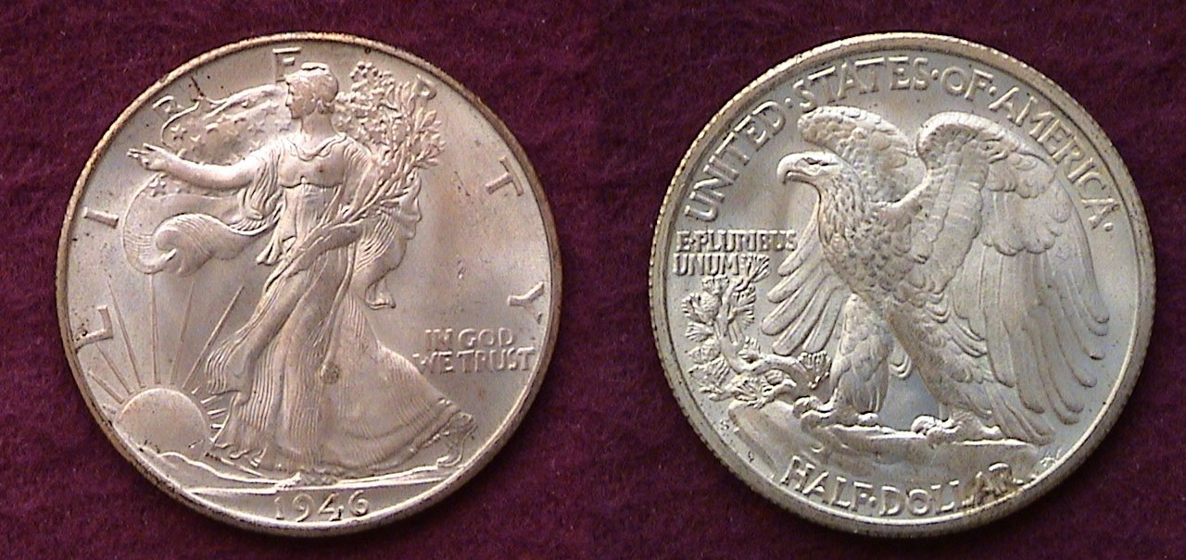

A 1946-S Walking Liberty Half Dollar grading MS-64

With a mintage of only 3,724,000, the 1946-S Walking Liberty Half dollar ranks below all but three dates of the entire Franklin half series yet it is priced as a common date.
____________________________________________________________________________________________________________________

Kindly Patronize Our Advertisers

