Pres. Willie Simon
V .P. James Barry
Sec. Helen Barry
Treas. Pat James
Sgt. in Arms: Glenn Sanders
Committees:
Programs: James Barry
Show Chairs: The Barry’s
Newsletter: Arno Safran
E-Mail: arnosafran@comcast.net
The Stephen James
CSRA Coin Club of Aiken
P.O. Box 1739
Aiken, SC 29802
Web site: www.sjcsracc.org
The SJ CSRA CC Now Meets on the 2nd Thursday of the Month at the Cedar Creek Community Center in Aiken, SC

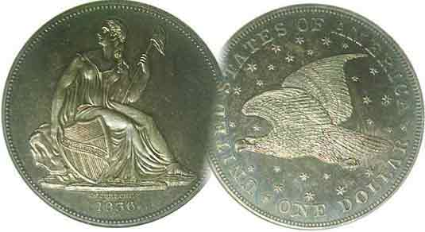

2008 Club Meeting Schedule
Volume 7, Number 4 the Stephen James CSRA Coin Club, Founded in 2001 April, 2008
Monthly Newsletter
GNA and ACC Shows Coming Up Fast
Our next meeting is on the 2nd Thursday, April 10 from 6:15 to 9:00 PM
Jan. 3 Apr. 10 July 10 Oct. 9
Feb. 14 May 8 Aug. 14 Nov. 13
Mar. 13 June 12 Sep. 11 Dec. 4 dinner

_________________________________________________________________________________________________________________________

Georgia Numismatic Association Annual Convention Set for April 18-20 at the Dalton, GA Convention Center

For hobbyists who have advanced to the point where they look forward to broadening their numismatic experiences, the upcoming three day Georgia Numismatic Association Show is a copper, silver and golden opportunity to move from a casual to a more selective collector. The GNA Convention will be held at the Dalton Convention Center in the north-west corner of the state starting on April 18 at 10 AM and continuing through Sunday afternoon, April 20. Around 200 dealers are expected to be on hand. Admission is free and there are a number of modestly priced hotels nearby. From Aiken, take I-20 to Atlanta, then I-75 north to Dalton; estimated time, five hours.
__________________________________________________________________________________________________________________

Club Officers Reelected for 2008-09 Fiscal Year

At our March meeting, the current Executive Committee was reelected unanimously with one exception. J.J. Engel asked to step down as Sgt. in Arms and Glenn Sanders consented to replace him. Thus, the Executive Committee for the 2008-09 fiscal year will be President Willie Simon, VP James Barry, Recording Secretary, Helen Barry, Treasurer, Pat James and Sgt. in Arms, Glenn Sanders. All of these officers have done a spectacular job in the capacities they have served which is why our club is one of the best in the state.

If you haven’t paid your dues yet, here’s a friendly reminder. Dues are $10 for adults, $5.00 for juniors under 18 years of age or under. Please send a check in the appropriate amount, payable to Pat James, PO Box 1739, Aiken, SC 29802 or better yet, join us for the April 10 meeting when Bill Myers will present a program on “Money in Iraq: Part II, and renew then and there.

For the Show & Tell session, Jim Barry brought in a silver tetradrachm of Mithradates VI of Pontius. Mithradates VI had a short reign; less than two years; 83-82 BC. The rare coin showed the emperor appearing as Alexander the Great on the obverse with a seated Zeus on the reverse. Member Bill Myers bought in an Antarctica $1.00, $2.00 and $3.00 plastic notes featuring penguins that were not redeemable on the continent but at the Antarctica blue and red tokens used as change for WWII Ration books printed by the OPA during World War II.
___________________________________________________________________________________________________________________________
(Club News continued on page 4. column 1)
A Look at More Odd U.S. Type Coins
By Arno Safran

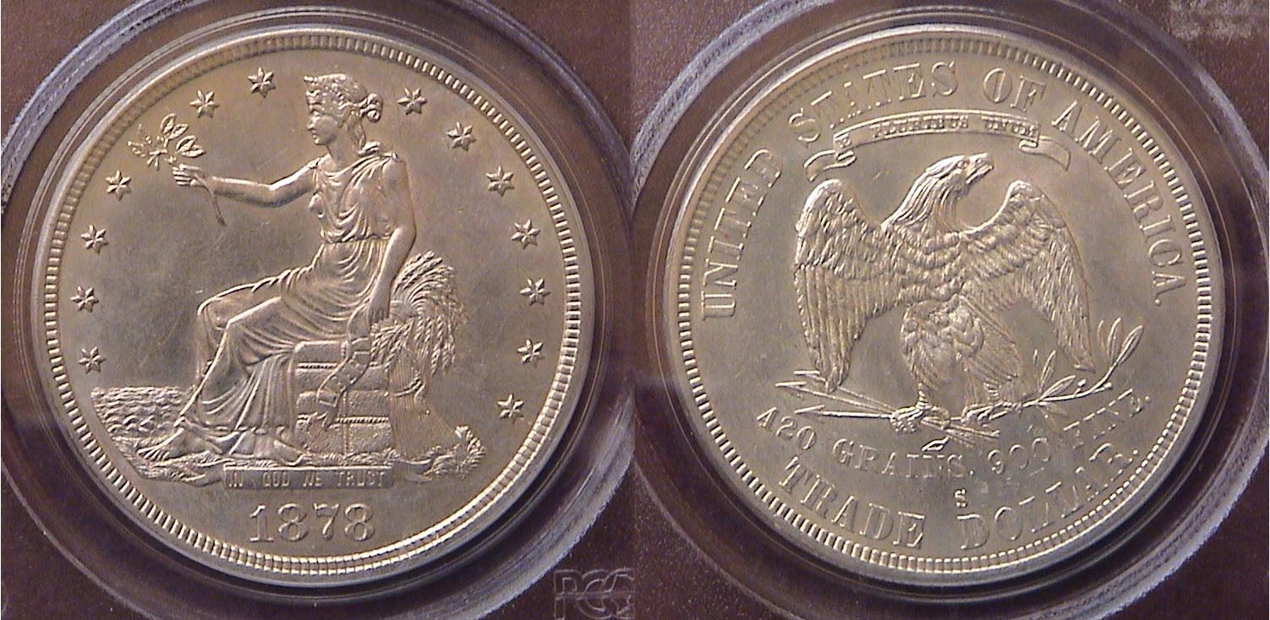

An 1878-S Trade $1.00 certified AU-58 by PCGS
Over 4 million issued at the San Francisco Mint
This was the last year the Trade dollar was struck for circulation.

While corresponding with a numismatic friend I mentioned the article on Odd Type Coins article I prepared for last month’s newsletter that included the ½¢, 2¢ and 3¢ pieces and the 20¢ piece. In his response, he asked, what about the Trade dollar? Thinking his query over, I had assumed the use of the word ‘odd’ applied only to the denominations based on the above. I reflected for a moment on the title embossed on the specific Lucite holder that the Capital Plastics Company manufactured. It read, “UNITED STATES ODD TYPE COINS” across the top; not ‘…odd denominational coins’. Seen in that light, my friend’s suggestion that the Trade dollar be included in such a set made sense. I wondered how many other US obsolete coins might fall into this broader category and concluded that the $1.00 and $3.00 gold pieces certainly could be considered and perhaps, even the half dime; long defunct since 1873.

The year 1873 is one of the most significant in US coinage history. It represented the high water mark for the number of different denominations produced; the 1¢ and 2¢ pieces, 3¢ silver and nickel pieces, 5¢ nickel, 5¢ silver (the Liberty Seated half dime), the LS dime, quarter, half dollar; also three one dollar coins; (the Liberty Seated, Trade and gold $1.00.). The $2.50, $3.00, $5.00, $10.00 and $20.00 gold pieces rounded out the 17 piece year set. There were a number of significant varieties as well.
__________________________________________________________________________________________________________________________
(Continued on page 2, column 1)
A Look at More US Odd Type Coins
(Continued from page 1, column 2)

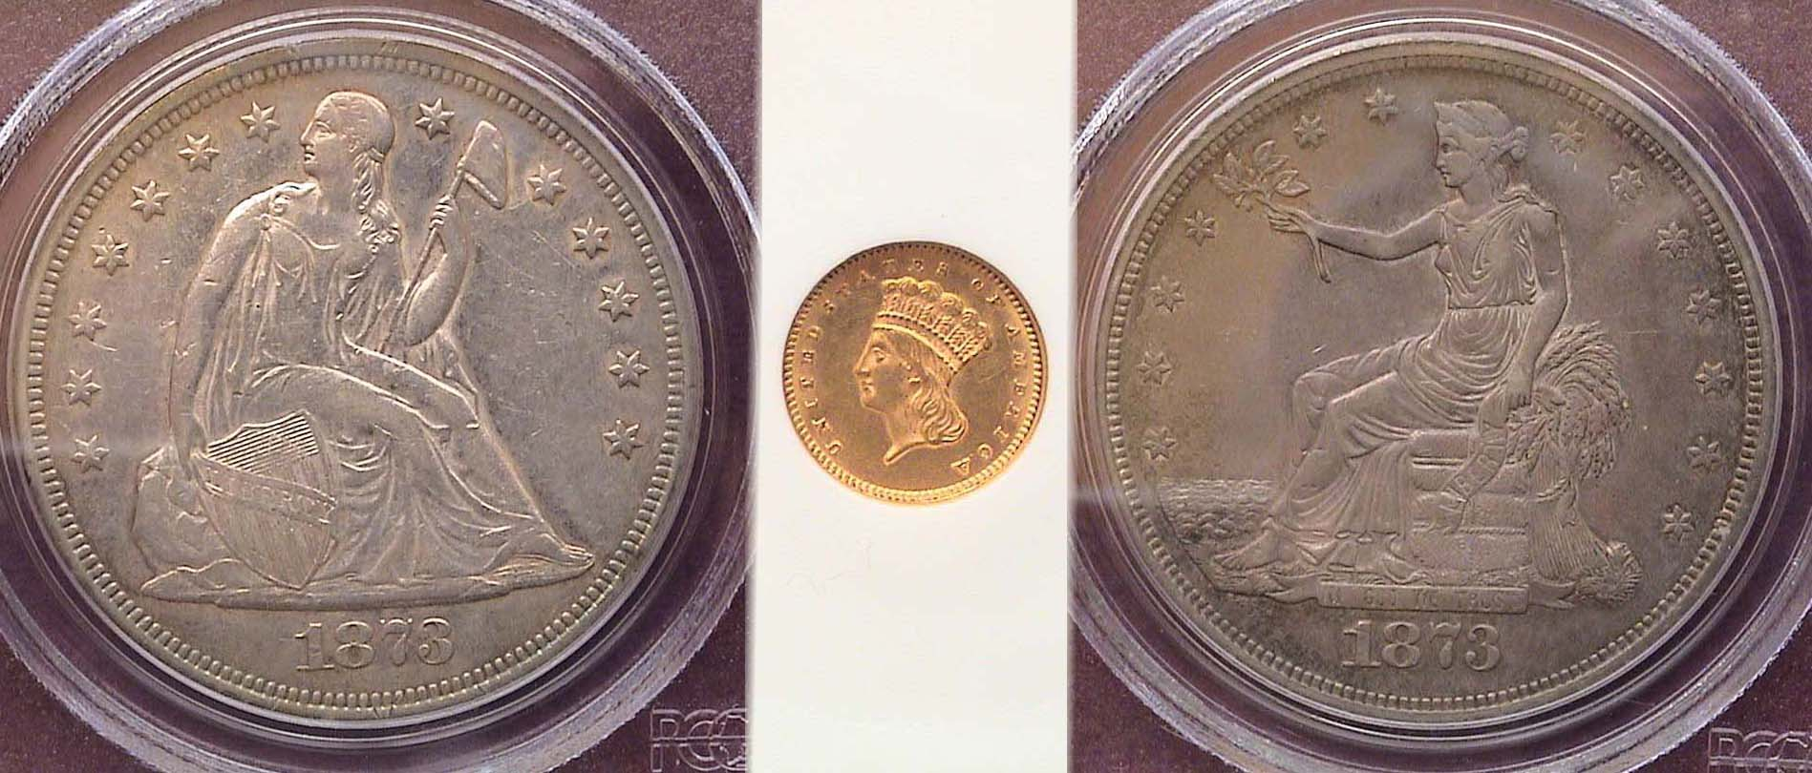

The obverses of the three $1.00 types struck in 1873
At left, Liberty Seated, center, Indian Princess Gold, at right, Trade $1.00
[Magnify to 200% to see details more clearly.]

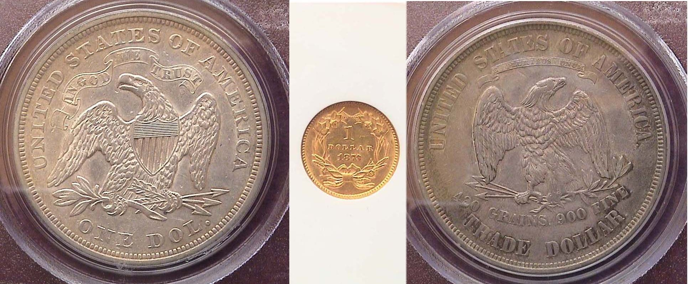

The reverses of the three $1.00 types struck in 1873

The Coinage Act of 1873 is sometimes referred to as “The Crime of 1873” because the law abolished the 2¢ copper piece, the 3¢ silver piece, the 5¢ half dime and the Liberty Seated dollar, the last being replaced by the Trade dollar intended for commerce with the Orient and not for US circulation as such. During its first five years the trade dollar was legal tender only up to five dollars worth and even though it weighed more than the Liberty Seated silver dollar it replaced, many merchants accepted it at only 80% of its stated value.

The silver half dime was first struck in 1794 and despite a number of interruptions, was coined through 1873. There were four major types; the Flowing Hair (1794 and 1795), the Draped Bust, 1796 with small eagle; and then 1800 to 1805 inclusive featuring the Heraldic eagle reverse. After a hiatus of 24 years the Capped Bust was introduced (1829-1837) inclusive and the Liberty Seated; first with no stars in 1837 and 1838-O and with stars around the seated Liberty figure from 1838 thru 1860. From 1861 thru 1873, the legend UNITED STATES OF AMERICA replaced the stars.

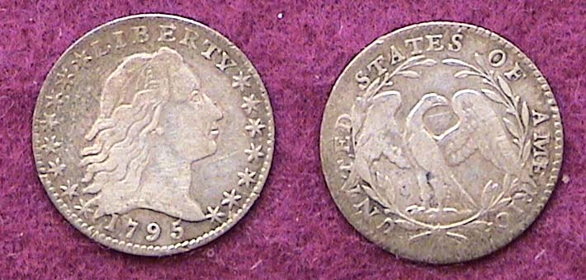

A 1795 flowing Hair Half Dime, V-4 R4 graded VF
The reported mintage was only 78,660
but the date is not considered rare.
[Magnify to 200% to see details more clearly.]

In 1854, a new $3.00 gold denomination was introduced in order to make it easier for businesses to acquire one hundred 3¢ first class postage stamps. The coin was slightly smaller than the $5.00 Liberty half eagle but because the obverse featured Longacre’s Indian Princess design instead of the Gobrecht Coronet Liberty, there was little confusion regarding the denomination. Also, the date was placed on the reverse.

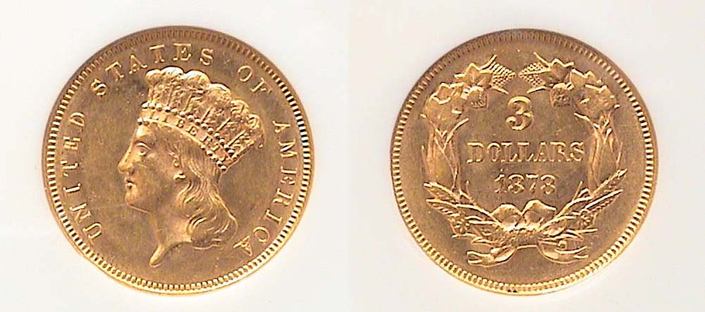

An 1878 $3.00 gold piece graded AU-58 by NGC

Some reading this may ask, what about the $4.00 Stellas of 1879 and 1880? Shouldn’t these be included as another odd denominational type coin? Well, if you consider a pattern that was released to VIP’s (such as high ranking Senators and Congressmen) as a bone fide US type coin, then perhaps these should be included, though it is doubtful that 99.9% of the numismatic fraternity will ever likely own one. They are that rare! There were two obverse types; the Flowing Hair designed by Charles Barber and the Coiled Hair designed by George Morgan, (arguably the more attractive of the two). Both showed the same central large centered star reverse; thereby providing the nomenclature “Stella” to the coin. The mintages for these pieces are unknown ranging from between 400 and 800 for the more common 1879 Flowing Hair Variety. Specimens of the Coiled Hair design are much rarer. The 1880 dated pieces appear to be considerably scarcer than those dated 1879.

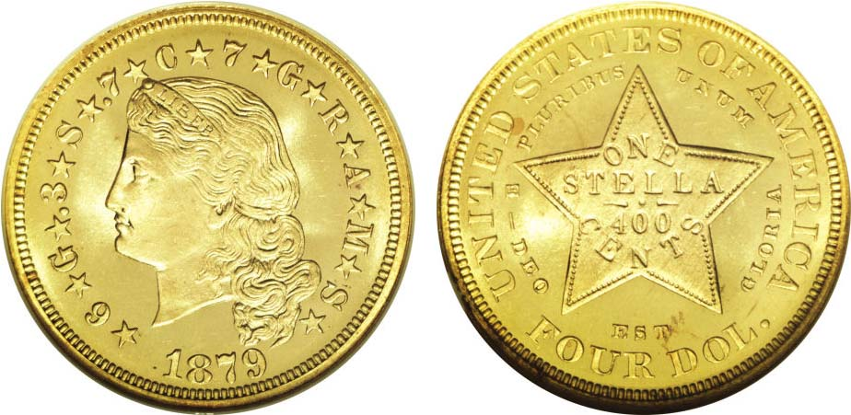

An 1879 Flowing Hair $4.00 Gold Stella graded Proof-67 by NGC.
The coin realized $410,500 at a Heritage Signature & Platinum Night Auction held at the ANA Convention in Denver on Aug. 13, 2006
(Courtesy of Heritage Auction Archives) [Magnify to 200% to see details.]

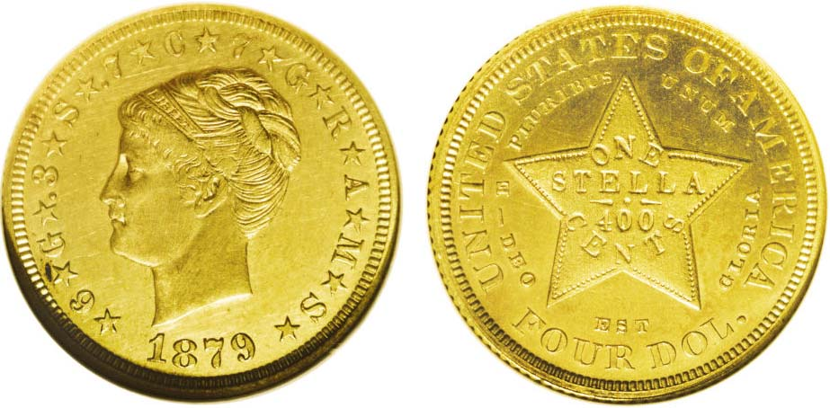

An 1879 Coiled Hair $4.00 Gold Stella graded Proof-63 by NGC.
This coin also realized $410,500 at a Heritage Signature & Platinum Night Auction held at the ANA Convention in Denver on Aug. 13, 2006
(Courtesy of Heritage Auction Archives) [Magnify to 200% to see details.]

The $4.00 Stella was never actually put into circulation due to complications that arose. These included the inscription on the reverse indicating a different alloy than the other standard US gold denominations along with the coin’s lack of corresponding value among European gold coins at the time.

With the exception of the $4.00 and possibly $3.00 gold pieces, most collectors could acquire a single example of a Capped Bust (1829-37) or Liberty Seated (1837-1873) half dime, a Trade dollar and Gold dollar in XF-40 to AU-58 over time, adding a few more types to one’s odd type set in the process.
_______________________________________________________________________________________________________________________
OLBIA DOLPHIN
By Bill Myers

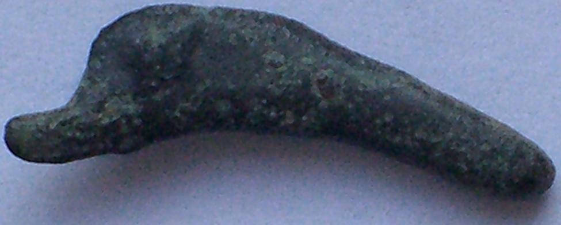

A Dolphin shaped object that was used as money in Olbia
From the 5th Century to the 3rd Century BC

I recently purchased a small bronze dolphin. At first glance it appears to be a charm but it is actually money.

Olbia was a Greek community located in the current countries of Bulgaria and Ukraine at the convergence of the Hypanis and Borythenes rivers, 15 miles from the Black Sea. Olbia was a prosperous trading city because of its location and was a major grain supplier.

The dolphins were produced from the 5th to the 3rd century B.C. They were originally earmarked as sacrificial objects for the worship of Apollo and then later used as a form of currency. They were cast in a mold that was in the form of a tree and the dolphins were attached to the branches of the tree at the tail. After casting, the dolphins were then cut off the tree for use. They vary in quality from crude to more detailed with eyes, dorsal fins and a mid fin down the side, to a rare variety with legends.

The Greeks were already minting round coins at this time, so a dolphin shaped coin is unusual. The reason lies in the fact that there are bottle nosed dolphins in the Black Sea so the inhabitants of Olbia are familiar with them. Also the dolphin is considered a “Sacred Fish” in Greek mythology, so the selection of this design is reasonable.

By the way, this piece of history cost $12.00.
______________________________________________________________________________________________________________________

References:
Cast Bronze Dolphin Coinage of Olbia at
http://www.ancientimports.com/cgi-bin/category.pl?id=79
Olbia Dolphin at http://www.forumancientcoins.com/catalog/roman-and-greek-coins.asp?vpar=1078
______________________________________________________________________________________________________________

Stronger Dollar Pushes bullion prices Downward

With gold dipping to $884.30 an oz an oz on April 1, down from its high of $1,002.00 on March 14, the start of the second quarter of 2008 was not viewed as an April fool’s prank but quite real. Recent gains in the US dollar against the world currency along with some profit taking in what financial market watchers viewed as a correction were some of the reasons for the recent downturn in precious metals but according to Numismatic News’ on line service NUMISMASTER, it was market manipulation by J. P. Morgan Chase and Merrill Lynch that forced down the precious metals by compelling commodity investors to double the amount of their down payments. This has not affected the strength of the overall numismatic market but could impact it if enough dealers find they are overextended when gold was at its peak. Meanwhile, the spot price of silver has stabilized around the $17.00 an ounce. Most economists believe the country has either already entered into recession or is approaching one. The price of gold is more related to the declining value of the dollar and the increase in oil prices.
______________________________________________________________________________________________________________________

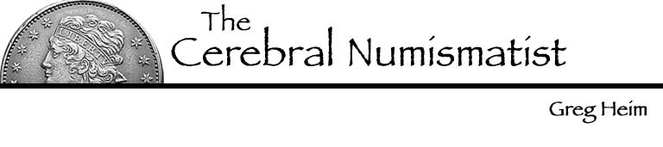
Most collectors are “hole fillers”. They attempt to plug away at a collection of whatever by type, date, mint mark, die variety, etc. It really does not matter how advanced of a collection you have, how much money you are spending or how much knowledge you possess. That’s because at some point you are going to get down to the “nitty-gritty” and it may not necessarily be in relation to a key date item; merely a coin that you have been searching for a long period of time. The “nitty-gritty” I am speaking of is the willingness to pay whatever it takes to get that coin because it puts you at a disadvantage with the seller, and that I have found this to be a big mistake.

Between 1999 and 2005, my wife Lisa and I assembled a fine half cent collection. During that period, we came across a few pieces that we simply “had to have” and our negotiating power was gone. Some of the very expensive desirable coins we added had to be paid over a long time period and that turned out not to have been a very good deal. In June, 2006 we sold the entire collection at auction. Granted, there were many excellent choices where we did quite well (as a matter of fact, we did quite well on the whole consignment) but had we been more disciplined we could have probably done a lot better.

Now I deal in coins as well as collect them even though my denomination of choice is still United States half cents. My new approach is to look for good values instead of filling holes. For example, I try to buy coins I can sell for a profit or at worst, break even on, and that includes the half cents I come across. That way I can enjoy them for a while yet not feel buried in them. This gives me a lot more negotiating power even with desirable items that one would consider “fresh inventory”. My horizons are broader, also boundless as well as more structured.

So, what is one still to do when they need a specific coin? The best thing is to know your own series and to recognize what is a good deal, what’s an OK deal and what’s a bad deal. Let’s say you collect Barber quarters and you come across an 1897-S, grading VF-20 that is totally original and it is priced at Gray Sheet (i.e., the Coin dealer Newsletter) “Ask”. That would be a “great deal”. Even if the 1897-S 25¢ was merely average for the grade that would represent an “OK deal” because with a mintage of only 542,229, over time, the 1897-S Barber quarter is certainly going to appreciate. On the other hand if you find yourself grossly overpaying for something because you have to have it; (e.g., full retail or more) then it’s time to stop yourself and wait for the next opportunity the date surfaces.

Isn’t amazing how education can be the determining factor in making good choices in numismatics? We make them not only with our coins but in the clubs to which we belong; the dealers with whom we do business and with our friends. It only took me 33 years to figure it out myself!
______________________________________________________________________________________________________________________
Greg Heim has been a collector and member of several NJ clubs as well as EAC (Early American coppers Club) and has recently started dealing in coins,
Club News (Continued from page 1)
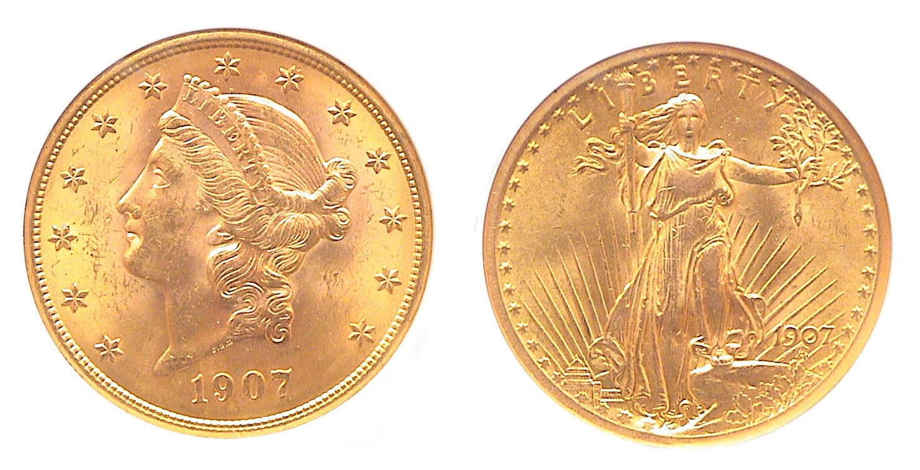
Obv. of the 1907 Coronet Liberty and Saint-Gaudens Double Eagle

On the day of our March 13 meeting the spot price of gold reached over $1,000 an ounce setting an all time record. Whether by coincidence or design, the program for the evening featured a PowerPoint presentation on “US Gold Coins from 1849 through 1833 intended for circulation” by Arno Safran. One of Arno’s collecting interests is transitional dates; (i.e. two design types or sub-types bearing the same date such as the 1938-D Indian Head and Jefferson nickels.) The speaker remarked that despite the increase in gold bullion values, the major transitional dates incorporated within the date-span of the topic were all relatively common dates and accesable at a moderate numismatic price above the spot price of gold. Thus the two types for the 1907 $10.00 and $20.00 and 1908 $5.00 gold pieces were all relatively affordable over spot. He displayed examples of all the 19th and 20th Century denominations struck from 1849 thru 1833 and admitted that while the $3.00 gold piece was the most expensive, it and the two lower denominations; the $2.50 quarter eagle and $1.00 gold pieces for type were less affected by the surge in bullion prices than the larger denominations. Also, each of the minor gold coins still looked attractive within the affordable certified grades of AU-58 thru MS-62.

VP Jim Barry confirmed the club’s annual spring Road Show will take place on Saturday May 17 from 12:00 noon to 3:00 PM at the Aiken Public Library. Member Bill Myers reported that the Augusta Coin Club’s spring show is on track for another sell out; possibly a record 50 dealers. The two day event is scheduled for May 2 and 3 (a Friday and Saturday) at the Belair Conference Center located on South Belair Road a block and a half from Interchange 194 off I-20. Hours are 9:00 to 5:00 both days and admission is free.

Treasurer Pat James reported a balance of $811.98 with all expenses paid. Thanks Pat! The Prize winners at the March 13 meeting were J. J. Engel who won the silver eagle door prize and Glenn Sanders, the 50/50 drawing. Congratulations gentlemen! Hope to see you all on April 10.
_________________________________________________________________________________________________________________________

Coin of the Month

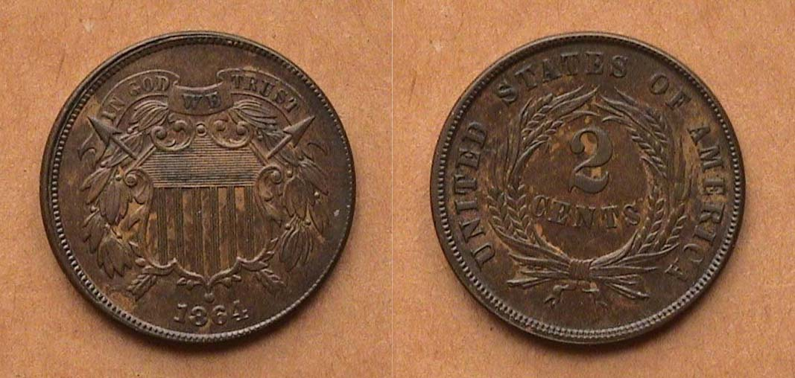
_
An 1864 2¢ Piece with large motto graded AU-55

The 2¢ denomination is still one of the best values in numismatics. Never very popular with collectors, the many common dates of this short series (1864-1873) languished around $25 in XF-40 to $50 in AU-50 for years. Even today, the increases since the 1990’s has been small and one can acquire an 1864 Large motto 2¢ piece grading AU-58 for around $60.00; An XF-45 will cost around $40.00 to $45.00; a bargain since this 23 mm bronze coin; slightly larger than our 5¢ nickel looks very attractive even graded VF-35 if original and well struck. This first date of the series had a mintage of almost 20 million and is easily the most available and affordable for type.
___________________________________________________________________________________________________________________

Kindly Patronize Our Dealers
