Pres. Steve Kuhl
V .P. James Barry
Sec. Helen Barry
Treas. Sharon Smoot
Sgt. in Arms: Glenn Sanders
The Stephen James
CSRA Coin Club of Aiken
P.O. Box 11
New Ellenton, SC 29809
Web site: www.sjcsracc.org
The SJ CSRA CC meets on the 2nd Thursday of the Month at the Cedar Creek Community Center in Aiken, SC

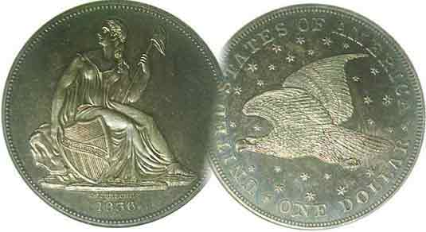
Committees:
Programs: James Barry
Show Chairs: The Barry’s
Newsletter: Arno Safran
E-Mail: arnosafran@comcast.net
Auctioneer: Glenn Sanders

2009 Club Meeting Schedule
Volume 8, Number 4 the Stephen James CSRA Coin Club, Founded in 2001 April, 2009
Monthly Newsletter
2009 Club Elections Produce Some Changes
Our next meeting is Thursday, April. 9, 2009 from 6:15 to 9:00 PM
Jan. 5 Apr. 9 July 9 Oct. 8
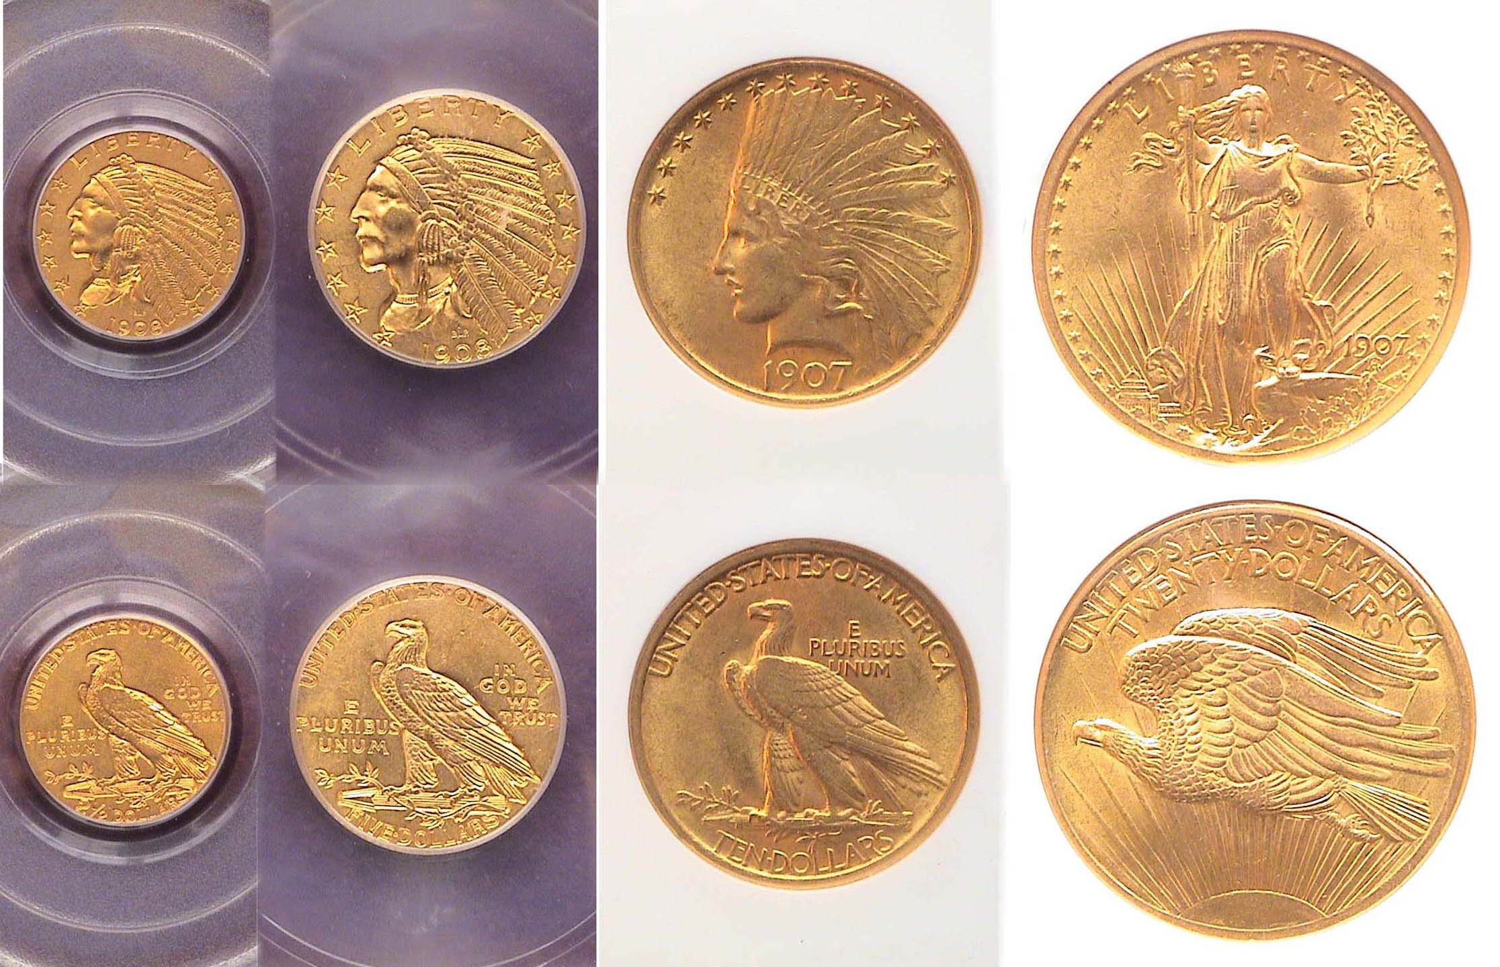
Feb. 12 May 14 Aug. 13 Nov. 12
Mar. 12 Jun. 11 Sep. 10 Dec. 3
____________________________________________________________

After Eight Years, Two New Names Surface On the SJ CSRA CC Board

At the club’s annual meeting held on March 12, President Willie Simon and Treasurer Pat James announced that they were stepping down from their posts as President and Treasurer respectively. Members Steve Kuhl and Sharon Smoot volunteered to serve in these vacated positions and were unanimously elected along with the previous board members, James and Helen Barry, VP and Secretary and Glenn Sanders, Sgt. in Arms. No one has to be told what a fantastic job both Willie Simon and Pat James have done over the eight years they have served on the SJ CSRA CC board. Their service to our club has been outstanding and we will all miss them. Fortunately, in Steve and Sharon, we have two fine members who are able to serve in these positions and the club looks forward to their contributions along with the continued excellent leadership provided by Jim, Helen and Glenn.

In his final comments as President, Willie praised Arno for the fine newsletter and encouraged members to take out personal numismatic ads for which there is no charge. Treasurer, Pat James in her final report stated the current balance as $914.53.

The following members were recognized for their help at our Sept. 13, 2008 Coin Show: Howard Black, Paul Simons, Jack Seech, Arno and Vilma Safran, Pat James, J.J. Engel, Sharon Smoot, , Jim Barry, Willie Simon, and Bill Myers.

As there was no specific program topic for the March meeting, program chair Jim Barry invited members to bring in Show & Tells. Those participating were Glenn Sanders, Mike Dodson, Jim Barry, Dick Lasure, Helen Barry and Roger Worpell.
_______________________________________________________________________________________________________________ (More Club news continued on page 4, column 1) _

Collecting Short Sets: US Gold Coins
Part Two: The new 20th Century types By Arno Safran

A Short Set of first year issues of early 20th Century gold
From Left to Right: 1908 $2.50, 1908 $5.00; 1907 $10.00 & $20.00
[Magnify to 200% to view details.]

In 1907 President Theodore Roosevelt’s dream of improving our coinage designs finally began to take shape when Saint-Gaudens’ designs for the $10.00 and $20.00 gold coins entered circulation. A year later Bela Lyon Pratt’s incused Indian head/ eagle type were released on the $2.50 quarter eagle and $5.00 half eagle. As the dies for the new designs for the $10 and $20 were not ready at the beginning of 1907 or for the $5.00 denomination in 1908, both the outgoing and incoming types were released in the same years. Since the Liberty $2.50 gold coin ended with the 1907 coinage the 1908 Indian head type had the year all to itself. All of the new designs contain a number of common dates including the first year issues shown. Assembling such a four piece 20th century gold type set will be based more on the value of gold than to any aspect of numismatic rarity.
__________________________________________________________________________________________________________
(Continued on page 2, column 1)
A Short Set of 20th Century Circulating Gold Coins
(Continued from page 1, column 2)

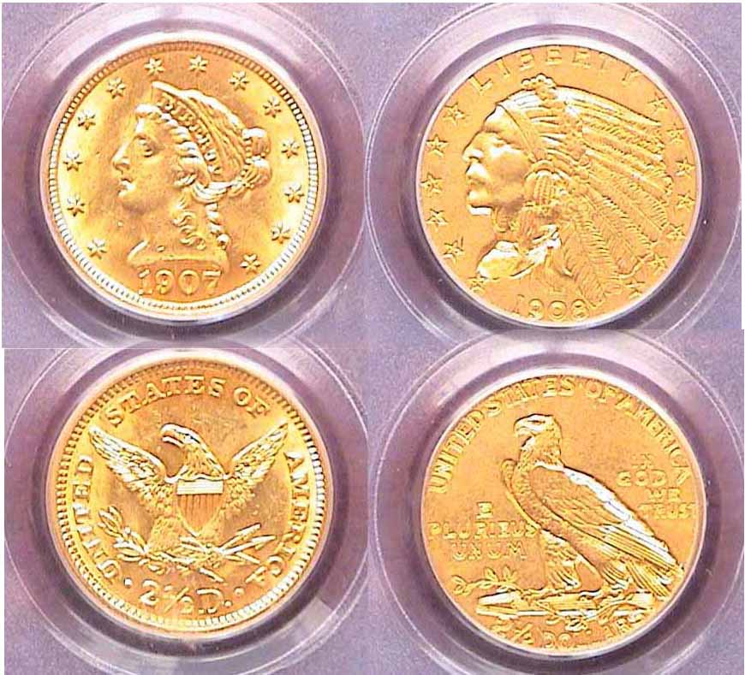

From the old to the new: A 1907 $2½ Liberty certified MS-62 by PCGS alongside a 1908 $2½ Indian certified AU-58 by PCGS.
Both coins are only 18 mm in diameter. [Magnify to 200%.]

The current increase in gold prices has not affected the cost of the $2½ or $5 gold coins as much as the $10 and $20 denominations. One can acquire a $2½ Indian Head quarter eagle grading AU-58 similar to the 1908 Indian Head shown for as little as $250 retail. The 1907 Liberty $2½ was certified MS-62 and cost $450. Some certified coins grading AU-58 can look as sharp as an uncirculated MS-62 specimen because of its small size, (only 18 mm in diameter.) As a result, an AU-58 can represent a “Best-buy” for a collector on a modest budget for coins.

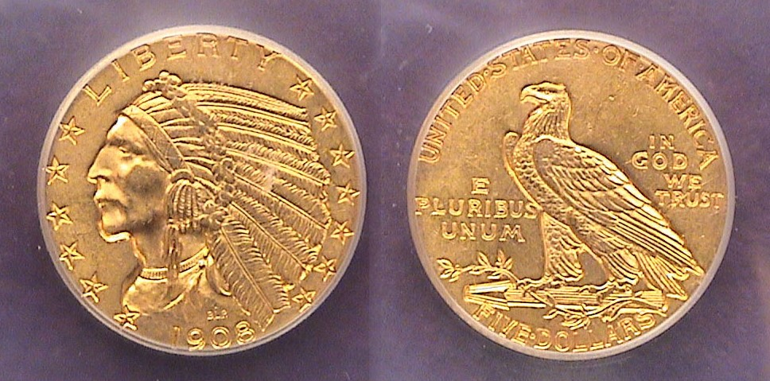

A 1908 Indian Head $5.00 Half Eagle graded MS-61 by IGC
The diameter of the Half Eagle was 21.6 mm [Magnify to 200%.]

With the $5.00 denomination, an MS-61 grade can serve just as well as the AU-58 grade does for the smaller coin. MS-61’s tend to be priced closer to MS-60 but because of the coin’s incuse design and its moderate size, (21.6 mm, only slightly larger than a nickel), surface blemishes don’t show up as much on an MS-61 as they do on a similarly graded $20.00 Saint-Gaudens for example. The 1908 $5.00 Indian had a mintage of 577,845 but is priced as a common date along with the 1909-D, (3.4 mil) and 1911-S (1.4 mil.).

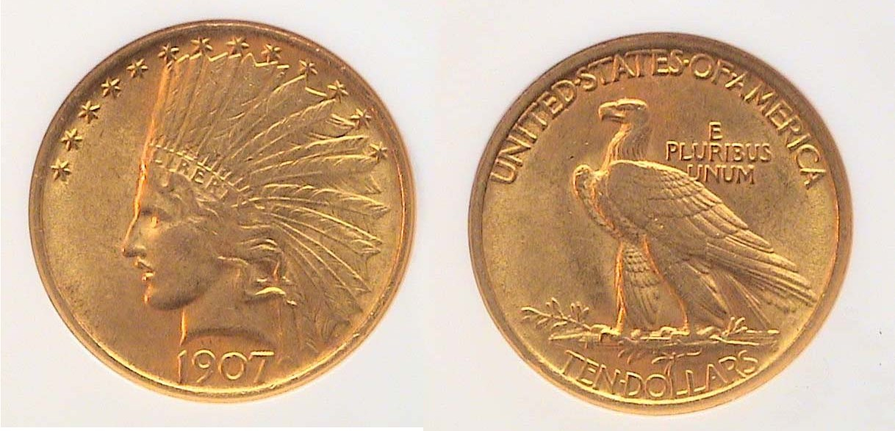
A 1907 Indian $10.00 eagle graded MS-61 by NGC
341,370 were minted with the new design [Magnify to 200%.]

One would think that the new Saint-Gaudens Indian Head type for the $10 eagle with its wide open fields surrounding the central devices on both sides of the coin would show more contact marks but for some reason this type surfaces with fewer blemishes even in a MS-61 grade. That’s a boon to the collector on a tight budget because between MS-62 and 63, the price jumps by $500. As a first year issue the 1907 $10 Indian with a mintage of just 341.370 is not as lustrous as the later dates but it is priced about the same as the extremely common dates; 1926 with over a million and the 1932 with more than 4 million making the 1907 a “Best Buy” especially if you want to acquire it alongside the outgoing 1907 $10.00 Liberty which is less expensive up to MS-62.

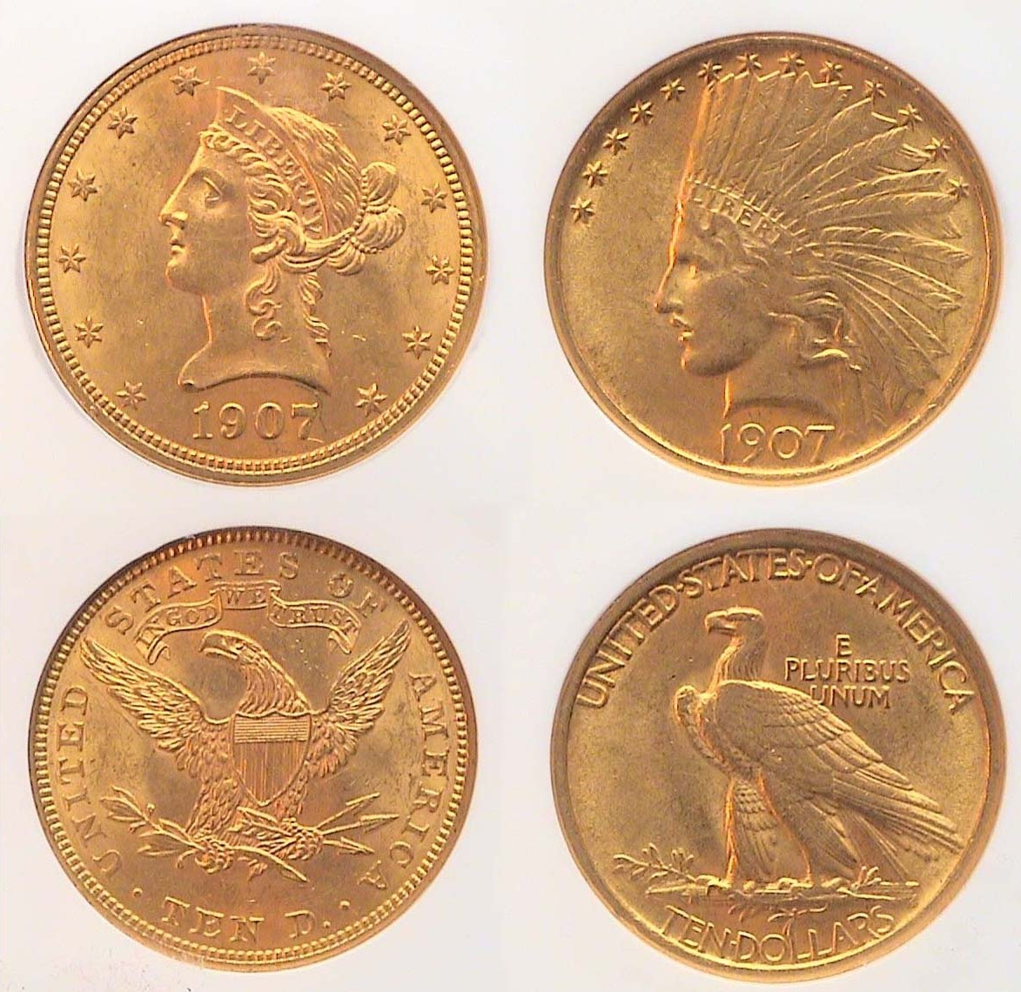

The 1907 Liberty and Indian Head $10.00 types side by side.
The Liberty was graded MS-62 and the Indian MS-61 both by NGC.

A number of factors have brought about the increase in the prices for gold coins in recent months. One has to do with the weakness of the US dollar against other world currencies. Another has to do with the deepening recession. As a result, an increasing number of people have been moving their savings out of the stock market and their bank accounts into gold coins. The coin most affected by this current trend has been the $20 double eagle which contains almost a full ounce of the yellow metal. Back in 2002 a common date Saint Gaudens $20 gold piece certified MS-63 could be acquired for $425. Today it would cost closer to $1,500 in the same certified grade. So if you are primarily a collector, is this the time to acquire generic gold coins? Probably not! Still, if you wish to add the beautiful original Saint-Gaudens Striding Liberty with floating horizontal eagle to your gold type set, that is what you may have to pay.
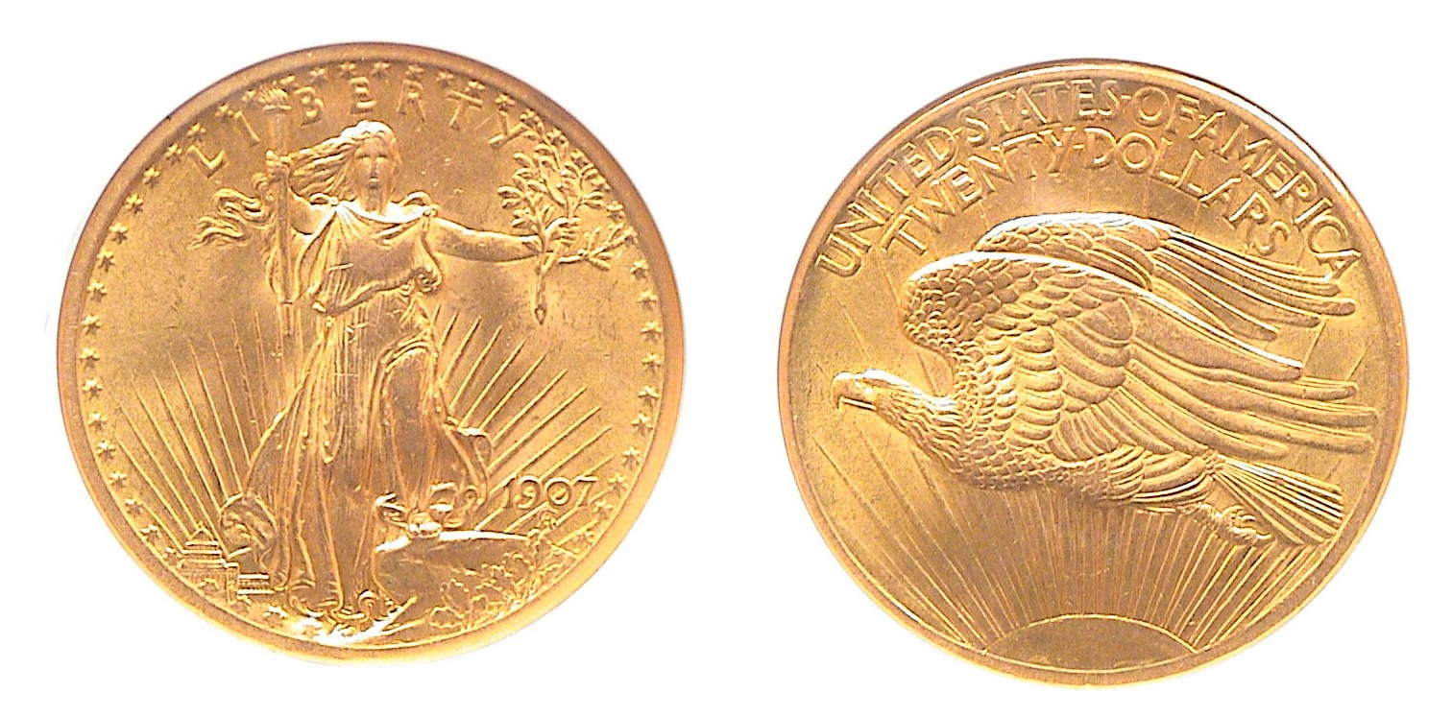
A 1907 Saint Gaudens $20.00 Double Eagle certified MS-62 by NGC
361,667 with the Arabic numerals were minted of this date.
It is priced slightly higher than a common date.

The 1907 “Saint” comes in the rare high relief with Roman numerals and is priced well into the five figures but the more common Arabic numerals sells in the lower four figures in MS-62, the certified grade of the example shown directly above.
________________________________________________________________________________________________________________________________
(Continued on page 3, column 1)
Collecting a Short Set of 20th Century Circulating Gold Coins (Continued from page 2, column 2)

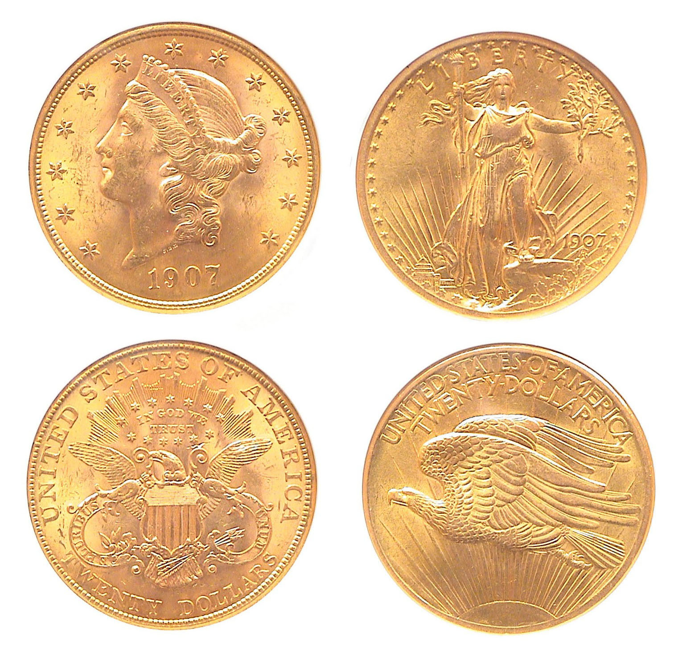
1907 Coronet and Saint-Gaudens $20.00 types side by side
The Coronet was graded MS-63 and the Saint, MS-62, both by NGC.
[Magnify to 200% to see details.]

If this were 2002, one could acquire both these transitional date $20.00 gold types for under $1,000. Only a year ago these two coins would have cost $2,600. Now, in 2009 the cost will be somewhat prohibitive, probably closer to $4,000. If you are a collector between 35 and 55 years old, my advice would be to hold off buying any common date $10 or $20 gold coin at the current price levels because if there is a turn around in the economy within the next two years these prices will surely drop; not down to the levels of 2002 but closer to those of 2005 or 06. If you are as much an investor as you are a collector of rare coins, you may have to weigh the possibilities in the shorter term. In February, 2008, gold was valued at about what it now; around $900 as this is being written, but prices for common date $20.00 double eagles are around 25% higher. Collecting gold coins can be as volatile an experience as investing in stocks or worse yet, hedge funds. There are simply no guarantees.

As much as one may wish to acquire a short set of 19th century US Liberty or early 20th century gold types, now may not be the time to attempt to do this. It would be better to study the Red Book. Look over other coins you may find interesting including some of the better date coins featured within. Check their prices relative to the best grade you can afford. Make use the time of higher coin prices for learning more about coin grading in order to be ready when the market stabilizes.

With this article we end our survey of the many different kinds of short sets that have appeared in the newsletter over its two year run. There are many other short sets one can acquire that are inexpensive and satisfying. One of the categories is year sets, something that touches everybody because there is always a special year that has a particular meaning for you.
________________________________________________________________________________________________________________

Numismatics from a Hand Manual
By Bill Myers

Topical collecting has allowed me to blend my vocation as a Hand Surgeon and my hobby as a Numismatist together by collecting coins, paper money and exonumia with hands on it. I have not had much competition in this area and have gotten some great help from friends. I recently had the opportunity to add numismatics to medicine for a change. Fellow Hand Surgeon Roy Meals, MD recently published his book “The Hand Owners Manual” and it is subtitled “A Hand Surgeon’s Thirty-Year Collection of Important Information and Fascinating Facts!” He asked me to write about hands on bank notes and my contribution appears on pages 118-120. There is a collage of 7 of my notes with very prominent hands on them on page 119. There is also a section on ancient coins with hands on them contributed by Arnold-Peter Weiss, MD.

I have enjoyed collecting numismatic items with hands on them and enjoy sharing it even more. Hopefully by having sections on numismatics in a non-numismatic publication will induce new collectors into our field.

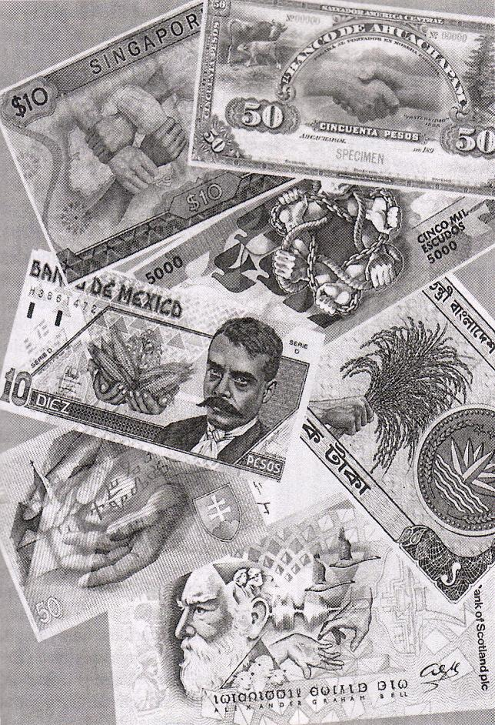

From page 119 of the Hand Owners Manual by Roy Meals, MD

The above plate shows a montage of Bank notes from former SJ CSRA CC member Bill Myers’ collection. If one looks carefully they will see a hand or pair of hands on each note. Bill contributed these as well as coins also showing hands from his personal collection and they appear on other pages of this book. Congratulations, Bill! (Ed.)
____________________________________________________________________________________________________________________

More club News
(Continued from page 1, column 1)

Under New Business, Glenn Sanders offered a correction to the March newsletter; He was named as chairman of the nominating committee which was in error as it was JJ Engel who chaired that important committee. The editor thanks Glenn for the correction and apologizes to JJ for his gaff. The other members of the nominating were Jack Seech and yours truly. Speaking of Jack, during the second week of March, he suffered what is believed to have been a mild stroke and was temporarily hospitalized at University Hospital in Augusta. The medical emergency appears to have been caught in time and Jack is at home resting comfortably with no serious ill effects from the incident. All the members of the club wish Jack well.

The club has two recent new members, Howard Hillman and John Orchenyk. Both were winners at the March 12 meeting, Howard taking the door prize (attendance drawing), a 2009 silver eagle and John winning the 50/50. Congratulations gentlemen!
Our next meeting is scheduled for Thursday, April 9. Renowned SC tokens specialist Tony Chibbaro will be returning to present a new slide program entitled “Odd Shaped Tokens”. Anyone who has seen Tony’s presentations know they are in for another numismatic treat, for even if you do not collect anything but coins, every one of Tony’s token slides bring to life a piece of South Carolina history. Hope to see you all then! (Ed.)
_________________________________________________________________________________________________________________________

Coins of the Month

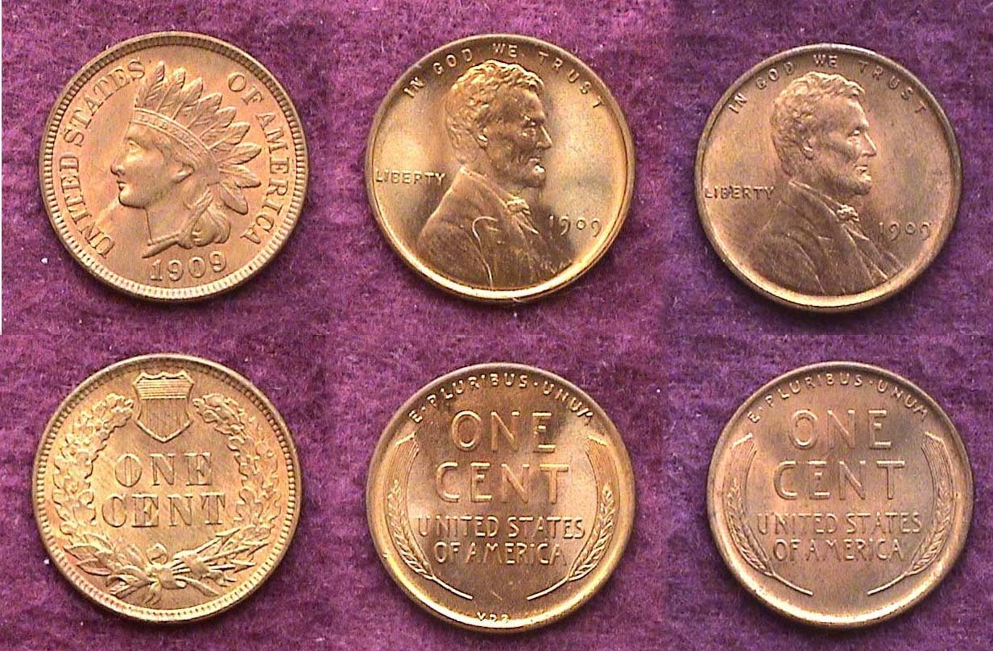

The three cent types of 1909 – 100 years ago
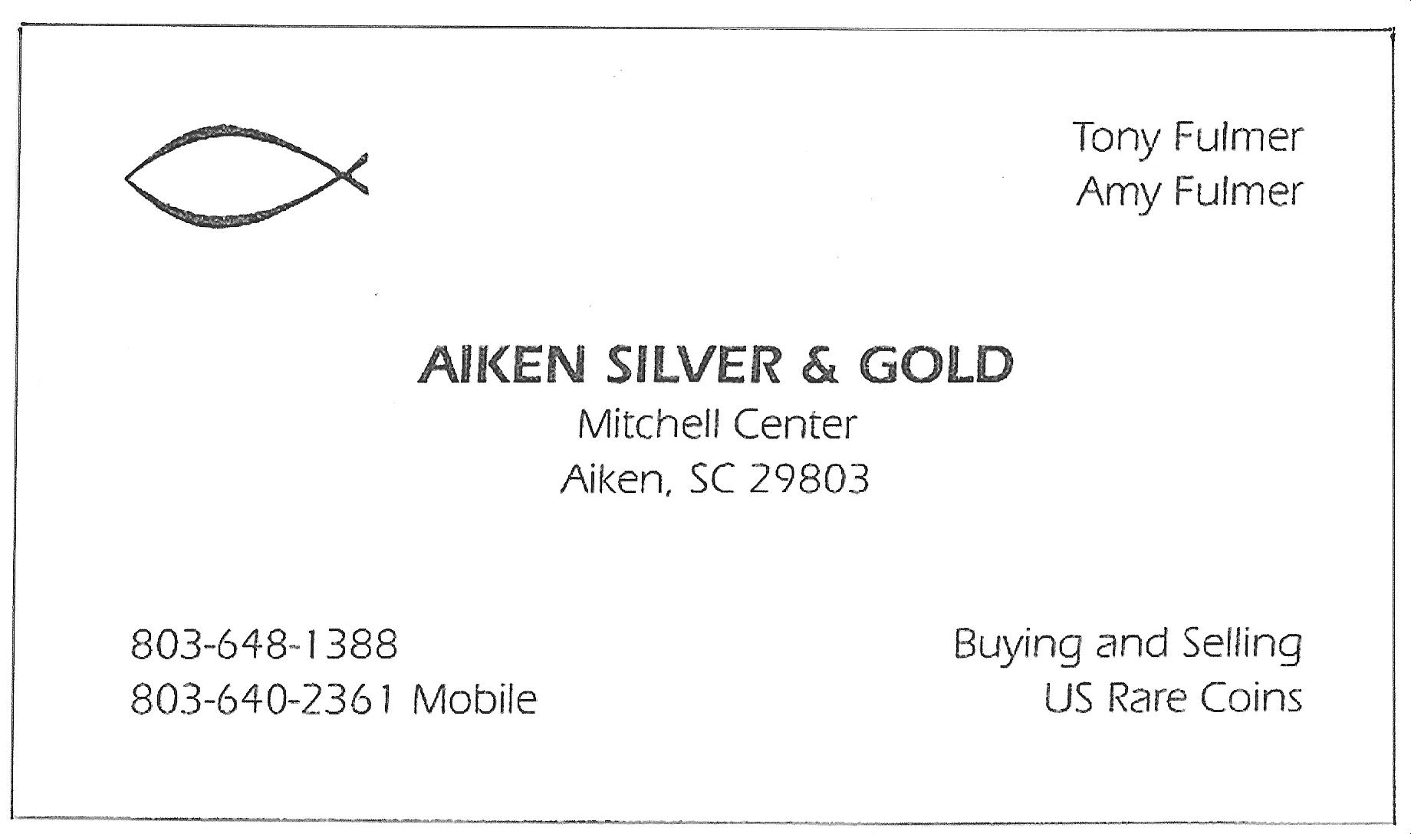
Indian Head, Lincoln VDB and no VDB

A century ago the Indian Head Cent which coincidently had first been struck on the fiftieth anniversary of Lincoln’s birth in 1859 was retired in favor of the new cent designed by Victor D. Brenner, a European born sculptor. Brenner had created a medal honoring those working on the construction of the Panama Canal (1904-1914). President Theodore Roosevelt appeared on the obverse and it was the 26th President (1901-1909) who asked Brenner to create a design for the cent honoring Abraham Lincoln on the 100th anniversary of his birth. The coin was an immediate success when it was first released but some political bigwigs objected to the engraver’s initials appearing so boldly on the reverse. A new hub was made without Brenner’s initials appearing on the coin providing for a third sub-type. To this day, a century later, all the Philadelphia Mint issues are fairly common and not expensive in MS-63.
___________________________________________________________________________________________________________________________
Articles Wanted

For seven plus years virtually all the articles appearing in this newsletter have been borne by the editor, former member Bill Myers and a few taken from other newsletters. One of the joys of coin collecting is sharing your finds or recent acquisitions with others. Before moving to the CSRA I either belonged to or was a guest speaker at a number of different coin clubs. Some held auctions at every meeting, others only twice a year. Four held programs at every meeting and at least three of these were dominated by the Show & Tell segment. Members couldn’t wait for the next meeting to bring in their latest numismatic acquisitions, and better yet, they didn’t care whether it was a great “numismatic rarity” or a cull found from a dealer’s junk box. Each numismatic item had its own story to tell. One way to share a story with your fellow club members is to jot it down and E-mail it to me at arnosafran@comcast.net, so if you have a particular year set of interest you would like to share with our readers, please send it to me and thanks! Your readers will enjoy learning what you found interesting and why it is important to you. By the way, please notice the highlighted changes in the club mailing address on the newsletter masthead and member Tony Fulmer’s new ad below. (Ed.)
______________________________________________________________________________________________________________________

Kindly Patronize Our Advertisers
