Pres. Steve Kuhl
V .P. Arno Safran
Sec. Jim Mullaney
Treas. Sharon Smoot
Sgt. in Arms: Glenn Sanders
The Stephen James
CSRA Coin Club of Aiken
P.O. Box 11
New Ellenton, SC 29809
Web site: www.sjcsracc.org
The SJ CSRA CC of Aiken, SC meets on the 1st Thursday of the month at the Aiken Public Library

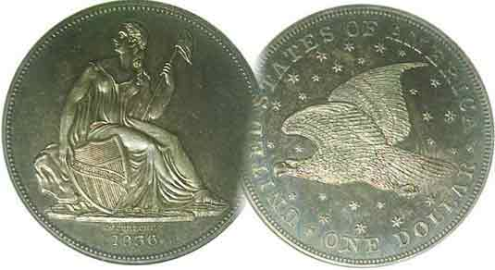
Committees:
Programs: Arno Safran
2010 Show: Jim & Helen Barry
Publicity: Jim Clapp
Newsletter: Arno Safran
E-Mail: arnosafran@comcast.net
Auctioneer: Glenn Sanders

2010 Club Meeting Schedule
Volume 9, Number 4 the Stephen James CSRA Coin Club, Founded in 2001 April, 2010
Monthly Newsletter
2010-2011 Club Officers and Revised By-Laws Set
Our next meeting is on Thursday, Apr. 1, 2010 from 6:00 to 8:45 PM

Jan. 7 Apr. 1 July 1 Oct. 7
Feb. 4 May 6 Aug. 5 Nov. 4
Mar. 4 Jun. 3 Sep. 2 Dec. 2

____________________________________________________________________________________________________________

Club Fiscal Year Begins Anew at April 1 Meeting

On April Fools Day, our club begins its tenth year since its founding in March of 2001; no fooling! This means that dues of $12.00 for adults are due along with $5.00 for juniors, 17 years of age or under. You can make your check payable to the SJ CSRA CC and mail to PO Box 11, New Ellenton, SC 29809 or better yet, please join us on Thursday April 1 at the Aiken public Library and pay in person. The meeting starts at 6:45 PM but members usually start arriving shortly after 6:00 PM. We will have an interesting PowerPoint presentation by returning guest speaker Xavier Pique who has treated us with fine programs in the past. His topic this coming month will be “The Images and symbols on 18th Century Gold and Silver Coins”. After the presentation, there will be a short break to look over the lots followed by the auction led by our fine auctioneer Glenn Sanders. Since an auction is only as good as its offerings, please bring in some numismatic goodies to whet the appetite of the bidders.

At the March 4, meeting President Steve Kuhl went over the proposed revisions of the various By-laws. Most of the changes were minor in nature as they were intended to allow the club to run more efficiently in light of the way it has evolved over the past several years. All were approved except for the proposed renaming of the club, which shall remain the Stephen James CSRA Coin Club. Member J.J. Engel praised the Executive Committee for its efforts to clarify various points in the revision. The election followed. Nominated for the 2010-11 fiscal year were for President, Steve Kuhl, VP, Arno Safran, Recording Secretary, Jim Mullaney, Treasurer, Sharon Smoot, and Sgt. in Arms, Glenn Sanders. As there were no other nominations forthcoming and the motion to close the nominations was passed unanimously, Secretary Helen Barry cast one ballot for the five nominees. The new Board will begin their duties on April Fools Day.
_____________________________________________________________________________________________________________
(More Club News continues on page 4, column 1)
Collecting Draped Bust Heraldic Eagle Coinage
By Arno Safran

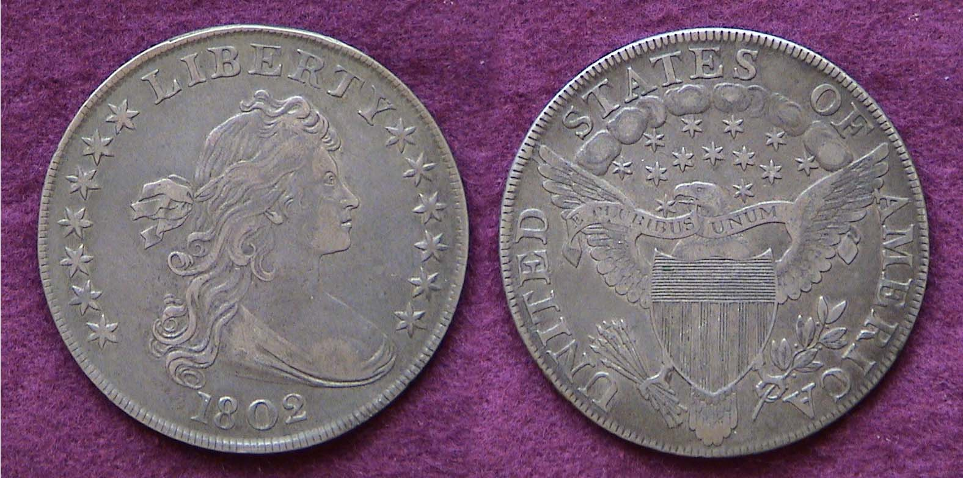

An 1802 Draped Bust/ Heraldic Eagle $1.00; diameter, 39-40 mm
It was designed by our first Chief Engraver, Robert Scot
[Use a 3X glass or magnify to 200% to see details more clearly.]

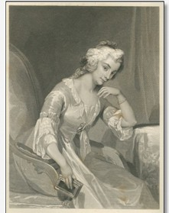
Pictured above is the majestic dollar design of Robert Scot. The reported mintage for the 1802 $1.00 was just 41,650. Scot was appointed as our first Chief Engraver of the US on Nov. 23, 1793 and remained in that position until 1823, the year he died. Born in Scotland, Scot arrived in Colonial American in 1778 and in 1781 engraved some medals for Thomas Jefferson who was Governor of Virginia at the time. His first US designs were the Flowing Hair half dime, half dollar and dollar coins of 1794-95 and they were not impressive, but after being shown a sketch by renowned portrait artist Gilbert Stuart and others made of the beautiful 21 year old Anne Willing Bingham, Scot created a new Draped Bust Liberty design that would adorn our copper and silver coins from 1795 thru 1808. Anne Bingham (1764-1801)

Scot’s Draped Bust style on US coins elevated the quality of our young nation’s coinage art on a par with the major European nations but today they are costly due to their low mintages.
__________________________________________________________________________________________________________________________
(Continued on page 2, column 1)
Collecting Draped Bust/ Heraldic Eagle Coinage
(Continued from page 1, column 2)

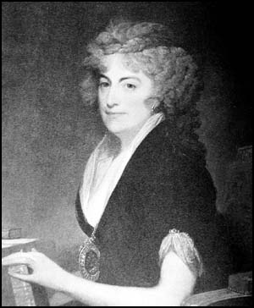
The Draped Bust silver series can be broken down into two sub-types; the small eagle reverse (very expensive today) and the large or Heraldic Eagle reverse (which is more affordable although still pricey.) In 1798, the reported mintage of Bust dollars was 327,536, the vast bulk of these being engraved with the popular large Heraldic eagle reverse. In 1799, the reported mintage increased to 423,515, a whopping number of cartwheels for that period. After 1800, the reported mintages languished in the five figures and though scarcer are only slightly more expensive than the 1798-1800 dates.
Anne Bingham in 1797
Painting by Gilbert Stuart

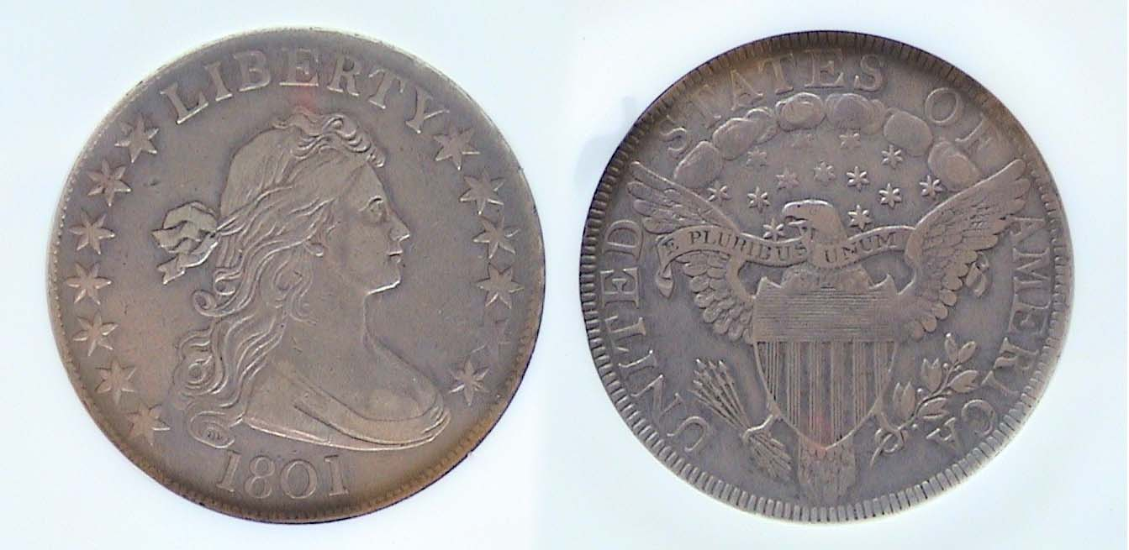

An 1801 Draped Bust/ Heraldic Eagle Half dollar, O-102, R4
Diameter, 32.5 mm. The coin was graded XF-40 by NGC
[Use a 3X glass or magnify to 200% to see details more clearly.]

Scot did not get around to placing the Heraldic Eagle reverse on the half dollar denomination until 1801 because no half dollars were needed during the years 1798 thru 1800. Only 30,289 were reportedly struck in 1801, just 29,890 in 1802 and 183,234 in 1803. None were struck with the 1804 date. The 1805 thru 1807 issues are more common and less expensive.

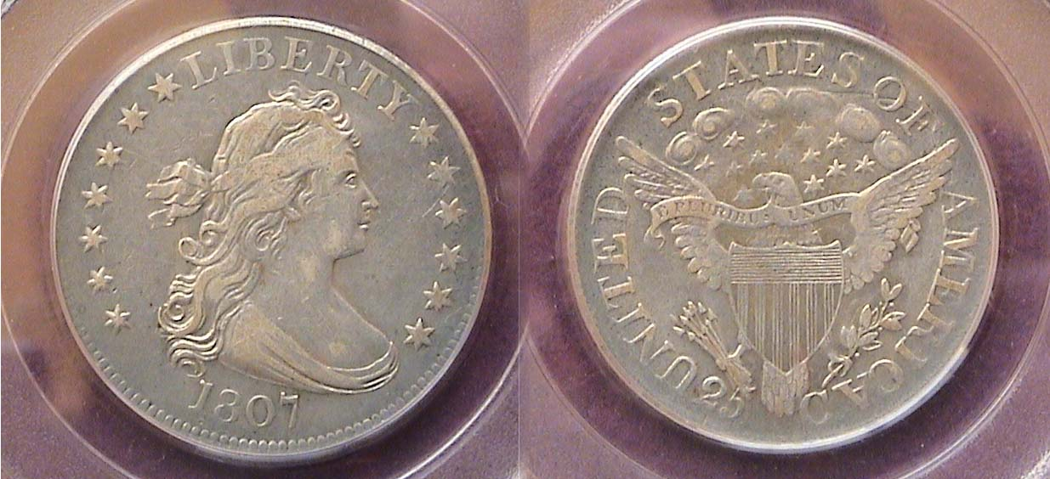

An 1807 Draped Bust Heraldic Quarter graded VF-35 by PCGS
The diameter of the Draped Bust quarter was 27.2 mm.
[Use a 3X glass or magnify to 200% to see details more clearly.]

Today the quarter dollar is the work horse of our coinage as it has been for more the half a century, but back in the early years of our Republic, silver for planchets was scarce and what was available was needed for the larger denominations that were used as specie to back business ventures. As there were plenty of Hispanic American 2 Reales (AKA 2 bits, and worth 25¢) circulating in the US at the time, these supplemented the need for the production of quarter dollars on a yearly basis.

The Draped Bust/ Heraldic Eagle first appeared on the 25¢ coin in 1804. It had a mintage of just 6,738 and is extremely expensive even in as low a grade as Good-4. The 1805, ’06 and ’07 had ample mintages in the six figures; the reported mintage of the 1807 shown at 220,643. The three dates are priced similarly but become expensive above Fine-12. Certified graded specimens are advised for all Draped Bust silver coins in the current numismatic market.
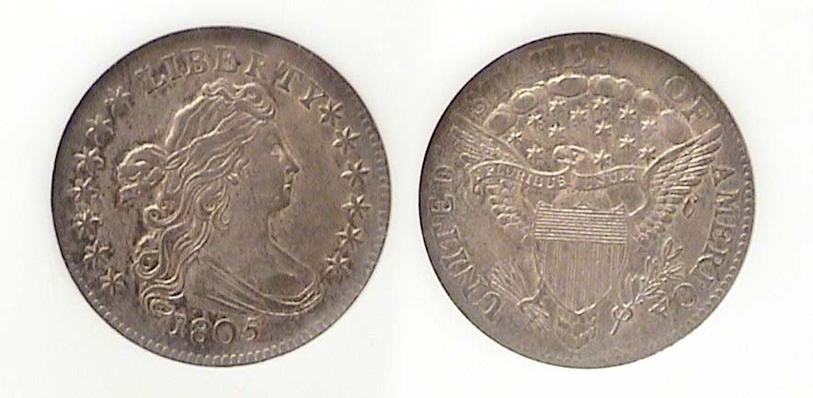
An 1805 Draped Bust dime graded AU-58 by NGC. The diameter
was 19 mm compared with 17.9 for dimes struck from 1837 on.
[Use a 3X glass or magnify to 200% to see details more clearly.]

The first US dimes, (originally spelt dismes) were struck in 1796 and 1797 and bore the Draped Bust obverse but with the small eagle reverse. From 1798 thru 1807 Draped Bust dimes with the Heraldic eagle reverse were issued but with the exception of the more common 1805 and 1807 dated pieces, the preceding dates had mintages mostly in the low five figures and are quite scarce. No dimes were dated 1799 or 1806. During the past ten years, the increased collector demand for early US type has minimized the available supply to a trickle resulting in huge price increases for even the commoner dates. At the time the Draped Bust/ Heraldic dimes were being issued 10¢ had the purchasing power of $1.75.

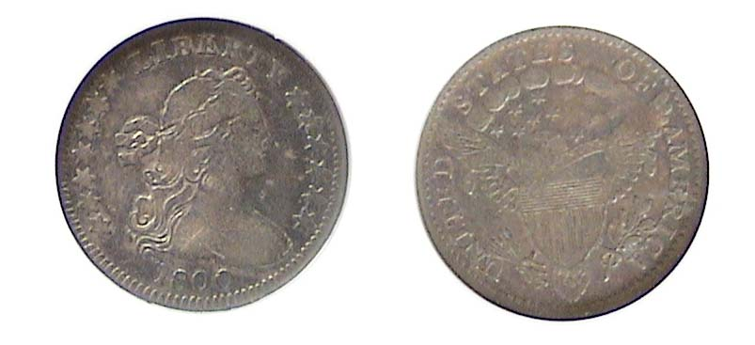
AN 1800 Draped Bust/ Heraldic Half Dime graded Fine-15 by NGC
The diameter was 16.5 mm
[Use a 3X glass or magnify to 500% to see details more clearly.]

The first half dismes were struck in 1794 and again in 1795 with the Scot’s Flowing Hair design. In 1796 and 1797, Scot placed his new Draped Bust design type on the obverse but with a modified version of the small eagle on the reverse. No half dimes were coined in either 1798 or 1799 but from 1800 through 1805 (excluding 1804 when no half dismes were issued) Scot’s Heraldic Eagle reverse appeared on the reverse. All Draped Bust half dismes are scarce; some extremely rare. The 1800 is the one date that surfaces more frequently than the others, and is the least expensive. With the tiny diameter, 16.5 milometers and an almost paper-thin thickness, many of the coins were unevenly struck leaving key portions bare of details. Some uncirculated specimens even have portions of the Bust, Eagle or Shield missing. The specimen shown above looks like a FINE but upon magnifying the coin (with a 3X glass or the page magnifier to 500% for those readers viewing this digitally) one will see evidence of finer detail in the stars, hair and date; also on the shield, some of the wing tips and lettering on the reverse. These suggest that the true grade of this specimen may be VF 25 or higher. There is even some hidden luster present. The five Draped Bust/ Heraldic eagle silver denominations are represented by different dates, are evenly matched as a set and have eye appeal within their respective grades. Acquiring them today is another matter.
______________________________________________________________________________________________________________________
(Continued on page 3, column 1)
Collecting Draped Bust Coinage
(Continued from page 2, column 2)

The Copper Corner

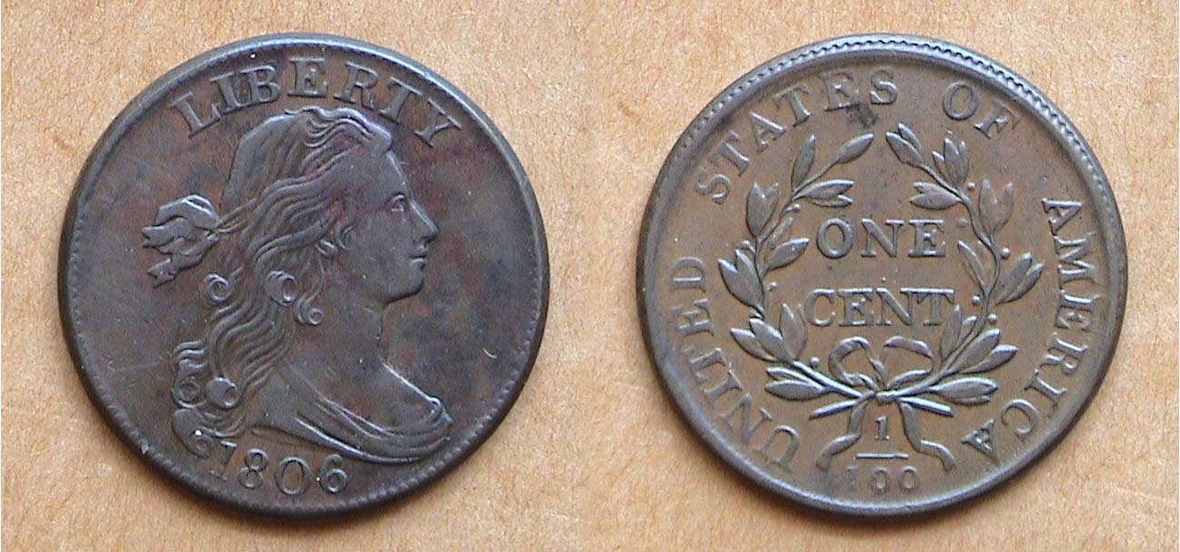

An 1806 Draped Bust Large Cent, S-270 R2 grading XF-45
The diameter was 29 mm, approx. 11/8 inches
[Use a 3X glass or magnify to 200% to see details more clearly.]

Between 1796 and 1807 inclusive, Robert Scot’s Draped Bust rendition of Liberty appeared on the obverses of our large cents. The figure of Miss Liberty seems more tapered than on the silver coinage. The overall design is simpler showing no stars surrounding the figure; just the word LIBERTY above and the date below. The reverse shows a Laurel wreath with berries and the denomination ONE CENT at the center with a tiny dot in-between. The legend, UNITED STATES OF AMERICA is arranged moving clockwise around the circumference of the coin from the fraction 1/100 that is centered at the bottom between the two strands of the ribbon. Above are two stems. (On some dates and varieties, the stems may be missing. Since there is only one known variety for the 1806, the design is complete as Scot conceived it.)

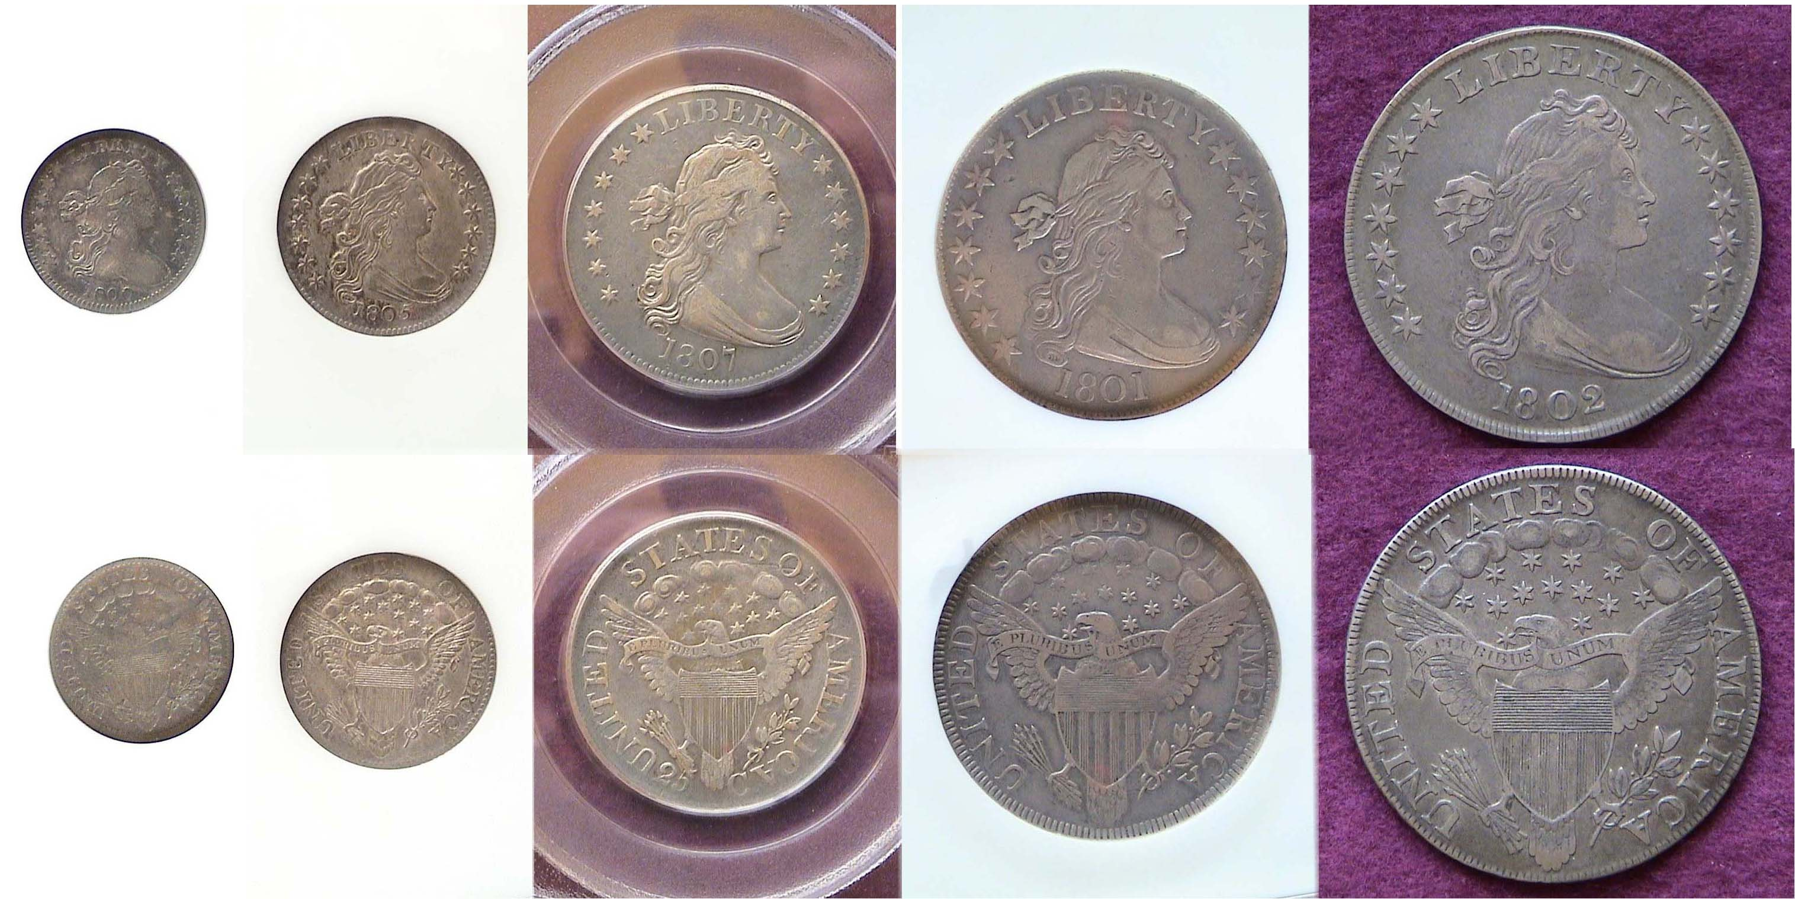
This particular cent date was chosen as it was not used on any of the five silver denominations but with the exception of the 1796, 1799 and 1804, the remaining dates of the Draped Bust cent series are common and from Good-4 through Fine-12 would not be as pricey as the Extra Fine example shown above. Many large cent collectors attempt to acquire their pieces by die variety and cannot afford high-end specimens. They seek coins grading G-4 to VG-10 that appear chocolate brown in color with smooth even surfaces, free of digs, cuts or rim nicks.

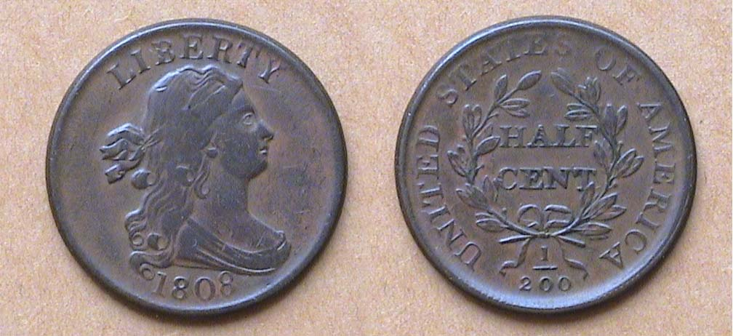

An 1808 Draped Bust Half Cent , C-3 R1 grading VF-25
The diameter was 23.5 mm, approx. 7/8 inches
[Use a 3X glass or magnify to 200% to see details more clearly.]

Since virtually all our basic goods cost over fifty cents today, one may wonder why the half cent denomination was ever included as part of the Coinage Act of 1792 in the first place, but during the early years of our Republic, the denomination came in very handy. In the late 18th and early 19th centuries the Mint was in short supply of silver and gold and even had to order copper planchets from Matthew Boulton’s Manufactory in Soho-Birmingham, England. Small change was needed to conduct business. To do so, merchants accepted foreign silver coinage, much of it from the Mexico, Peru and other Latin American countries. Aside from the 8 Reales (worth $1.00 in silver), the second most used Latin American denomination was the Real, a silver coin slightly larger than our disme worth 12½¢. A number of basic goods were priced in half cents as well, so the denomination was handy in providing either exact change upon purchase of for making change.

Scot’s Draped Bust half cents first appeared in 1800. None was made the following year and not many were struck in 1802, the key date of the series, but from 1803 through 1808 inclusive, the dates are fairly common and a collector can acquire a specimen for type up through Fine-15, possibly VF-20 at a modest price. The most common date of the series is the 1804, the one date that is scarce in all the other denominations. The 1808 shown happens to be an attractive specimen, which is why it is portrayed for the purpose of this article.

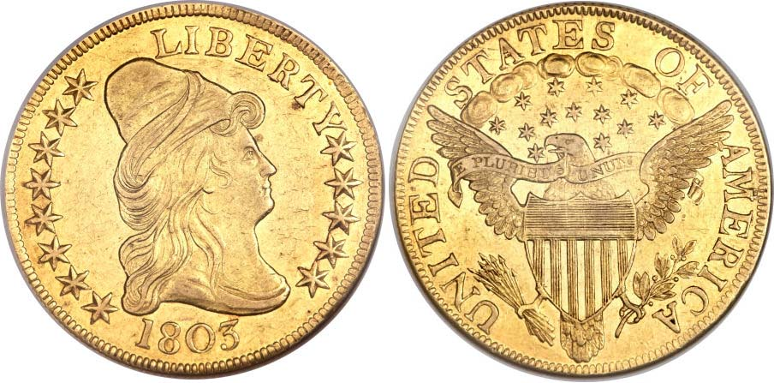
The three gold denominations designed by Robert Scot, the $2.50 quarter eagle, the $5.00 half eagle and the $10.00 eagle were somewhat different, known as the Capped Head type, but no less magnificent. These were not included in this article because all dates are extremely rare and prohibitively expensive in the current US coin market. Among the silver and copper examples, all seven different denominations are displayed representing the early 1800’s, each with a different date.

The Draped Bust Silver Set (not actual size)
1800 5¢, 1805 10¢ 1807 25¢, 1801 50¢ and 1802 $1.00
[Use a 3X glass or magnify to 200% to see details more clearly.]
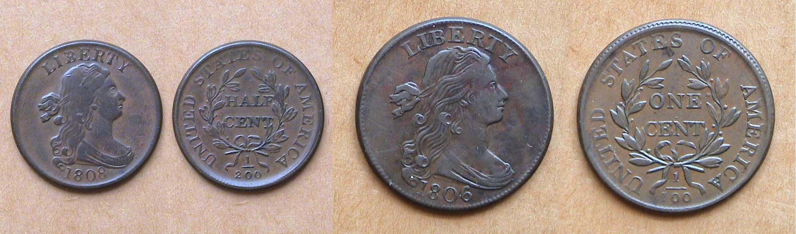
The Draped Bust Copper Set; 1808 ½¢ and 1806 1¢ (not actual size)
[Use a 3X glass or magnify to 200% to see details more clearly.]
____________________________________________________________________________________________________________________

More Club News
(Continued from page 1, column 1)

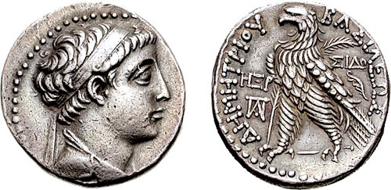
With all expenses paid as of March 4, Treasurer Sharon Smoot reported a balance of $1,244.36. Thank you, Sharon. There were four members with Show & Tells, all of them interesting. Paul Simons brought in a bunch of unusual numismatic items; among them a Series 1976 $2.00 Star note, a $10,00 gold back Series of 1922 large US currency note, an 1883-S Proof-like Morgan dollar, a micro replica of the $20.00 Saint-Gaudens double eagle, a $25.00 Platinum Statue of Liberty coin and a one lb. .999 fine silver eagle replica of our one-ounce bullion coin. Jim Barry displayed a 1944-D silver dollar struck at the Denver Mint for Curacao certified MS-64 by NGC. Arno Safran displayed a 1940 P, D, S BU year set with each Mint housed in a five-piece Capital Lucite holder. One of the coin slots was blank. Can you guess which denomination and Mint was missing? Time’s up! It was the Walking Liberty Half dollar as none were struck in Denver in the year 1940. Charles Goergen brought in an 1804 dollar that actually circulated in the United States, unlike the bogus coin that was not made for commerce but struck as presentation pieces in 1834 during the Andrew Jackson administration for foreign potentates. Chuck’s coin saw circulation in two sovereign nations, Peru and the United States. A monogram punches for Limae (in which the five letters are combined for Lima provides the true source of the coin. Chuck also brought in a Demetrius II Greek tetradrachm from the Seleucid Kings of Syria (ca. 127-126 BC.)

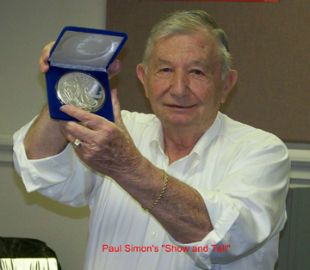

Member Paul Simons displays a 1 lb. US silver eagle round
[photo and all those that follow, courtesy of Helen Barry]

SJ CSRA CC Photo Gallery

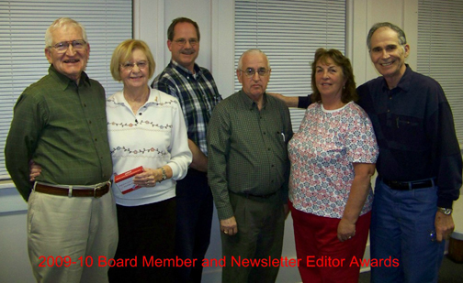

From left to right: VP Jim Barry, Sec. Helen Barry, Pres. Steve Kuhl, Sgt. & Arms, Glenn Sanders, Treasurer, Sharon Smoot and Newsletter editor, Arno Safran



Left to right: Jim Barry, Show Chairman, J.J. and Marion Engel, Pres. Steve Kuhl, Glenn Sanders, Dick Smoot nodding, Pat James
Jim Clapp, Past Pres. Willie Simon, Vilma & Arno Safran
and Young Numismatist Austin Kuhl.

[Not shown is Co-Show Chairperson Helen Barry
who took the picture.]

2010-11 Executive Committee

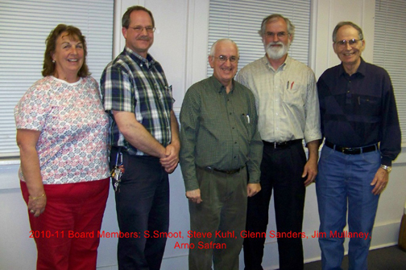

Left to Right: Treasurer, Sharon Smoot, Pres. Steve Kuhl, Sgt. in Arms: Glenn Sanders, Secretary Jim Mullaney and VP, Arno Safran
___________________________________________________________________________________________________________________
(More club news continues on page 5, column 1)

More club News
(Continued from previous page)

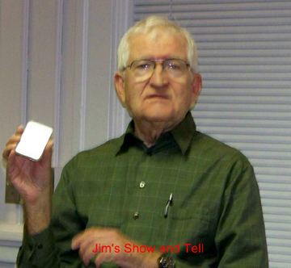

The invisible coin?
At least that is what Jim Barry appears to be holding in the NGC-MS-64 certified hermetically sealed holder. Actually, it is a silver size $1.00 coin struck by the Denver Mint for Curacao in 1944.

The prizewinners at the March 4 meeting were Helen Barry who won the one-ounce silver eagle door prize and Art Ludwig who took the 50/50 drawing - $20.00. Congratulations Helen and Art.
___________________________________________________________________________________________________________________________

Transitional Date Coin Pairings of the Month

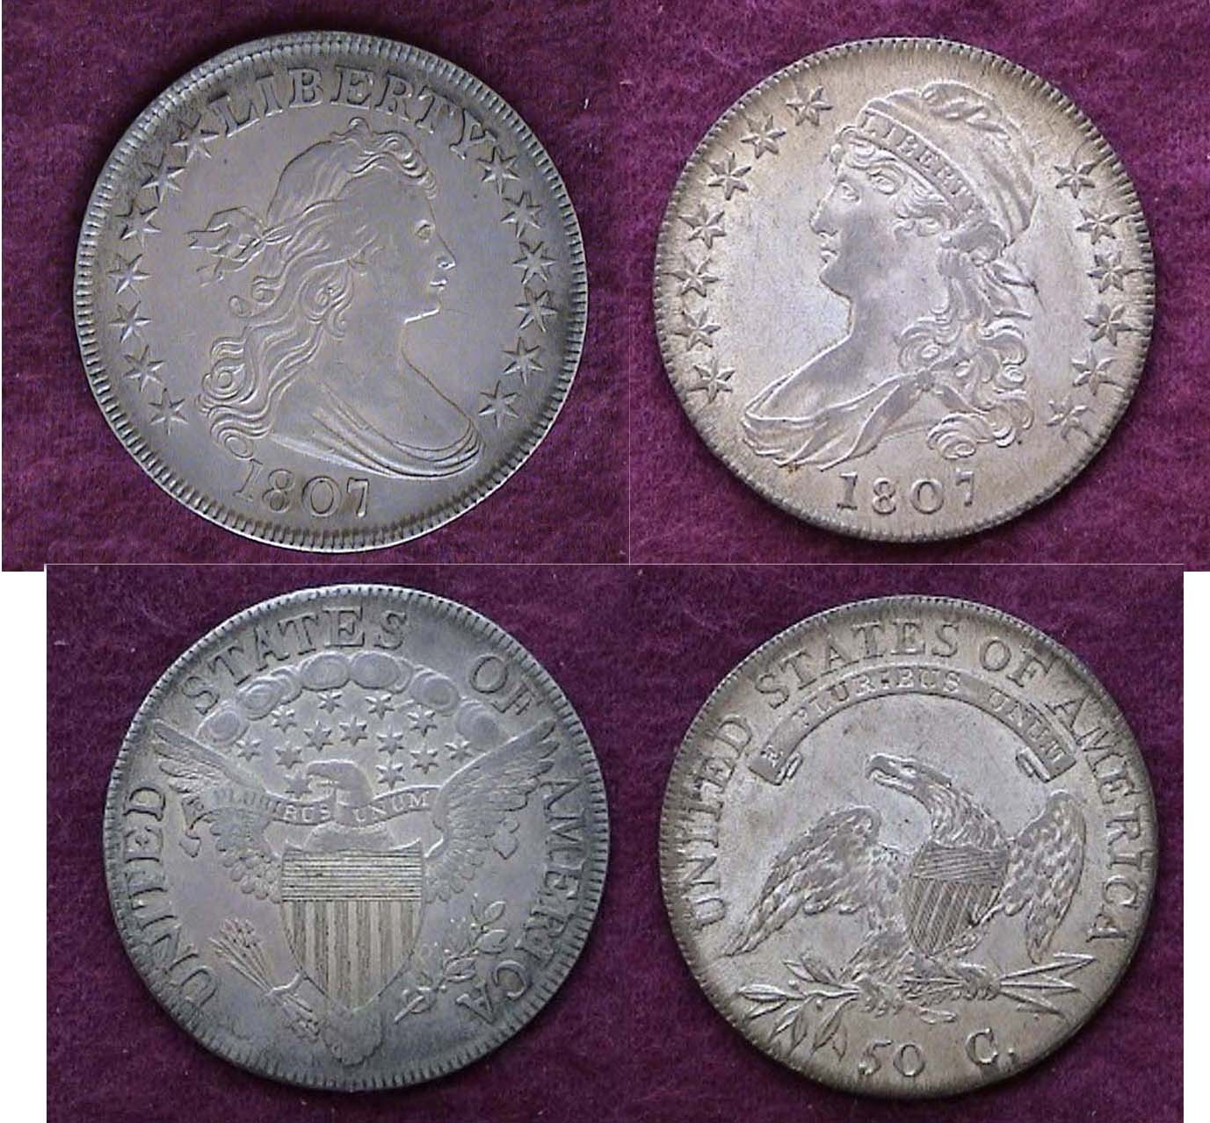

1807 Draped Bust (left) to Capped Bust (right) Half dollars
Both coins are 32.5 mm in diameter
Robert Scot designed the coin at left; John Reich, the coin at right
[Use a 3X glass or magnify to 200% to see details more clearly.]

In 1807, John Reich was appointed Assistant Engraver to Robert Scot and assigned to “improve” all our coinage designs. The 50¢ coin shown at right was one of the first.

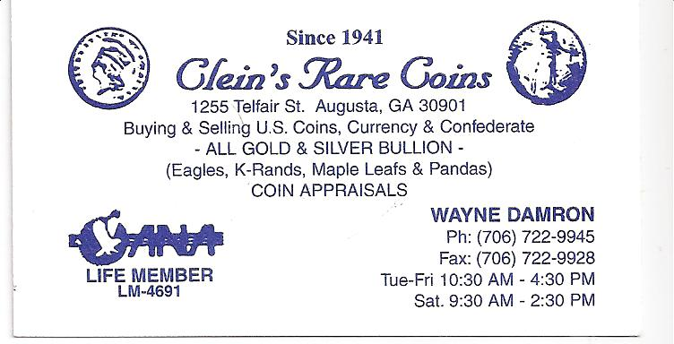

Kindly Patronize our Advertisers

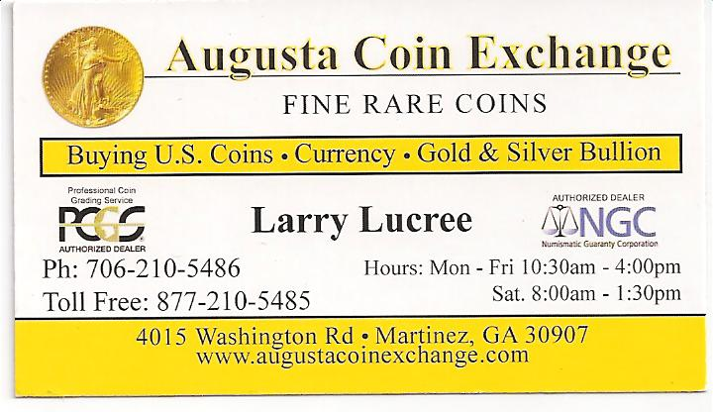
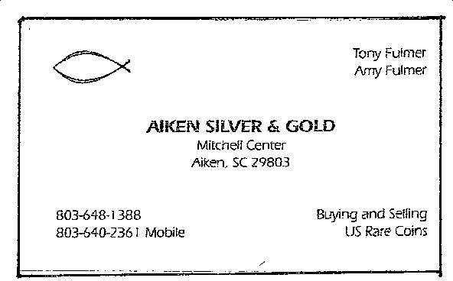
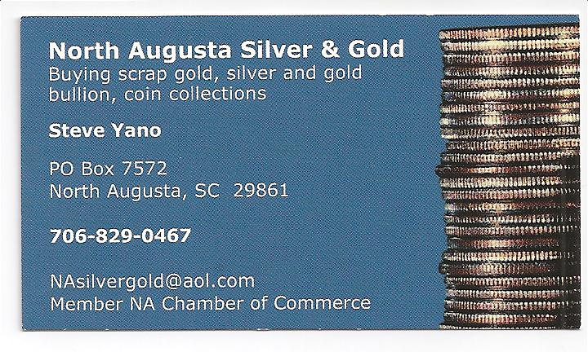

For the serious and casual collector

COINS, STAMPS & CURRENCY

P.O. Box 1739 Patricia James
Aiken, SC 29802 143 York Street
(803)-643-9957 Aiken, SC 29801

