Pres. Steve Kuhl
V .P. Pat James
Sec. Jim Mullaney
Treas. Sharon Smoot
Sgt. in Arms: Glenn Sanders
The Stephen James
CSRA Coin Club of Aiken
P.O. Box 11
New Ellenton, SC 29809
Web site: www.sjcsracc.org
The SJ CSRA CC of Aiken, SC meets on the 1st Thursday of the month at the Aiken Public Library

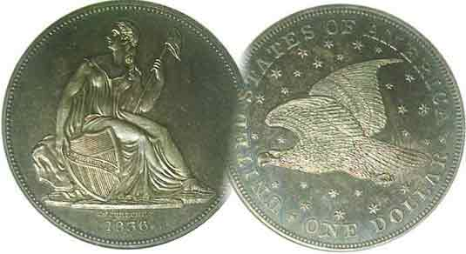
Programs: Pat James
Show: by Committee
ANA Representative: Jim Barry
Publicity: Jim Clapp
Newsletter: Arno Safran
E-Mail: arnosafran@comcast.net
Auctioneer: Glenn Sanders
Web site: Susie Nulty (see above.)

2011 Club Meeting Schedule
Volume 10, Number 4 the Stephen James CSRA Coin Club, Founded in 2001 April, 2011
Monthly Newsletter
Hobo Nickels DVD by Bill Fivaz Fascinating
Our next meeting is on Thursday, April 7, 2011 from 6:45 to 8:45 PM

Jan. 6 Apr. 7 July 7 Oct. 6
Feb. 3 May 5 Aug. 4 Nov. 3
Mar. 3 Jun. 2 Sep. 1 Dec. 1

____________________________________________________________________________________________________________

DVD offers Insight into the Creation of Hobo Nickels

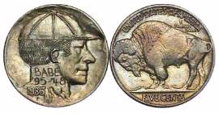
The program for March meeting was a DVD produced by noted numismatist Bill Fivaz on Collecting Hobo Nickels. During the 1920’s into the Great Depression and beyond, many homeless men who could not find steady jobs became drifters. A large number of these men hopped on freight trains crisscrossing the United States. They might disembark in a town taking on temporary low paying work before moving on in what seemed to be a never-ending series of travels to somewhere and nowhere, often with only a bottle of whiskey to keep them company when no other buddies were around. Some of these men decided to take a more creative approach in the hopes of earning some money. They engaged in the dubious craft of defacing the then circulating Indian Head side of the Buffalo nickel, creating self images, portraits of girlfriends or famous personages. The most famous engraver of Hobo nickels was a black man named George Washington “Bo” Hughes. Specimens of his art eventually became so popular that some “originals” bring as much as four figures at auction today. Bill Fivaz has done the world of Exonumia a great service in assembling a wide variety of hobo nickels for view in this outstanding video presentation. The Club would also like to thank Jim and Helen Barry for arranging to make the video available to our club members.
________________________________________________________________________________________________________________
Election of Officers Brings One Change

At the March 3 meeting the club elected officers for the 2010-11 fiscal year. Elected were Steve Kuhl, President, Pat James, VP. [Pat replaces Arno Safran who volunteered to serve for one year], Jim Mullaney, Secretary, Sharon Smoot, Treasurer and Glenn Sanders, Sgt. in Arms. Their term begins April 7.
__________________________________________________________________________________________________________________________
(Club News continued on page 4, column 1)
The Amazing US Coinage of 1916 (excluding gold)
95 Years ago By Arno Safran

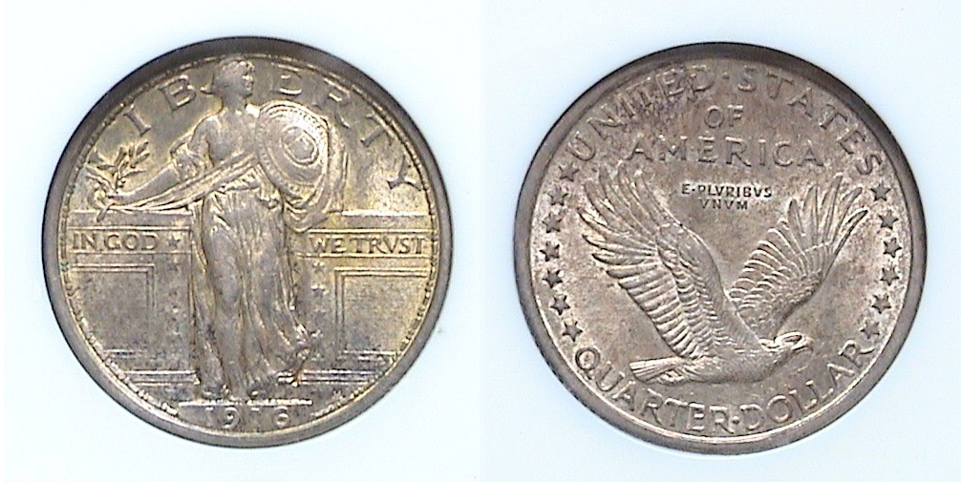

A 1916 Standing Liberty Quarter graded MS-62 by NGC
[Use 3X glass or magnify to 200% to see details more clearly.]

1916 was a banner year for US numismatics for at least four reasons. First, there were the three new design types, the Winged Liberty (Mercury) dime, the Standing Liberty Quarter and the Walking Liberty Half Dollar. These replaced Charles Barber’s Liberty Head dimes, quarters and halves respectively. Second, in 1916 two transitional dates were struck as the new designs for the dime and quarter followed the Barber coinage later that same year. The third resulted in the production of two highly popular American rarities; the 1916-D Mercury dime (with a mintage of only 264,000) and the 1916 Standing Liberty Quarter, (with just 52,000 struck) while the fourth represented the continuation of more exquisite artistic design types begun in 1907 with the Saint-Gaudens $20.00 gold Double Eagle.

It was Theodore Roosevelt--who upon becoming President after the assassination of William McKinley in 1901--recognized that our nation’s coinage ought to portray the values of peace and strength along with beauty and majesty. He asked Augustus Saint-Gaudens--one of the leading sculptors of the period--to come up with a new design for the $20 and $10 gold pieces. These were released in 1907. In 1908, Bella Lyon Pratt’s $2.50 and $5.00 gold pieces followed. In 1909, Victor David Brenner’s Lincoln Head cent was introduced followed by James Earl Fraser’s Indian Head/ Buffalo 5¢ nickel in 1913. The year 1916 continued the numismatic Renaissance with the three aforementioned denominations. Many numismatists regard this period as the golden age of United States coinage.
_______________________________________________________________________________________________________________________
(Continued on page 2, column 1)
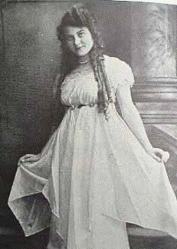
The Coinage of 1916 (continued from page 1, column 2)
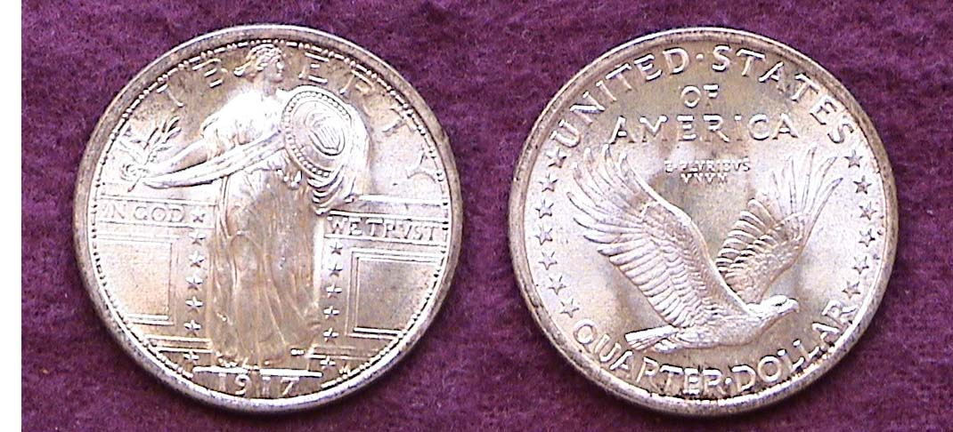
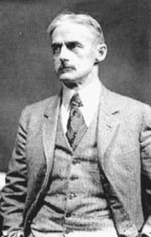

A MS-64 1917 Type I Standing Liberty 25¢
Far more affordable than the rare 1916 issue

Hermon MacNeil

Saint-Gaudens died in 1907 but among his younger contemporaries were Hermon MacNeil (1866-1947) and Adolph Weinman (1870-1952). Both MacNeil and Weinman were already noted sculptors when they entered the competition for new coinage designs announced in late December, 1915 by Mint Director Robert W. Woolley. Despite Chief Engraver Charles Barber’s irritation at the prospect of having his quarter century old Liberty Head designs replaced, MacNeil and Weinman’s new adaptations were chosen in early March of 1916 from the many talented artists who entered the design contest. Weinman was actually the winner of two denominations for his Mercury dime and Walking Liberty Half Dollar entries.
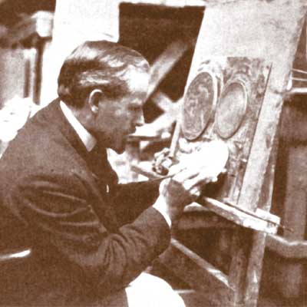
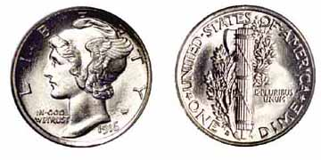

This rare and highly prized
1916-D Mercury dime graded
MS-65 by PCGS realized $36,800 in a 2003 Bowers & Merena sale

Adolph Weinman in his Studio

Unlike the rare and expensive 1916 Standing Liberty Quarter issued only at the Philadelphia Mint, the Mercury dime was struck at all three Mints, allowing the collector of modest means to purchase the low cost Philadelphia issue or San Francisco offering from MS-63 to 65 without having to take a second mortgage on the house. With the 1916 SL quarter now selling in the five figures from AU-50 on up, many collectors opt for the 1917 Type I issue pictured above. The date looks almost identical to the 1916 and usually come well struck with lustrous surfaces, even in MS-63. As such, it is priced within the range of most avid numismatists.

There is an interesting debate as to who actually posed for the Standing Liberty Quarter. Originally it was believed to be Doris Doscher, a model and sometimes Broadway actress and singer who went by the stage name of Doris Doree. In 1972, a news story suggested that another woman might have been the model. Irene MacDowell, then 92, reported that it was she who had posed for the 1916 quarter. Her husband had been a tennis partner of the sculptor. Like Doris Doscher, Irene MacDowell was an actress and a beauty. The source for this information is found in “Standing Liberty Quarters” by J.H. Cline, a noted dealer in the series.
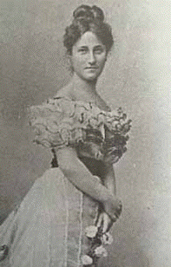
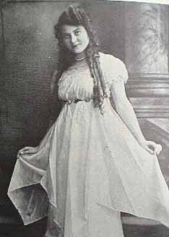
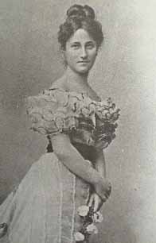

Doris Doscher Irene MacDowell
Which beauty was the model for the 1916 SL Quarter?

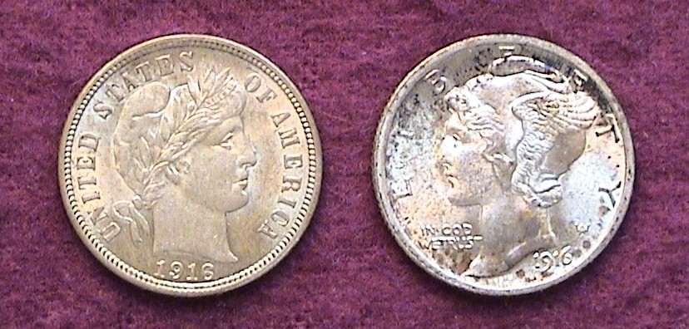
On the other hand, the model for the Weinman’s Winged Liberty Mercury dime has never been in doubt. In addition to being a great artist, Weinman was frugal in matters of business and owned property in New York. One of the young couples who rented an apartment in his building was the now famous poet Wallace Stevens and his attractive wife Elsie. It was she who Weinman asked to pose for the new dime. For collectors who like to collect two different design types of the same date and denomination, acquiring a 1916 P Mint Barber and Mercury dime are affordable from VF-35 thru MS-64 and make for an attractive pairing as long as they are approximately in the same grade.

It is still possible to acquire at a modest price both 1916-P Barber & Mercury dime types that make for a attractive transitional date pairing.

Of all three innovative silver coinage designs initiated in 1916, Weinman’s Walking Liberty Half dollar is perhaps the most eloquent. The grace of the slender figure of Liberty is arguably equal to Saint-Gaudens $20 gold Striding Liberty design while the fully feathered eagle on the reverse of the half dollar is among the finest renditions of our national bird ever to appear on a coin. Both the 1916 and ‘16-D (with mintmark on obverse) are more affordable than the 1916-S and can be acquired as high as MS-63 at a reasonable price. That said, most 1916 Walking Liberty halves lack the bold strikes of the later issues. Better-struck examples can be found in MS-64 grades with sensational pieces grading MS-65 or higher but such specimens are quite costly for one on a moderate budget.

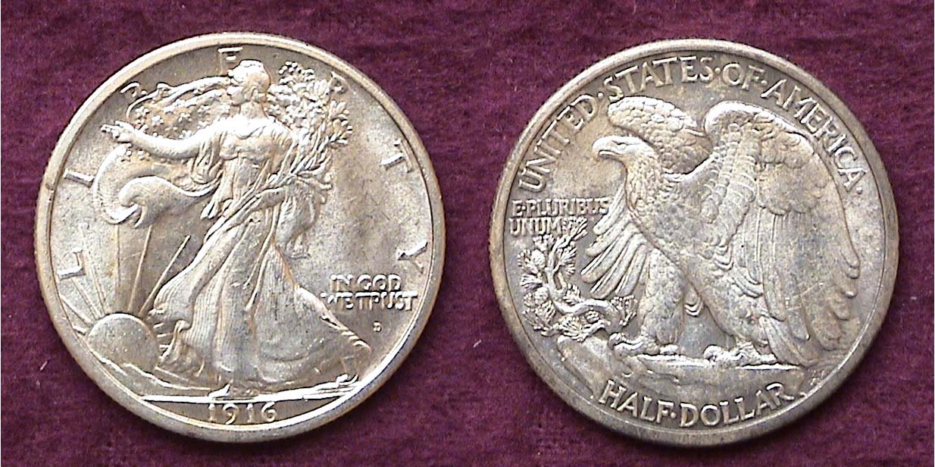

A 1916-D Walking Liberty Half Dollar grading MS-63
[Use 3X glass or magnify to 200% to see details.]
________________________________________________________________________________________________
(Continued on page 3, column 1)
The Coinage of 1916 (Continued from previous page)

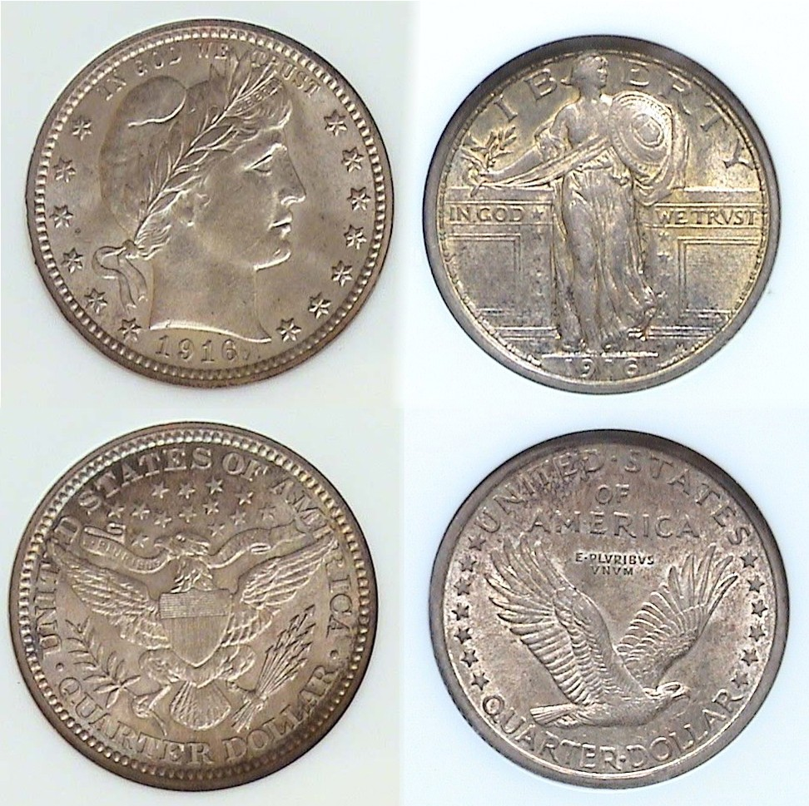

1916 Transitional Type Quarters
Barber’s on the left, MacNeil’s Standing Liberty, right
[Use 3X glass or magnify to 200% to see details.]

Collecting transitional dates is usually an economic means to acquire a variety of different type coins as in most cases, people tended to save the first and last year of a specific type. Exceptions to this rule occur when one of the transitional date pairings just happen to be a key date of a series. For 20th century transitional date types, it is the 1916 Standing Liberty quarter, one of the biggest “stoppers” of them all. Despite a relatively low mintage of 52,000 compared with a whopping 1,788,000 for the 1916-P Barber quarter, enough 1916 Standing Liberties were saved from AU-58 through MS-63 as a first year type that should have kept the cost down. What makes the coin so costly then? Demand! At the height of the recent coinage boom (2000-2009) MS-65’s were selling for well over $25,000 with MS-63’s going for $21,000. AU’s were priced at $15,000 while specimens grading as low as VF-20 were selling for as much as $11,000. Unlike the Barber designed 25¢ and 50¢ which displays a large Bust of Liberty and can appear attractive in grades as low as Fine-12, both the Standing Liberty quarter and Walking Liberty half lose much of their beauty once the luster is gone; in other words, below XF-45. Therefore, paying five figures for a well circulated 1916 SL quarter lacking eye appeal would probably not be a wise decision. Recently the prices for the 1916 SL quarter have come down some. Although still quite expensive, if a collector specializing in transitional dates wants to acquire both quarter types of 1916 obtaining this elusive beauty ranging in certified grades from AU-58 thru MS-62 could be the numismatic achievement of a lifetime. Fortunately, the 1916 Lincoln cent and Indian Head nickel completing the year set are inexpensive up through MS-64.

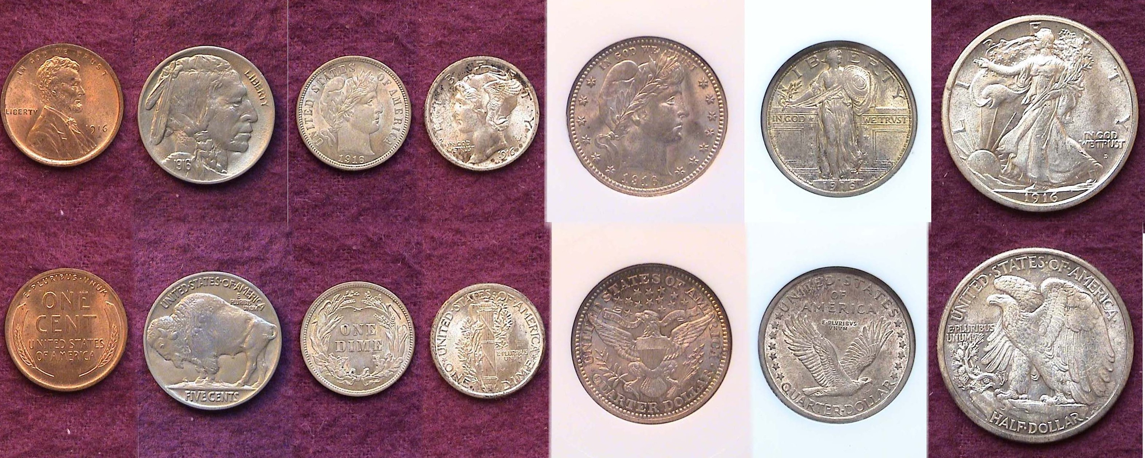

A mint state US 1916 Year set (excluding gold) [Magnify to 200%]
____________________________________________________________________________________________________________________
The US Election of 1916

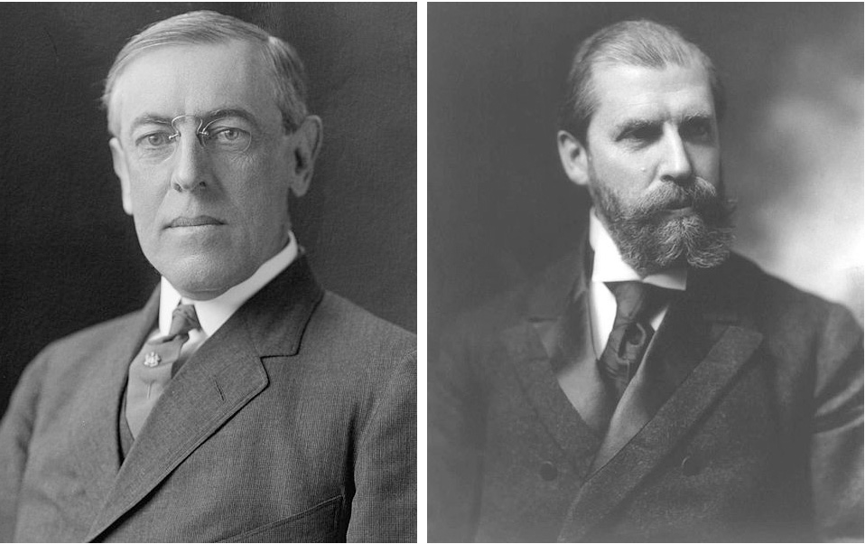

Woodrow Wilson, (D. NJ) Charles Evans Hughes, (R. NY)

Woodrow Wilson was the first Democrat to win an election since Grover Cleveland’s second term (Mar. 4, 1893-Mar. 4, 1897). Between 1897 and 1913 three Republicans had sat in the White House, William McKinley, Theodore Roosevelt and William Howard Taft. Before Cleveland, Republicans had dominated the American political landscape going all the way back to Lincoln. It was believed that Wilson won the election of 1912 because Taft, Roosevelt’s heir apparent, had so disappointed Teddy while the ex President was on Safari in Africa that upon his return he decided to challenge his old friend for the nomination, running as a third party candidate. This split the Republican vote and the Democrat standard barer Wilson won. By 1916, the Republicans became united and chose Charles Evans Hughes of New York to run against Wilson. America was at peace in 1916 and most Americans wanted it to stay that way despite the brutal war that was raging in Europe since 1914. Wilson ran on the slogan, “Reelect Wilson, he kept us out of war”. After the California vote came in early on the morning of Nov. 8, 1916 Wilson learned that he had been reelected in one of the closest elections ever, defeating Hughes in the in the popular vote by 9.1 million to 8.5 million and in the Electoral College by 277 to 254.

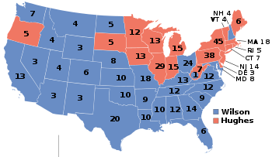
Wilson was a man of strong faith. His father had been a Minister in Staunton, VA and moved to Augusta, GA when Wilson was still a child. Wilson became a professor at Princeton, later served two terms as Governor of New Jersey before becoming President. Not even an honest politician can guarantee all his promises. The sinking of the Lusitania in 1915 by a German sub raised Wilson’s concerns, but despite US protests, German attacks on American vessels continued. Within a year of his reelection Wilson asked Congress for a declaration of war against Germany thus plunging the US into WWI.
_____________________________________________________________________________________________________________________________
Club News (Continued from page 1, column 1)

Glenn Sanders reported on all the upcoming shows for the month of March. Treasurer Sharon Smoot reported a balance of $1,783.50. Thank you Glenn and Sharon. President Steve Kuhl discussed plans for our September show. It will be held Saturday, Sept. 10, 2011 at the H. Odell Weeks Activity Center on Whiskey Road across the street from the Home Depot in Aiken. A Committee will be working together to contact dealers, prepare the publicity and arrange for volunteers to help with the set-up welcoming desk and take down.

There were five Show & Tells: Chuck Goergen brought in a sea salvaged 1836 Pillar dollar that was raised from the 1739 Rijswijk shipwreck.

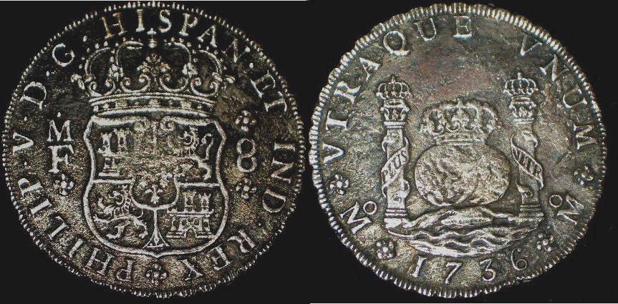

A 1736 8 Reales of Philip V struck at the Mexico City Mint
[Use 3X glass or magnify to 200% to view details.]

Chuck also displayed a tetradrachm from Ptolemy II.

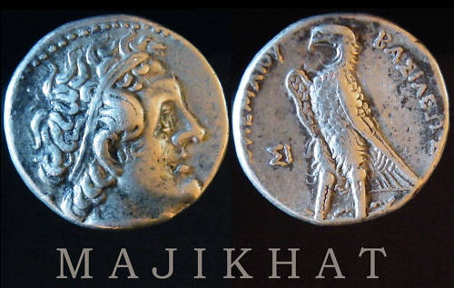

Ptolemy II (285-246 BC) AR tetradrachm, Sidon Mint
OBV. Diademed head of Ptolemy II facing right, dotted border
REV. eagle standing left on thunderbolt
[Use 3X glass or magnify to 200% to view details.]

Rick Owen brought in an interesting numismatic novelty; a complete set of five-ounce .999 fine silver replicas featuring the 2010 National Parks designs that appeared on our quarters but struck on large size planchets. These were all certified by NGC. Chuck Braun brought two coins commemorating two famous men. The first was a billon piece (a coin struck in an alloy less than 500% silver and copper) depicting Genghis Khan (1162-1277). The second piece was an archaic gold dinar showing Haran al-Rashid (766-804) of 1001 Nights fame. Arno Safran brought in a 75 year old uncirculated US year set of 1936 dated coins housed in a Capitol Lucite holder. All but the Washington quarter were struck at the Denver Mint. Arno explained that at the time he was assembling the set back in the late 1981, he learned that the 1936-D quarter was the third scarcest issue behind the 1932-D & S of the entire Washington quarter series in mint state, so he substituted the less expensive San Francisco Mint issue in its place.

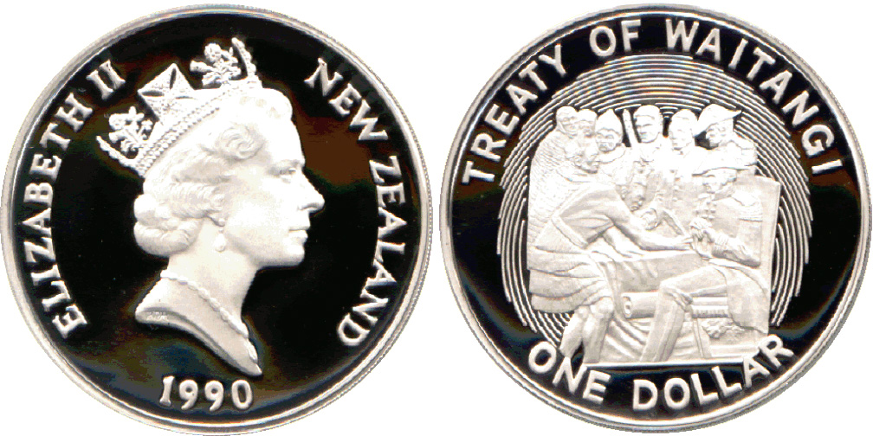

A 1990 New Zealand Commemorative silver proof $1.00
The coin shown in actual size is 38.735 mm in diameter
and produced with a reeded edge. [Use 3X glass or magnify to200%.]

Jim Barry brought in a 1990 New Zealand commemorative dollar celebrating the 150th anniversary of the 1840 Treaty of Waitangi by the British and Maori. A portrait of Queen Elizabeth II appears on the obverse while the reverse shows the principals at the Treaty of Waitangi signing.

The prize winner at the March 3 meeting was Helen Barry who won both the door prize and the 50/50 - $18. Congratulations, Helen! Our next meeting is April 7. The program will be on Collecting Charles Barber’s Coins. Show & Tells are always welcomed! Looking forward to seeing you all.
____________________________________________________________________________________________________________________

Please Patronize Our Dealer Advertisers
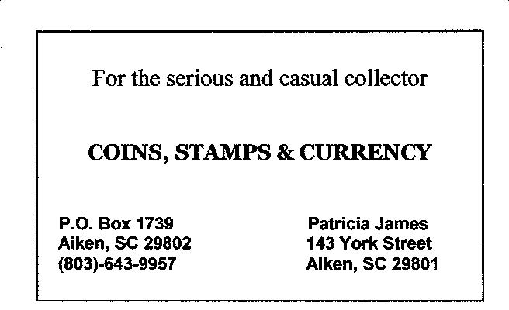

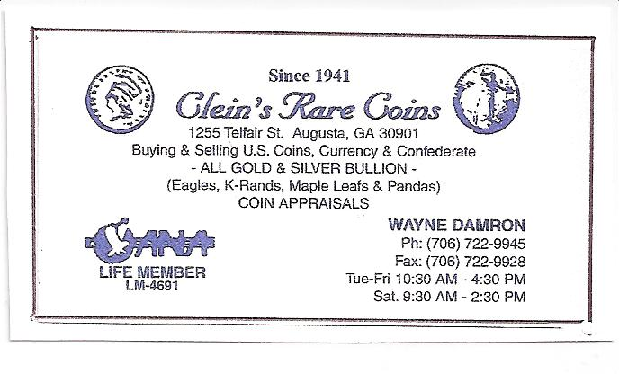
Don’t forget! $12.00 membership dues will be due for the 2011-12 fiscal year at the beginning of April. You can mail a check in that amount to PO Box 11, New Ellenton, SC 29809 or better yet, join us at the meeting on Thursday, April 7 and pay Treasurer Sharon Smoot in person and thanks in advance.
__________________________________________________________________________________________________________________________

