Pres. Steve Kuhl
V .P. Pat James
Sec. Jim Mullaney
Treas. John Meinhardt
Sgt. in Arms: Glenn Sanders
The Stephen James
CSRA Coin Club of Aiken
P.O. Box 11
New Ellenton, SC 29809
Web site: www.sjcsracc.org
The SJ CSRA CC of Aiken, SC meets on the 1st Thursday of the month at the Aiken Public Library

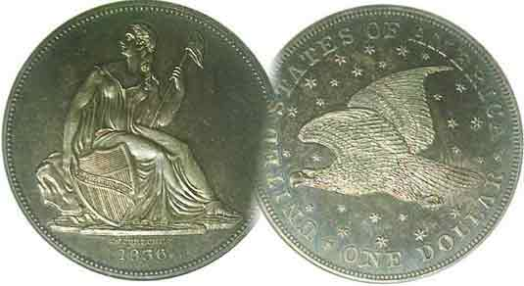
Programs: Pat James
Show: by Committee
ANA Representative: Jim Barry
Publicity: Jim Clapp
Newsletter: Arno Safran
E-Mail: arnosafran@comcast.net
Auctioneer: Glenn Sanders
Web site: Susie Nulty (see above.)

2012 Club Meeting Schedule
Volume 11, Number 4 the Stephen James CSRA Coin Club, Founded in 2001 April, 2012
Monthly Newsletter
Club to begin Twelfth Year at April 5 Meeting
Our next meeting is on Thursday, April 5, 2012 at the Aiken Public Library

Jan. 5 Apr. 5 July 5 Oct. 4
Feb. 2 May 3 Aug. 2 Nov. 1
Mar. 1 Jun. 7 Sep. 6 Dec. 6

______________________________________________________________________________________________________

.
Club officially began in 2001: Brief Recollections

In March 2001, a small group of area coin collectors met to form what is now called the Stephen James CSRA Coin Club. The club was named in honor of the late Stephen James, husband of one of the founders and current Vice President Pat James. Stephen James operated a coin shop in Aiken and was instrumental in helping to educate and assist budding coin collectors residing in and around Aiken County. The original Executive Board consisted of Past President, Willie Simon, VP Jim Barry, Secretary Helen Barry, Treasurer, Pat James and Sgt. In Arms Cliff Norwood. The club held its meetings on the second Thursday at the Aiken Public Library but on a month-to-month basis based on availability. Thanks to the efforts of these founders, the club soon set the standard for raising the level of local club meetings to include--in addition to the monthly auction--timely news about the world of coin collecting. a Show & Tell segment and an educational program. During its second year, the South Carolina Numismatic Association presented the SJ CSRA CC with a plaque honoring it as “Club of the Year”.

The first issue of the Newsletter was published in January of 2002 and distributed at the meeting, later to be mailed in advance of the meeting. In 2006, the Newsletter went digital. Today most members receive it by E-mail.

Without being assured of a regular monthly time slot, the club began to look for another site in 2006. In that year, the SJ CSRA CC moved to the Cedar Creek Activity Center in New Ellenton. The state of the art facility was excellent but not centrally located and attendance began to wane. In April 2009, Steve Kuhl was elected President and Sharon Smoot became Treasurer. The following year Arno Safran became VP and Jim Mullaney, Secretary. Finally, trough the efforts of Willy Simon, the Library granted us a regular meeting slot on the first Thursday of the month where we have been meeting ever since.
_____________________________________________________________________________________________________________________
The Case for Buying Certified Coins: Part 4
Small Change: By Arno Safran

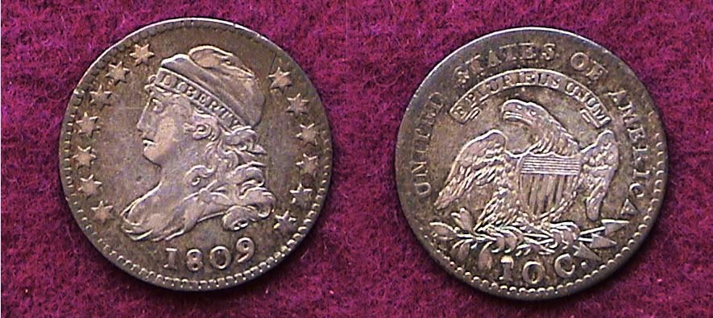

An 1809 Capped Bust dime JR1, R4 (18.8 mm,)
[Use a 3X magnifying glass or magnify page to 200% to view details.]

Living in central New Jersey during the 1980’s and ‘90s made it possible for one to drive either south to Philadelphia or north to New York City in less than two hours. The big problem was once you got there, one had to find a place to park and it was expensive. That was not going to keep an avid coin collector from attending one of the major coin shows and so it was in March of 1988, I made the trip along the NJ T’pke through the Holland Tunnel into lower Manhattan in order to attend the Metropolitan NY Coin Show. Back then, it was held in the spacious basement of the World Trade Center.

While scanning the bourse I came across an 1809 Capped Bust dime graded Choice VF at one of the dealer’s tables. The professional certification of coins was less than two years old, so most early US type coins either could still be found “raw” housed in stapled cardboard holders or transparent plastic Mylar flips. I had recently purchased an important book on the Bust dime series entitled “Early United States Dimes 1796-1837” (1984) written by five distinguished collectors. According to the authors, the 1809 dime had a total mintage of 51,065. This was much lower than the two preceding 1805 and 1807 Draped Bust issues with 120,760 and 165,000 respectively, yet the 1809 Capped Bust coin was priced at a far more reasonable rate; $350 as opposed to $1,400 for either the Draped Bust 1805 or 1807. dates in the same grade according to the 1988 Red Book.

Recently, I decided to have a number of my early date US coins certified in order to solidify their numismatic value and the 1809 dime shown above was one of them. I eagerly awaited the shipment of my coins to be returned from PCGS.
________________________________________________________________________________________________________________
(Continued on page 2, column 1).
The Case for Buying Certified Coins: Part 4
(Pocket Change)

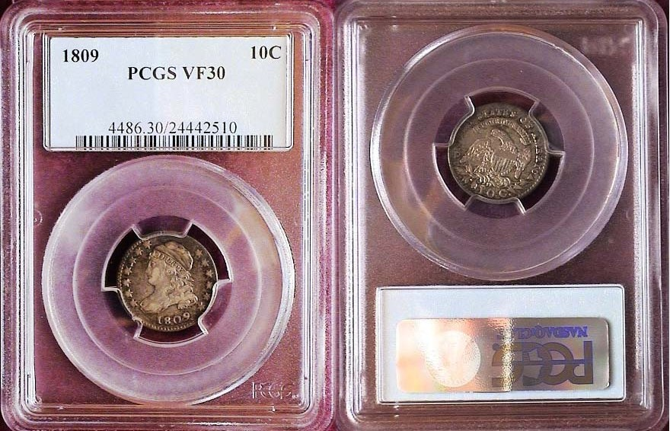

The same 1809 Capped Bust dime JR1, R4 certified AU-58 by PCGS
[Use a 3X magnifying glass or magnify page to 200% to view details.]

I was pleasantly surprised to learn that PCGS graded the 1809 dime VF-30. As recently as Jan 9 of this year a PCGS-VF 25 specimen sold for $2,530 at a Heritage Auction and the image of it posted on their website does not appear as sharp as the VF-30 graded specimen shown above. This does not guarantee that any coin certified similarly will fetch $2,500 but it is gratifying to learn that the rarity of this issue is becoming better known and some are willing to pay high premiums to attain it. A “raw” coin would not bring anywhere near the price realized at a Heritage auction.

An Unusual 1883 Shield Nickel
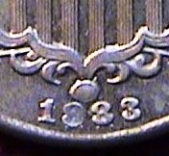
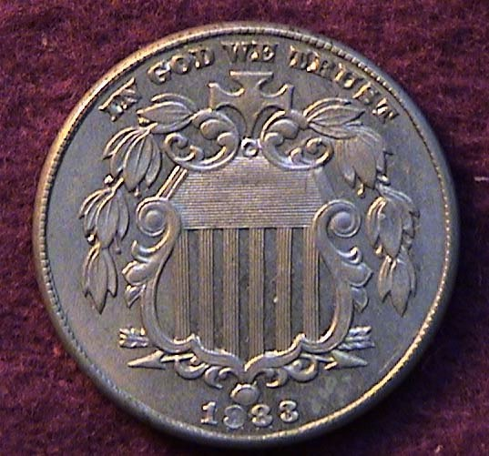

The obverse of an 1883 Shield nickel, with detail of re-punched date
Designated Breen #2523 or RPD FS-312
[Use a 3X magnifying glass or magnify page to 200% to view details.]

This particular coin shows a re-punched date with the remnants of the original appearing below it. It catalogs as #2523 in the Shield nickel chapter in Walter Breen’s Encyclopedia of US and Colonial Coins. It also is listed in “The Cherry Picker’s Guide… by Bill Fivaz and J.T. Stanton.

Back in 1989 I was visiting my friendly neighborhood coin dealer’s shop in Warrenville, NJ and the proprietor showed me this unusual error of an otherwise very common date 1883 Shield nickel. I asked him what he wanted for the coin and he replied, “$42.00”, but as he was holding it for another collector; he told me to wait a week and if the client had not made up his mind by then, the coin was mine at that price. During the week I checked out the coin in the aforementioned Breen Encyclopedia in which is pictured an enlarged detail of the date with the author’s comments, “Rarest has the date entered far too low” The following week I returned to the dealer’s shop and he handed me the coin at the agreed price. As the years went on it became more apparent that this particular variety was extremely uncommon. In the 1990’s I finally came across a lower grade specimen at a commercial show in which the dealer was asking $1,500. Could this coin really be worth that much? When the “Cherry picker’s Guide…” came out I looked to see if the particular 1883 Shield nickel variety was mentioned and sure enough, there it was on the final page of the Shield nickel series. It was listed as a Rarity 6, between 17 to 32 pieces known, in other words “RARE”. There were two other factors that accompanied the listing: Interest level and Liquidity. In each case these were given the number 3, (i.e., better than average interest by collectors, .and the variety was worth a premium to specialists.) Therefore, at the recently held FUN Show in Orlando last January, I submitted the 1883 dropped date coin to PCGS and the 1883 Shield nickel came back certified AU-58.

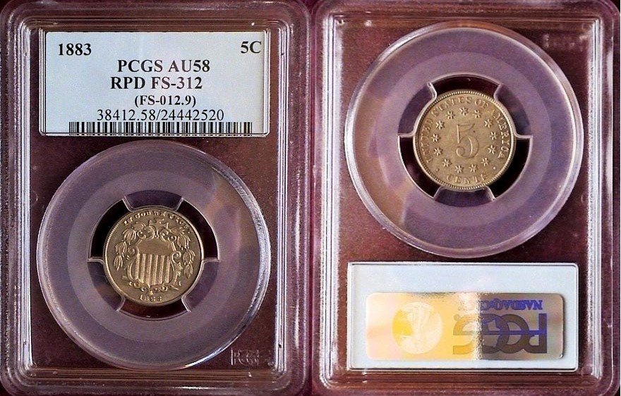

The 1883 Shield nickel with dropped date certified AU-58 by PCGS
[Use a 3X magnifying glass or magnify page to 200% to view details.]

Recently, a normal date 1883 Shield nickel certified AU-58 by NGC sold for $115 at a Heritage auction. The coin was accurately graded and pleasing to the eye. The certified re-punched date shown directly above should bring substantially more if a specialist in these types of errors is interested enough to pay a premium over the normal date price, but probably nowhere near the $1,500 quote I received from that particular dealer back in the 1990’s. The point of the tale is the RPD is now certified as an attractive AU-58 and is far more “liquid” than it would have otherwise been had it remained “raw”.

The 1846 Half Dime

With a mintage of just 27,000 the 1846 Liberty Seated half dime (shown atop page 3) is the “key date” of the entire series (1837-1873). At only 15.5 mm in diameter, the half dime was our smallest denomination issued before 1849. The coin was acquired “raw” at the Garden State Numismatic Convention in 1994 from a highly respected dealer who specialized in better date Liberty Seated coinage. This was New Jersey’s largest annual show and it is at shows such as this that collectors are likely to find scarce to key date coins to add to their collection.
__________________________________________________________________________________________________________________________
(Continued on page 3, column 1)
The Case for Buying Certified Coins: Part 4
(Pocket Change)

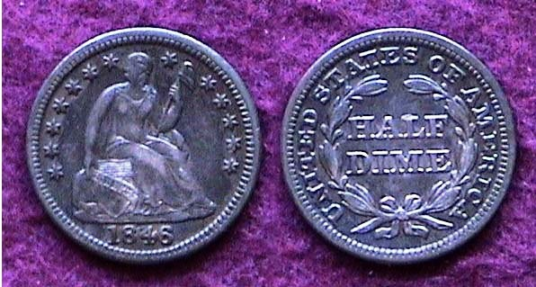

The “key date” 1846 Liberty Seated Half dime
[Use a 3X magnifying glass or magnify page to 200% to view details.]

As I recall there were two specimens of the 1846 half dame at the show and the one pictured above was the better of the two yet offered at a slightly lower price. The dealer graded the piece XF but due to the tiny size of the coin, it was difficult to discern whether it was a high-end VF (30 to 35) or an XF-40 specimen as there was considerable wear observable above Miss Liberty’s knees. The coin did not come “cheap” but I liked the “originality” of the piece (never cleaned, just normal wear), and respected the dealer’s judgment based on past sales. In looking at the coin’s value in the 2012 Red Book the 1846 half dime is currently listed at $2,500 in XF-40 but only $950 in VF-20. That is a pretty big gap between the two grades. So, after more than 17 years, since its acquisition I decided to submit the coin to PCGS and was gratified to discover that they considered the piece not only certifiable but graded it XF-45 in the bargain.

An 1846 Liberty Seated half dime certified XF-45 by PCGS
[Use a 3X magnifying glass or magnify page to 200% to view details.]

The Saga of a 1900 Indian Head Cent

Between 1976 and 1981 I used to frequent a coin shop in Levittown, PA located in a shopping center on the south side of the Delaware River not far from Trenton, NJ. The proprietor prided himself on having the finest US type coins in the area and for a novice collector I was impressed. To be fair, most of his selections were properly graded and had tons of eye appeal and while his prices were not cheap, they appeared reasonable considering the quality. The owner used to boast how years later he could recognize every coin he either sold or bought back from his customers because of their high quality. Part of this was hype but I came to think of him as an honest dealer.
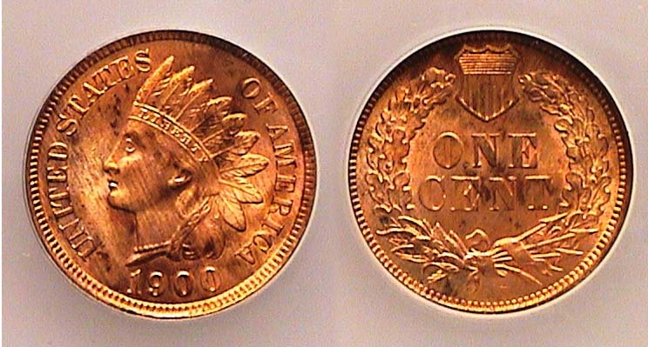

A 1900 Indian Head cent originally sold as MS-65 Red
[Use a 3X magnifying glass or magnify page to 200% to view details.]

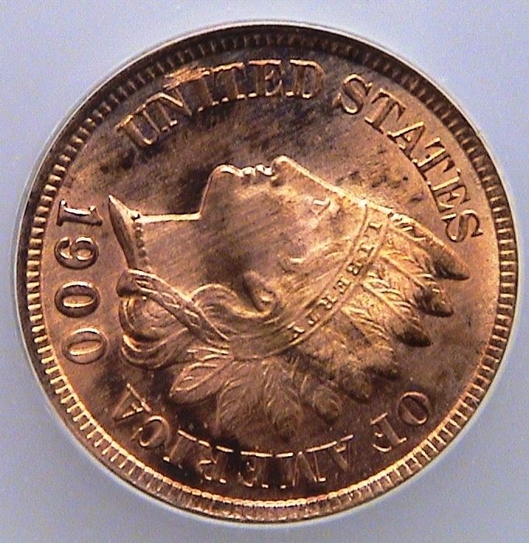
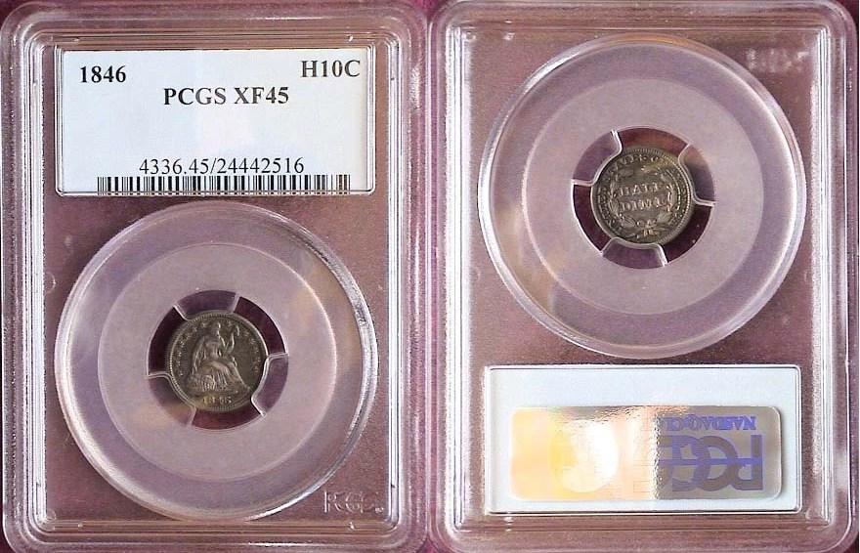
One of the so-called spectacular coins I acquired from him was a 1900 Indian Head cent he graded MS-65 Red and sold for $48.00. This was back in 1978 when prices for a large number of common date coins were dirt cheap even grading MS-65. In 1982 I completed my 1900 year set inserting the six coins into a Lucite Holder, later placing it in my Safe Deposit Box. The coins included the aforementioned 1900 cent, Liberty nickel (graded MS-65 by the same dealer), a 1900 Barber dime, quarter and half dollar and 1900 Morgan dollar... Before relocating, I took the set out of the SDB and noticed that the cent had toned unevenly and thought the problem was due to environmental damage. I decided to certify the set with ICG in January 2010 and the cent came back “Tooling between NI on obverse, UNC details”.

Detail showing tooling between N & I in UNITED
[Use a 3X magnifying glass or magnify page to 200% to view details.]

I decided to acquire another specimen of the cent and was the successful bidder of a 1900 Indian Head cent graded MS-64 Red Brown by PCGS at a recently held Heritage Internet auction. The coin is problem-free and attractive for grade.

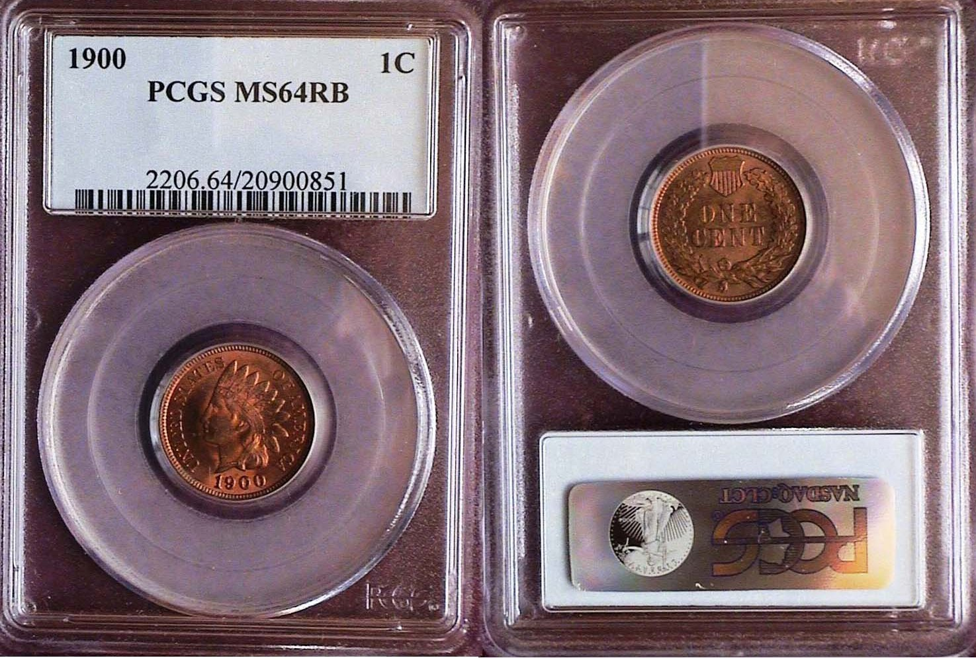

A 1900 Indian Head Cent graded MS-64 Red Brown by PCGS
[Use a 3X magnifying glass or magnify page to 200% to view details.]

Was the dealer aware of the tooling on my first 1900 cent and had it been artificially retoned to hide it? This I may never know but acquiring the certified replacement softened the blow.
__________________________________________________________________________________________________________________________________

Club News

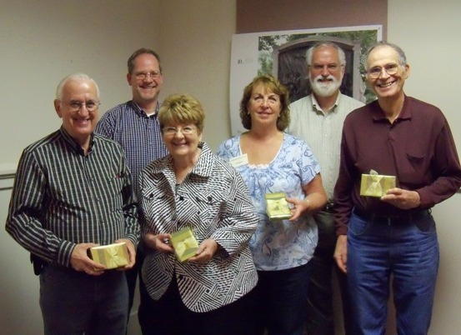

2011-12 SJ CSRA CC Executive Board and Editor Recognized
From L to R: Glenn Sanders, Sgt. in Arms, Steve Kuhl, President, Pat James, Vice President, Sharon Smoot, Treasurer, Jim Mullaney, Recording Secretary and Arno Safran, Newsletter Editor
[All pictures on this page courtesy of Helen Barry]

At the March 1 meeting, the 2011-12 SJ CSRA CC Executive Board and Newsletter Editor were recognized for their contributions during the fiscal year just ended. Each received a 2011 US Mint Proof Set, which includes one of each circulating coin denomination. These contained the 2011 Lincoln-Shield cent, the Jefferson Head nickel, and the clad Roosevelt dime. Also included were the five 2011 clad quarters honoring the following national parks, Gettysburg, Olympic, Glacier, Vicksburg and Chickasaw. The set also contains the 2011 clad Kennedy half dollar and 2011 Sacagawea dollar with the Wampanoag Treaty of 1621 reverse and the four Presidential dollars honoring Nos. 17 thru 20, Andrew Johnson, Ulysses Simpson Grant, Rutherford B. Hayes and James Garfield. This is a beautiful proof set and the recipients are all appreciative of the club’s generosity.

Sgt. in Arms Glenn Sanders announced that 22 members and 1 guest were present and announced a number of coin shows that were coming up within an hour to two hours drive. One of the first items on the agenda after President Steve Kuhl called the meeting to order was the election of officers for 2012-13. Treasurer, Sharon Smoot reported that the balance of March 1 was $1,481.20. President Kuhl thanked Sharon who is stepping down as Treasurer for her service and Sharon received a warm hand of applause from the members for her dedication. He also reminded everyone that $12.00 dues will be due starting with the April 5 meeting. Jim Barry Chairman of the Nominating Committee reported that John Meinhardt had volunteered to run for Treasurer. His nomination along with the remaining Board members was approved unanimously by the membership with the result that the 1212-13 Executive Committee of the club will be President, Steve Kuhl, VP, Pat James, Rec. Secretary, James Mullaney, Treasurer, John Meinhardt and Sgt. in Arms, Glenn Sanders.

The program featured a PowerPoint presentation by Tony Chibbaro on the Medals Commemorating Fort Sumter. As we have come to expect, Tony gave another one of his historically interesting and illuminating presentations providing a short history of Fort Sumter leading up to the outbreak of the Civil War and its aftermath. Tony showed some remarkable photographs and sketches of Fort Sumter before and after the multiple shillings by both sides in the conflict along with the citizens of Charleston observing some of the battles. He also displayed from his personal collection the various medallions struck commemorating the Fort, created initially by the North honoring Major Robert Anderson and the Union soldiers who were first attacked by rebel shelling on April 12, 1861.

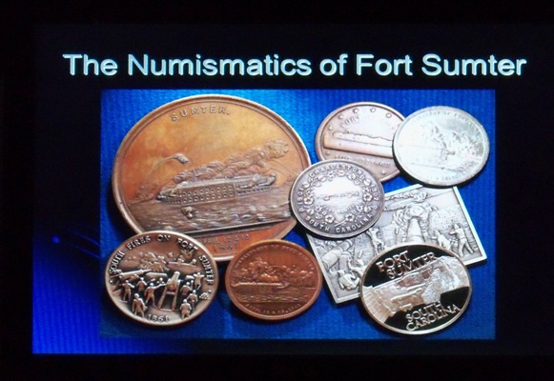

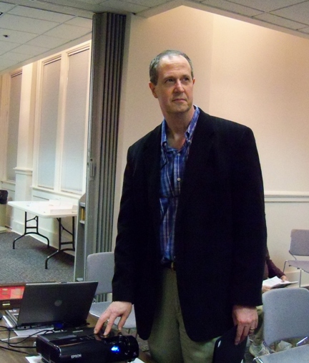
Tony reported that the first Fort Sumter medallions were produced in New York and struck in silver and bronze with one gold given to the Major Robert Anderson. The speaker related that one of the silver medallions realized $11,000 at auction in 2005 and a bronze piece sold for $4,600.at a Heritage Auction held in Long Beach, CA September 2007.

Tony Chibbaro speaking before our club

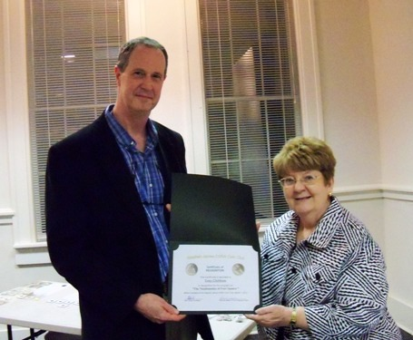

Tony Chibbaro receiving an Appreciation Certificate from
VP Pat James, Club Programs Coordinator
_____________________________________________________________________________________
(Club News, continued on page 5, column 2)
Coins from Ecuador
By Bill Myers

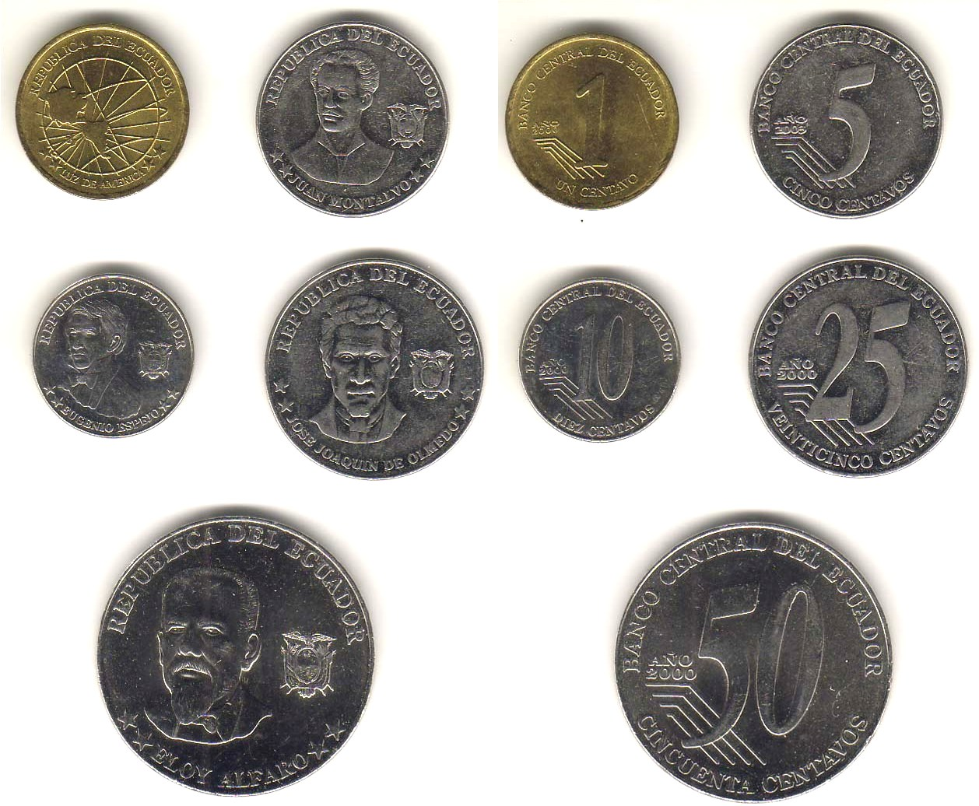
Modern Ecuadorian coinage
[Use a 3X magnifying glass or magnify page to 200% to view details.]

I recently returned from a trip to the Galapagos Islands, which are part of Ecuador. The purpose of the trip was to see the diverse plant and animal life of the Islands, but I managed to sneak in some numismatics during the trip.

I can say with certainty that everyone reading this possess Ecuadorian currency. That is because they use the US dollar. US coins and paper notes circulate freely. They prefer the dollar coin to the dollar bill, as it lasts longer. I rarely see dollar coins in the US, but they were in common use in Ecuador and the Galapagos. As a side story, one of the other people on the tour argued with a sales person at a shop at the airport when we were leaving, as he wanted dollar bills not coins in change, as he did not know what he would do with them when he got back to the US. I informed him that they are WE coins and he could easily spend them.

There is more to Ecuadorian coinage, however, as the country also has its own 1, 5, 10, 25 and 50 centavos coins first minted in 2000. The One centavo has a map of the Americas on it. It is composed of brass in 2000 but copper plated steel in 2003. The remaining coins are all steel and the 5 centavos features a bust of Juan Montalvo. Eugenio Espejo is on the 10 centavos, Jose Joaquin De Olmedo on the 25 centavos and Eloy Alfaro on the 50 centavos. These coins are the exact same size as the US equivalents and circulate alongside the US coins. The 50 centavos circulate freely, unlike half dollars in the US, but the 1-centavo coins were hard to find, as they are not used much. Interestingly, when Ecuador used the Sucre as its currency, there was a 20 centavos coin. That had to be changed to 25 centavos when they adopted the US dollar.

This is the second foreign country I have visited that uses the US dollar as its currency but also has its own coins that mimic the US counterparts in size, though not necessarily composition. That other country is Panama.
_____________________________________________________________________________________________
More Club News
(Continued from page 4, column 2)

The Prize Winners at the March 1 meeting were Arno Safran whose wife Vilma (inexplicably) drew the winning nametag and Todd Starbuck who won the 50/50 - $20.00. Congratulations, Todd and thanks, Vilma! (ED.) Our next meeting will be Thursday, April 5 at the Aiken Public Library. The program will be on Confederate Gold presented by Mark Waters. (I cannot wait to see this one, ED.) A reminder that dues of $12.00 will be due as we start our 12th year.

Please bring in some numismatic items for Show and Tell and for the monthly auction. Looking forward to seeing many of you there!
________________________________________________________________________________________________________________________

Kindly Patronize our Advertisers

