The Stephen James
CSRA Coin Club of Aiken
P.O. Box 11
New Ellenton, SC 29809
Web site: www.sjcsracc.org
The SJ CSRA CC of Aiken, SC meets on the 1st Thursday of the month at the Aiken Public Library

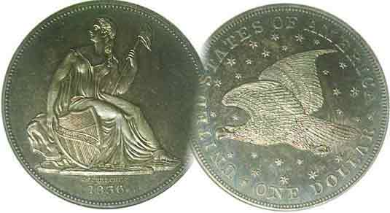
Pres. Steve Kuhl
V .P. Pat James
Sec. Jim Mullaney
Treas. Chuck Goergen
Sgt. in Arms: Jim Sproull
Programs: Pat James
ANA Representative: Jim Barry
Photos: Helen Barry
Publicity: Pat James
Newsletter: Arno Safran
E-Mail: arnosafran@comcast.net
Auctioneer: Glenn Sanders
Web site: Susie Nulty (see above.)

2013 Club Meeting Schedule
Volume 12, No. 4 the Stephen James CSRA Coin Club, Founded in 2001 April, 2013
Monthly Newsletter
Eight Show & Tellers Highlight March Meeting
Our next meeting will be held on Thursday, April. 4, 2013 at the Aiken Public Library

Jan. 3 Apr. 4 July ? Oct. 3
Feb. 7 May 2 Aug. 1 Nov. 7
Mar. 7 June 6 Sept. 5 Dec. 5

______________________________________________________________________________________________________

Show & Tells Can Produce Interesting surprises

Since there was no speaker scheduled for the March 7 meeting, the program was dubbed as a Show & Tell night. Eight different members brought in coins from their collections to share with the members. Member Todd Starbuck had earlier proposed to VP and Program chairperson Pat James that he would like to share some of his experiences with the professional third party grading companies and led off the session with a mini-program describing the results of submitting a number of his “raw” coins for certification, which he had acquired years ago. The very first coin he displayed turned out to be one of the major rarities of the Liberty Seated half-dollar series (1839-1891). It was the 1855-S, the first half dollar to be coined at the San Francisco Mint (The S Mint opened in 1854 but did not strike half-dollars until the following year). NGC had graded the coin “XF details, improperly cleaned”. A few years ago, NGC would have returned such a coin in a polyethylene bag ungraded but recently the two leading grading companies, PCGS (for Professional Coin Grading Service) and NGC, (for National Guarantee Company.) have decided that if they deem a coin to be “genuine” (PCGS’s term for authentic), they will grade the coin even if it has been cleaned or retoned. Survivors of the 1855-S 50c piece are scarce in all grades and many an ardent collector of this series would be grateful to be the temporary custodian of the 1855-S half since high-end certified pieces are extremely expensive.

According to the latest Red book, an 1855-S Liberty Seated half-dollar is valued at $1,750 retail in VF-20, $850 in Fine-12 and $550 in VG-8. It is unlikely that the coin Todd displayed would bring the $3,500 listed under the XF-40 column but depending on the demand combined with the lack of availability; this specimen could sell for quite a bit, despite its one time cleaning. Thank you, Todd for sharing your experiences with the club. Under Club News more of the Show & Tells will be covered.
___________________________________________________________________________________________________________________
(Continued under club news on page 4, column 1)
Collecting the US Coins of 1938: 75 Years Ago
By Arno Safran

. 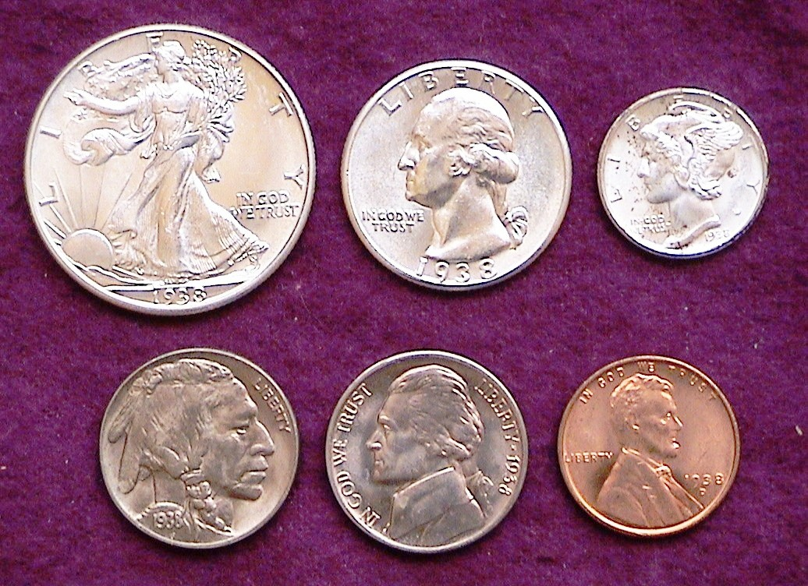

The Obverses of a 1938 Year Set showing mostly Denver Mint issues.
[Use 3X glass or magnify page to 200%]

Between 1933 and 1936 economic growth was beginning to show slow but steady progress as a result of New Deal legislation. Many of these stimulus packages enacted during the early years of the Depression era were working. The problem was that the Supreme Court found a number of the laws enabling these programs to be unconstitutional. On the heels of his landslide victory in the 1936 election President Franklin Roosevelt attempted to have legislation passed that would allow him to appoint a new Justice to the high court when a sitting justice turned seventy. The effort failed but some economists believe the Court’s earlier decisions to override caused another downturn in the economy during 1937 into 1938. Because of this, mintages for all five US coin denominations dropped considerably from their 1936 and ‘37 highs. The highlight of the 1938 coin year was the production of two-nickel types. The Denver Mint had already prepared dies for the Buffalo nickel before word reached them that the new Jefferson nickel was to replace it providing a transitional date pairing between the two-nickel types. Both coins are inexpensive through MS-65 grade.
____________________________________________________________________________________________________________________
(Continued on page 2, column 1)

Collecting the Coins of 1938: 75 Years Ago
(Continued from previous page)

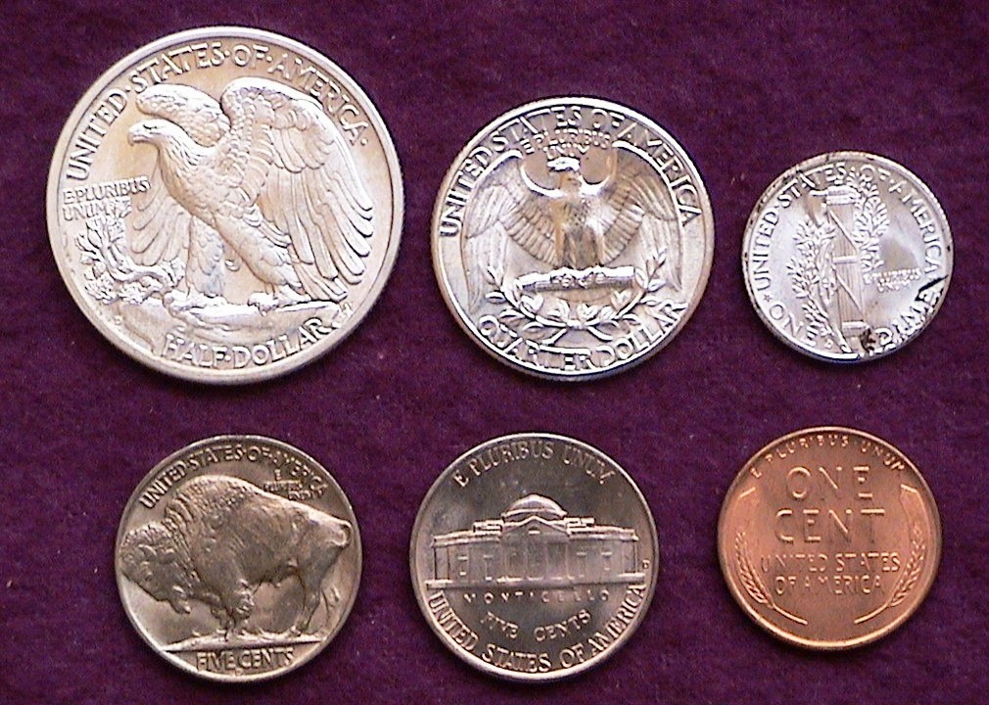

The Reverses of a 1938 Year Set showing mostly Denver Mint issues
[Use 3X glass or magnify page to 200%]

Back in 1873 the US Mint produced a record seventeen different coins that contained fourteen different denominations. These included two struck in copper, two in nickel, seven silver and six gold denominations. By 1936, the total number of denominations had been reduced to just five. These included the cent, nickel, dime, quarter and half-dollar.. This trend would continue for a total of 35 years until 1971, the year the clad Eisenhower dollar was introduced. While only five denominations were coined back in 1938, the two-nickel types add a little panache to the coinage for that year.

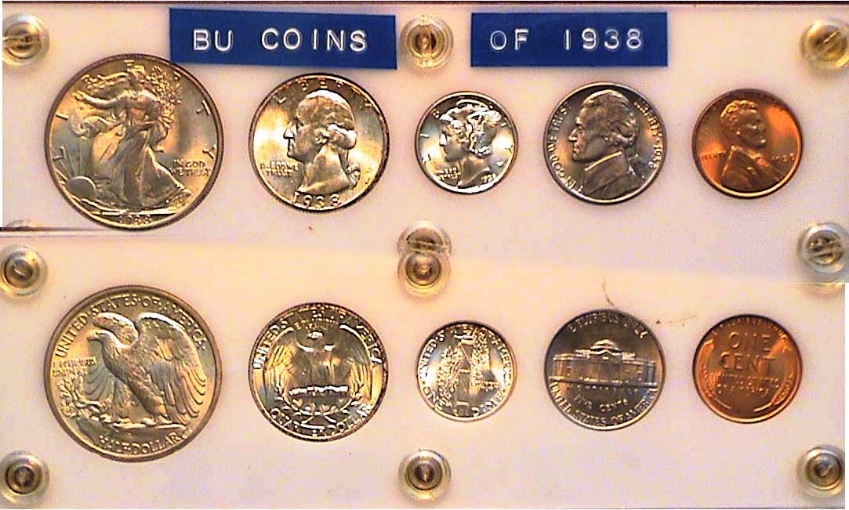

A complete 1938-P BU Year Set
[Use 3X glass or magnify page to 200%]

Despite the ongoing Depression, the Philadelphia Mint continued to lead the way with much larger mintages than either the Denver or San Francisco facilities. More than 156 million Lincoln cents were struck at the Philadelphia Mint that year yet the output was far below the more than 309 million struck there in both 1936 and ’37. Despite a mintage of only 20 million for the ’38-D and only 15 million for the ’38-S all three cents are priced around $9.00 in MS-63 according to the latest Red Book.

The new Jefferson nickel made a quiet debut with slightly less than 19.5 million being coined in Philadelphia as

compared 79 million Buffalo nickels produced the previous year and a whopping 119 million struck in 1936. Felix Schlag’s original prize winning design for the Jefferson nickel featured a very different--and arguably more artistic--portrayal of a three dimensional Monticello on the reverse than the two dimensional version of Jefferson’s home but the later revision prevailed.

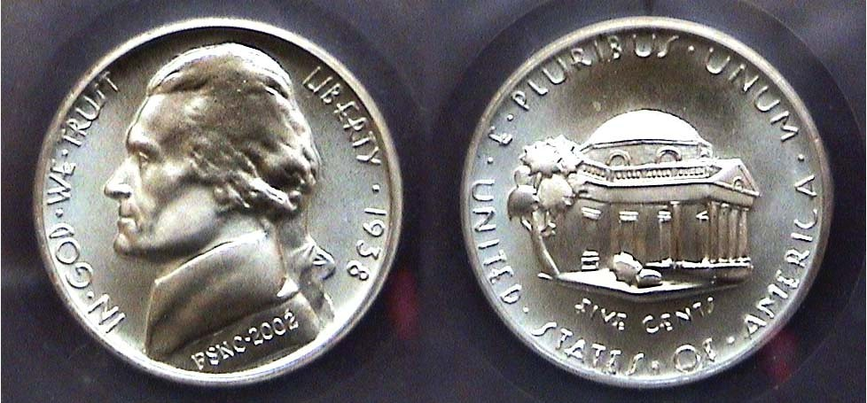

The original 1938 Jefferson nickel concept of engraver Felix Schlag
as seen in this Gallery Mint replica produced for the Jefferson Nickel Full Step Nickel Club [Use 3X glass or magnify page to 200%]

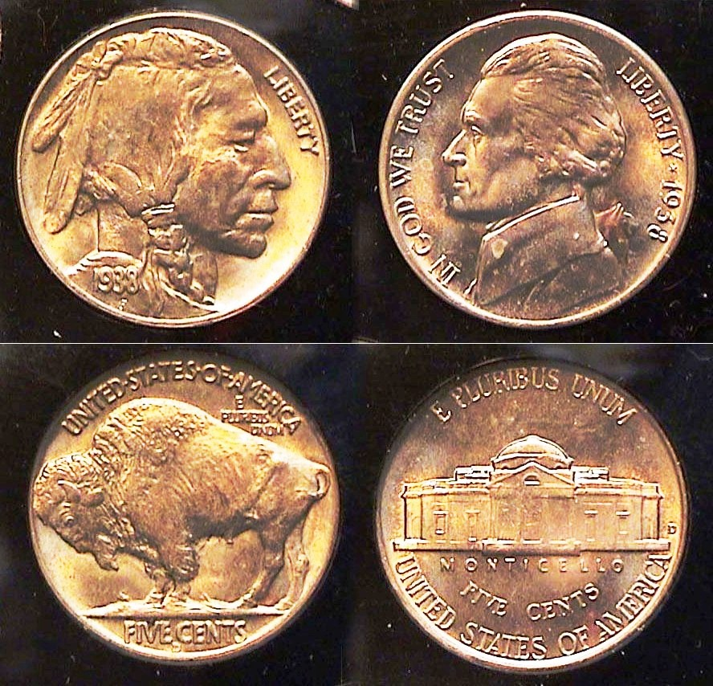
19.4 million of the new Jefferson nickels were struck at the Philadelphia Mint in 1938 and despite being 75 years old in 2013 (as this is being written), the date is very inexpensive. According to the latest Red book a 1938-P Jefferson nickel is priced at only $4.00 in MS-63 and $18.00 in MS-65. The mintages for the 1938-D Jefferson nickel are 5.3 million and 1938-S at just slightly over 4 million. yet in MS-65, both are priced lower at $16 and $17 respectively. The common 1938-D Buffalo nickel retails at $50 in MS-65.

1938-D Buffalo & Jefferson 5c types

The 1938 Mercury dimes were coined at all three Mints. Despite the Philadelphia Mint’s striking of 22 million compared with 5.5 million for Denver and 8 million at San Francisco, all three dimes are relatively inexpensive in mint-state. They range in price from $15 (P), $25 (D) to $28 (S) in MS-63 and from $30 (P) to $40 (S) in MS-65 according to the latest Red Book. Reverses showing fully split bands enjoy a premium.

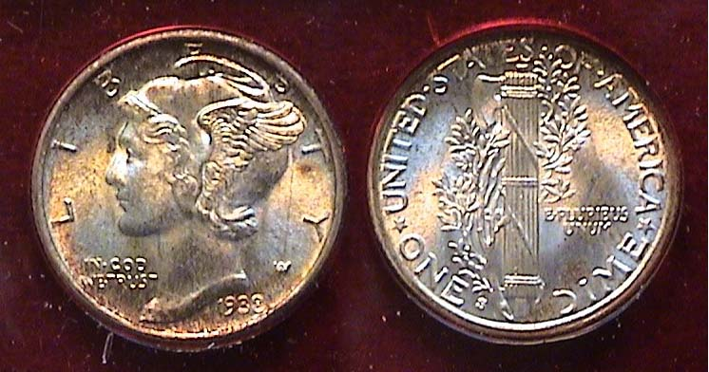

A 1938-S Mercury Dime with Full bands grading MS-64
[Use 3X glass or magnify page up to 500% to view details]

Due to the 1937 Recession, quarters were struck only in Philadelphia and San Francisco. The Philadelphia mintage that year was 9.4 million down from its peak of 41.3 million in 1936 while the output from the San Francisco Mint was a ‘paltry’ 2.8 million. At one time the 1938-P was valued higher than the 1938-S but the situation has become reversed with the 1938-S quarter now listed slightly more in MS-63 at $140 compared with $110 for the 1938-P. In MS-65, the prices are $10.00 closer, $230 to $210 according to the latest Red Book.
__________________________________________________________________________________________________________________
(Continued on page 3, column 1)
Collecting the US Coins of 1938: 75 Years Ago
(Continued from the previous page)

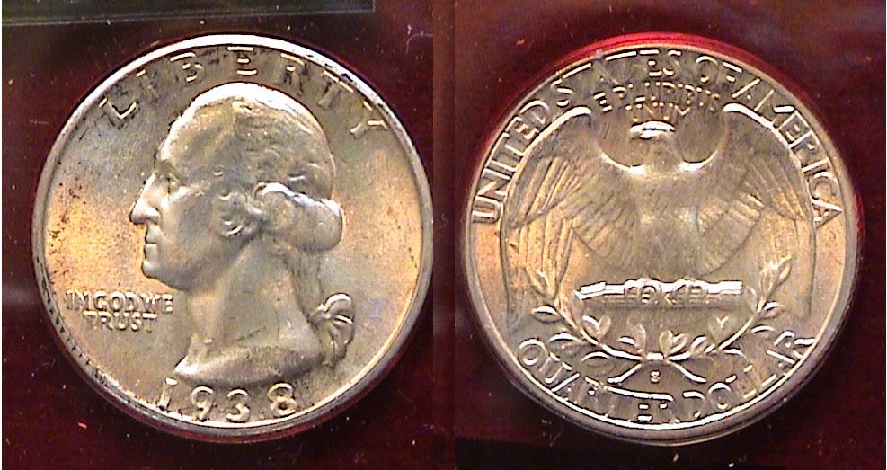

A 1938-S Washington Quarter grading MS-64
[Use 3X glass or magnify page to 200% to view details.]

Upon magnification, one can observe the S mintmark on the reverse centered under the ribbon directly above QUARTER DOLLAR.

As with the quarter dollar, the beautiful Walking Liberty half-dollar was struck at only two mints, Philadelphia and Denver. 4 million halves were produced at the Philadelphia facility while only 491,600 were struck at Denver suggesting the 1938-D issue might become a modern rarity.

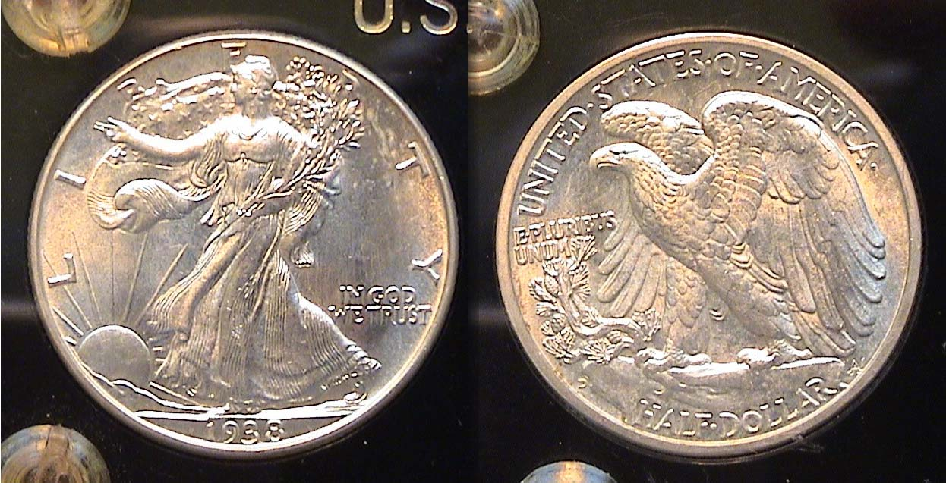

A 1938-D Walking Liberty half dollar graded MS-63
[Use 3X glass or magnify page to 200% to view details.]

Despite the low mintage for the 1938-D half enough rolls of uncirculated specimens was put away by knowledgeable dealers to provide reasonable access to the date even today. Still, the cost to own one, even in MS-63 is significant. In MS-63, a 1938-P specimen is listed at $160 while the ’38-D is priced at $625 according to the latest Red Book. While boasting the third lowest mintage above the 1921-P & D, it’s overall survival rate in MS-63 is much higher than many of the earlier dates in the series boasting far greater mintages.

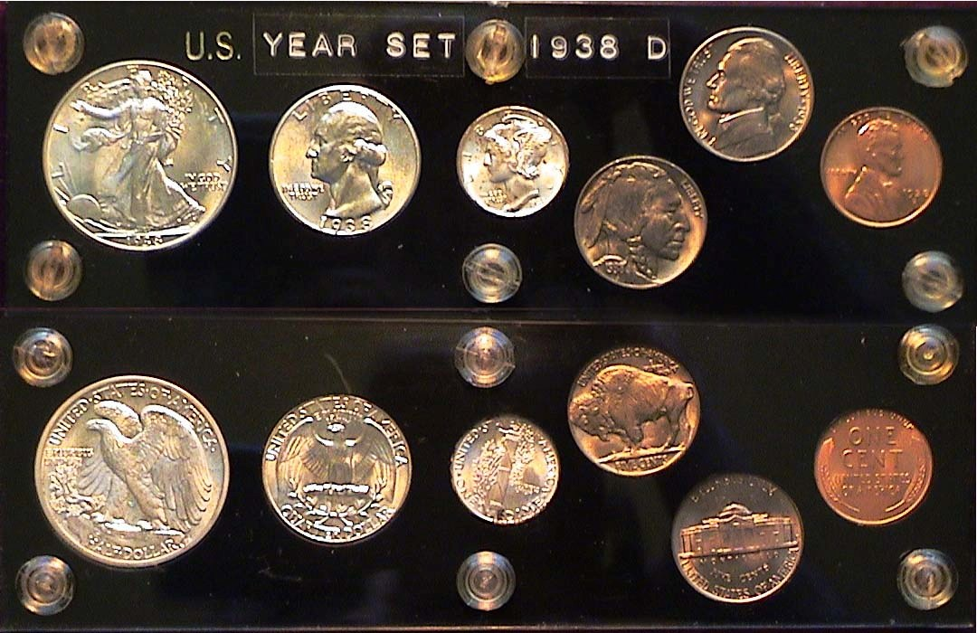

A complete 1938-D BU Year Set showing both nickel types
As there was no 1938-D quarter issued, the slot is filled b another 1938-P
[Use 3X glass or magnify page to 200%]
The thirteen coins that make up the 1938 year set were gradually assembled over a period of years ending with the acquisition of the ’38-D Walking Liberty half-dollar in April 2000. From 1939 on, Mint state Walking Liberty halves are common and moderately priced with the exception of the 1941-S and ’42-S. The 1942-S quarter is a little more pricey as well but for the most part all of the coins that make up year sets starting in 1941 are relatively inexpensive. 1938 is possibly the last year that some of the silver coins in the set would sell at a premium due to lower mintages and greater demand.

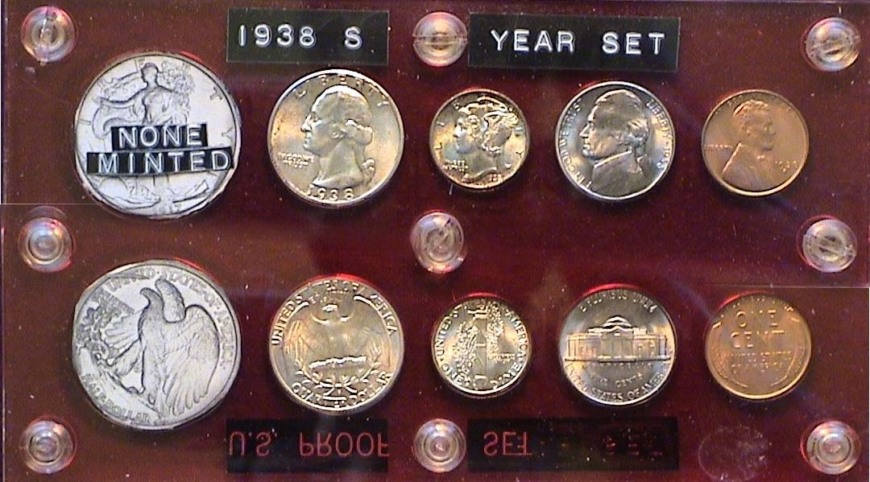

A 1938-S Mint-state Year Set housed in a Capital Lucite Holder
No 1938-S Walking Liberty Halves were issued that year.
[Use 3X glass or magnify page to 200% to view details.]

For collectors seemingly dissatisfied with the empty hole on the left hand column of the 1938-S year set shown above, one can acquire a 1938 half dollar commemorating the 250th anniversary of the founding of New Rochelle, NY. Of course, the addition will be somewhat costly as the reported mintage was only 15,266.
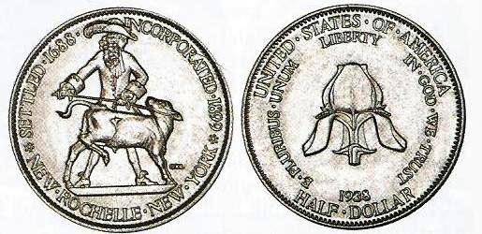

A 1938 New Rochelle Commemorative half-dollar
(Courtesy of the 2013 Red book)

The coin commemorated the founding of the small New York City suburb located in Westchester County by the French Huguenots in 1688. Further information on the issue can be found in the Red Book, a copy of which no serious collector should be without.

One other set of coins was issued in 1938. It is quite beautiful but also somewhat costly. Not shown is the 1938 Proof Set that contains the Walking Liberty half, Washington quarter, Mercury dime, the Jefferson nickel for the first time and the Lincoln cent. In 1938, it sold for $1.89 but today it is listed in the latest Red book at $2,000. Collecting all the US coins issues of 1938 in mint-state will be expensive but one can acquire a complete 1938-P Year set plus the very common 1938-D Buffalo nickel up to MS-64 at a modest figure.
________________________________________________________________________________________________________________________

An Introduction to Canadian Large Cents

By Tom Rothacker
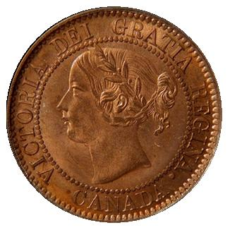
The budget-minded collector looking for a wonderful challenge might find bronze Canadian Large Cents just what they are looking for.

With the adoption of decimal coinage in the Province of Canada in 1858, the government proceeded to produce huge numbers of large cents in 1858 and 1859.

The Dominion of Canada government at the time of the Confederation in 1867 subsequently inherited a substantial number of large cents, remaining from the original 1858-59 mintage. Almost ten years had passed before the population absorbed this initial mintage.

Designer and modeler Leonard C. Wyon was again called upon to update the large cent, and the new version, with a more mature, crowned bust of Queen Victoria, went into production in 1876.

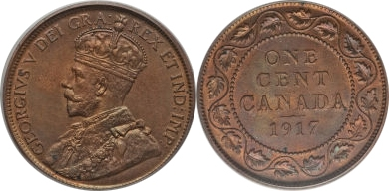
The Heaton Mint issues of 1876-1882, as well as those of 1890, 1898, and 1900, have an “H” mintmark on the reverse under the wreath at the bottom of the design. London mint issues have no letter.
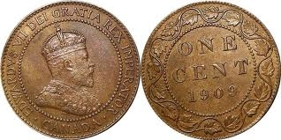
The passing of the venerable and beloved Queen Victoria in 1901 saw the next change in the large cent. Designer and modeler G.W. DeSaules designed the new obverse with the crowned bust of King Edward VII. The reverse remained the same, as did the original composition of .95 copper, .04 tin, and .01 zinc. The weight and diameter also remained the same at 5.67 grams and 25.4 mm respectively.

The Birmingham Mint issue of 1907 has an “H” mintmark on the reverse under the wreath. London mint issues from 1902-1907, and the Ottawa mint issues of 1908-1910, have no mintmark. With a mintage at a mere 800,000, the 1907 H is the key to the Edward VII strikes.

The most significant change to the Large Cents came about with the Coronation of King George V. Sir E.B.
MacKenna designed the new obverse with the crowned bust of King George V, omitting the term “DEI GRA”, meaning “By the Grace of God”, around the obverse edge. This aroused such public criticism in 1911 concerning a “Godless” coin, that the government was forced to alter the obverse again in 1912 to include “DEI GRA”.

The word “Canada” had also been placed on the reverse in 1911, a departure from its previous position on the obverse of the Victorian and Edwardian cents. The collector will find various interesting die varieties to enhance the experience of this beautiful series of coins. Some of them include the 1859 Wide 9 over 8, the Narrow 9, and the Double Punched Narrow 9 Varieties 1 and 2.

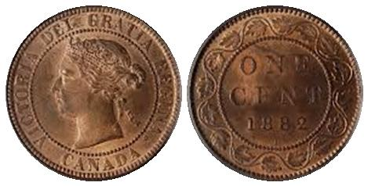
More recently, in depth research by renowned Canadian specialist James A. Haxby indicates that there may be more than one hundred different varieties of the 1859 Victoria cent.

The collector will find three major varieties of the 1891 Victorian issues. They are the Large Date / Large Leaves with leaves protruding into the inner border ring; the Small Date / Small Leaves where the leaves do not touch the inner border ring; and the Small Date / Large Leaves variety, the scarcest of the three.

Mintage of the Large Cent continued until 1920 when the government decided to reduce the size of the coin as a matter of economy, with a similar size and composition to the United States cent.

For a greater in-depth look at this beautiful series of coins, as well as other Canadian coins, there are three significant references available, listed below:

- Charlton Standard Catalogue of Canadian Coins, W.K. Gross, Charlton Press, North York & Ontario
- Coins of Canada, J.A. Haxby and R.C. Willey, Unitrade Press, Toronto
- A Guide Book of Canadian Coins and Tokens, James Haxby, Whitman Publishing Co., Atlanta, GA.
______________________________________________________
Tom Rothacker is a long time collector of US and Foreign type coins and enjoys sharing his knowledge of the Hobby with others. He is currently President of the Watchung Hills Coin Club, Watchung, NJ. His article was reprinted from the just published April. 2013 edition of the Hills Numismatist, with permission of Mark Abramson, editor.

Club News

President Kuhl called the March 7 meeting to order at 6:45 Pm. The Minutes were dispensed with, a copy to be placed on file. Treasurer Chuck Goergen reported a balance of $1,806.21 and that 2013-14 dues of $12.00 was due by the April 4 meeting. The annual election produced only one change in the Executive committee. Glen Sanders is stepping down as Sgt. in Arms and Jim Sproull was elected to take replace him.

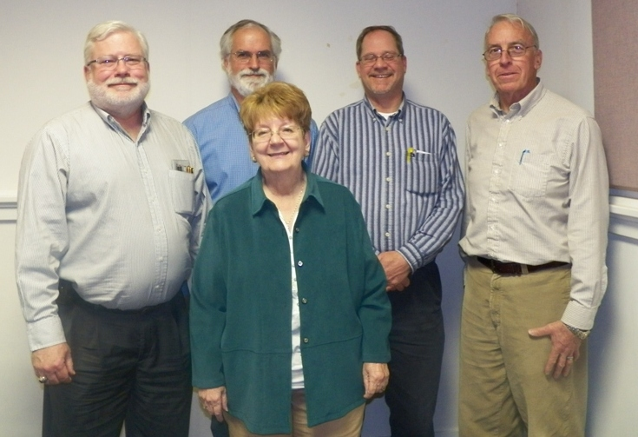

The SJ CSRA CC Executive Committee for the 2013-14 fiscal year
L to r: Chuck Goergen, Sec. Jim Mullaney behind VP Pat James, Pres. Steve Kuhl and Sgt. In Arms Jim Sproull
[Photo by Helen Barry]

Glenn Sanders highlighted some upcoming shows including one in Myrtle Beach, SC April 6 & 7, the Georgia Numismatic Association Convention in Dalton, GA on April 19-21 and the Augusta coin Club Show, May 10 and 11.

The main event was Show & Tell night and eight members brought in some very interesting numismatic items. As reported earlier, Todd Starbuck decided to submit many of his “raw” coins for certification which garnered mixed results but expressed satisfaction overall from the experience. Todd passed around all of the coins, a number of which were scarce to rare. Thanks, Todd for sharing your grading experiences with us.

Marian Engel brought in a late Roman copper follis, from the early 4th century AD. The obv. featured the Bust of Maxentius as Augustus (AD 308-312), The rev. portrayed a six Column Temple with a seated Roma presenting globe to Maxentius.

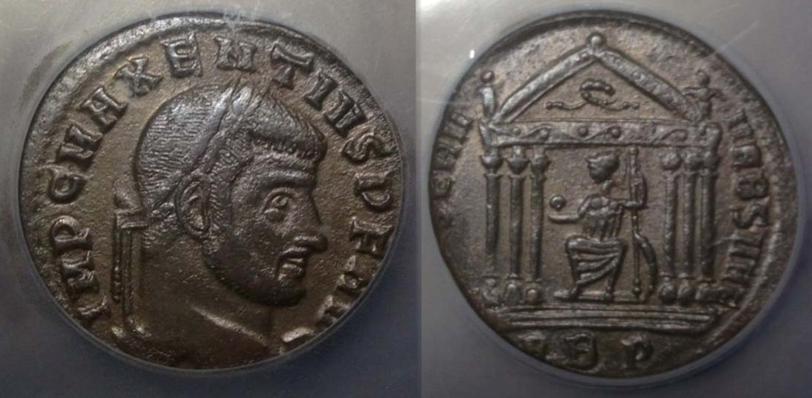

Follis of Maxentius Augustus (AD 308-312)

Dick Lasure brought in a nice set of three early US Commemoratives, the 1893 dated Isabella quarter and Columbian half-dollar plus the 1900 Lafayette dollar.

Jim Barry brought in an unusual ancient piece related to the ancient Scythian tribes of Russia

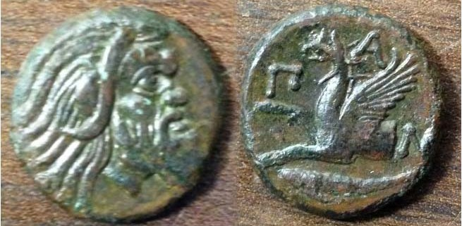

A Greco-Russian Crimean Black Sea area Scythian tribe
coin brought in by Jim Barry

Jim explained that the bronze coin shown above was from Pantikapaion, a city on the N.E. Coast of the Black Sea. It was located in an area settled by the Ancient Greeks and struck from the fourth century BC. The obverse has a portrait of Pan, a rural Greek divinity. He is represented as old and bearded, a part goat and part human. The reverse portrays a Griffin - a monster with the body, feet and claws of a lion and the head and wings of an eagle. At the bottom of the coin is a sturgeon.

Chuck Braun, a bird enthusiast, displayed proof crowns featuring birds from the Cook Islands Eliz. II Proof and Poland.

J.J. Engel displayed a 1970 East German 20 Marks cupro-nickel coin.

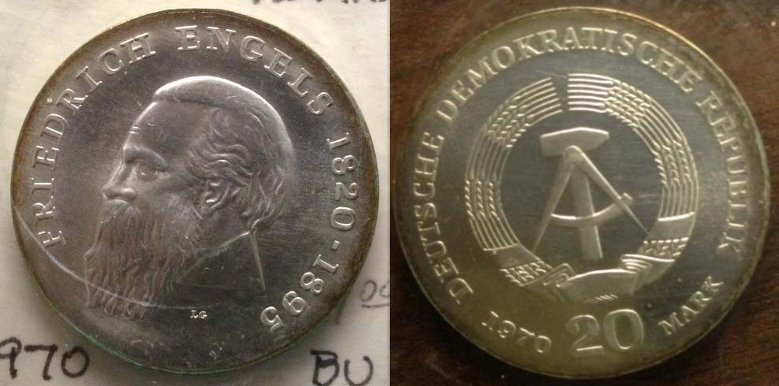

JJ Engel’s East German 1970 20 Marks

Jim Mullaney brought in a three-piece set of Canadian Proof $20.00 silver commemoratives.

Arno Safran brought in an 1832 reduced size Capped Bust quarter certified EF-40 by PCGS.

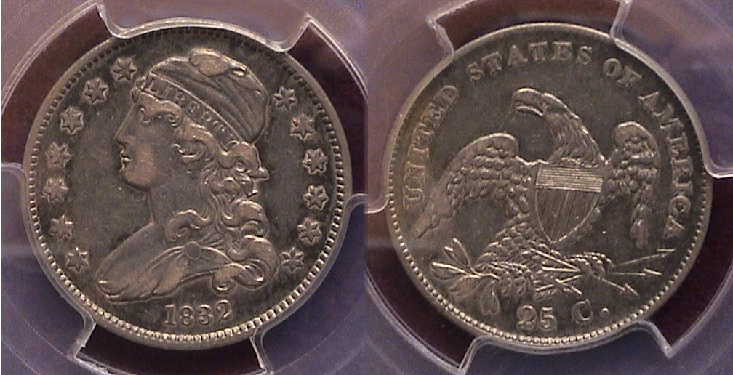

An 1832 Capped Bust quarter

Starting in 1831, the Capped Bust quarter was reduced from 27 mm in diameter to its present size of 24.3 mm (approximately one inch) with the motto, E PLURIBUS UNUM removed from above the eagle. It was produced in consecutive years thru 1838. The coin was struck in the lower hundred-thousands with the exception of 1835 when over a million were struck.
_______________________________________________________________________________________________________________
(Continued on page 6, column 1)

Club News
(Continued from the previous page)

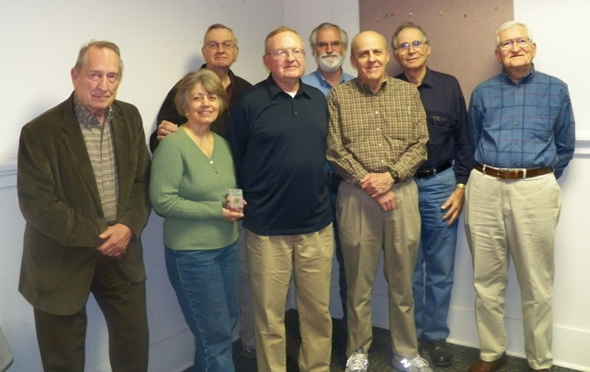

Exhibitors: from left to right: Chuck Braun, Marion Engel,
J .J. Engel in back, Dick Lasure, Jim Mullaney in back,
Todd Starbuck, Arno Safran and Jim Barry
(photo, courtesy of Helen Barry)

For our upcoming meeting scheduled for April 4, VP and programs chair Pat James has arranged to have area collector, Garry Naples present a PowerPoint program on “Carson City Morgan dollars”. Since the Morgan dollar series is one if the more popular numismatic collectibles, this program should be of interest to many of our members.

The prizewinners at the March 7 meeting were new member Bill Howell who won the door prize, a 1957 Proof Franklin half-dollar and Secretary Jim Mullaney who won the 50/50 drawing - $14.00. Congratulations, Bill and Jim. Our next meeting is Thursday, April 4, at the Aiken Public Library starting time, 6:45 PM, early arrivals from 6:15. Since the date inaugurates the club’s thirteenth fiscal year, please` remit $12.00 dues to our treasurer Chuck Goergen at that time and thanks in advance.
___________________________________________________________________________________________________________________

A Show & Tell Request from the Editor

The Show and Tell segments at our meeting have become increasingly important part of our club’s activities since the SJ CSRA CC was founded in March of 2001. It is virtually impossible, however for the editor to jot down all the data with any accuracy regarding each display in the time allotted. In order to publish the correct information for the monthly newsletter, the editor is requesting he be given a short typed memo from the presenters at the meeting. It should include the item’s country of origin, date or period, denomination and metal (or alloy) if known, and background regarding the piece. If not a banknote or scrip, other helpful information could include the size of the coin and mintage (if available). This would not only be helpful for the editor but also provide the chroniclers of our club’s proceedings the necessary information to add to the club’s history. Thank you.
_______________________________________________

Kindly Patronize Our Advertisers

