The Stephen James
CSRA Coin Club of Aiken
P.O. Box 11
New Ellenton, SC 29809
Web site: www.sjcsracc.org
The SJ CSRA CC of Aiken, SC meets on the 1st Thursday of the month at the Aiken Public Library

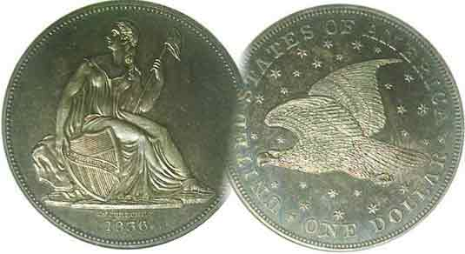
Pres. Willie Simon
V .P. Pat James
Sec. Jim Mullaney
Treas. Chuck Goergen
Sgt. in Arms: Jim Sproull

Programs: Pat James
ANA Representative: Jim Barry
Show Chairman: Steve Kuhl
Photos: Helen Barry
Publicity: Pat James
Newsletter: Arno Safran
E-Mail: arnosafran@comcast.net
Auctioneer: Jim Sproull
Web site: Susie Nulty (see above.)

2014 Club Meeting Schedule
Volume 13, No. 4 the Stephen James CSRA Coin Club, Founded in 2001 April, 2014
Monthly Newsletter
Our next meeting will be held on Thursday, April 3, 2014 at the Aiken Public Library

SJ CSRA CC begins its 14th fiscal year - $12 dues due
Jan. 2 Apr. 3 July 3 Oct. 2
Feb. 6 May 1 Aug. 7 Nov. 7
Mar. 6 June 5 Sept. 4 Dec. 4

On a blustery, cold and rainy night, 18 members and 6 guests braved the inclement weather to attend the March 6 meeting. This was an important one because elections for 2014-15 officers were scheduled to be held. At the February 6 meeting, President Steve Kuhl announced that he was stepping down after five years at the helm. Concerns as to whether any current member was willing to run for President were dashed when former President, Willie Simon volunteered to serve again. With the remaining members of the Executive Committee willing to continue in their present posts, Willie’s name now appears on the masthead as President and Steve Kuhl will continue as Show Chairman for another year. The club appreciates the work that Steve has done during his five years as President of the SJ CSRA CC and thanks him for continuing to serve in the capacity of Show Chairman.

Recently it was learned that the Low Country Coin Club moved their Fall show to coincide with our original Sept. 6 scheduled date. This conflict impacted on our expected dealer base which could adversely affect our show. At the moment the board members and other interested members are trying to ascertain whether we can 1) get enough new dealers to replace those that have opted to do the Low Country thereby keeping our scheduled show date or change our date to Sept. 20 if enough dealers are available then. The H. Odell Weeks Activity Center is available for both Sept. 6 and Sept. 20.

With the coming of April, our new fiscal year begins and dues of $12.00 will be due. The cut off date is usually three months from the due date. We don’t wish to lose any members, so please put this on your “Things to remember list” and thanks in advance.

At the Mar. 6 meeting, the prizewinners were Chuck Goergen who won the attendance drawing and Zach Richardson who won the 50/50 drawing - $10.00. Congratulations go out to the winners! Our next meeting is this coming Thursday, April 3.
__________________________________________________________________________________________________________
(More Club News on page 4, column 1)

Grade the Coin before you Buy the Slab because “Things are not always what they seem” By Arno Safran

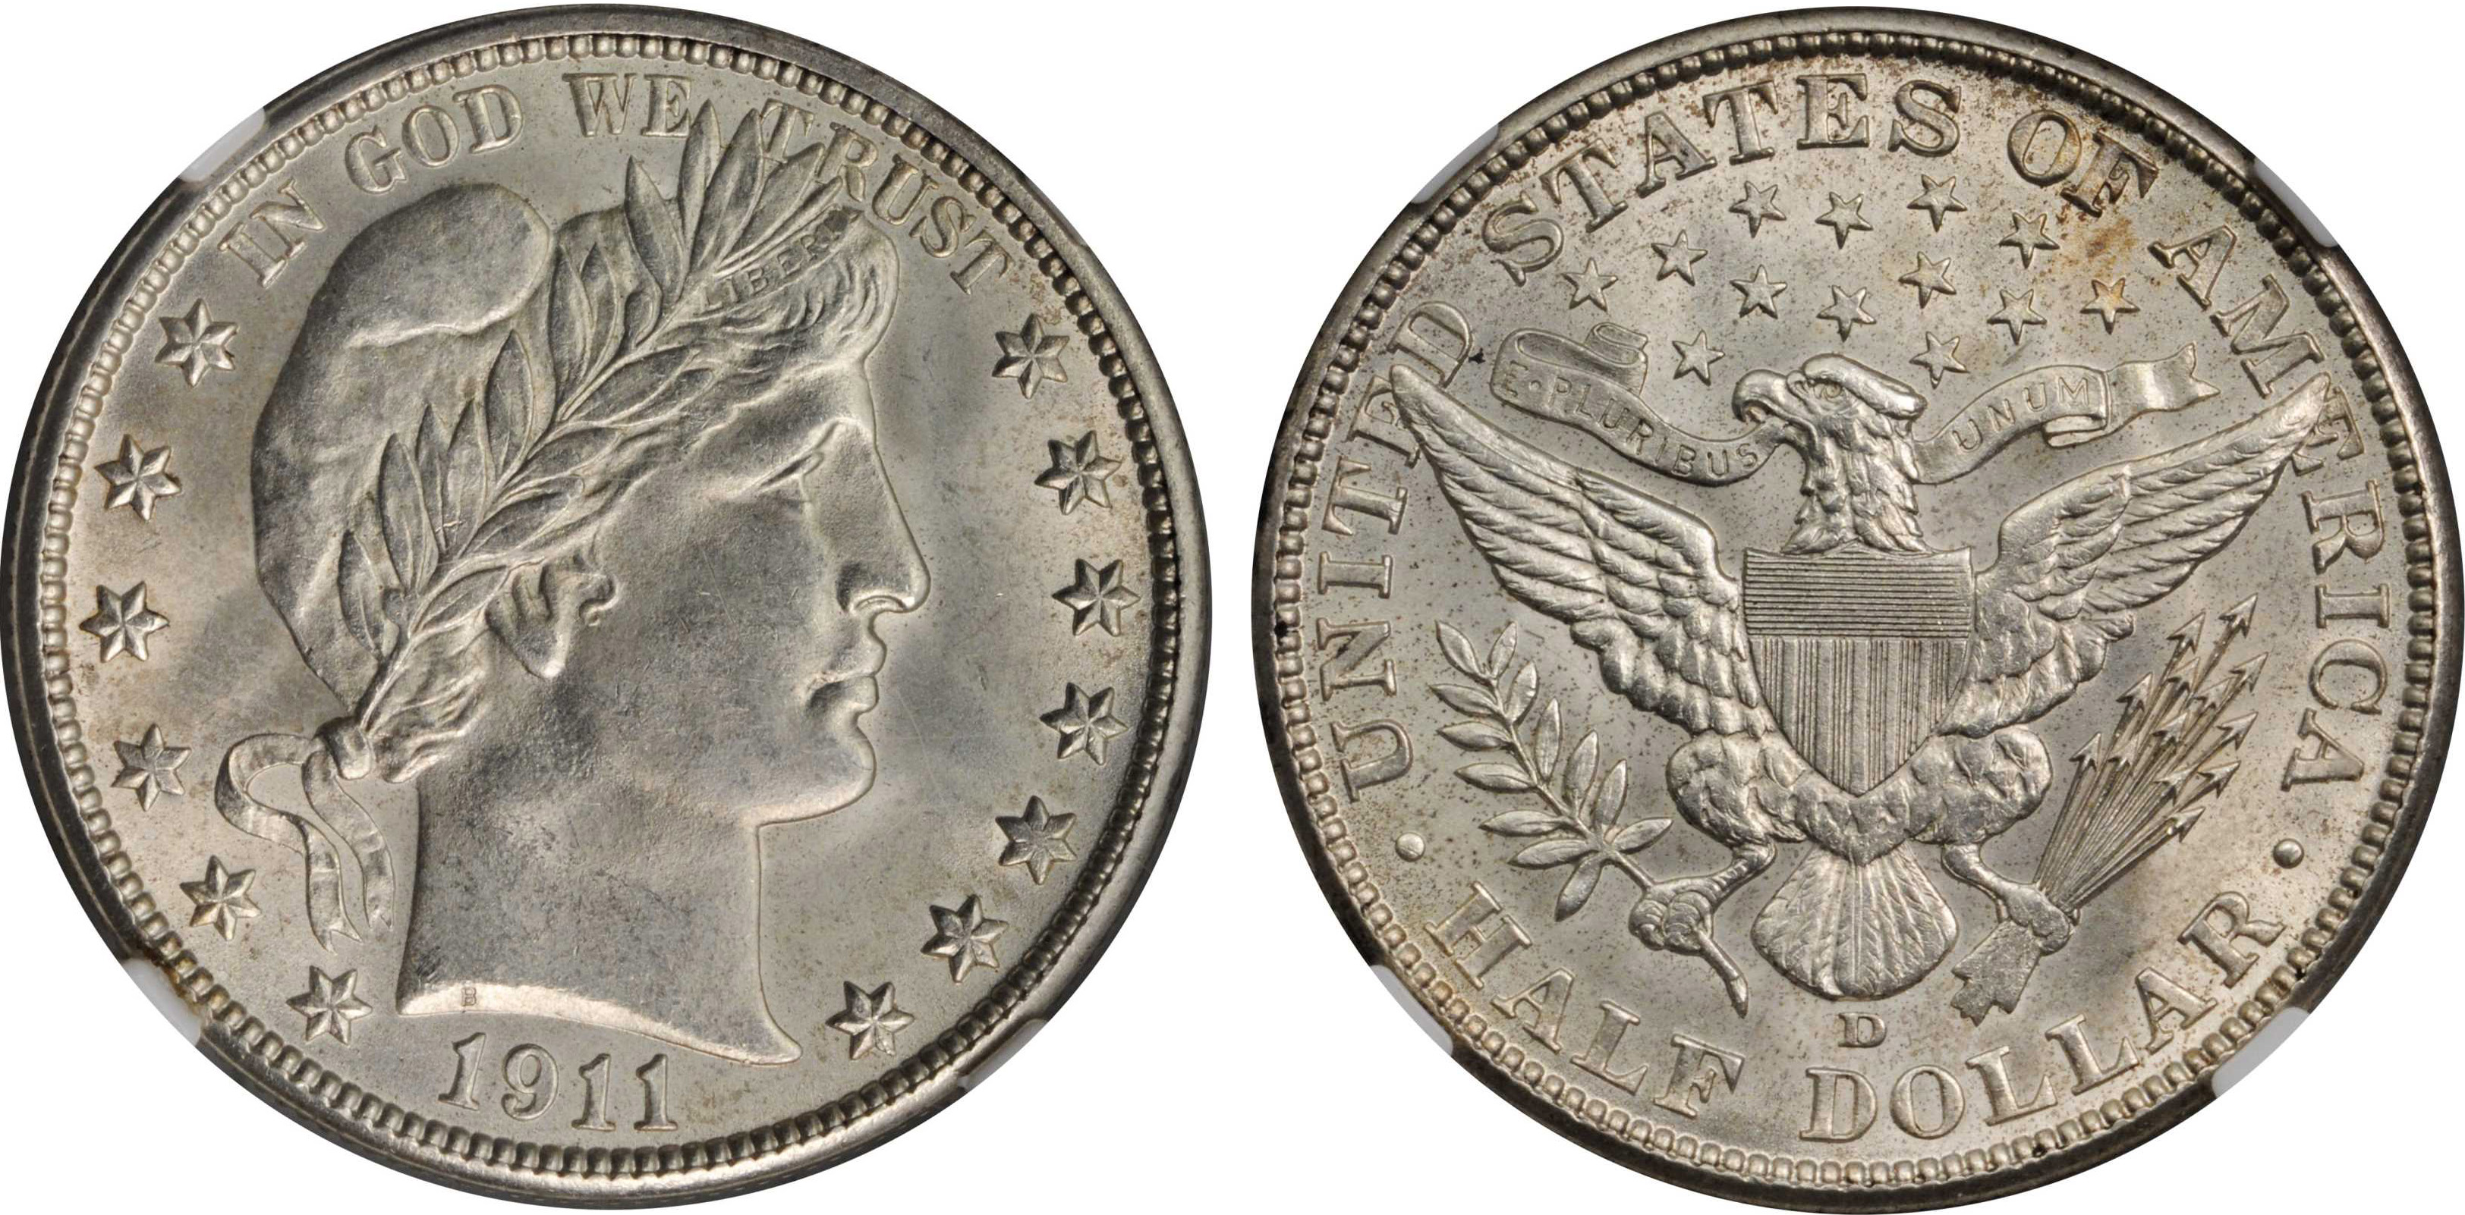

A 1911-D Barber half-dollar graded MS-64 by NGC
[Use 3X glass or magnify page to 200% to view details.]

You may have heard the expression, “Things are not always what they seem.” This adage now applies to numismatics, especially with the advancement of internet technology since the turn of the century. Back then, most coin collectors using mail order services still had to depend on the verbal descriptions dealers published as few displayed digital images of their coins on their web sites. By 2003, many dealers would post images but only of their more expensive coins. With the tremendous increase of collectors entering the market stimulated by the Statehood quarter series begun in 1999, many more internet dealers began imaging all their coins, even those in the lower grades. How accurate are these digital images?

The photo of the NGC graded MS-64 1911-D Barber half shows a brilliant uncirculated coin with virtually no blemishes whatsoever, save a` tiny bit of rust in the toning just below the F in OF and A in AMERICA on the reverse. The writer ordered this coin off a major dealer’s website and his first impression upon viewing the coin was extremely gratifying. It appeared “blast-white” and spotless. He decided to check the coin out more carefully by tilting the “slab” ever so slightly to the right. With his 3 X magnifying glass, a noticeable pin scratch descending diagonally downward across Miss Liberty's cheek came into view. Due to the expense involved, (MS-64 Barber halves are not cheap!) he sent the coin back fully insured for the dealer’s value the following day. This was not the first time the writer discovered that “things are not always what they seem” when it comes to ordering imaged coins off the internet.
______________________________________________________________________________________________________________________
(Continued on page 2, column 1)

“Things are not always what they seem”
(Continued from page 1, column 2)

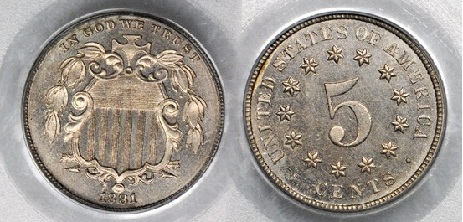

An 1881 Proof Shield nickel graded MS-63 by PCGS
[Use 3X glass or magnify page to 200% to view details.]

Directly above is a digitized image of an 1881 proof Shield nickel sent to the writer “on approval” several months earlier. The business strike version of the date is regarded as one of the three key rarities of the Shield nickel series but in “proof” ,most of the mintages were saved and the date is relatively available an inexpensive, even at this grade level. When the package was opened, the obverse looked especially decent for a PF-63 graded specimen but something about the reverse was troubling.
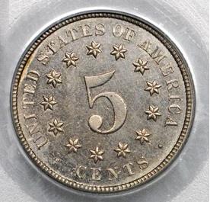
The coin looked fuzzy. Upon closer examination, I began to notice what appeared to be hairline scratches in the fields surrounding the right of the numeral 5 and around CENTS at the bottom. I showed it to one of our area dealers without mentioning it and his was` response, was, “The coin has a nice obverse. Pity the reverse has hairlines!” Enlargement of reverse
Needless to say, the coin was returned to the dealer.

If you have ever tried to take a picture of the coins in your collection you soon come to realize that one requires a camera with a lens capable of producing sharp images of small metal objects from 13 mm to 40 mm in diameter. Most of the coin pix in this newsletter were taken with a Sony Camcorder acquired back in 2005. The pictures for the most part are sharp but not at the level seen on the web. Nonetheless, I have found that simply by tilting the camera angle or altering the manner in which the light shines on the object, imperfections or blemishes appearing on a coin can be lightened or removed. If an amateur can do this imagine what professional photographers hired by the major dealers can do with their state of the art equipment.

Finally, there are the major professional grading companies that bare some of the responsibility. The 1911-D Barber half should never have been graded MS-64, especially since at least three independent graders examined it. One of them should have seen the scratch. While the digital image of the piece looked grayish, in reality, the actual coin appeared virtually blast white, indicative of having been dipped in Jewel Luster. At most, it should have been graded MS-62 and at worst, slabbed ‘”Cleaned” with “surface damage” Unc. Details. “
________________________________________________________________________________________________________________

A Century old Quarter-dollar
And the MS-62 Grade By Arno Safran

A century ago, in 1914, the Barber Quarter was issued at all three Mints, in Philadelphia, (6.2 million), at Denver, (slightly over 3 million) and at San Francisco (just 264 thousand, scarce in all grades.) Despite receiving half the total mintage of the 1914-P, the 1914-D Barber quarter is priced the same as the Philadelphia Mint issue in all grades, this according to the 2014 Red Book. and moderately priced thru MS-63.

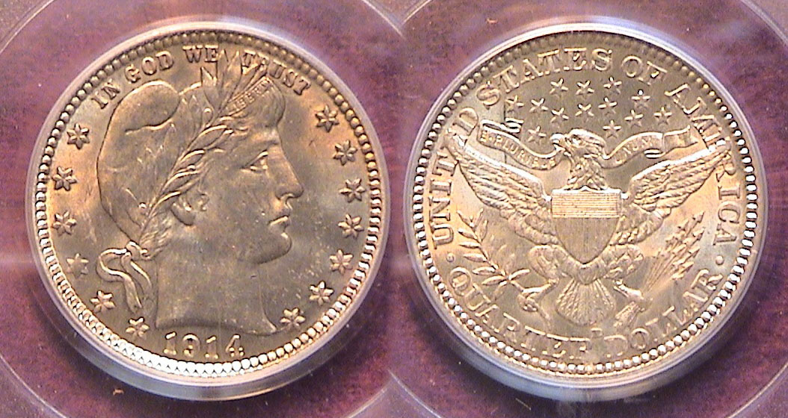

A 1914-D Barber Quarter graded MS-62 by PCGS (actual size)
[Use 3X magnifying glass or maximize page to 200% to view details.]

During the 1990’s when many US type coins were a lot less costly than they are now, many collectors on a tight budget realized they could not afford high-end mint state coins. The challenge for many was to locate circulated coins with eye appeal. When the AU category was split into four categories, AU-50, 53, 55 and 58, collectors became cognizant of the fact that many type coins certified AU-58 had more eye appeal than certified coins graded MS-60 and 61 yet cost considerably less. A number of dealers were heard to categorize the AU-58 grade as “MS-63 quality with just a touch of rub”.

With the paucity of more eye appealing type coins entering the market during the past ten years, the grade of MS-62 is now becoming more popular with collectors. Like the AU-58, not all MS-62 graded coins look the same or have eye appeal, but a number of coins so certified have come very close to many MS-63s, and in some cases even MS-64s, yet are offered by dealers at a lower price. The MS-62 graded 1914-D quarter above might be regarded as a good example in favor of this position. Despite a few minor marks on the obverse, the coin exhibits lots of eye appeal.

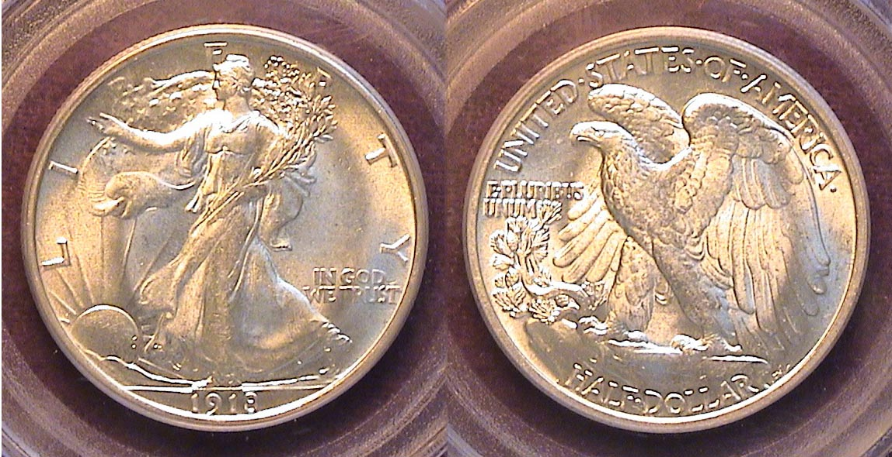

A 1918 Walking Liberty half-dollar graded MS-62 by PCGS
[Use 3X magnifying glass or maximize page to 200% to view details.]

Just above is an attractive example of a MS-62 graded coin, the lovely 1918 Walking Liberty half. The dealer thought it should have been graded MS-63. This specimen exhibits lots of luster with decent surfaces. It was acquired at the Georgia Numismatic Association Convention in April, 2012.
__________________________________________________________________________________________________________________

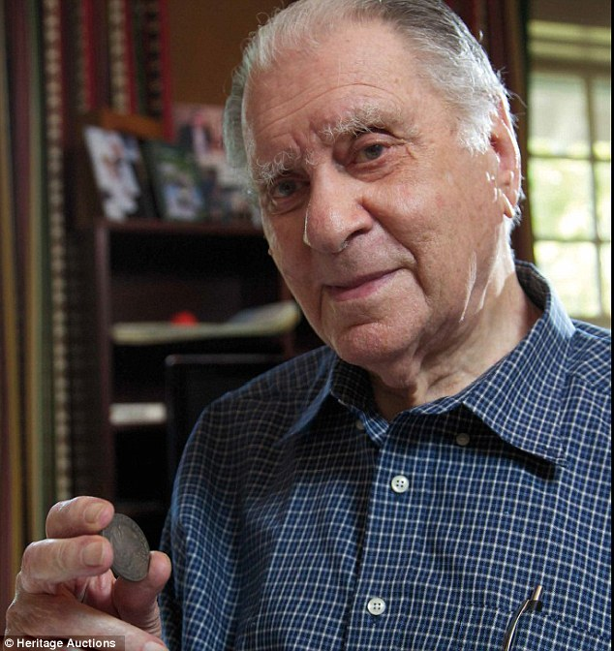
Eric Newman, Renowned Numismatist- Part of Coin Collection Sells for $23M By D.G. Lamar
We all read in the online news about the recent auction of legendary numismatist, barrister, and philanthropist Eric Newman's coin collection, which sold at auction for over $23 Million. Behind the headline, though, is the story of a great human being and shrewd coin collector.
Newman, now retired and 102 years of age, became an avid collector during the 1930s when early US type coins in high grade were incredibly cheap even by Depression era standards and by the late 1930s was earning a hefty salary as an attorney, which allowed him the luxury of buying some of the great rarities at bargain basement prices. Based on his reported age of 102, I assume he was born in 1911 when William Howard Taft was president

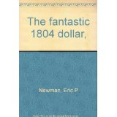
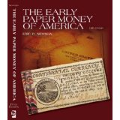
Eric Newman is one of the great legendry numismatists of all time and possibly one of the top five collectors of US coins. His co-authored book on the origin of the 1804 dollar debunked the idea that the great rarity was struck in the year of its date. He proved that it actually had been made in 1834 in order to be included as part of a complete year set of US proof coins to be presented as gifts to foreign potentates, most notably Sultan of Oman and the King of Siam. In 1804, the Mint had suspended the coining of silver dollars and $10.00 gold pieces, the last dollar being dated 1803 although some were struck in 1804 but with the '03 date. By 1834, the Mint realized the US would not have much world respect without restoring the two larger denominations in their respective alloys and so, ordered the Mint to produce examples of the silver dollar and $10.00 gold eagle with the 1804 date in their original designs

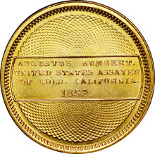
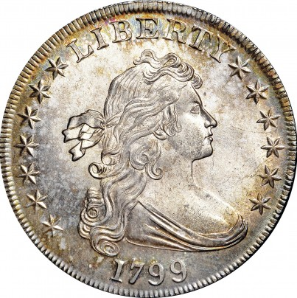
The auctioned items included a 1795 U.S. silver dollar in almost pristine condition that sold for $910,625 and another one from 1799 that sold for $822,500.A rare quarter-dollar from 1796, the first year the denomination was produced by the U.S. Mint, sold for $1,527,500 —compared to the $100 initially paid by Newman. Another valuable coin in the collection was the 1852 Humbert Ten Dollar Gold piece. . The coin, which has been graded a 68 on rarity on a scale of 1 to 70, is the only privately owned version of the $10 gold piece coin from the U.S. Assay Office.
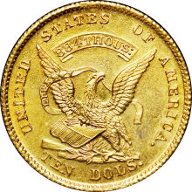
Much of his recently-sold collection was obtained in the 1930s from the estate of a colorful collector, Col. E.H.R. Green, whose wealthy mother, Hetty Green, was known as “The Witch of Wall Street.”
Jim Halperin, co-chairman of Dallas-based Heritage Auctions, called Newman "One of the world’s most accomplished numismatists". He’s written at least fifteen well-received books and countless articles on the topic in a journey that began with a present from his grandfather when Newman was just seven. Many of his books can be found online at Amazon.com.

Mr. Newman was also the editor for the popular "Red Book" Manual of United States Type Coins. Mr. Newman also wrote a book on U.S coin scales and mechanical counterfeit coin detectors, published in 1999. All coin collectors and enthusiasts owe a debt of gratitude to this fabled numismatist and scholar, Eric Newman.
More Club News
The March 20 meeting program: Reported by VP Pat James

The Program: At the March 6 meeting of the SJ CSRA CC, USCA student Mary Faubert was our guest speaker and presented her paper on the “penny” (To Be or Not to Be"). Pat decided to make it a question and answer presentation with the result that a number of members jumped in with questions and shared information on the topic offering their opinions as the speaker went from point to point. It was Mary's private opinion that the minting of the cent should be discontinued, as has been done in Canada, since the cost to mint a cent is more than twice its value and she doesn't have any use for the pennies she gets and will throw them away (interesting view from a 19 or 20 year old who didn't grow up with anything one could buy for a penny). Mary and the club members all enjoyed the lively discussion. In coming President Willie Simon commented that her presentation had excited more discussion than any other program we've ever had.
_______________________________________________________________________________________________________________

Editorial

As the editor was unable to attend the March 6 meeting I would like to add my ”two cents” worth regarding the “penny”. For one who has enjoyed collecting large cents, (1793-1857), one might think I would not wish to retire the cent but I believe it is time to do just that and more.

When Benjamin Franklin and Thomas Jefferson proposed the decimal system for our coinage prior to 1792, the world economy was entirely different than it is today. Even the half-cent functioned as it could make change for goods costing a Real, (the Latin American silver coin worth 12½¢). From 1793 thru 1960 our monetary system performed brilliantly. During the entire 19th century there was little to no inflation with the result that the denominations proposed remained extremely functional. From a total of seventeen denominations produced in 1873 to a mere five (the cent thru the half-dollar) from 1936 thru 1970, our coinage system still functioned adequately. Since the late`1960s inflation has soared with the result that today’s prices range from twelve to twenty times what they were back in the 1960s. Short of the daily local newspaper, one cannot purchase anything outright for a dollar, our largest ‘circulating’ denomination.

A 5¢ candy bar that many of us enjoyed when we were young now costs over a dollar. The half dollar has hardly been used since 1941. One can still use a quarter in a parking meter but that’s about it. The “best buy” around today is the $1.50 both Costco and Sam’s Club charges for an all beef hot dog and a soft drink; something that cost a total of 15¢ during the halcyon days of our youth. As a result, many of us use a credit card for virtually all purchases today, (somewhat ironic for coin collectors).

If we were to revamp our entire coinage system I would start with the dime as our lowest denomination while resizing the quarter, half dollar and dollar coin proportionally plus adding a larger $2.00 coin, I would eliminate the $1.00 and $2.00 bills but retain the $5.00 $10.00, $20.00, $50.00 and $100.00 bank notes. Despite similar modifications in other countries, this is unlikely to happen in the United States, due--in my view--to bureaucratic laziness at best or incompetence at worst.
_______________________________________________________________________________________________________________________
Kindly Patronize Our Advertisers

