The Stephen James
CSRA Coin Club of Aiken
P.O. Box 11
New Ellenton, SC 29809
Web site: www.sjcsracc.org
The SJ CSRA CC of Aiken, SC meets on the 1st Thursday of the month at the Aiken Public Library

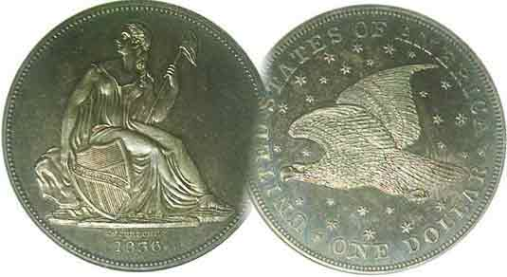
Pres. J.J. Engel
V .P. Pat James
Sec. Jim Mullaney
Treas. Chuck Goergen
Sgt. in Arms: Jim Sproull

Programs: Pat James
ANA Rep.: Glenn Sanders
Show Chair: Board members
Photos: Steve Kuhl
Publicity: Pat James
Newsletter: Arno Safran
E-Mail: arnosafran@comcast.net
Auctioneer: Jim Sproull
Web site: Susie Nulty (see above.)

Our next meeting is on Thursday, April. 2, 2020 at the Aiken Public Library, early arrivals, 6:15

2019 Club Meeting Schedule
Volume 19, No. 4 the Stephen James CSRA Coin Club, Founded in 2001 April, 2020
Monthly Newsletter
April meeting cancelled due to the Coronavirus
Jan. 2 Apr. 2 July 2 Oct. 1
Feb. 6 May 7 Aug. 6 Nov. 5
Mar. 5 June 4 Sept. 3 Dec. 3

Buddy, can you spare a dime?

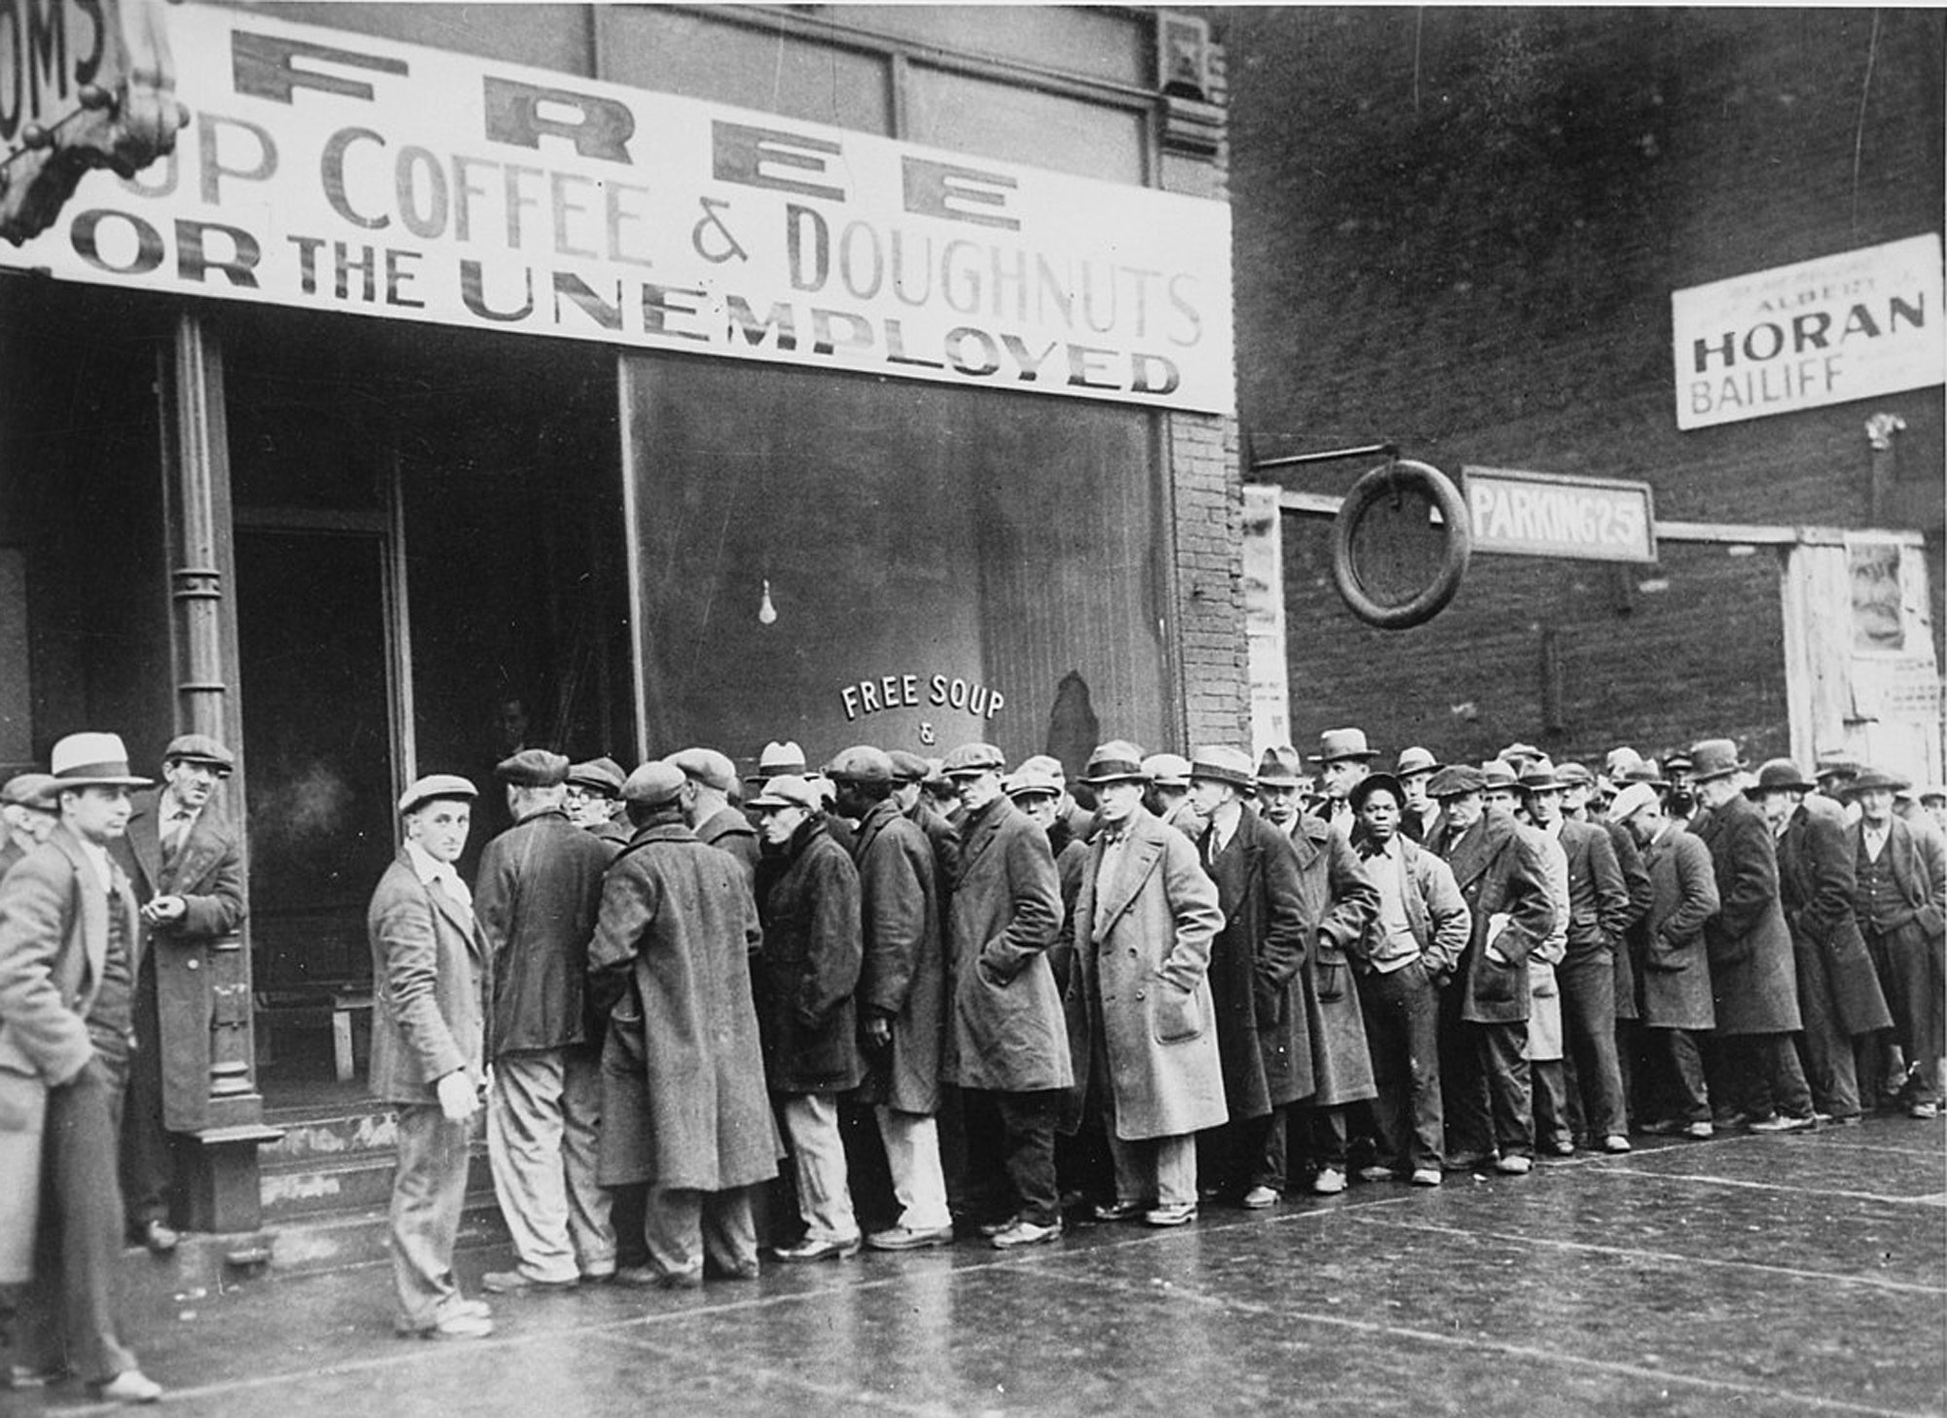

Men waiting on line at a soup kitchen during the early 1930s

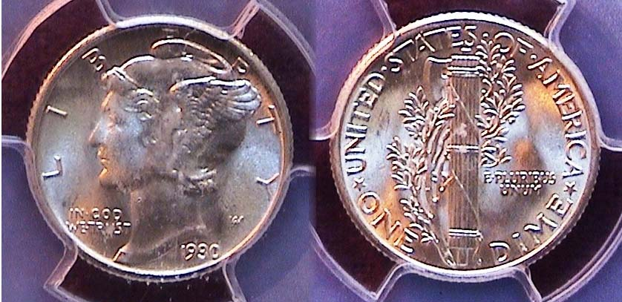

A 1930-P Mercury dime graded MS-65 by PCGS
[Enlarge page to fill monitor screen to view details.]

Will the Coronavirus and possible ignoring of the early breakout of the disease cause another Great Depression similar to the 1930s? With the stock market plummeting from record highs of 29,000 down to below 19,000 in less than two weeks, the incredible collapse is somewhat similar to what happened in late October of 1929 although in that case, stocks were over-valued. Another similar aspect was the raising of tariffs to foreign nations during the 1920s. In all other respects, this current state of affairs was brought on by a viral pandemic. The threat of spreading the disease launched the concept of “Social distancing” of the public, not the economy per se.
The US Coinage of the Great Depression (1930-34)
By Arno Safran

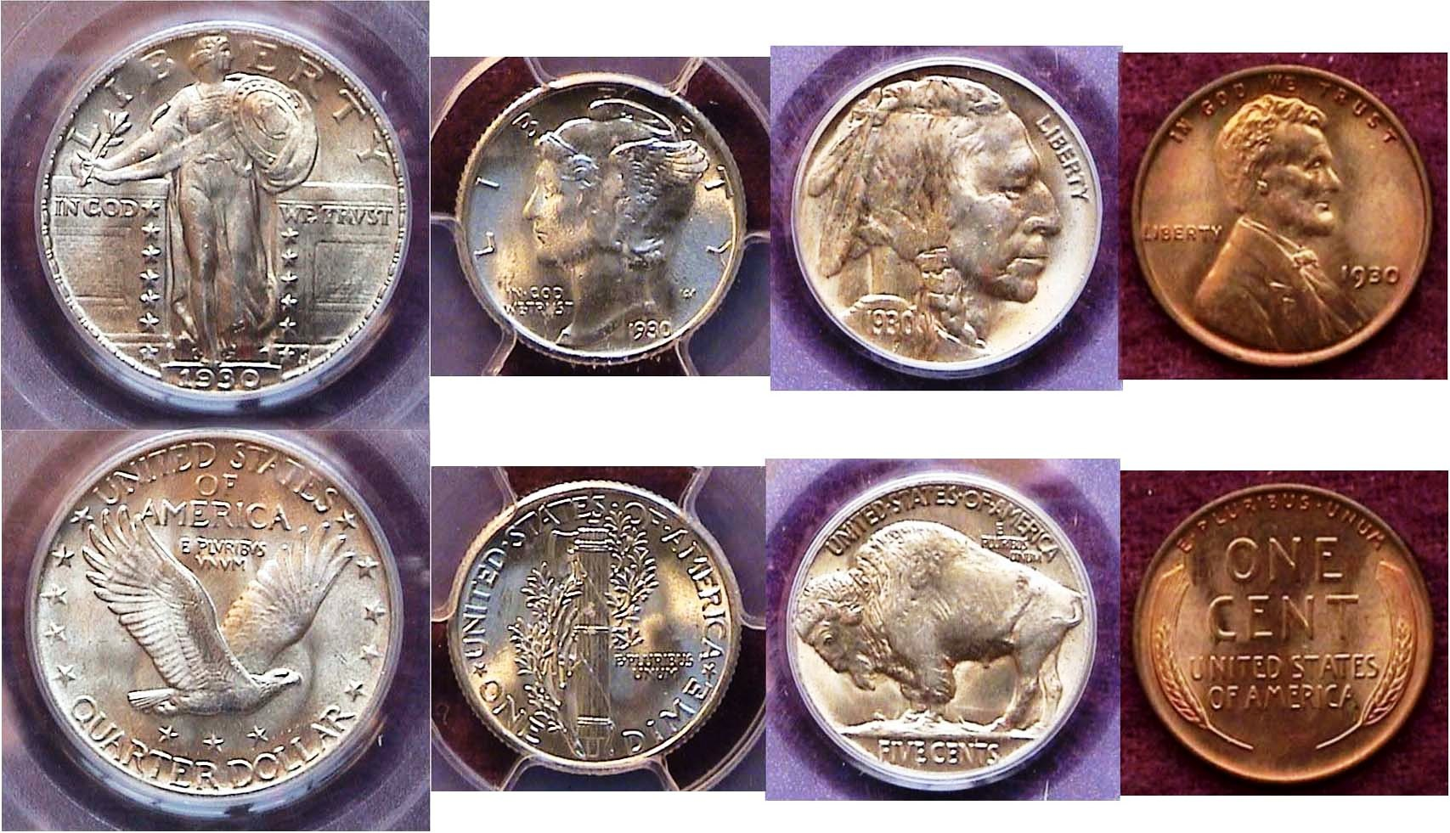

A certified BU 1930 year set of US coin types (excluding gold)
[Enlarge page to fill monitor screen to view details.]

During most of the Roaring Twenties, which were considered “very good economic times” all three of the US mints did not produce every denomination. The Walking Liberty half-dollar was mostly struck at the San Francisco Mint when it was coined but after the stock market crash in 1929, excluding gold, only four coins were struck in 1930, the cent thru the quarter, three in 1931, the cent, nickel and dime, just two in 1932, the cent and the new Washington quarter and two in 1933, the cent and the Walking Liberty half-dollar. It would not be until the following year, 1934 when all six denominations--the Lincoln Wheat-back cent thru the Peace dollar--would reappear. By then, the striking of gold coins had been discontinued. In 1930, the only two gold coins struck were Augustus Saint-Gaudens’ $10.00 eagle and $20.00 double eagle but they were just struck at the San Francisco Mint. Today they are extremely scarce due to many of these pieces being called back in 1933 to be melted. 1930 turned out to be the final year of the Standing Liberty quarter which were coined at both the Philadelphia and the San Francisco Mints, Both issues are well struck and are easily obtained at moderate prices thru MS-64.
___________________________________________________________________________________________________________________
(Continued on page 2, column 1)
The US Coinage of the Great Depression (1930-34)
(Continued from previous page)

The US Coinage of 1931

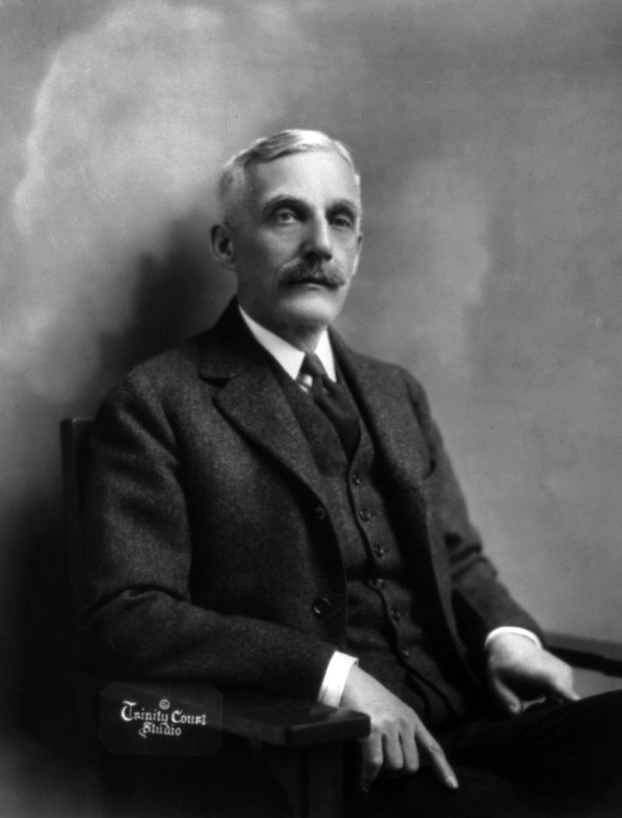
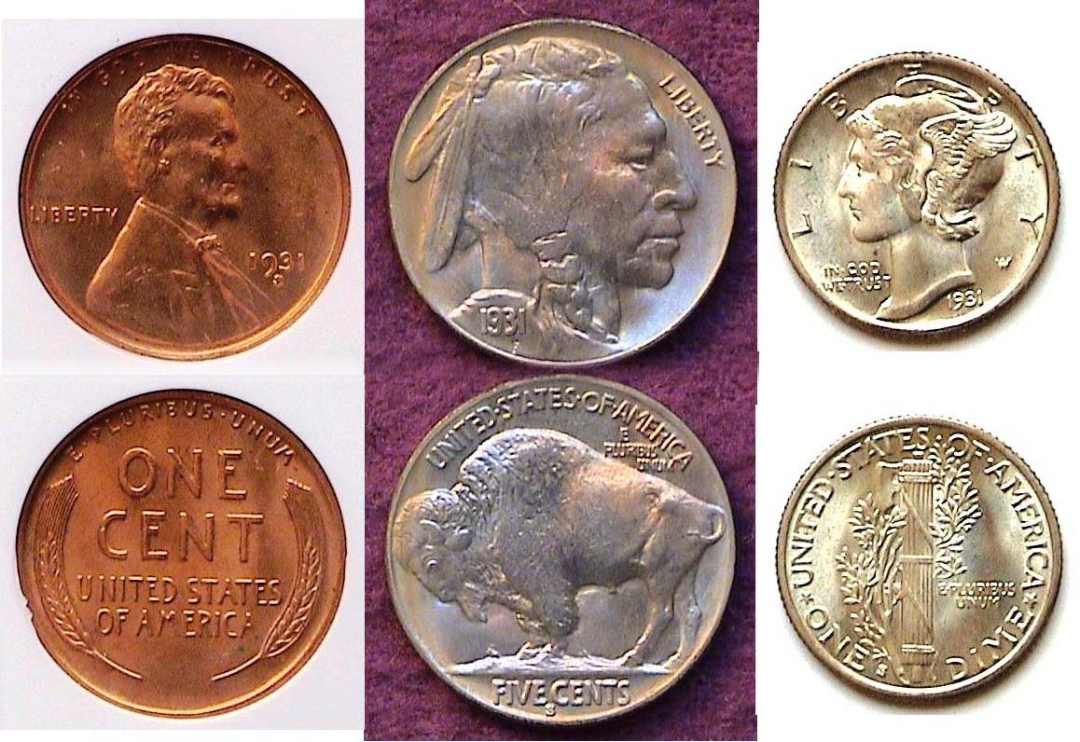

A trio of 1931-S coinage featuring the cent, nickel and dime
[Enlarge page to fill monitor screen to view details.]

In 1931, only three denominations were produced, (excluding gold) although the cent and the dime were struck at all three mints. That year, the Philadelphia Mint produced no nickels, dimes, quarters or halves. The Denver Mint struck only 4.4 million cents compared with 20.1 million in 1930 and just 1,260,000 dimes in 1931 after none were struck in 1930. Oddly, the San Francisco Mint was the busiest of the three in 1931 although no quarters, halves or silver dollars were coined there. Despite generally far lower mintages, collectors interested in obtaining one specimen including some of the popular semi key dates such as the 1931-S cent, nickel and dime shown above, should be able to do so since enough were saved by dealers to keep the prices within an affordable range up thru MS-64.

The US Coinage of 1932

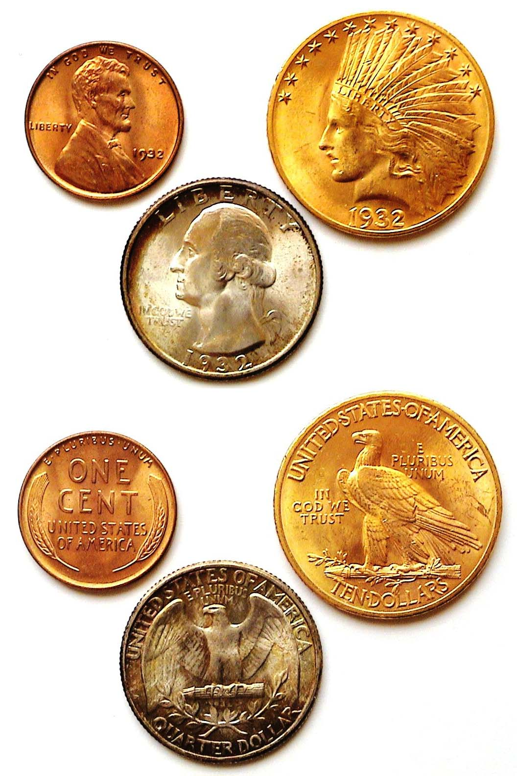
Mint state examples of the 1932 cent, quarter and $10.00 eagle
[Enlarge page to fill monitor screen to view details.]

In 1932, the Depression continued to deepen but as it was the bicentennial anniversary of our first president, George Washington’s birth, a new one-year commemorative quarter was being considered by the Council for Fine Arts. Laura Gardin Fraser’s designs for the 1922 Grant Commemorative, the 1925 Fort Vancouver Centennial and the 1926 Oregon Trail were praised as three of the finest of the early US Commemorative half-dollar series (1892-1954). She submitted her design for the Bust of George Washington and it was selected by the Council and all set to go when Secretary of the Treasury Andrew Mellon overruled the Committee and instead, chose John Flanagan’s--a sculptor from New York--entry instead. After 88 years it’s still with us!
Andrew Mellon
Years latter, friends of the late James Earl Fraser-- designer of the Buffalo nickel--and his wife, Laura Gardin Fraser, made it possible for her original deign of the 1932 Washington quarter to appear on a 1999 $5.00 gold coin commemorating the 200th anniversary of Washington’s death .

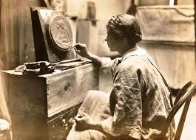

Laura Gardin Fraser working in her studio
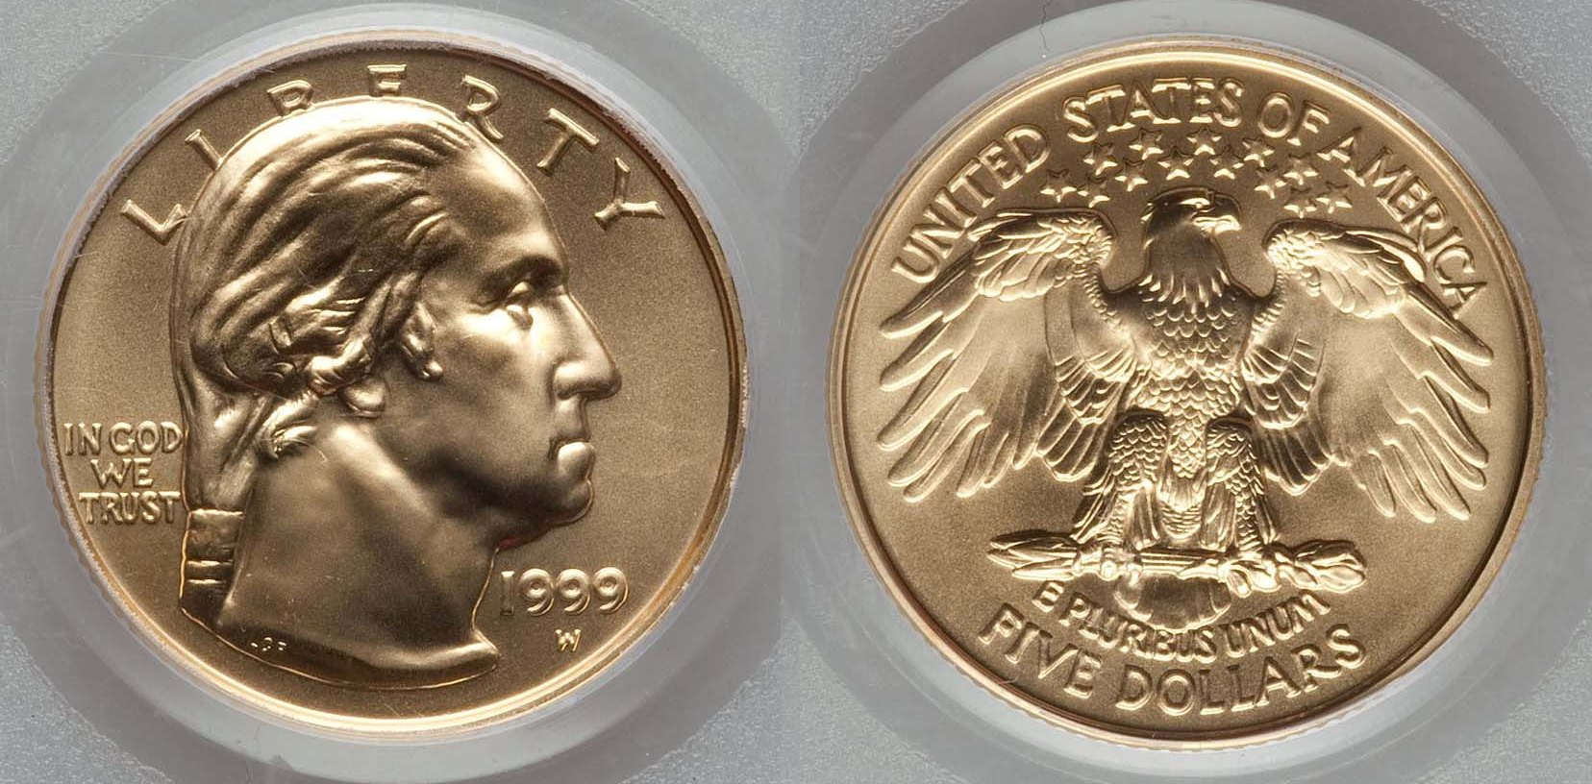

1999 $5.00 gold commemorative certified MS-70 by PCGS showing Laura Gardin Fraser’s original design for the Washington quarter
As for the three denominations produced in 1932, the Lincoln cent was struck at the Philadelphia Mint with slightly over 9 million and the Denver Mint with 10.5 million. Both are priced about the sane, and while neither are consider scarce, the two are slightly more expensive than all of the regular Lincoln cent dates struck after woods.
The 1932 quarter was coined at all three mints with 5,404,00 coined for the 1932-P. It is considered fairly common but with just 436,800 for the 1932-D (which apparently wasn’t saved as a first year of issue) is designated as the key date of the entire silver portion of the series (1932-1964). The 1932-S had a slightly lower mintage of 408,000 but since it had far more survivors, it is nowhere near as expensive as the 1932-D.
Finally, there’s the 1932-P $10.00 gold eagle. which was struck only at the Philadelphia mint that year. Its mintage of 4,463,000 is more than the 1932-P quarter and easily the most common date of all the $10.00 gold eagles ever coined.
_________________________________________________________________________________________________________________________________(Continued on page 3, column 1)_
The US Coinage of the Great Depression (1930-34)
(Continued from previous page)

The US Coinage of 1933

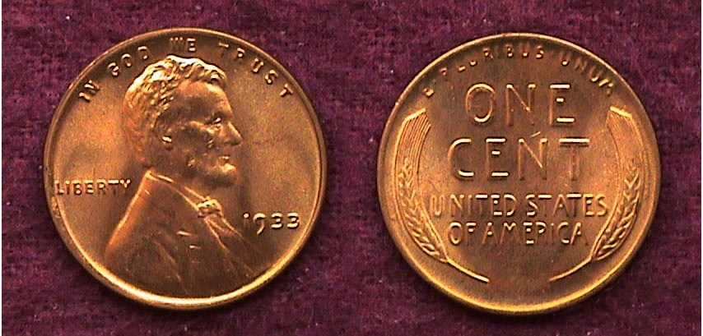

A 1933-P Lincoln cent graded MS-65 Red
[Enlarge page to fill monitor screen to view details.]

As with the 1932 cents, no Lincoln cents were struck by the San Francisco Mint in 1933. A total of 14.3 million were struck at the Philadelphia Mint, up five million from 1932 but at Denver, the number dropped to just 6.2 million from the 10.5 million produced in the previous year. Despite these statistics, the 1933-P is slightly more expensive than the 1932-D issue grading MS-64 Red but less expensive than the 1933-D if grading MS-65 Red.

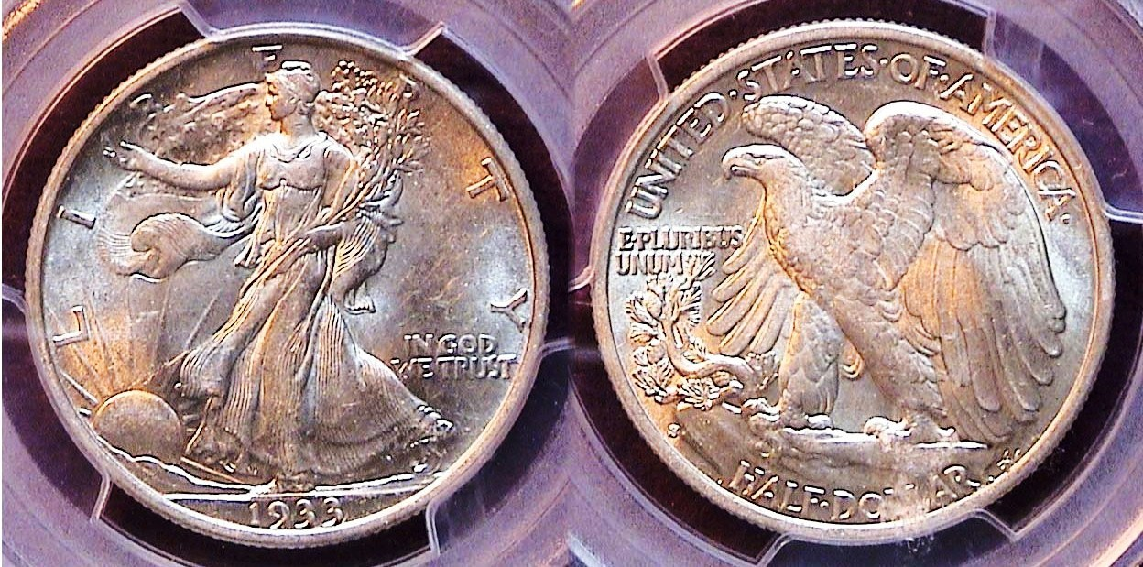

A 1933-S Walking Liberty half-dollar graded AU-58 by PCGS
[Enlarge page to fill monitor screen to view details.]

The only other collectible US coin from 1933 is the Walking liberty half-dollar. It was struck just at the San Francisco Mint with a reported mintage of 1,786,000. When it comes to the earlier portion of the Walking Liberty half series (1916-1933-S) the mintages don’t always indicate a date’s true rarity. The foregoing said, the 1933-S half represents the last of the scarcer portion of the Walking Liberty halves series, especially in the uncirculated grades. Despite the ups and downs of the numismatic market, the AU-58 price of $500 for the 1933-S half has hardly changed from what it was back during the 1980’s. This particular piece was obtained by the author at the Augusta Coin Club show held in May 2012.
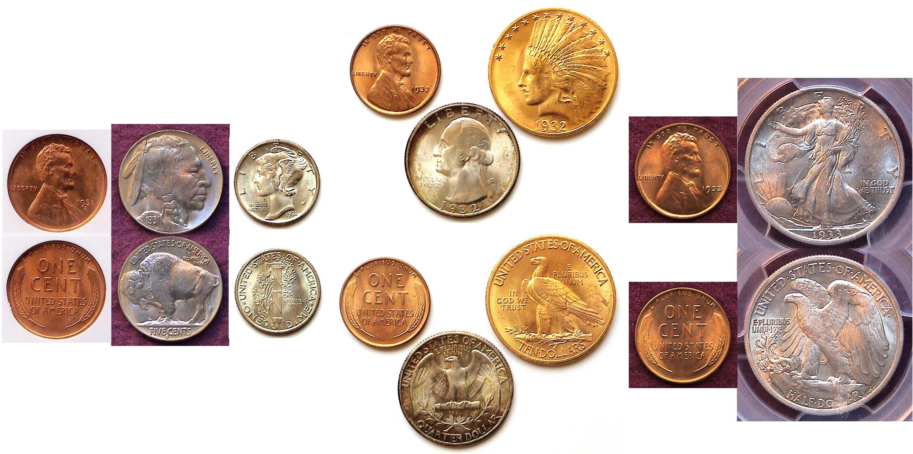
A reduced size display of an AU-58 to MS-65 set of US coins
from the three deepest years of the Great Depression
the 1931-S cent, nickel & dime, the 1932 cent, quarter & $10 Indian- Head $10.00 eagle and the 1933-P cent and 1933-S WL half-dollar
[Enlarge coinage display up to 500% to view details clearly.]
When it comes to the gold issues of 1933, both the $10.00 Indian and $20.00 Saint-Gaudens were among the bullion coins of the period that were called in by President Franklin Roosevelt except for collectors who wanted to keep them, although for some reason, this didn’t include the 1933 $20 Saint-Gaudens double eagle of which much has been written.

The US Coinage of 1934

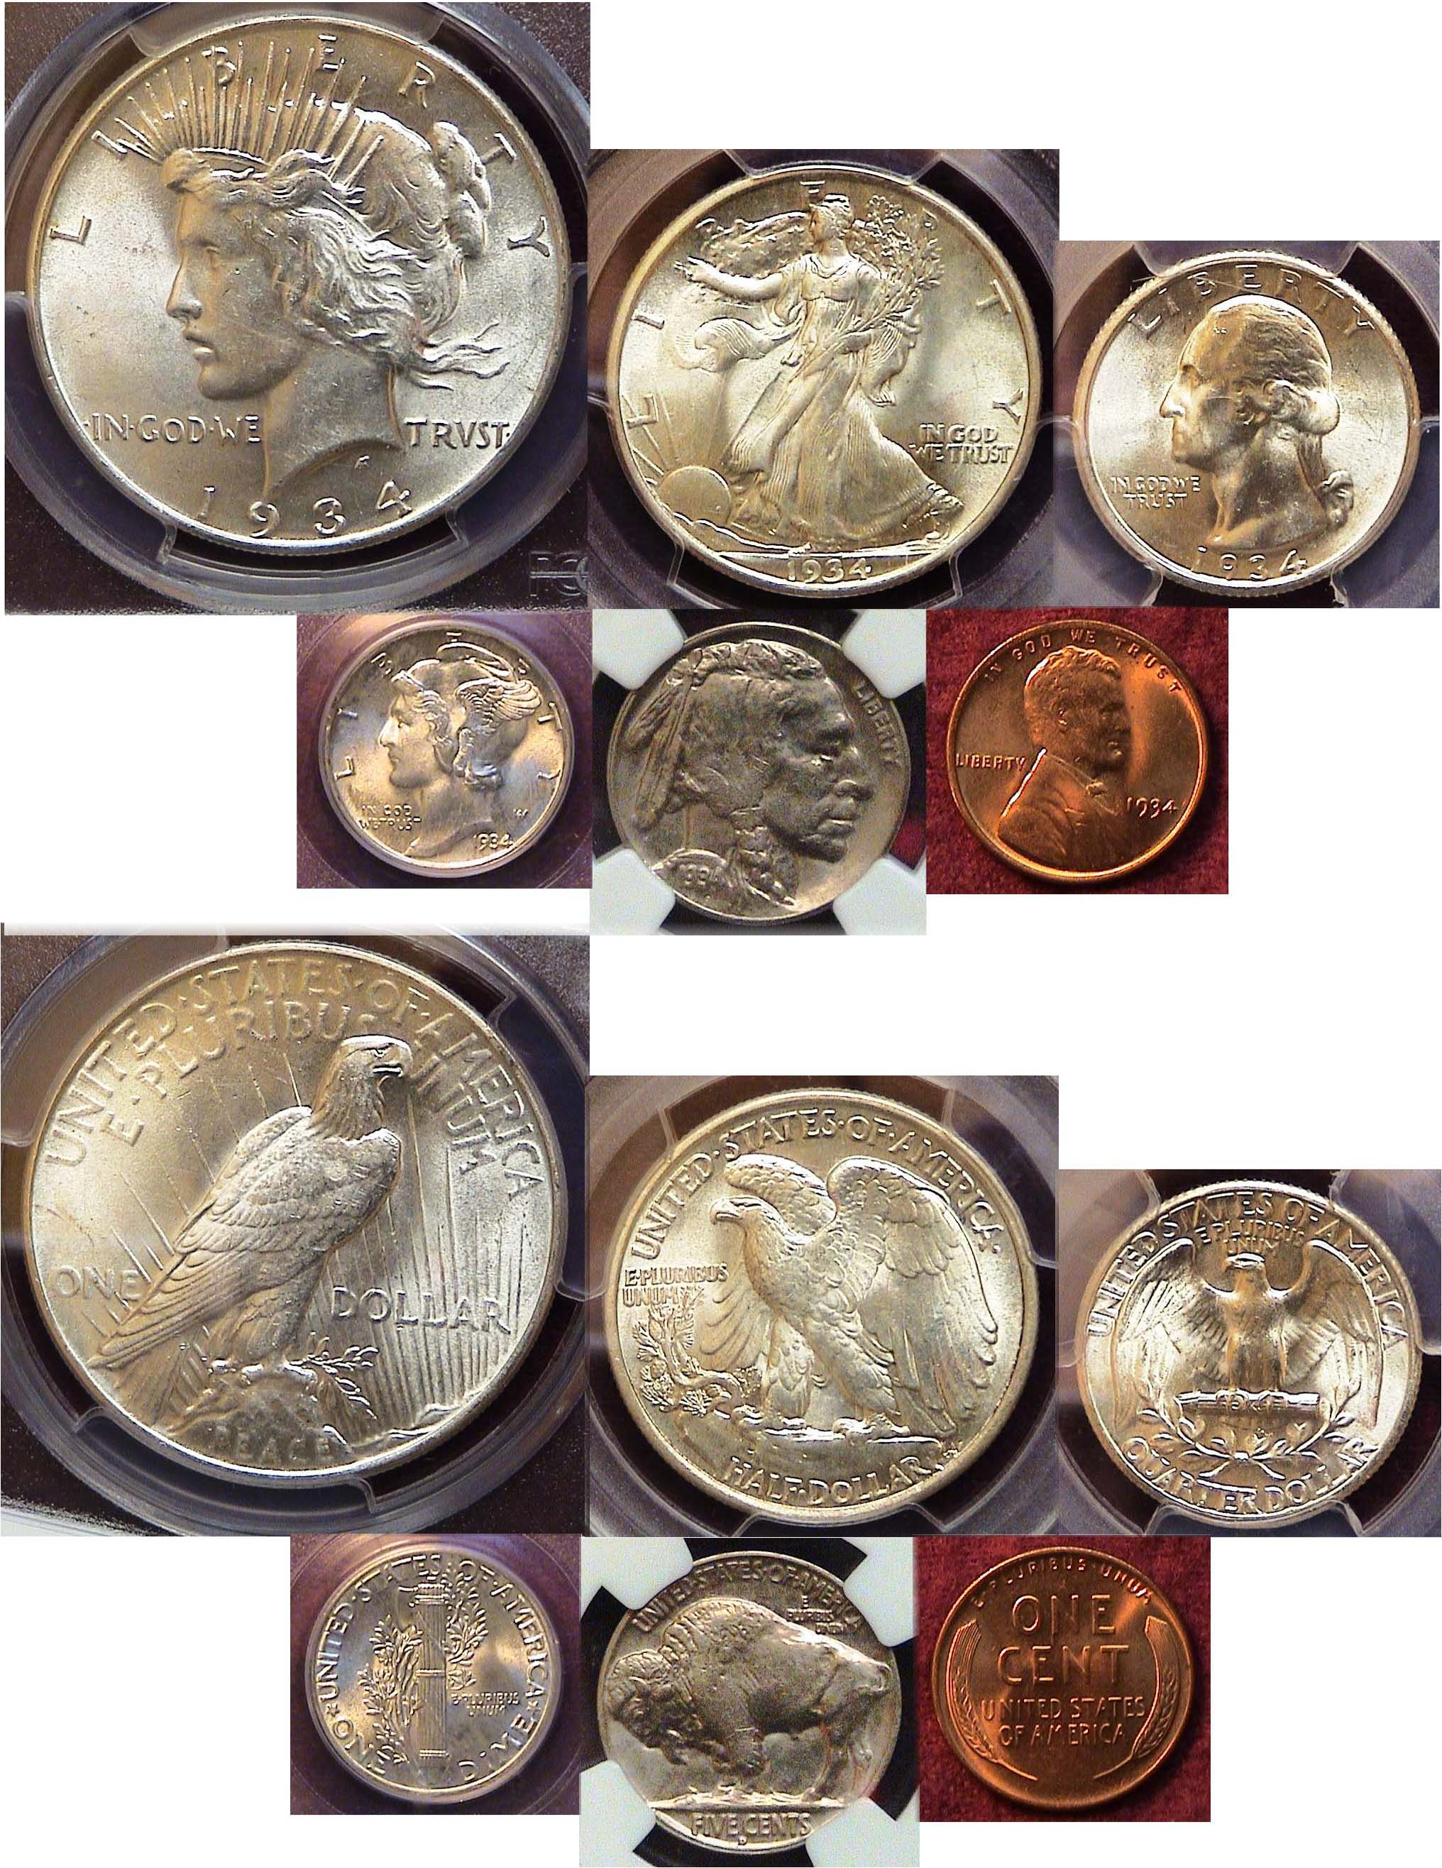

A 1934 certified BU year set showing all six denominations
[Enlarge page to fill monitor screen to view details.]

As a result of he election of Franklin Delano Roosevelt in 1932, the new president along with an affable congress were able to stem the deepening tide of the depression.. Although it was far from over, Roosevelt’s efforts due in part to his uplifting series of Fireside Chats to the American people along with newly passed congressional legislation, helped to uplift the general mood of the public Numismatically, despite going off the gold standard which eliminated the four gold denominations, all six lower denominations would again be struck in sufficient numbers which included the cent thru the silver dollar. That same year, dealers began hoarding the new coins by the roll as soon as they left the mint with the result, that for years, (well into the 1960s), examples of this era of US coinage grading from MS-60 to MS-65 continues to be available to collectors of today. Hopefully, the downturn caused by the Coronavirus will be overcome in the not too distant future as well.
___________________________________________________________________________________________________________________

Why Collect Ancient coins?
By James R. Barry - reprinted from the May, 2006 ACC Newsletter
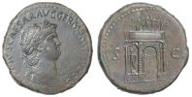
Rome: Nero Sestertius c. 64 A.D Laureate Bust o; Triumphal Arch r.

People have been collecting coins for thousands of years. One of the first known collectors was the Roman Emperor Augustus who lived before the birth of Jesus. Holding an ancient coin one can only wonder what important person may have held the same coin in antiquity. Was it Julius Caesar, Jesus, Constantine the Great (the founder of Christianity) or a soldier in a Roman Legion? Coins of the ancient world connect us with our past. In many cases the only known portraits of early rulers can be found on their coins. The coins of Alexander the Great, Tiberius, Marc Antony and Cleopatra are just a few of those important persons whose portraits can be found on ancient coins.
Ancient coins form the basis for many of our modern coin designs. The Saint-Gaudens $20 gold coin, the “Mercury”
Dime and the Walking Liberty half dollar are all examples of coins whose designs have been taken from antiquity. Yes, owning an ancient coin is like having a fragment of history that you can hold in your hand and connects us to the past. Ancients are not only fun to collect but in many cases they are not expensive to own.
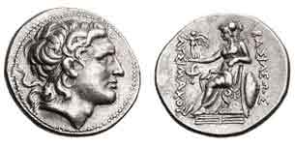
Thrace – Lysimachus Tetradrachm c. 297/6 to 282/1 BC
Obv. Head of Alexander; Rev. Athena seated
Our Liberty Seated silver coins owe its genesis to this coin’s reverse
____________________________________________________________________________________________________________________

The ACC spring show on May 15 & 16 is still on?
but could be cancelled if the Coronavirus worsens
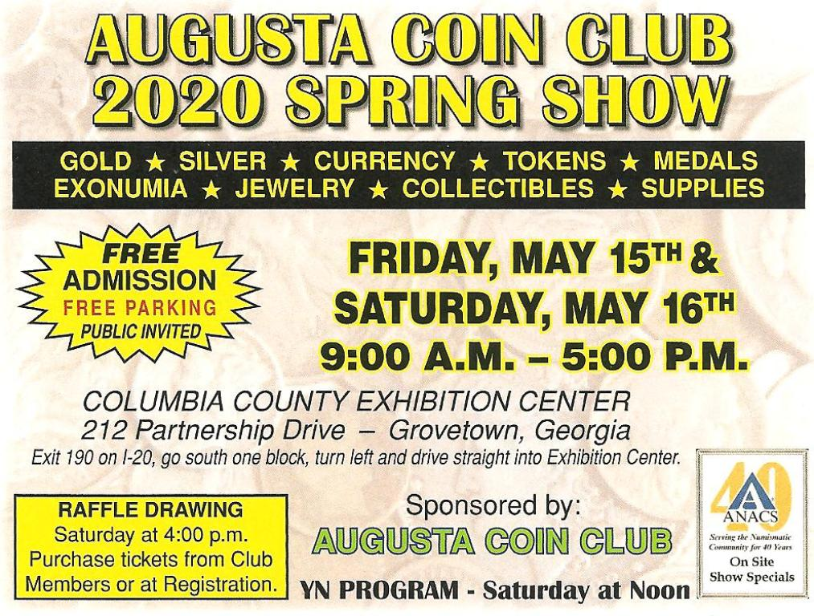
No Meetings doesn’t mean, no hobby

Why not email the editor .jpegs of some of your numismatic Show & Tells! Here’s all you have to do! Choose an item from your collection you wish to share with your fellow and lady members. In two separate mini-files, write a short description of the item, why it interested you accompanied by a pic. If you are unable to merge the two sides of the coin, merely send the editor two separate pics representing the obverse and revere, labeling each separately followed by .jpe. (There is a period before .jpe.) Send the short description as a word.doc to the editor at arnosafran@comcast.net around two weeks before the end of the month. If the editor receives it in time, it will appear in the following monthly issue of our club newsletter. This way we can all continue to have cyber meetings if not the real thing.
______________________________________________________________________________________________________________________

Kindly Patronize our Advertisers

