The Stephen James
CSRA Coin Club of Aiken
P.O. Box 11
New Ellenton, SC 29809
Web site: www.sjcsracc.org
The SJ CSRA CC of Aiken, SC meets on the 1st Thursday of the month at the Aiken Public Library

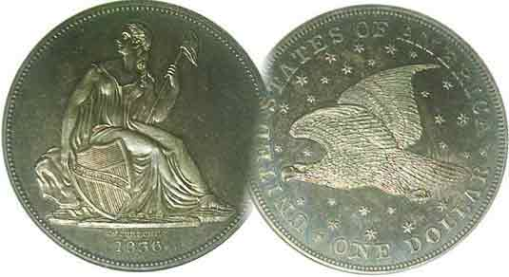
Pres. J.J. Engel
V .P. Pat James
Sec. Jim Mullaney
Treas. Chuck Goergen
Sgt. in Arms: Jim Sproull

Programs: Pat James
ANA Rep.: Glenn Sanders
Show Chair: Board members
Photos: Steve Kuhl
Publicity: Pat James
Newsletter: Arno Safran
E-Mail: arnosafran@comcast.net
Auctioneer: Jim Sproull
Web site: Susie Nulty (see above.)

Due to the Coronavirus, our upcoming Zoom Meeting will be held Thursday, April, 1 at 6:45 PM

2021 Club “Zoom” Meeting Schedule
Volume 20, No. 4 the Stephen James CSRA Coin Club, Founded in 2001 April, 2021
Monthly Newsletter
Collecting attractive circulated Early US coinage
Jan. 7 Apr. 1 July 1 Oct. 7
Feb. 4 May 6 Aug. 5 Nov. 4
Mar. 4 June 3 Sept. 2 Dec. 2

The Coinage of the Central American Republic

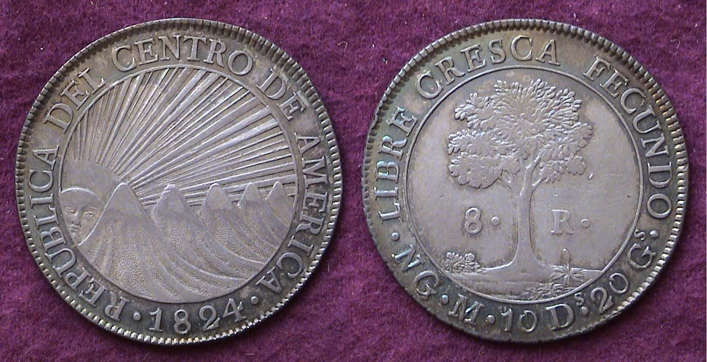

An 1824 Central American 8 reales graded AU-50
[Enlarge photo to 150% or to fill page in order t view details.]

The Central American Republic was formed in 1823 and lasted until 1842. The Confederation included Guatemala, Honduras, El Salvador, Nicaragua and Costa Rica. In 1824, it started producing its own coinage which portrayed a design of great beauty showing the sun rising to the lower left of five mountains on four of the six silver denominations called reales, each representing the five nations of the federation .

Surrounding the central device on the obverse is the Legend, REPUBLICA DEL CENTRO DE AMERICA for Central American Republic The reverse’s central device features a Ceiba Tree at its center with the denomination. 8R (or 8 Reales) which had the same value as the US dollar during that period. The motto surrounding the tree, LIBRE CRESCA FECUNDO means “Grow free and fruitful” with the NG at the lower left signifying the New Guatemala Mint, which struck the coin. The Central American peso was produced from 1824 thru 1847 except in 1832, 1833, 1838, 1843 thru’45, actually beyond its existence as the New Guatemala Mint continued to produce the coin through 1845. The 1824 is the most common date and the lest expensive and plentiful in the higher circulated grades such a s AU-50, the grade of the coin shown above.
Collecting Attractive US Coinage Ending in one (Part 2)
By Arno Safran

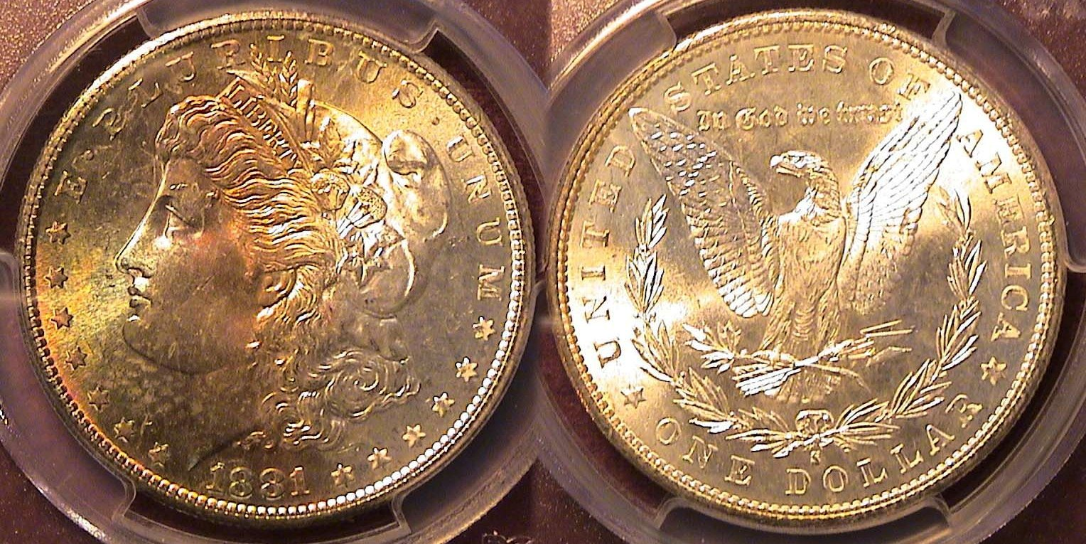

An 1881-S toned Morgan dollar graded MS-64 by PCGS

The previous issue covered examples of collectable US coinage ending in one from 1821 thru 1881, closing with a proof 65 example of an 1881 Shield nickel. In the continuation of the current series, the author decided to begin where he left off by displaying this lovely toned 1881-S toned Morgan dollar. In that period, there were four active mints in the United States; the Philadelphia Mint which struck 9,163,000 Morgan dollars that year, the Carson City Mint, which made just 296,000, the New Orleans Mint which struck 5,708,000 and the San Francisco Mint which produced a whopping 12,760,000, thereby breaking all previous records for the US silver dollar.

As a result, the 1881-S Morgan dollar is an extremely common date and is easy to obtain in all grades through MS-65. The current retail price of an 1881-S certified MS-64 is only $80.00 compared with $155 for am 1881-P, $185 for an 1881-O, and lastly, a whopping $575 for the low mintage 1881-CC. One of the reasons for the date’s popularity with collectors however, are the examples similar to the coin pictured above and that is it’s toning. There are a number of 1881-S Morgan dollars along with some 1881-O’s that have developed lovely rainbow toning over the decades for which dealers charge a handsome premium over the more common specimens without that feature. The author acquired his toned specimen at the Georgia Numismatic Association annual convention held in April, 2015 at the Dalton, GA Convention Center.
____________________________________________________________________________________________________________
(Continued on page 2, column 1)
Collecting Attractive US Coinage Ending in one (Part 2)
(Continued from page 1, column 2)

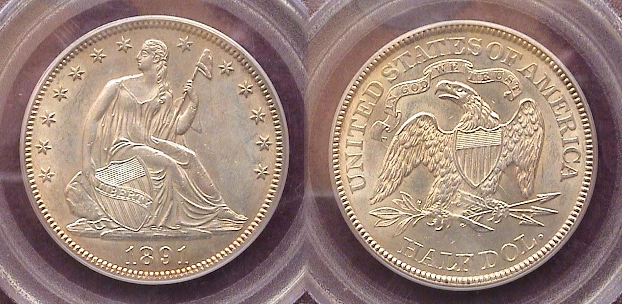

An 1891 Liberty Seated half-dollar graded MS-62 by PCGS
[Enlarge photo to 150% or to fill page in order t view details.]

From 1879 thru 1890, the mintages of the quarter and the half-dollar were very low primarily due to the Bland Allison Act which authorized the striking of millions of Morgan dollars annually beginning in 1878 at the expense of the three lower silver denominations, the half-dollar, quarter and dime. As a result, no quarters or halves were struck at the branch mints during those years; but as a bone to collectors, the law permitted the Philadelphia Mint to strike a small number of silver quarters and halves for collectors. For those interested in the 1879 thru 1890 Liberty Seated half-dollars series, the mintages ranged from a low of 4,400 to 12,000 thru 1890 and while the proof issues were struck in lower numbers still, the business strike pieces circulated far more heavily and are a lot scarcer than the proofs today.

In 1891, the final year of the Liberty Seated silver series, the Mint struck 200,000 halves; perhaps as a farewell to the long running type, the most coined since 1878 when the Philadelphia Mint struck 1,377,600 halves, yet the 200,000 Liberty Seated half-dollars of 1891 has a far lower mintage than all of the Barber halves that were coined between 1892-1915 except for the last three dates struck at the Philadelphia Mint, the 1913, 1914 and 1915. So, compared with those dated 1879 thru 1890, the 1891 Liberty Seated half is only slightly more common and may be underrated in value today. The example of the date shown above was certified MS-62 by PCGS but has the eye appeal of a higher grade, say MS-63+. It was acquired at the FUN show held in Orlando, FL in January, 2009.

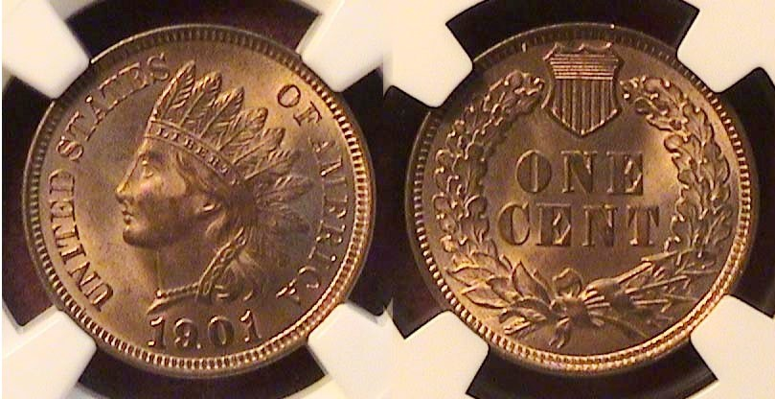

An 1901 Indian Head cent certified MS-65-RB by NGC
[Enlarge photo to 150% or to fill page in order t view details.]

Between 1898 and 1902, the mintage of cents steadily broke the previous year’s record for most cents coined in the nation’s history. The 1901 Indian Head cent had a mintage of 79,609,158, which surpassed the century mark’s record of 66.831,502, the previous year and is an extremely common date grading MS-65, Red. The MS-64 Red/Brown specimen shown was acquired at the Augusta Coin Club show on May, 2015. It is a well-struck beauty and sold at an extremely moderate price.
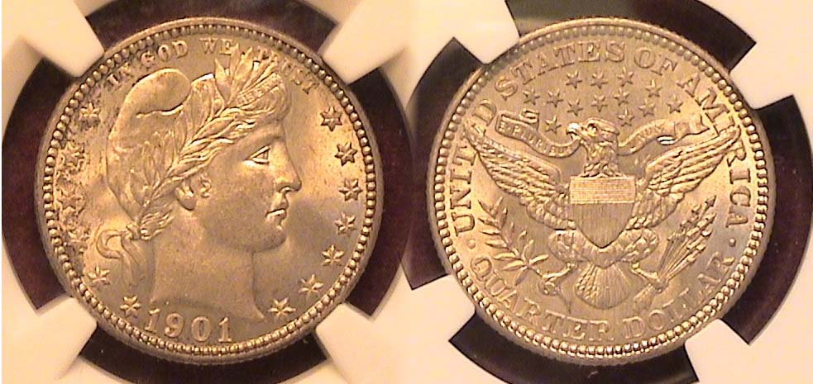

A 1901 Barber quarter graded MS-65 by NGC
[Enlarge photo to 150% or to fill page in order t view details.]

1901 was an unusual year for the Barber quarter dollar. It was struck at all three mints, but in great disparities from the very common to the extremely rare. In that year, the Philadelphia Mint struck a whopping 8.892,000 Barber quarters compared with just 1,612,000 struck at he New Orleans Mint while the San Francisco Mint released a paltry 72,664 coins thereby tagging the1901-S Barber quarter as one of the great rarities of United States coinage.

For a collector desiring a brilliant uncirculated example of the 1901 quarter dollar, the only affordable choice is one struck at he Philadelphia Mint and the best grade for the money is one certified MS-64 because even for the 1901-P, the price jumps from $500 retail to $1.050 in MS-65. By comparison, a 1901-O specimen certified MS-64 retails at $3,750 while with the far fewer MS-65’s are priced at $7,250. When it comes to the 1901-D--the key date of the entire series--an example graded only Fair-2 and retails for $2,250. One recently sold in a Jan. 2021 Heritage auction for $1,680--but had the appearance of a cull. If the reader is curious as to what an MS-64 1901-S Barber quarter brings today, according to PCGS’COINFACT, it is priced at a whopping $60,000. Since the author considers most obsolete US coinage challenging from VF-35 to the MS-64 and prefers to acquire the highest grade affordable, he decided to chose an example of the 1901-P example shown above.

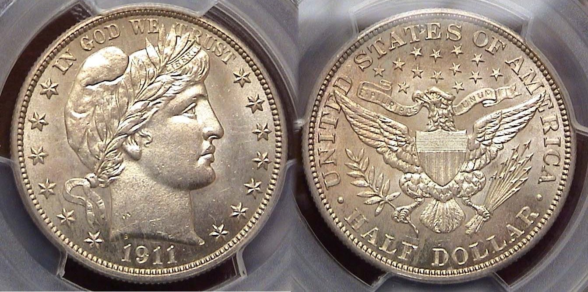

An 1911 Barber Half girded M S-63+ by PCGS
[Enlarge photo to 150% or to fill page in order t view details.]

In 1911, the Barber half dollar was coined at all three mints, the most at Philadelphia with 1,948,000 struck. 1,272000 were produced at the San Francisco facility while just 695,080 were made at the Denver with both branch mint issues being far more expensive.

Now is a good time to acquire Barber coinage since the price has dropped around 20% since the author acquired the specimen you see above at the Georgia Numismatic Association convention back in April, 2014. The coin was graded MS-63+ by PCGS and is well struck. In order to acquire the coin, he sold a few of his well-circulated better date Barber halves that had substantially risen in value; as he was now working on completing a date set ranging in grades from AU-58 thru MS-64. So, in essence, the new acquisition didn’t cost a cent since the trade-in value was considered “old money”.
(Continued on page 3, column 1)
Collecting Attractive US Coinage Ending in ones (Part 2)
(Continued from page 2, column 2)

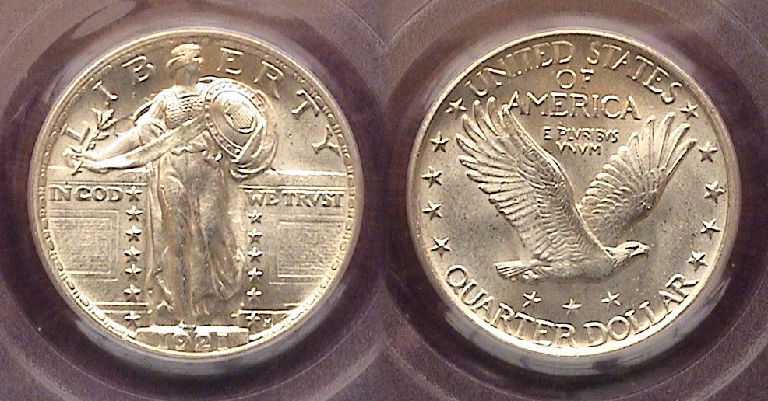

A 1921 Standing Liberty quarter graded MS063 by PCGS
[Enlarge photo to 150% or to fill page in order to view details.]

With a mintage of just 1,196,000, the 1921 Standing Quarter shown above is one of the scarcer dates of the Standing Liberty Series. None were struck at either the Denver or San Francisco Mints that year and during its short sixteen year lifespan, the coin type circulated heavily with the exception of the 1930 and 1930-S issues. None were struck in 1922. This example of the 1921 Standing Liberty quarter was acquired at the FUN show held in January 2010 and has the appearance of a MS-64. Upon magnification, every rivet in Miss Liberty’s shield appears strong and the head is almost full.

For those that appreciate the Standing Liberty Quarter series (1916-1930), engraver Hermon McNeil’s artistic masterpiece is one of the last works of art to appear on our coinage intended for circulation. That of course, is the author’s opinion but when one thinks about the designs that followed the Peace dollar (1921-1935), namely, the Washington quarter, continuing with notable national political leaders that included Thomas Jefferson, Franklin Delano Roosevelt, Benjamin Franklin, John F. Kennedy, Dwight David Eisenhower as well as Susan B. Anthony and Sacajawea; the latter four seen on coins that hardly circulated, these were not particularly artistic. Since the 1980’s our coinage has been barely functional as even the clad or brass dollar cannot buy anything, the one exception, being a parking space in urban communities where there are parking meters that will accept a quarter.

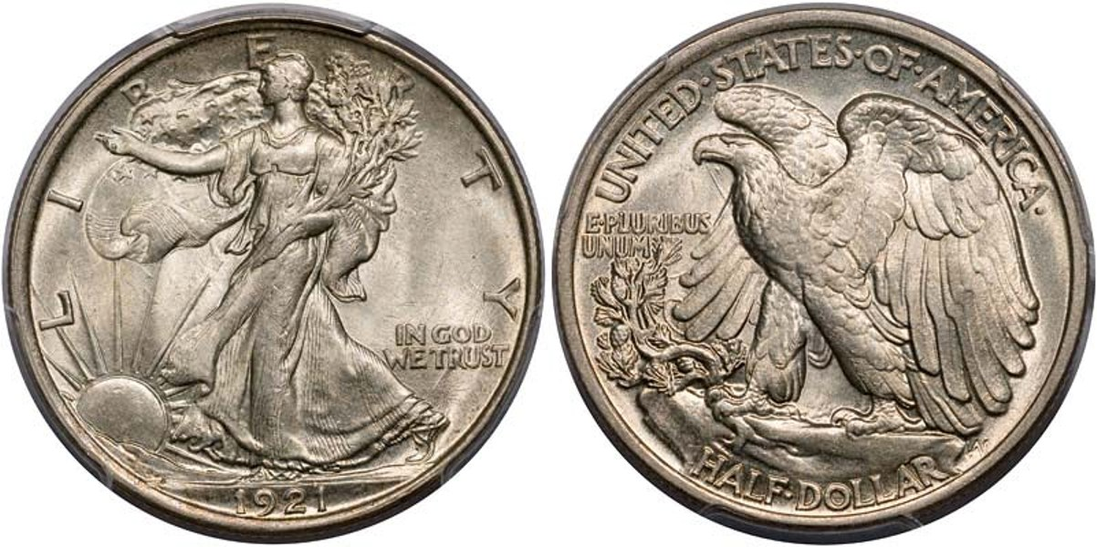

A 1921 Liberty Walking half-dollar graded MS-63 by PCGS
[Enlarge photo to 150% or to fill page in order to view details.]

The engraver of the Walking Liberty Half-dollar was Adolf A. Weinman, an immigrant from Germany and one of the several engravers who were disciples of Augustus Saint-Gaudens who was considered the finest sculptor of the period. The Walking Liberty half was struck from 1916 thru 1947. In 1921 and part of 1922, there was a recession and while the Walking Liberty halves of 1920 were struck in fairly large numbers, they circulated heavily especially those struck at Denver and San Francisco which are very scarce today, especially in the higher grades. By 1921, the recession became a slight depression and all three mints struck our coins in far lower numbers with the 1921-P half having a mintage of just 246,000. The author, who enjoys putting together year sets, in the highest grades he can afford had longed wanted to acquire an 1921-P WL half but due to the cost, was unable to do so until 2014 when he spotted the example shown on a major dealer’s web-site. It was a beauty in every sense of the word. The coin was lustrous, mark-free and had a decent strike but quite costly. However, since he hadn’t acquired anything expensive for a while, he had the resources to afford the coin, and as a long time customer of the dealer, asked if he would send the piece “on approval”, which he did. It turned out to be a “no brainer” since the coin was a “gem” for its grade. After 1921, the Philadelphia Mint would not strike another WL half-dollar until 1934.

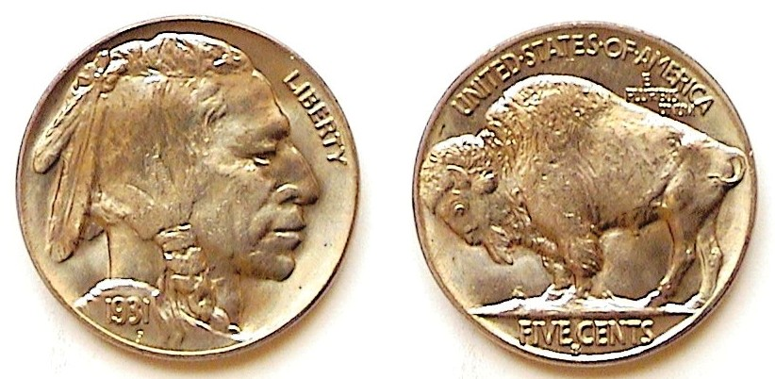

A 1931-S Buffalo nickel graded MS-64 by NGC
[Enlarge photo to 150% or to fill page in order to view details.]

The Buffalo nickel has been considered “the most American of all our type coins”. It was designed by James Earl Fraser, another disciple of Augustus Saint-Gaudens and first issued in 1913. As a rule, virtually all Philadelphia Mint issues struck from 1913 thru 1937 are affordable in mint-state (at least from MS-60 thru MS-64!) with some even in grades as high as MS-66 such as the late dates from 1934 thru 1937-P. There were a number of years when no Philadelphia Mint issues were made and due to the Great Depression, the 1931-S--with a mintage of 1,200,000--was one of them. However more BU’s remain than circulated specimens do, with the result that a 1931-S graded as high as an MS-64 is affordable.\

\
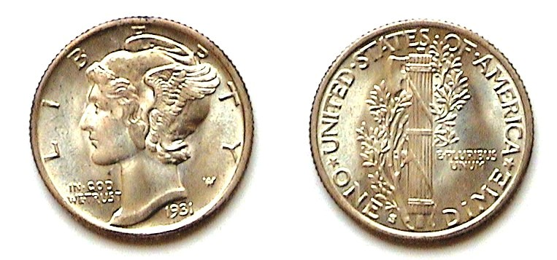
A 1931-S Mercury dime graded MS065 by PCGS
[Enlarge photo to 150% or to fill page in order to view details.]

Despite the great Depression, the Mercury dine was struck at all three Mints in 1931, with a mintage of 3,150,000, at Philadelphia; 1,200,000 at Denver with 1,800,00 struck at the San Francisco facility. The coin was also designed by Adolf A, Weinman and was originally called the Winged Liberty dime. The 1931-S shown is slightly less scarce than the 1931-D but is closer in price than the more common 1931-P issue and in MS-65 retails for $275 today. The author acquired the coin away back in 1983 at Stack’s Coin Galleries in Manhattan and at that time, an MS-65 specimen cost just $95.00. If the coin displayed fully split bands on the reverse, it would have cost more and if purchased with that feature today; a great deal more since a 1931-S Mercury dime with fully split bands on the reverse grading MS-65 is now valued at $2,500. Happy hunting!
_________________________________________________________________________________________________________________________
STEPHEN JAMES CSRA COIN CLUB
Regular Meeting
Thursday, March 4, 2021 VIA Zoom

The Club held the March 4, 2021, meeting via a Zoom session arranged by Club Secretary, Jim Mullaney.
President J.J. Engel called the regular meeting of the club to order at 6:58 p.m. There were 14 members and one guest who joined the Zoom session. A motion was made by John Kolmar, seconded by Willie Simon, and passed, to dispense with the reading of the February 2021 meeting minutes. A copy of the minutes will be on file with the other club records, and a copy will appear in the club newsletter.
Treasurer Chuck Goergen reported the Club’s bank balance is $1,083.39.

Jim Sproull reported that the Georgia Numismatic Association’s annual Coin Show is scheduled for April 16 -18, 2021, in Dalton, Georgia, and the Augusta Coin Club’s annual Spring coin show is scheduled for May 14 -15, 2021, at the Columbia County Exhibition Center in Grovetown, Georgia. He also reported that it appeared
there was a full docket of coin shows in South Carolina planned for every weekend in the month of October 2021.

President Engel reported no change with the situation with the Aiken Library wherein the Library might be able to make a Meeting Room available for coin club meetings in November or December of 2021, so our coin club meetings will continue to be online until the Covid-19 situation changes. JJ indicated again that we were hopeful that the Club might be able to hold in person meetings at Jim Mullaney’s horse farm, which had both a suitable barn and large patio area, starting in May with warmer weather, but with continuation of the meetings also presented via Zoom for those not wanting to attend meetings in person yet.
President Engel reminded members that it was time for the annual election of club officers and asked for any nominations from the floor, and there were none. He reported that the present office-holders had agreed to continue in their offices. According to the club’s Bylaws when there is only one nominee per office, the President shall declare those persons elected. JJ thus declared the current slate of officers re-elected: President, J.J. Engel,
Vice President, Patricia James, Secretary, James Mullaney, Treasurer, Charles Goergen, and Sergeant-at-Arms, James Sproull.

President Engel reported that the Board was hopeful that the Coronavirus situation might be improved with the national vaccination efforts and the coin club could resume its annual September Coin Show in 2021. It was determined that the Board would send out letters to the Dealers gauging prospective Dealer interest in attendance at $100, $90, $80 table charges, and with the caveat that our coin show plans were, of course, contingent upon permission to hold the event by the
relevant authorities and with the South Aiken Presbyterian
Church making the venue available to the Club, as well as the country’s progress in dealing with the pandemic through vaccination and the return to a semblance of normalcy.
JJ reminded members that the current annual dues of $15 for adult members were due. He further reported that the Board had determined to suspend giving out door prizes until we again had regular, in-person meetings. One consideration was the challenge of getting the door prize, a 2020 Silver Eagle with a current price of $30 or more to the winner each month at a reasonable cost. VP Pat James had been mailing the coins at her own expense using stamps from her former coin and stamp shop and paying at the post office an additional $1 to $2 for tracking. Pat had reported to the Board that she had unsuccessfully tried to get a mailing and tracking app which would reduce the mailing cost. Another consideration at arriving at the Board’s decision was that previously the cost of the door prizes had been offset in large part by the income generated from the 50/50 ticket sales at each meeting, and the 50/50 drawings had been suspended until the club resumed regular meetings.

Steve Kuhl informed the members that the
Midlands Coin Club was now also holding virtual meetings with the next meeting on Thursday, March 11, 2021. Our Club’s distinguished Life-time Member, Tony Chibbaro, is the current President of the Midlands Coin Club. Anyone wishing to join the Midlands’ meeting could contact Steve or Tony for information for virtual attendance.

Show & Tells:
Kelsey Forde shared an article on the newly minted WW II Memorial Commemorative Coin celebrating the 75th Anniversary of the end of World War II. Jim Mullaney found and put up on the screen an
ad displaying a picture of the coin which is part of the American Eagle Coins Program and has a “75” Privy mark on the obverse to distinguish it from the regular one ounce Silver Eagle coins issued by the Mint. The ad listed the coin’s cost at a whopping $83. JJ Engel said he’d heard the cost of silver bullion had risen considerably since the start of the pandemic and now bullion dealers were paying about 20 times face for silver coins.

The Program:
Steve Kuhl presented a program “South Carolina Blue Ridge Rail Road Scrip.” The Blue Ridge Railway was a railroad originally chartered in 1852 with plans for a 195-mile railroad from Anderson, South Carolina, to Knoxville, Tennessee. The rail line was to go through the Blue Ridge Mountains with thirteen tunnels, including the Stump-house Mountain Tunnel. Steve and his wife, Crissy, on a day trip from Aiken had visited and photographed the Stump-house Tunnel and two nearby cascade waterfalls. The Tunnel is 25 feet high, 17 feet wide, and extends 1,617 feet into the mountain.
(Minutes continued on page 5, column 1)

Minutes of the March, 2021 Meeting
And Steve Kuhl’s program
(Continued from previous page)

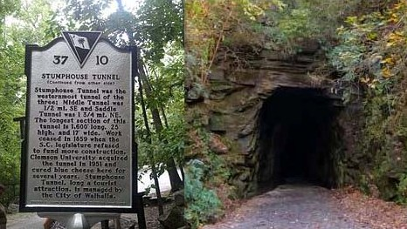

Sign and Entrance to the Stumphouse Tunnel
(Courtesy of Wikipedia)

Steve gave a brief history and related that by 1859, the railroad company had built track between Anderson and West Union, SC, with substantial work on several tunnels started, however with the start of the Civil War and a chronic lack of funds, work on the tunnels ceased. After the end of the Civil War, an extension of the rail line from West Union, SC, to Walhalla, SC, was completed, with the first train arriving there in November of 1877. The total amount of track laid was approximately 33 miles and had been primarily built by 1,500 Irish immigrants. The 33-mile track had cost $2,500,000 with the most costly and challenging portion being the uncompleted Stumphouse Tunnel which required manual chiseling of the rock and the use of low explosive black powder, as dynamite wasn’t invented by Nobel until 1867.

Following the end of the Civil War, Governor Robert Scott in 1868 persuaded the SC General Assembly
to issue bonds to pay for the completion of the railroad route. Steve related in his portion of his program entitled,
“Bait and Switch,” the story of the ensuing notorious example of egregious fiscal misconduct and corruption of
the Reconstruction Era whereby the value of the bonds decreased to a fraction of their original worth, and then
finally resulting in a South Caroling Supreme Court case ruling that the issuance of the revenue bond scrip had
been unconstitutional and the U.S. Supreme Court subsequently ruling that pursuant to the federal Eleventh
Amendment the State of South Carolina couldn’t be sued and didn’t have to honor the $4 million bonds.

Steve showed a beautifully engraved $1000/200 Pounds Sterling Gold Bond certificate from the Blue Ridge Railroad Company. The certificate was printed by the
American Bank Note Company with an ornate border and vignette of a train passing by a body of water. The interest payment coupons were attached on the bottom of the certificate. Steve also showed examples of the Bank of South Carolina $2, $5, $10 and $50 notes with beautifully engraved vignettes of agrarian and Revolutionary War scenes, although the $2 note curiously included a drawing of the wife of Napoleon Bonaparte III.
​
President Engel reminded the members that the next meeting would be on April 1, 2021, and adjourned
the meeting at 7:57 p.m.

Respectively submitted
James Mullaney, Recording Secretary
____________________________________________________________________________

Kindly Patronize our advertisers

