Pres. Willie Simon
V .P. James Barry
Sec. Helen Barry
Treas. Pat James
Sgt. in Arms: J.J. Engel
Committees:
Auction: J.J. Engel
Programs: James Barry
Newsletter: Arno Safran
The Stephen James
CSRA Coin Club of Aiken
P.O. Box 1739
Aiken, SC 29802
Web site: www.sjcsracc.org
The SJ CSRA CC Now Meets on the 2nd Thursday of the Month at the Cedar Creek Club House in New Ellenton

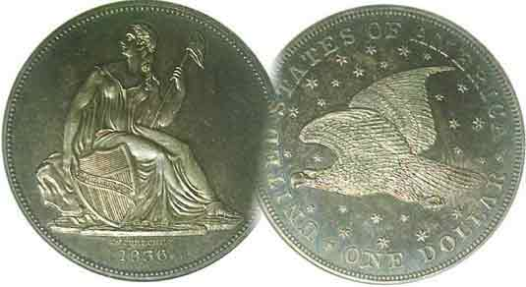

Volume 5, Number 5 the Stephen James CSRA Coin Club Monthly Newsletter May, 2006
Club Moves to Cedar Creek Club House
Our Next Meeting is on the 2nd Thursday, May 11, 2006 at 7:00 PM
Change in Location, a Major Step for Our Club
Entire Board Reelected

At the April 18 meeting, held on the third Tuesday of the month, the club reelected all members of the Executive Committee and bade farewell to the Aiken Public Library. Reelected were President Willie Simon, Vice President, James Barry, Recording Secretary, Helen Barry, Treasurer, Pat James and Sgt. in Arms, J.J. Engel. Their stewardship over the club has allowed it to grow and the membership showed its appreciation by unanimously reelecting them for another term.

Since its founding in March, 2001, the Library had been the club’s regular meeting venue but that was about the only thing that was regular. Executive officers and members were never given a specific evening of the month in which to hold their meetings. At first, it was hoped we could meet on the fourth Thursday. Soon the newsletter masthead changed the wording to read, “Usually meets on the 4th Thursday”, but as of this year, the club had been able to meet only once on a 4th Thursday. That was in January with no meetings in February, two meetings in March; on the 1st and 5th Thursdays and in April on the third Tuesday. At the Mar. 30 meeting, the members present voted unanimously to move to the Cedar Creek Club house that is situated in a lovely retirement community located near New Ellenton. Members from N. Augusta, Augusta and Evans, GA approved the change despite increased travel times.

Directions to Cedar Creek Club House

From the Aiken Public Library, drive south on Rte. 19 (AKA Whiskey Road). Continue past the Mall. After Target, make a left at the third traffic light on to Citadel Rd. [Note the Phillips Gas Station on left.] Go to end. Turn right on Banks Mill Rd. and continue to Cedar Creek. Turn right into main entrance (Club Dr.) After third Stop sign, make right into Community Center/Pool area. The Center is on the left.

From Augusta: Take Rtes. 1 -78 to Rte. 118. Turn right. Take 118 into Rte. 19 south (Whiskey Rd.) and follow above directions from there –OR- from downtown Augusta, continue on Broad Street (Rte. 28) past I-520 across bridge into Beech Island and follow Rte. 278 to New Ellenton. After New Ellenton there is a Reeds on the left; then a big church. Atop the next hill (across from restaurant), take a right on to White Pond road (1¼ mi.) and enter Cedar Creek on left on Club Drive. Approximately ¼ mi. after the second stop sign is the entrance to the Community Center and Pool area at left ahead of the stop sign.
________________________________________________
(Club News continues on page 3, middle of column 2)

America’s Half Cents (1793-1857)
The Large Cent’s “Little sister” By Arno Safran
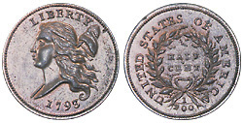

Our first half Cent, the 1793 Liberty Cap with head facing left,
Thought to be the design of Adam Eckfeldt

There doesn’t seem to be a month that goes by that one doesn’t read in Numismatic News or Coin World opposing views on whether to eliminate the cent or not. Back in 1857 arguments for retaining the half cent—our nation’s lowest denomination at the time--were few to nonexistent. The coin had long outlived its usefulness in primarily making change for the Hispanic-American real worth 12½¢. It had enjoyed legal tender status until the Coinage Act of Feb. 21, 1857 demonetized all foreign coinage. Unlike the large cent denomination which was dated in every year except 1815, there were numerous interruptions in the production of half cents, principally because they were not needed. During its 65 year tenure--between 1793 and 1857--five types of half cents were issued. First there was the 1793 Liberty Cap with head facing left; a one year issue with a reported mintage of only 35,334. Due to high collector interest and a low survival rate, this type is financially out of the reach of most collectors.

The Liberty Cap with head facing right was coined from 1794 thru 1797. Robert Scot, out first Chief Engraver was the designer. The type is somewhat costly and the 1796 issue is a renowned rarity. That said, the 1795 Liberty Cap is probably the least expensive to acquire up to VG-10.

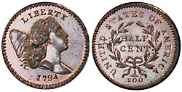
The 1794 Liberty Cap ½¢ with head facing right (1794-97)

___________________________________________________________________________________
(Continued on page 2, column 1)
America’s Half Cents (continued from page 1, column 2

Back in 1995 the writer attempted to assemble a 200 year old year set (excluding gold) and found a decent problem-free VG specimen of the 1795 Liberty Cap half cent off the Internet. In those days, few coins were pictured and one usually contacted the dealer through an E-mail address rather than a web site. As it turned out this one was a true “original”, accurately graded and has since risen in value.

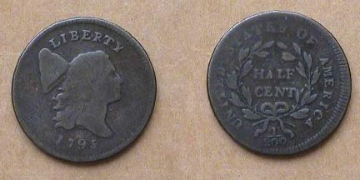

A 1795 Liberty Cap Half Cent C-1, lettered edge grading VG-10
The reported mintage is 139,650 and is considered a more common date.

The third type—known as the Draped Bust (or fillet head) was also the work of Robert Scot and was struck from 1800 thru 1808). Aside from the 1802/0 and the 1808/7, a collector should be able to afford most other dates from VG-8 to VF-30.

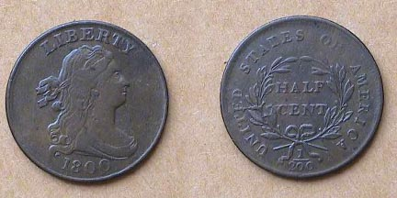

An 1800 Draped Bust Half Cent grading Fine-15

When magnified up to 200%, you will notice on the reverse, the two top leaves are single leaves facing each other.

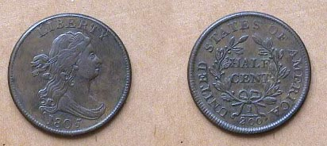

An 1805 Draped Bust Half Cent grading VF-30

When magnified up to 200%, notice on the reverse, at the top of the wreath, there are now two leaves on the right facing the single leaf at left.

From 1793 through 1808, the reverse included the fraction 1/200 under the wreath. With the fourth type—known as the Classic Head series beginning in 1809, the fraction was removed. In 1807, John Reich, a talented engraver was brought in as Assistant to Chief Engraver Robert Scot with the sole purpose of redesigning all our coinage. He was paid $600 a year which amounted to less than $2.00 a day and served in this capacity for ten years without a salary increase before resigning in 1817. Reich had fashioned the beautiful Classic Head design on the large cent in 1808 and added the same design type to the half cent the following year.
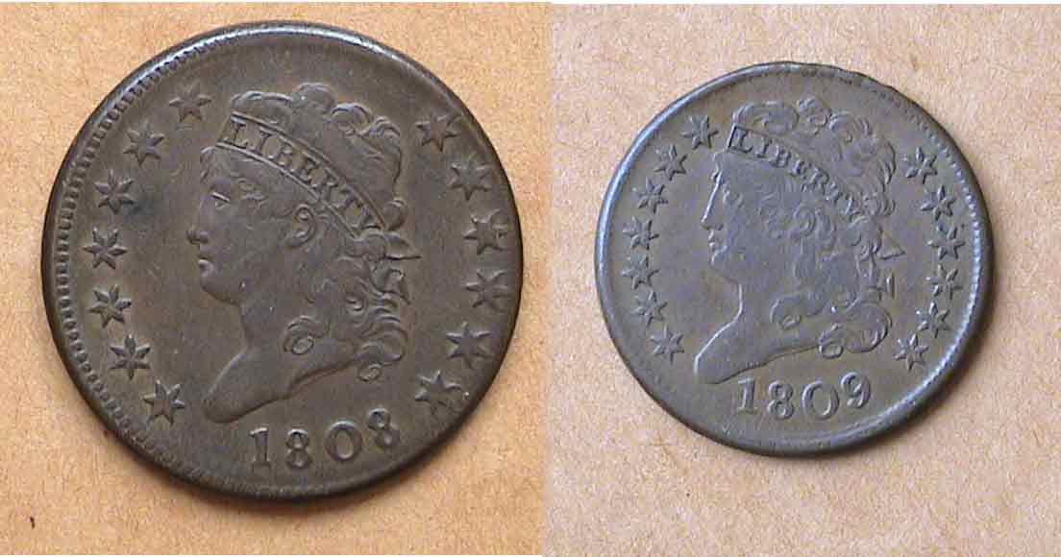

John Reich’s Classic Heads: an 1808 1¢ & 1809 ½¢ obverses
These were the first years of issue for the Classic Head Cent and Half Cent

The coining of the Classic Head type ½¢ was interrupted numerous times. Reich produced the 1809-1811 pieces; with only the ’09 considered common. After 1811, the denomination was suspended for thirteen years. Coinage was resumed in 1825 at the request of some Baltimore businessmen. Despite this, the Classic Head type continued to be struck intermittently in large enough numbers during the years 1825 and 1826, 1828 and 1829 and finally, 1832 thru 1835 to be deemed collectible today. Prices start around $65 in VF-20 and $85 in EF-40 according to the 2006 Red Book. Small numbers of proofs were coined in 1831 and in 1836. Both of these proof dates are considered great rarities. The design was modified slightly by William Kneass, the new Chief Engraver in the 1820’s and early 1830’s.

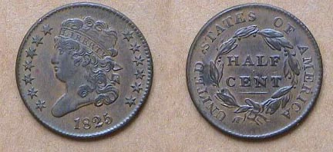

An 1825 Classic Head Half Cent, C-2 R2
Despite a reported mintage of only 63,000, the date is considered common.

No government half cents were coined again during the next three years but there is an interesting Hard Times token dated 1837 showing a spread eagle on the obverse-- similar to John Reich’s design on our silver coins of this period--but with the date below. Inscribed around the eagle is U.S. STANDARD WEIGHT AND VALUE. On the reverse there are thirteen stars surrounding a wreath with the inscription, HALF CENT WORTH OF PURE COPPER. During the Era of Hard Times, (especially between 1837 and 1844) large cent-size copper tokens circulated along side cents and this half-cent size token did also. As a result, many half cent collectors attempt to include this piece as part of their date set.

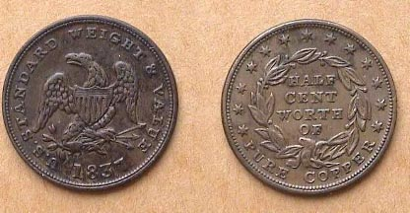

An 1837½¢ size Hard Times Token, Low-49 R2
Showing Spread Eagle, thirteen stars and wreath
Magnify up to 200% to better observe details and read inscriptions.
__________________________________________________________________________________________________
(Continued on page 3, column 1)
America’s Half Cents (Continued from previous page)

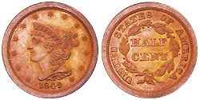

An Proof 1840 dated Braided Hair “Mature Head” Half Cent
(Courtesy of Superior Galleries)

One of the great unsolved mysteries of U.S. Numismatics is the Half Cent coinage of 1840 to 1849. After Kneass’s tenure ended due to a stroke in 1835, Chief Engraver Christian Gobrecht began tinkering with the Coronet large cent design. There were two important sub-types struck of the 1835 cents; two for the 1837, and five for the 1839. One of those struck in 1839 was called the Petite Head which showed a more refined, tapered Bust of Miss Liberty tipped slightly downward towards the date. In 1843, Gobrecht produced more varieties; one of which portrayed the Bust of Miss Liberty placed directly over the date. This has been called the “Mature Head”, and in that form, the design would remain the same on both the large cent and half cent through the end of run in 1857.

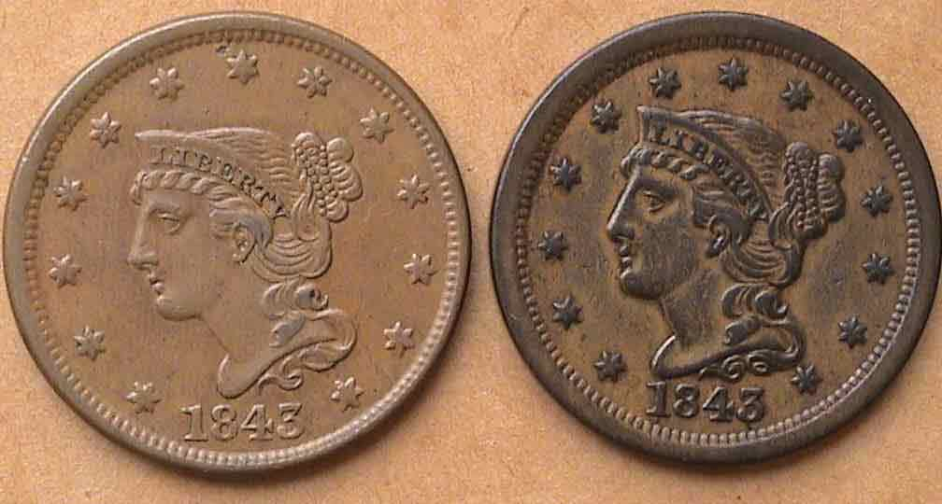

1843 Petite Head (l.) and Mature Head (r.) Large Cent obverses

It was during this very same period that no half cents were issued for circulation and therein lays the mystery. The Red Book shows that half cent coinage was resumed in 1840 as proofs bearing the “Mature Head” Braided Hair design type. A famous 1843 Proof set displays specimens of all US denominations issued that year. Of the two copper pieces, the large cent shows the tipped “Petite Head” design but the half cent portrays the erect “Mature Head” design type. Normally, it was the larger denomination within a particular metal alloy that was changed or modified first as shown in the changeover from Liberty Cap to Draped Bust and Draped Bust to Classic Head cents. How then does one explain the 1840 to 1843 half cent pieces showing the “Mature head” type before the cent? One theory is that the 1840 to 1843 half cents were back dated; possibly in 1844 and if so, why? Compounding the mystery is the lack of mintage figures for these ‘original’ proof issues struck between 1840 and 1849. Then there are the numerous re-strikes that occurred in the 1850’s; these having small berries as opposed to large berries on the originals.

The first Braided Hair Mature Head type half cents actually issued for circulation occurred in 1849. To distinguish the business strike from the proof only issue, the Mint placed a large date below the Bust. A glance at page 92 of the 2006 Red Book shows the differences in the date sizes. Some 39,864 were minted of the large date circulation issues for that year. With the exception of the proof only date for 1852, the Mint struck half cents for circulation in relatively small numbers through 1857 but despite the low mintages, these coins hardly circulated and many exist in Choice AU to MS-63 today starting at around $150.

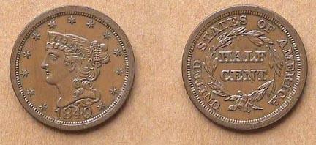

AN 1849 Braided Hair “Mature Head” Half Cent with Large Date in AU
This was the last collectible type struck for circulation from 1849 thru 1857.

Collecting Half Cents by Type

Despite the scarcer earlier issues, the collector of today could assemble a complete US Half cent type set at minimal expense. For the 1793 Liberty Cap facing left and 1794 Liberty Cap facing right issues, the Gallery Mint out of Eureka Springs, AR struck reproductions based on the standard alloys, weight, diameter and thickness of the originals. Originally priced at $8.00, [with the word copy incused on the obverse or reverse; your choice] these pieces may still be available either directly from GMM or on the secondary market at a nominal increase. The Draped Bust, Classic Head, and Coronet “Mature Head” types along with the 1837 Hard Times ½¢ token are all affordable in a number of circulated grades from AU-55 down to VG-8 depending on the type and the strength of your wallet. Many believe that it only a matter of time before this long neglected series catches on with a greater number of collectors.
________________________________________________________________________________________________________________________________

More Club News (Continued from page 1, column 1)

At the April 18 meeting, Nominating Committee Chairperson Coleen Reed announced that no other members’ names were put forth in nomination to challenge the current Executive Committee, and since there were no cries from the assembled to “throw the rascals out”, the entire five member Board was reelected by acclimation. Acting Secretary Marion Engel--in the absence of Helen Barry--cast one ballot for Willie Simon, President, James Barry, Vice President, Helen Barry, Secretary, Pat James, Treasurer and J.J. Engel, Sgt. In Arms. Kudos and congratulations go out to the Board for a job well done. Jim Barry noted that member Bill Myers won two Exhibit awards at the ANA Money Show in Atlanta. One was on “Clasped Hands” and the other on “Puffin Coins”; the last named, also the subject of an article by Bill in the August, 2003 edition of this newsletter. Congratulations, Bill.

Arno Safran presented a slide-talk on Latin American Coins that were Legal Tender in the US until 1857. The slides showed images of a wide variety of Crown size silver dollar coins known as Pesos, 8 Reales or Pieces of Eight from the Pillar dollar (1732-1772) through the Portrait coinage of Charles III and IV, Ferdinand VII into the era of the early Republican coinage of Mexico, Central America, Colombia and Peru. Also displayed were the less expensive but hard to find minor silver coinage from the 4 Reales down to the tiny pea-sized ¼ Real.

Winner of the door prize was Billy Ray Randall. Jack Schulz won the 50/50. Congratulations gentlemen. The next meeting will be at our new location; the Cedar Creek Club House on May 11, the second Thursday in May starting at 7:00 PM. Hope to see you there!
_______________________________________________________________________________________________________________________________
BRITISH OCEANIA J.I.M Notes
By Bill Myers

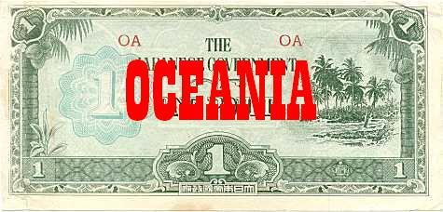

The face side of a One Pound Oceania JIM note

British Oceania is a group of islands and atolls in the South Pacific. By April 1942, the Japanese captured the Bismarcks, Gilberts and British New Guinea but further expansion was stopped and the Japanese were pushed back. The JIM for this area was intended for use in the Gilberts and Solomon’s, New Britain and Papua-New Guinea.

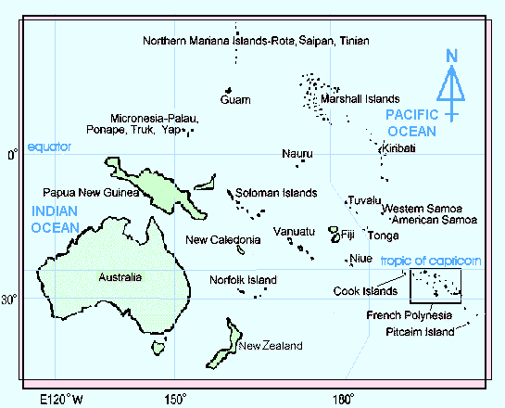

The Oceania notes were produced in shillings and pounds. The series letter is "O" and the block letters are red. The notes are lithographed and have the quatrefoil watermark. Specimens exist for all of the notes and are not included in the descriptions below.

The face of all the notes has "THE JAPANESE GOVERNMENT" and the denomination spelled out and in numeral form. There is a shore scene on the right of all the notes. On the back of the ½, 1 and 10 shillings notes the denomination numeral is repeated on an ornate design.
The back of the 1 pound note has the denomination spelled out and in numerals on an ornate design.

The ½ shilling varieties are: ½ shilling blocks 42mm apart - blocks 50-53mm apart

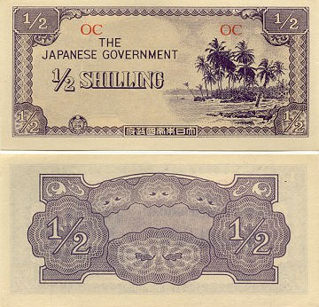

A One-Half Shilling OCEANIA JIM note

The face of the 1 shilling note has a breadfruit tree on the left. The lone variety is: 1 shilling - block letters

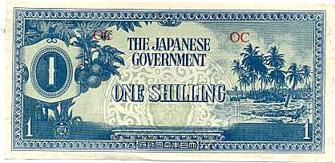

A One Shilling OCEANA JIM note

The 10 shilling has a coconut palm on the left and a pawpaw tree with the shore scene on the right. The only variety is: 10 shilling - block letters.

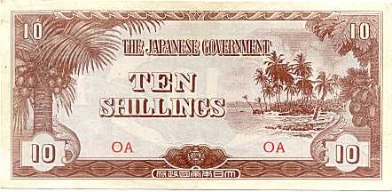

The face of a Ten Shilling OCEANIA JIM note

To meet the demand for the notes, replicas were made of the ½ and 1 shillings and the 1 pound note. They come in a variety of colors but all have "REPLICA" on the back. Little is actually known about the replicas. There is a crude fantasy ¼ shilling note, as well. It resembles the fractional notes described above, but there is no block number. The origin is unknown.
________________________________________
-to be continued- Final t installment; JIM notes of the Philippines

A Lion’s Tale: Maundy Money
By Dave Bailey
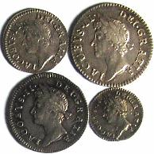

An undated 1687 Maundy Set of James II
The coins were silver and given to the poor on Holy Thursday.

Government Giveaway! Rare coins given to a select few! Silver coins to be issued at face value! Aged and poor to be honored by the Queen of England! These are all possible headlines that the British tabloids could have a field day with. However, this event will be largely ignored except for the participants, their families and collectors of English coins. Therein lies the tale.

In AMERICA, the Christian community calls the Thursday before Easter “Holy Thursday” but in England it is referred to as “Maundy Thursday”. Maundy can b traced back to the Latin word, MANDATUM, meaning commandment. During the early middle ages, the king would wash the feet of some of his poor subjects to imitate Christ when he washed the feet of the apostles. Gifts of food as well as clothing from the royal household would also be distributed to the poor. This might cause a problem in that the clothing might look better on a poor person than on a royal.

Samuel Pepys informs us that Charles II made an important change in the Maundy ceremony. His highness felt that a king should not be washing the smelly feet of the great unwashed--as it is said--that kings “did not wash the poor peoples’ feet himself but the Bishop of London did it for him.” Now the Bishop of London was not too keen on the idea, so it was decided to solve the problem the way all governments do; throw money at it.

Instead of a feet washing ritual, money would be distributed based on the age of the monarch. Thus, a monarch who was fifty years of age would give fifty worthy men and fifty deserving women fifty pence each for a total of 5,000 pennies. This would be made up of four piece sets consisting of one, two, three and four penny denominations for an approximate mintage of only five hundred each. The money was given in two leather purses, one red and the other white. The older the monarch, the larger would be the distribution.

Queen Elizabeth II’s grandfather, George V was the first monarch to attend the ceremony in two hundred years. This took place in 1932 and he personally distributed the coins. Queen Elizabeth always attends the annual ceremony usually held in one of the nation’s cathedrals. She, the Royal Almoror and other officials will walk down the cathedral aisle and distribute the coins to eighty men and women who are considered worthy of the honor for services to the community during the year. They will be carrying nosegays and flowers in the old tradition of wading off the smell of the poor. The coins themselves are made of sterling silver and are treasured by the recipients with the extras sold to waiting dealers who supply the collector demand. All in all, a charming numismatic ceremony and a great collectible.

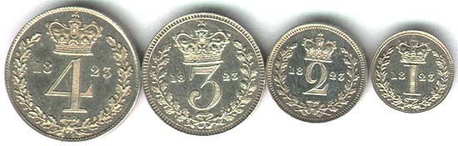

An 1823 Maundy set of King George IV
______________________________________________________________________________________________________________________________
“The Lion’s Tale” is an ongoing series by Dave Bailey, (Ed.)
______________________________________________________________________________________________________________________________

Why Collect Ancient coins?
By Jim Barry - reprinted from the April, 2002 SJ CSRA CC Newsletter
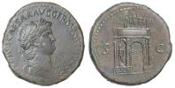
Rome: Nero Sestertius c. 64 A.D Laureate Bust o; Triumphal Arch r.

People have been collecting coins for thousands of years. One of the first known collectors was the Roman Emperor Augustus who lived before the birth of Jesus. Holding an ancient coin one can only wonder what important person may have held the same coin in antiquity. Was it Julius Caesar, Jesus, Constantine the Great (the founder of Christianity) or a soldier in a Roman Legion? Coins of the ancient world connect us with our past. In many cases the only known portraits of early rulers can be found on their coins. The coins of Alexander the Great, Tiberius, Marc Antony and Cleopatra are just a few of those important persons whose portraits can be found on ancient coins.
Ancient coins form the basis for many of our modern coin designs. The Saint-Gaudens $20 gold coin, the “Mercury”
Dime and the Walking Liberty half dollar are all examples of coins whose designs have been taken from antiquity. Yes, owning an ancient coin is like having a fragment of history that you can hold in your hand and connects us to the past. Ancients are not only fun to collect but in many cases they are not expensive to own.
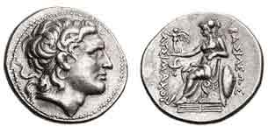
Thrace – Lysimachus Tetradrachm c. 297/6 to 282/1 BC
Obv. Head of Alexander; Rev. Athena seated
Our Liberty Seated silver coins owe its genesis to this coin’s reverse, (Ed.)
An Historic Bank Note by Arno Safran

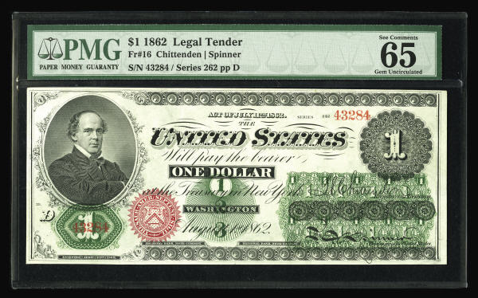
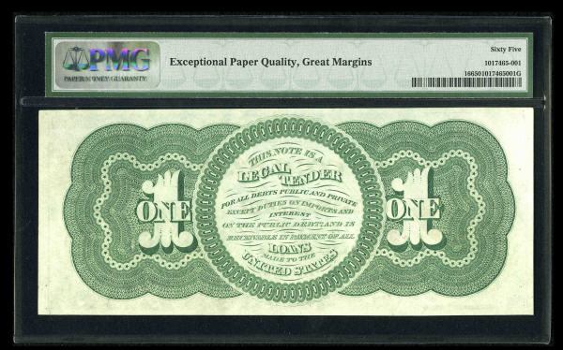

A $1.00 Legal Tender Large Size Greenback
Fr.-16 Series of 1862, our first One Dollar Bill
(Courtesy of Heritage Currency Auctions)

In 1862 the United States was at war--with itself. The War Between the States, better known as the Civil War was already in its second year and silver and gold coins had virtually disappeared from circulation right down to the 3¢ silver trime. Even the Flying Eagle and Indian Head copper-nickel cents seemed to have vanished. To overcome this disastrous situation, the government began printing greenbacks; paper money in fractions of the dollar—to take the place of coin and in the larger denominations from the $1.00 up to $1,000. The first series of March 10, 1862 provided for the larger denominations starting with the $5.00 note. The second series, August 1, 1862 allowed for the $1.00 and $2.00 notes to be issued. The first general issues of fractional currency--in the form of postage stamps--was approved by Congress and signed into law by President Abraham Lincoln on July 17, 1862.

The $1.00 note shows a picture of then Treasury Secretary Salmon P. Chase within an oval frame situated at the upper left of the face of the note. The obligation appears boldly to the right and centered, “The United States Will pay the barer ONE DOLLAR”. Under a numeral 1 is WASHINGTON and below that, the date of the authorization, August 1, 1862. The color green dominates the back of the note accounting for its nickname, “greenback”. Two ornate large numeral 1’s surround a large coiled circle which further explains the Treasury’s obligation to the holder; “THIS NOTE IS A LEGAL TENDER FOR ALL DEBTS PUBLIC AND PRIVATE EXCEPT FOR DUTIES ON IMPORTS AND INTEREST ON THE PUBLIC DEBT AND IS RECEIVABLE IN PAYMENT FOR ALL LOANS MADE TO THE UNITED STATES.”.

The statement on the back of the note obligates the government to back all purchases in the amount of the note--in this case $1.00--but not to redeem it in coin but in fractional currency; especially since no coins were available at the time.

`The note pictured appeared as part of a Buy or Bid sale off the Heritage Web site and was certified as CU-65; (i.e. Gem Crisp Uncirculated with no folds, good contrast, natural ink color along with fairly even margins). The asking price was $3,000. Interestingly enough, this $1.00 note and all subsequent federally authorized bank notes are still backed by the US Treasury today. No other sovereign nation can boast this record. As such, a well worn specimen of this same note--with lots of folds--would still be worth $1.00 at your local bank.

