Pres. Willie Simon
V .P. James Barry
Sec. Helen Barry
Treas. Pat James
Sgt. in Arms: J.J. Engel
Committees:
Programs: James Barry
Show Chairman: JJ Engel
Newsletter: Arno Safran
E-Mail: arnosafran@comcast.net
The Stephen James
CSRA Coin Club of Aiken
P.O. Box 1739
Aiken, SC 29802
Web site: www.sjcsracc.org
The SJ CSRA CC Now Meets on the 2nd Thursday of the Month at the Cedar Creek Community Center in Aiken, SC

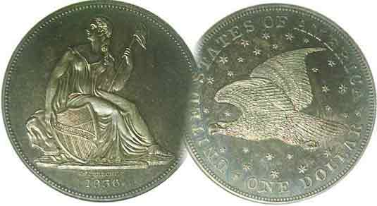

Volume 6, Number 5 the Stephen James CSRA Coin Club, Founded in 2001 May, 2007
Monthly Newsletter
Club hears program on “Coins of the Bible”
Our next meeting is on the 2nd Thursday of the month, May 10, 2007 at 7:00 PM
2007 Club Meeting Schedule - 2nd Thursdays at 7 PM Jan. 11 Apr. 12 July 12 Oct. 11
Feb. 8 May 10 Aug. 9 Nov. 8
Mar. 8 June 14 Sep. 13 Dec. 6
Annual Club Show: Sat. Sept. 15, 2007
_____________________________________________________________________________________________________________________________

2007-08 Dues of $10.00, Srs. $5.00, Jrs. Now Due

The SJ CSRA CC’s was founded in March of 2001 and held its first public meeting as a coin club in April of that year. As a result the club’s fiscal year is from April 1 thru March 31 of the following year which means 2007-08 membership dues were due in April. For those who have not yet renewed, please make out a check for $10.00 (seniors) or $5.00 (juniors through 18 years of age) payable to Pat James and mail to her c/o of the club’s mailing address, PO Box 1739, Aiken, SC 29802. Better, yet, join us on May 10 for our “Grade a slab” program and renew in person. The renewal grace period lasts thru June.

Wayne Damon’s Talk on “Coins of the Bible”,
A Fascinating Travel Back in Time

At the April 12 meeting our guest speaker was Wayne Damron, proprietor of Clein’s Rare Coins in Augusta. Wayne spoke on Biblical coins of Classical Greece, Ancient Judea and Rome, also the later Byzantine Era when images of Christ were placed on the obverse with the emperor on the reverse. He mentioned some of the metals and denominations used in biblical times such as copper, the sestertius (Rome) and follis, (late Roman and Byzantine); silver; the shekel, half shekel and denarius, (Rome and Judea) and gold; (the solidus). Some of the famous coins of the Bible included the Widow’s mite, the Tribute penny, the follis issued by Byzantine emperor Justinian II showing Christ’s portrait. He told how Emperor Augustus, the first great Roman gave 1.4 billion sestertii to the citizens of Rome towards the end of his reign in appreciation for their support and dedication to the empire. Wayne passed around a number of examples from his fine collection enabling members to get a close hand look at these marvelous numismatic examples of history. The club thanks Wayne Damron for his fine presentation.
____________________________________________________________________________________________________________________________
(Club News continues on page 4, column 1)
Ode to a Numismatic Colleague and Dear Friend
By Arno Safran

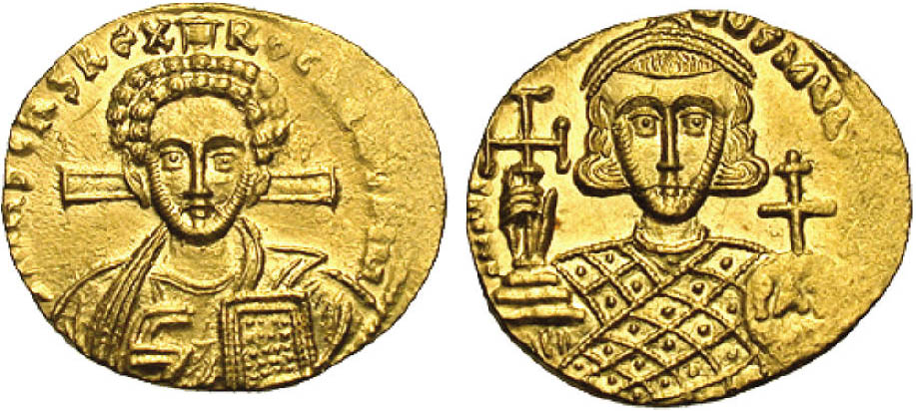

A Byzantine solidus of Justinian II (second reign) AD 705-711
A gold coin with a diameter of 20 mm, weighing 4.44 grams
Struck in Constantinople (Istanbul, Turkey today)
The obverse depicts a bust of Christ holding Gospels; a cross behind head.
The reverse shows the crowned emperor, Justinian II holding a cross potent on three steps and patriarchal globus inscribed PAX.
(Photo and description courtesy of Heritage Auctions Archives)

Pictured above is a gold coin struck during the second reign of Justinian II. (A.D. 705 – 711). I might never have come to know such a piece -let alone comprehended its significance--had it not been for a numismatic colleague whose collecting specialty was Byzantine coinage, for this was the first emperor to have an image of Christ depicted on his coins.

In 1989, at a meeting of the Ocean County Coin Club in Brick, NJ, I bumped into a member I hadn’t noticed before. We started chatting and it was apparent from the get go that this was a warm, good natured individual who enjoyed talking coins. His name was Chris Connell and he told me that he was an Episcopal Priest at nearby Saint Raphael’s in the same community. Like many of us, Chris started out collecting US coins but moved towards Ancients and eventually into Byzantine coins because it related more to his calling. I replied that he was only the second person I knew who collected the coinage of the Byzantine Empire (a civilization that exited from about A.D. 491 until 1453) and invited Chris to attend a meeting of the New Jersey Numismatic Society where he might meet more individuals who shared his numismatic interests. During the next ten years Chris would present many slide programs on Byzantine coins at coin clubs, schools and conventions. In every program, Chris brought this ancient world back to life describing the principle figures, the intrigues, the wars, the economy and the coinage. Sadly, the other day, I learned that Chris had passed away from complications of Diabetes.
________________________________________________________________________________________________________________________
(Continued on page 2, column 1)
Ode to a Byzantine Coin Collector
(Continued from previous page)
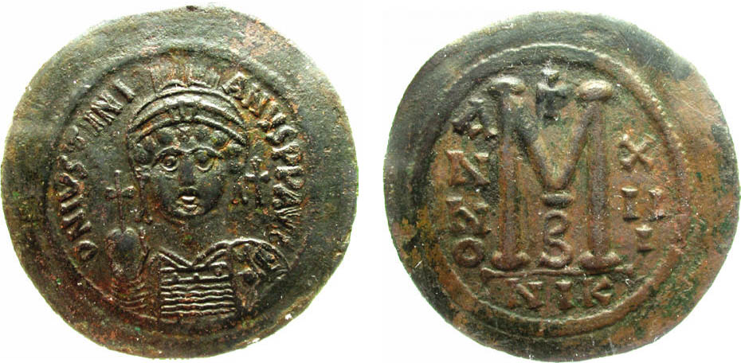

A follis of Justinian I, Byzantine emperor from A.D. 527-565
Under Justinian I, this copper coin was 42 mm in diameter.
This specimen was struck in Nicomedia in the 13th year of the emperor’s reign
The obverse shows a crowned facing bust of the emperor holding a globus cruciger; (cross). The reverse shows the denomination as a large M;
[the Greek symbol for 40 nummi which was equal to one follis.]
(Photo and description courtesy of Heritage auctions Archives)

In 1990, shortly after that first encounter, Chris and I drove up to attend a meeting of the New Jersey Numismatic Society (NJNS). I had been a member since 1984 and from my first experience; I realized this was no ordinary coin club. It was founded in 1933 during the height of the great Depression and was now in its third generation of seasoned numismatists. Members met in a private room of the Madison, NJ Public Library once a month. The room had two large TV monitors suspended from the ceiling and a large screen that would descend for slide presentations simply by the push of a switch at the back of the room. Seated around a T shaped table that was as long as it was wide were around 25 persons who specialized in Ancients, World coinage, US type and Colonials. Others collected tokens and medals. Still others favored US and World bank notes. Regardless of one’s collecting interests, most everyone knew their stuff. Every meeting consisted of a short business segment, a numismatic program by either a guest speaker or fellow member and a Show & Tell session in which members brought in one or more items to display and discuss.

At the first meeting Chris attended, I introduced him to the only other collector of Byzantine coins I knew, Mal Heckman. Each was delighted to meet a kindred spirit. Now there were two to fend off those collectors who considered anything struck after 5th Century Rome were too modern or anything coined before the Council of Trent (1545-63) to be too crude. It was at such gatherings that one could learn about a large cartwheel size copper coin such as the oversized follis of Justinian I shown above or the scarcer silver miliaresion denomination of Basil I depicted below.

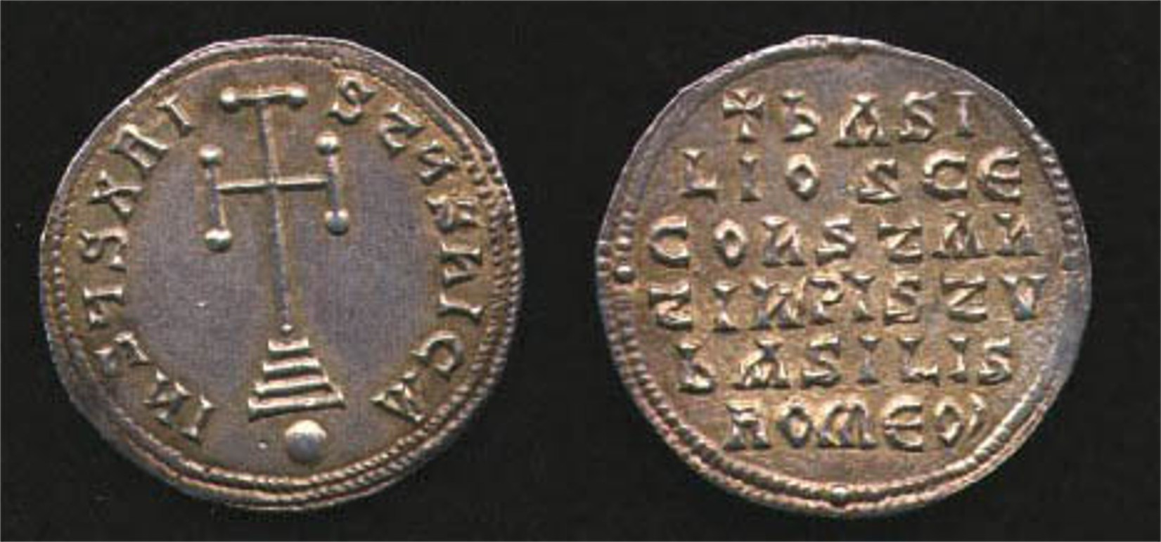

Basil I, 867-886 miliaresion (silver) ca. 26 mm; Sear 1708
Obv., Cross potent on three steps, globe beneath, Rev., inscription
(Courtesy of Heritage Auctions Archives)

Chris Connell was one of the most focused collectors I have ever known. He collected Byzantine coins by particular emperors; from different Mints throughout the empire; also from periods of crisis such as the “Emperors of Chaos” as well as unusual denominations; (e.g., uneven fractions of the follis such as the 33 nummi.) Many of these coins were extremely rare ( as was the 4 nummi copper coin of which only four were known at the time) but since the demand was virtually nonexistent outside of a handful of ardent collectors, many of these rarities were not all that costly when Chris eventually came across one of them.

Byzantine coins were produced in a region centered in Turkey and Greece expanding through the Balkans and beyond during a thousand years of conquest, expansion, defeats, and contraction. Throughout the millennium the empire experienced great periods of commerce and culture but also setbacks from usurpers, assassinations of emperors, retribution in the extreme, and brutality amidst piety.

Over this incredible time span the coins changed gradually from the Greek and Roman influence involving side-views (Anastasius I A.D. 491-518) to full face portraits beginning with (Justin I A.D. 518-527) and as the empire began to wane, the precious metal coins began to become more and more debased. The follis eventually disappeared. The gold coins became bowl shaped (scyphate). One of Chris’s favorite Byzantine coins was a debased small silver quarter hyperpyron piece struck in the waning days of the Empire under the aegis of the last Byzantine emperor, Constantine XI (Oct. 31, 1448 to May 29, 1453, the day the Moslems defeated the empire.) Upon finally acquiring the piece, he gave a presentation entitled, “The Last Byzantine coin” describing the piece as grading AU but appearing as an AG-3.
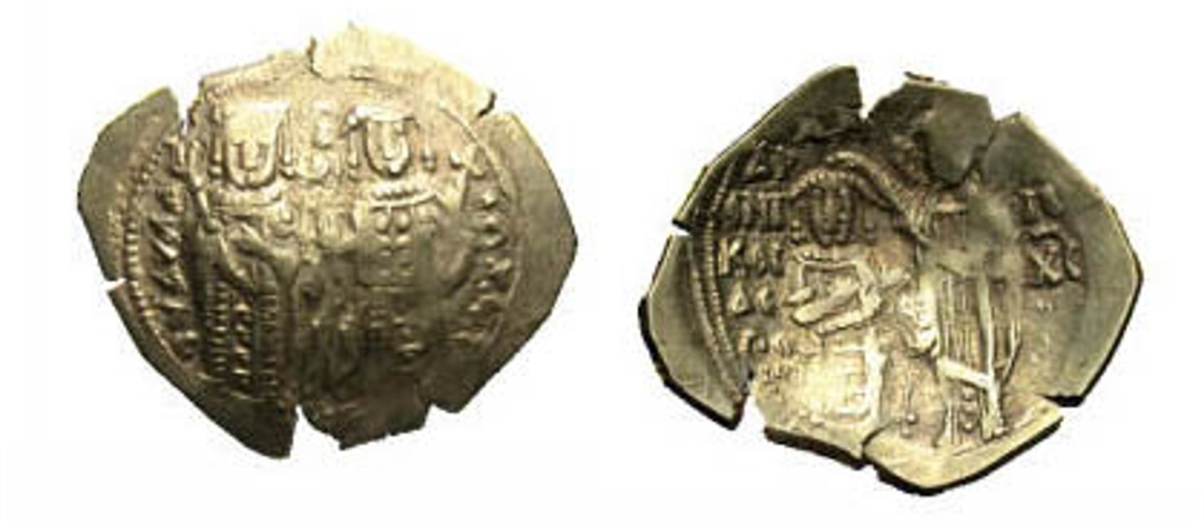
An example of a crudely struck debased scyphate silver hyperpyron from the reign of Andronicus III (1328-1341)
Obv., Anna of Savoy l, regent of John V, r. standing and facing
Rev., Andronicus III kneeling before Christ (Sear #2466)
The coin was between 24 mm and 25 mm in diameter.
(Courtesy of Heritage Auctions Archives)

While the coin shown above was struck a full century before the demise of the Byzantine empire it is a far cry from the quality produced during the culture’s first five hundred years. Chris did extensive research into the Byzantine economy comparing the coin values relative to today’s US coins and currency. He estimated that the copper follis had the purchasing power of a half dollar (50¢) and related that the annual pay of a Byzantine soldier was one gold solidus, the equivalent of $3,000 purchasing power in today’s US currency.

Chris so enjoyed Byzantium that he even named his dog after the emperor Maurice Tiberius (A.D. 582-602). [Having known the dog, the name fit.]. The effect of Chris’s programs, Show & Tells and his enthusiasm broadened one’s knowledge and understanding of a civilization that lasted longer than the Greek and Roman empires combined. His personal charm was unique and his impact on the hobby was immeasurable.
__________________________________________________________________________________________________________________________
TAKE YOUR TIME BUT HURRY UP
By Greg Heim

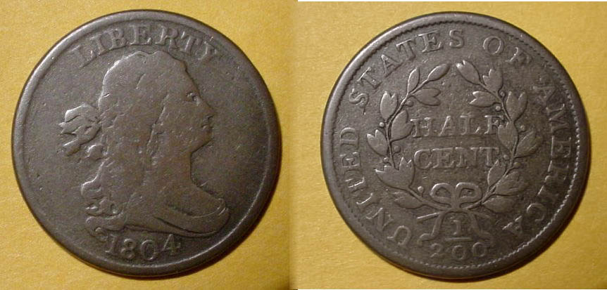_

An 1804 Draped Bust Half Cent, C-7 R4 (actual size)
From the author’s collection

The year 2007 marks by thirty-third year in Numismatics. Over that time I have developed a variety of strategies as they apply to acquiring coins for my collection. Some of these may not be for you, sp please read what follows with an open mind.

My maternal grandfather was an avid and proficient golfer. So proficient, that at age 74, he came within two years of shooting his age. The oxymoronic title of this article was one of his favorite aphorisms while he was on the golf course as he wanted to get his round in without totally rushing his opponent.

It’s been eleven years since my grandfather passed away. As the years went by our family often chuckled warmly over his many sayings. However, it was this one, “Take your time but hurry up”, that made me think about my pastime; numismatics.

Whether it is at a coin shop, the bourse floor or on an internet auction site such as eBay (especially one with a “buy it now” message); one occasionally sees a coin instantly pop up that has been eluding you for a long time. You are forced to make a decision of literally buying it now--at the fixed price--or taking your time in order to survey the landscape. Buying it now has the disadvantage of finding another at a better deal and/or a specimen of even better quality. Taking your time has the disadvantage of possibly missing out on an item that has been on your radar for quite some time. So, what’s the right answer?

The right answer can be summed up in one word – EXPERIENCE. Experience does not happen by osmosis. It comes from years and years of properly guided hard work. It goes beyond the attendance at a club meeting, or at an occasional coin show (although those help). Experience comes from building a numismatic library, reading articles and books you have acquired; learning about rarity and how to grade and then reinforcing what you have learned with others. Experience comes from participating in Show & Tells and exhibiting. Although there are other examples, these are essentially the main points.

What about providing an example? My specialty is United States Half Cents, so I will use an example from that series. Even if your collecting interests lie elsewhere, I believe my example will be helpful:

I am an early arrival at an annual show with 35-40 tables set up that has just opened to the general public. One of the dealers has an 1804 Draped Bust half cent showing a plain 4 in the date on the obverse with stems under the wreath below the tie in the ribbon on the reverse. The coin has only minor contact marks, no porosity with above average color. The grade on the dealer’s flip is marked, FINE-15 and the die variety is a C-4 (for Roger S. Cohen, Jr., noted half cent attributer.) with a rarity factor of R4 (76 to 200 pieces known to exist in all grades). The dealer knows what he has and is asking VF-20 money (firm) based on the Coin Dealer Newsletter (Gray Sheet) Quarterly. It is my first pass around the room and purchasing this coin would wipe out over half of my budget for the show. What do I do?

ANSWER: From my study of the series I know that this is a tough variety to fine, even in pleasing Fine-12 or better. Color and surfaces play a MAJOR role in the pricing of early US copper. In my judgment, the dealer is not being unreasonable in his asking price. If one is a specialist in this series, I believe the purchase has to be made. If it coin in question is a secondary or tertiary option then I would give the entire floor a lap and return as soon as possible to reassess my position.

An enlargement of the 1804 Draped Bust ½¢, Cohen 7 variety R4 the photo was taken by the author.

Now bear in mind this is just one example which listed a set of controlled variables. It is beyond the scope of this article to review every dynamic but the one commonality, EXPERIENCE, was the determining factor in making this calculated decision. Happy hunting.
_____________________________________________

Greg Heim is the Corresponding Secretary of the Watchung Hills Coin Club in north central New Jersey, a long time member of the Early American Coppers Club (EAC) and a contributor to its journal PENNY-WISE. He started out as a child collecting Lincoln cents and as a teen, 20th century US type before moving into large cents and now half cents collecting as an adult.
____________________________________________________________________________________________________________

Augusta coin Club Show Coming Up Fast
Friday and Saturday, May 4 & 5

While our next club meeting is scheduled just under one week later (May 10), this newsletter is being sent earlier to alert members that our sister club to the west will be holding its annual Spring coin show this coming Friday and Saturday, May 4 & 5 at the Belair conference Center. The site is located 1½ blocks beyond Interchange 194 off I-20 on the Fort Gordon bound side at 4083 S. Belair Road behind the Waffle House and Hampton Inn. Hours are 9:00 AM to 5:00 PM both days. The show is free and there is free parking. A record 40 tables have been sold. Hope to see many of you there!
______________________________________________________________________________________________________________________
More Club News
(Continued from page 1, column 1)

At the April 12 meeting Treasurer Pat James reported a balance of $1,035.28. At this early date, Show Chairman J.J. Engel stated that three tables have been sold for our September show. Krause Publications' latest Coin Show & Auction Guide: 2007-2008 has been published and our show is listed under South Carolina in the states section and again in the back under September, 2007 in the calendar section. The special supplement accompanies all of Krause's numismatic publications which include Numismatic News, World Coin News, Bank Note Reporter and Coins Magazine.

For Show & Tell Vice President Jim Barry displayed an example of a classical Greek owl on a Decadrachm, (a Greek silver coin valued at 2½ times the Tetradrachm) that if real would realize around $600,000 in auction today. Jim did not suggest that he came into possession of this renowned rarity after winning the latest Power Ball drawing explaining that the coin was in fact, an attractive replica. He noted that the owl symbolized the wise Athena who was regarded as the patron of Athens.

“Grade a Slab” returns for our next program. The idea is for members to bring a certified coin from their collection or inventory but hide the grade listed by placing a removable small swath of adhesive tape over the grade on the holder. Members should bring a pad and pen to the meeting, record the date and denomination and grade the coin independently. A small group will tally up the consensus and report the club’s overall grade and then the certifying company’s grade. We did this once before with surprising results.

ANA Elections Coming Up Soon: Below are the names of candidates running for the Board of Governors of the American Numismatic Association that our club is supporting. If you are an ANA member, please consider these individuals when you cast your vote.

1. Clifford Mishler
2. Chester Krause
3. Edward Rochette
4. Joseph Boling
5. Walter Ostromecki
6. Radford Stearns
7. John Esbach

Prizes: At the April 12 meeting Glenn Sanders won both the door prize; a 2007 silver eagle and the 50/50 drawing; $23.00. Congratulations, Glenn. Our next meeting is Thursday, May 10. Many members have already renewed their 2007-08 membership dues and for that the Executive Committee of our club thanks you. For those who have yet to do so, please come to the meeting and rejoin in person and meanwhile, don’t forget to attend one of the two days of the Augusta Coin Club spring show on May 4th and 5th. Forty tables have been sold. This means a larger selection from which to browse. Happy hunting for those who are able to attend. Hope to see you at the May 10 meeting and perhaps you’ll have a new acquisition from the Augusta show to display as a Show & Tell.
____________________________________________

Coin of the Month

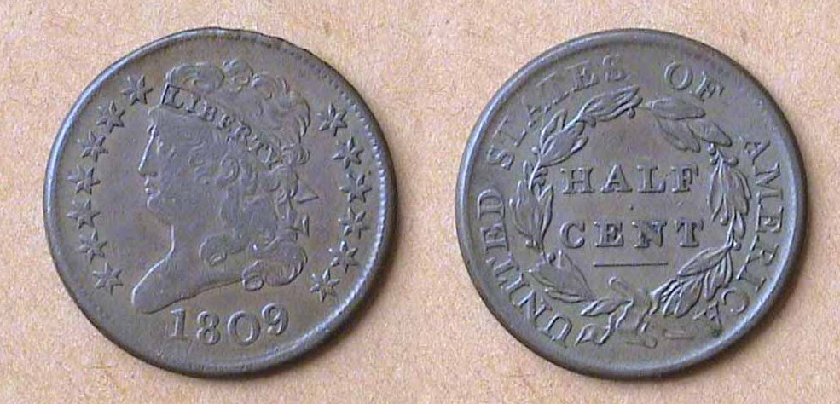

An 1809 Classic Head ½¢, C-6 R1 grading VF-30

Based on Greg Heim’s half cent article we will feature another half cent type; this one, the Classic Head (1809-1836) as coin of the month. As a series the half cent is still undervalued according to many numismatists and attractive problem free specimens such as the one above sell for under $100.
__________________________________________________________________________________________________________________

Kindly Support Our Advertisers
