Pres. Willie Simon
V .P. James Barry
Sec. Helen Barry
Treas. Pat James
Sgt. in Arms: Glenn Sanders
Committees:
Programs: James Barry
Show Chairs: The Barry’s
Newsletter: Arno Safran
E-Mail: arnosafran@comcast.net
The Stephen James
CSRA Coin Club of Aiken
P.O. Box 1739
Aiken, SC 29802
Web site: www.sjcsracc.org
The SJ CSRA CC Now Meets on the 2nd Thursday of the Month at the Cedar Creek Community Center in Aiken, SC

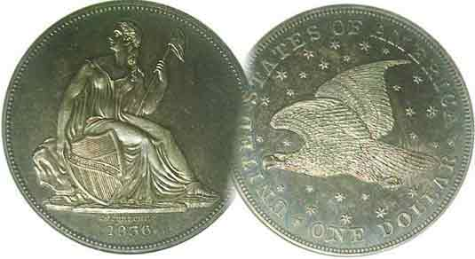

2008 Club Meeting Schedule
Volume 7, Number 5 the Stephen James CSRA Coin Club, Founded in 2001 May, 2008
Monthly Newsletter
Club Now in Eighth Year
Our next meeting is on Thursday, May 8 from 6:15 to 9:00 PM
Jan. 3 Apr. 10 July 10 Oct. 9
Feb. 14 May 8 Aug. 14 Nov. 13
Mar. 13 June 12 Sep. 11 Dec. 4 dinner
___________________________________________________________________________________________________________________________

Our Next Club Show- Sat. Sept. 13, 9:30 AM to 4:30 PM
H. Odell Weeks Activity Center - Whiskey Rd (Rte. 19) Aiken

_________________________________________________________________________________________________________________________

SJ CSRA CC in Eighth Year – Newsletter in Seventh

It was back in March, 2001 that a group of coin collectors met to discuss starting a coin club to serve Aiken, SC and the surrounding communities. The first official meeting was held in April, 2001 at the Aiken Public Library. Back in those days, we could be virtually assured of holding our monthly meetings once a month on the fourth Thursday but as the population increased, more and more groups started requesting meeting space and by 2005 the library could no longer provide us a regular meeting night on a monthly basis. Sometimes, we were forced to hold meetings on a fifth Thursday (when there was one); then not be provided another meeting time until the first Thursday two months hence. Finally, the club voted to leave the library in April of 2006 and moved to its current location, the Cedar Creek Activity Center near New Ellenton in May. As a result, we lost around one-third of the membership but found a spacious commodious new home with state of the art multi-media facilities.

The Newsletter was started in January, 2002 and has been published regularly ever since. The first five volumes were produced on an old Windows 95 PC but in February, 2006, with the acquisition of a new XP Windows computer, the newsletter became digitized and was sent out in color as E-mail attachments in addition to those members who requested snail mail black and white copies. For newer members curious to learn something about the early years of our club, contact the editor for a complimentary copy of one of the earlier issues if still available. The club has usually featured a numismatic program and auction including show & tells by members at its meetings and holds an annual show in September.
____________________________________________________________________________________________________________________
(More Club News continues on page 4, column 1)

Collecting Short Sets Satisfy Short Term Goals
By Arno Safran

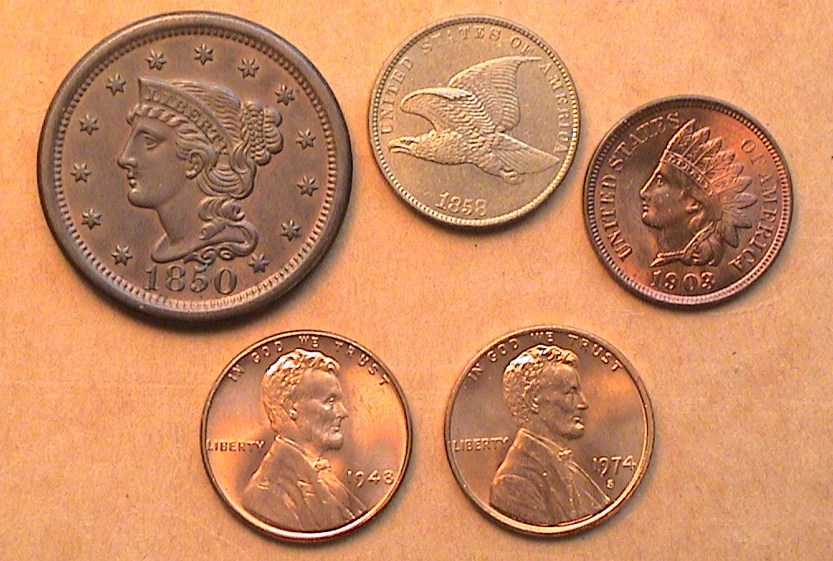

The obverses of a 1¢ Short Set removed from a Capital holder
1850 lg. 1¢, 1858 FE 1¢, 1903 Ind. 1¢ 1948 & 1974-S Lincoln 1¢s

The coins pictured above are relatively common examples of the final four major obverse US cent types. Coin collectors usually assemble sets by a series or by type. With US coins, this can be costly. In a series, the ‘keys’ and tougher dates can act as “stoppers”; coins so scarce--especially in the higher grades--as to be prohibitively expensive. If there is anything a collector cannot abide it is the inability to realize completion. Type collectors seemingly have the advantage here by merely choosing attractive common date specimens from a particular series (as shown above) to include in their set, but even they can be stymied by the increasing difficulty of finding decent specimens of especially early 18th & 19th Century US coinage due to their diminished supply and higher cost.

One way of getting around this problem is to assemble short sets. These can take the form of a denomination type set, limited in scope (like the cents shown above) or the affordable portion of a long running series; (e.g., Buffalo nickels dates from 1934-1938). Other options are selecting coins representative of a specific decade (such as the 1930’s) or a year set of one’s choice. In this article we will discuss some denominational type sets that can be completed and still appear both attractive and affordable.
_______________________________________________________________________________________________________________________
(Continued on page 2, column 1)
Collecting Short Sets by Type and Denomination
(Continued from page 1, column 2)

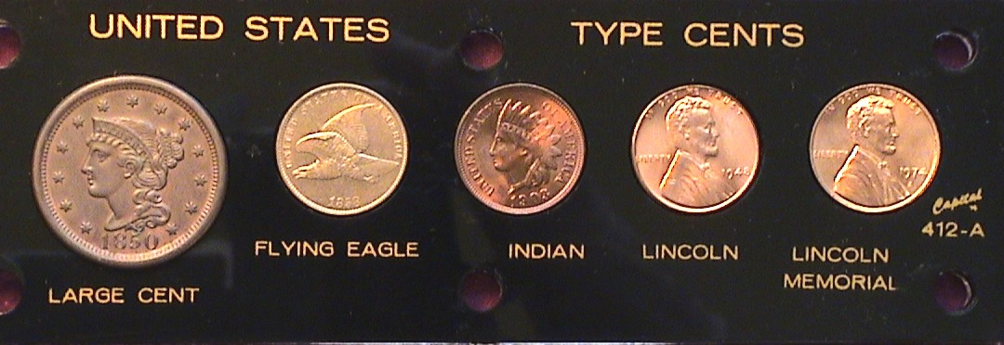

The same cent types now shown in the Capital holder
1850 lg. 1¢, 1858 FE 1¢, 1903 Ind. 1¢ 1948 & 1974-S Lincoln 1¢s
[Reduced in size to fit in a single column]

Some years ago the Capital Plastics Company began issuing 2” x 6” Lucite holders to house limited type sets. For the cents they chose only one example for the large cent type and just four of the small cent issues; the Flying Eagle, Indian Head, Lincoln Wheat and Memorial reverse sub-types. They even reduced the diameter for the large cent slot from 29 mm to 27.5 mm to conform to the slightly smaller and more common Braided Hair type (1840-1857) because even back then, all the preceding types were far more costly in XF-45 or better.

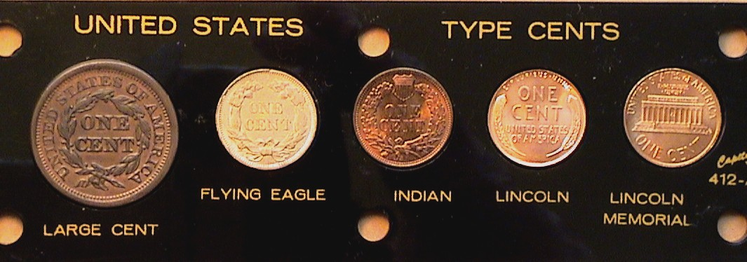

The reverses of the same cent types in the Capital holder
1850 lg. 1¢, 1858 FE 1¢, 1903 Ind. 1¢ 1948 & 1974-S Lincoln 1¢s

Eye appeal is an integral component of displaying one’s collection and each collector eventually has to come to terms with the realities one’s discretionary income imposes on their collecting criteria. Should one opt for quality or rarity, merely filling holes towards the goal of completion?

A complete set of Barber Quarters (1892-1916) would be regarded by most collectors as an impressive achievement but what if the average grade for most dates and mint marked pieces fall within the range of VF-30 to EF-45 while the 1896-S; 1901-S and 1913-S grade only About Good-3. Those three “keys” probably cost more in AG than the all the others combined yet arguably would mar the overall appearance of the set. One has to question whether the enormous cost of the three low-end key date acquisitions were worth the financial stress put on the buyer since none of these keys are actually rare below the grade of VG-10.

Applying the Short Set principle, one can find it easier to avoid this dilemma. While all of the dates shown above in the UNITED STATES TYPE CENTS Lucite holder are common, the quality of the five pieces ranging from AU-50 to MS-65 is high and appear well suited in appearance to each other. One might ask, this is all fine and good, but isn’t the desire for acquiring “rarity” the main reasons people collect coins? The answer is Yes and No! Yes, if you can afford it, No, if you are more interested in the style of the coin’s artwork, the history plus the economic and social conditions at the time these coinage types were made.
In addition to the cent types, Capital Plastics issued Short Set type holders for the nickel, dime, quarter and half dollar; the two last named in 4” x 6” holders.

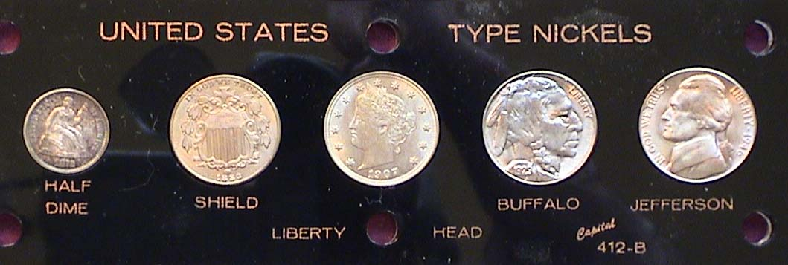

The Capital Holder Mini-Type set for 5¢ coinage

What is particularly interesting about the five cent holder is the first designated type is not a nickel but the silver half dime. As a denomination that was only 16.5 mm in diameter for the early and scarcer series (Flowing Hair thru Draped Bust) and 15.5 for the more common Capped Bust (1829-1837) and Liberty Seated series (1837-1873), the half dime has never enjoyed the popularity of its larger silver counterparts with the result that there are a still a number of bargains out there.

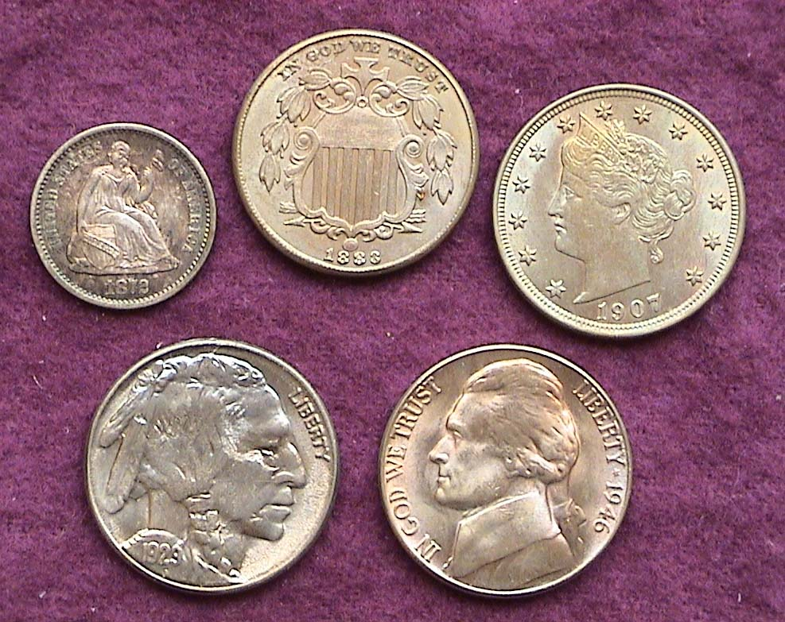

The obverses of the five coins shown actual size removed from the holder
From l to r: top: the 1872-S half dime, 1883 Shield nickel, 1907 Liberty 5¢, Bottom, 1929-S Buffalo nickel and 1946-D 5¢
[Magnify page to 200% to see details.]

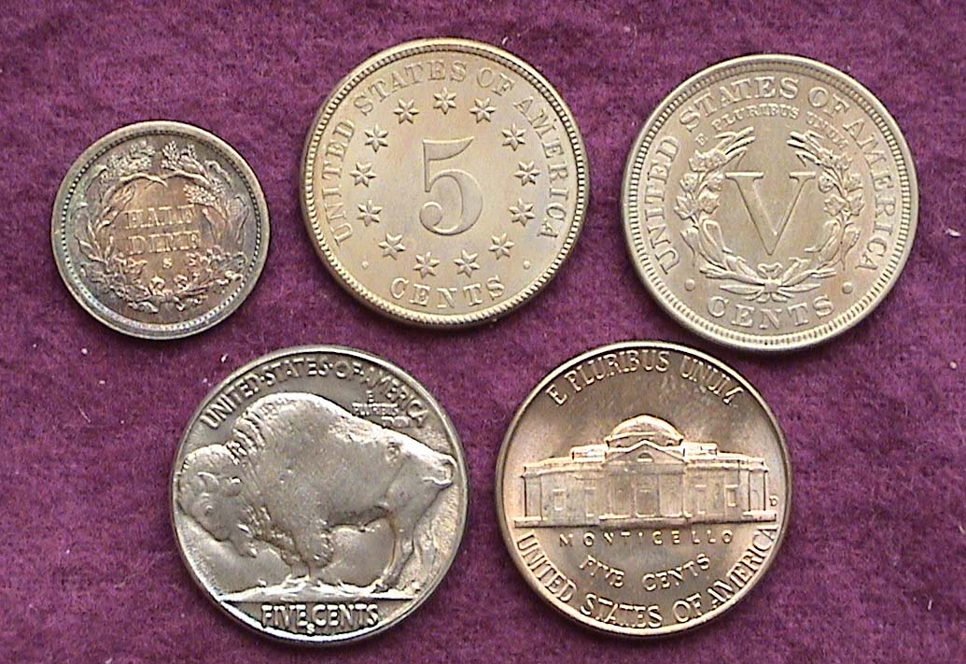

From l to r: top: Reverses of the 1872-S half dime, 1883 Shield nickel, 1907 Liberty 5¢, Bottom, 1929-S Buffalo nickel and 1946-D 5¢

Notice the S Mint mark on the half dime is inside the wreath, not under it. The grades of the three older coins are Choice AU while both the Buffalo and Jefferson nickels are at least MS-63.
The 1929-S Buffalo is not a scarce date but is comes weakly struck as shown. Well struck specimens are scarce however.
_______________________________________________________________________________________________________________________
(Continued on page 3, column 1)
Collecting Short Sets by Type and Denomination
(Continued from page 2, column 2)

For this issue, we will cover one more Short Set that is affordable and can appear attractive despite a greater disparity in the grades. It is the 10¢ denomination.

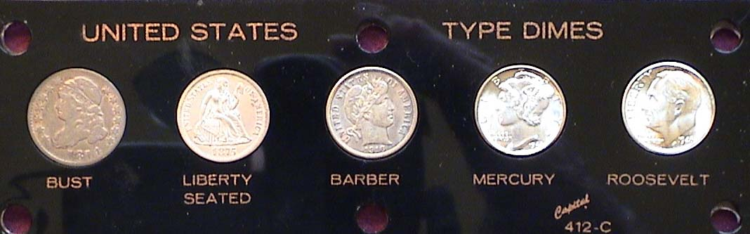

A Short Set Capital Lucite Holder featuring the 10¢ denomination

For the dimes issue, Capital chose to omit the Draped Bust series (1796-1807) due to the rarity of the earlier type. The set begins with the Capped Bust (1809-1837) followed by the Liberty Seated (1837-1891), the Barber Liberty Head (1892-1916), the Winged Liberty [AKA Mercury dime], (1916-1945) and the Roosevelt dime (1946 to date). Removed from the holder and enlarged to actual size one can see the dates and details of type more clearly.

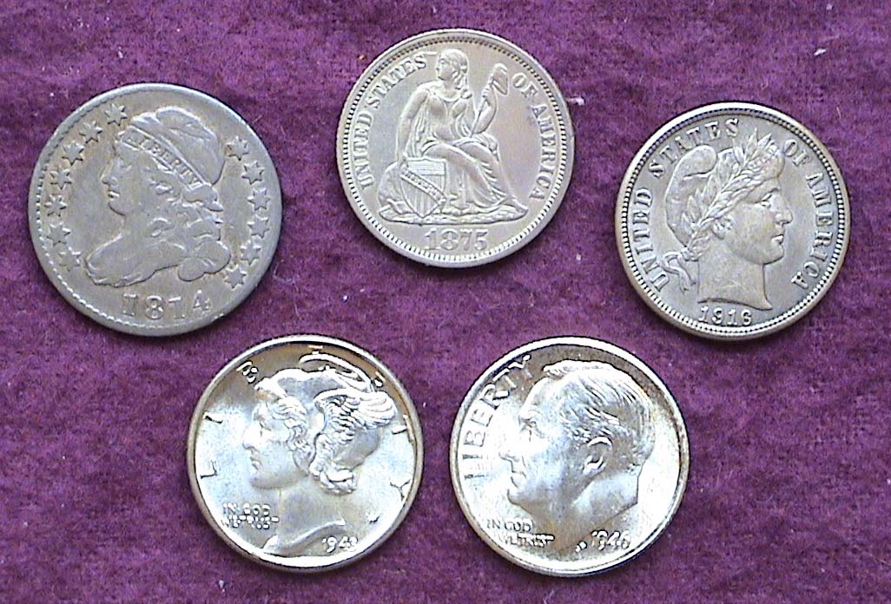

The Short Set of dimes in actual size (obverses) removed from the holder
From l to r: Top row: 1814 Capped Bust, 1875 Lib Std., 1916 Barber,
Bottom row: 1943 Mercury, 1946-S Roosevelt
[Magnify page to 200%, even 500% to view coin features more clearly.]

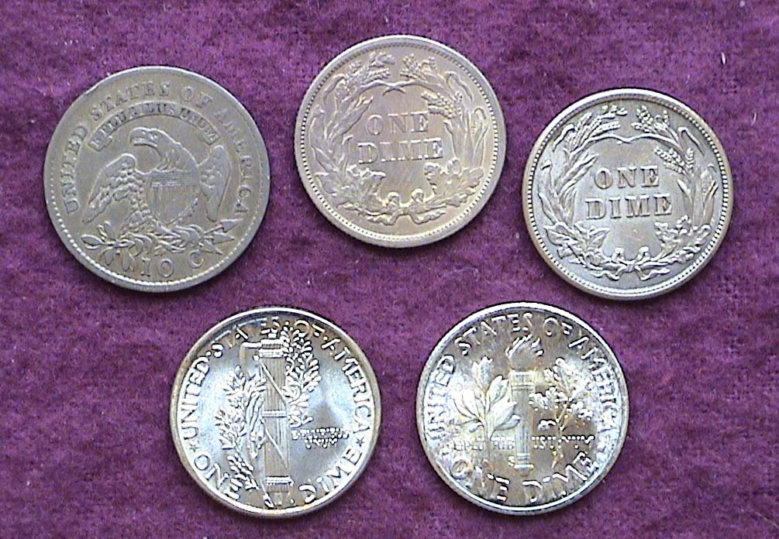

The Short Set of US dimes (reverses) actual size

The lowest grade coin in the set is the 1814 Bust dime. With a reported mintage of 421,500 it is still considered a common date and the large date variety (seen) also happens to be the more common compared with the scarcer small date variety. For years, this series remained underrated and under priced. The other four coins represent common dates as well; the 1875 with 10,350,000 minted is a borderline Unc, the Barber, an AU, the Mercury and Roosevelt both MS-65’s each with fully split bands on the reverse. Despite the 1814 being only a VF, it is original and well struck and blends in with the rest of the set._
____________________________________________________________________________________________________________________
-to be continued-
Share Your Story
By Bill Myers

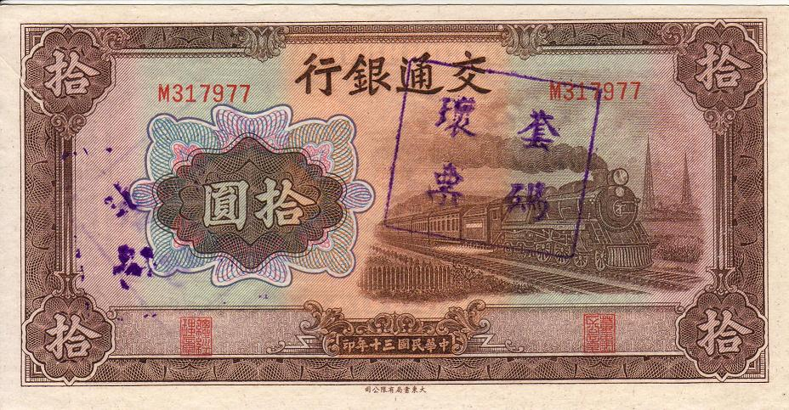

The face of a 1941 Chinese Bank of Communications 10 yuan note

I propose a challenge to the club members. I suggest that you spend a few dollars at the next coin show or at the coin shop you frequent, and buy a coin, note or token that you find of interest but know very little or nothing about. Then research what you purchased and write it up for our club newsletter. I have done it many times, and I find it a rewarding numismatic activity. Here is another example.

I recently came across an uncirculated 1941 Chinese Bank of Communications 10 yuan note. It had a square stamp on the face and back with four oriental characters on it. The note also had a pair of red serial numbers, on both the face and back. There was an interesting vignette of a train on the face. The price of the note, prior to the dealer’s discount of 20%, was $3 – the same amounts many people spend on their daily cup of coffee. I readily acquired the note, as I felt it might have something to do with World War II, an area I am interested in both in general and numismatically.

Counterfeiting the currency of the enemy has long been a tactic of wars, and was utilized in World War II by the Japanese in their east-Asian campaign. Unlike the Germans counterfeiting British notes in Operation Bernard (see book review in Augusta Coin Club Newsletter – February 2007), the Japanese did not have to start from scratch. When they captured Hong Kong in December, 1941 they also captured the Chung Hua Book Company and the Dah Tung Printing Company, which printed bank notes for the Chinese Nationalist Government.
The Japanese obtained the plates, paper, ink and presses, so they were able to make original notes. The captured materials were taken to the Togo Research Office in Tokyo in 1941. 1940 - 10 yuan notes from the Central Bank of China (P228) and the 1941 - 5 yuan (P157) and 10 yuan (P159) notes of the Bank of Communications of China were printed.

In addition, notes and printer’s waste were also liberated at the captured printing plants. The printer’s waste consisted of notes with errors, such as mismatched serial numbers, which prevented them from being released into circulation. These had cancellation stamps put on them to prevent them from being spent. They were worthless, but they were not destroyed, and years later were somehow released into the collector’s market.
__________________________________________________________________________________________________________
(Continued on page 4, column 1)

The note I have is a 10 yuan from the Bank of Communications that has the Chinese cancellation stamp, but matching serial numbers. However, there is a crease in the upper left corner of the note that is actually a fold in the paper that occurred prior to printing. If the paper is pulled open at this crease, there is an unprinted white area. It is probably due to this error that the note was cancelled.
My note was printed by the Chinese in 1941, cancelled due to an error, captured by the Japanese, stored throughout World War II, then released to the collector’s market and, finally, 67 years after its release managed to make its way into my collection.

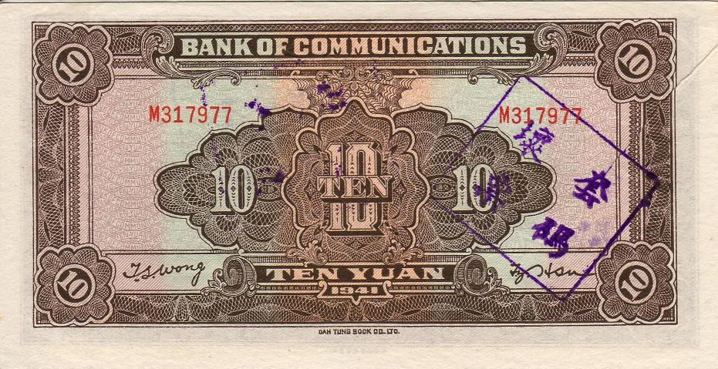

The back of a 1941 Chinese Bank of Communications 10 yuan note

This note is packed with history, but at a small price. What story do you have to share?
____________________________________________________________________________________________________________

REFERENCES:
Schwan, C.F. Boling, J.E. World War II Remembered: History in Your Hands - A Numismatic Study. 1995, p.600.
Personal communications with Joe Boling
Shafer N, Bruce CR. Standard Catalog of World Paper Money General Issues. Volume two. Krause Publications. 9th Ed. 2000. Pg 253
______________________________________________________________________________________________________________

Club News (Continued from page 1, column 1)

President Willie Simon announced at the April 10 meeting that the winners of the perfect attendance record for the 2007-08 fiscal year were Glenn Sanders, Pat James and Jim and Helen Barry. Bill Myers told the members about the upcoming Georgia Numismatic Association and Augusta Coin Club shows; Apr. 18-20 and May 2-3 respectively. There were two Show & Tells, Jim Barry brought in a tetradrachm from Thrace (South eastern Bulgaria and parts of European Turkey today) showing Dionysius, the God of Wine with grape leaves on the obverse and Hercules leaning on his club on the reverse. In conjunction with the year of 2008, Arno Safran brought in another anniversary mini-set, the last year of the Trade dollar intended for circulation here and in the orient, the 1878-S issue and the first year of the popular Morgan dollar series; also 1878-S. Both coins were certified by PCGS-an AU-58 for the 1878-S Trade dollar and an MS-63 PQ for the 1878-S Morgan dollar.

For the program, Bill Myers presented the second part of his two part series, “Numismatics in Iraq”. He described the Iraqi monetary system as 1,000 fils equal to one dinar or (part of a Base 1,000 system) and proceeded to show digital pictures of Iraqi coins from 1975 through 1982 representing denominations of 5, 10, 25, 50, 250 and 500 fils up to the 1 dinar coin of 1981. He also showed pictures of some of the counterfeit specimens alongside the legitimate ones. Bill showed a number of commemorative pieces as well, a dinar struck commemorating the 50th anniversary of the Iraqi Army (1971) and Iraqi Air force (1981). He also showed Amusement tokens, challenge coins and medals including the Bronze Star he received for serving with distinction in the 3rd Medical Command Task Force 3 Desert medics.
This was another great program and again, our Congratulations, Bill!

The winner of the Door prize at the Apr. 10 meeting was Marjorie Simons. Pat James won the 50/50. To both these charming women and charter members of our club we offer our congratulations.

Our next meeting is Thursday, May 8 when Wayne Damron, proprietor of Clein’s Rare Coins in Augusta will be the featured speaker. His topic will be, “The Roman Coinage of the Twelve Caesars” with emphasis on the sestersius denomination; the ancestors of the copper British half penny and the US large cent. You won’t want to miss this one.
___________________________________________________________________________________________________________________________

Kindly Patronize Our Advertisers

