Pres. Steve Kuhl
V .P. James Barry
Sec. Helen Barry
Treas. Sharon Smoot
Sgt. in Arms: Glenn Sanders
The Stephen James
CSRA Coin Club of Aiken
P.O. Box 11
New Ellenton, SC 29809
Web site: www.sjcsracc.org
The SJ CSRA CC meets on the 2nd Thursday of the Month at the Cedar Creek Community Center in Aiken, SC

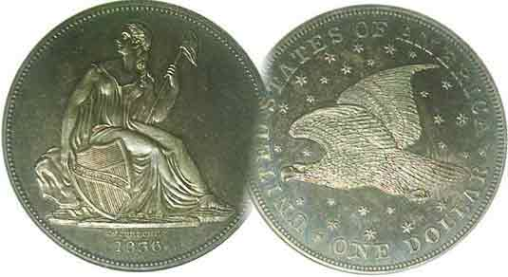
Committees:
Programs: James Barry
Show Chairs: The Barry’s
Newsletter: Arno Safran
E-Mail: arnosafran@comcast.net
Auctioneer: Glenn Sanders

2009 Club Meeting Schedule
Volume 8, Number 5 the Stephen James CSRA Coin Club, Founded in 2001 May, 2009
Monthly Newsletter
Augusta Coin Club Show – May 8 & 9
Bill Fivaz to speak at May 14 Meeting
Our next meeting is Thursday, May 14, 2009 from 6:15 to 9:00 PM
Jan. 5 Apr. 9 July 9 Oct. 8
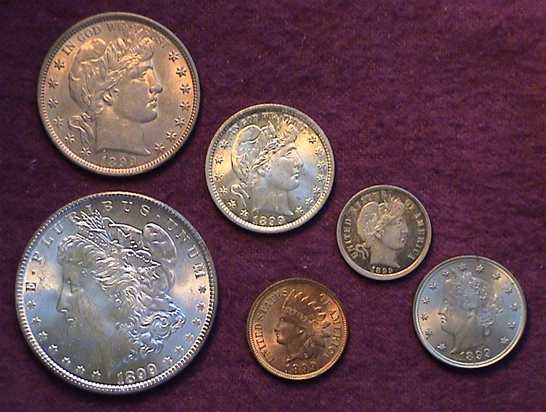
Feb. 12 May 14 Aug. 13 Nov. 12
Mar. 12 Jun. 11 Sep. 10 Dec. 3
_ ___________________________________________________________________________________________

Augusta Coin Club to hold Show May 8 & 9

The newsletter is being sent out a week earlier to remind members that our sister club to the west will be holding its annual spring coin show at the Belair Conference Center this coming Friday and Saturday, May 8 & 9 between 9 AM to 5 PM both days. Admission is free and there is ample free parking at the site. The Conference center is located off Belair Road behind the Waffle House and the Hampton Inn, one traffic light beyond Interchange 194 of I-20 driving in the direction of Fort Gordon. As of this edition, the show is a virtual sell-out with almost all fifty tables sold. For further information, contact David Chism by E-Mail: dcchism@att.net or call 706-541-4143.

For our upcoming May 14 meeting, VP and Programs Chairman Jim Barry has arranged to have renowned former ANA governor and noted numismatist Bill Fivaz speak before members of our club. Bill, an Atlanta area coin collector, writer and speaker is an error coins specialist and with J.T. Stanton from Savannah, has coauthored the error coin collectors’ bible, The Cherry Picker’s Guide… now in its fourth edition. Bill’s topic for the evening will be “Counterfeits”. You will not want to miss this program.

Meeting News: As the April 9 meeting of the SJ CSRA CC fell during Master’s Week, the schools were out and many families took the opportunity to take a little R & R. Included in that number was our new club President Steve Kuhl, so VP Jim Barry presided. Our new Treasurer Sharon Smoot reported a club balance of $914.53. Secretary Helen Barry mentioned that 2009-10 dues are now due, $10.00, adults & $5.00, (juniors under 18). Please remit payable to the SJ CSRA Coin Club (or Sharon Smoot) and send to PO Box 11, New Ellenton, SC 29809 before June 30 and thanks in advance.
________________________________________________________________________________________________________________________
(Club News continues on page 4, column 2)
Collecting US Year Sets: Part I, the Coins of 1899
By Arno Safran
The obverses of an 1899 Year set [Magnify to 200%]

Many a numismatist became a coin collector upon receiving a birth year coin set from a loving aunt, uncle or grandparent. When my older son got married some years ago, in addition to the wedding present for the bride and groom, I presented him along with his three siblings a set of proof coins representing the year of their birth. The more modern year sets can be assembled from government packaged uncirculated sets or proof sets. From 1965 on, most of these are inexpensive. In fact, some of these sets going back to 1957, which feature three silver coins including the long obsolete Franklin half, are still relatively “cheap” in both proof or in uncirculated condition. For older US year sets, one may have to seek circulated specimens due to lower survival rates. The V nickel and Barber half in the 1899 set shown are both AU’s but still attractive.
____________________________________________________________________________________________________________________________
(Continued on page 2, column 1)
Collecting Year Sets I: The Coins of 1899
(Continued from page 1, column 2)
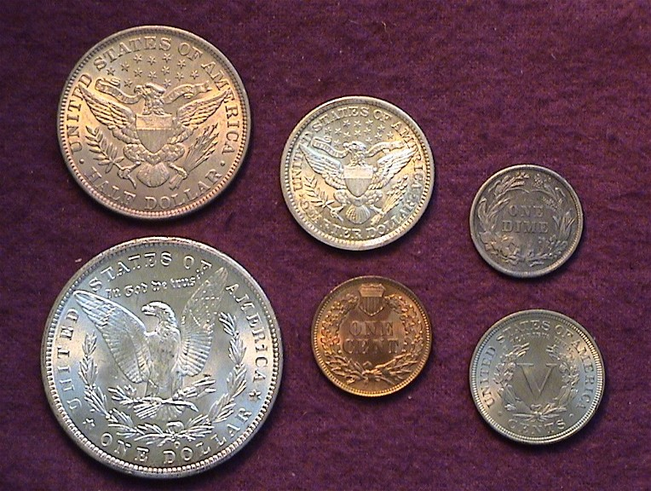

The reverses of an 1899 Year set. [Magnify to 200% to see details.]
The Morgan dollar was struck at the New Orleans Mint.

I started collecting in 1976, our bicentennial year and like many neophytes, I began by assembling modern year sets in uncirculated condition going back in time towards my youth. Since I grew up during the “WWII” years I was pleasantly surprised to discover as late as the 1980’s, most dates and Mints were still relatively affordable in MS-63 to MS-64 condition and many are still comparatively inexpensive today.

Beginning in 1934, during the heart of the Great Depression, dealers began putting away rolls of uncirculated coins with the result that most of the P Mint issues--usually struck in the largest numbers--are still modestly priced in mint state. Moving into the early 1930’s and further back in time, through the 1920’s and teens, assembling a year set of uncirculated coins--even from the most common mints--can be very costly. One solution was to select Choice XF to AU items.

I have always enjoyed collecting decade anniversaries based on the current year. This being 2009, one could highlight dates of significance ending in nine. Around the turn of the previous century I was delighted to discover that the coins struck at the Philadelphia Mint for the most part were coined in prodigious numbers with enough AU to BU survivors still available at affordable prices within budget over time. This was true not only for 1900 but for the immediate years following and preceding. Thus we come to 1899, a group of six coins (excluding gold) that was produced eleven decades ago.

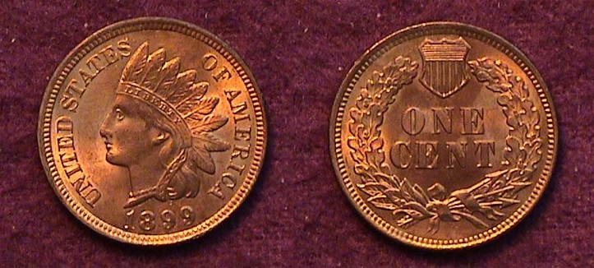

An 1899 Indian Head cent grading MS-65 Red
53,598,000 were struck [Magnify up to 200%]
With a few exceptions most Indian Head cents dated from 1880 on are considered common and moderately priced up through MS-63 and the 1899 cent with a mintage of over 53,500,000 is one of them. Back in 1987, you could still find a nice MS-65 Red specimen for around $30.00. Indian cents have increased in value quite a lot since then. Today it is advisable to look for a certified specimen graded Red-Brown to full Red. That said, even a well struck Brown MS-64 may be considered a “best buy” in today’s market.

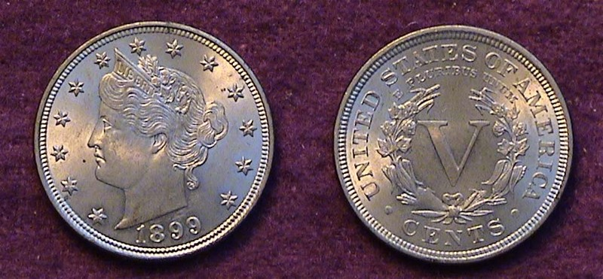

An 1899 Liberty nickel graded AU-58.
The mintage was 26,027,000. [Magnify to 200%]

Like the Indian Head cent, the 5¢ Liberty “V” nickel is generally considered to be a common coin type with most dates priced inexpensively; the exceptions being such key dates as the 1885, 1886, 1912 D and 1912 S issues. The 1899 with a mintage of over 26 million is easily affordable in AU up through MS-63. The AU example shown cost $40 when it was acquired in 1990. Today, the Coin Dealer Newsletter’s Monthly Supplement lists an AU-50 at only $47.00, a MS-60 at $70.00 and just $110 for a MS-63. While these are wholesale figures, one could hardly call my original purchase a good investment. My purpose then was to form a year set having eye appeal at very little cost which represented a portal to my grandparents’ era as newlyweds. Rarity was not a priority.

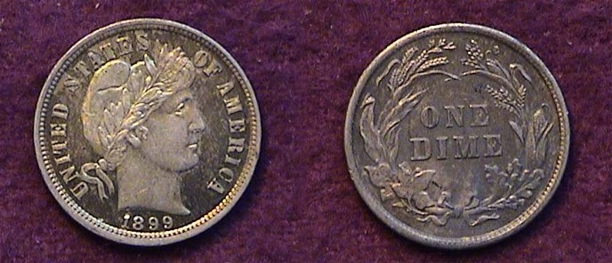.

An 1899 Barber dime grading MS-63 Proof-Like [Magnify to 200%]

In 1997, I realized I had not yet found a suitable 1899-P dime to match some of the other denominations for the date. At a major show scheduled for the huge Baltimore Convention Center that year, I was pretty sure that I would be able to find a choice MS-63 or 64 which was in my price range. I wasn’t on the bourse floor ten minutes when I came across a blazing uncirculated gem. It was certified MS-67 by PCGS. Out of curiosity I inquired what the dealer wanted and he calmly replied, $2,500. I couldn’t believe it as the 1899 Barber dime, with a mintage of 19,580,000, was considered an extremely common date. At that time the rare 1802 Draped Bust dime with a reported mintage of just 10,975 was valued at the same figure, $2,500 in the still appealing grade of VF-20. I had never been a fan of grade rarity and so, continued looking. A couple of hours later I came across a proof-like 1899 Barber dime graded MS-63 for $125. The coin was no blazer but it had reflectivity and looked attractive and blended in with the others in the set. Back in 1899 a dime had the purchasing power of $2.65.
____________________________________________________________________________________________________________________
(Continued on page 3, column 1)
Collecting Year Sets I: The Coins of 1899
(Continued from page 2, column 2)

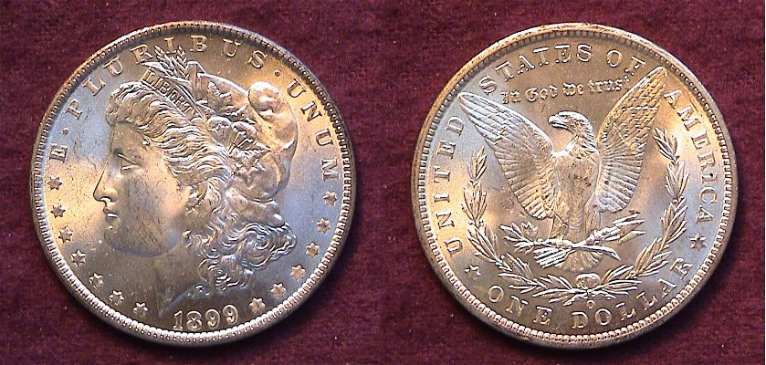
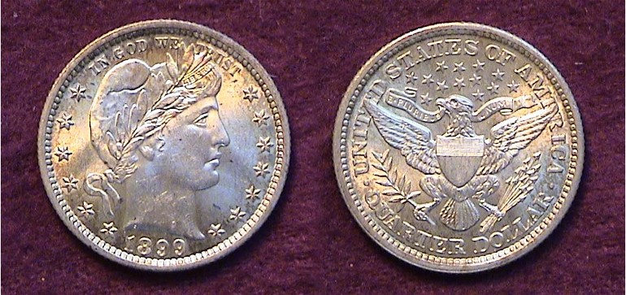

An 1899-P Barber Liberty Head quarter graded MS-62
The mintage was 12,624,000 [Magnify to 200%]

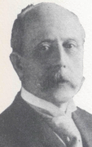
With the 1899 25¢ coin we come to the first of the three “big” denominations of this year set. Ridiculed and berated by later numismatists and politicos as lacking artistic imagination in his designs, Charles E. Barber in 1899, was in the midst of his tenure as Chief Engraver of the US Mint in Philadelphia and had four of his design types then in circulation; the Liberty nickel (since 1883), the Liberty Head dime, the quarter and half dollar (all since 1892). He was also the designer of the commemorative Columbian Exposition half dollar (1892 & 1893) and Isabella quarter (1893). Charles E. Barber

With over 12.6 million quarters struck at the Philadelphia Mint in 1899, a collector should have no trouble picking up an attractive specimen within a grade range of VF-30 up through MS-63 depending on your budget.

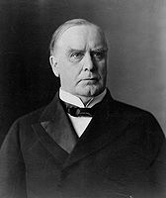
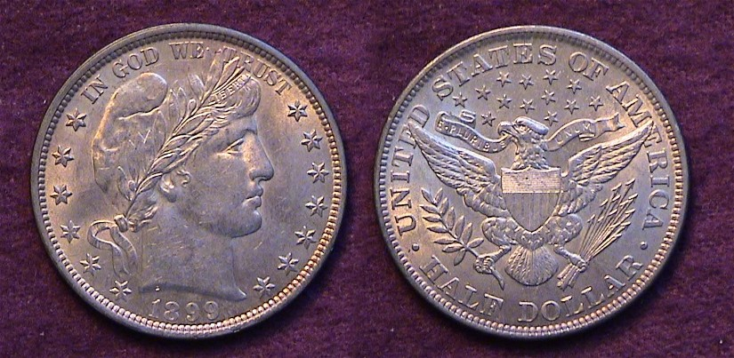

An 1899-P Barber Half dollar grading AU-58
The mintage was 5,538,000 for the Philadelphia Mint issue
representing the high water mark of the entire 73 coin series.
[Magnify to 200% to see details.]

Despite what former critics have said about Barber’s designs, the Barber half dollar has enjoyed an ardent collector base during the past sixty years. When the majority of these coins were minted, the average laborer’s weekly wages were disproportionately lower compared with later generations. Fortunately, so were prices, but as a result, a smaller number of mint state fifty-cent pieces were removed from circulation because its purchasing power at the turn of the 19th Century into the 20th was enormous; around $13.25. At 24 years of age, Grandfather received around $5.00 a week in wages and needed that fifty-cent piece for basic goods. Despite a record 5.5 million P Mint halves struck in 1899, an MS-63 is priced at $800 today with an AU, listed at $300. XF’s are hard to find but a VF-30 specimen should sell for around $100 and is still attractive.
The final denomination; the Morgan dollar is the most popular yet the least expensive in mint state of all the others in the set. That’s if the collector opts for the 1899 New Orleans Mint issue with 12,290,000 struck as opposed to only 330,000 for the much scarcer 1899-P issue. The 1899-S has a mintage of over 2.5 million but is even rarer in mint state than the 1899-P. Back in 1899, a dollar had the purchasing power of $26.50.

This 1899-O Morgan dollar was certified MS-63 PQ by PCGS
but only cost $23.00 back in the late 1990’s.

In 1999, one hundred years after it was minted a certified 1899-O Morgan dollar could be acquired for as little as $23 in MS-63 condition. Today it would be closer to $40.00; still a good value.

The four 1899 gold denominations (the $2.50, $5.00, $10.00 & $20.00) are also represented by common dates with only the $2.50 quarter eagle showing a low mintage, although still priced as a common date. The problem for a collector of modest means is not just dealing with the increased bullion value of gold during the past three years but with the frenzied activity of gold buyers in this current market that has raised the prices of generic gold type coins to unprecedented heights.
______________________________________________________________________________________________________________________________

In 1899 William McKinley, fresh from the successful campaign against Spain in the Spanish-American War of the previous year, was in the third year of his first term as 25th president of the United States. The former Governor of Ohio along with VP Garret Hobart of NJ had defeated William Jennings Bryan 23 states to 22 in the Electoral College three years earlier.
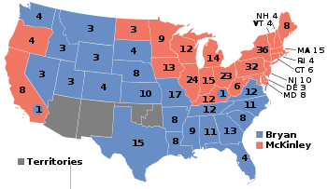

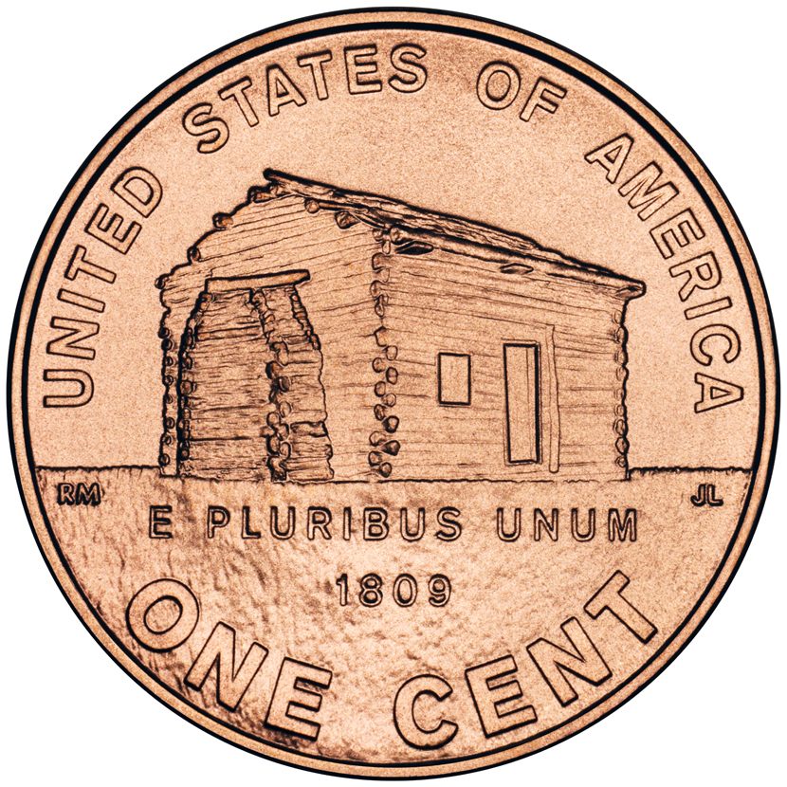
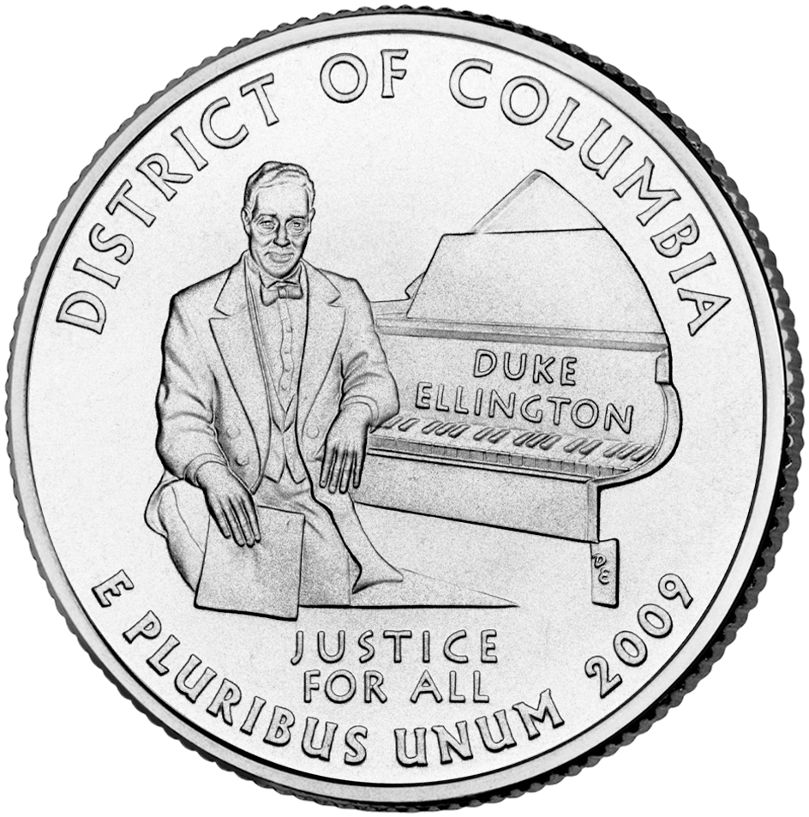
2009 A Year for Rarities?
By Eric Knapp

If you are like me, you have probably been to a number of banks these past couple of months looking for the new Lincoln Cents and U.S. Territories Quarters. You have probably also gotten the same response I have to your inquiries: “We won’t be ordering any of these new coins.” or “We don’t know when or if we will be getting them.” Explanations typically turn to the fact that there are too many older coins in circulation so the banks see no need to order anything new. These banks are seeing a steady supply coming in their doors from local businesses and customers. Local banks also usually get all of their coin orders through a regional branch, so they have even less control over the type of coins they can order. If their regional branch isn’t specifically ordering the new 2009 coins, there is no guarantee that they will receive them.

Recent reports have shown that the first 2 coins in the Territories Quarter series have had the lowest mintages out of all of the State Quarter issues - by far. In fact the 172,400,000 for D.C. and 139,200,000 for Puerto Rico COMBINED are less than the lowest issue of the Statehood series (Oklahoma at 416,600,000).

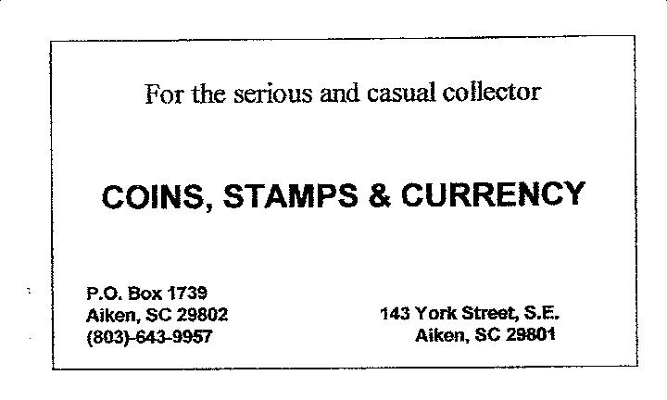
The Mint also just announced last week that they will halt production of the nickel and dime for 2009. Through the end of March, the Mint reports a total coinage of 69.36 million nickels and 120 million dimes. These figures are just a little over 10% of the mintages of these coins in 2008. Even more staggering is the comparison to 2007 mintages, when 1,197,840,000 nickels and 2,089,500,000 dimes were coined.

As with 2008, the 2009 Kennedy Half Dollar saw a mintage of only 3.4 million coins. Half Dollar coins are not minted for circulation, but this is still an incredibly low number. Dollar coins for 2009 seem to be holding steady - current mintage figures for 2009 appear to be on target to match or exceed mintage figures for previous years. This should hold true, considering that the Mint has been heavily promoting the use of the dollar coin and there has been no indication of a halt in production yet.

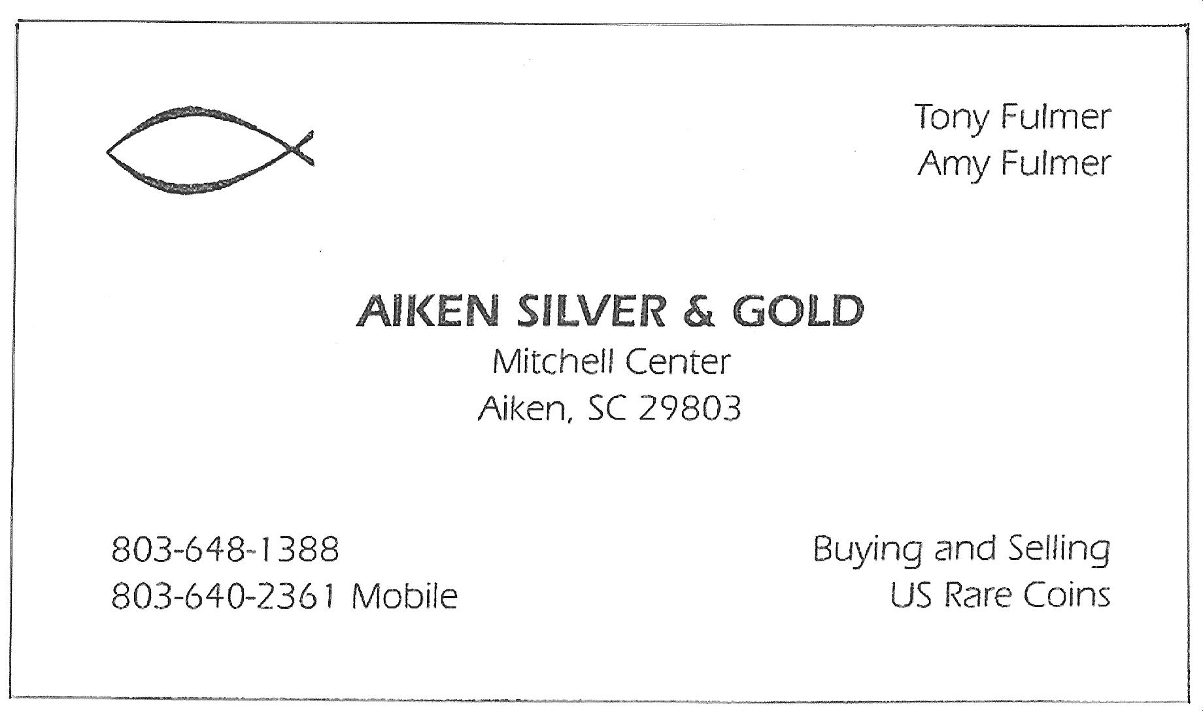
So what does this all mean? Will 2009 coins become key dates for collectors years from now? Of course not, but for the short-term, there may be some profits if you are lucky enough to get a hold of some of these “rarities”. The Mint was selling sets of P and D mint rolls of the log-cabin cents for $8.95 and these have sold out as of this writing. A quick glance at EBay shows sellers getting $2 to $3 PER COIN for the cents and rolls selling for over $6 apiece! Territories Quarter rolls are showing a more modest profit as well. In the long run, these coins will eventually make their way into circulation, but even then they are certain to be hoarded because of their perceived rarity. With mintages in the millions they will never approach the levels of a key date, but this may be as close as we will get to see a “key date” circulating coin in this modern era.
__________________________________________________________________________________________________________
Eric Knapp is editor of the Hills Numismatist, monthly newsletter of the Watchung Hills Coin Club in Watchung, NJ, (Ed.)
More club News
(Continued from page 1, column 1)

At the April 9 meeting there were three Show & Tells. Jim Barry displayed a Tetradrachm of Demetrius issued between 306 and 283 BC showing Victory on the obverse and Poseidon with trident on the reverse. Recently joined member Howard Hillman discussed the transition of hammered to milled silver coins and displayed a German thaler ca. 1620 of Munster berg. Arno Safran, in anticipation of guest speaker Tony Chibbaro program on Odd shaped tokens, brought in a slightly curved square shaped copper token reminiscent our early B&W TV’s showing a large 4 commemorating the 20th anniversary (1953-1973) of Greenville, SC’s WFBC (AKA Channel 4 ).

Our guest speaker was Tony Chibbaro and he provided another one of his phenomenal talks via PowerPoint; this time on a wide variety of odd shaped tokens. These included the following geometric types: triangular, square, rectangular, pentagon, hexagon, and octagon; also diamond shaped, scalloped, notched edge, acorn shaped, half moon and crescent moon shaped. Tony’s talks describe why he is such a superb numismatist. He is focused. While others accumulate, Tony assembles sets that are both historically important within logical categories of interest and aesthetically arresting to the eye.

At the April 9 meeting the two prize winners were Jerry Axner who won the silver eagle door prize and Glenn Sanders who took the 50/50 - $15.00. Congratulations Jerry and Glenn. Don’t forget the ACC Show May 8 & 9. Our next meeting is May 14. Look forward to seeing you there!
___________________________________________________________________________________________________________________

Kindly Patronize Our Advertisers

