Pres. Steve Kuhl
V .P. Arno Safran
Sec. Jim Mullaney
Treas. Sharon Smoot
Sgt. in Arms: Glenn Sanders
The Stephen James
CSRA Coin Club of Aiken
P.O. Box 11
New Ellenton, SC 29809
Web site: www.sjcsracc.org
The SJ CSRA CC of Aiken, SC meets on the 1st Thursday of the month at the Aiken Public Library

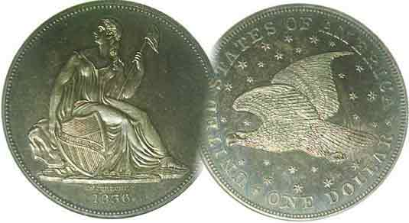
Committees:
Programs: Arno Safran
2010 Show: Jim & Helen Barry
Publicity: Jim Clapp
Newsletter: Arno Safran
E-Mail: arnosafran@comcast.net
Auctioneer: Glenn Sanders

2010 Club Meeting Schedule
Volume 9, Number 5 the Stephen James CSRA Coin Club, Founded in 2001 May, 2010
Monthly Newsletter
Augusta Club to hold Two-Day Show May 7-8
Our next meeting is on Thursday, May 6, 2010 from 6:00 to 8:45 PM

Jan. 7 Apr. 1 July 1 Oct. 7
Feb. 4 May 6 Aug. 5 Nov. 4
Mar. 4 Jun. 3 Sep. 2 Dec. 2

____________________________________________________________________________________________________________

Upcoming Augusta Coin Club Show to take place
at a new Site, Patriot’s Park, May 7 & 8

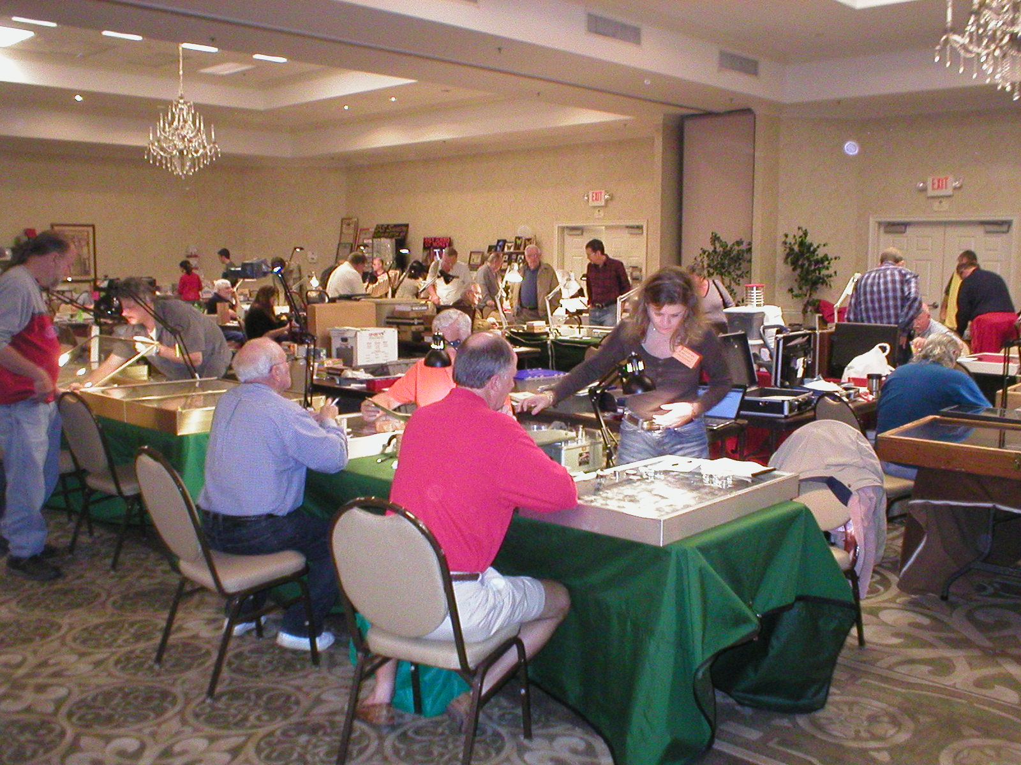

A busy bourse at the Augusta Coin Club Show [Magnify to 200%]

Our next meeting is Thursday, May 6. The very next two days, May 7 and 8, our sister club to the west, the Augusta Coin Club, will be holding their annual spring show; this time at a new site, Patriot’s Park, located near the intersection of Columbia Road and William Few Parkway. Directions from Aiken and environs are simple enough if you take I-20 west across the Savannah River to Interchange 190. Make a right on to Lewiston Road and drive about 1½ miles north to Columbia Road. At the traffic light there, make a left and proceed about two miles. Patriot’s Park will appear on your right. If you come to William Few Parkway, you have driven just beyond it. Hours for the show are 9 AM to 5 PM both days. There is plenty of parking and admission is free. Fifty or more tables are expected to be sold by the time of the show but since the facility is very large, if any member wishes to take a table for the event, please contact the bourse chairperson David Chism at 4168 Waters Edge Lane, Appling, GA 30802, or by E-mail at dcchism@att.net. You can also reach him by phone at 706-541-4143 or Cell phone (706) 829-5484.
_____________________________________________________________________________________________________________________
(Club News appears on page 4, column 2)

The Origin of Liberty Seated Coinage
By Arno Safran

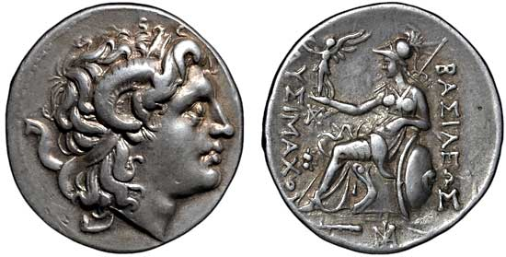

Lysimachos: Kingdom of Thrace silverTetradrachm305-281 BC
Obv. Head of Alexander the Great, Rev; Athena seated holding
Nike (“Victory”) in right hand with left arm on shield [Courtesy Apollo Coins] [Use a 3x glass or magnify to 200% to see details more clearly.]

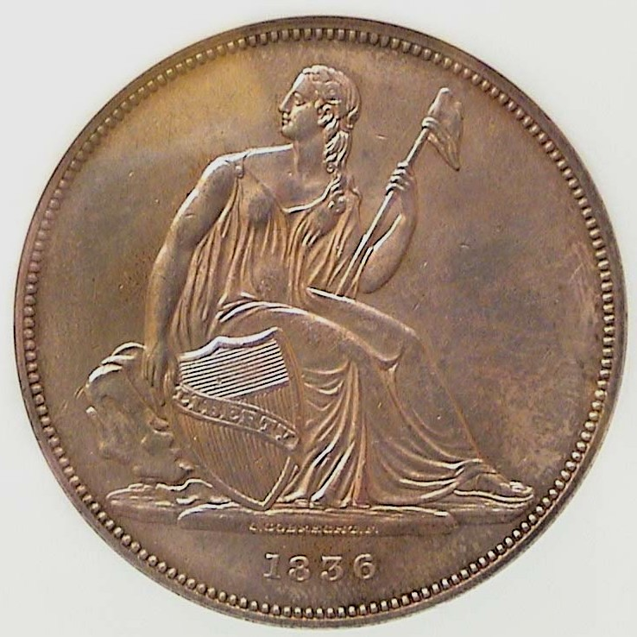
Every summer, the American Numismatic Association holds their World Money Show in a major US city. Back in 1997, the event was held in New York at the Marriott Marquis on West 45th Street just off Broadway’s famed Times Square. Due to the confined space in midtown Manhattan hotels the show had to be held on two floor levels with US coins on the 5th and World coins on the 6th. Looking to add some more Latin American 8 Reales types to my collection, I took the escalator up to the sixth floor on the second day of the show. While there, I came across an extraordinary quarter-sized silver coin. It showed a man’s head facing right on the obverse and a helmeted woman seated on a throne-like chair holding a winged figure in her right hand and a rod in her left with her left arm resting on a shield below. What struck me about the piece was the reverse’s resemblance to the obverse of our US Liberty seated coinage. The dealer explained that this was a Classical Greek tetradrachm from the Macedonian Kingdom of Thrace under the auspices of Lysimachos who ruled that territory between 305 and 281 BC. The dealer concurred that this type was the original ancestor of our Liberty Seated coinage design.
Obv. Of 1836 Gobrecht $1.00
[Use 3 x glasses or magnify to 200%]
____________________________________________________________________________________________________________________
(Continued on page 2, column 1)
Origin of Liberty Seated Coinage
(Continued from page 1, column 2)

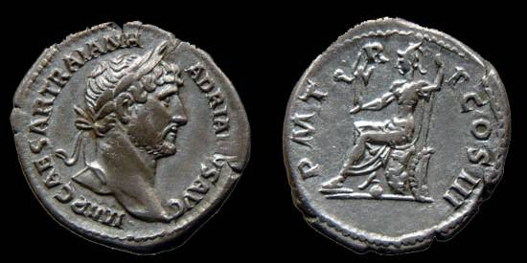

The obv of this Denarius shows Laureate Bust of Hadrian 117-138
The rev. portrays Roma seated on a cuirass facing left
holding Victory and spear with shield behind.
The coin is shown in its actual 18 mm size.
[Use 3 x glasses or magnify first to 200%, then up to 500%]

My personal encounter with the Greek allegorical seated Athena aroused my curiosity further. I assumed that Rome issued coinage similar to the Greek Athena reverse. Indeed there were several. One of the earlier portrayals possibly starts with the Roman Emperor Hadrian, who ruled from 117 to 138 AD; also the Emperor Antoninus Pius (140-44 AD). The Hadrian denarius shown above (a coin about the size of our dime) portrays Roma, (the Goddess of Rome and the empire) seated, wearing a helmet and cuirass, (an armor plated vest). She is seen holding “Victory” (AKA Nike) with a shield behind her throne.

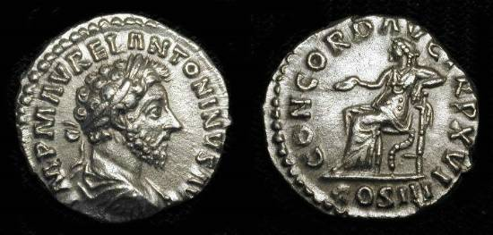

Obv. Marcus Aurelius 161-180 AD Denarius/ Rev. Concordia seated Shown actual 19 mm size [Use 3 x glasses or magnify to 200%]

From the reign of Marcus Aurelius (161-180 AD) is another example of a seated allegorical female on a silver denarius. It shows the Laureate Bust of the emperor at left with Concordia on the reverse. She was the Goddess of agreement, understanding and marital harmony. In art, Concordia was often depicted sitting, wearing a long cloak and holding onto a patera (sacrificial bowl), a cornucopia (symbol of prosperity), or a caduceus (symbol of peace.) She represented the opposite of Discordia, (Eris in Greek), the Goddess of strife, discord and stress.

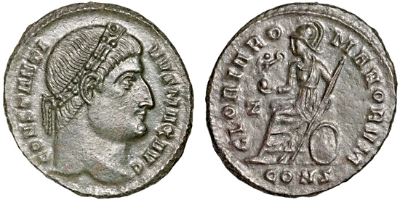

A late Roman copper follis type from Constantine I (307-337 AD)
The reverse shows a helmeted Roma seated left on shield holding a long scepter. Victory is seen on the globe in her right hand.
The coin is 19.8 mm and is shown approximately actual size.
[Use 3 x glasses or magnify first to 200%, then up to 500%]

Some think Anastasias I (491-518 AD) was the first actual Byzantine emperor while others believe Constantine I was because it was he who moved the central government from Rome to Constantinople (Istanbul, Turkey today) in the 4th Century AD. The obverse of the coin shown above portrays the Laureate Bust of Constantine I facing right. The reverse shows Roma fully armed seated and facing left emblematic of nationalistic fervor continuing in the tradition started by the Greeks.
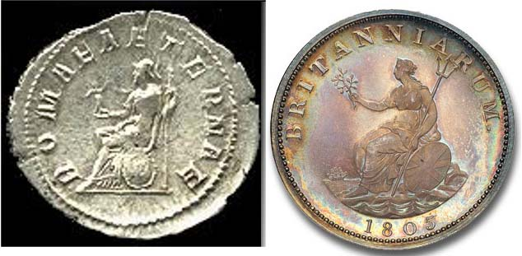

Roma on antoninianus Britannia on 1805 Geo. IIII
Of Gordian III (enlarged) silver Proof ½ penny

It was during the reign of Roman Emperor Claudius I that Britain was finally conquered and occupied by the Romans. Claudius’ son by Messalina was named Britannicus. While the allegorical figure of Britannia is first seen on a Roman coin issued by Hadrian it would not be placed on an English coin until 1762 when it appeared on the copper farthings and half pennies of King Charles II.

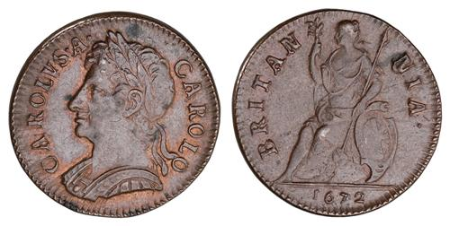

1762 Half Penny of Charles II
The copper coin was 28 to 30 mm in diameter.
[Use 3 x glasses or magnify to 200%]

Over the centuries the depiction of Britannia has changed and improved. Below is a half penny of George III.

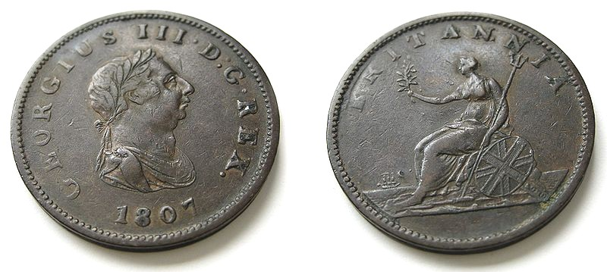
1807 Half Penny of George III, Britannia seated facing left
[Use 3 x glasses or magnify to 200%]

Through the reign of King George III, the representation of Britannia is still seen facing left as shown above.

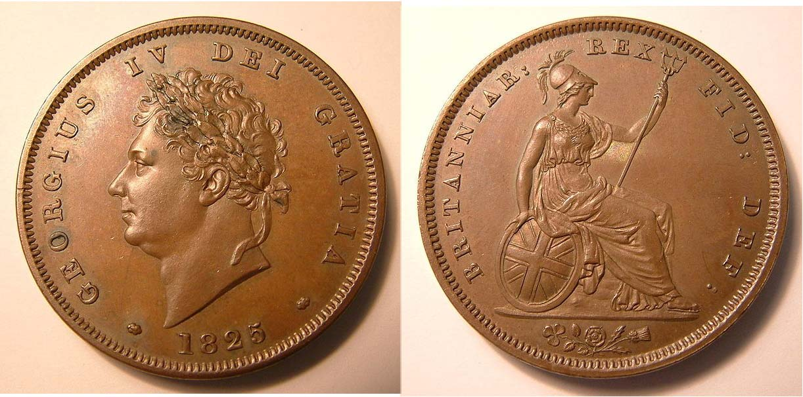

An 1825 Proof Penny of George IV
Showing a more regal Britannia facing right
[All photos, courtesy of Google searches including Wikipedia]
[Use 3 x glasses or magnify to 200%]
_______________________________________________________________________________________
(Continued on page 3, column 1)
Origin of Liberty Seated Coinage
(Continued from page 2, column 2)

This brings us up to 1835, two years before Victoria became Queen of England. United States Mint Director William Maskell Patterson was tired of the old Capped Bust style on our coinage and wanted the central device of the newly proposed dollar coin to be fashioned in the manner of Britannia seen on the British copper penny of then reigning monarch, King George IV. He asked renowned American painter Thomas Sully to come up with a sketch, which is shown below alongside the penny of George IV.

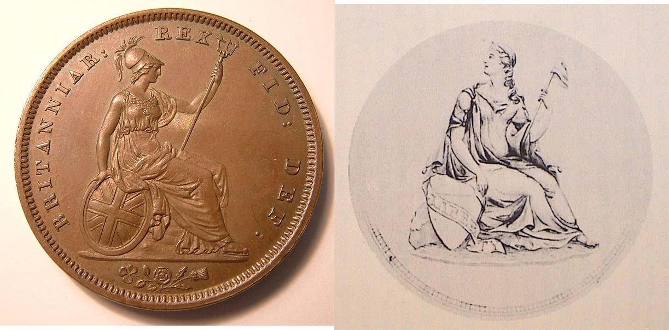

Left: Geo IV Britannia; right: Sully sketch of seated Liberty

In 1836, the new Engraver Christian Gobrecht produced a Liberty Seated dollar with a Soaring Eagle in a sea of stars (based on a sketch by another renowned painter, Titian Peale) that is today regarded as one of our most exquisite coins.
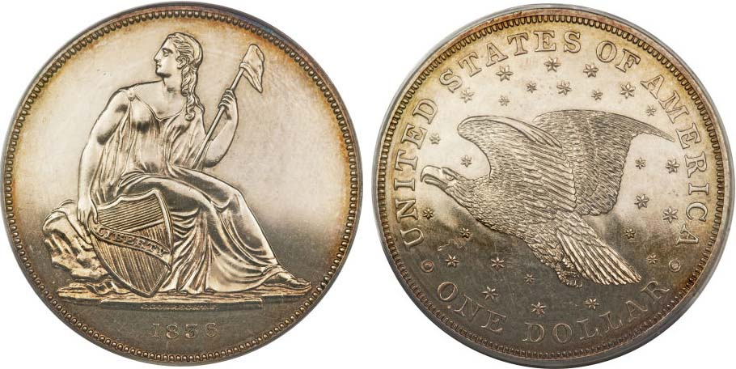

An 1836 Gobrecht $1.00, J-60 original graded Proof-62 by PCGS
[Courtesy of Heritage Auctions Archives]
[Use 3 x glasses or magnify to 200%]

The 1836 Gobrecht Liberty Seated $1.00 coin shown directly above is one of 1,000 proofs struck by the Philadelphia Mint and placed into circulation on December 31, 1836. One recently sold for $21,850 in the Heritage Auction held at the FUN show in January of this year.
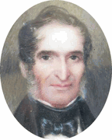
This Liberty obverse design would come to be placed on the obverse of all our silver coins through 1891 although it would be modified considerably over the years it saw service, often not for the best. There are many dates from which the collector can assemble a type set for all denominations.

Christian Gobrecht
_______________________________________________________________________________________________________________________

Examples of Liberty Seated Coinage

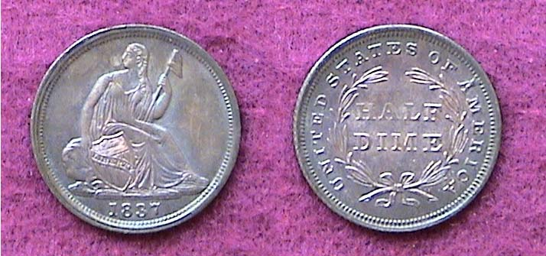

An 1837 Liberty Seated Half dime with no stars grading AU-50
The small 5¢ silver coin was 15.5 mm in diameter.
[Magnify using a 3X glass or up to 500% to see details.]

With Mint state specimens selling for around $22,000 or higher according to the latest auction results, the 1836 Gobrecht dollar is a fairly expensive coin. On the other hand the tiny 1837 half dime boasts the same no stars obverse and is far more affordable ranging from a low of $42 in Good-4 to around $500 in AU-50 according to the 2010 Red Book. While the small size coin is not as magisterial in appearance as the dollar shown on the preceding column this little bauble, if similar to the one shown above, can still appear quite attractive.

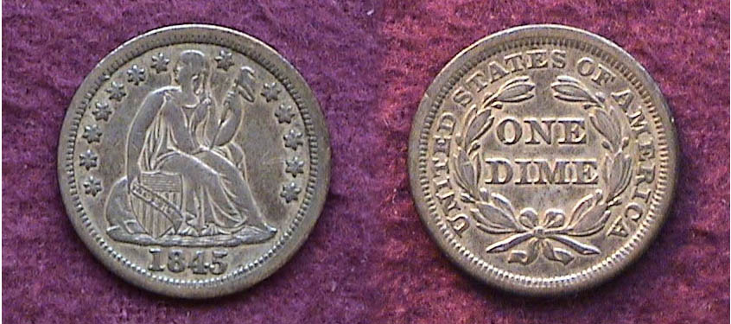

An 1845 Liberty Seated dime with stars and drapery grading VF-30
In 1837 the dime was reduced from 18.5 mm to 17.9 mm in diameter.
[Magnify using a 3X glass or up to 500% to see details.]

By 1845 the Liberty Seated dime had been modified. Thirteen stars were placed around the periphery in 1838 and in 1840 the shield was changed from tilted to an upright position. Drapery was also added to Miss Liberty’s gown under the arm holding the Liberty cap. There are many common dates among the Liberty Seated dime series and the 1845 is one of them as 1,755,000 were struck at the Philadelphia Mint that year. In VF-20 it is listed at just $30; $50 in XF-40, so the coin shown above would probably sell for around $35.00 to $40.00 today.

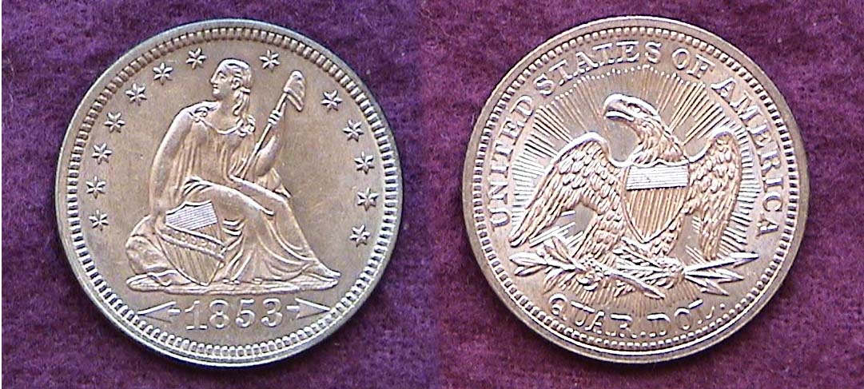

An 1853 Lib. Std. 25¢ with Arrows & Rays grading MS-62.
The quarter has been 24.3 mm (1”) in diameter since 1831.
[Magnify using a 3X glass or up to 200% to see details.]

With the discovery of gold at Sutter Mill near Sacramento, CA in 1848 and the subsequent gold rush, the value of silver rose in relation to gold causing speculators to remove silver coinage from circulation. To remedy this, the Government authorized a reduction of the silver weight in all silver denominations except the dollar coin. Arrows and rays were placed on the quarters and half dollars issued in 1853 denoting the change. More than 15 million 1853 arrows and rays quarters were produced for circulation that year. The date has always been popular with collectors elevating the prices in AU to BU.
_________________________________________________________________________________________________________________________
(Continued on next page, column 1)
More Examples of Liberty Seated Coinage
(Continued from preceding page)

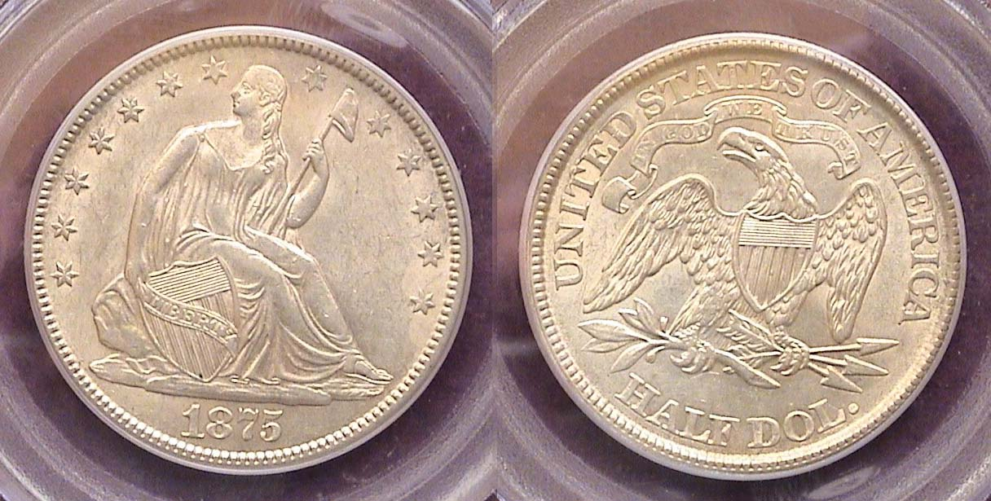

An 1875 Liberty Seated Half Dollar with motto on reverse
The coin was graded AU-58 by PCGS
The diameter was 30,6 mm, same as now.
[Magnify using a 3X glass or up to 200% to see details.]

With over 6 million 1875 half dollars struck at the Philadelphia Mint this is one of the more common dates of the with motto portion of the Liberty Seated half dollar series. The motto, IN GOD WE TRUST was added to the reverse on the quarter, half dollar and silver dollar in 1866. XF to AU specimens are still relatively affordable.

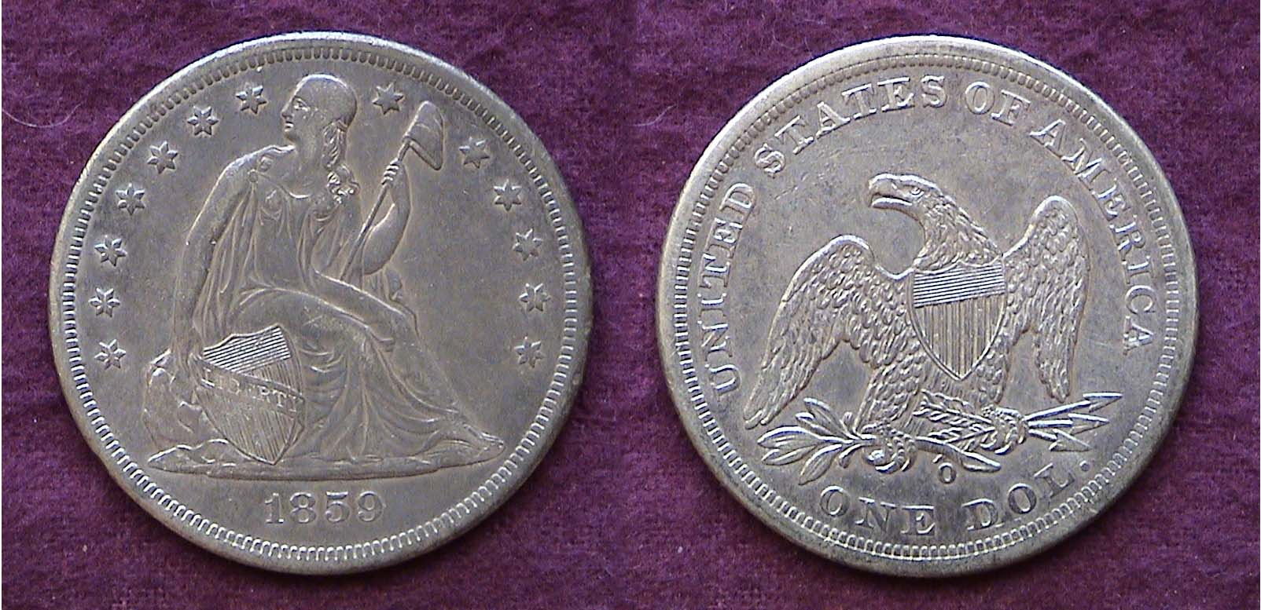

An 1859-O Liberty Seated no motto silver dollar grading XF-45
360,000 were minted. The diameter was 38.1 mm
Magnify using a 3X glass or up to 200% to see details.]

The Liberty Seated dollar was modified extensively between 1836 and 1840; the first three years by Gobrecht himself. Sometime during 1839-40 Robert Ball Hughes was brought into the Mint to “improve” Gobrecht’s design. Hughes thickened Miss Liberty’s torso and head on the obverse that now had thirteen stars placed along the rim. As for the reverse, it is not known why Mint Director Patterson decided to replace Gobrecht’s magnificent rendition of renowned painter Titian Peale’s soaring eagle with John Reich’s pterodactyl-looking version of the spread eagle used on the previous Capped Bust silver type. By 1840 Gobrecht’s masterful Liberty Seated dollar creation had been completely emasculated.

During its 34 year run (1840-1873), the Liberty Seated dollar was struck only four times at the New Orleans Mint, in 1846, 1850, 1859 and 1860. With 360,000 coined there in 1859, the ‘59-O is one of the more common dates of the entire series and is among the least expensive in XF-40 thru MS-60.

Two other Liberty Seated types were issued later in the 19th century; the Trade dollar (1873-1885) and the 20¢ piece (1875-1878), both designed by William Barber (Chief engraver from 1869 to 1879). These will be the subject for another article.
__________________________________________________________________________________________________________________________
More Club News

Xavier Pique presents PP presentation on
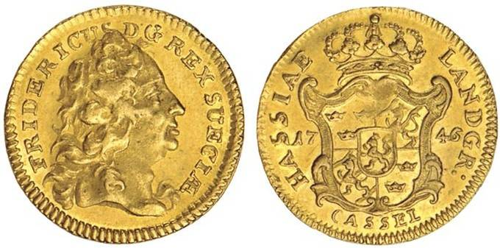
18th Century Gold Coins and Weights

A 1746 Ducat of Germany
[Magnify using a 3X glass or up to 200% to see details.]

At the April 1 meeting, guest speaker Xavier Pique presented a PowerPoint program illustrating the various gold coin types produced in Europe during the 18th Century along with the many different kinds of scales and weights sets that were manufactured to assay these issues. The first part of Xavier’s presentation was filled with gorgeous photographs of the many magnificent gold coins and denominations that were struck in Great Britain, France, the German States, Holland, Russia, Hungary, Spain and Portugal while the second portion included pictures of the different kinds of coin weights and scales manufactured during the period. A large number of these coin weights and scales were portable and could be carried in small cases by those merchants who were paid in gold coin for their products. The speaker provided facsimiles of the kinds of spreadsheets that assayers used to adjudicate transactions. This was speaker Pique’s fourth program before members of the Stephen James CSRA Coin Club, all of which have been scholarly researched and entertaining.

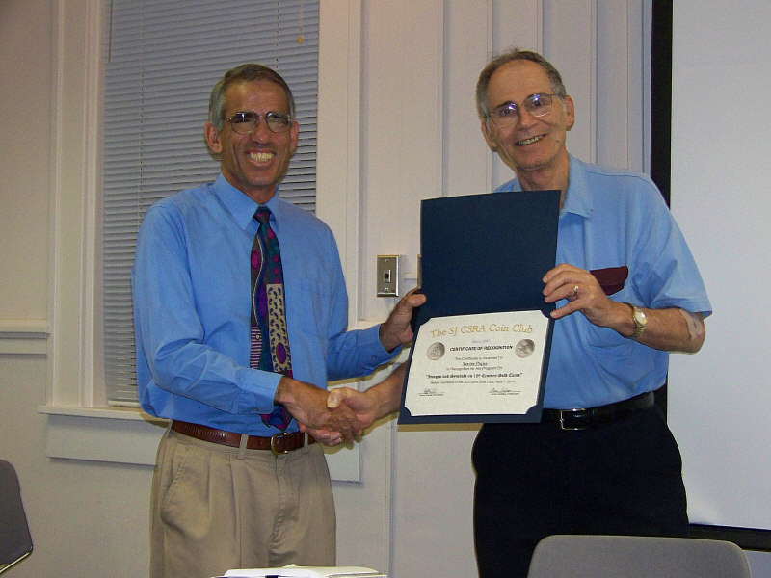

Guest Speaker Xavier Pique receiving
Appreciation Award from VP Arno Safran
Photo taken by Jim Mullaney, courtesy of Helen Barry

In other Club News Sgt. in Arms Glenn Sanders reported that 22 members had signed in. There were also a number of guests. Of these, John Meinhart and Richard Owens joined on the spot. Welcome, John and Rick. Treasurer Sharon Smoot reported a balance of $760.21. Thank you, Sharon. This serves as a reminder that dues of $10.00 are due for the 2010-11 fiscal year for those who have not as yet paid. We do not wish to lose any member in good standing so please remit by the June 3 meeting to avoid being removed from the membership rolls.
____________________________________________________________________________________________________________________________
(More Club News continued on page 5, column 1)

Show & Tells

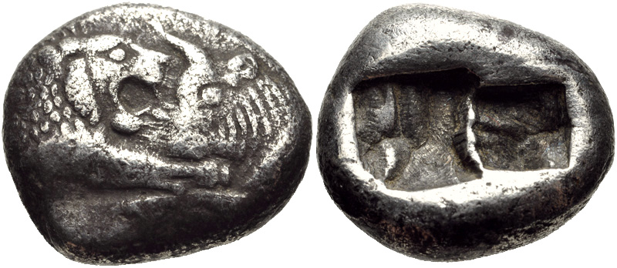

AR Siglos or ½ Stater 545-520 BC, Lydia, Sardes Mint
[Magnify using a 3X glass or up to 200% to see details.]

Jim Barry brought in a half stater struck in Lydia for the Emperor Croesus (pronounced Creesus) who ruled from 560 to 546 BC five centuries before Julius Caesar. The small sized coin was around 15 mm and depicted a lion and bull facing each other. Jim explained that the lion symbolized strength and power while the bull represented fertility. The reverse shows two heavy punch marks.

Arno Safran followed Jim’s display with a 1920-P Year set that after only ninety years must be considered downright contemporary in comparison. While most US coins produced during the 1920’s are expensive, especially in BU condition, 1920 Philadelphia mintages were large and today are more affordable than any other year or branch mint during the decade. The set was formed between 1979 and 1983 well before third party certification and housed in a Lucite holder.

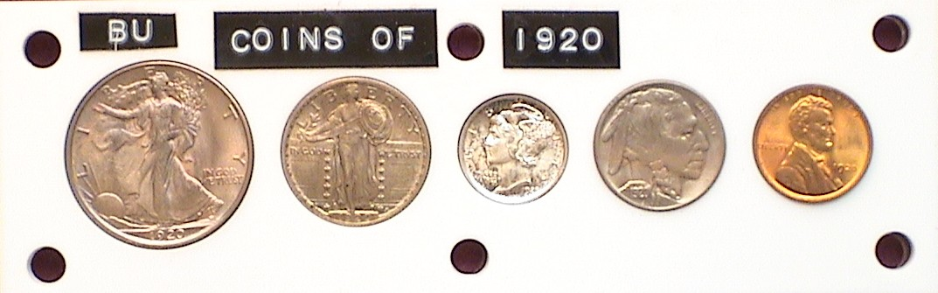
A 1920-P BU Year Set in a Capital Lucite holder, [reduced in size].
[Magnify using a 3X glass or up to 200% to see details.]
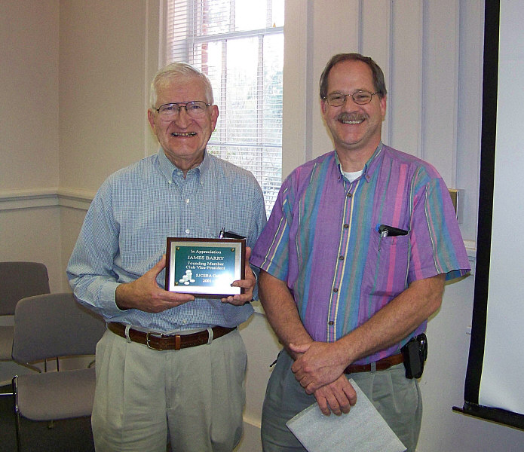
In other club news President Steve Kuhl (on the right) presented Jim Barry (at the left) with an honorary Plaque of appreciation for his decade long service to the club as Vice President, Director of Programs and Bourse co-chairperson for our annual coin show.

The Prize winners at the April 1 meeting were Paul Simons who won the silver eagle attendance drawing and Young Numismatist Austin Kuhl who added $22.00 to his coin collecting budget, winning the 50/50 drawing. Congratulations Paul and Austin!
Our next meeting is scheduled for Thursday evening, May 6 beginning 6:45 PM sharp at the Aiken Public Library. Early arrivals may gather at 6:00 PM. Bring in some numismatic Show & Tells to share with your fellow members. The program will be a PowerPoint presentation featuring some of the women who posed as Miss Liberty on United States coinage. Hope to see you there.
______________________________________________________________________________________________________________________

Kindly Patronize our Advertisers

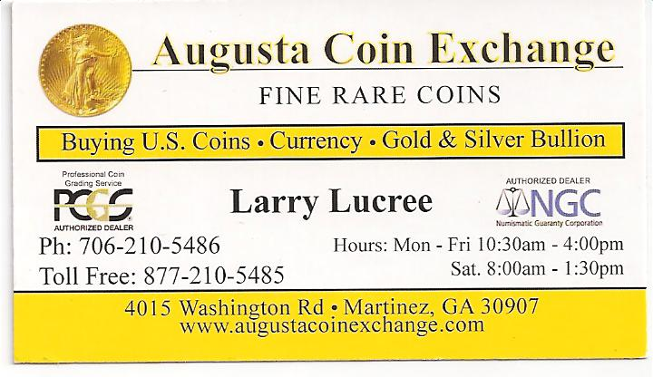

For the serious and casual collector

COINS, STAMPS & CURRENCY

P.O. Box 1739 Patricia James
Aiken, SC 29802 143 York Street
(803)-643-9957 Aiken, SC 29801

