Pres. Steve Kuhl
V .P. Pat James
Sec. Jim Mullaney
Treas. Sharon Smoot
Sgt. in Arms: Glenn Sanders
The Stephen James
CSRA Coin Club of Aiken
P.O. Box 11
New Ellenton, SC 29809
Web site: www.sjcsracc.org
The SJ CSRA CC of Aiken, SC meets on the 1st Thursday of the month at the Aiken Public Library

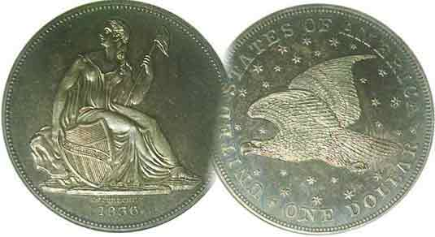
Programs: Pat James
Show: by Committee
ANA Representative: Jim Barry
Publicity: Jim Clapp
Newsletter: Arno Safran
E-Mail: arnosafran@comcast.net
Auctioneer: Glenn Sanders
Web site: Susie Nulty (see above.)

2011 Club Meeting Schedule
Volume 10, Number 5 the Stephen James CSRA Coin Club, Founded in 2001 May, 2011
Monthly Newsletter
May offers three Regional Coin Shows to Consider
Our next meeting is on Thursday, May 5, 2011 from 6:45 to 8:45 PM

Jan. 6 Apr. 7 July 7 Oct. 6
Feb. 3 May 5 Aug. 4 Nov. 3
Mar. 3 Jun. 2 Sep. 1 Dec. 1

____________________________________________________________________________________________________________

Consider attending More Shows

Sgt in Arms Glenn Sanders is not only an observer of behavioral activity at our monthly meetings (which is merely a pro forma role assumed by most hobby organizations) but he is also keenly aware of the various coin shows that are scheduled each month and reports them to the membership at the start of every meeting. At the April 7 meeting Glenn ran off a list of five upcoming numismatic events that included four in South Carolina and one in Georgia, two of which have already occurred. Three of the shows from Glenn’s list are scheduled in May and are worthy of consideration by our members.

The first is the Midlands Coin Club Coins & Currency Show scheduled for Saturday, May 7. It is being held in Columbia at the American Legion Hall Post #6 located at 200 Pickens Street. Admission is free. Glenn considers this a pretty active show with around 25 dealers and is worth the one hour ride from Aiken.

The second is a two day show sponsored by our sister club to the west, the Augusta Coin Club. It is being held on May 13 and 14 at Patriot’s Park which is located in Columbia County, GA near the intersection of Columbia Road and William Few Parkway. From Aiken, take I-20 westbound into Georgia and exit at Interchange 190. Turn right on to Lewiston Rd. At first light, turn left on Columbia Rd. The entrance to Patriot’s Park will appear on your right about two miles from the intersection of Columbia and Lewiston roads. The Show hours are 9 AM to 5 PM both days. Admission and parking are free. Around 45 to 50 tables are expected to be sold for this event.
The third show is sponsored by the Camden Coin Club and is located about twenty-five miles east of Columbia along I 20 but on Rte. US 1 at the Recreation Department Building in Camden, SC. and is scheduled for Saturday, May 21.
___________________________________________________________________________________________________________________
(Club News continues on page 4, column 1)
Collecting a Set of 1936 Coinage: 75 Years ago
By Arno Safran

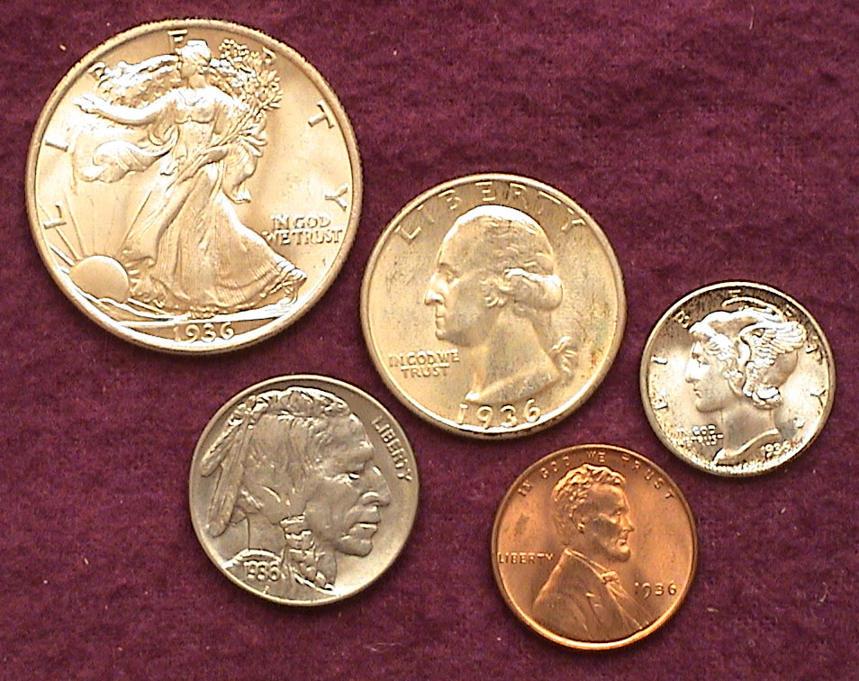

The obverses of an uncirculated 1936-P Year Set
Top : 1936 WL 50 cents, Washington 25 cents & Mercury dime
Bottom, 1936 Buffalo nickel, &Lincoln Wheat back cent
[Use 3X glass or magnify to 200% to view details.]

It is hard to believe that after three quarters of a century, a set of 1936-P coins is still relatively affordable in choice uncirculated condition. One might think that collecting coins from the pre-clad era (i.e., before 1965) would be costly, but starting in 1934 dealers began putting away uncirculated coins by the roll. A roll of cents and dimes included fifty coins, a roll of nickels and quarters forty each, and half dollars, twenty. Still, even this figure represented a lot of uncirculated specimens being stashed away for the fifty-cent coin. With so many dealers able to do this, a large number of specimens continue to surface in Choice to Gem BU for all five denominations. Of the three branch mints, the coins struck at the Philadelphia Mint during 1936 are the most plentiful in Unc. and the usually the best struck. With silver currently trading at over $40.00 an ounce there is a slight premium attached to an otherwise moderately priced set. What makes the 1936-P set still so affordable 75 years later can be answered by the record-breaking mintages struck for four of the five denominations produced that year.
_________________________________________________________________________________________________________________________
(Continued on page 2, column 1)
The US Coins of 1936 (75 Years ago)
(Continued from page 1, column 1)

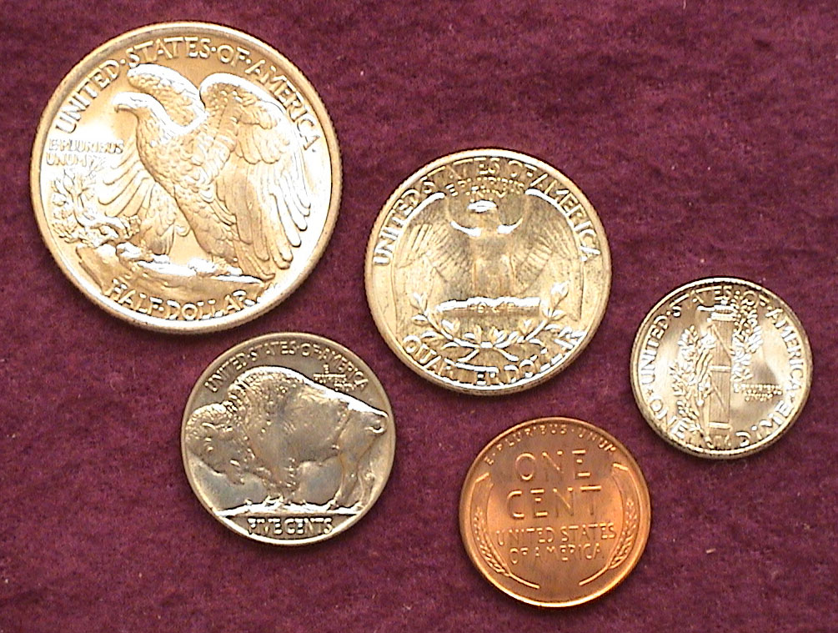

The reverses of an uncirculated 1936-P Year Set
Top : 1936 WL 50 cents, Washington 25 cents Mercury dime
Bottom, 1936 Buffalo nickel, Lincoln Wheat back cent
[Use 3X glass or magnify to 200% to view details.]

The remarkable thing about the coin types of this era is the exquisite artistry of the designs featured on both sides of the coin, especially the Walking Liberty Half, Mercury dime and Indian Head-Buffalo nickel.

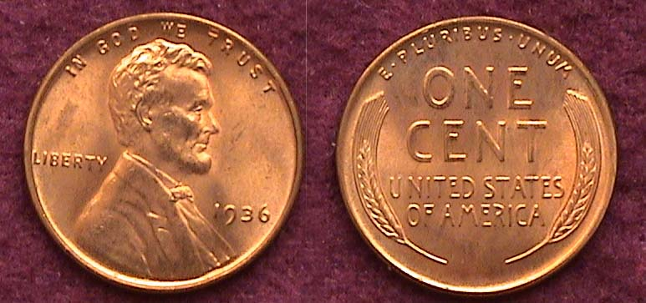

A Brilliant Uncirculated Red 1936 Lincoln Wheat back cent
[Use 3X glass or magnify to 200% to view details.]

Victor David Brenner’s Lincoln cent obverse hasn’t changed much since its inception over a century ago but the reverse design that accompanied it from 1909 thru 1958 was arguably far more attractive than the Memorial reverse that followed in 1959 and the wholly unimaginative shield reverse that now adorns the current 2010 and 2011 issues. In 1936 The Philadelphia Mint struck 309,632,00 cents, the third highest up to then behind 1919 and 1920. Today one can obtain a MS-65 specimen for about $5.00, around $3.00 for one grading MS-64.

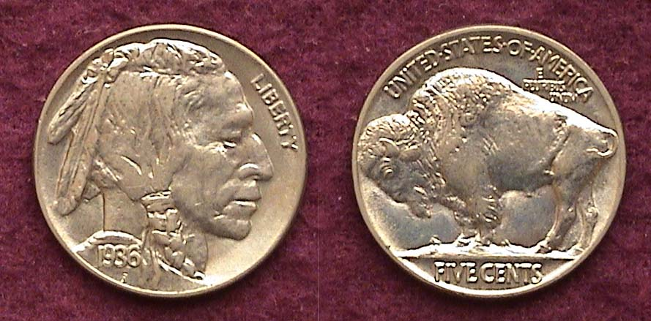

A BU 1936 Indian Head-Buffalo Nickel
[Use 3X glass or magnify to 200% to view details.]

In 1936 the Philadelphia Mint struck a record 118,997,000 nickels, the largest one year total for the entire series (1913-1938-D). The previous high water mark occurred in 1920 was 63 million were produced. The 193w6-P is well struck and often surfaces with an attractive gun metal blue toning. In MS-64 it sells for around $45.00 and in MS-65 around $70.00.

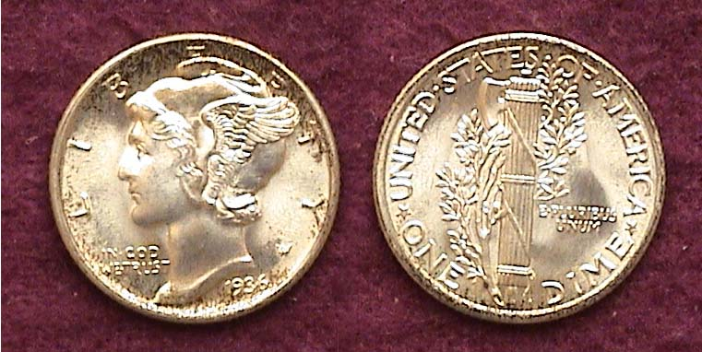

A BU 1936 Mercury dime
[Use 3X glass or magnify to 500% to view fully split bands on the reverse..]

The Philadelphia Mint struck 87,500,000 Mercury dimes in 1936, breaking all previous records by a wide margin. According to the 2012 “A Guide Book of United States Coins”, (AKA Red Book), the date is listed at only $30.00 in MS-65. Of course one could purchase an example grading XF-40 for $3.50 (according to the same source) and receive an extremely dull looking coin by comparison. Mercury dimes boasting fully split bands on the fasces located on the reverse generally bring a premium. The latest Coin Dealer Newsletter, (AKA the Grey Sheet) a weekly publication used by most coin dealers lists a 1936-P dime with full bands at $65.00.

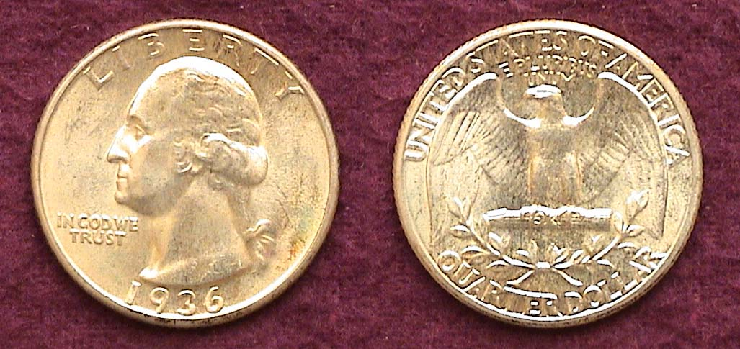

A BU 1936 Washington Quarter
[Use 3X glass or magnify to 200% to view details.]

In 1936 the Philadelphia Mint struck a whopping 43.3 million quarters breaking the record of 27.8 million set in 1920 by a wide margin. The mintage would be surpassed in 1941 by an even larger margin but as a date, the 1936-P is one of the most common of the silver portion of the Washington quarter series (1932-1964). According to the 2012 Red Book, specimens grading MS-63 are listed at $35 but an MS-65 which is much harder to find is shown at $120. For reference purposes, the CDN Grey Sheet Monthly Supplement provides a more accurate grading ratio listing all grades from Good-4 up thru MS-65. A 1936-P quarter in MS-63 is listed at only $24.00, in MS-64, at $27.00 but in MS-65 at $80.00. The writer believes that this date should be available closer to Grey sheet figures than the Red Book because it is so readily available.

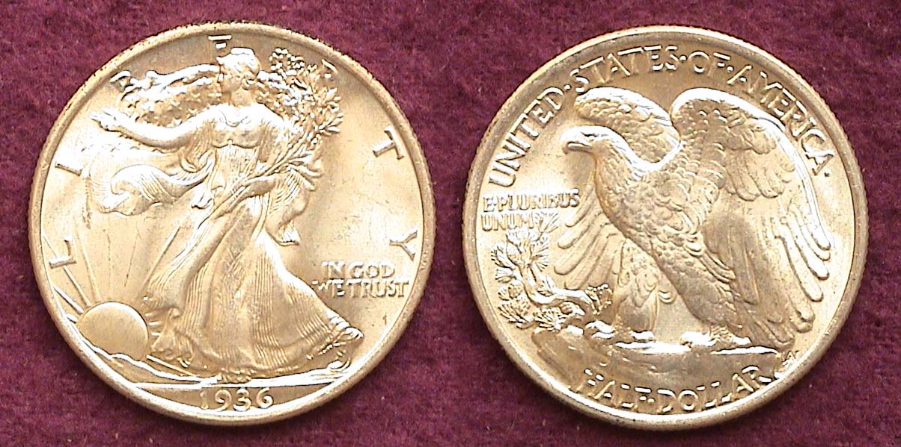

A 1936-P Waling Liberty Half dollar graded MS-65
[Use 3X glass or magnify to 200% to view details.]

The Walking Liberty half dollar is arguably our most exquisite design type for the 50 cent denomination and would appear as the crowning jewel in a Choice Uncirculated 1936-P set.
____________________________________________________________________________________________________________________________
(Continued on page 3, column 1)
The US Coins of 1936 (Continued from preceding page)

The Philadelphia Mint struck 12,614,000 halves in 1936 barely passing the previous high water mark of 12,292,000 of 1917, the second year of the series. While the 1917-P issue is easily the most available WL half coined prior to 1934, the strike was much weaker than the 1936 and lacks the overall luster of a 1936-P. Before 1934, dealers weren’t putting away rolls of uncirculated coins since the increase in the number of coin collectors did not begin to emerge until the 1930’s. As a result the 2012 Red Book just out lists a 1917 in MS-63 at $200 compared with only $75 for the 1936. The CDN Grey Sheet weekly shows the 1936-P in MS-63 at just $53.00, in MS-64 at $65.00 and in MS-65 at $175.00. By comparison, the almost as common 1917-P issue is listed at $850.00 in MS-65. As for as acquiring an attractive BU 1936-P, a “Best Buy” for the budget conscious collector would be to consider a certified specimen grading MS-64.

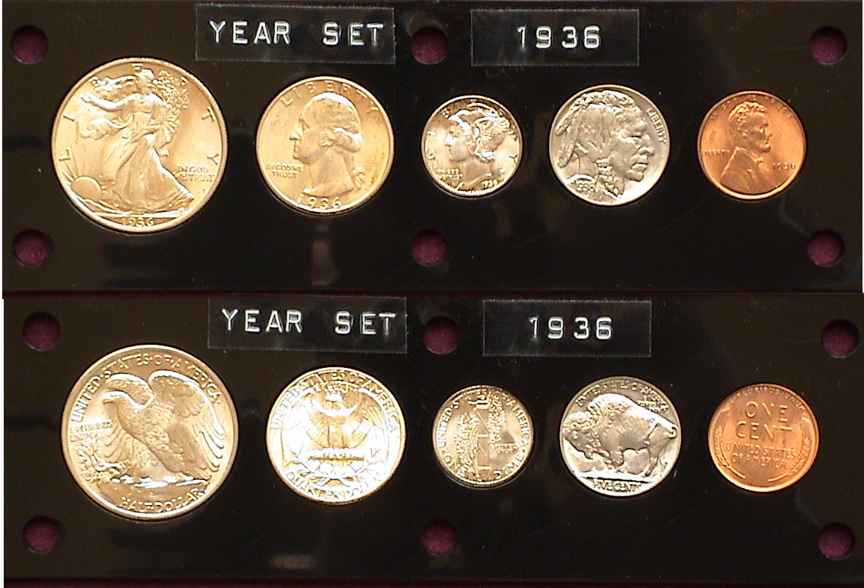

A BU 1936-P housed in a Capital Lucite holder (not actual size)
[Use 3X glass or magnify to 200% to view details.]

Before PCGS introduced third party certified coin grading (AKA “slabbing”) in 1986, collectors bought their obsolete type coins “raw”. The coins were sold in 2X2 stapled cardboard holders or plasticized flips. When proof set production was resumed in 1936 the packaging of the original sets left much to be desired. Each coin was inserted into a cellophane bag stapled together to the four other denominations, then wrapped in a layer of soft material and placed in a square cardboard box. The problem was, that over the years, the staples often rusted, sometimes corroding or scratching the proof specimen inside. The Mint’s packaging for the Uncirculated Mint Sets was no better. Whether to remedy this or simply for display purposes, the Capital Plastics Company of Massillon, Ohio began to produce durable Lucite holders to house proofs, mint sets and various coin types with the result that many of the 1936-1964 proof sets and later Mint sets surface today in five piece Lucite holders. Since 1968, the Mint has used their own hard plastic containers but with most rare or higher graded coins being submitted for certification during the last two decades, the need for these Lucite holders has diminished. As shone above, a BU 1936-P Year Set acquired “raw” (perhaps one coin at a time) can still appear stunning when housed in a five piece Lucite holder .
_____________________________________________________________________________________________________________________________
The US Election of 1936

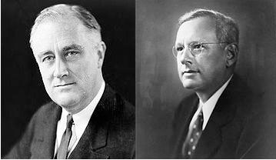

Franklin Delano Roosevelt, D of NY Alf Landon, R of Kansas

The election of 1936 represented a test of President Roosevelt’s efforts in combating the effects of the Great Depression during first term in office. When FDR came into office on March 4, 1933 after three and a half years of a deepening economic depression, 25% of Americans were out of work. During the 1932 campaign FDR had promised a “New Deal” for the American people and in the now famous “first 100 days” was able to sign into law many new bills, among them the Agricultural Adjustment Act (AAA), The Federal Emergency Relief Administration (FERA) giving relief to States, the Civil Conservation Corps (CCC) which put 250,000 able bodied young men to work, the Public Works Administration (PWA) for building projects, also legislation still in effect known as the Security and Exchange Commission (SEC), Federal Deposit Insurance Corporation (FDIC) and the Tennessee Valley Administration (TVA); examples of which can still be seen throughout the deep south. In 1935, he signed into law the Social Security Act. While the combined total of all this legislation did not end the Depression, it had the effect of lowering unemployment along with giving hope to the American people that the government was doing things to improve the economy. As a result, in the November 1936 general election Roosevelt won the popular vote by a record 11 million votes while winning 523 votes to eight for Alf Landon in the Electoral College. Roosevelt swept the Solid South (which was Democratic back then) and took all the rest of the states except Maine and Vermont. It was the largest landslide in American History to be surpassed only by Ronald Reagan’s victory against Walter Mondale in the 1984 general election.

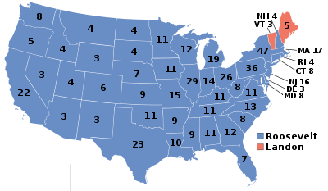
_____________________________________________________________________________________________________________________________

Club News

In the absence of President Steve Kuhl, outgoing VP Arno Safran called the meeting to order at 6:45 PM and installed incoming VP Pat James before turning the gavel to Recording Secretary Jim Mullaney who had prepared the agenda for the April 7 meeting. Sgt. In Arms Glenn Sanders announced the attendance as 21 with four guests, Sonia Hillman, Ernest Wilson, ,Mable Webb and Augusta Coin Club President, Steve Nix. Treasurer Sharon Smoot reported a balance of $1,666.50. Thank you, Sharon. It is the custom of he club to present awards to members who have performed services on behalf of the club during the previous fiscal year which ended March 31.

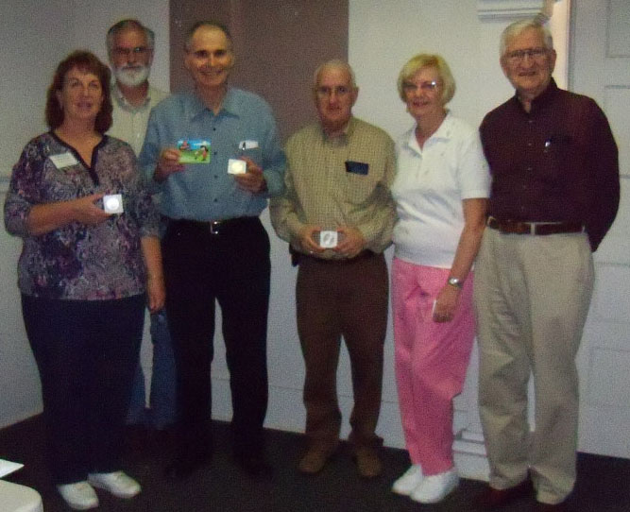

2010-11 Board receiving their gifts for service: From left to right: Sharon Smoot, Treasurer, Jim Mullaney, Sec., Arno Safran VP & newsletter editor, Jim & Helen Barry, Bourse Chairs.
Missing: Pres. Steve Kuhl.
(Photo, courtesy of Helen Barry)

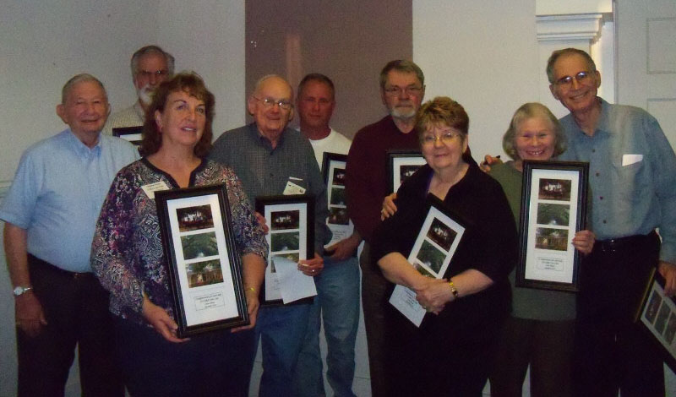

2010-11 Helpers at Club’s Annual Coin Show: From left to right
Paul Simons, Jim Mullaney, Sharon Smoot, Jim Jewitt, Willie Simon, Jim Clapp, Pat James, Vilma & Arno Safran
Missing from the picture are Steve & Austin Kuhl,
Marion Engel, Doug Moody and Art Ludwig.
(Photo, courtesy of Helen Barry)

Following the presentations were Show & Tells by Richard Lasure, who displayed sets of Barber dimes, quarters and halves he acquired out of circulation. Also a coin from the Crusades c. 1169-1193 AD and Ptolemy I of Egypt (52-30 BC brought in by Chuck Braun and a sixty-five year old 1946 PDS Mint Set housed in a Capital Lucite holder by Rick Owen.

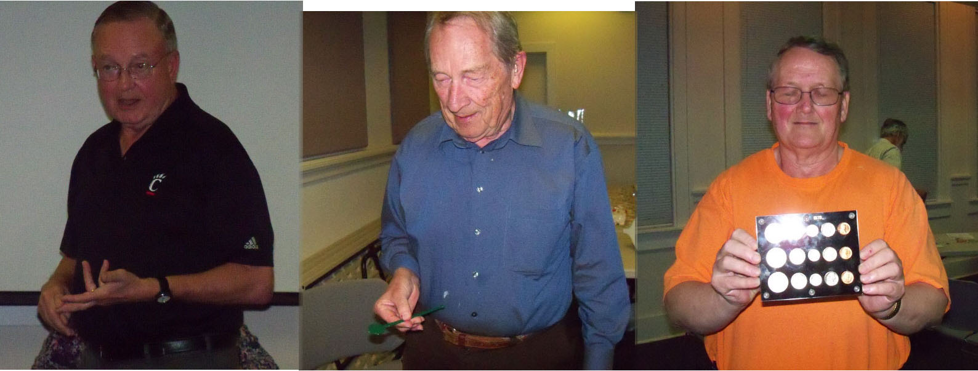

From Left to right: Dick Lasure, Chuck Braun & Rick Owen
(Photo, courtesy of Helen Barry)

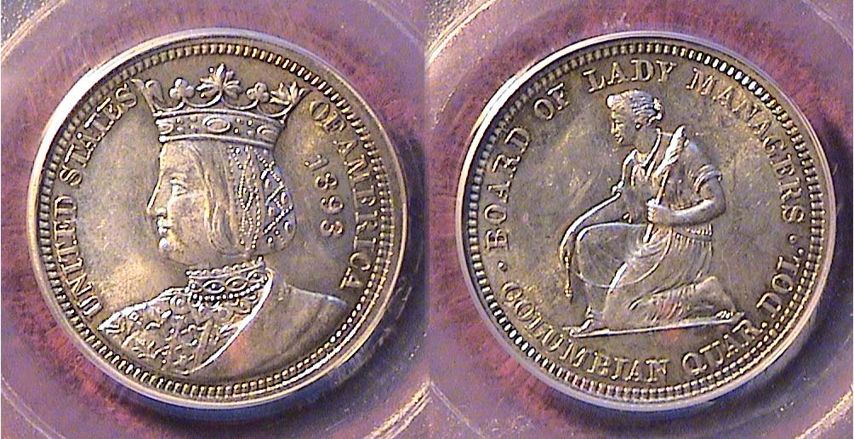

An 1893 Isabella Quarter graded MS-62 by PCGS
[Use 3X glass or magnify to 200% to view details.]

The program for the evening was a PowerPoint presentation by Arno Safran on “Collecting the Coins of Charles Barber”. Depicted were coinage examples of the Liberty “V” nickels, Liberty Head dimes, quarters and halves along with
Commemorative, Isabella quarter and Columbian half dollar and one of the half dollar pattern coins. Arno described the role Bertha Palmer played in the creation of the first US coin honoring a real woman, Queen Isabella who appears on the commemorative quarter of 1893 that was sold at the Chicago Columbian Quadra-centennial Exposition.

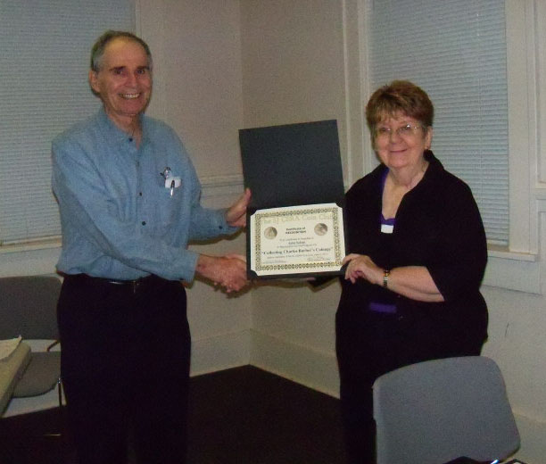

Arno Safran receiving an Appreciation Award from VP Pat James
(Photo, courtesy of Helen Barry)

The Prize Winners at the April 7 meeting were. Richard Owen who won the door prize and Pat James who won the 50/50 drawing - $26.00. Congratulations to the winners.

Wayne Damron to Give Program in May

At our May 5 meeting Wayne Damron, proprietor of Clein’s Rare Coins in Augusta will be our scheduled speaker. Wayne, an advanced collector of Ancient Coins, has given talks on “Coins of the 12 Caesars” and more recently “Coins of the Bible” but he also knows the US numismatic market extremely well and has presented programs on “The Case for Collecting Key Date Coins” and “Strategies involved with Coin Grading”.
_________________________________________________________________________________________________________________________
Framed Aiken Scenes as Gifts of Appreciation
Questionable Choice for a Numismatic Club

-An Editorial-

While members who volunteer to help out at our Show, arrange club functions or present programs do these things without expecting to be remunerated in any way, it is always nice to receive a token of appreciation commensurate with the club’s basic interest. Being a Numismatic Club all past presentations awards have been related to coins, tokens or medals. These have taken the form of silver eagles; Canadian dollar coins, proof sets or other numismatic items. While the 2010-11 Executive Committee members received numismatic awards at the April 7 meeting, those who helped out at the Show were presented with identical framed photos of well known historic scenes of Aiken. In the case of a couple receiving two of the same, one of the presenters realizing this, took one back. This would not have happened if all the prizes were numismatic. Another recipient was presented with a gift certificate to a restaurant; a nice gesture, but again, having nothing to do with the reason the club meets once a month; the sharing of numismatics.

With silver priced at well over $40.00 an ounce as this is being written it is understandable that our club can no longer enjoy the luxury of giving away a silver eagles, now worth at least eight times their value since the club’s founding in 2001. We are all living in uncertain economic times and must budget accordingly. That said, there are a number of numismatic prizes that are attractive mementos of history that cost $25.00 or less even with silver at its current rate of value. Since most local dealers will sell relatively common date coins to clubs at Bid, here are some suggestions listed at current Coin Dealer Newsletter (Grey Sheet) prices:

- There are a number of Franklin half dollar dates grading as high as MS-64 that are bid between $14 to $16. The recipient would be receiving an obsolete type coin with 90% silver content.
- With the exception of three issues, virtually all Commemorative half dollars struck from 1982 on are priced from a low of $2.75 (clad issue) to a high of $15.00 (silver issue) and they most come in presentation cases.
- Silver proof sets from 1957-1964 one priced at around $19 to $20 are currently bid at $26.00, slightly above the $25.00 figure due to the spike in silver prices. These perennial underrated sets are still bargains.
- A 1938-D Buffalo nickel grading MS-64 is bid at just $23.00; a perfect award for the Young Numismatist.
- Foreign Coinage: Most modern foreign coins are of cupro-nickel alloy containing no silver and are relatively inexpensive in BU condition.
- Obsolete Foreign Banknotes, many of them demonetized, survive in Crisp Uncirculated condition and are vey attractive yet inexpensive.
There are a number of web sites on the internet offering attractive examples of modern uncirculated foreign coin sets and paper money at reasonable prices (including shipping).
_____________________________________________________________________________________________________________________________

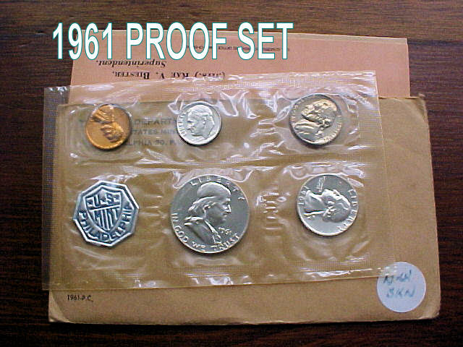

This is an example of a sealed 1961 Proof Set now 50 years old.
It is currently bid at $26.00 according to the Coin Dealer Newsletter
[Use 3X glass or magnify page to 200% to view details.]
______________________________________________________________________
___________________________________________________________________________________________
. Please Patronize Our Dealer Advertisers
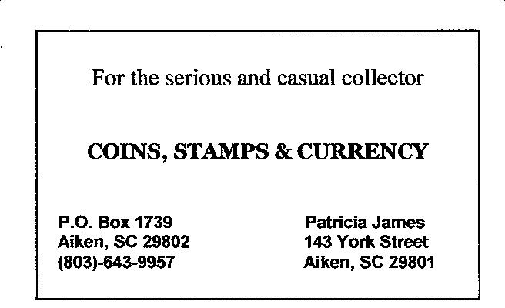
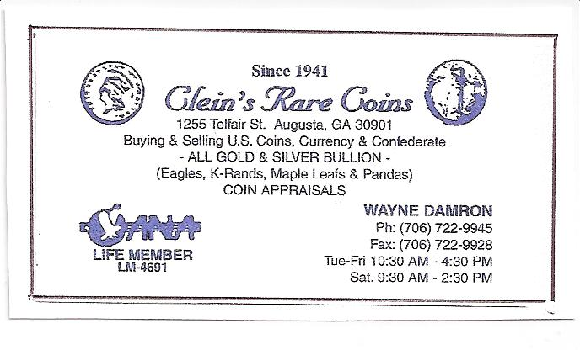
2011-12 Club Dues Now Due

This is a friendly reminder that dues for the SJ CSRA Coin Club’s 2011-12 fiscal year is due: $12.00 for adults and $5.00 for children under eighteen. We do not want to lose any members but after, June 1, those who have not paid in person at our meetings or sent in their dues will be removed from the membership rolls. Dealers, if you have not yet renewed your ads for the new fiscal year, please contact Treasurer Sharon Smoot at SJ CSRA CC, PO Box 11, New Ellenton, SC 29809.
_________________________________________________________________________________________________________________________
Don’t forget the Augusta Coin Club coin show, Fri. & Sat. May 13-14 at Patriot’s Park 5445 Columbia Road in Columbia County, GA
________________________________________________________________________________________________________________________

