Pres. Steve Kuhl
V .P. Pat James
Sec. Jim Mullaney
Treas. John Meinhardt
Sgt. in Arms: Glenn Sanders
The Stephen James
CSRA Coin Club of Aiken
P.O. Box 11
New Ellenton, SC 29809
Web site: www.sjcsracc.org
The SJ CSRA CC of Aiken, SC meets on the 1st Thursday of the month at the Aiken Public Library

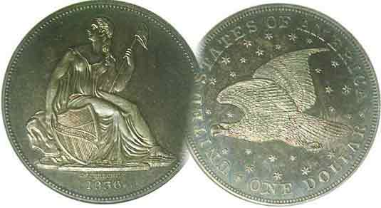
Programs: Pat James
Show: by Committee
ANA Representative: Jim Barry
Publicity: Jim Clapp
Newsletter: Arno Safran
E-Mail: arnosafran@comcast.net
Auctioneer: Glenn Sanders
Web site: Susie Nulty (see above.)

2012 Club Meeting Schedule
Volume 11, Number 5 the Stephen James CSRA Coin Club, Founded in 2001 May, 2012
Monthly Newsletter
Attending Club Shows Good place to improve grading skills
Our next meeting is on Thursday, May 3, 2012 at the Aiken Public Library

Jan. 5 Apr. 5 July 5 Oct. 4
Feb. 2 May 3 Aug. 2 Nov. 1
Mar. 1 Jun. 7 Sep. 6 Dec. 6

______________________________________________________________________________________________________

Augusta Coin Club to hold Show May 11 & 12

. 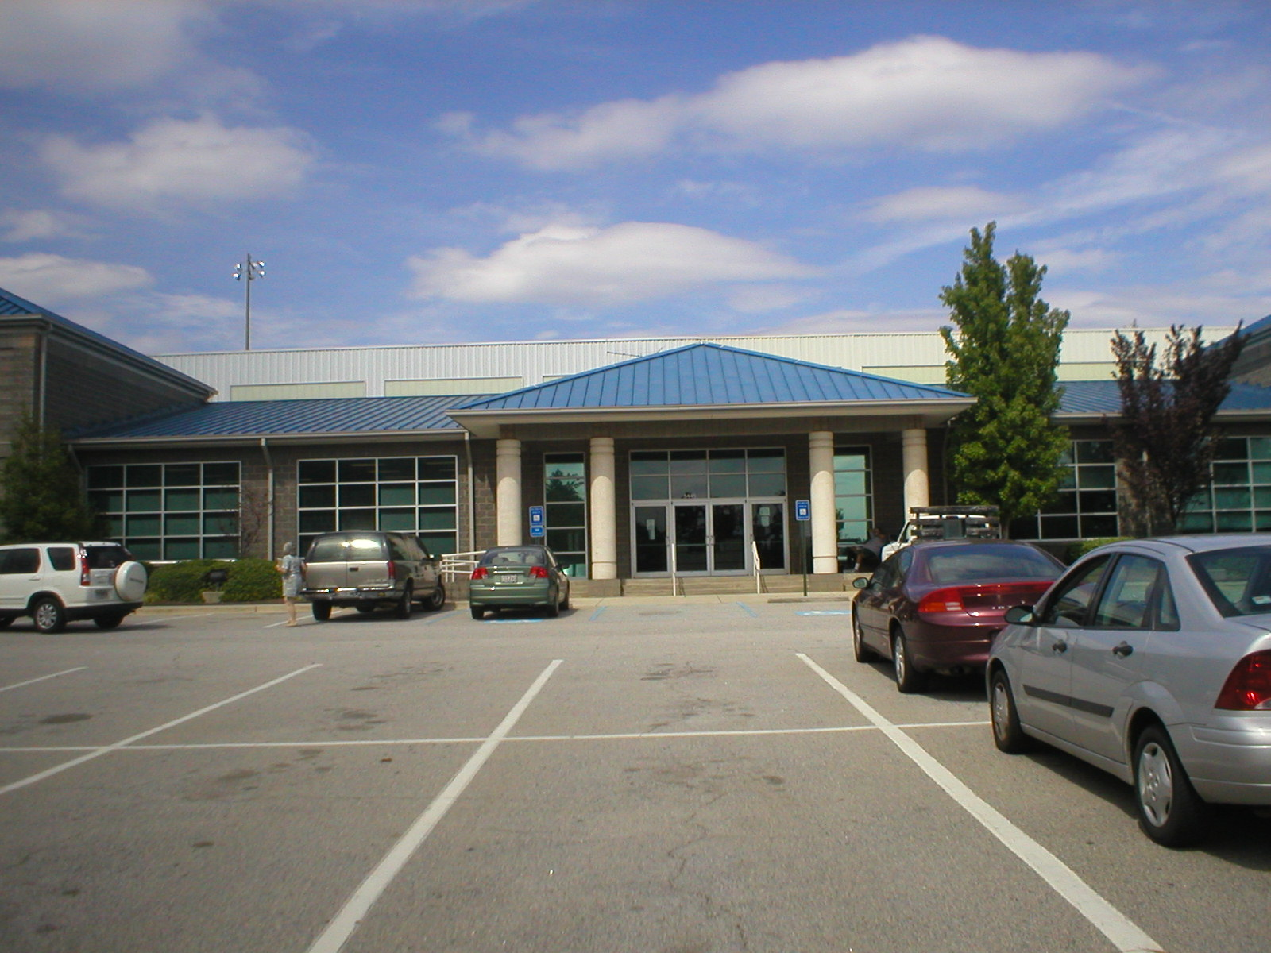

Patriot’s Park, Site of Augusta Coin Club’s Show

One of the best ways to improve grading skills is to visit your local coin dealer’s shop periodically and to attend coin shows. Members of the two local clubs residing in the CSRA are fortunate in these respects because there are two coin shops in Aiken and one each in Augusta and Martinez, GA. Our club holds its annual show in conjunction with Aiken-Makin’ Day, usually on the second Saturday in September and the Augusta Coin Club holds its two shows around the second Fri & Sat in November and again in May. On May 11 & 12, 2012 the Augusta Coin Club will be holding its spring show at Patriot’s Park, located at 5445 Columbia Rd. in Columbia County, GA.

Directions from Aiken, Take I-20 west to GA Exit 190. At the end of the exit ramp, make a right onto Lewiston Road. At first light (Columbia Road), take a left. After passing the Bartram Trail entrance, look for the Patriot’s Park entrance on right as well.

Show hours are 9:00 AM to 5:00 PM both days. There is plenty of parking and admission is free. Around fifty tables are expected to be manned by dealers touting a wide range of coins, bank notes, tokens & medals.
_____________________________________________________________________________________________________________________
(Continued on page 3, column 2)
The Case for Buying Certified Coins: Part 5
Some Mysteries Regarding Certified Coins
By Arno Safran

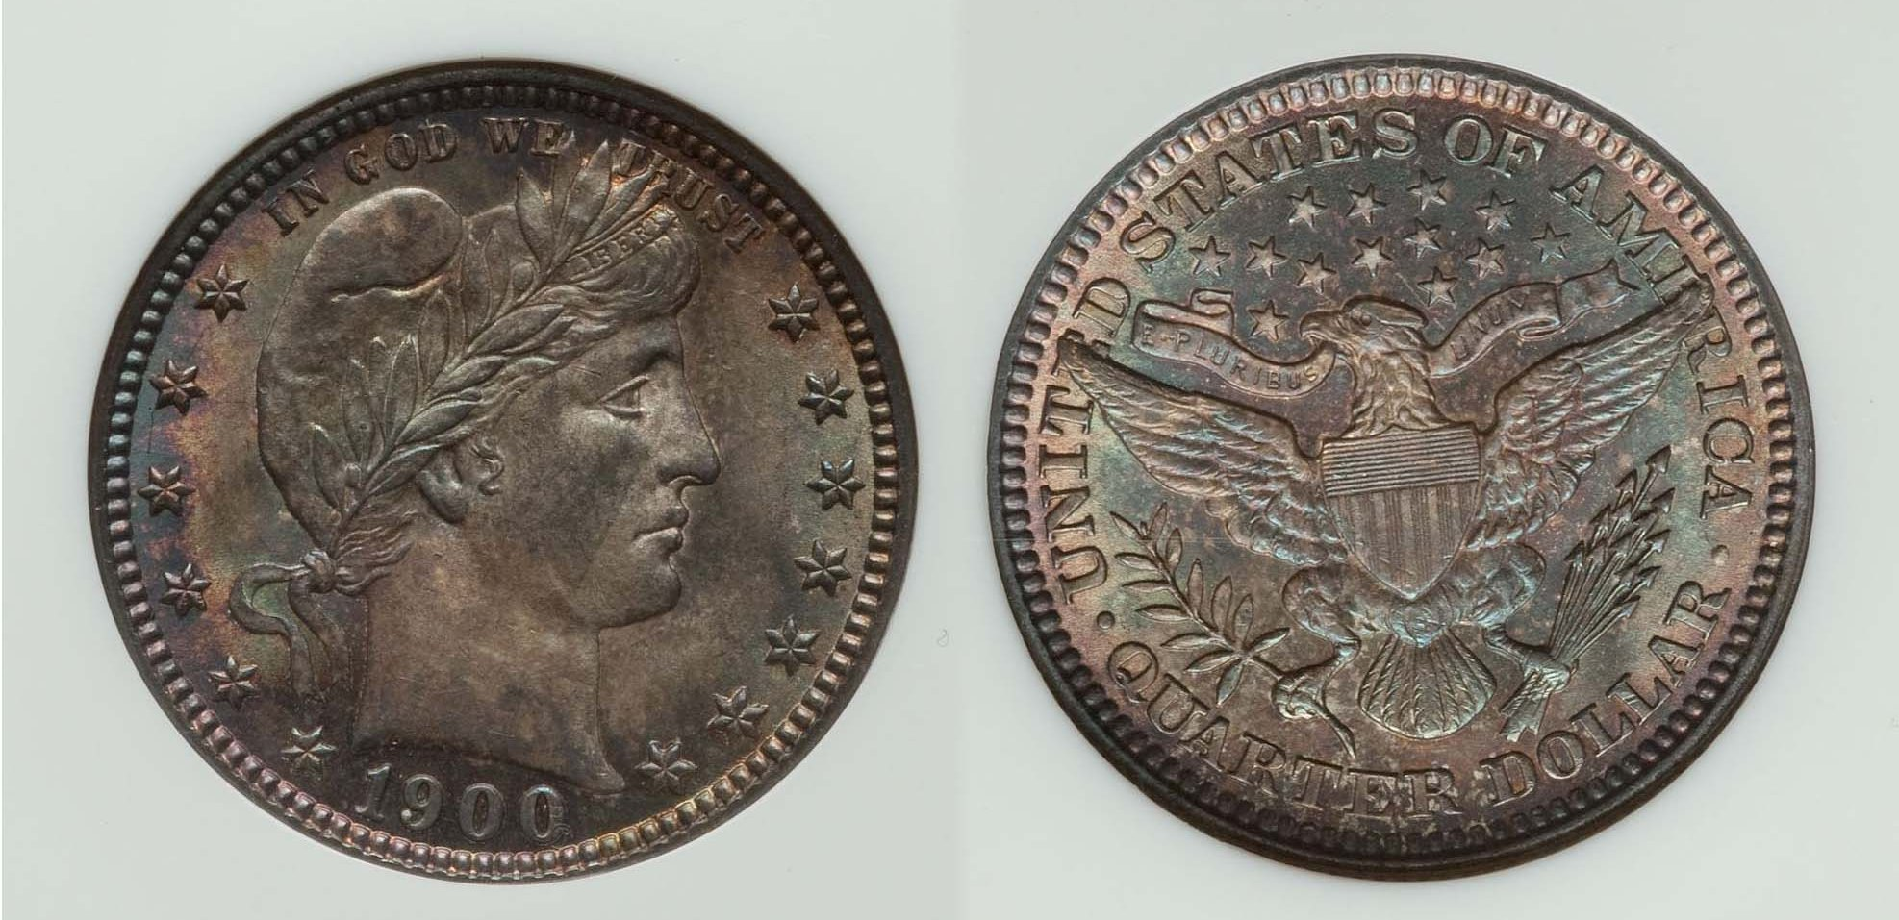

A 1900 Barber Quarter graded MS-64 by NGC
[Use 3x magnifying glass or magnify page up to 500%]
(Courtesy of Heritage Auctions Archives)

Each of the four previous articles in this series has attempted to make the case for acquiring certified coins for one’s collection, especially if they are priced at $200.00 or higher. Despite these entreaties there remains an important caveat which still requires the perspective buyer to make the effort to hone one’s grading skills; in other words, to be able to “grade the coin and not the slab”.

The beautifully toned Barber quarter shown above was graded MS-64 by NGC (the National Guarantee Company grading service based in Sarasota, FL) and it realized $632.50 at a Heritage auction in 2011. The Heritage website provides a special category called “Make an Offer” for those successful bidders to resell the same coin to others seeking that particular date. Upon clicking on the MAKE AN OFFER box, one will find the minimum offer a dealer will accept for the item. In this case it was $759.00 or $126.50 more than the winning bid/ The Coin Dealer Newsletter (AKA the Gray sheet) wholesale bid column lists a MS-64 1900 quarter at $525 while the suggest retail price is $725/00 based on Coin World’s monthly “Coin Values”

Armed with that information, a collector could offer $759, just $34.00 above MS-64 retail. and see what happens. The writer considered doing just that but decided to see if a similar graded same date piece would surface at an upcoming major show in order to get an on site look at an actual specimen rather than a digital image, but then a strange thing happened.
________________________________________________________________________________________________________________________________
(Continued on page 2, column 1)

Some Mysteries Regarding Certified Coins
(Continued from the previous page)

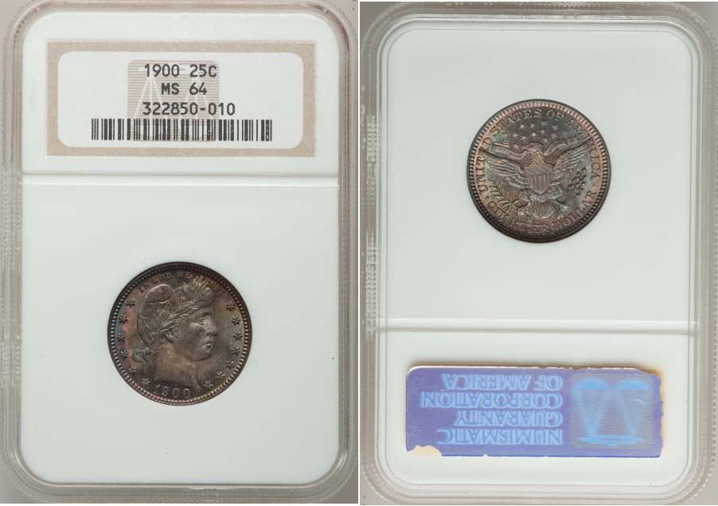

The same 1900 Barber Quarter as it appears in the full slab
[Use 3x magnifying glass or magnify page up to 500%]
(Courtesy of Heritage Auctions Archives)

While surfing the internet the writer happened on another source for available 1900 dated Barber Quarters. was the PCGS coin prices site, which lists all United States coin denominations by date and type that are currently on the market. A large number of 1900 quarters came up grading from as low as VF-25 to Proof 67, each priced accordingly, all certified and accompanied by digital images. One of them piqued my curiosity. It was graded MS-65 by PCGS and priced at $1,795 and like the MS-64, displayed similar if lighter toning.

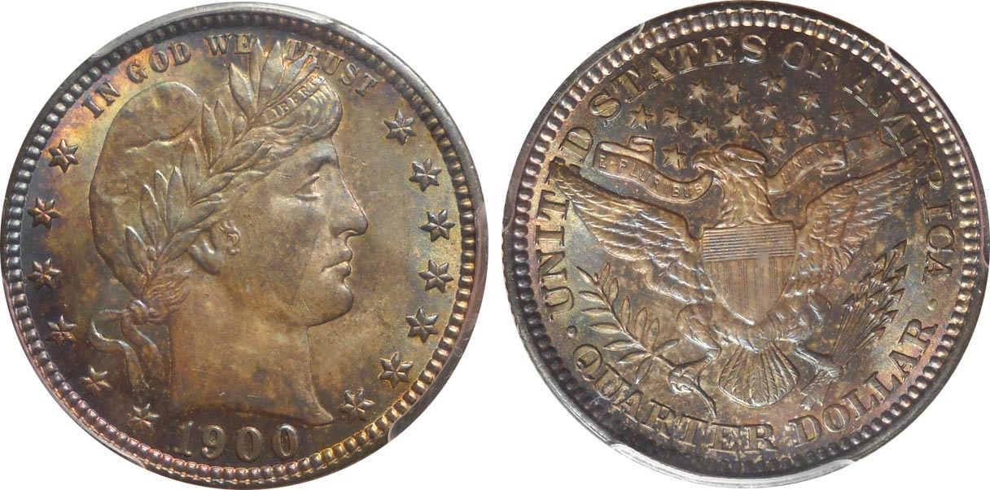

1900 Barber Quarter graded MS-65 by PCGS
[Use 3x magnifying glass or magnify page up to 500%]
(Courtesy of PCGS)

Having done a lot of digital coin photography over the years I knew how easy it was to alter a coin’s appearance by using specific shading features that are at one’s disposal on most modern PCs. Could the image of the MS-65 specimen have been lightened up just a bit more than the NGC-64 example? I decided to enlarge the images of both the NGC-64 and PCGS MS-65 specimens of the 1900 Barber quarter. (See below!)

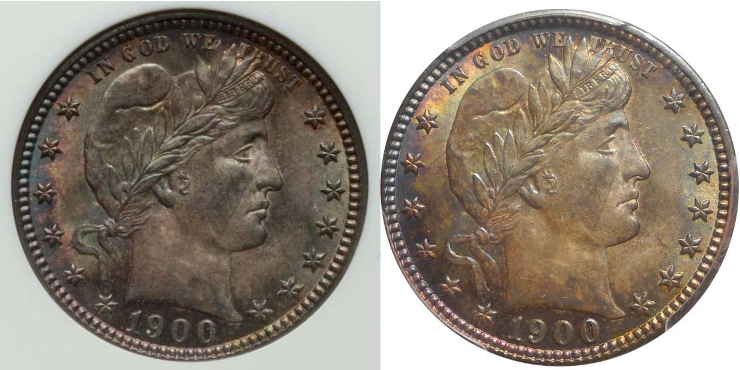

Enlargement of 1900 25c obverses. Magnify up to 500%.
Readers who receive the newsletter digitally are in a good position to observe minute details of a coin when magnified to 200% or 500%, although it may take some getting used to for some. Upon magnifying the images of the two 1900 quarters what do you notice? The most obvious similarity is the diagonal toning swath appearing in the same position across Miss Liberty’s face on both coins. The second similarity appears across Miss Liberty’s neck where one can observe some faint yellowish streaking in the same areas on both coins. Then, just behind the lower portion of Miss Liberty’s Phrygian cap, you will observe a tiny white fleck in the same spot on both coins as well. These and a number of other like similarities can be observed on both sides of the each coin image. This brings one to conclude that the image of the 1900 25c graded NGC-64 at left and that of the 1900 25c piece graded PCGS-65 on the right are from the same coin.

Two possibilities exist on how this transformation from a MS-64 became a MS-65. Either the Heritage buyer was an actual dealer and decided to resubmit the coin to another grading company or accepted an offer from a dealer who then cracked out the coin from the NGC holder and resubmitted it to PCGS obtaining the higher grade. The result of all this fine-tuning demonstrates that even certified grading is not a science but still open to interpretation that can increase one’s profits considerably under the circumstances just described. In less than a year’s time this particular coin went from a wholesale price of $550 to one now listed at $1,250 and a retail price of $632.50 commensurate with its then certified grade to an asking price of $1,795 all because a second grading company graded the same coin one point higher from 64 to 65 on a scale of 1 to 70 than previous grading company did.

This is not the only time I have personally encountered this situation. At the ANA convention held in the summer of 2004 in Pittsburgh, I brought an 1873 Liberty Seated dollar housed in a PCGS holder graded XF-45. The dealer who sold it to me earlier thought it should have been graded AU-50, so I decided to attempt to upgrade the piece offering it to one of the other grading services. Back then, NGC would offer an appraisal if you showed them some coins prior to submitting them for certification. I showed the 1873 $1.00 to one of the graders and he told me that in his opinion, the coin would not be graded because of altered surfaces. It had a ding on the lower left side of the obverse, which bothered me, so I decided to sell it at the show, taking a 20% loss in the process. While surfing the Internet two months later I came across my same 1873 dollar (with the ding in the lower left side of the obverse) in another major dealer’s web site but now housed in a NGC-50 holder. Ouch! The coin that NGC would not grade, they graded higher.

The Quest for an 1801 Half Dollar

The situation can cut both ways. At the same Pittsburgh ANA show, I wanted to acquire an 1801 Draped Bust half dollar. This is a much tougher date than the 1803, ‘05, ‘06 and ‘07 issues as the reported mintage for the 1801 was a scant 30,289. The date comes in two die varieties, O-101 and O-102 of which the second named is scarcer listed as an R4.
______________________________________________________________________________________________________________________________
(Continued on page 3, column 1)

Some Mysteries Regarding Certified Coins
(Continued from the previous page)

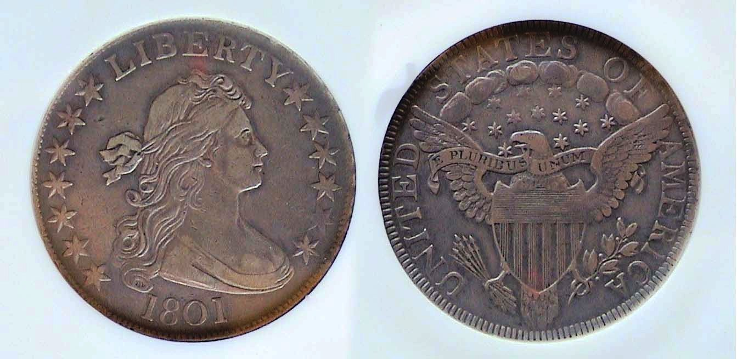

An 1801 Draped Bust 50c O-102, R4 graded XF-40 by NGC
[Use 3x magnifying glass or magnify page to 200%

While moving through the huge ANA bourse, I spotted at least three certified 1801 half dollars, graded XF, others lower but none of them had any eye appeal. They were either dark or had distracting marks or scrapes on the surface. Finally, I came upon a dealer who was renowned for specializing in the series. Among the many attractive examples in his case, I found an uncertified “raw” 1801 Bust half that looked more attractive than any of the certified specimens I had seen earlier and it was the scarcer variety to boot. The dealer priced the piece as a VF-35. It was expensive. However, inside the same envelope that housed the coin I discovered another dealer’s label marked XF. With the dealer’s permission, I showed the coin to one of the NGC graders and he thought it would grade XF. I knew I could not afford the 1801 50¢ coin outright but had other coins of value that I offered the dealer in trade which he accepted. With the new acquisition in hand, I took the 1801 half over to the NGC table and submitted for overnight certification. When I picked up the order, the following afternoon it was graded XF-40. The coin had doubled in value overnight.

More recently, I have done some back checking on specific coins that I have purchased from internet dealers and have found examples of the same coin being upgraded by the grading service from VF-30 to 35 or XF-40 to XF-45. When the grade climbs from VF to XF or XF to AU or in the case of the 1900 Barber quarter, which inspired this article--from MS-64 to MS-65--the increase in value, can be substantial. In each instance major dealers appeared to receive the benefit of the upgrade.

One final observation that I have made has to do with the status of the four major grading companies. Today PCGS is regarded as the leader of the professional grading industry with NGC second followed by Anacs along with ICG distant third ands fourth. From personal experience, I have found for the most part, the coins graded by all four companies to be generally reliable and accurate within half a grade for circulated coins and just one point apart for uncirculated ones. I regret that PCGS will crossover only NGC graded coins but no longer crossover coins graded by Anacs or ICG. In my view, that is pure snobbery. Unlike the other three companies, PCGS labels artificially toned coins, “Questionable toning”. This indicates uncertainty and in my view, such renderings should not disqualify a coin identified with uncertainty from being graded.
____________________________________________________________________________________________________________________________
-End of Series but probably not the last word on the Subject-
It’s Fun to Attend a Coin Show
(Continued from page 1, column 1)

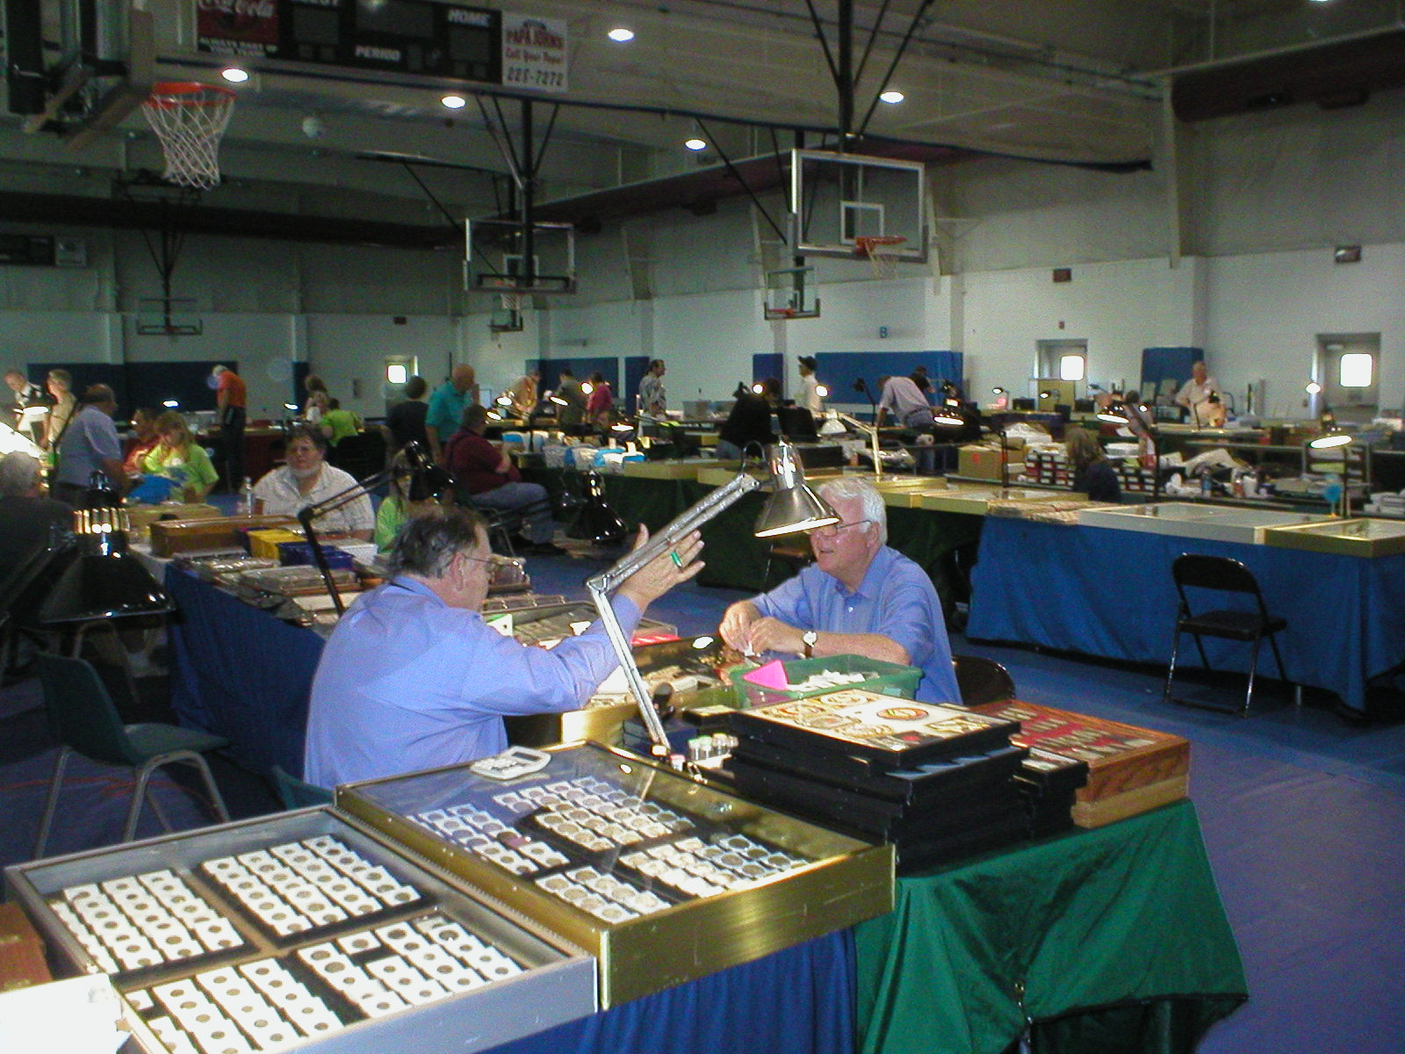

Inside the spacious Patriot’s Park facility
A collector is looking over dealers’ stock.

Before the Coinage Act of 1965, which removed silver from our circulating coinage, many a collector could assemble sets of some obsolete types such as Barber dimes or halves, Standing Liberty quarters or Walking Liberty halves directly from circulation. The 1965 law put an end to that when clad cupro-nickel dimes, quarters and halves replaced their silver counterparts. From that point on, if collectors wanted to add even a common date Barber dime or quarter to their collection they would have to buy it, either at a coin shop or by attending a show where there were many dealers set up and plenty of coins to select.
What is somewhat surprising is that only about a half of the members of our two local clubs bothers to attend the shows held in their area. If coin show attendance in a particular area continues to be soft dealers will soon stop coming opting for other venues supported by a stronger collector base. Coin Clubs cannot survive without putting on an annual show since dues alone will not produce enough revenue to sustain them. Members of the SJ CSRA CC club who have attended the Augusta Show in the past have often added items to their collections that they were unable to acquire locally. Drive time to the Patriot’s Park site from Aiken is about 45 to 50 minutes, less for those residing closer to North Augusta.

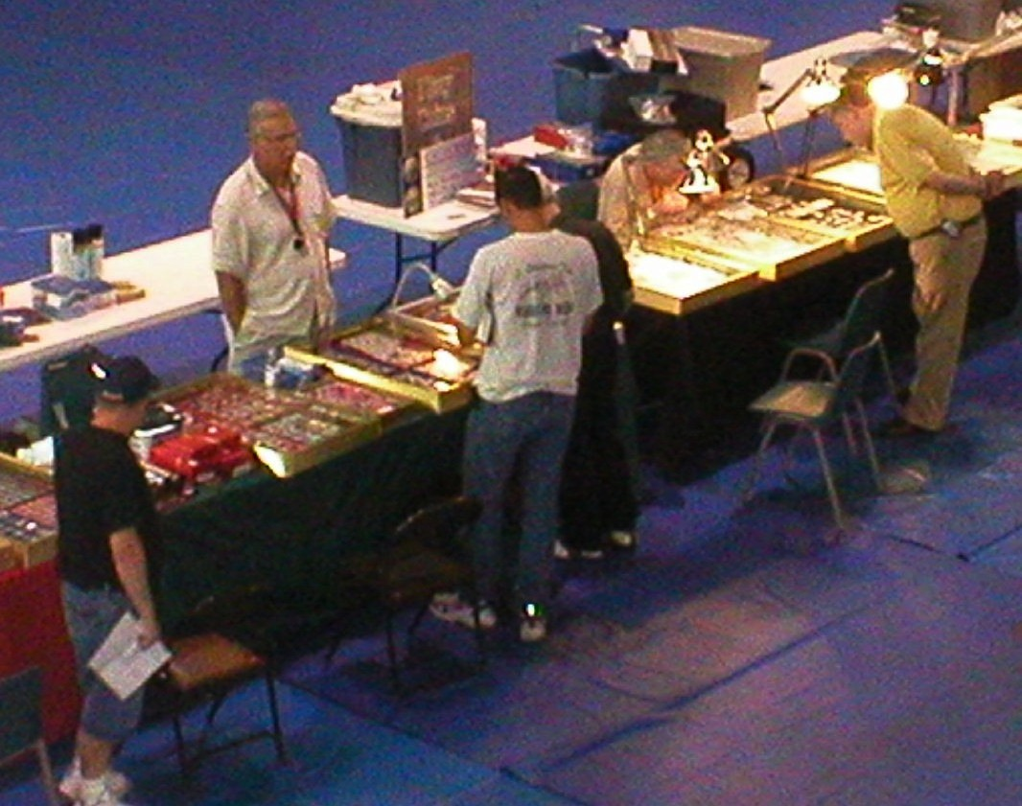

Collectors looking over foreign coins at a dealer’s table
_______________________________________________________________________
__KERGUELEN ISLANDS NOTES
By Bill Myers

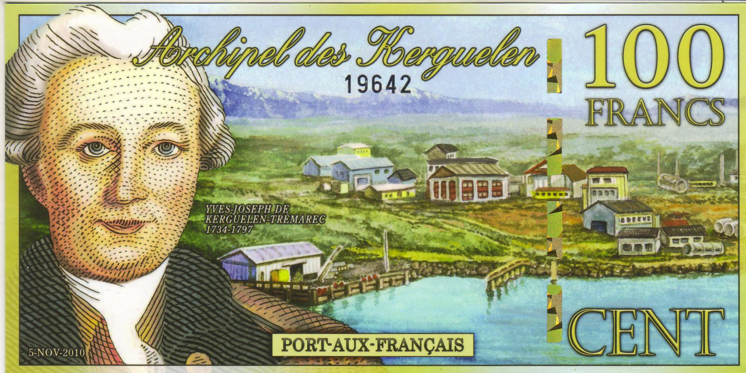

The face of a Kerguelen 100 Francs Note
[Use 3x magnifying glass or magnify to 200% to view details.]

My wife obtained three polymer notes from the Kerguelen Islands. I was curious as to where the Kerguelen Islands were and why they were issuing notes. First, this is a fantasy note and was printed by the Antarctic Overseas Exchange Office at http://www.bankofantarctica.com. Part of the money raised by printing the notes is used to fund research in Antarctica. The Kerguelen Islands were discovered by French navigator Yves-Joseph de Kerguelen de Trémarec on 12 February 1772 and claimed for France. They are located in the southern Indian Ocean near Antarctica. After their discovery, the islands were visited by whalers and sealers who nearly decimated those populations. Since 1950, it has been home to 50-100 scientists and a satellite and rocket tracking station and is now part of the French Southern and Antarctic Lands. Sheep are raised to feed the scientists and there is a population of feral rabbits, sheep, reindeer and cats that were previously introduced.

The face of the 100 francs note features the bust of Yves-Joseph de Kerguelen de Trémarec on the left next to Port-aux-Français, which is the capital settlement.

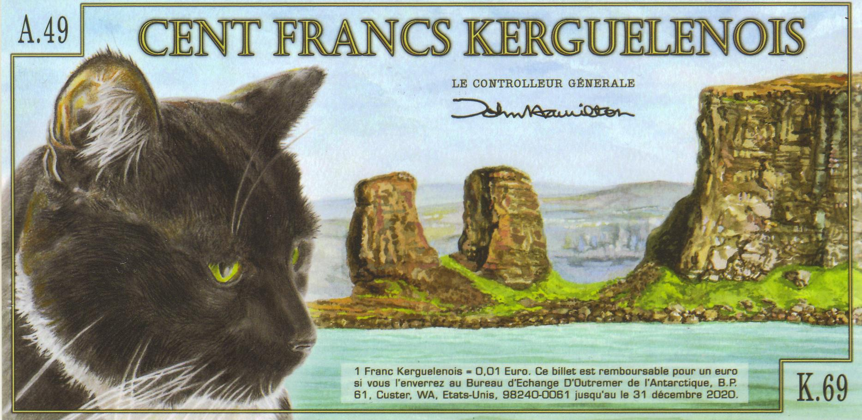

The Back of a 100 Francs Kerguelen Islands note
[Use 3x magnifying glass or magnify to 200% to view details.]

The back of the note has the head of a black and white cat with a scene of the rocky shore along with a clause that notes that the value is 1 franc = 0.01 euro (making the note worth 1 euro) and is redeemable until 31 DEC 2020 at the Bureau of Exchange in Custer, WA. The euro is the currency in use on the islands, which is why there is a conversion clause, and it is the same on all of the notes. On the face of the 200 francs note is the bust of René Bossiére, who had established a spiny lobster cannery on the Island of Saint-Paul, standing in front of Le Doigt, a rocky monolith on the shore.

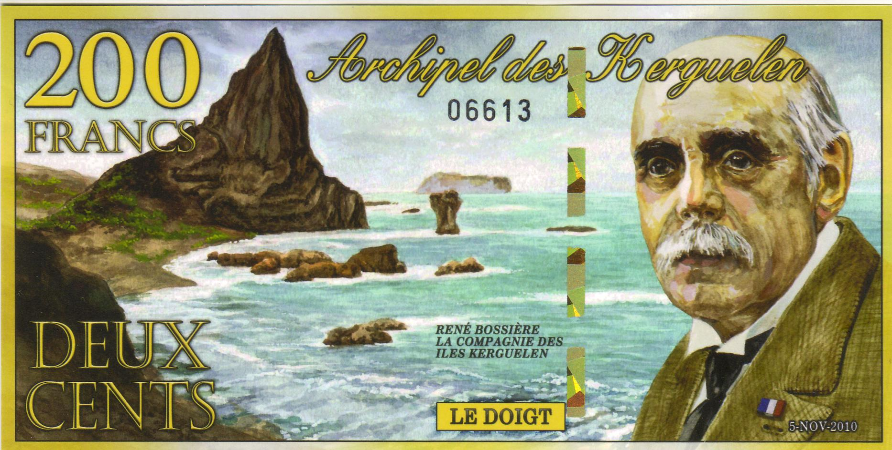

The Face of a 200 Francs Kerguelen Islands note
[Use 3x magnifying glass or magnify to 200% to view details.]

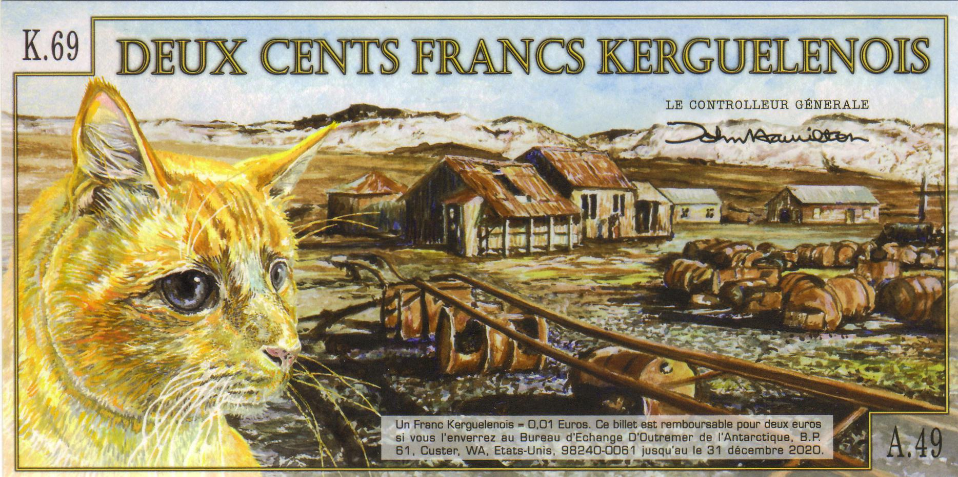

The Back of a 200 Francs Kerguelen Islands note
[Use 3x magnifying glass or magnify to 200% to view details.]

The face of the 500-franc note has a bust of Raymond Rallier de Baty who surveyed the islands, with a shore scene with the sailboat J. B. Charcot, the vessel he used. The back has an orange cat and a scene of a ranch.
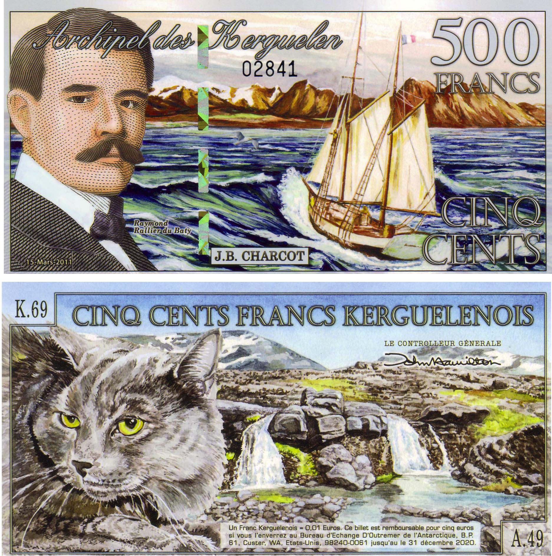

The Face and Back of a 500 Francs Kerguelen Islands note
[Use 3x magnifying glass or magnify to 200% to view details.]

My wife was fascinated by the cats on the notes but in addition to adding notes to our collection, we learned something new about the world we live in.

_________________________________________________________________________________________________________________
(Thanks, Bill for another fascinating article on an attractive numismatic topic
most of us knew nothing about, ED.)
Club News

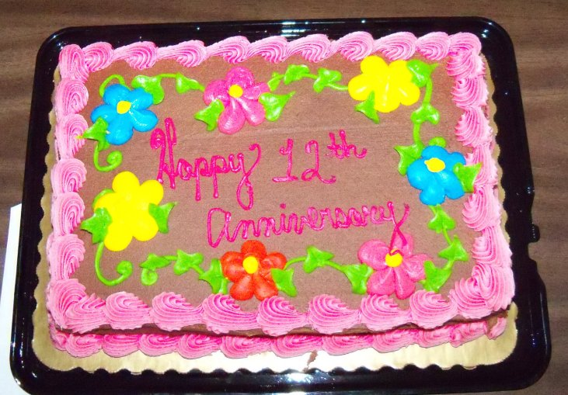

Club Starts 12th Year Cake brought in my member Rick Owen
(Photo, courtesy of Helen Barry)

President Steve Kuhl called the meeting to order around 6:45 PM. and asked Sgt. in Arms Glenn Sanders to provide the attendance figures and upcoming shows report. Glenn reported 21 members present with 1 guest, Jerry O’Leary and listed a number of shows including the Georgia Numismatic Association Convention in Dalton on April 27-29 and the Augusta Coin Club show scheduled for May 11 & 12. The club’s treasury balance was announced at $1,378.14 by outgoing Treasurer, Sharon Smoot. President Kuhl thanked Rick Owen for bringing in a club anniversary cake, which the members shared with delight during a break in the meeting.

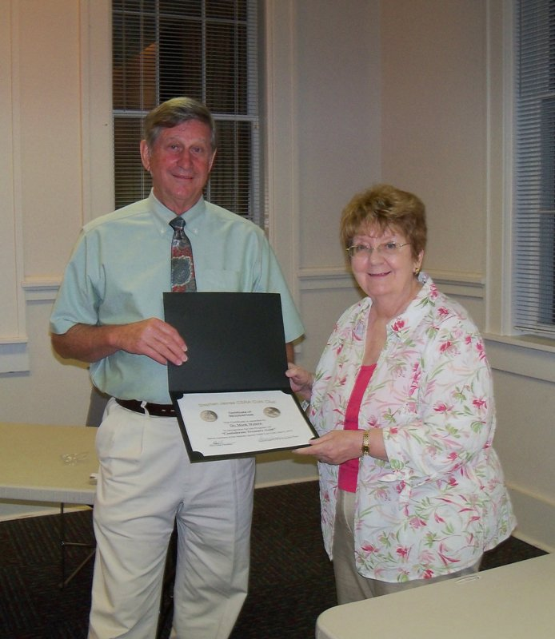
The Program: VP and Programs Chair Pat James introduced guest speaker Marshall Waters III, PHD a specialist in the financial aspects of the Confederacy and a resident of Washington, GA. This lovely town was an important depot used by the Confederacy during the last days of the Civil War and its immediate aftermath. Dr. Waters presented a highly illuminating PowerPoint presentation on the factors leading up to the theft of a major portion of the Confederate Treasury’s assets that were being moved from Richmond, VA banks to Washington, GA. A series of events continually interrupted the shipment of Confederate funds with the result that after a number of reversals in direction, along the route from Richmond to Augusta, a large portion of the Confederate Treasury was stolen by bandits in an area known today as the John Chennault Plantation, located near the crossroads of GA Rtes. 79 and 44 in Lincoln County.

Dr. Mark Waters receiving certificate
of appreciation from VP Pat James
(Photo, courtesy of Helen Barry)
For May 3, Ms. Pat has arranged to have Robert Moon present another program on US Banknotes. Show and Tell: There were two presenters at the April 5 meeting. Rick Owen displayed two useful numismatic accessories; a visor with a magnifying glass and light attached to it; also a small magnifying glass on a stand with a light. Rick explained that both gadgets were useful in examining the details of coins while attending shows as well as at home. Arno Safran displayed a 75 year old BU 1937-D Year set housed in a Capital Lucite holder.

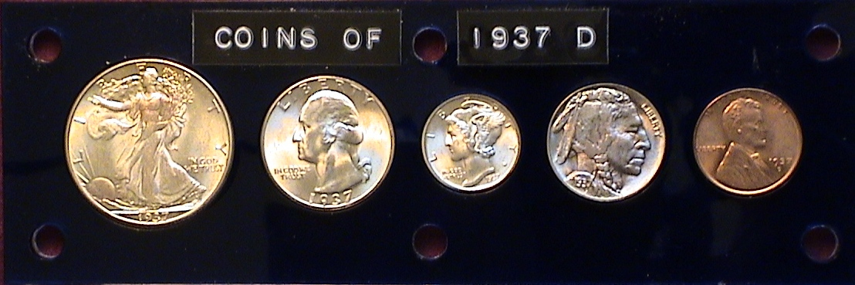

The prize winners at the April 5 meeting were Jim Barry who won a 1957 Proof Franklin half and his` wife Helen Barry who won the 50/50: $21.00. Congratulations, Barry’s!
_________________________________________________________________________________________________________________________________

Kindly Patronize our Advertisers

