The Stephen James
CSRA Coin Club of Aiken
P.O. Box 11
New Ellenton, SC 29809
Web site: www.sjcsracc.org
The SJ CSRA CC of Aiken, SC meets on the 1st Thursday of the month at the Aiken Public Library

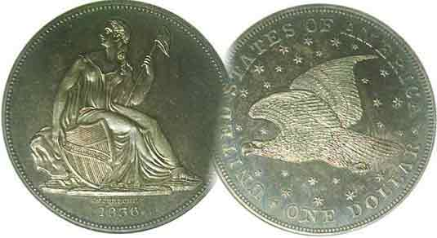
Pres. Steve Kuhl
V .P. Pat James
Sec. Jim Mullaney
Treas. Chuck Goergen
Sgt. in Arms: Jim Sproull
Programs: Pat James
ANA Representative: Jim Barry
Photos: Helen Barry
Publicity: Pat James
Newsletter: Arno Safran
E-Mail: arnosafran@comcast.net
Auctioneer: Glenn Sanders
Web site: Susie Nulty (see above.)

2013 Club Meeting Schedule
Volume 12, No. 5 the Stephen James CSRA Coin Club, Founded in 2001 May, 2013
Monthly Newsletter
Augusta Coin Club Show May 10 & 11
Our next meeting will be held on Thursday, May. 2, 2013 at the Aiken Public Library

Jan. 3 Apr. 4 July ? Oct. 3
Feb. 7 May 2 Aug. 1 Nov. 7
Mar. 7 June 6 Sept. 5 Dec. 5

______________________________________________________________________________________________________

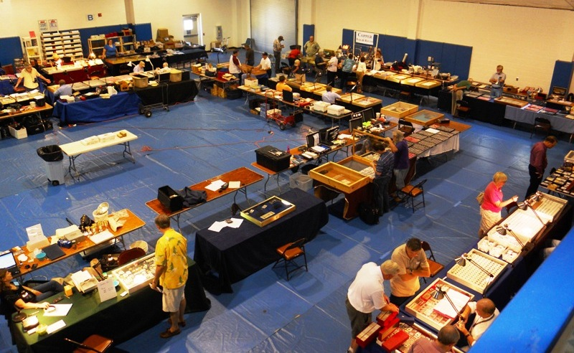

A section of a past Augusta Coin Club Show at Patriot’s Park
[Use 3x glass or magnify page to 200%]

The Augusta Coin Club will be holding their spring coin show on May 10 and May 11, a Friday & Saturday at Patriot’s Park on Columbia Road in Columbia County, GA. The site is attended by thousands of area residents for the annual Fourth of July Fireworks festivities and despite concerns by some regarding its location, it is not unknown to the denizens of the CSRA. In fact, this section of Columbia County is the fastest growing area of the Augusta suburban population and has been so for more than four years. To get to Patriot’s Park from Aiken or North Augusta, take I-20 west across the Savannah River into Georgia to Interchange 190. At the end of the exit ramp, turn right on to Lewiston Road. At the Columbia Road light, make a left. About a mile and a half, notice the Bartram Trail sub-division entrance on right and not far after that is Patriot's Park. [If you come to the William Few Parkway light, you have gone too far.] The hours for the show are 9:00 AM to 5:00 PM both days. Parking and admission are free. Fifty or more tables have been sold for past shows at this site which should provide ample opportunities for our club members to add to their collections.
_________________________________________________________________________________________________________________

Collecting the US Coins of 1913: 100 Years Ago
By Arno Safran

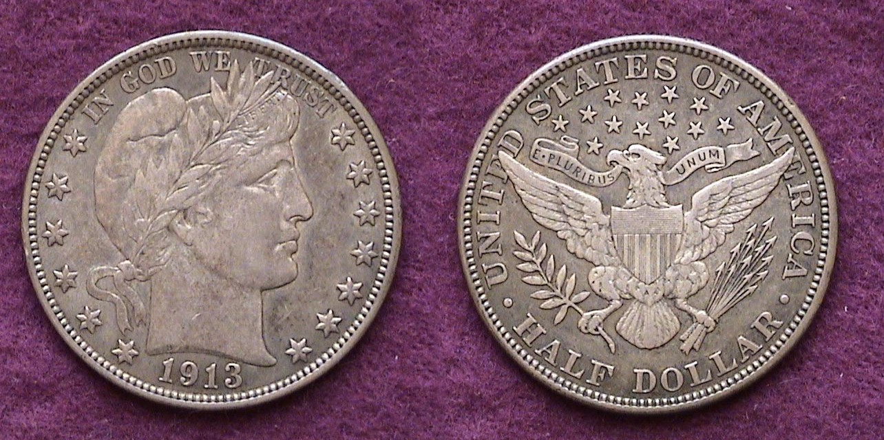

A 1913 Barber Liberty Head half-dollar grading XF-40
[Use 3x glass or magnify page to 200%]

In 1913, the US Mints struck a total of nine authorized denominations. These included one in bronze, the cent, one in nickel, the five-cent piece, three in silver, the dime quarter and half dollar, and four in gold, the $2.50 quarter eagle, the $5.00 half eagle, the $10.00 eagle and the $20.00 double-eagle, After 1889, no more three cent nickels, $1.00 and $3.00 gold pieces were made, the denominations having been terminated and in 1905 the Morgan dollar was suspended. There were three US Mints active in 1913, the Philadelphia, San Francisco and Denver Mint, the last named having opened in 1906.

A century later, it is possible for a collector of modest means to assemble a five piece denomination set (excluding gold) averaging in grades from XF-40 up through MS-63 depending on the Mint as some 1913 Mint issues are scarcer than others. For example, the 1913-P Barber half shown above with a mintage of only 188,000 is considered one of the keys to the 73 piece set, the 1913-D and S issues with slightly higher mintages being less expensive and easier to attain. The 1913-S Barber quarter with only 40,000 struck is considered one of the three “stoppers” of the set but even the 1913-P with a mintage of 484,000 is a tough date in high grade leaving the 1913-D with a mintage of over 1.4 million the least costly to attain for the 25c denomination. With the 20 14 Red Books now on the market, the collector is advised to acquire one at the club discount in order to check not only the mintages but the suggested retail values for any of the 1913 denominations.
_____________________________________________________________________________________________________________________
(Continued on page 2, column 1)
Collecting the US Coins of 1913: 100 Years Ago
(Continued from page 1, column 2)

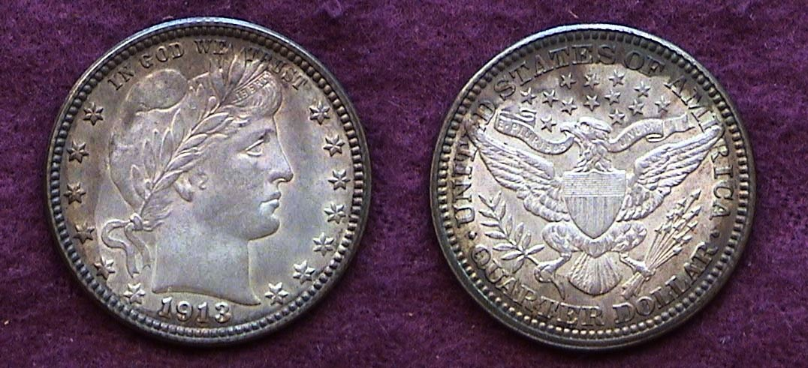

A 1913 Barber Quarter graded MS-62
[Use 3x glass or magnify page to 200% to view details.]

The 1913 Barber Quarter shown above was acquired twenty years ago back in the summer of 1993 at the American Numismatic Association World Money Show held that year in Baltimore, Maryland. It was the first ANA convention the writer had ever attended and it was awesome. There were hundreds of dealers set up all over the vast Baltimore Convention Center with numismatic items priced from 10¢, (e.g., modern obsolete foreign bank notes grading crisp CU) to coin rarities valued at over $10,000. Since then the ANA has selected this site two more times, 2003 and again in 2008 and in the minds of many serious collectors--“the Inner Harbor” as this section of Baltimore is known--is by far the best site in the United States for the ANA summer money show. The 1913 Barber quarter was not on the collector’s original want list but it looked “original”, well struck and attractive. In 2012 the coin was certified MS-62 by ICG.

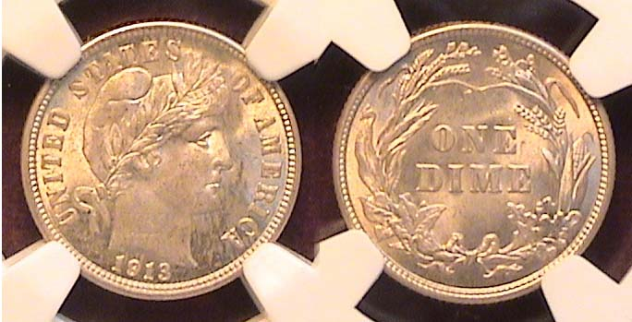

A 1913 Barber dime graded MS-63 by NGC
[Use 3x glass or magnify page to 200% to view details.]

The 1913 Barber dime shown directly above was acquired at the Georgia Numismatic Association Convention held at the Georgia Northwest Trade Convention Center one year ago in the lovely city of Dalton. The collector had discovered only a year earlier that the his originally owned “raw” specimen of the date acquired back in 1988 was judged by one of the certification companies to be “Genuine” but cleaned and retoned. Because the coin was in his possession for so long a period it had risen in value enough to sell well below wholesale bid enabling him to replace it with a problem-free certified example. Despite the 1913-P being a common date, it took a while to find a replacement as not all certified MS-63s are the same. Some appear darkish or lackluster. Others are spotted while still others have distracting tics on their surfaces. The 1913 dime was struck at only two of the three Mints, at Philadelphia where a whopping 19,760,000 were produced and at the San Francisco facility where only 510,000 were made. In MS-63, the 1913-P is valued at $225 according to the 2014 Red Book while the low mintage 1913-S is listed at a robust $750, more than three times higher. While a number of specimens were observed on the Internet, attending a “live” show still represents the best opportunity to evaluate a coin properly.

The hype of the rare 1913 Liberty nickel possibly attracted more people to coin collecting than any other numismatic event before the advent of the statehood quarter program of 1999. It has been alleged that Samuel W. Brown, an employee in the coining department at the Philadelphia Mint in 1913 became aware of the government’s intention to produced a new five-cent nickel type and supposedly ordered the striking of five proof specimens of the outgoing Liberty nickel dated 1913 without authorization. He somehow managed to remove the five coins surreptitiously before retiring from his position that same year. Some years later, in 1919, he advertised in “The Numismatist” (monthly journal of the ANA) that he was looking to buy 1913 dated Liberty nickels. Of course, no one came forward because Brown had the only specimen in existence, displaying them at the ANA convention the following year. He later gradually sold all five pieces.
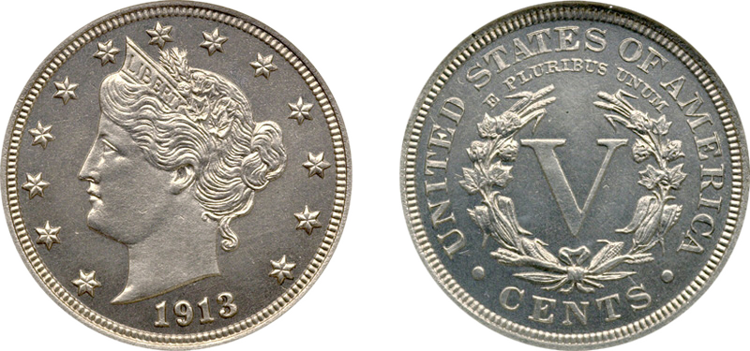

The Eliasberg specimen of the 1913 Liberty Head Proof nickel
The coin was graded Proof-65 and is considered to be the highest graded specimen of the five clandestine proofs
[Use 3x glass or magnify page to 200% to view details.]

During the 1920s and ‘30s, B. Max Mehl, a coin dealer out of Fort Worth, Texas began to run ads seeking a specimen of the 1913 Liberty nickel listing what he was prepared to pay for them. These ads, more than anything, encouraged people to check their pocket change in the hope of finding another specimen of the great rarity.

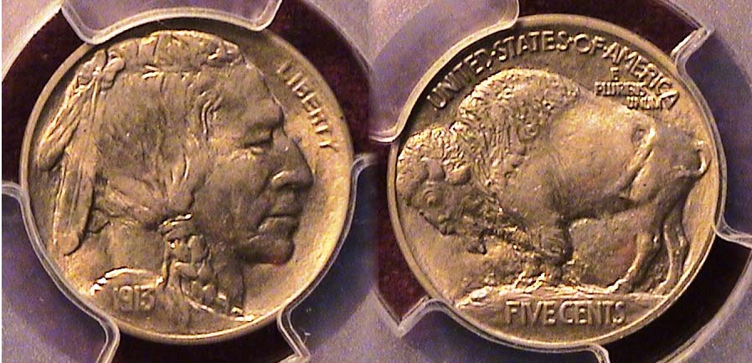

A 1913 Indian Head/ Buffalo nickel (with Type I reverse)
Graded MS-65 by PCGS
[Use 3x glass or magnify page to 200% to view details.]

Despite the notoriety of the 1913 Liberty Head nickel, which in actuality is an un authorized manufactured rarity, one of our most popular coinage designs emerged that year, the Indian Head obverse, Bison reverse five-cent piece, which has come to ne known as the Buffalo nickel. The engraver was John Earl Fraser, a disciple of the renowned sculptor Augustus Saint-Gaudens, designer of the resplendent $20.00 gold piece which bears his name. The coin was released into circulation around the same date as President Woodrow Wilson’s inaugural, March 4, 1913. The coin was produced at all three Mints with Philadelphia striking the lion’s share, 30.9 million compared with 5. 3 million at Denver and 2.1 million at San Francisco. It soon became evident that the denomination FIVE CENTS would wear too quickly. Chief Engraver Charles Barber removed the mound inserting the words FIVE CENTS under an exergue (or straight line) as the Type II reverse came to be known.
____________________________________________________________________________________________________________________
(Continued on page 3, column 1)
Collecting the US Coins of 1913
(Continued from previous page)

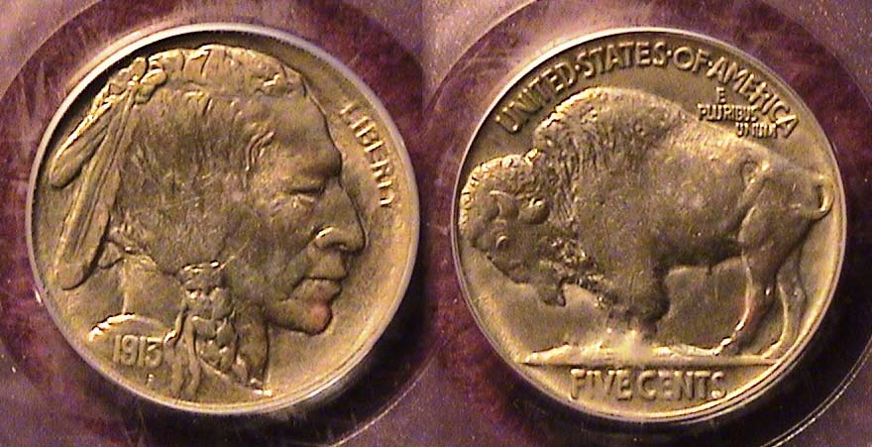

A 1913 Type 2 Buffalo nickel graded MS-64 by PCGS
[Use 3x glass or magnify page to 200% to view details.]

Almost as many of the 1913 Type II Buffalo nickels were struck as the Type 1 with the Philadelphia Mint again producing the most, 29.8 million followed by Denver with 4.1 million and San Francisco with only 1.2 million, the last considered a R-5 in MS-65 because so many of the San Francisco Mint issue saw heavy circulation despite it being a first year type.

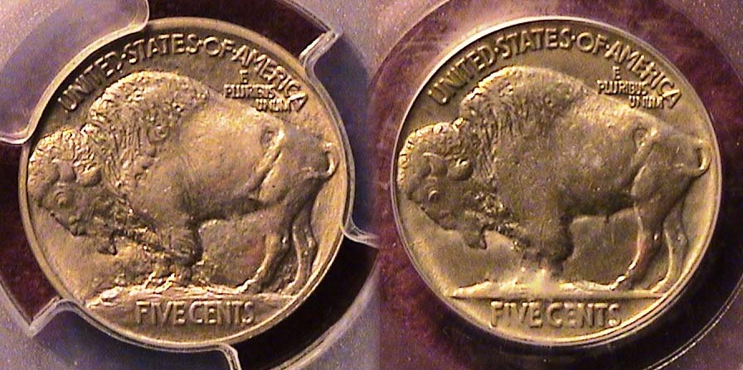

The two reverses of the 1913 Buffalo nickel
Type 1, Bison on mound, Type 2, Bison on straight line
[Use 3x glass or magnify page to 200% to view details.]

In 1913, the Lincoln Wheat back cent was struck at all three Mints. More than 76 million were coined in Philadelphia. 15.8 million were produced in Denver but only 6.1 million were struck at San Francisco and these are scarce and costly in the higher grades.

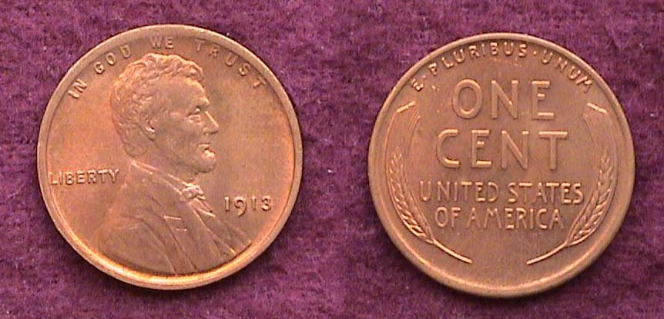

A 1913 Lincoln cent grading MS-63 Red
[Use 3x glass or magnify page to 500% to view details.]

The 1913-P is easily the lest expensive in all grades. The one shown directly above was graded MS-63 Red by ICG.

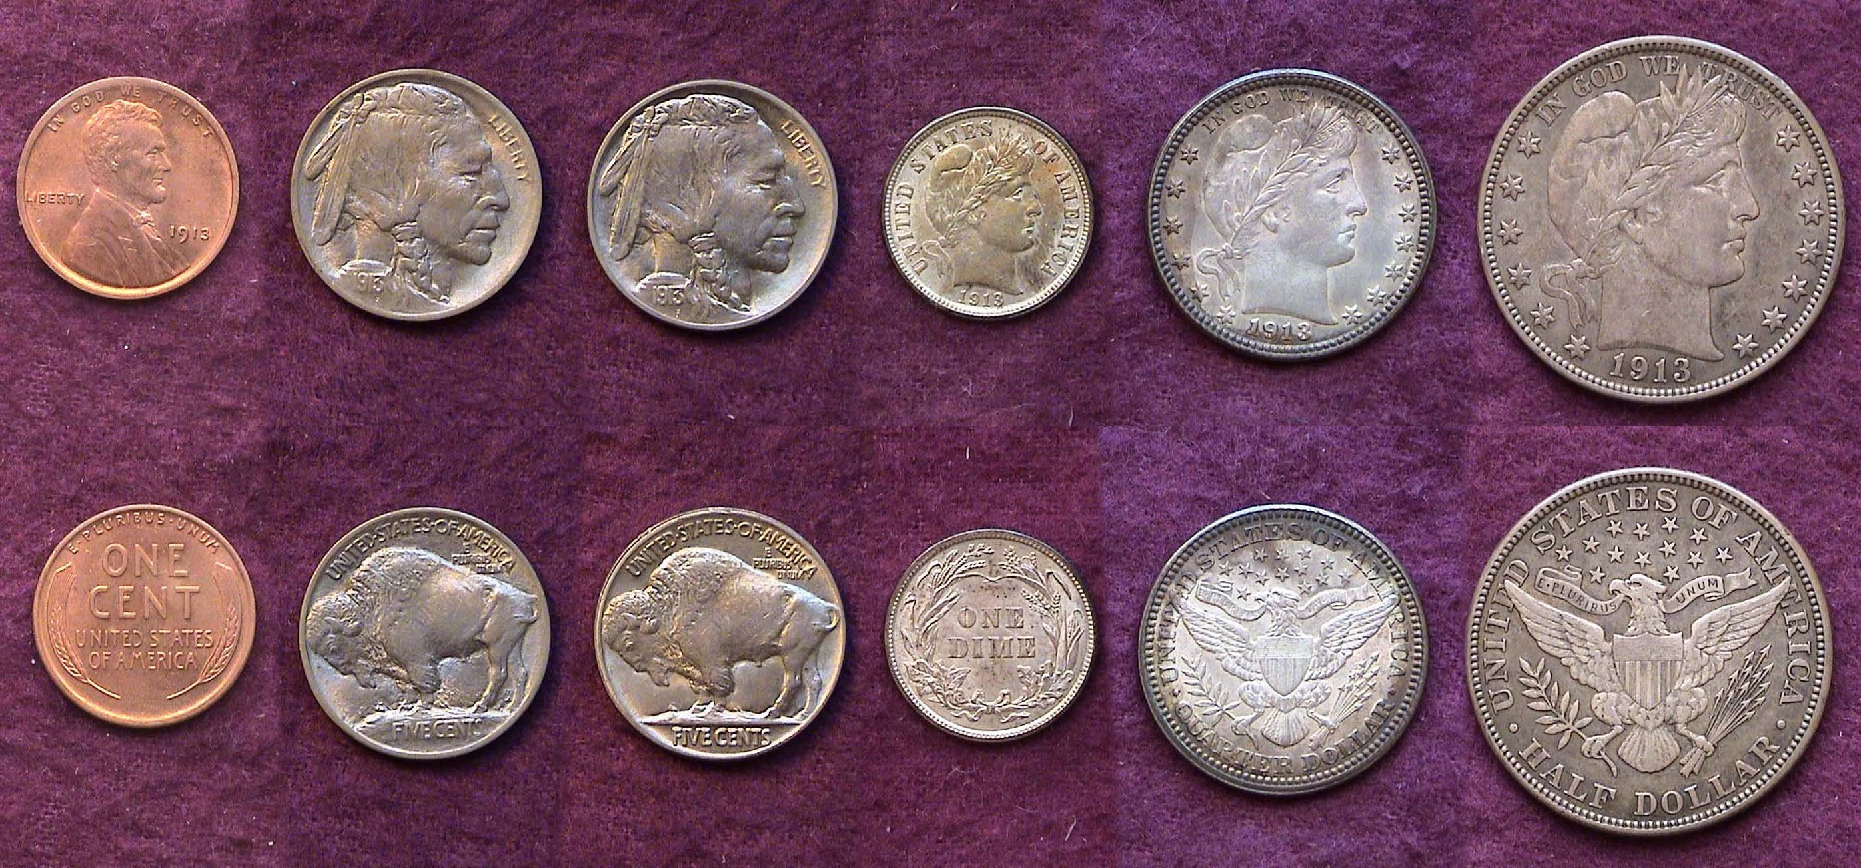

A 1913 Year set (excluding gold) showing both nickel types
Reduced in size to fit on page
[Use 3x glass or magnify page to 200% to view details.]
____________________________________________________________________________________________________________________

Club News

In the absence of President Steve Kuhl, VP Pat James presided and called the April 4, 2013 meeting to order at 6:45 PM at the Aiken Public Library. Our newly elected Sgt. In Arms, Jim Sproull announced that thee were 16 members present along with five guests. Jim also reported on the upcoming shows for April and early May. Thank you, Jim! Treasurer Chuck Goergen reported a treasury balance odf $1,734.21. Vice President Pat James made a special presentation to Glenn Sanders for his long service to the club as both Auctioneer and Sgt. In Arms. Glenn received a heart round of applause.

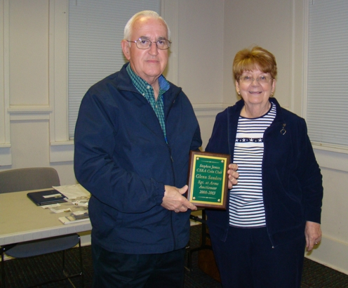

Glenn Sanders holds appreciation plaque presented by Pat James
[Picture, courtesy of Secretary Jim Mullaney]

There were two Show & Tell presentations. Arno Safran displayed a 1794 Year set of replicas produced by the Galley Mint. The coins were all recreated in their actual metal alloys and sizes, and were struck on a screw press modeled after the original at the Philadelphia Mint. The five piece set included replicas of the 1794 copper Lib. Cap ½¢ and 1¢, and the silver Flowing hair half-disme, half dollar and silver dollar.

David Amey displayed a large medal showing Columbus landing in America in 1492.

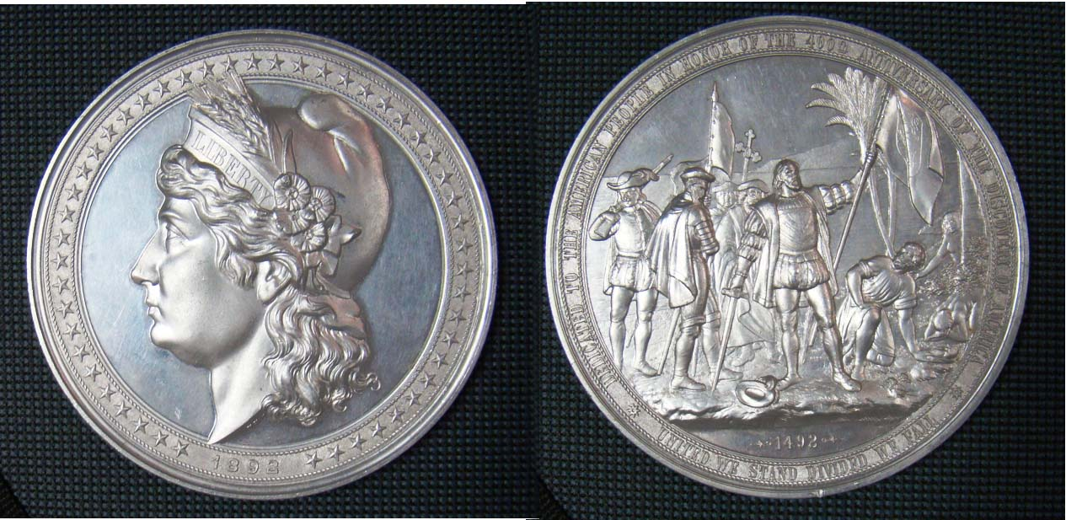

Columbian Medal showing Morgan dollar type Liberty on obverse and Columbus landing in America in 1492 on reverse.
______________________________________________________
(More Club News continues on page 4)

More Club News
(Continued from previous page)

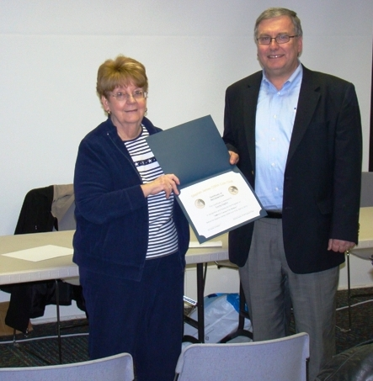
The Program: VP Pat James arranged for Garry Naples, a specialist in the Morgan dollar series to present a PowerPoint program on the Carson City Morgan dollar overdates of 1880. Garry gave a brief history on Carson city Mint which began operations in 1870. He also gave some background on the Morgan dollar series explaining the Van Allen diagnostics (identified by VAM numbers) and then displayed close-ups of the three major overdate varieties on the 1880/79 CC Morgans describing them as VAM 4, 5 & 6. We hope Garry will become a member and present more interesting program. Pat James presenting appreciation award
to Garry Naples
The April, 4 meeting represented the official beginning of our 2013-14 fiscal year. Awards of 2012 Proof Sets were given in appreciation in recognition to members who served as elected officers or in other capacities during the 2012-13 fiscal year.

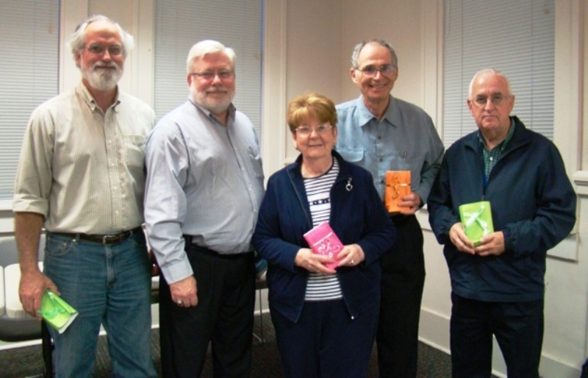

Recipients of appreciation awards for the club 2012-13 fiscal year
From left, Jim Mullaney, Secretary, , Chuck Goergen, Treasurer, Pat James, Vice President, Arno Safran, Newsletter Editor and Glenn Sanders, Sgt. In Arms, President Steve Kuhl, who was unable to attend, also received an appreciation award.

The prizewinners at the April 4 meeting were Dick Lasure who won the door prize and Pat James who won the 50/50 drawing. Congratulations, Dick and Pat. Our next meeting is May 2. John Attaway will present a program on “The Banknotes of Hamburg, SC” (the former name of a portion of North Augusta. Please bring in something for show & Tell and the auction. Looking forward to seeing many of you there.
____________________________________________________________________________________________________________________

‘
Kindly Patronize Our Advertisers

