The Stephen James
CSRA Coin Club of Aiken
P.O. Box 11
New Ellenton, SC 29809
Web site: www.sjcsracc.org
The SJ CSRA CC of Aiken, SC meets on the 1st Thursday of the month at the Aiken Public Library

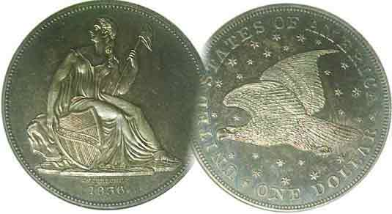
Pres. J.J. Engel
V .P. Pat James
Sec. Jim Mullaney
Treas. Chuck Goergen
Sgt. in Arms: Jim Sproull

Programs: Pat James
ANA Rep.: Glenn Sanders
Show Chair: Board members
Photos: Steve Kuhl
Publicity: Pat James
Newsletter: Arno Safran
E-Mail: arnosafran@comcast.net
Auctioneer: Jim Sproull
Web site: Susie Nulty (see above.)

Our next meeting would have occurred on Thursday, May 7 but is cancelled due to the Coronavirus

2019 Club Meeting Schedule
Volume 19, No. 5 the Stephen James CSRA Coin Club, Founded in 2001 May, 2020
Monthly Newsletter
Meetings via “Zoom” could replace “live” meetings soon
Jan. 2 Apr. 2 July 2 Oct. 1
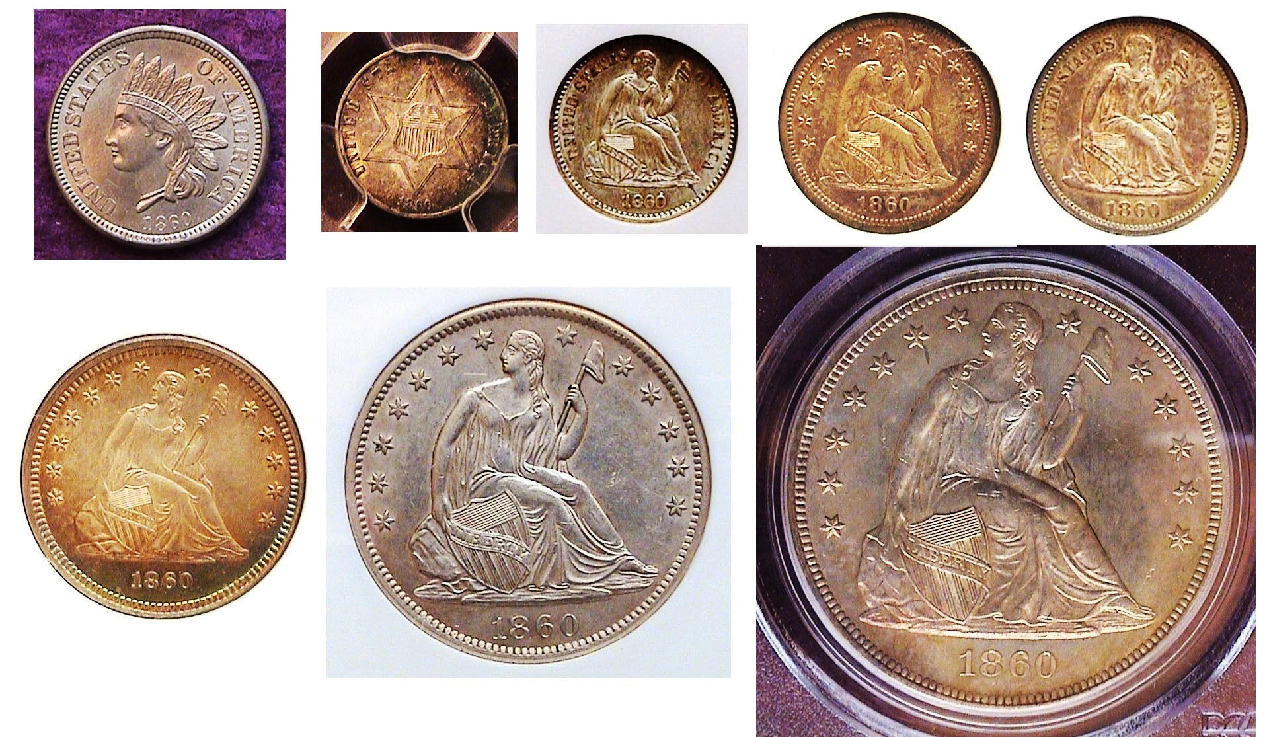
Feb. 6 May 7 Aug. 6 Nov. 5
Mar. 5 June 4 Sept. 3 Dec. 3

SJ CSRA CC Trial Meeting
By Pat James, Club VP & Programs Chair

On the 1st Thursday of April I got a text from Jim Mullaney to call him. I did at about 3 p.m. and he informed me about ZOOM and in just ten minutes walked me through installing it and getting ready to join the proposed on-line meeting of the coin club Board at 6 pm. At 6 pm, I got an email to join the session. I responded and was hooked up with members Jim M., JJ. Engle, Steve Kuhl, Jim Sproull, as well as Tim and Kelsey who were allowing us to hold our meeting on their business ZOOM account to demonstrate it, as well as Steve Twitty from, former editor of the SCNA SCanner who Steve Kuhl had invited. We all just talked about ZOOM and its capabilities were explained to us by Tim and Kelsey, and Steve Kuhl, as well as the estimated cost of $150/yr for the coin club to have an account if we wanted to get one. JJ and Jim Sproull were only able to get the audio portion for some reason. Jim M offered to help them. Electronically, it challenged me but I was able to get the whole thing and participated in the session with no problem. Steve Twitty thought it would be a good thing to put in t the SCNA, the quarterly journal of the South Carolina Numismatic Association, currently edited by our own past President, Steve Kuhl.
I loved ZOOM, especially as we could record the club's programs not only during any given to the entire membership during the Coronavirus lockdown, but also later when we're meeting normally.

You know, I have been advocating for the purchase of good video recording equipment to record our wonderful programs and be able to donate them to the ANA Library as part of the coin club's non-profit status mission of educating the public on numismatics.
_______________________________________________________________________________________________________________________
Thank you, Pat, for that excellent report and
thank you, Jim Mullaney for bringing it to fruition., ED.
Collecting the Coins of 1860 (exc. gold) 160 Years Ago
By Arno Safran

The obverses of the US coinage of 1860 (excluding gold)
[Enlarge page to fill monitor screen to view details.]
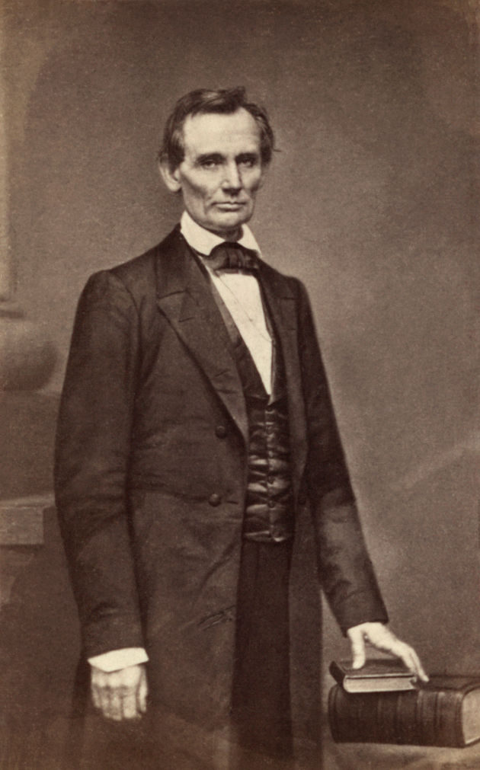
In 1860, the United States was on the verge of Civil War due to the slavery issue and the economic structure of the southern states’ that were dependent on its continuation. The election of our first Republican president, Abraham Lincoln in November represented the death-blow to that region of our nation with various southern states led by South Carolina succeeding from the union eventually leading to what has been called “the War Between the States”
Abraham Lincoln in 1860
Before all that occurred however, three of our coinage denominations were slightly altered, the Indian Head cent with a new wreath on the reverse and the Liberty Seated half-dime & dime to be discussed later. Despite the impending war that followed, most of the 1860 denominations struck at he Philadelphia Mint (excluding gold) are considered common dates.
____________________________________________________________________________________________________________________________
(Continued on page 2, column 1)
Collecting the Coins of 1860 (exc. gold) 160 Years Ago
(Continued from page 1, column 2)
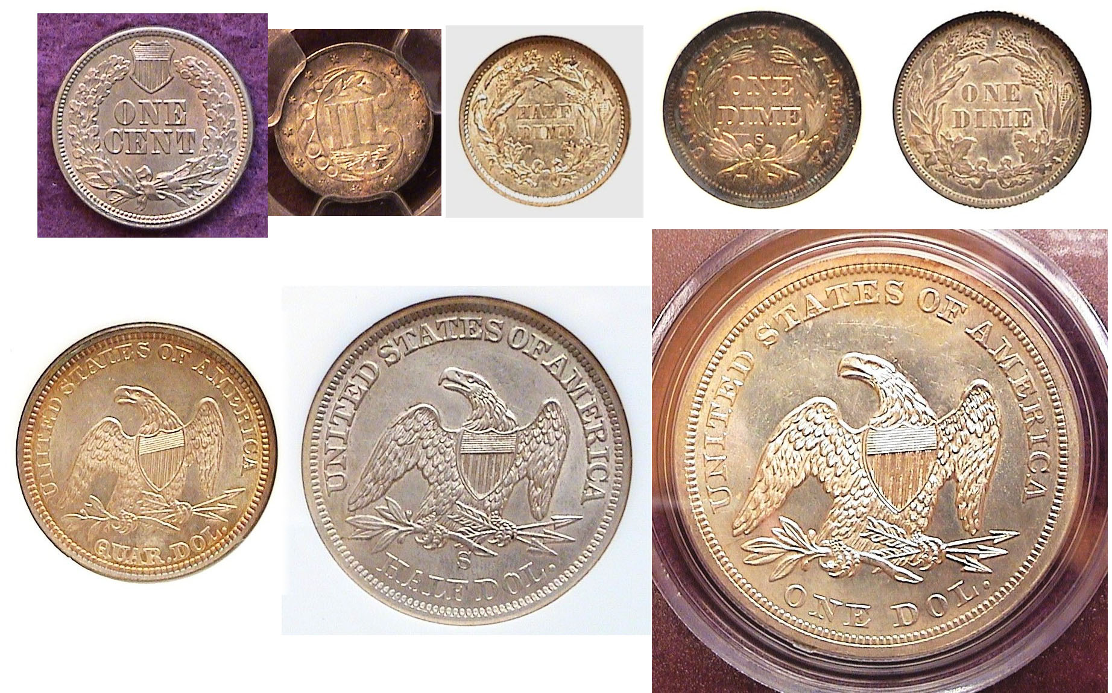

The reverses of the US coinage of 1860 (excluding gold)
[Enlarge page to fill monitor screen to view details.]

Shown above are the reverses of the cent, 3c silver trime, the silver 5c half-dime, the two dime reverses along with the reverses of the Liberty Seated quarter, half-dollar and silver dollar. The six gold denominations which included the $1,00, $2.50, $3.00, $5.00, $10,00 and $20.00 double eagle were struck in smaller numbers except for he double eagle that year but all remain fairly expensive in the higher circulated and BU grades and are above the discretionary income for most of us.

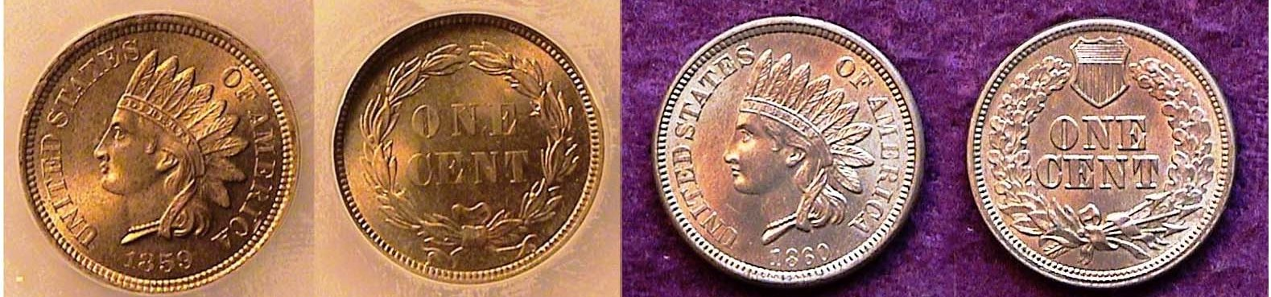
The 1859 & 1860 Indian Head shown slightly enlarged
copper-nickel cents
[Enlarge page to fill monitor screen to view details.]

In 1860, The Indian cent was struck in its second year but the wreath was altered considerably from the 1859 version to the 1860 coin at right which shows a shield atop a thicker wreath. More subtle, was the slight rounding out of the truncation on the tip of native American’s neck from the pointed one on 1859 to the rounded one on the 1860. See directly below.

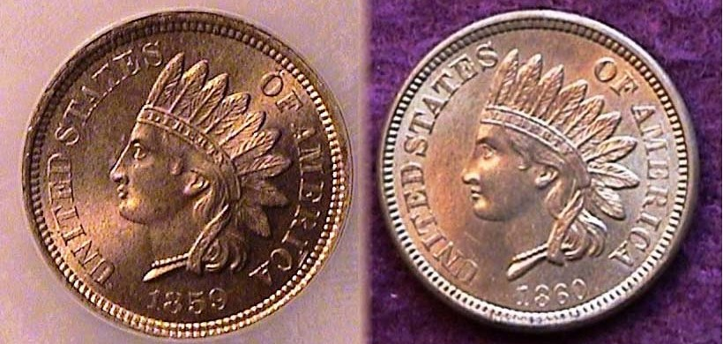

Further enlarged are the two 1859 & ’60 obverses
Showing more clearly the pointed and rounded neck

In 1860, 20,596,000 cents were coined compared with 36,4000.000 for the 1859, but because the 1859 was a one year type, it is much more in demand and therefore more expensive than the 1860, which is still moderately priced thru MS-64. There is one more anomaly regarding the 1860 cent issue, A smaller number of pointed busts were also struck for the 1860 cent and they are priced around three times those of the rounded Bust-type. In 1860, a cent had the purchasing power of 24¢.

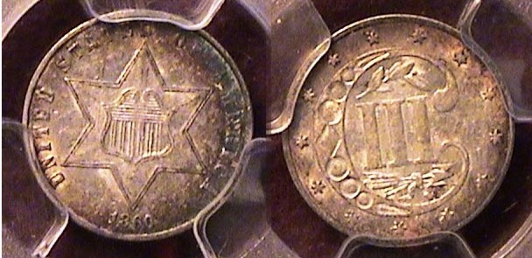

An 1860 three cent silver trime graded MS-62 by PCGS
[Enlarge page to fill monitor screen to view details.]

In 1860, the three cent silver trime was in its tenth year of existence and second year of its third and final sub-type. It was deigned by Chief Engraver James Barton Longacre and originally produced in 1851 to stimulate the circulating of silver coinage after the discovery of gold in 1849 had caused the value of silver to rise above a silver coin’s face value. The silver three cent piece was only 14 mm in diameter but by 1860, had become the smallest US coin, since by then, the $1.00 gold coins--first struck in 1849--had increased in diameter from 13 mm to 15 mm in 1854 along with a more ornate crown. The 3¢ trime--as it came to called--was originally used to buy a first class postage stamp which had been reduced from 5¢ to 3¢. Also, starting in 1854, the amount of silver in the trime had been increased from .750 to .900 fine with minor changes to both sides having been finalized in 1859. The mintage for the 1860 3¢.trime was not as large as the earlier ones; only 286,000, the second lowest since the 1855 issue but is priced as a common date today, presumably because by then, the coinage crisis was long over. In 1860, a trime had the purchasing power of 72¢.

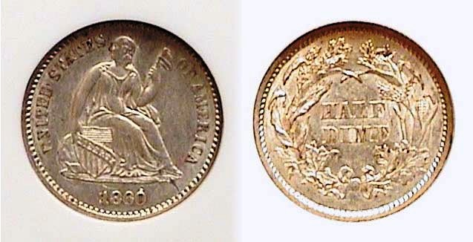

An 1860 Liberty Head silver half-dime graded AU-55 by NGC
[Enlarge page to fill monitor screen to view details.]

In 1860, the Liberty seated half-dime underwent a alteration without actually changing the obverse’s central device. The 13 stars were removed from the obverse and was replaced by , the legend, UNITED STATES OF AMERICA. On the reverse, the wreath was thickened by combining four different types of flora. The coin’s diameter remained at 15.5 mm. 798,000 were struck at the Philadelphia Mint compared with 1,060,000 at the and New Orleans facility in 1860 yet many more of the Philadelphia Mint specimens survive and are less expensive to acquire. The AU-55 specimen shown is relatively inexpensive yet still attractive to the viewer when enlarged. In 1860, a half-dime had the purchasing power of $1.56. ( Continued on page 3, column 1)
Collecting the Coins of 1860 (exc. gold) 160 Years Ago
(Continued from page 1, column 2)

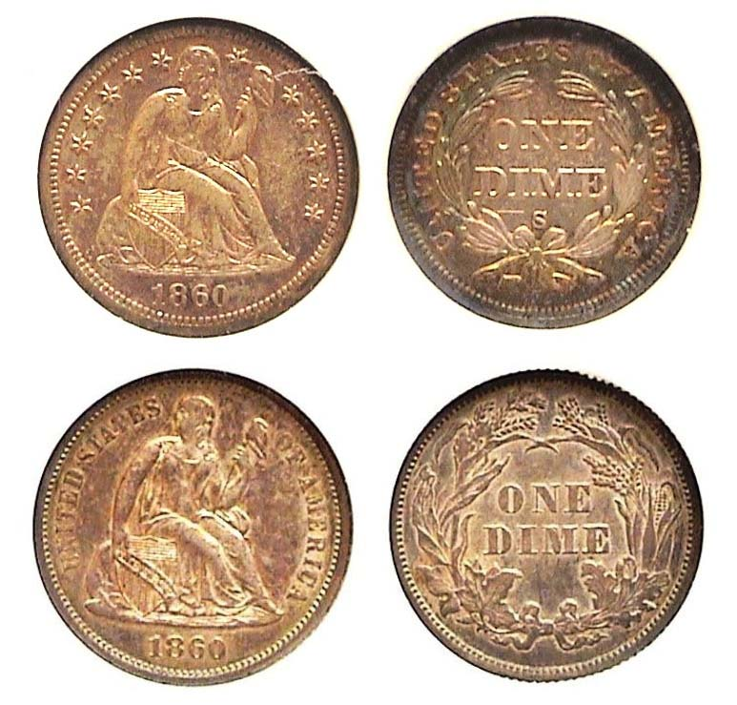
An 1860-S old style over an 1860-P new style Liberty Seated dime
[Enlarge page to fill monitor screen to view details.]

Transitional date coins are enjoyable to collect whether they represent two completely different design types such as the 1938 Native American/ Buffalo nickel into the Jefferson nickel or less obvious alterations like the two dimes shown above. Upon enlargement, the viewer can see that the obverses retain the Liberty Seated design but the 1860-S dime shown atop displays the thirteen stars circling Miss Liberty while the 1860-P dime below it displays the legend UNITED STATES OF AMERICA surrounding her. The reason for the disparity occurred because the San Francisco Mint received the word of the change too late before striking the 1860 dimes there.

In 1860, the Philadelphia Mint struck 606,000 dimes with the Legend and many were saved because they are plentiful and quite inexpensive today. On the other hand, the New Orleans mint coined just 40,000 of the newly designed pieces and most of them circulated so, they are considered rare and very expensive today. As for the San Francisco Mint--which struck the older with stars type obverse,--the mintage was only 140,000 and while not as rare as the 1860-O with legend sub-type, are still a lot scarcer then the 1860-P with legend on obverse dimes. As a result, despite both the 1860-P and 1860-S dimes having been certified AU-55, the 1860-S is worth twelve times the price of a 1860-P in today’s numismatic marketplace.

In 1860, a dime had the purchasing power of $3.17.
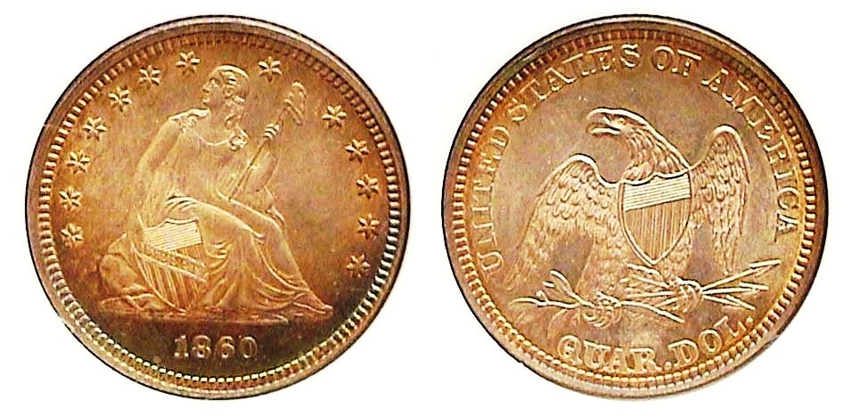
An 1860 Liberty Seated quarter graded MS-63 by NGC
[Enlarge page to fill monitor screen to view details.]

In 1860, the Liberty Seated quarter was struck at the Philadelphia, New Orleans and San Francisco mints with the first named producing the most examples, 800,400 and easily the most acquirable and affordable of the three mints in which the 1860-S is considered scarce to rare. The date usually comes unevenly struck on the stars surrounding the Miss Liberty on the obverse but this example appears sharply struck on both sides of the coin. In 1860, a quarter had the purchasing power of $7.93.

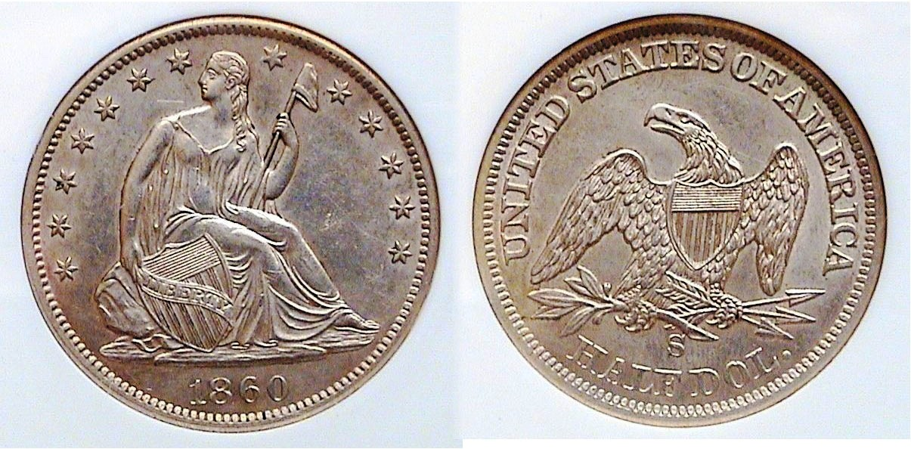

An 1860-S Liberty Seated half-dollar graded AU-55 by NGC
[Enlarge page to fill monitor screen to view details.]

In 1860, the Philadelphia Mint struck only 302,700 1860 Liberty Seated half-dollars compared with 1,290,000 at New Orleans and 472,0000 at San Francisco yet according to numismatic scholar Ron Guth of PCGS’ COINFACT, less examples surface of the 1860-S than the 1860-P. As a result, the coin is affordable in AU-55, the grade shown. The author also found this “beauty” also at the FUN show in Jan. 2011 held in Tampa. It is well struck and appears to have nice eye appeal.
In 1860, a half-dollar had the purchasing power of 15.30.

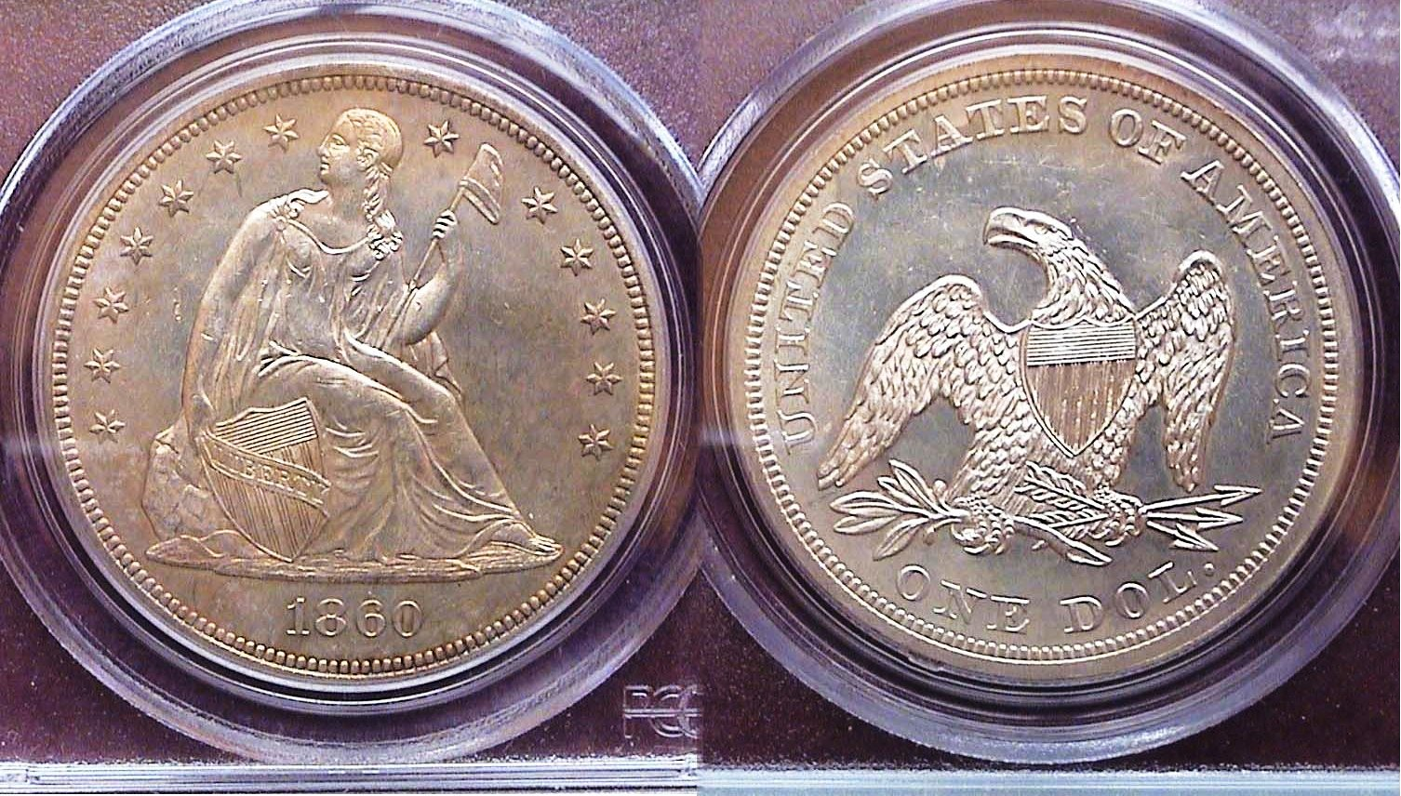

An 1860 Liberty Seated dollar graded MS-62 by PCGS
[Enlarge page to fill monitor screen to view details.]

In most instances the silver coins of this era of US coinage were struck at the Philadelphia, New Orleans or San Francisco Mints with the smaller Charlotte and Dahlonega mints devoted to the gold $1.00, $2.50 quarter eagle and $5.00 half-eagle denominations and these were coined in far smaller numbers and are rare today. As a rule, the Philadelphia Mint produced the most coins but not always. There were some years when the New Orleans and even the San Francisco mint struck more.
When it came to the Liberty Seated silver dollar no motto portion of that series, the New Orleans Mint coined the denomination just four times, in 1846, 1850, 1859 and 1860 and the San Francisco Mint just once, in 1859 with just 20,000 and it is rare. Oddly, in both 1859 and 1860, the New Orleans Mint struck more silver dollars than the Philadelphia Mint did with the 1860-O considered the most common date of the entire no motto portion of the series, (1840-1865), so when trying to complete his 1860 year set, the author was delighted to come across this lovely example of the scarcer 1860-P at the 2011 FUN show. Before one attends a major show whether it be the ANA, the Whitman Show in Baltimore or F.U.N., a collector starts saving up sufficient funds or consider selling no longer needed coins from one’s collection in order to acquire a better date coin like the 1860-P Liberty Seated silver dollar shown above. In 1860, a dollar had the purchasing power of $31.70.
Collecting Coins During the Coronavirus pandemic

If you are an avid coin or paper money collector and have been attending coin shows both near and far for most of your active association with numismatics, you like many other hobbyists, must be frustrated to learn of the cancellation of virtually ever show, local to national over the past two months well into the early summer. Fortunately, for this writer, attending the ANA National Money Show in Atlanta at the end of February provided him with enough acquisition satisfaction to overcome his frustration. For many others, those ardent collectors who looked forwarded to attending the Georgia Numismatic Association’s mid April show had to be disappointed when they were informed of its cancellation due to the pandemic we all are facing at present. Could this be the death-knell for the hobby? Perish the thought! Absolutely not! How so?

The internet: That’s how so! During the past month and a half, there has been more numismatic action on the internet than ever before. Having acquired a number of acquisitions in that manner during the past two decades, the editor has observed two very important improvements since the turn of the century. Virtually all coins are displayed as certified mostly by PCGS or NGC, occasionally by Anacs or ICG. Secondly, the coins show both the obverse and reverse and thirdly, the images can be magnified by the viewer to the point where one can view the finer details such as distracting marks, discoloration, nicks, bumps and even minor scratches or best yet, none of the above, which usually apply to higher-end uncirculated pieces.

Another factor brought on by the pandemic is the chaotic manner in which the political divide has caused a rise in our precious metals with gold now trading at $1,716.50 as this is being written (May 4) compared with $1,500 at the ANA Atlanta Show at the end of February. During this time, two of our local coin stores have been dealing almost exclusively in the trading and selling of bullion /over type coins. Precious metals tend to rise during periods of uncertainty and when you have the medical and scientific professions saying one thing and the leader of the free world another, there can be no greater cause for uncertainty; especially when the lives of potentially millions are at stake, which is one of the reasons precious metals rise.
For members who have never gone on-line to obtain a numismatic item, click Google, then the coin denomination and type you wish to acquire. Up will come numerous dealers and pics of coins with varying dates. Another search engine is eBay in which you will receive emails showing you examples and prices. Finally for those desiring a wide range of coin types and their cost, click on either PCGS’ Collector’s Corner for availability or PCGS’s COINFACT for educational aspects such as rarity factors concerning grading and recent pricing.. NGC also has its own web-site and guides.
Once you make up your mind to place an order, click on the dealer’s web-site, set up your on line name and password, make sure your charge card is before you and follow the directions on the dealer’s on line order system and viola, in most cases, you will receive your selection within two to three day priority mail delivered to you from your local post office.
______________________________________________________________________________________________________________
2021 Red Book Available to Club Members

Glenn Sanders reports that those members that preordered a 2021 Redbook know that he will have them at the next meeting. If they can't wait until then, they can call him at (803) 663-6557 and he will make arrangements to get theirs to them.

Member John Kolmar and his
Ryobi Lithium hybrid project Light

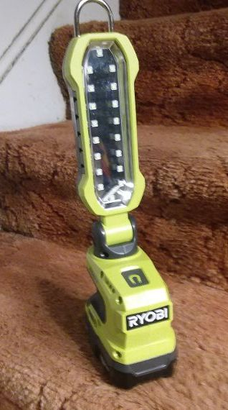
Here is a light I bought at Home Depot that I use a lot for looking at coins. It is a Ryobi lithium hybrid project light. It has an adjustable arm and can run off an 18 volt Ryobi rechargeable lithium battery or be plugged into a 120 v socket. The LED light is really bright and makes it very easy to see the finest details of coins. I have found it invaluable in examining my coins. It is currently available at Home Depot for $39.88.

____________________________________________________________________________________________________________________
(It may look like a vacuum cleaner but it isn’t! Thanks, John! ED)

Kindly Patronize our Advertisers
